Supporting information for
Alkaline-based aqueous sodium-ion batteries for large-scale energy storage
Han Wu^{1,†}, Junnan Hao^{1,†}, Yunling Jiang¹, Yiran Jiao¹, Jiahao Liu¹, Xin Xu¹, Kenneth Davey¹, Chunsheng Wang² & Shi-Zhang Qiao^{1,*}
¹ School of Chemical Engineering, The University of Adelaide, SA 5005, Australia
² Department of Chemical and Biomolecular Engineering, University of Maryland, College Park, MD 20742, USA
* Corresponding author’s Email: s.qiao@adelaide.edu.au

Table of Contents
Supplementary Discussion
Text S1 Function of carbon in Ni/C coating.
Text S2 Transformation of Ni in coating and its contribution to the H₃O⁺-rich microenvironment.
Supplementary Figures
Supplementary Fig. 1 X-ray diffraction (XRD) pattern for Na₂FeMn(CN)₆ (NMF) cathode.
Supplementary Fig. 2 XRD pattern for NaTi₂(PO₄)₃ (NTP) anode.
Supplementary Fig. 3 XRD pattern for Ni/C.
Supplementary Fig. 4 In-situ DEMS test for NaClO₄ electrolytes at a rate of 5 mV s⁻¹.
Supplementary Fig. 5 Electrolyte characterization.
Supplementary Fig. 6 Cycling performance for half-cell using three-electrode system.
Supplementary Fig. 7 Interface structure characterization of the coated cathode.
Supplementary Fig. 8 ICP-MS findings for electrolytes collected from three-electrode cell following cycling with/without Ni/C coating on the cathode surface in alkaline electrolyte.
Supplementary Fig. 9 Electrochemical performance of NMF/NTP full cell.
Supplementary Fig. 10 Differential scanning calorimetry (DSC) for selected electrolytes.
Supplementary Fig. 11 Testing for safety of NMF/NTP full cell.
Supplementary Fig. 12 Comparison of electrolyte cost for the new battery with reported liquid aqueous Li/Na/K-ion batteries with energy density > 80 Wh kg⁻¹.
Supplementary Fig. 13 Function of carbon in the coating.
Supplementary Fig. 14 Generation of H₃O⁺.
Supplementary Fig. 15 Operando synchrotron XRPD (λ = 0.5903) for NMF/NTP full cells with Ni/C coating in range 0.5 to 2.2 V.
Supplementary Fig. 16 Soft XAS spectra for Ni/C coated NMF cathode in the pristine state, charged to 2.2 V and discharged to 0.5 V (Ni L-edge).
Supplementary Fig. 17 Digital image of cycled batteries.
Supplementary Fig. 18 TEM image of uncycled NMF and cycled NMF.
Supplementary Fig. 19 EDS mapping for NMF particles with Ni/C coating cycled following 1, 5th and 20th cycles.
Supplementary Fig. 20 Cycling performance for NMF/NTP full cells with Co/C coating in alkaline electrolyte.
Supplementary Fig. 21 Electrochemical performance for Na₃V₂(PO₄)₃@C in alkaline electrolyte.
Supplementary Tables
Supplementary Table 1 Viscosity and pH for selected electrolytes.
Supplementary Table 2 Comparison of electrolyte cost for full battery with reported aqueous Li, Na and K-ion full batteries > 80 Wh kg⁻¹
Supplementary Table 3 Comparison of lifespan and energy density of this work with report aqueous Na full batteries.
Supplementary Table 4 Comparison of this work with commercial batteries.
Supplementary Table 5 Adsorption energy for adsorbed H, OH and H₂O at most stable adsorption sites on (200) and (111) facets of Ni nanoparticles under differing electro-potential.
Supplementary Table 6 Elemental atomic fraction for NMF cathode prior to and following cycling from EDS mapping.
Supplementary Table 7 Detailed structural information on samples cycled for 1st cycle after Rietveld refinement.
Supplementary Videos
Supplementary Video 1 The cut pouch cell to power blue lights in water.
Supplementary Video 2 The cut pouch cell to power an electric fan in water.
Supplementary Video 3 The cut pouch cell to power a hygrometer in water.
Supplementary Discussion
Text S1. Function of carbon in Ni/C coating.
The binder was Nafion-Na which forms a dense coating on the surface of the cathode. With low ionic conductivity, it raises interfacial resistance and compromises rate performance. Adding carbon matrix improves the porosity of the polymer and conductivity of the coating, ameliorating the detrimental effect of the coating on rate performance. As is shown in Supplementary Figs. 13a-b, after the introduction of the carbon matrix, the resistance of the coating with a thickness of 25 µm, was reduced from ca. 150 to < 10 Ω, evidencing that carbon addition reduces the interfacial resistance of the coating. However, because of the absence of Ni, the carbon coating itself cannot induce a H₃O⁺-rich microenvironment to suppress OER and cathode dissolution. Therefore, batteries with pure carbon coating exhibit significant over-charging caused by water decomposition (Supplementary Fig. 13c) and poor cycling performance induced by cathode deterioration (Supplementary Fig. 13d).
Text S2. Transformation of Ni in coating and its contribution to the H₃O⁺-rich microenvironment.
Generation of H₃O⁺ is predicated on two transformation steps, 1) irreversible oxidation of Ni → Ni(OH)₂, which consumes OH⁻ anions on the cathode surface, and 2) reversible Ni(OH)₂ $⇌$ NiOOH. This irreversible step was confirmed by the gradually decreasing peak intensity for Ni (111) and growing intensity for peak intensity related to Ni(OH)₂ in XRPD patterns during battery charging (Supplementary Figs. 15a-b, Chemical equation S1). However, following charging to > 1.8 V, the peak exhibiting Ni(OH)₂ vanishes and a new peak related to NiOOH appears, evidencing the transformation of Ni²⁺ to Ni³⁺ (Supplementary Figs. 15b-c). Additionally, this reaction generates H⁺ to initiate a H₃O⁺-rich microenvironment (Chemical equation S2). Moreover, NiOOH can be fully reduced to Ni(OH)₂ following discharging where it is beneficial to dynamically maintain the H₃O⁺-rich microenvironment. As for the capacity provided by the Ni(OH)₂/NiOOH redox, due to the minimal amount of Ni in the coating (< 0.1 mg cm⁻²) and ultra-thick electrode (ca. 10 mg cm⁻²), the capacity provided by the Ni(OH)₂/NiOOH redox can reasonably be assumed negligible.
Ni + 2OH⁻ → Ni(OH)₂ (S1, during charging, irreversible)
Ni(OH)₂ $⇌$ NiOOH + H⁺ (S2, reversible)
The oxidation of Ni and reversible transformation between Ni(OH)₂ and NiOOH were confirmed via soft XAS. As shown in Supplementary Fig. 16, Ni has the greater spectral mass in two locations in the L₃ edge absorption band (peak A in the lower, and peak B in the higher energy region). The intensity ratio peak B/peak A is good evidence for state changes in Ni element^{1,2}. An increase in the intensity ratio evidences the oxidation of Ni, whilst a decrease evidences the reduction of Ni. In the pristine state, the average oxidation state for Ni will be close to Ni⁰. Following charging to 2.2 V, the ratio peak B/peak A increases, confirming the oxidation of Ni. However, following discharging to 0.5 V, the intensity ratio decreases, evidencing that Ni oxidation and reduction are partially reversible during battery cycling.

Supplementary Figures

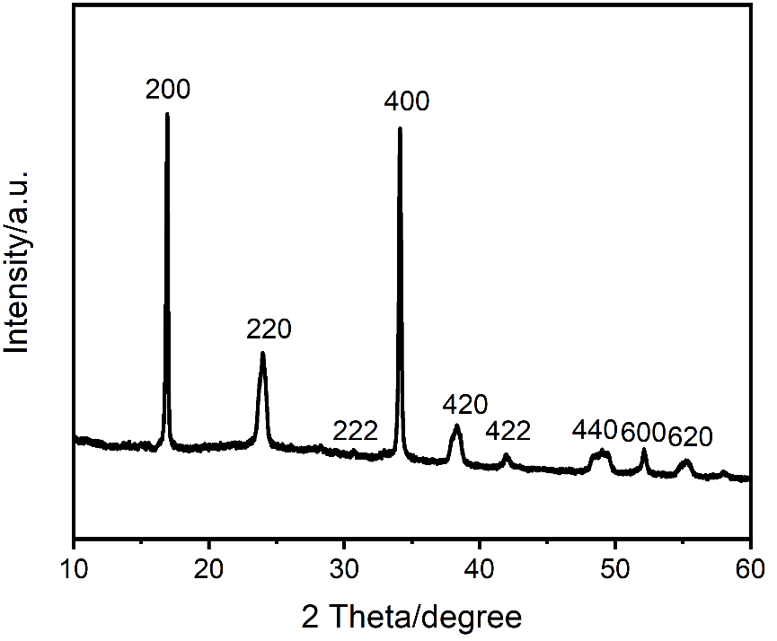
Supplementary Fig. 1 | X-ray diffraction (XRD) pattern for Na₂FeMn(CN)₆ (NMF) cathode. The pattern confirms crystallinity for NMF in good agreement with reported findings³.

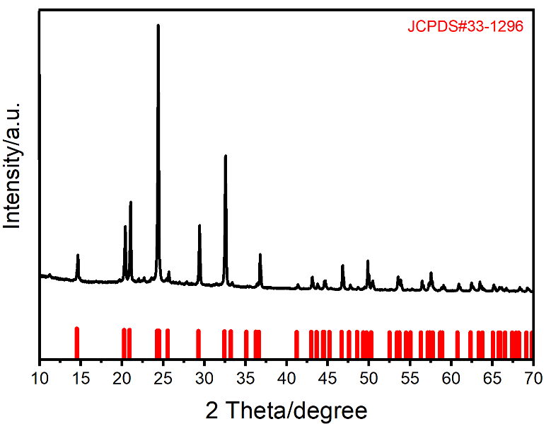
Supplementary Fig. 2 | XRD pattern for NaTi₂(PO₄)₃ (NTP) anode. The pattern for synthesized NTP anode agrees well with the Powder Diffraction File (PDF) standard card for NaTi₂(PO₄)₃.
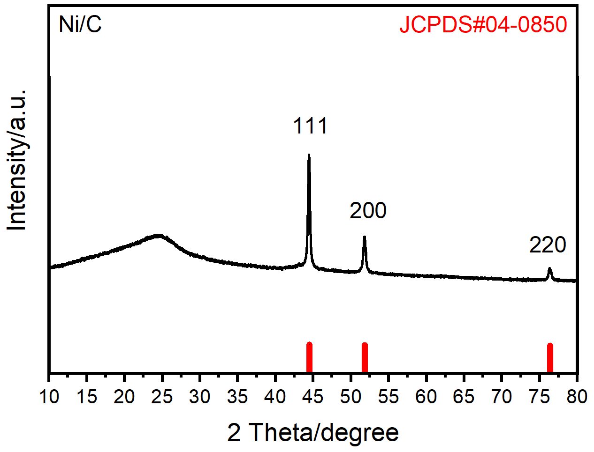
Supplementary Fig. 3 | XRD pattern for Ni/C. The pattern confirms hybrid of Ni/C.

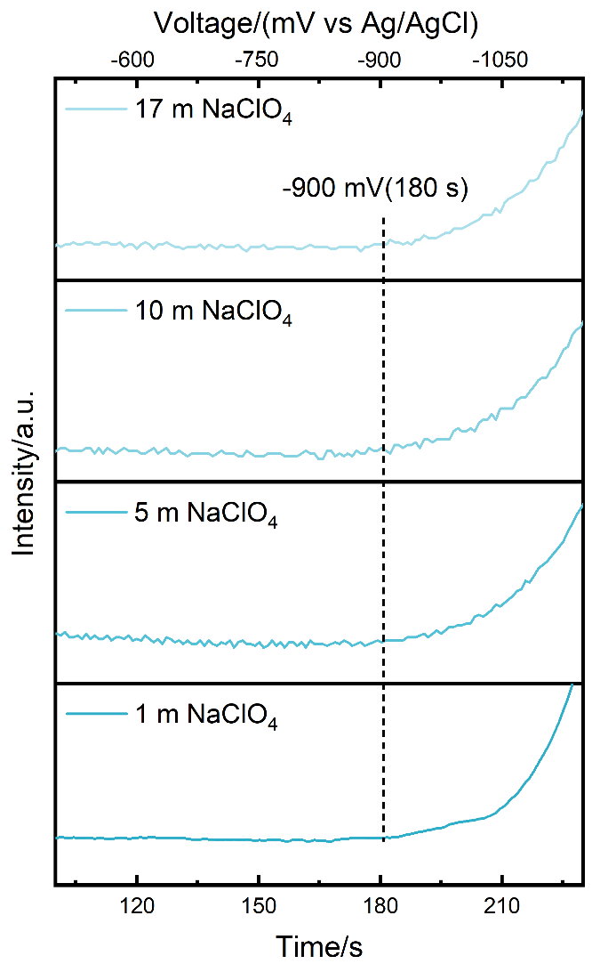
Supplementary Fig. 4 | In-situ DEMS tests for NaClO₄ electrolytes at a rate of 5 mV s⁻¹. Au-coated PTFE as the working electrolyte, Pt-wire as the counter electrode, and Ag/AgCl as the reference electrode.
Supplementary Fig. 5 | Electrolyte characterization. a, pH for neutral electrolyte following the addition of selected volumes of 1 M NaOH. b, Ionic conductivity for neutral electrolyte following the addition of selected volumes of 1 M NaOH. c, LSV curves for electrolytes with NaOH addition from −1.0 to −2.0 V. d, LSV curves for different electrolytes from 0 to 2.0 V. (with glass carbon as the working electrode, Ti as the counter electrode, and Ag/AgCl as the reference electrode).
As evidenced in Supplementary Figs. 5a-b, with the addition of 1 M NaOH (from 0 to 0.8 mL), the pH and ionic conductivity for the electrolyte (30 mL) increase, which lowers cathodic limiting potential (Supplementary Fig. 5c). From LSV curves in Supplementary Fig. 5c, the electrolyte with 0.4 mL NaOH addition exhibits similar HER overpotential to that with 0.8 mL NaOH addition. The alkaline system with 0.4 mL NaOH addition was therefore selected as an example. However increased alkalinity with 0.4 mL 1 M NaOH addition, boosts OER at the cathode (Supplementary Fig. 5d).

Supplementary Fig. 6 | Cycling performance for half-cell using three-electrode system (Ag/AgCl electrode with sat. aq. KCl solution as reference electrode and carbon black as counter electrode at current density of 100 mA g⁻¹). Charge and discharge profiles for NTP electrode in three-electrode cell using a, neutral and b, alkaline, electrolyte. c, CE comparison for NTP electrode in three-electrode cell using neutral and alkaline electrolyte. Charge and discharge profiles for NMF electrode in d, neutral and e, alkaline, electrolyte and f, alkaline electrolyte (NMF with Ni/C coating). Digital image of cycled NMF electrode in three-electrode system using g, neutral and h, alkaline, electrolyte and i, alkaline electrolyte (NMF with Ni/C coating).
Supplementary Fig. 7 | Interface structure characterization of the coated cathode. a, Cross-section SEM image of Ni/C coated NMF. b-c, EDS point scan of cross-section SEM image.

Supplementary Fig. 8 | ICP-MS findings for electrolytes collected from three-electrode cell following cycling with/without Ni/C coating on the cathode surface in alkaline electrolyte. a, Fe, b, Mn, concentration.

Supplementary Fig. 9 | Electrochemical performance of NMF/NTP full cell. a, Rate capability and corresponding CE for three NMF/NTP cells with, neutral, alkaline and alkaline (with Ni/C coated) electrolytes. b, Comparison of average discharge voltage for three cells at varying rates.

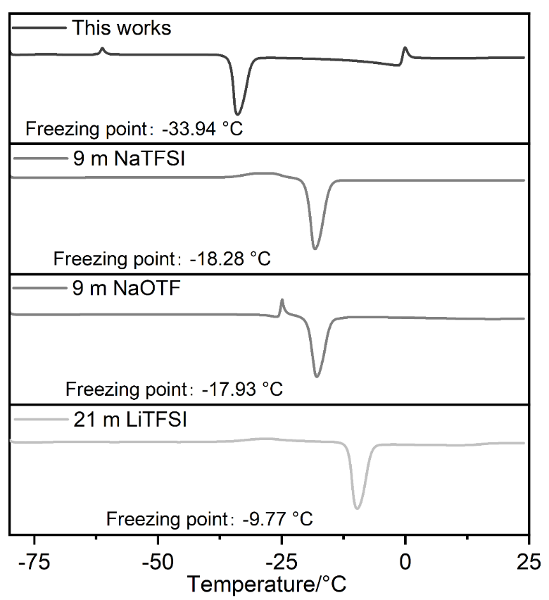
Supplementary Fig. 10 | Differential scanning calorimetry (DSC) for selected electrolytes. New (this work) electrolyte exhibits the lowest freezing point of −33.94 °C compared with commonly used electrolytes, 9 m NaTFSI, 9 m NaOTF, and 21 m LiTFSI.

Supplementary Fig. 11 | Testing for safety of NMF/NTP full cell. a, Output voltage for pouch cell. b, Digital image of blue-colour LED lights powered by two NMF/NTP pouch cells. c, Digital image of cut pouch cells powered blue-colour lights in water. d-e, A cut pouch cell following recharge powering humidity clock in water for > 20 h.

Supplementary Fig. 12 | Comparison of electrolyte cost for the new battery with reported liquid aqueous Li/Na/K-ion batteries with energy density > 80 Wh kg⁻¹.

Supplementary Fig. 13 | Function of carbon in the coating. EIS spectra for a, Nafion-Na and b, Nafion-Na and 25 wt% carbon in Nafion-Na (following addition of 10 μL alkaline electrolyte). c, Charge/discharge profile for NMF/NTP full cell after coating carbon. d, Comparison of cycling performance for NMF/NTP full cell after coating carbon with that after coating Ni/C in the alkaline electrolyte.
Supplementary Fig. 14 | Generation of H₃O⁺. a, In-situ Raman spectra for Ni/C in alkaline electrolyte (D₂O as solvent). b, H₂ and O₂ evolution during battery cycling at 0.5 to 2.2 V in neutral electrolyte.
Supplementary Fig. 15 | Operando synchrotron XRPD (λ = 0.5903) for NMF/NTP full cells with Ni/C coating in range 0.5 to 2.2 V. a, b and c, XRPD patterns for Ni/C coated NMF cathode during 1st charge/discharge and d, corresponding charge/discharge profile (right).
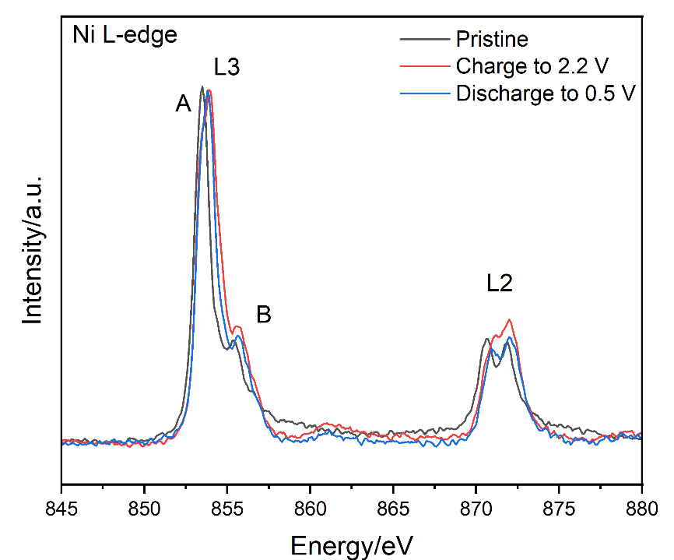
Supplementary Fig. 16 | Soft XAS spectra for Ni/C coated NMF cathode in the pristine state, charged to 2.2 V and discharged to 0.5 V (Ni L-edge).

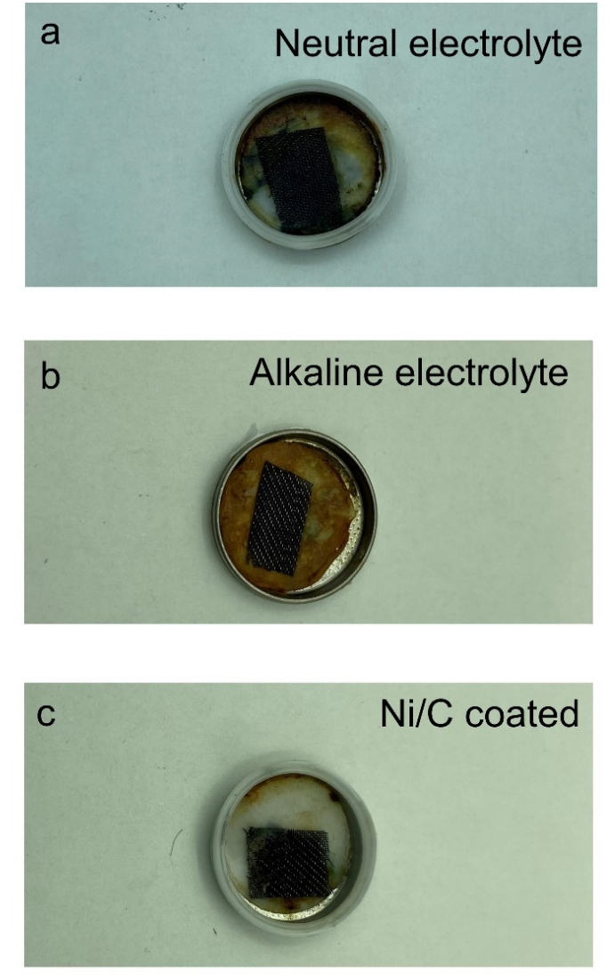
Supplementary Fig. 17 | Digital image of cycled batteries. Digital image of cycled coin cell in a, neutral b, alkaline electrolyte and c, alkaline electrolyte with Ni/C coating.
Supplementary Fig. 18 | TEM image of uncycled NMF and cycled NMF. a, Uncycled NMF. b, NMF cycled in neutral electrolyte. c, NMF cycled in alkaline electrolyte. d, Ni/C coated NMF cycled in alkaline electrolyte.

Supplementary Fig. 19 | EDS mapping for NMF particles with Ni/C coating cycled following 1st, 5th and 20th cycle.
Supplementary Fig. 20 | Cycling performance for NMF/NTP full cells with Co/C coating in alkaline electrolyte. a, Cycling performance for NMF/NTP full cells in selected systems at 1 C with NMF cathode coated with Co/C. b, Charge/discharge curves for NMF/NTP cells with NMF cathode coated with Co/C.

Supplementary Fig. 21 | Electrochemical performance for Na₃V₂(PO₄)₃@C in alkaline electrolyte. a, CV curve for Na₃V₂(PO₄)₃@C using three-electrode with Ag/AgCl with sat. KCl solution as the reference electrode, and carbon black as the counter electrode. b, Charge/discharge profiles for Na₃V₂(PO₄)₃@C/NMF full cell with Ni/C coating.
Supplementary Tables
Supplementary Table 1 | Viscosity and pH for selected electrolytes.
Electrolyte | pH | Viscosity  (mPa. s)
This work | 12.3 | 6.0 at 23.5 °C
21 m LiTFSI (Tested in this work) | ~7 | 46.8 at 23.5 °C
9 m Na CF₃SO₃⁴ | ~7 | 4.5 at 25 °C
22 m KCF₃SO₃⁴ | ~7 | 6.5 at 25 °C
9 m NaOTF + 22 m TEAOTF⁵ | ~7 | 30.2 at 25 °C
8 m LiOAc +32 m KOAc⁶ | ~9 | 374 at 25 °C
19.4 m LiTFSI + 8.3 m LiBETI⁷ | ~7 | 203 at 30 °C

Supplementary Table 2 | Comparison of electrolyte cost for full battery with reported aqueous Li, Na and K-ion full batteries > 80 Wh kg⁻¹
Reference | Electrolyte | Unit price of componentª  (AUD kg⁻¹) | Total cost^{b}  (AUD kg⁻¹)
This work | 17 m NaClO₄ + ~0.03 M NaOH | NaClO₄: 500  NaOH: 170 | 1040.6
8 | 2 m LiTFSI | LiTFSI: 7520 | 4316.5
9 | 4.5 m LiTFSI  0.1 m KOH | LiTFSI: 7520  KOH:65.3 | 9713.5
10 | 21 m KCF₃SO₃ | KCF₃SO₃: 6600 | 26080.0
4 | 22 m KCF₃SO₃ | KCF₃SO₃: 6600 | 27321.9
11 | 15 m LiTFSI | LiTFSI: 7520 | 32373.6
12 | 21 m LiTFSI +7 m LiOTF | LiTFSI: 7520  LiOTF:11640 | 58033.958
ª Based on the lowest reported price in Sigma (Australia).
^{b} Cost of solvent(s) and quasi-solid aqueous batteries are not included.

Supplementary Table 3 | Comparison of lifespan and energy density of this work with reported aqueous Na full batteries.
Battery system | Energy densityª  (Wh kg⁻¹) | Average voltage  (V) | Cycling life  (Cycles, Rat  e)
This work | 90 | 1.4 | ~100%, 200 cycles, 1 C  74.3%, 13,000 cycles, 10 C
NMF//polymer electrolyte//NTP¹³ | 86 | 1.36 | 80%, 4,000 cycles, 10 C
NMF//eutectic electrolyte//NTP¹⁴ | ~80 | 1.35 | 74.5%, 1,000 cycles, 4.2 C
Na_{1.88}Mn[Fe(CN)₆]_{0.97}·1.35H₂O// NaTiOPO₄¹⁵ | 71 | 1.74 | 76%, 800, 1 C
Na₃V₂(PO₄)₃// Na₃V₂(PO₄)₃¹⁶ | 70 | 1.75 | 87.5%,100,1 C
NaCoHCF//NTP¹⁷ | 67 | 1.33 | 98%, 100 cycles, 5 C
Na₃(VOPO₄)₂F//NTP¹⁸ | 64 | 1.44 | 77%, 500 cycles, 1 C
NMF//17 m NaClO₄//NTP¹⁹ | ~60 | 1.3, 1.8 | ~60%, 100 cycles, 2 mA cm⁻²
Na₂MnFe(CN)₆//KMnCr(CN)₆²⁰ | 58 | 1.6 | 75%, 100 cycles, 30 C
Na₂Zn₃Fe(CN)₆//NTP²¹ | 55 | 1.6 | 100%, 1,000 cycles, 10 C
NaCuHCF//NTP²² | 48 | 1.4 | 88%, 1,000 cycles, 10 C
Na₂NiFe(CN)₆//NTP²³ | 42.5 | 1.47 | 88%, 100 cycles, 5 C
Na₃MnTi(PO₄)₃// Na₃MnTi(PO₄)₃²⁴ | 40 | 1.4 | 98%, 250 cycles, 1 C
K_{0.27}MnO₂//NTP²⁵ | 34 | 0.8 | 80%, 100 cycles, 1 C
Na₃V₂O_{2x}(PO₄)₂F_{3−2x} //NTP²⁶ | 31 | 1.47 | 75%, 400 cycles, 10 C
Na_{0.66}Mn_{0.66}Ti_{0.44}O₂//NTP²⁷ | 31 | 1 | 92.7%, 1,200 cycles, 1 C
NaMnO₂//NTP²⁸ | 30 | 0.81 | 75%, 500 cycles, 10 C
ª Based on the total mass of cathode and anode.
Supplementary Table 4 | Comparison of this work with commercial batteries.
Battery system | Element abundance  (ppm) | Lifespan  (Cycles) | Energy density  (Wh kg⁻¹) | Safety | Environmental friendliness | Cost-efficacy
This work | Fe (41000)  Mn (950)  Na (23000)  Ti (5600)  Ni (80) | 1,3000 | ~50 | High | High | High
Lead-acid²⁹ | Pb (14) | 300-1,000 | 25-40 | High | Low | High
Ni-MH³⁰ | Ni (80)  La (32) | 200-1,200 | 50-85 | Medium | Medium | Medium
Li-ion³¹(LFP/graphite) | Li (20) | 160-2,000 | 160 | Low | Medium | Medium
Super-capacitor³⁰ | C (480) | 5,000-10⁵ | 5-10 | High | High | Low
Flow battery²⁹  (Vanadium redox) | V (120) | 5,000-10⁴ | 10-25 | High | Low | Medium

Supplementary Table 5 | Adsorption energy for adsorbed H, OH and H₂O at most stable adsorption sites on (200) and (111) facets of Ni nanoparticles under differing electro-potential.
Voltage  (V vs SHE) | Facet (2 0 0) |  |  | Facet (1 1 1)
Voltage  (V vs SHE) | *H₂O | *OH | *H | *H₂O | *OH | *H
0.0 | −0.53 | −1.17 | 0.61 | −1.61 | −2.52 | −4.21
0.5 | −0.62 | −1.25 | 0.28 | −1.12 | −1.81 | −0.86
1.0 | −0.41 | −1.08 | 0.33 | −1.13 | −1.72 | 0.90

Supplementary Table 6 | Elemental atomic fraction for NMF cathode prior to and following cycling from EDS mapping.
Cathode | Fe (%ª) |  | Mn (%ª) |  | Ni (%ª)
Cathode | Atomic fraction | Atomic error | Atomic fraction | Atomic error | Atomic fraction | Atomic error
NMF with Ni/C following cycling in alkaline electrolyte for 1 cycle | 44.63 | 7.64 | 53.19 | 6.00 | 2.18 | 0.40
NMF with Ni/C following cycling in alkaline electrolyte for 5 cycles | 44.70 | 7.66 | 53.24 | 6.01 | 2.06 | 0.38
NMF with Ni/C following cycling in alkaline electrolyte for 20 cycles | 45.00 | 7.73 | 53.05 | 6.02 | 1.95 | 0.36
ª The total amount of Fe, Mn, and Ni was normalized to 100%.

Supplementary Table 7 | Detailed structural information on samples cycled for 1st cycle following Rietveld refinement.
Sample | a=b=c (Å) | α=β=γ | Volume (Å³) | Size  (μm) | Ni Occ.  (%) | R_{wp}  (%)
NMF cathode following cycling in alkaline electrolyte | 5.26358 | 90º | 145.829 | 0.0454 | 0 | 5.36
Ni/C coated NMF cathode following cycling in alkaline electrolyte | 5.28161 | 90º | 147.333 | 0.2229 | 0.046 | 5.35

References
1. Lin, F. et al. Surface reconstruction and chemical evolution of stoichiometric layered cathode materials for lithium-ion batteries. Nat. Commun. 5, 9 (2014).
2. Tian, C. X. et al. Depth-dependent redox behavior of LiNi_{0.6}Mn_{0.2}Co_{0.2}O₂. J. Electrochem. Soc. 165, A696-A704 (2018).
3. Han, J., Zhang, H., Varzi, A. & Passerini, S. Fluorine-free water-in-salt electrolyte for green and low-cost aqueous aodium-ion batteries. Chemsuschem 11, 3704-3707 (2018).
4. Jiang, L. W. et al. Building aqueous K-ion batteries for energy storage. Nat. Energy 4, 495-503 (2019).
5. Jiang, L. W. et al. High-voltage aqueous Na-ion battery enabled by inert-cation-assisted water-in-salt electrolyte. Adv. Mater. 32, 1904427 (2020).
6. Lukatskaya, M. R. et al. Concentrated mixed cation acetate "water-in-salt" solutions as green and low-cost high voltage electrolytes for aqueous batteries. Energy Environ. Sci. 11, 2876-2883 (2018).
7. Yamada, Y. et al. Hydrate-melt electrolytes for high-energy-density aqueous batteries. Nat. Energy 1, 9 (2016).
8. Xie, J., Liang, Z. J. & Lu, Y. C. Molecular crowding electrolytes for high-voltage aqueous batteries. Nat. Mater. 19, 1006-1011 (2020).
9. Xu, J. J. et al. Aqueous electrolyte design for super-stable 2.5 V LiMn₂O₄||Li₄Ti₅O₁₂ pouch cells. Nat. Energy 7, 186-193 (2022).
10. Ge, J. M., Fan, L., Rao, A. M., Zhou, J. & Lu, B. G. Surface-substituted prussian blue analogue cathode for sustainable potassium-ion batteries. Nat. Sustain. 5, 225-234 (2022).
11. Shang, Y. X. et al. An "ether-in-water" wlectrolyte boosts atable interfacial chemistry for aqueous lithium-ion batteries. Adv. Mater. 32, 2004017 (2020).
12. Yang, C. Y. et al. Aqueous Li-ion battery enabled by halogen conversion-intercalation chemistry in graphite. Nature 569, 245-250 (2019).
13. Hou, Z. G. et al. Bipolar electrode architecture enables high-energy aqueous rechargeable sodium ion battery. Nano Res. 15, 5072-5080 (2022).
14. Liu, T. et al. Water-locked eutectic electrolyte enables long-cycling aqueous sodium-Ion batteries. ACS Appl. Mater. Interfaces, 14, 33041-33051 (2022).
15. Jiang, L. W. et al. High-voltage aqueous Na-ion battery enabled by inert-cation-assisted water-in-salt electrolyte. Adv. Mater. 32, 1701189 (2020).
16. Jin, T. et al. High-energy aqueous sodium-ion batteries. Angew. Chem. Int. Ed. 60, 11943-11948 (2021).
17. Wu, X. Y. et al. Vacancy-free prussian blue nanocrystals with high capacity and superior cyclability for aqueous sodium-ion batteries. Chemnanomat 1, 188-193 (2015).
18. Reber, D., Kuhnel, R. S. & Battaglia, C. Suppressing crystallization of water-in-salt electrolytes by asymmetric anions enables low-temperature operation of high-voltage aqueous batteries. ACS Mater. Lett. 1, 44-51 (2019).
19. Nakamoto, K., Sakamoto, R., Ito, M., Kitajou, A. & Okada, S. Effect of concentrated electrolyte on aqueous sodium-ion battery with sodium manganese hexacyanoferrate cathode. Electrochemistry 85, 179-185 (2017).
20. Nakamoto, K., Sakamoto, R., Sawada, Y., Ito, M. & Okada, S. Over 2 V aqueous sodium-ion battery with prussian blue-type electrodes. Small Methods 3, 5 (2019).
21. Shao, M. M. et al. A high-voltage and cycle stable aqueous rechargeable Na-ion battery based on Na₂Zn₃[Fe(CN)₆]₂ NaTi₂(PO₄)₃ intercalation chemistry. ACS Appl. Energ. Mater. 2, 5809-5815 (2019).
22. Wu, X. Y. et al. Energetic aqueous rechargeable sodium-ion battery based on Na₂CuFe(CN)₆-NaTi₂(PO₄)₃ intercalation chemistry. Chemsuschem 7, 407-411 (2014).
23. Wu, X. Y., Cao, Y. L., Ai, X. P., Qian, J. F. & Yang, H. X. A low-cost and environmentally benign aqueous rechargeable sodium-ion battery based on NaTi₂(PO₄)₃-Na₂NiFe(CN)₆ intercalation chemistry. Electrochem. Commun. 31, 145-148 (2013).
24. Gao, H. C. & Goodenough, J. B. An aqueous symmetric sodium-ion battery with NASICON-structured Na₃MnTi(PO₄)₃. Angew. Chem. Int. Ed. 55, 12768-12772 (2016).
25. Liu, Y. et al. Hollow K_{0.27}MnO₂ nanospheres as cathode for high-performance aqueous sodium ion batteries. ACS Appl. Mater. Interfaces 8, 14564-14571 (2016).
26. Kumar, P. R., Jung, Y. H., Lim, C. H. & Kim, D. K. Na₃V₂O_{2x}(PO₄)₂F_{3-2x}: a stable and high-voltage cathode material for aqueous sodium-ion batteries with high energy density. J. Mater. Chem. A 3, 6271-6275 (2015).
27. Suo, L. M. et al. "Water-in-salt" electrolyte makes aqueous sodium-ion battery safe, green, and long-lasting. Adv. Energy Mater. 7, 1701189 (2017).
28. Hou, Z. G., Li, X. N., Liang, J. W., Zhu, Y. C. & Qian, Y. T. An aqueous rechargeable sodium ion battery based on a NaMnO₂-NaTi₂(PO4)₃ hybrid system for stationary energy storage. J. Mater. Chem. A 3, 1400-1404 (2015).
29. Yang, Z. G. et al. Electrochemical energy storage for green grid. Chem. Rev. 111, 3577-3613 (2011).
30. Opiyo, N. Energy storage systems for PV-based communal grids. J. Energy Storage 7, 1-12 (2016).
31. Hesse, H. C., Schimpe, M., Kucevic, D. & Jossen, A. Lithium-ion battery storage for the grid-a review of stationary battery storage system design tailored for applications in modern power grids. Energies 10, 42 (2017).

