Dear participant,
Following questionnaire aims to identify private community pharmacy stakeholders and analyze their saliency. We believe that the results of this study could be useful for policymakers as well as researchers.
A focus group was carried out to identify the pharmacy stakeholders and categorized them based on three saliences of power, legitimacy, and urgency. Figure 1 shows the results of the focus group discussion. In this questionnaire, we are interested in comprehending your opinion about each defined stakeholder. We appreciate your time and consideration of this project.
- Kindly check the following definition before the answer to the questions.
Stakeholders: any group or individual who can affect or is affected by the achievement of the organization’s objectives
Organization: an organized group of people with a particular purpose. In this study, we assume a private community pharmacy as an organization pursues two levels of purposes. 1- The economic purposes and profit maximization, and 2- the health care purposes that are induced and followed by the regulatory body.
Power: the ability of stakeholders to exercise influence, which could be through using political, coercive, utilitarian, or normative means.
Legitimacy: a stakeholder whose actions are considered desirable and proper within the context of the social system.
Urgency: extent to which a stakeholder’s claims are considered critical or time sensitive and need attention.

- Participants’ information:
First name: | Last name:
Age: | Academic degree:
Organization: | Position:

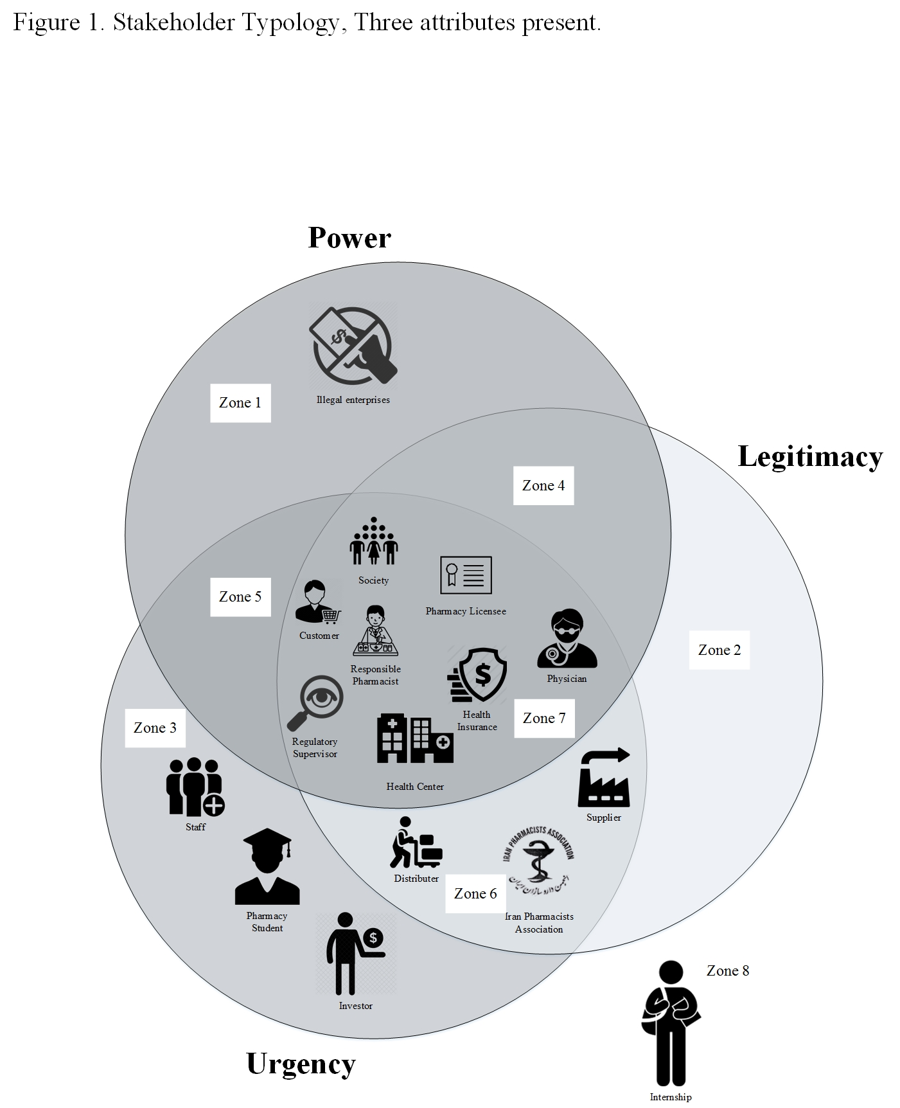
- Please complete the table below:
If you are agree with the identified stakeholder please insert check mark below the “I accept the stakeholder and its position” column, if you are not agree with the identified stakeholder please insert check mark below the “I reject the stakeholder” column, and if you think the identified stakeholder is not in a right zone, write the right zone number below the “The position of the stakeholder should change to the zone …”.
Potential stakeholder | I accept the stakeholder and its position | I reject the stakeholder | The position of the stakeholder should change to the zone …
Responsible pharmacist
Pharmacy licensee
Physician
Customer
Regulatory Supervisor
Health center
Health insurance
Society
Supplier
Distributer
Iran Pharmacists Associations
Staff
Pharmacy Student
Investor
Illegal enterprises

- If you believe some other stakeholders are not listed in figure 1, please add them in the table below.
Stakeholder | Zone

Thank you.

