Table I, Representative samples, their provenance, and dates of collection. (Images credit, H Szczepanowska, with exception of the last RS1, 1917).
Group I, samples labels: LR- Lingga Riau, L-Langkawi, SG- Singapore Gardens, CI-Cipetir Indonesia; fresh liquids and solids collected 2015-2019 by author.
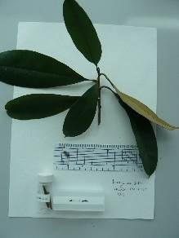 | 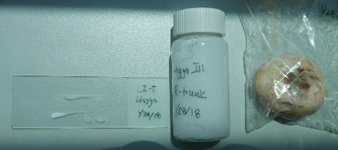 |  | 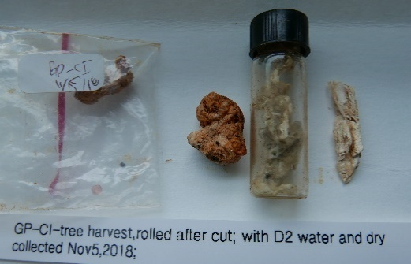
Latexes collected from trunks and leaves in Singapore, Malaysia, and Indonesia. Cis- or trans- were confirmed with NMR accordingly to plant source (fig.5). | Samples of natural rubber and balata prepared for analysis on microscopy glass slides and solids stored in glass vials. Cis- for natural rubber and trans- for balata were confirmed with NMR (fig.5, and 6). |  | Samples of gutta percha latex removed from under bark, Cipetir, Indonesia; trans- was confirmed with NMR (fig. 5 and 6).
Group II, samples labels: SC-Singapore, 10-year old commercial stock, gutta perch and balata
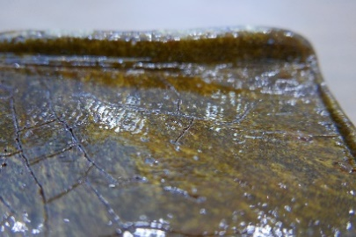 | 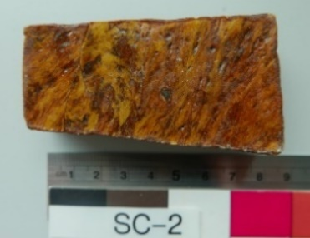 |  |  |  | 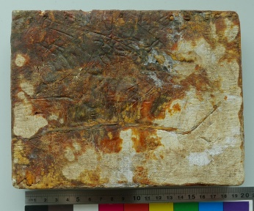
SC1, block of gutta percha shows lip around edges from being pressed into a form. NMR confirmed trans-polyisoprene (fig. 6). | SC2, the mottled color indicates mixture of latexes, possibly of gutta percha and balata. Identified in NMR as trans- polyisoprene (fig, 6). |  |  |  | SC5, the surface of block is matte, rather than resinous, indicating a mixture of latexes. NMR identified as trans-polyisoprene (fig. 6)
Group III, samples labels: ASG Archives of Singapore Gardens, 1892-1906
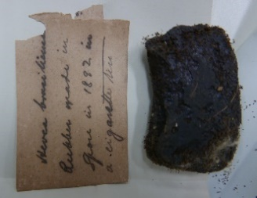 | 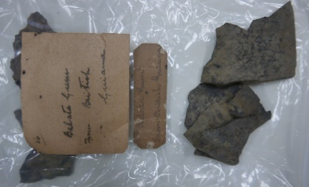 |  |  | 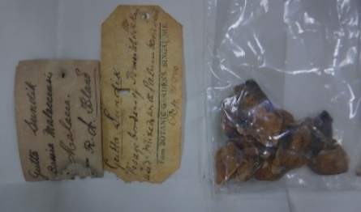
ASG 51 Small, 1892, labelled as natural rubber, confirmed with NMR cis-polyisoprene (fig. 7). | ASG 51 Medium, 1892; labelled as Manilkara, that supplied balata. NMR confirmed trans-polyisoprene (fig. 7) |  |  | ASG 89, 1900; sample brittle, labelled as Sundik gutta, NMR confirmed as trans-polyisoprene (fig. 7).
Group IV, early 20th century artifacts (WC) and Tjipetir block 1917 (RS)
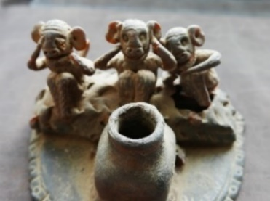 | 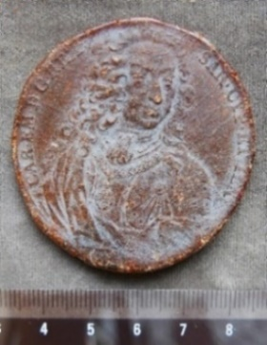 | 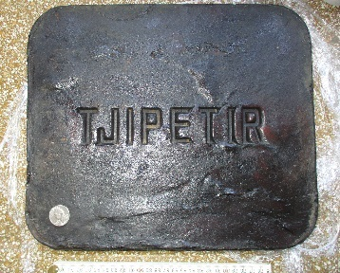
CW 13, Three Monkeys, an ink well, very brittle. NMR confirmed trans-polyisoprene (fig 8). | CW 14 commemorative medallion, brittle; NMR confirmed trans-polyisoprene (fig. 8). | RS 1, 1917, a block of gutta percha produced in Tjipetir (Cipetir in Indonesian). NMR confirmed trans-polyisoprene (figs.4,5,9). (Image courtesy R. Schoevaart)

