Supplementary Materials to “Neglecting farmer cropping adaptation can overstate water shortages in large-scale hydrological modeling assessments.”
Authors: Jim Yoon¹, Nathalie Voisin¹, Christian Klassert², Travis Thurber¹, Wenwei Xu¹
¹Pacific Northwest National Laboratory
²Helmholtz Centre for Environmental Research – UFZ
Evaluating the plausibility of simulated modeling results
To evaluate the plausibility of our modeling results, we compare simulated irrigated land use values via WM-ABM with observed irrigated land use values from the USDA Agricultural Census, retrieved using the USDA’s National Agricultural Statistics Quick Stats tool (USDA, 2017). As non-hydrological factors (e.g., crop prices, crop production costs, equipped irrigated area, etc.) are treated statically in our simulations, a formal validation process is not possible for the model results for the hypothetical experiments. Given such, our strategy for the evaluation of model plausibility is to isolate a relatively short time window over which significant hydrological changes occurred, comparing model results against USDA surveyed data over this time period. As irrigated land use data from the USDA census is limited (available in 5-year intervals from 1997-2007), we specifically focus on the 2000-2005 time period during which much of the Western United States experienced drought conditions.
For the evaluation, we specifically compare percent changes in irrigated land use area between 2000-2005 from WM-ABM, comparing these changes with those recorded by the USDA agricultural census in 2002 and 2007. For the WM-ABM output, we report the total irrigated land use area (over all crops and including both surface water and groundwater sources). For the USDA data, we specifically report the land area of harvested cropland that is entirely irrigated. The comparison (shown in Table S1) is conducted for the 11 states in the Western United States in which irrigated land use and water shortages are most prevalent.
States | USDA Initial Area (2002) | ABM Initial Area (2000) | USDA Initial Area (2007) | ABM Final Area (2005) | USDA Percentage Change | ABM  Percentage Change
Arizona | 0.90 | 0.91 | 0.82 | 0.85 | -8.9% | -6.6%
California | 7.40 | 7.78 | 6.90 | 7.37 | -6.8% | -5.3%
Colorado | 1.74 | 2.05 | 1.77 | 1.83 | 1.7% | -10.7%
Idaho | 2.68 | 3.65 | 2.67 | 3.16 | -0.4% | -13.4%
Montana | 1.12 | 1.50 | 1.08 | 1.18 | -3.6% | -21.3%
Nevada | 0.61 | 0.50 | 0.62 | 0.49 | 1.6% | -2.0%
New Mexico | 0.64 | 0.61 | 0.61 | 0.60 | -4.7% | -1.6%
Oregon | 1.28 | 1.19 | 1.21 | 1.03 | -5.5% | -13.4%
Utah | 0.81 | 0.89 | 0.90 | 0.82 | 11.1% | -7.9%
Washington | 1.40 | 1.40 | 1.31 | 1.22 | -6.4% | -12.9%
Wyoming | 1.28 | 1.07 | 1.12 | 0.84 | -12.5% | -21.5%
Table S1. Comparing simulated versus observed irrigated land use areas (in millions of acres) for the early to mid 2000s for eleven states across the Western United States.
The comparison of the simulated and USDA irrigated land use areas indicate that the model performs reasonably well in capturing irrigated land use changes over the period of interest, especially for the states in which reliance on irrigation is most prominent. In California for example, the model indicates a decrease in irrigated land use of 5.3 percent (from 7.78M acres to 7.37M acres), while the USDA survey data indicates a 6.8 percent decrease (7.40M acres to 6.90 acres). The states with the largest discrepancy between modeled and observed irrigated land use changes include Colorado, Idaho, Montana, Utah, and Oregon. We note that the most arid states with the heaviest reliance on irrigation for agriculture (e.g., California, Arizona, Nevada) show reasonably close percentage changes to the USDA data, possibly pointing to the limitations of the comparison. Specifically, comparing simulated results against USDA harvested cropland that is entirely irrigated introduces an inconsistency in the comparison (in many of the less arid states, cropland might only be partially or periodically irrigated depending on climatic conditions). Such inconsistencies potentially explain the discrepancies between modeled and observed results in the less arid states included in the comparison.
We reiterate that the comparison only provides a first-order evaluation of model plausibility, providing an initial indication that the model behaves reasonably during periods of water shortage in regions of high irrigation activity. To fully evaluate the performance of the model in reproducing historical observations, a more extensive comparison exercise would need to be conducted in which non-hydrological factors (e.g., crop prices, production costs, etc.) are also input as exogenous time series to the model, matching observed conditions over the period of comparison. The comparison would also be enhanced through identification or development of observed irrigated land use datasets at higher temporal frequency and spatial resolution.
Matching crop categories between datasets
For the model, we use 10 general crop categories that closely follow those used in the Global Change Assessment Model (GCAM), which include: corn, fiber, fodder, grain, miscellaneous, oil, rice, root tuber, sugar, and wheat. Each of the datasets used to calibrate the farmer agents (USDA Farm and Ranch Irrigation Survey, USDA Cropland Data Layer, and USDA Economic Research Service’s Commodity Costs and Return datasets) reports on crop statistics using different (typically more detailed) crop categorizations compared to GCAM. We accordingly assign crop types from the various datasets to one of the general GCAM crop categories using the crop category mapping provided in Table S2.
The utilization of the 10 general crop categories for the model introduces simplifications in modeled crop representations with potential implications for model results. For example, over 50 crops from the CDL dataset are assigned to the miscellaneous crop category, with the model only tracking irrigated areas for all these crops combined into a single category. Similarly, each general crop category is characterized by a representative economic price/cost (e.g., the miscellaneous crop category is characterized by a single representative price, though this price can vary between regions/agents). Such an aggregation of economic prices/costs could introduce significant bias in the calibration procedure, specifically as cost data from the USDA ERS dataset is limited to a select group of crops. For miscellaneous crops for example, the economic data for peanuts is utilized as the representative crop for all other miscellaneous crops due to limitations in the USDA ERS dataset.
While such aggregation and mapping of crops introduces limitations and potential inaccuracies in the model calibration and outcomes, we argue that such aggregation is necessary and reasonable given the large-scale nature of the modeling endeavor and limited data at more detailed levels of crop categories at CONUS-scale. The introduction of additional or more detailed crop categories would also result in excessive computational burden (each new crop is an additional decision variable in the farmer’s optimization problem) for such a large-scale effort. For future research, we recommend evaluating the sensitivity of model results to these crop categories and the underlying data inputs used for each crop category during model calibration.
GCAM Category | USDA FRIS Crops | USDA ERS | CDL Crops
Corn | Corn for grain or seed, Alfalfa, Corn for Silage or Greenchop | Corn | Corn, Sweet Corn, Por or Orn Corn, Dbl Crop Barley/Corn, Dbl Crop Corn/Soybeans
Fiber | All cotton | Cotton | Cotton
Fodder | All other hay, | Grain Sorghum* | Alfalfa, Other Hay/Non Alfalfa
Grain | Other small grains, Sorghum for grain or seed | Barley, Oats, Sorghum | Sorghum, Barley, Other Small Grains, Rye, Oats, Millet, Speltz, Buckwheat, Triticale, Dbl Crop Oats/Corn, Dbl Crop Lettuce/Barley, Dbl Crop Durum Wht/Sorghum, Dbl Crop Barley/Sorghum, Dbl Crop WinWht/Sorghum, Dbl Crop Soybeans/Oats, Dbl Crop Barley/Soybeans
Miscellaneous | Beans, Tomato, Berries, Orchards, Vegetable, Lettuce, Peanuts, Sweet Corn, Tomatoes | Peanut | Tobacco, Mint, Mustard, Dry Beans, Other Crops, Misc Vegs & Fruits, Watermelons, Onions, Cucumbers, Chick Peas, Lentils, Peas, Tomatoes, Caneberries, Hops, Herbs, Clover/Wildflowers, Sod/Grass Seed, Cherries, Peaches, Apples, Grapes, Christmas Trees, Other Tree Crops, Citrus, Pecans, Almonds, Walnuts, Pears, Pistachios, Asparagus, Garlic, Cantaloupes, Prunes, Oranges, Honeydew Melons, Broccoli, Peppers, Pomegranates, Nectarines, Greens, Plums, Strawberries, Squash, Apricots, Vetch, Lettuce, Pumpkins, Dbl Crop Lettuce/Cantaloupe, Dbl Crop Lettuce/Cotton, Blueberries, Cabbage, Cauliflower, Celery, Eggplants, Gourds, Cranberries
Oil | Soybeans for beans | Soybean | Soybeans, Sunflower, Peanuts, Canola, Flaxseed, Safflower, Rape Seed, Camelina, Olives, Dbl Crop Soybeans/Cotton
Rice | Rice | Rice | Rice
Root Tuber | Potatoes | Potatoes* | Potatoes, Sweet Potatoes, Carrots, Radishes, Turnips
Sugar | Sugarbeets* | Beets | Sugarbeets, Sugarcane
Wheat | Wheat for grain or seed | Wheat | Durum Wheat, Spring Wheat, Winter Wheat, Dbl Crop WinWht/Soybeans, Dbl Crop Lettuce/Durum Wht, Dbl Crop WinWht/Cotton
Table S2. Crop category mappings between datasets.

USDA Economic Research Service’s (ERS) Commodity Costs and Return Datasets
Economic data on agricultural crop prices and productions costs for calibration of the farmer agent model is obtained from the USDA ERS Commodity Costs and Return Datasets (USDA, 2022). The USDA has estimated annual agricultural production costs and returns since 1975, with the annual estimates based upon producer surveys that are conducted every 4-8 years depending upon the commodity. As reported in the USDA ERS documentation, “The theoretical basis and accounting methods used for the most recent estimates of commodity costs and returns conform with standards recommended by the American Agricultural Economics Association (AAEA) Task Force on Commodity Costs and Returns.” While some previous studies deploy similar economic costs and returns, these are typically focused on specific locales or regions. While datasets collected for specific locales might provide a more accurate economic farm information, such local studies likely adopt different data collection methods and estimates potentially leading to regional biases in model results if consolidated for use in our analysis. As such the, USDA ERS commodity costs and returns dataset is adopted for the current analysis, given its national coverage and consistent data collection and estimation approach across all regions.
Reservoir Management in WM
WM has two components – reservoir operations which influence the seasonality of flow and river storage, and water supply management which allocates supply from reservoirs to spatially distributed demands across grid cells. Our CONUS set up of MOSART-WM model includes all (1,848) reservoirs with a storage capacity larger than 10 million m³, i.e. focusing on reservoirs that most influence river discharge. The reservoir database and locations are obtained from the Global Reservoir and Dam Database (GRanD) reservoir database (Lehner et al., 2011). For daily reservoir storage and release operations, MOSART-WM adopts generic operating rules that mimic monthly release and storage patterns based on the objective of the reservoir (e.g., flood control, irrigation, etc.), its physical characteristics (storage) and monthly climatologies of inflow (from VIC) and demand (from USGS), and follows daily constraints for minimum environmental flow, and minimum and maximum storage volumes. While called generic rules due to a common set of equations, each reservoir’s operating rules are individually parameterized.
The reservoir model builds upon generic operating rules first detailed in Biemans et al. (2011) and Hanasaki et al. (2006) and improved for multi objective operations (Voisin et al. 2013). In brief, monthly target releases are pre-defined for different reservoir purposes (e.g., flood control, water supply, hydropower and navigation, and irrigation). For example, reservoirs with substantial storage and operated for flood control and irrigation tend to have a steady release following mean annual flow and monthly demand patterns which tends to drop reservoir storage just prior to the Spring freshet and fills up storage just before the irrigation season. Reservoirs with less storage capacity see their monthly inflow having more influence on the pre-release computation. These pre-release targets are then adjusted annually to account for inter-annual hydrological variability, thus accounting for drought conditions. The modeling framework also includes daily rules for initiating reservoir spilling when the maximum capacity of a reservoir is reached, as well as generic rules that are initiated to adjust releases in order for a reservoir to avoid dropping below a minimum storage threshold.
The water supply allocation component includes a dependency database for associating spatially distributed daily water demands with various reservoirs (implemented using a general rule based on topography and distance), as well as an allocation algorithm that associates individual grid cells’ water demand to reservoirs with the most storage capacity and operated for water supply. A series of reservoirs is typically involved in supply management, and the demand from individual grid cells thus influences the releases from multiple reservoirs. The water supply (available withdrawal) from an individual reservoir’s release is then further allocated daily, and is proportionally pro-rated through all dependent requesting grid cells when the cumulated water demand cannot be fully met. This conceptual approach differs from operational water management models with strict withdrawal locations, user priority rules, and complex operating rules. The generalized approach reasonably captures overall water scarcity at large-scales associated with water demand and supply management.
A complete description of the MOSART-WM model, including detailed description of the generic reservoir operating rules, is provided in Voisin et al. (2013) and the CONUS set up is described in Hejazi et al. (2015).
Agent Memory Parameterization
The agent memory parameter controls how agents weigh the relative importance of recent versus distant experience in their expectations of future water availability. Based on the memory decay formulation, a chart indicating the relative weight for preceding years on agents’ expectations of water availability is shown on Figure S1.
Figure S1 - The relative weight of previous years experience (with 0 being the most recent year of experience and 17 being the most distant) on influence farmer’s future expectation of water availability based on various values of agent’s memory decay factor, µ

Additional Monthly Model Results
Monthly water shortage changes with adaptation are presented on Fig. S2, supplementing the annual results provided in the main manuscript text.
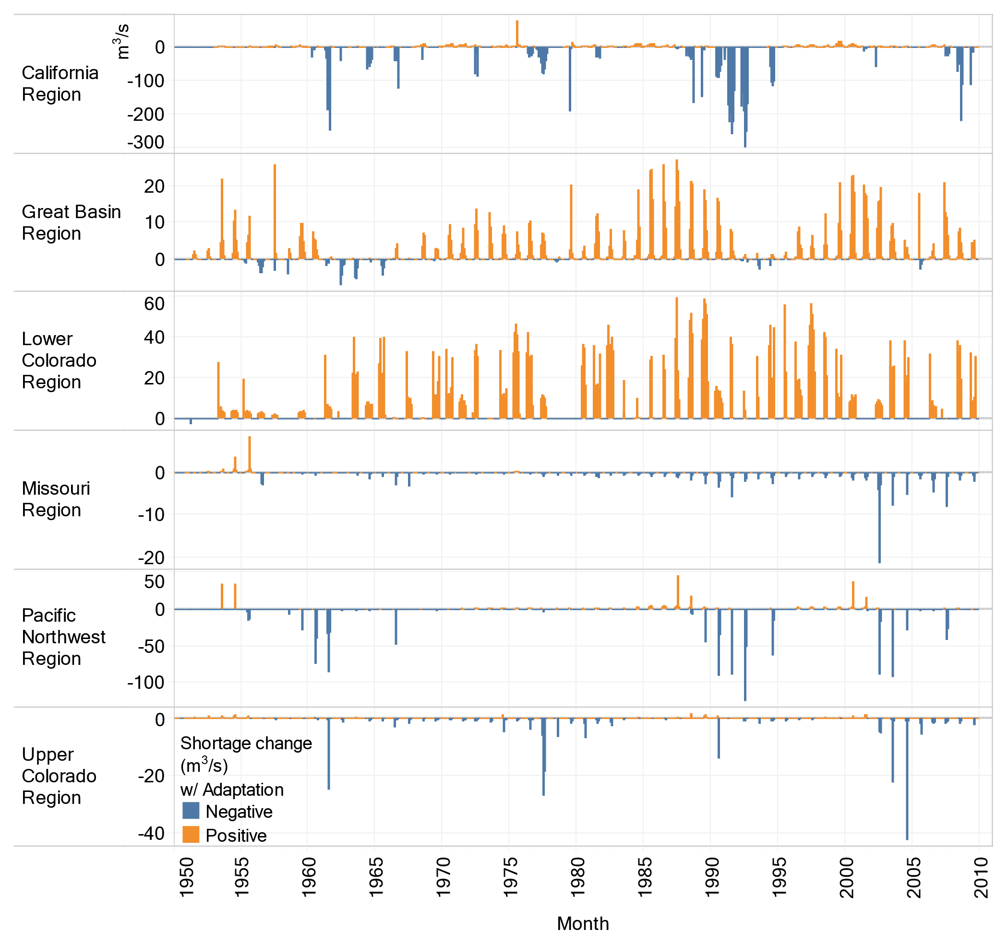Figure S2 – Monthly water shortage change (m³/s) with adaptation when comparing the adaptive to the baseline run (i.e., monthly water shortage in the adaptive run subtracted by monthly water shortage in the baseline run), aggregated over six HUC 2 regions of interest.. Blue colors (negative values) indicate reduced shortages when accounting for adaptation, while orange colors (positive values) indicate higher shortages when accounting for adaptation. These results provide monthly detail on the annual results presented in Fig. 1 of the main manuscript.

References
USDA National Agricultural Statistics Service (2017). NASS - Quick Stats. USDA National Agricultural Statistics Service. https://data.nal.usda.gov/dataset/nass-quick-stats. Accessed 2022-07-01.USDA Economic Research Service (2022). Commodity Costs and Returns. Economic Research Service, Department of Agriculture. https://data.nal.usda.gov/dataset/commodity-costs-and-returns. Accessed 2022-07-01
Lehner, B., Liermann, C.R., Revenga, C., Vörösmarty, C., Fekete, B., Crouzet, P., Döll, P., Endejan, M., Frenken, K., Magome, J. and Nilsson, C., 2011. High‐resolution mapping of the world's reservoirs and dams for sustainable river‐flow management. Frontiers in Ecology and the Environment, 9(9), pp.494-502.
Biemans, H., Haddeland, I., Kabat, P., Ludwig, F., Hutjes, R. W. A., Heinke, J., ... & Gerten, D. (2011). Impact of reservoirs on river discharge and irrigation water supply during the 20th century. Water Resources Research, 47(3).
Hanasaki, N., Kanae, S. and Oki, T., 2006. A reservoir operation scheme for global river routing models. Journal of Hydrology, 327(1-2), pp.22-41
Voisin, N., Liu, L., Hejazi, M., Tesfa, T., Li, H., Huang, M., Liu, Y. and Leung, L.R., 2013. One-way coupling of an integrated assessment model and a water resources model: evaluation and implications of future changes over the US Midwest. Hydrology and Earth System Sciences, 17(11), pp.4555-4575.
Hejazi, M.I., Voisin, N., Liu, L., Bramer, L.M., Fortin, D.C., Hathaway, J.E., Huang, M., Kyle, P., Leung, L.R., Li, H.Y. and Liu, Y., 2015. 21st century United States emissions mitigation could increase water stress more than the climate change it is mitigating. Proceedings of the National Academy of Sciences, 112(34), pp.10635-10640.

