Supplementary data
Supplementary Table 1. Characteristics of cases of proven and probable invasive aspergillosis at time of diagnosis

EORTC/MSG | Culture | Malignancy | Survival⁺ | Neutropenia¥ | Serum EIA | Serum LFA | BAL EIA | BAL LFA
Probable IA* |  | ALL | Alive | Yes | 7.174 | 4.3
Probable IA |  | MM | Alive | No | 2.5 | 2.03 | 4.453 | 2.17
Probable IA | A. fumigatus | MH | Ex | Yes | 2.08 | 1.69
Probable IA |  | AML | Alive | Yes | 1.839 | 1.53
Probable IA |  | AML | Alive | Yes | 0.03 | 0.1 | 2.655 | 1.09
Proven IA | Aspergillus spp. | KLL | Alive | Yes | 1.765 | 2.23
Probable IA | Aspergillus spp. | MM | Alive | No | 5.188 | 3.02 | 4.7 | 21.13
Probable IA |  | AA§ | Ex | Yes | 1.7 | 1.52
Probable IA |  | NHL | Alive | No | 0.039 | 0 | 3.288 | 1.13
Probable IA | A.fumigatus | NHL | Ex | Yes | 3.926 | 2.7 | 20 | 1.5
Probable IA |  | AML | Ex | No | 20 | 4.37
Probable IA |  | KML | Alive | No | 0.04 | 0.31 | 2.84 | 0.87
Probable IA |  | NHL | Alive | No | 2.307 | 2.01 | 1.195 | 1.17
Probable IA |  | AML | Alive | Yes | 0.776 | 0.96 | 0.859 | 1.24
Proven IA | A.fumigatus | NHL | Ex | Yes | 1.36 | 1.12
Probable IA |  | NHL | Ex | No | 5.468 | 1.3
Proven IA* | Aspergillus spp. | NHL | Alive | No | 2.963 | 1.45
Probable IA |  | MM | Alive | Yes | 2.8 | 1.2
Probable IA* |  | AML | Alive | No | 4.77 | 3.41
Proven IA | A.flavus | ALL | Ex | Yes | 3.94 | 15.03
Probable IA | A.flavus | AML | Alive | No | 0.17 | 0.2
Probable IA |  | AML | Ex | Yes | 2.7 | 1.34
Proven IA | Aspergillus spp. | HL | Ex | Yes | 2.116 | 2.46 | 4.034 | 1.7
Probable IA |  | ALL | Alive | Yes | 1.083 | 1.91
Probable IA* |  | AML | Ex | Yes | 22.4 | 15.2
Probable IA* | A. tereus | AML | Alive | Yes | 0.228 | 0.116
Proven IA* | A.flavus | AML | Alive | Yes | 0.286 | 0.273 | 0.241 | 0.223
Probable IA | A. fumigatus | ALL | Alive | Yes | 0.236 | 0.213 | 2.88 | 2.05
AA: Aplastic anemia, AML: Acute myeloid leukemia, ALL: Acute lymphoblastic leukemia, BAL: Bronchoalveolar lavage, CML: Chronic myeloid leukemia, CLL: Chronic lymphocytic leukemia, EIA: Enzyme immunoassay, HL: Hodgkin lymphoma, IA: Invasive aspergillosis, LFA: Lateral flow assay, MH: Malignant histiocytosis, MM: Multiple myeloma, NHL: Non-Hodgkin lymphoma, PMNL: Polymorphonuclear leukocyte
§ The patient with aplastic anemia was using of steroids and cyclosporine
+ 30-day survival
¥ Presence of neutropenia on day 0
* Patients taking mold-active antifungals on the day 0

Supplementary Table 2. Host factors and clinical features of patients on day 0.
 | Overall |  | Proven/  Probable IA |  | Possible IA |  | No IA |  | P*
N % | 171 | % | 28 | % | 55 | % | 88 | % | P*
MA / TKI | 19 | 11.1 | 4 | 14.3 | 3 | 5.5 | 12 | 13.6 | .26
Corticosteroids | 30 | 17.5 | 11 | 39.3 | 9 | 16.4 | 10 | 11.4 | .003
T cells immunosuppressant | 8 | 4.6 | 1 | 3.6 | 2 | 3.6 | 5 | 5.7
IFI in the last 6 months | 14 | 8.1 | 5 | 17.9 | 7 | 12.7 | 2 | 2.3
Fungemia | 4 | 2.3 | 2 | 7.1 | 1 | 1.8 | 1 | 1.1
Possible IFI | 10 | 5.8 | 3 | 10.7 | 6 | 10.9 | 1 | 1.1
AF Prophylaxis | 86 | 50.3 | 10 | 35.7 | 29 | 52.7 | 47 | 53.4 | .24
Mold-active | 27 | 15.8 | 1 | 3.5 | 9 | 16.3 | 17 | 19.3
Mold-inactive | 59 | 34.5 | 9 | 32.1 | 20 | 36.3 | 30 | 34.0
AF Therapy | 19 | 11.1 | 7 | 25.0 | 9 | 16.4 | 3 | 3.4 | .002
Respiratory Symptom | 65 | 38.0 | 17 | 60.7 | 34 | 61.8 | 14 | 15.9 | <.001
Fever | 80 | 46.8 | 20 | 71.4 | 43 | 78.2 | 17 | 19.3 | <.001
Pip&Tazo | 31 | 18.1 | 3 | 10.7 | 16 | 29.1 | 12 | 13.6 | .035
Bacterial Disease† | 30 | 17.5 | 10 | 35.7 | 12 | 21.8 | 8 | 9.1 | .003
Influenza† | 3 | 1.8 | 1 | 3.6 | 1 | 1.8 | 1 | 1.1
Duration of Neutropenia (Mean±SE) | 17.04 ± 4.15 |  | 35.7 ± 9.5 |  | 14.5 ± 2.7 |  | 12.6 ± 7.2
AF: Antifungal, IA: Invasive aspergillosis, IFI: Invasive fungal infection, MA: Monoclonal Antibody, Pip&Tazo: Piperacillin tazobactam, SE: Standard error, TKI: Tyrosine Kinase Inhibitor

GM ODI | Proven IA |  | Probable IA |  | Possible IA |  | No IA
GM ODI | LFA | EIA | LFA | EIA | LFA | EIA | LFA | EIA
Min. | 1.12 | 1.36 | 0.0 | 0.03 | 0.0 | 0.04 | 0.0 | 0.03
25% percentile | 1.39 | 1.46 | 0.26 | 0.20 | 0.16 | 0.07 | 0.13 | 0.086
Median | 2.34 | 1.94 | 1.52 | 1.83 | 0.3 | 0.15 | 0.24 | 0.11
75% percentile | 11.88 | 3.48 | 2.02 | 3.36 | 0.46 | 0.31 | 0.33 | 0.15
Max. | 15.03 | 3.94 | 4.37 | 20.0 | 1.14 | 0.76 | 0.48 | 0.4
IQR | 10.4 | 2.02 | 1.75 | 3.16 | 0.29 | 0.23 | 0.19 | 0.06
EIA: Enzyme immunoassay GM: Galactomannan, IA: Invasive aspergillosis, IQR: Interquartile range, LFA: Lateral flow assay, Max: Maximum, Min: Minimum, ODI: Optical density index
Supplementary Table 3. GM-LFA and GM-EIA index values of patients who did not receive antifungal on day 0.

Supplementary Table 4. BAL GM-LFA and GM-EIA index values in the case groups
GM ODI | Proven + Probable IA |  | Possible IA
GM ODI | LFA | EIA | LFA | EIA
Min. | 0.223 | 0.241 | 0.01 | 0.103
25% percentile | 1.09 | 1.195 | 0.17 | 0.126
Median | 1.24 | 2.88 | 0.26 | 0.185
75% percentile | 2.05 | 4.45 | 0.57 | 0.25
Max. | 21.13 | 20.0 | 0.91 | 0.628
IQR | 0.96 | 3.25 | 0.4 | 0.127
EIA: Enzyme immunoassay GM: Galactomannan, IA: Invasive aspergillosis, IQR: Interquartile range, LFA: Lateral flow assay, Max: Maximum, Min: Minimum, ODI: Optical density index

 | ODI | Sensitivity | Specificity | PPV | NPV
Proven IA (n=4) VS No IA (n=87)
 | 0.5 ODI | % 100 | % 100 | % 100 | % 100
 | 1.0 ODI | % 100 | % 100 | % 100 | % 100
Proven IA (n=4) + Probable IA (n=18) VS No IA (n=87)
 | 0.5 ODI | % 77.3 | % 100 | % 100 | % 94.6
 | 1.0 ODI | % 72.7 | % 100 | % 100 | % 93.5
IA: Invasive aspergillosis, NPV: Negative predictive value, ODI: Optical density index, PPV: Positive predictive values
Supplementary Table 5. Performance of the GM-LFA in patients who did not receive mold-active antifungal therapy on the day 0.

Supplementary Table 6. Performance of the GM-LFA in patients who did not receive mold-active antifungal therapy/prophylaxis on the day 0.
 | ODI | Sensitivity | Specificity | PPV | NPV
Proven IA (n=4) VS No IA (n=70)
 | 0.5 ODI | % 100 | % 100 | % 100 | % 100
 | 1.0 ODI | % 100 | % 100 | % 100 | % 100
Proven IA (n=4) + Probable IA (n=17) VS No IA (n=70)
 | 0.5 ODI | % 76.2 | % 100 | % 100 | % 93.3
 | 1.0 ODI | % 71.4 | % 100 | % 100 | % 92.1
IA: Invasive aspergillosis, NPV: Negative predictive value, ODI: Optical density index, PPV: Positive predictive values

Supplementary Table 7. Serum GM-LFA and GM-EIA index values according to the neutrophil counts of the patients on day 0.
A) GM-LFA | Proven/Probable IA |  | Possible IA |  | No IA
PMNL | <500/µl  (n=18) | ≥500/µl  (n=10) | <500/µl  (n=26) | ≥500/µl  (n=29) | <500/µl  (n=18) | ≥500/µl  (n=70)
Min. | 0.10 | 0.0 | 0.04 | 0.0 | 0.0 | 0.0
25% percentile | 0.78 | 0.28 | 0.17 | 0.16 | 0.16 | 0.14
Median | 1.52 | 1.73 | 0.26 | 0.29 | 0.26 | 0.25
75% percentile | 2.52 | 3.11 | 0.34 | 0.46 | 0.35 | 0.33
Max. | 15.2 | 4.37 | 1.06 | 1.14 | 0.48 | 0.49
IQR | 1.7 | 2.83 | 0.178 | 0.3 | 0.192 | 0.19
B) GM-EIA | Proven/Probable IA |  | Possible IA |  | No IA
PMNL | <500/µl  (n=18) | ≥500/µl  (n=10) | <500/µl  (n=26) | ≥500/µl  (n=29) | <500/µl  (n=18) | ≥500/µl  (n=70)
Min. | 0.03 | 0.039 | 0.06 | 0.03 | 0.044 | 0.033
25% percentile | 0.63 | 0.13 | 0.12 | 0.06 | 0.08 | 0.08
Median | 1.80 | 2.73 | 0.19 | 0.12 | 0.113 | 0.115
75% percentile | 3.08 | 5.25 | 0.50 | 0.21 | 0.16 | 0.14
Max. | 22.4 | 20.0 | 0.76 | 0.71 | 0.202 | 0.407
IQR | 2.42 | 5.1 | 0.23 | 0.15 | 0.075 | 0.068
EIA: Enzyme immunoassay GM: Galactomannan, IA: Invasive aspergillosis, IQR: Interquartile range, LFA: Lateral flow assay, Max: Maximum, Min: Minimum ODI: Optical density index, PMNL: Polymorphonuclear leukocyte

Supplementary Figure 1. Clustered box plot of serum GM-LFA and GM-EIA index values of patients without the use of mold-active antifungals on day 0. EIA: Enzyme immunoassay GM: Galactomannan, IA: Invasive aspergillosis, LFA: Lateral flow assay, ODI: Optical density index.

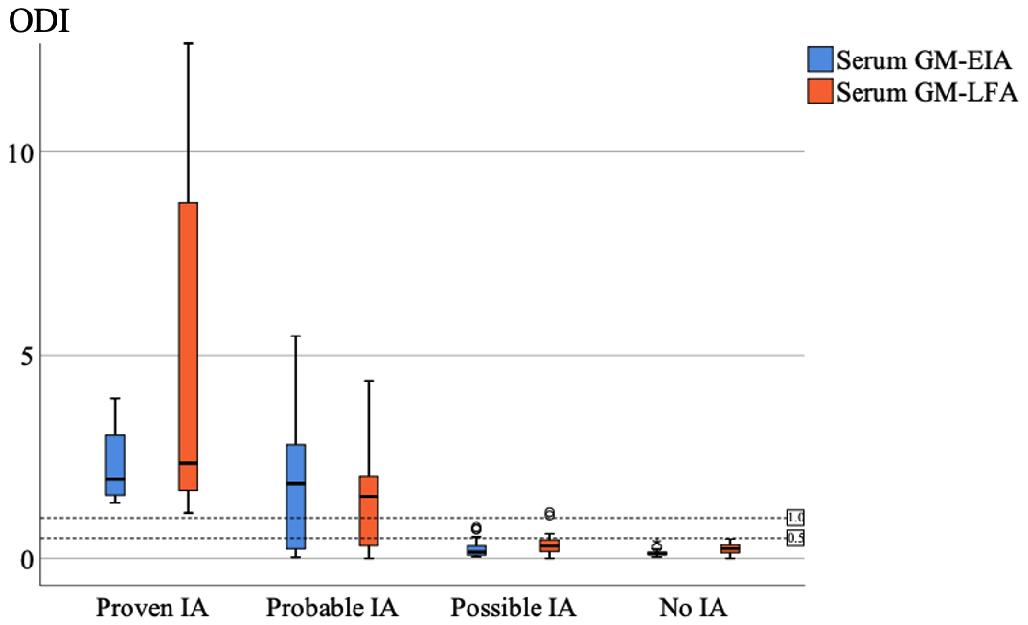

Supplementary Figure 2. Clustered box plot of BAL GM-LFA and GM-EIA index values of case groups. EIA: Enzyme immunoassay GM: Galactomannan, IA: Invasive aspergillosis, LFA: Lateral flow assay, ODI: Optical density index.

