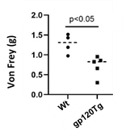
Paw withdraw threshold (g)
WT
gp120Tg

Supplementary Figure 1. Von Frey test demonstrated gp120Tg mice (4-5 months) developed mechanical allodynia.

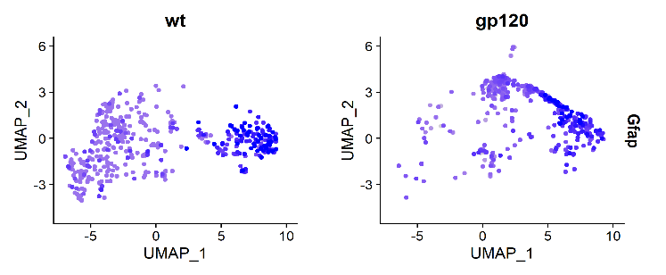
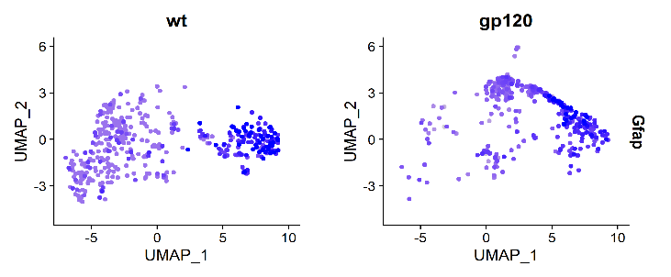
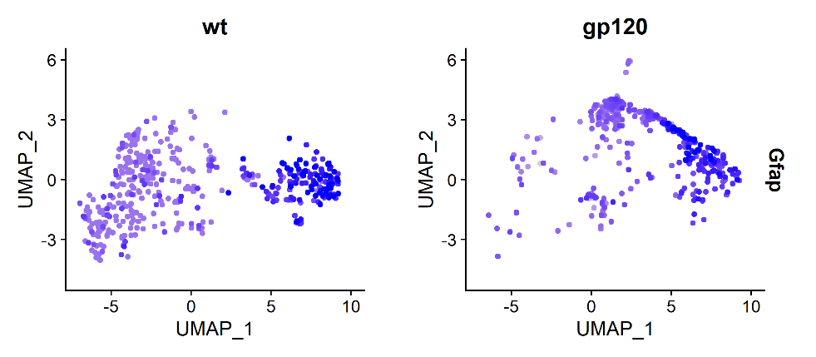
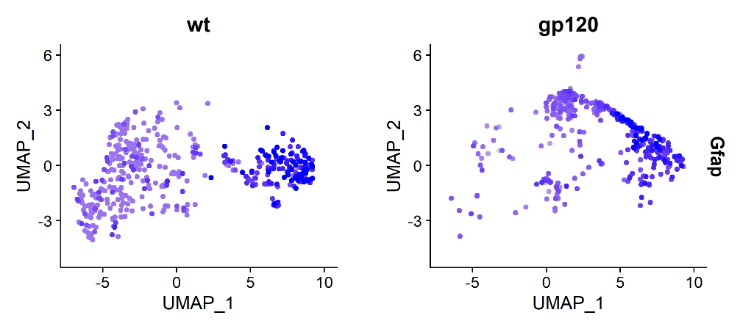
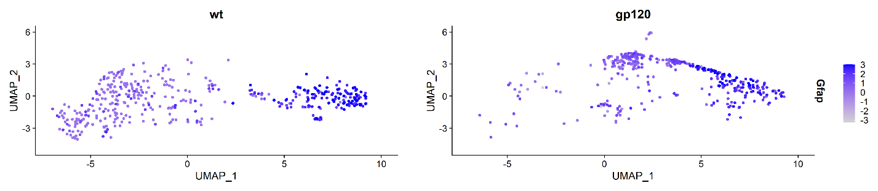
b
WT
gp120Tg
a

Supplementary Figure 2. Comparison of clustering patterns of Gfap-expression astrocytes in WT and gp120Tg mice by UMAP plots. a. In WT, majority of astrocytes fall in the clusters expressing a low level of Gfap (Gfap^{low}) (circled by a blue line), while a smaller number of astrocytes in the clusters with a high level of Gfap (Gfap^{high}) (circled by a red line). b. In gp120Tg mice, astrocytes in the Gfap^{high} clusters is increased, accompanying with a drastic decrease of astrocytes in the Gfap^{low} clusters. Scale bar: Gfap expression levels (log2 values)

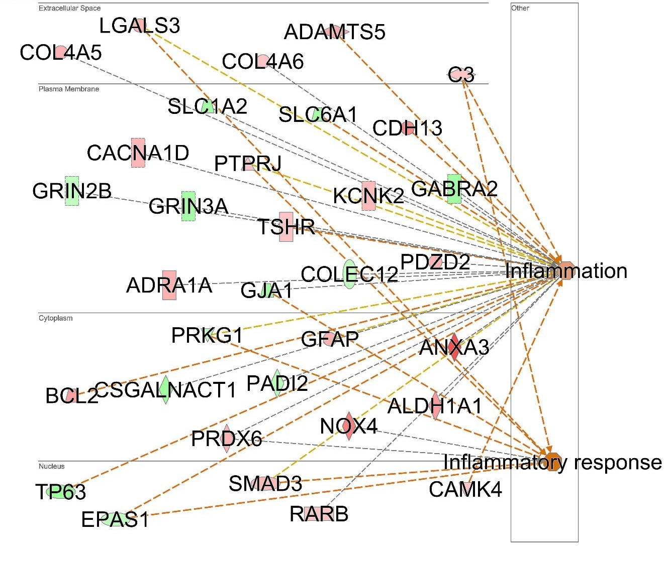

Supplementary Figure 3. Enrichment of inflammation-related genes in HIPAs. 112 HIPA (cluster 7) marker genes with adjusted p-value < 0.05 were imported into Ingenuity Pathway Analysis (IPA). IPA identified 33 well-characterized inflammation-related genes. Green: down-regulated; red: up-regulated; the orange dots: indicating increased inflammatory activity.

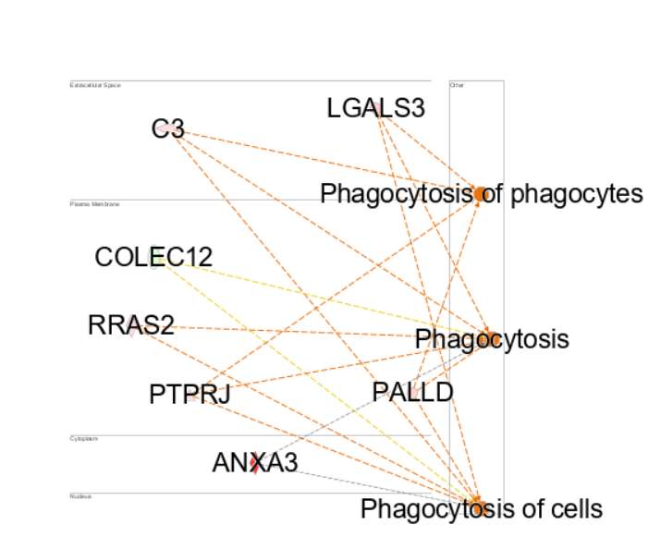
Supplementary Figure 4. Phagocytosis-related genes in HIPAs. Among the 112 HIPA (cluster 7)-specific genes with adjusted p-value < 0.05, IPA identified 7 well-characterized phagocytosis-related genes. Green: down-regulated; red: up-regulated; orange dots: indicating increased phagocytotic functions.
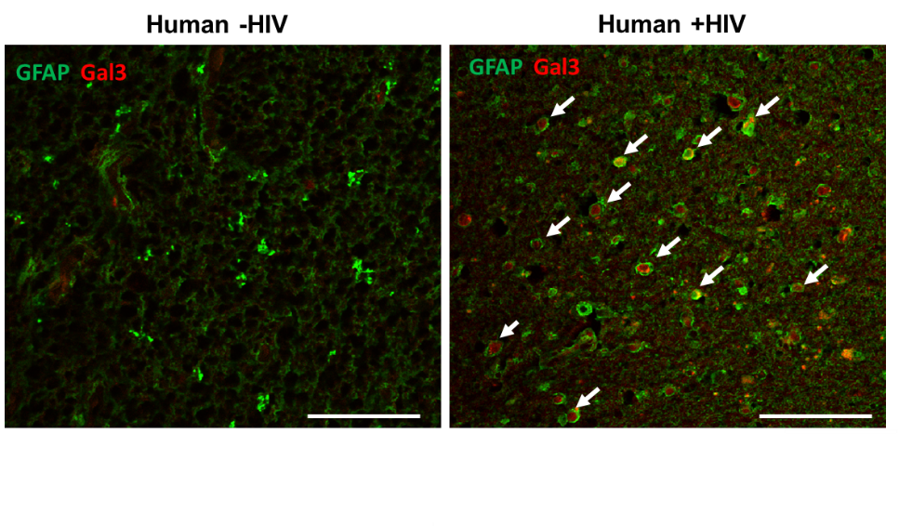
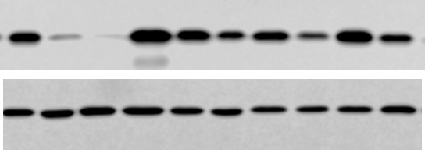
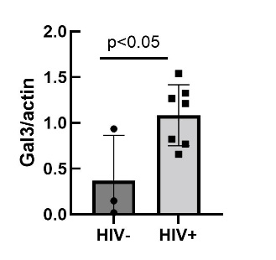
100µm
100µm
HIV- patient
HIV+ patient
c
HIV⁻ HIV⁺
Gal3 26kD
Actin 42kD
Supplementary Figure 5. Upregulation of Galectin-3 (Gal3) protein expression in spinal cords of human HIV⁺ patients. a, Western blotting analysis showing significant increase of Gal3 protein in spinal cord autopsies from HIV patients, compared with spinal autopsies from control patients died of other non-HIV conditions (endocarditis, pulmonary embolus, and pneumonia). b and c, Representative images of immunofluorescent (IF) staining of Gal3 protein (red, white arrows) in astrocytes (GFAP, green) in spinal cord autopsies of HIV patients (c) or in the spinal cord autopsy of a control patient (endocarditis) (b). Note the increase of Gal3⁺ astrocytes (white arrows) in the HIV spinal cord (c), compared with the control (b).
a
b

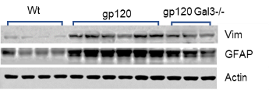
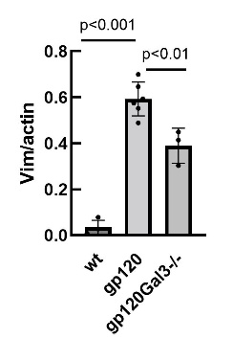
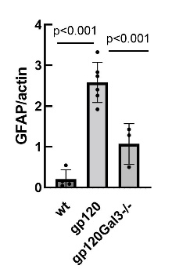
gp120Tg/Gal3^{-/-}
gp120Tg
Vim 75kD
GFAP 55kD
Actin 42kD

WT
Supplementary Figure 6. Gal3 knockout (Gal3KO) significantly attenuated the upregulation of reactive astrocytic marker proteins Vimentin (Vim) and GFAP in the lumbar spinal cords of gp120Tg mice. a, Western blots of Vim and GFAP in spinal cords of WT (n=4), gp120Tg (n=6), and gp120Tg/Gal3^{-/-} (n=3) mice; b and c, Quantification of Vim (b) and GFAP signals (c).
a
c
b
GFAP/actin
WT
gp120Tg
gp120Tg/Gal3^{-/-}
WT
gp120Tg
gp120Tg/Gal3^{-/-}

