Nigrospora_guilinensis |  | 0 | 0 | 0
Nigrospora_oryzae | 0 |  | 0 | 0
Nigrospora_sphaerica | 0 | 0 |  | 0
Nigrospora_sp. | 0 | 0 | 0
Table S1 Compensatory base changes detected among the species of Nigrospora oryzae

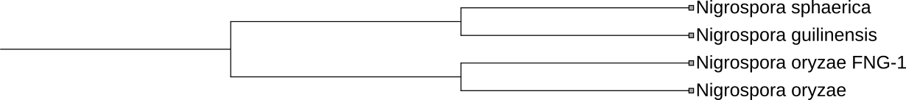

Figure. S1 Internal Transcribed Spacer 2 sequence-secondary structure based phylogenetic tree of Nigrospora oryzae and reference sequences.

