Supplementary Information

SI Materials:
SI Materials 1. Antibodies used in DigiWest protein profiling analysis.

Supplementary Figures:
Figure S1. Correlation of nuclear grade in PDM and PTT.
Figure S2. Proteomic comparison of NST and ILC-derived BC PDM.
Figure S3 Identification of resistance and sensitivity marker panels in treatment responder and non-responder microtumors and regression analysis of differently expressed proteins.

Supplementary Tables:
Table S1. Clinical patient data of the patient cohort.
Table S2. Descriptive statistics of “area” and “fluorescent intensity live/dead” measurements in PDM.
Table S3. Raw data of DigiWest® protein signals in PDM and PTT samples and total measured protein amounts.
Table S4. DigiWest®-based AFI protein signals in matched PDM-PTT pairs DigiWest®-based AFI protein signals in matched PDM-PTT pairs.
Table S5. DigiWest®-based AFI protein signals of matched PDM-PTT pairs sorted by pathway affiliation
Table S6. Pearson correlation of protein abundances in PDM and corresponding PTT (PDM/PTT pairs).
Table S7. DigIWest®-based AFI protein signals of n = 42 PDM samples.
Table S8. Descriptive statistics of averaged, median-centered and log2 transformed protein signals for cell cycle, MAPK/RTK and PI3K/AKT pathway in n = 42 PDM samples.
Table S9. Celltox™ Green assay RFU (relative fluorescent unit) values of BC microtumors treated with TAM, DTX, PTX and PAB.
Table S10. Descriptive statistics of simple logistic regression analysis of differentially expressed proteins in treatment responder and non-responder groups.

SI Materials
SI Materials 1. Antibodies used in DigiWest protein profiling analysis.
Analyte | Uniprot | Product_No | Supplier
4E-BP1 | Q13541 | 1557-1 | Abcam
53BP1 | Q12888 | 4937 | Cell Signaling
53BP1-pThr543 | Q12888 | 3428 | Cell Signaling
Akt | P31749 | 4685 | Cell Signaling
Akt-pSer473 | P31749 | 4060 | Cell Signaling
alpha-SMA | P62736 | 14968 | Cell Signaling
alpha-Tubulin | P68366 | 302211 | Synaptic Systems
A-Raf | P10398 | 4432 | Cell Signaling
ATG5 | Q9H1Y0 | 12994 | Cell Signaling
Beclin-1 | Q14457 | 3738 | Cell Signaling
beta-Catenin | P35222 | 8480 | Cell Signaling
beta-Catenin(non-pSer33/37/Thr41) | P35222 | 8814 | Cell Signaling
beta-Catenin-pSer552 | P35222 | 9566 | Cell Signaling
b-Raf | P15056 | 14814 | Cell Signaling
b-Raf-p-Ser445 | P15056 | 2696 | Cell Signaling
BRCA1 | P38398 | 9010 | Cell Signaling
Caveolin-1 | Q03135 | 3238 | Cell Signaling
CD11c | P20702 | 45581 | Cell Signaling
CD16 | P08637 | 80006 | Cell Signaling
CD25 | P01589 | 13517 | Cell Signaling
CD3epsilon | P07766 | 4443 | Cell Signaling
CD4 | P01730 | PA5-87425 | Thermo Fisher Scientific
CD56 | P13591 | 3576 | Cell Signaling
CD68 | P34810 | 86985 | Cell Signaling
CD8alpha | P01732 | 85336 | Cell Signaling
cdc2(CDK1) | P06493 | 9112 | Cell Signaling
CDK2 | P24941 | 2546 | Cell Signaling
CDK2-pThr160 | P24941 | 2561 | Cell Signaling
CDK4 | P11802 | 12790 | Cell Signaling
CDK4-pThr172 | P11802 | PA-64482 | Invitrogen
CDK6 | Q00534 | sc-7961 | Santa Cruz
CDKN2A | P42771 | 10883-1-AP | Protein Tech Group
CIP2A | Q8TCG1 | A301-454A | Bethyl
c-Met | P08581 | 3148 | Cell Signaling
c-Met-pTyr1003 | P08581 | 3135 | Cell Signaling
c-Raf | P04049 | 9422 | Cell Signaling
c-Raf-pSer259 | P04049 | 9421 | Cell Signaling
CREB | P16220 | 9197 | Cell Signaling
CREB-pSer133 | P16220 | 9198 | Cell Signaling
CTMP | Q96KR2 | 4612 | Cell Signaling
CyclinD1 | P24385 | 2978 | Cell Signaling
CyclinE1 | P24864 | 4129 | Cell Signaling
Cyp1B1 | Q16678 | sc-374228 | Santa Cruz
Cytokeratin5 | P13647 | M3270 | Spring Bioscience
Cytokeratin6 | P02538 | 2302-1 | Abcam
Cytokeratin8/18 | P05783 | 4546 | Cell Signaling
Cytokeratin8-pSer23 | P05787 | 2147-1 | abcam (Epitomics)
E2F-1 | Q01094 | 3742 | Cell Signaling
E2F-2 | Q14209 | DR1095-100UG | Millipore
E2F-4 | Q16254 | orb10571 | Biorbyt
E-Cadherin | P12830 | sc-59778 | Santa Cruz
E-Cadherin-pSer838/840 | P12830 | 2239-1 | Abcam
eIF2alpha-pSer51 | P05198 | 3398 | Cell Signaling
eIF4E | P06730 | 2067 | Cell Signaling
eIF4E-pSer209 | P06730 | 9741 | Cell Signaling
ER | P03372 | RM-9101-S | Thermo Fisher Scientific
ERalpha-pSer167 | #NV | 2514 | Cell Signaling
Erk1/2 | P28482 | 4695 | Cell Signaling
Erk1/2-pThr202/Tyr204 | P28482 | 4370 | Cell Signaling
FGFreceptor1 | P11362 | 9740 | Cell Signaling
FGFreceptor-pTyr653/654 | P11362 | 3476 | Cell Signaling
FLOWER(C9orf7) | Q9UGQ2 | orb164624 | Biorbyt
FoxO3a | O43524 | 2497 | Cell Signaling
GATA3 | P23771 | 5852 | Cell Signaling
GLUT-1 | P11166 | 07-1401 | Millipore
GSK3beta | P49841 | 9315 | Cell Signaling
GSK3beta-pSer9 | P49841 | 9336 | Cell Signaling
HDAC1 | Q13547 | 2062 | Cell Signaling
Her2 | P04626 | A0485 | Dako
HIF1beta(ARNT) | P27540 | 5537 | Cell Signaling
HistoneH3 | P68431 | 9715 | Cell Signaling
HLA-A,B,C | n.a. |  | AG Stevanovic
IDH1 | O75874 | 8137 | Cell Signaling
IGF1Rbeta | P08069 | 3018 | Cell Signaling
IGF1R-pTyr1135/Tyr1136 | P08069 | 3024 | Cell Signaling
IKKalpha | O15111 | 2682 | Cell Signaling
IKKalpha-pThr23 | O15111 | ab38515 | Abcam
IKKepsilon | Q14164 | 2905 | Cell Signaling
IKKepsilon-pSer172 | Q14164 | 8766 | Cell Signaling
JNK/SAPK | P45983 | 9252 | Cell Signaling
JNK/SAPK-pThr183/Tyr185 | P45983 | 4668 | Cell Signaling
Ki-67 | P46013 | K1700-05D | US Biologicals
LAMC1 | P11047 | 92921 | Cell Signaling
LDHA | P00338 | 2012 | Cell Signaling
MAD2L1 | Q13257 | 4636 | Cell Signaling
MEK1 | Q02750 | 9124 | Cell Signaling
MEK1/2-pSer217/221 | Q02750 | 9154 | Cell Signaling
MEK2 | P36507 | 9125 | Cell Signaling
mTOR(FRAP) | P42345 | 2983 | Cell Signaling
NF1(Neurofibromin) | P21359 | 14623 | Cell Signaling
NF-κBp65-pSer468 | Q04206 | 3039 | Cell Signaling
p38MAPK | Q16539 | 9212 | Cell Signaling
p38MAPK-pThr180/Tyr182 | Q16539 | 4511 | Cell Signaling
p53 | P04637 | 9282 | Cell Signaling
p53-pSer37 | P04637 | 9289 | Cell Signaling
p70S6kinase | P23443 | 2708 | Cell Signaling
p70S6kinase-pThr389 | P23443 | 9206 | Cell Signaling
PADI4 | Q9UM07 | sc-365369 | Santa Cruz
PAK1/2/3 | Q13153 | 2604 | Cell Signaling
PARP | P09874 | 9532 | Cell Signaling
PARP-cleavedAsp214 | P09874 | 9541 | Cell Signaling
PD1 | Q15116 | 86163 | Cell Signaling
PDK1 | Q15118 | 3062 | Cell Signaling
PDK1-pSer241 | Q15118 | 3061 | Cell Signaling
PD-L1 | Q9NZQ7 | 13684 | Cell Signaling
PI3-kinase p85 | P27986 | 4292 | Cell Signaling
PP2AC | P67775 | 2259 | Cell Signaling
PP2AC-pTyr307 | P67775 | AF3989 | R&D
PgR | P06401 | 8757 | Cell Signaling
PTEN | P60484 | 9552 | Cell Signaling
PTEN non-pSer380/Thr382/Thr383 | P60484 | 7960 | Cell Signaling
PTEN-pSer380 | P60484 | 9551 | Cell Signaling
Rad51 | Q06609 | ab109107 | Abcam
Ras | P01116 | 8955 | Cell Signaling
Rb-pSer795 | P06400 | 9301 | Cell Signaling
Rb-pSer807/811 | P06400 | 8516 | Cell Signaling
RSK1(p90RSK)-pThr573 | Q15418 | ab62324 | Abcam
S6RP | P62753 | 2217 | Cell Signaling
S6RP-pSer235/236 | P62753 | 2211 | Cell Signaling
Snail | O95863 | 3879 | Cell Signaling
Src | P12931 | 2109 | Cell Signaling
Src-pSer17 | P12931 | 5473 | Cell Signaling
Src-pTyr527 | P12931 | 2105 | Cell Signaling
STAT3 | P40763 | 4904 | Cell Signaling
STAT3-pTyr705 | P40763 | 9145 | Cell Signaling
Tau | P10636 | sc-32274 | Santa Cruz
Tau-pSer202 | P10636 | 39357 | Cell Signaling
Tubulin acetylated | P68366 | T6793 | Cell Signaling
Tubulinbeta-1chain | Q9H4B7 | MAB16676 | Abnova
Vimentin | P08670 | 5741 | Cell Signaling
Vimentin-pSer56 | P08670 | 7391 | Cell Signaling

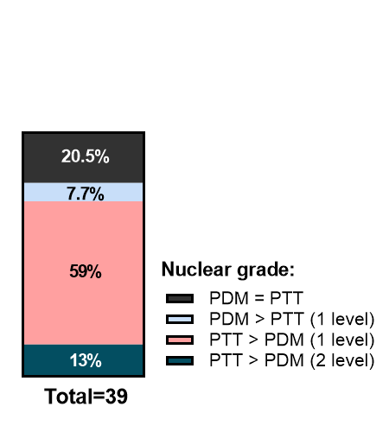
Supplementary Figures

Figure S1. Correlation of nuclear grade in PDM and PTT. Nuclear grading of n = 39 PDM and PTT was assessed by a pathologist. In 20.5% of the specimen, nuclear grading of PTT was reflected by PDM. In 59% of the cases, PDM resembled a one-degree lower nuclear grade.

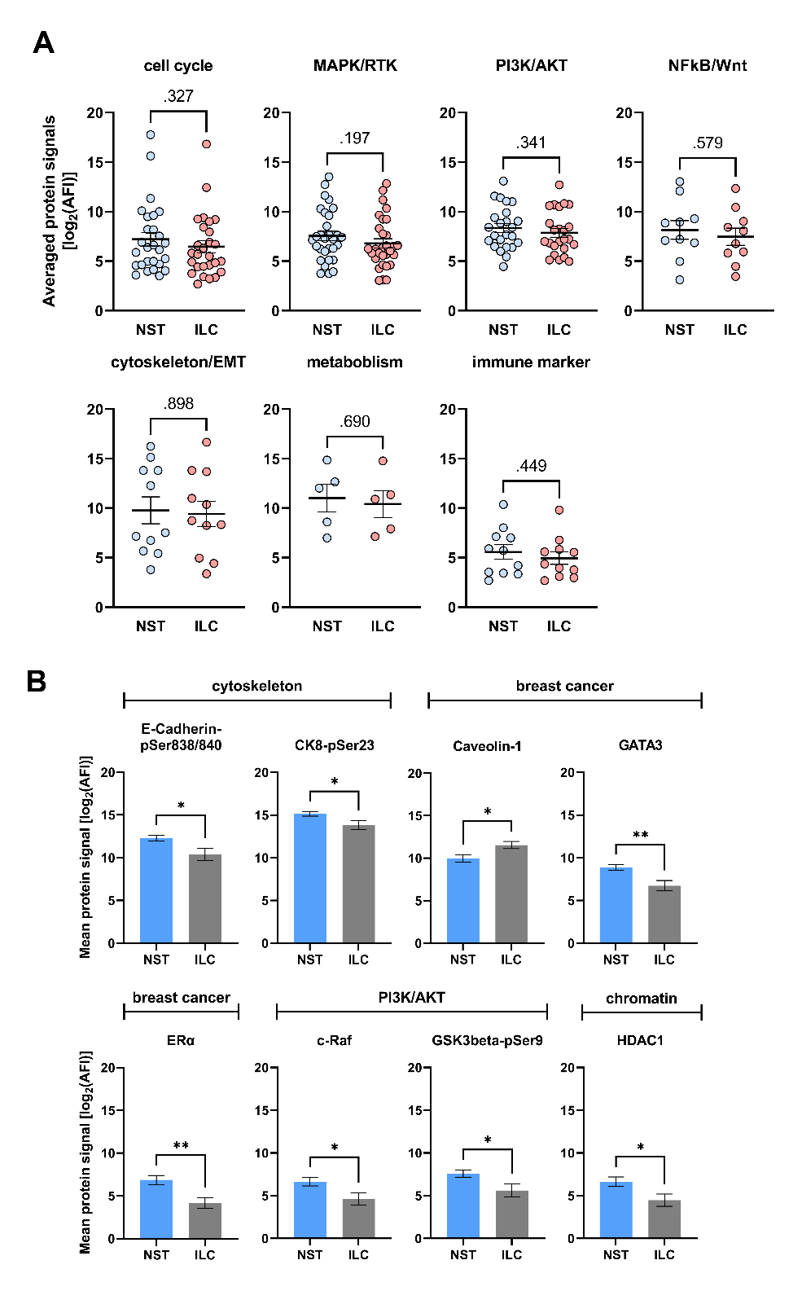
Figure S2. Proteomic comparison of NST and ILC-derived BC PDM. (A) Signaling pathway comparison of NST- and ILC-derived BC PDM. Normalized protein signals (AFI) in NST-/ILC-BC PDM were averaged and log2 transformed. No significant differences were detected. Mann-Whitney U test, p < 0.05.(B) Differentially expressed proteins in NST-/ILC-BC PDM. Enhanced protein abundances in NST- BC PDM were identified for several proteins associated with cell cytoskeleton, PI3K/AKT pathway and chromatin regulation, and with general breast cancer markers. Mann-Whitney U test, *p < 0.05, **p < 0.01, ***p < 0.001. Data are mean with SEM.

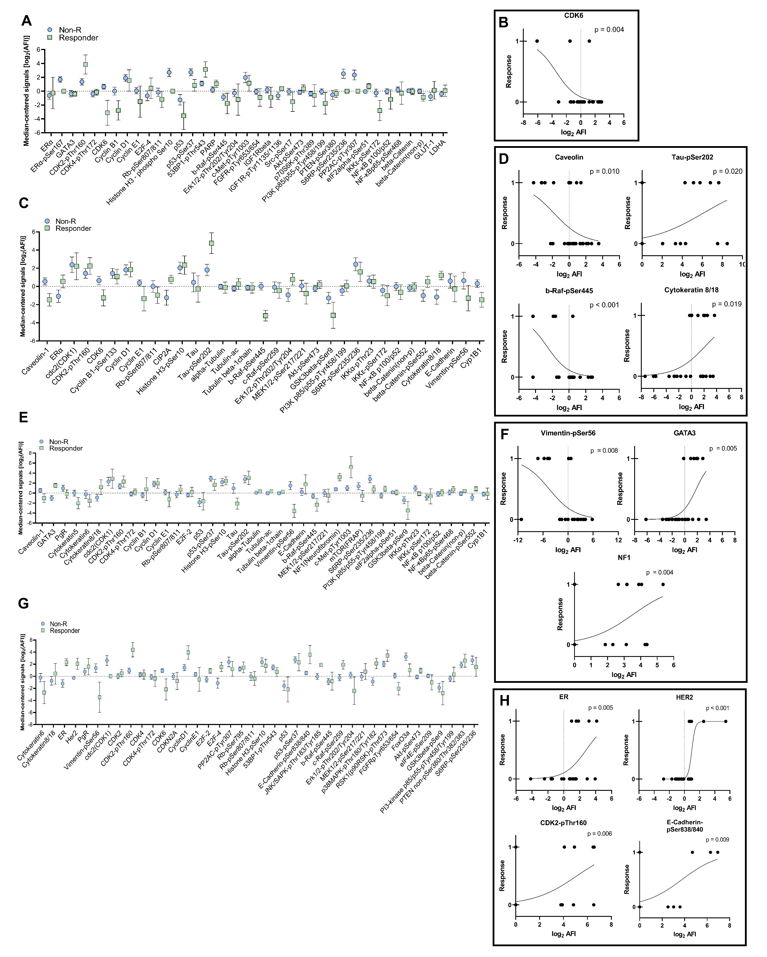
Figure S3. Identification of resistance and sensitivity marker panels in treatment responder and non-responder microtumors and regression analysis of differently expressed proteins. Microtumors were treated with four anti-cancer drugs and grouped into treatment responder and non-responders based on the results of cell death assays (CellTox ™ green cytotoxicity assay, Promega). DigiWest AFI protein signals of microtumors were median-centered, log2-transformed, and compared between R and Non-R groups. Proteins that are associated with response/resistance to therapy according to literature, are differentially expressed, or are involved in therapy-related signaling pathways were plotted as interleaved scatter plots for tamoxifen (A), docetaxel (C), paclitaxel (E), and palbociclib (G) treatment. Blue symbols indicate the mean protein signal of the non-responder group, green symbols indicate the mean protein signal of the responder group. Simple logistic regression of differentially expressed proteins are depicted in (A) for tamoxifen, (C) for docetaxel, (E) for paclitaxel and (G) for palbociclib responses (1 = response; 0 = no response). Protein signals are displayed as log₂ transformed AFI signals. As indicated by p-values (LRT) < 0.05, the amount of the shown proteins (predictor variables) significantly affected the likelihood of response to treatment. Descriptive statistics of simple logistic regressions are shown in Table S10. *p < 0.05, **p < 0.01 and ***p < 0.001. Shown are mean with SEM. Non-R and R. AFI: average fluorescent intensities; Non-R: non-responder; R: responder.

Supplementary Tables
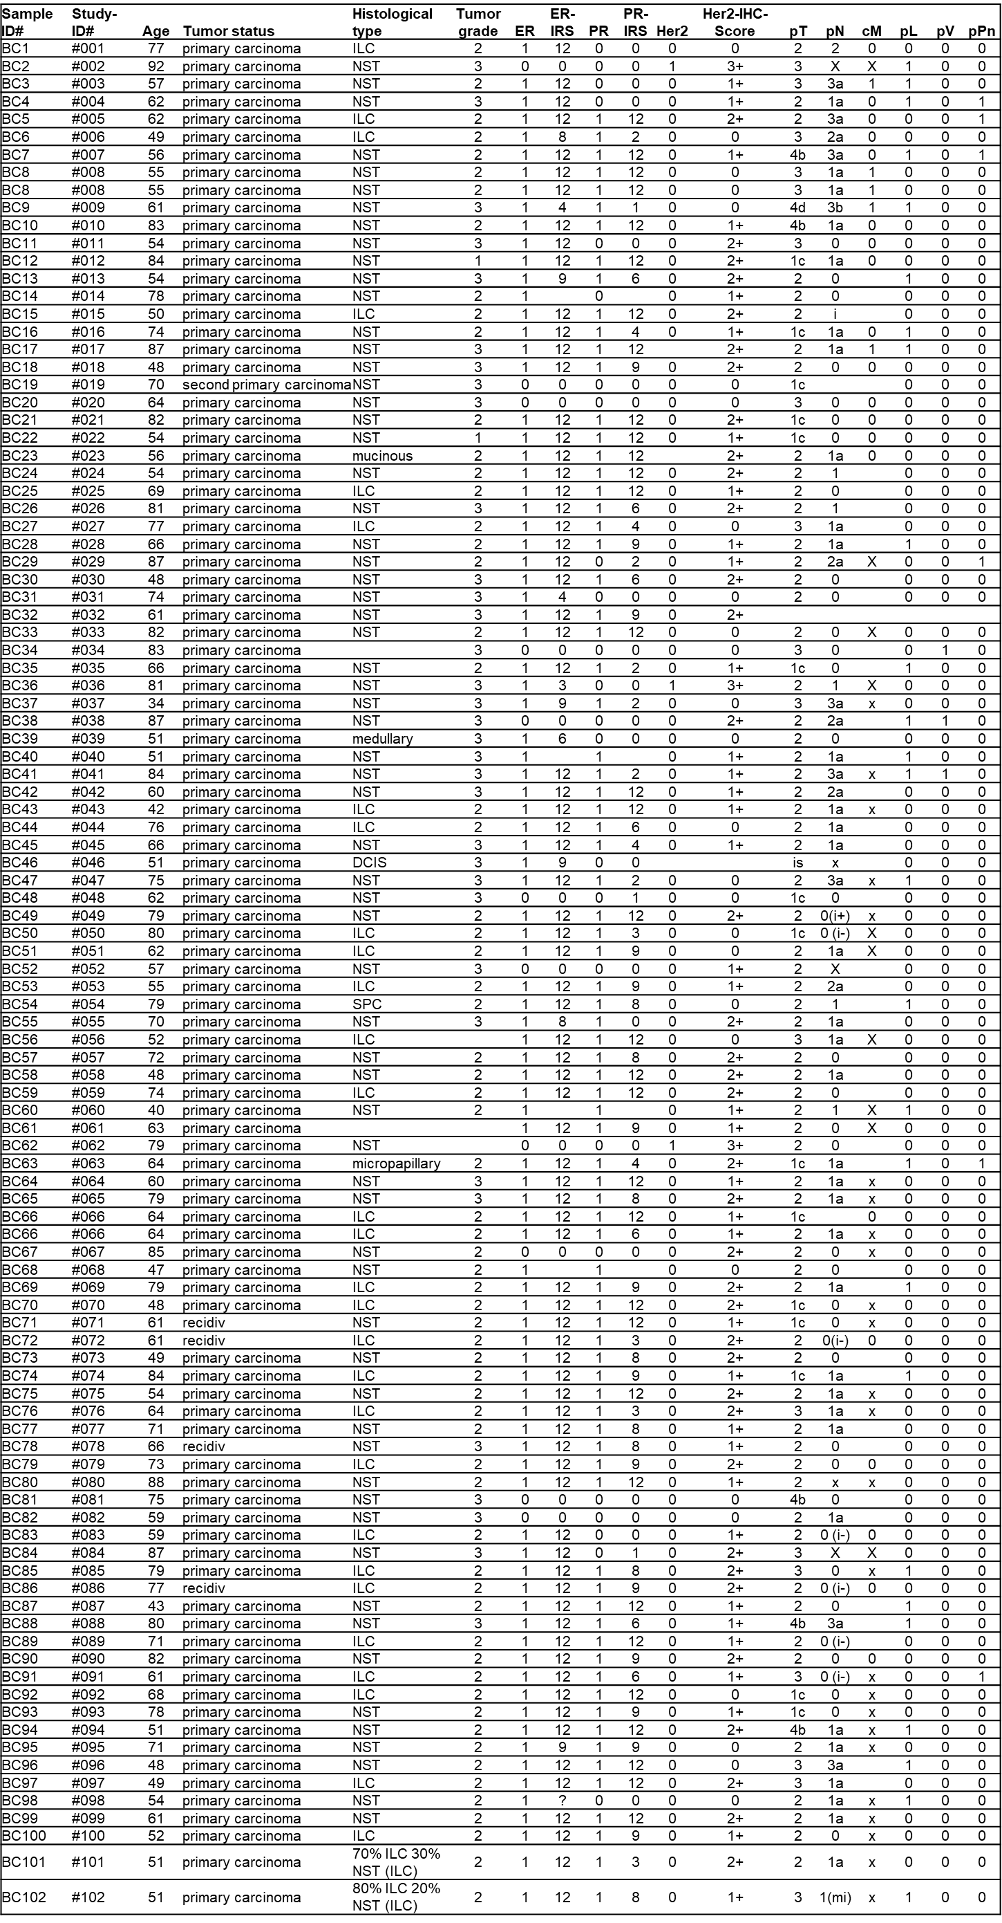
Table S1. Clinical patient data of the patient cohort.

BC: breast carcinoma; NST: invasive ductal carcinoma of no special type; ILC: invasive lobular carcinoma; DCIS: ductal carcinoma in-situ; ER: estrogen receptor status; PR: progesterone receptor status; HER2: HER2/neu-Erb-b2 receptor status; IRS: immunoreactive score (0-12); p: pathological; c: clinical; T: tumor size; N: lymph node spread; M: metastasis; L: lymphatic vessel spread; V: blood vessel spread; Pn: perineural invasion; “0” (ER, PR, HER2) = negative; “1” (ER, PR, HER2) = positive
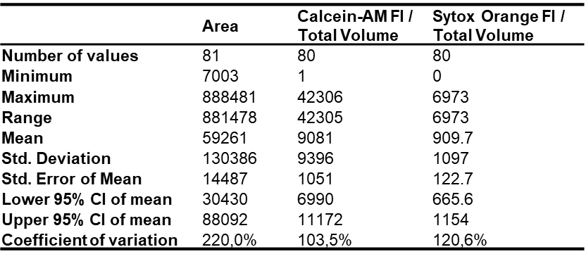
Table S2. Descriptive statistics of “area” and “fluorescent intensity live/dead” measurements in PDM.

Table S3. Raw data of DigiWest® protein signals in PDM and PTT samples and total measured protein amounts.

Table S4. DigiWest®-based AFI protein signals in matched PDM-PTT pairs DigiWest®-based AFI protein signals in matched PDM-PTT pairs.

Table S5. DigiWest®-based AFI protein signals of matched PDM-PTT pairs sorted by pathway affiliation
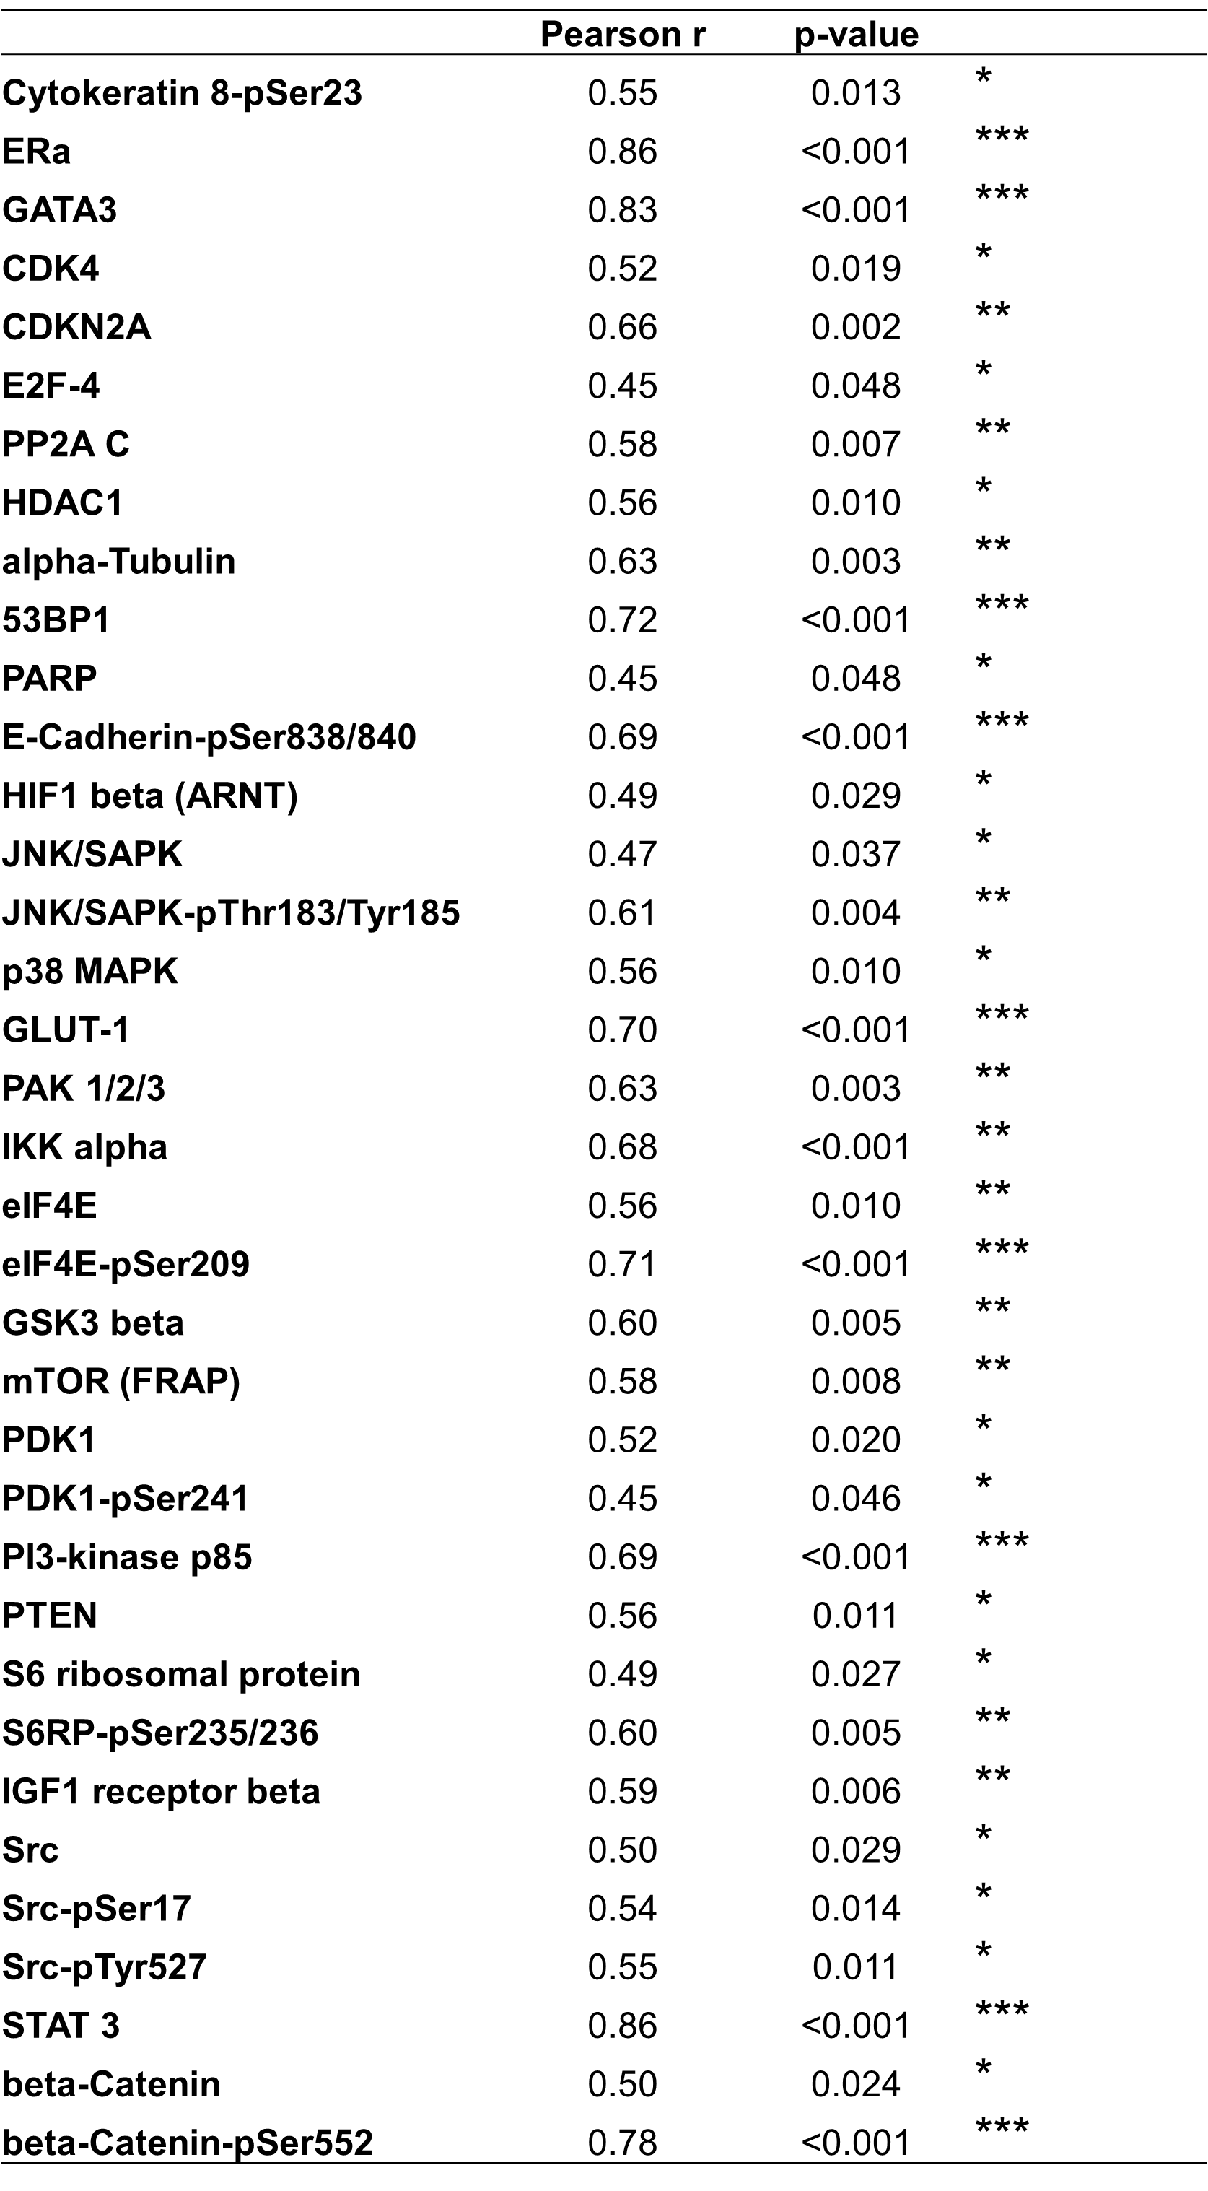
Table S6. Pearson correlation of protein abundances in PDM and corresponding PTT (PDM/PTT pairs).

Table S7. DigIWest®-based AFI protein signals of n = 42 PDM samples.
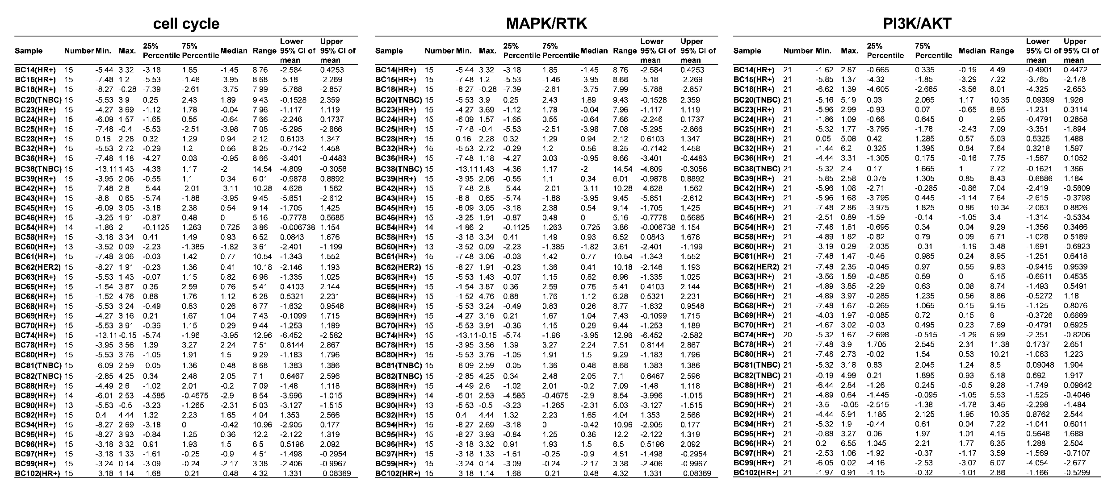
Table S9. Celltox™ Green assay RFU (relative fluorescent unit) values of BC microtumors treated with TAM, DTX, PTX and PAB.
Table S8. Descriptive statistics of averaged, median-centered and log2 transformed protein signals for cell cycle, MAPK/RTK and PI3K/AKT pathway in n = 42 PDM samples.

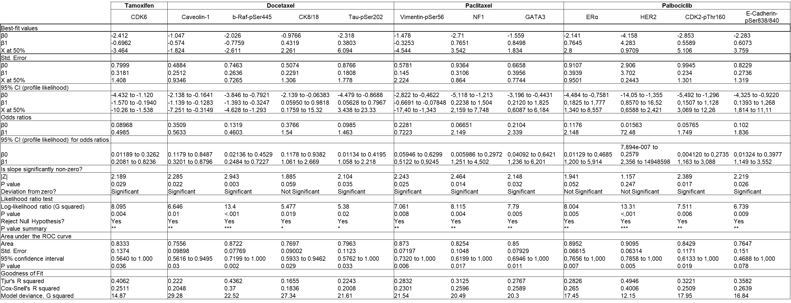
Table S10. Descriptive statistics of simple logistic regression analysis of differentially expressed proteins in treatment responder and non-responder groups.

