Extended Data
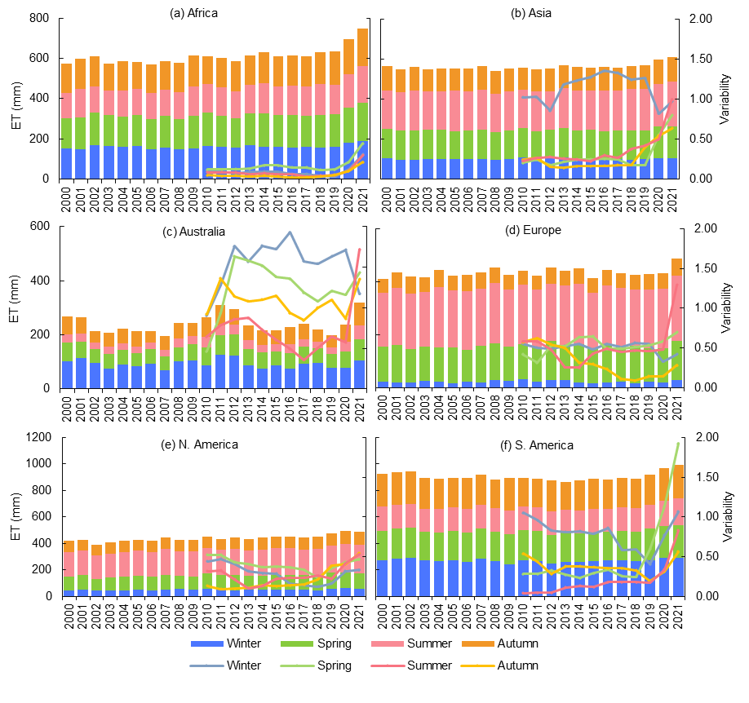
Extended Data Fig.1 Time series of seasonal ET (mm/season) as bar graphs with lines representing the ET seasonal decadal variability for each continent (a-f).

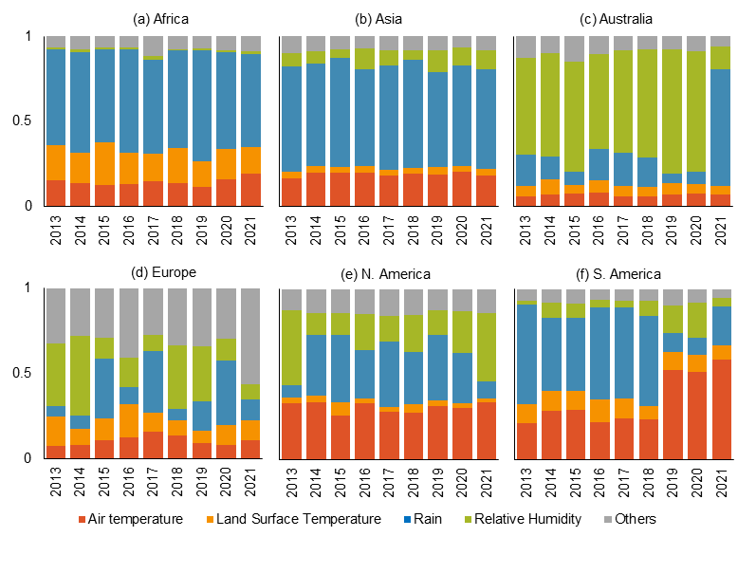
Extended Data Fig. 2 Relative contributions of the main weather and climatic factors towards ET by continent (a-f). The main four variables are air temperature, land surface temperature, rain, and relative humidity. Others are soil moisture, wind, solar radiation, and vapor pressure deficit. Plot shows the temporal changes in variable importance proportions derived from a machine learning boosted tree model.

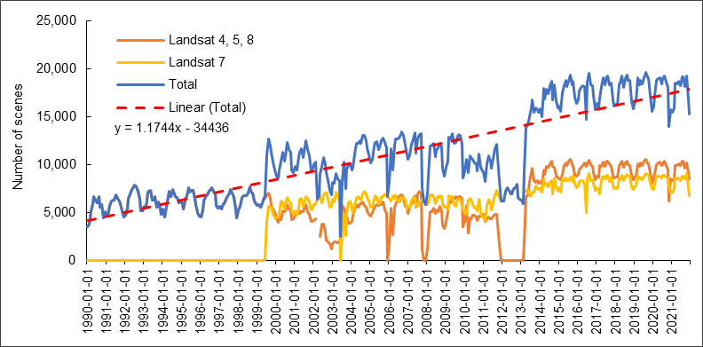
Extended Data Fig. 3 Total number of Landsat scenes used per month and year.
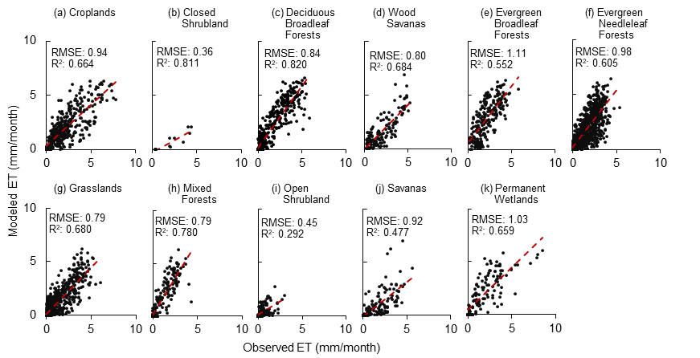
Extended Data Fig. 4 Scatter plots of HSEB-ET (modeled) vs ET from Flux sites (observed) divided by land type
Extended Data Table 1. Annual Evapotranspiration (ET) trends using the MK test and Sen’s Slope by Climate group for period 2000 – 2021. Two asterisks indicate significance at p-value < 0.01, and three asterisks indicate significance at p-value < 0.001
Climate Type | Climate Code | Sen's Estimate | Significance level
Tropical, rainforest | Af | 3.41 | ***
Tropical, monsoon | Am | 2.94 | ***
Temperate, no dry season, hot summer | Cfa | 3.39 | **
Temperate, no dry season, warm summer | Cfb | 1.69 | **
Temperate, no dry season, cold summer | Cfc | 3.50 | **
Temperate, dry summer, hot summer | Csa | 2.58 | **
Temperate, dry summer, warm summer | Csb | 1.96 | ***
Cold, no dry season, warm summer | Dfb | 1.98 | ***
Cold, no dry season, cold summer | Dfc | 2.61 | ***
Cold, dry summer, warm summer | Dsb | 1.57 | **
Cold, dry summer, cold summer | Dcs | 4.15 | ***
Cold, dry winter, hot summer | Dwa | 5.19 | ***
Cold, dry winter, warm summer | Dwb | 4.18 | ***
Cold, dry winter, cold summer | Dwc | 3.12 | ***
Tropical, savannah | Aw | -0.84
Arid, steppe, hot | BSh | -1.34
Arid, steppe, cold | BSk | 0.31
Arid, desert, hot | BWh | -1.74
Arid, desert, cold | BWk | -0.71
Temperate, dry winter, hot summer | Cwa | 1.40
Temperate, dry winter, warm summer | Cwb | 0.97
Temperate, dry winter, cold summer | Cwc | -0.78
Cold, no dry season, hot summer | Dfa | 0.91
Cold, no dry season, very cold winter | Dfd | 1.62
Cold, dry summer, hot summer | Dsa | -1.59

Extended Data Table 2. Annual Evapotranspiration (ET) trends using the MK test and Sen’s Slope by Landcover type for period 2000 – 2021. Blue color indicates a significant positive trend and red color indicates a significant negative trend. One asterisk indicates significance at p-value < 0.05, two asterisks indicate significance at p-value < 0.01, and three asterisks indicate significance at p-value < 0.001
LC 10 |  |  |  |  |  |  | **
LC 20 |  | *** |  | *
LC 30 |  | *** |  | ***
LC 40 |  | * | * | *** |  | * | ***
LC 50 |  |  | ** | *** | ** |  |  | *
LC 60 |  |  | *** | *** |  | *** | *** | *
LC 70 |  | *** |  | *** |  | *** | ***
LC 80 |  | *** |  | ***
LC 90 |  | ** |  |  |  | ** | ***
LC 100 |  |  | *** | ***
LC 110 |  |  | ***
LC 120 |  | ***
LC 130 |  | *** |  |  |  |  | ***
LC 140 |  | **
LC 160 |  | ***
LC 170
LC 180 |  | *
 |  | Global | Africa | Asia | Australia | Europe | N. America | S. America
Extended Data Table 3. MK test and Sen’s slope for relative humidity (RH), vapor pressure deficit (VPD), rain, solar radiation (Solar Rad), Air Temperature, Landsat Land Surface Temperature (Landsat Temp), Land Surface Temperature (LST-MOD) and NDVI-MOD from MODIS for 2000 – 2021, and actual evapotranspiration (ETA). One asterisk indicates significance at p-value < 0.05, two asterisks indicate significance at p-value < 0.01, and three asterisks indicate significance at p-value < 0.001
Continent / Variable | Africa | Asia | Australia | Europe | N. America | S. America
RH | 0.0004 | 0.0000 | -0.0007 | -0.00074  * | 0.0001 | -0.0008
VPD | 0.0016 | -0.0004 | 0.0063 | 0.0025 | 0.0002 | 0.0039  **
Rain | 5.8795  ** | 2.2025 | 0.1625 | -1.4076 | 4.7692  *** | 0.8050
Solar Rad | -0.1330  * | -0.3092  *** | -0.0458 | 0.0171 | -0.1492 | 0.1043
Air Temp | 0.0383  *** | -0.0055 | 0.0428  * | 0.0071 | 0.0205 | 0.0322  ***
Landsat Temp | -0.2651  *** | -0.1136  ** | 0.0342 | -0.0456  *** | -0.0187 | 0.0025
LST-MOD | -0.0134 | -0.0505  ** | 0.0166 | 0.0040 | -0.0102 | 0.0247  **
NDVI-MOD | 0.0020  *** | 0.00090  * | 0.0004 | -0.0001 | 0.0004 | 0.0006  *
ETA | 3.629  *** | 0.897  ** | 0.7698 | 0.8017 | 3.258  *** | -0.1049

