Table S1
Composition and nutrient levels of the basal diet (air-dry basis, g/kg)
Items | Content
 | d 1 to 21 | d 22 to 42 |  |  | d 1 to 21 | d 22 to 42
Ingredients |  |  | Analyzed values
Corn | 619 | 600 | Crude protein |  | 211.9 | 204.9
Soybean meal | 280 | 276 | Crude fat |  | 32.4 | 61.3
Corn gluten meal | 28 | 35 | Calcium |  | 9.9 | 7.5
Soybean oil | 8 | 35 | Total phosphorus |  | 8.9 | 6.4
Monosodium glutamate residue | 15 | 15 | Calculated composition
Limestone | 15.0 | 10.0 | Metabolizable energy (MJ/kg) |  | 12.15 | 12.98
Calcium hydrophosphate | 14.0 | 10.0 | Available phosphorus |  | 3.7 | 3.0
Sodium chloride | 3.0 | 2.5 | Lysine |  | 13.4 | 12.8
Choline chloride | 1.0 | 1.0 | Methionine |  | 5.0 | 5.1
L-lysine | 6.5 | 6.5 | Threonine |  | 10.0 | 8.3
DL-methionine | 1.8 | 2.0 | Tryptophan |  | 2.8 | 2.1
L-threonine | 2.3 | 1.0
Premix¹ | 6.0 | 6.0
¹ The premix provided per kg of diets: Cu (as copper sulfate), 16 mg; Fe (as ferrous sulfate), 180 mg; Mn (as manganese sulfate), 87 mg; Zn (as zinc sulfate) 100 mg, I (as potassium iodide) 0.70 mg, Se (as sodium selenite) 0.40 mg; vitamin A, 10,000 IU; vitamin D, 3,000 IU; vitamin K₃, 3 mg; thiamine, 5 mg; riboflavin, 10 mg; pyridoxine, 13 mg; cobalamin, 0.01; niacin, 50 mg; pantothenic acid, 17 mg; folic acid, 0.3 mg; biotin, 0.2 mg.
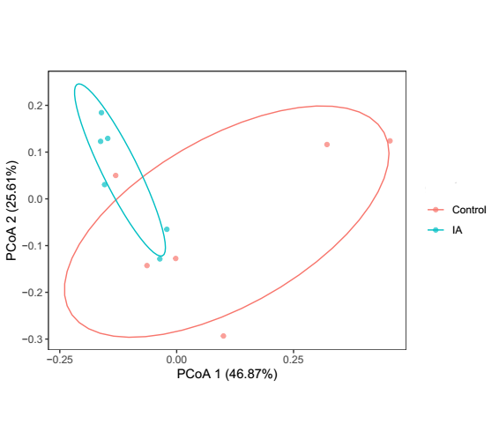Fig S1. Principal coordinates analysis (PCoA) of the microbial community in the cecal digesta of broilers at 42 days of age. Control: basal diet; IA group, basal diet supplemented with 6 g/kg itaconic acid.

