Graphical abstract
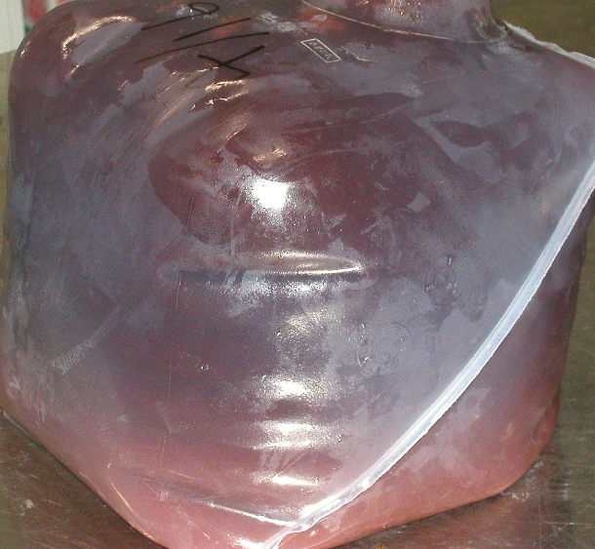
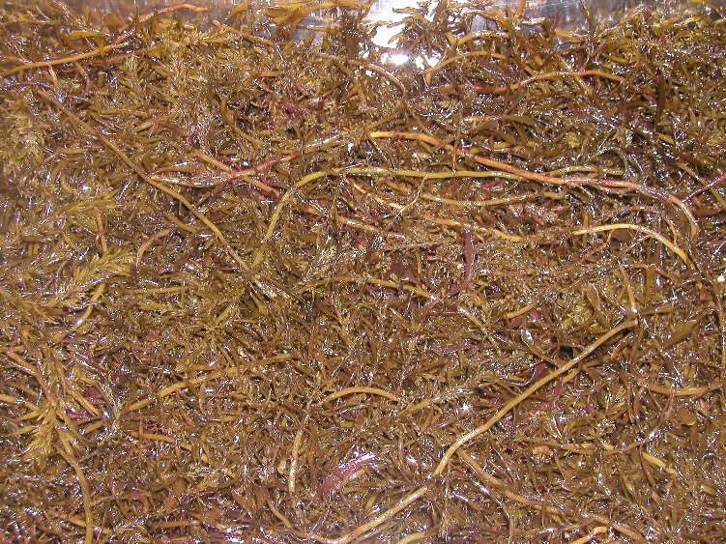
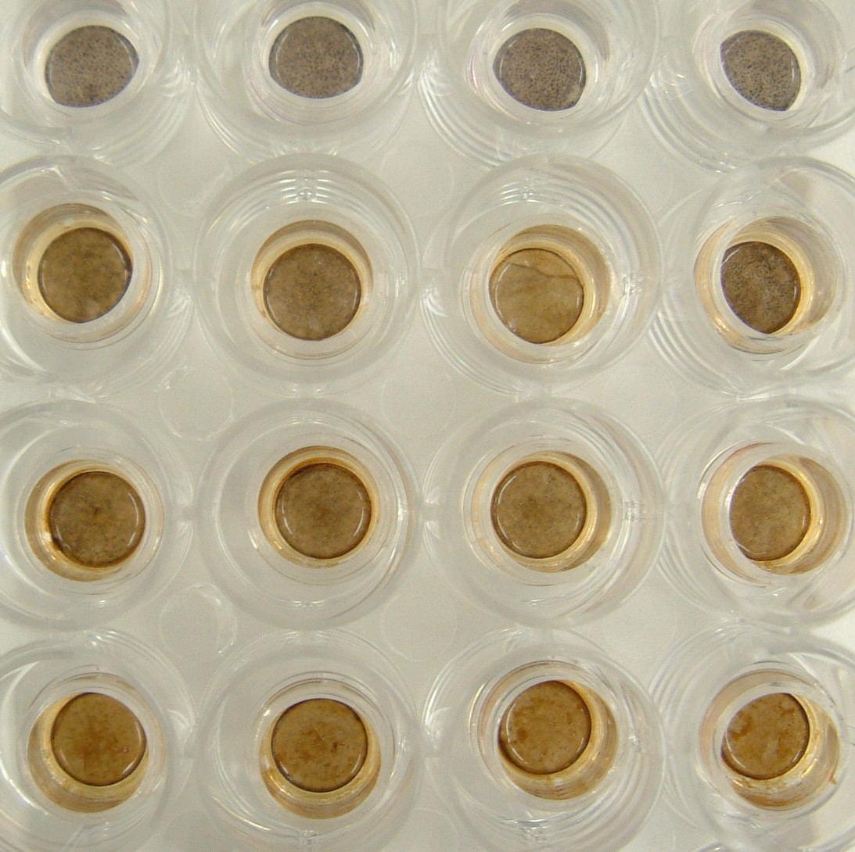
Control
Hijiki lipuor
MeOH fractionation 10mg/ml
Hijiki lipuor
MeOH fractionation 5mg/ml
Hijiki lipuor
MeOH fractionation 20mg/ml

