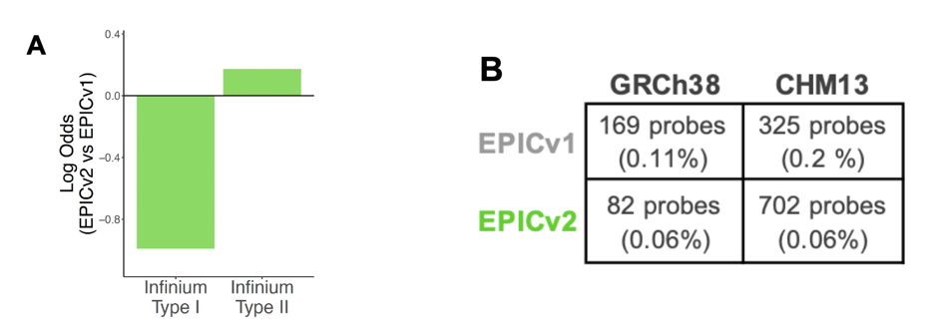
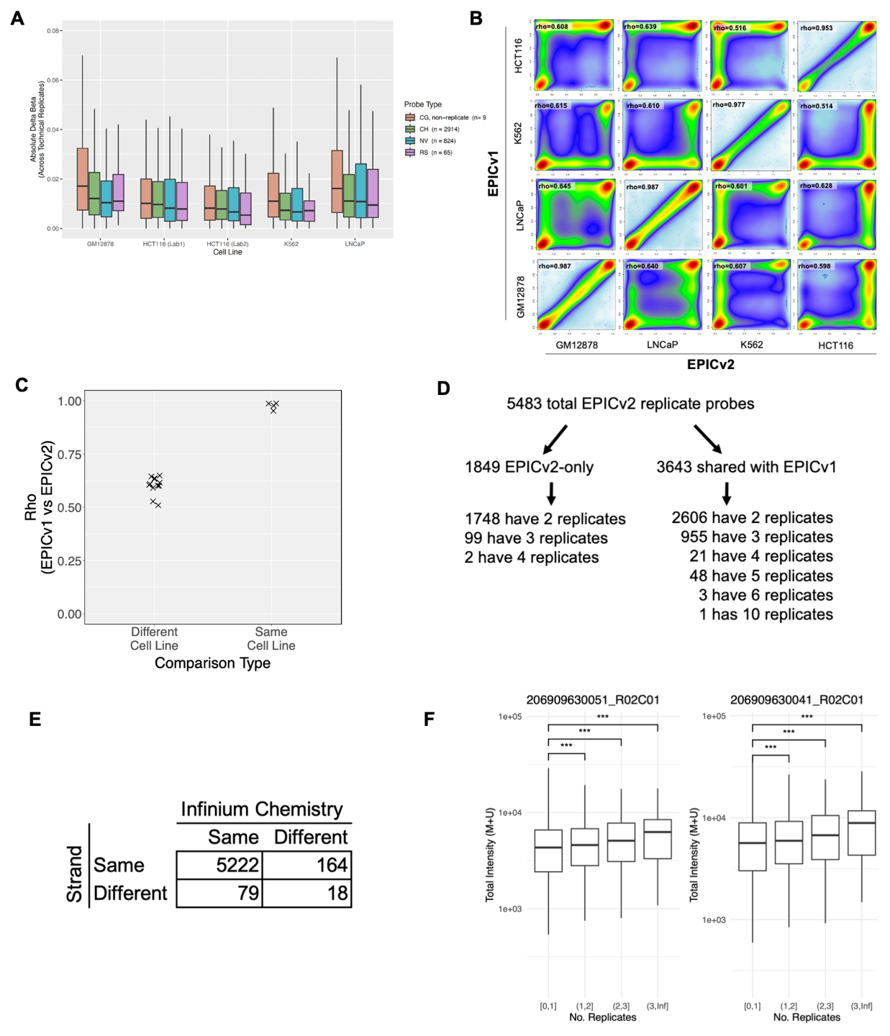
Supplemental Figure S1: (A) Log odds ratio comparison between probes exclusive to EPICv2 and EPICv1, classified by Infinium-I and Infinium-II chemistries. (B) Discrepancies in mapping Infinium Type I U and M probes against GRCh38 and CHM13 genome assemblies.
Supplemental Figure S2: (A) Absolute delta beta values between technical replicates stratified by probe types (fill color) and cell lines (x-axis). (B) Smooth scatter plot comparing EPICv1 and EPICv2 measurements between and within cell lines. (C) EPICv1-EPICv2 correlation on shared probes comparing within and across cell lines. (D) Grouping of EPICv2 replicate probes by the number of replicates and whether one of the replicates is shared in EPICv1. (E) A breakdown of replicate probes on whether they have the same strand and/or Infinium chemistry. (F) The total signal intensity per replicate compared to number of replicates, showing probes with higher number of replicates do not exhibit reduced total intensity under standard processing.

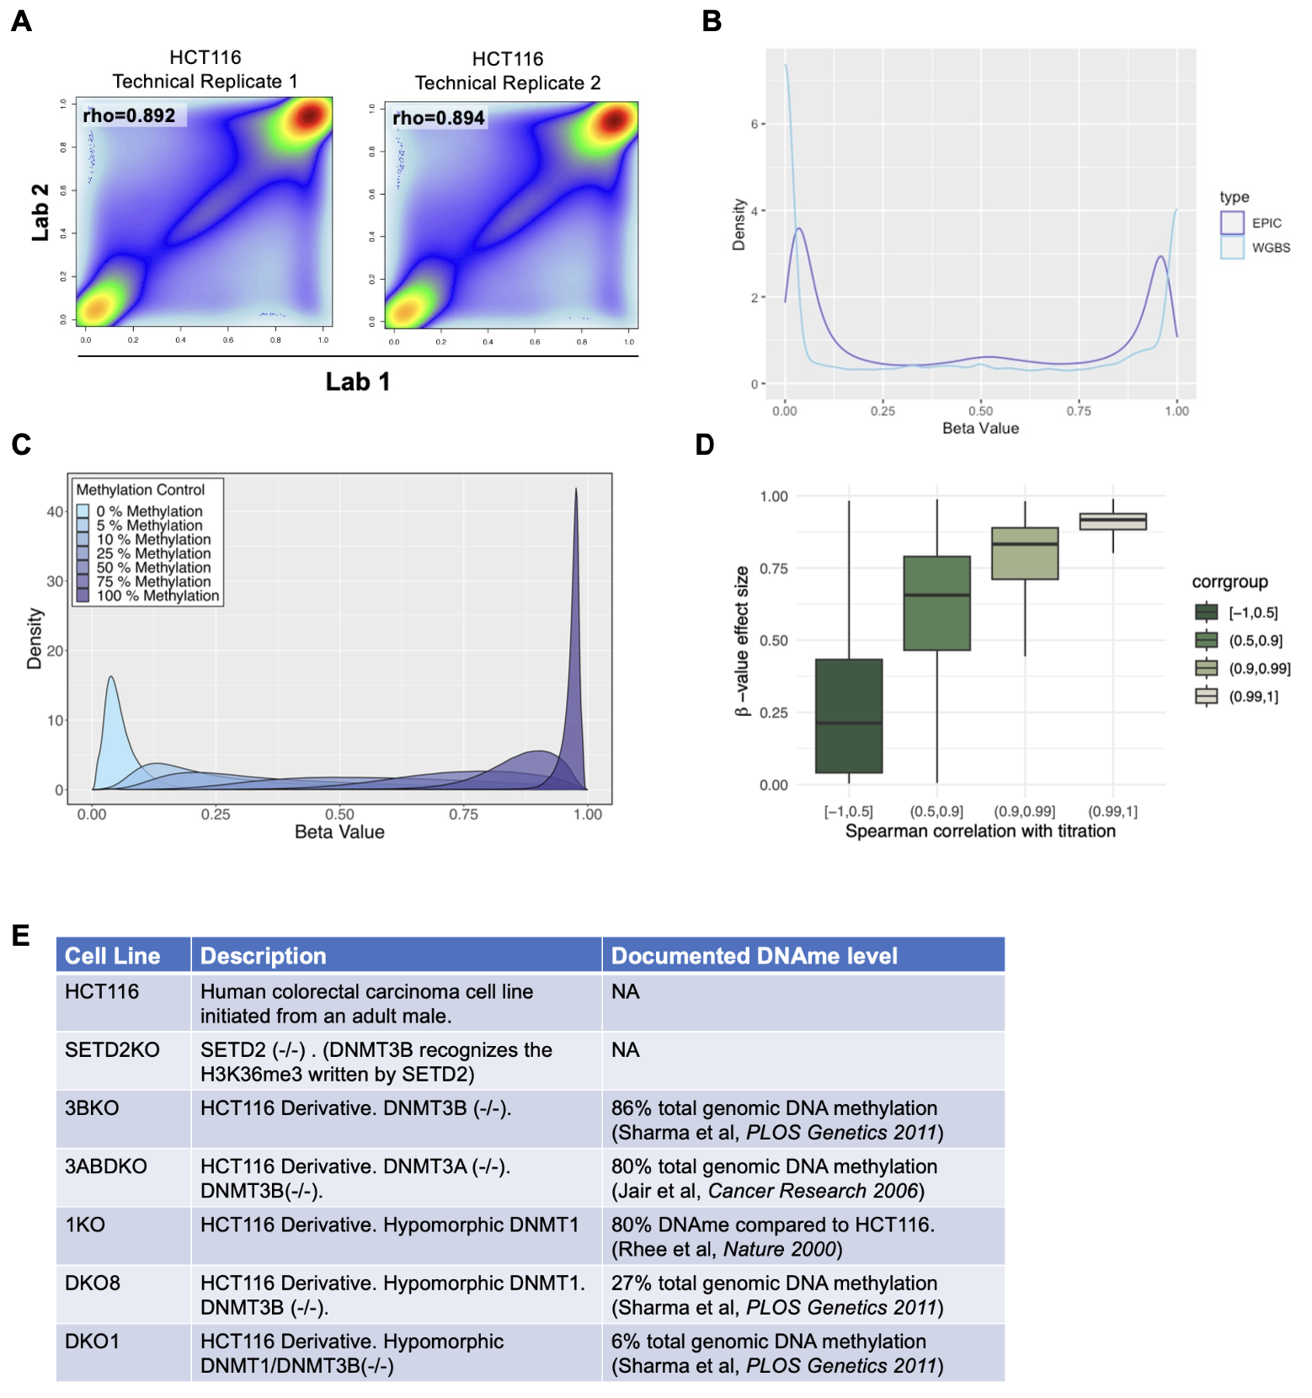

Supplemental Figure S3: (A) Correlation of HCT116 genomic DNA extracted and run by EPICv2 at two independent labs. The two HCT116 cells are cultured independently at the two locations. (B) beta value distribution comparing EPICv2 and WGBS. (C) DNA methylation beta value density plot of genomic DNA of titrated methylation levels. (D) Beta value effect size (maximum subtracted by the minimum) of probes with various levels of correlation on with DNA methylation titration. (E) HCT116 and derivative cell lines with DNMTs and/or SETD2 mutations.

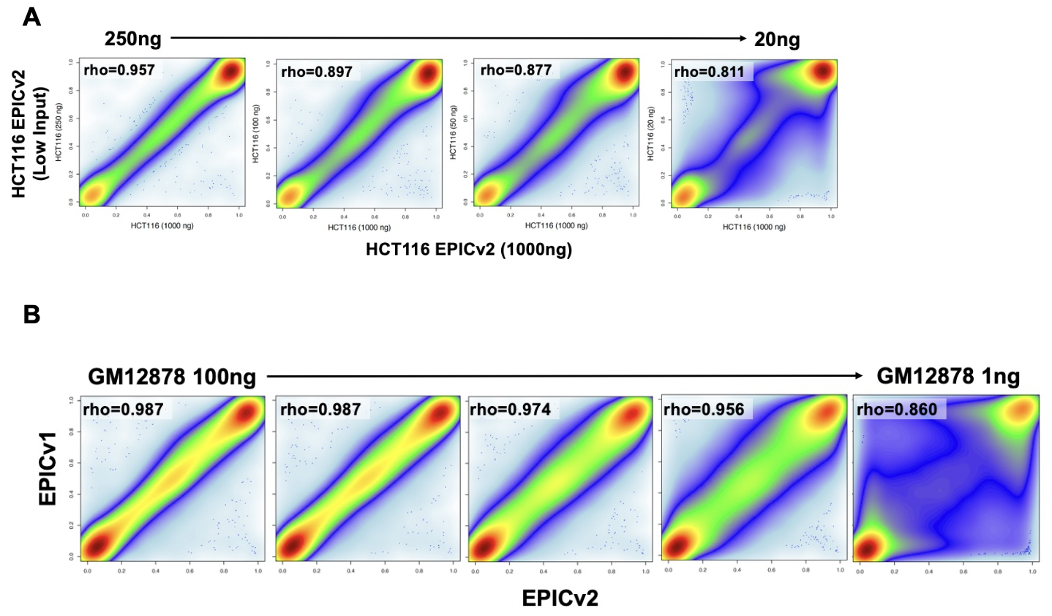 Supplemental Figure S4: (A) Correlation between EPICv2 data obtained from high and low input HCT116 DNA. (B) Correlation between EPICv2 data collected from high and low input GM12878 data and EPICv1 data from high input (250ng) DNA.
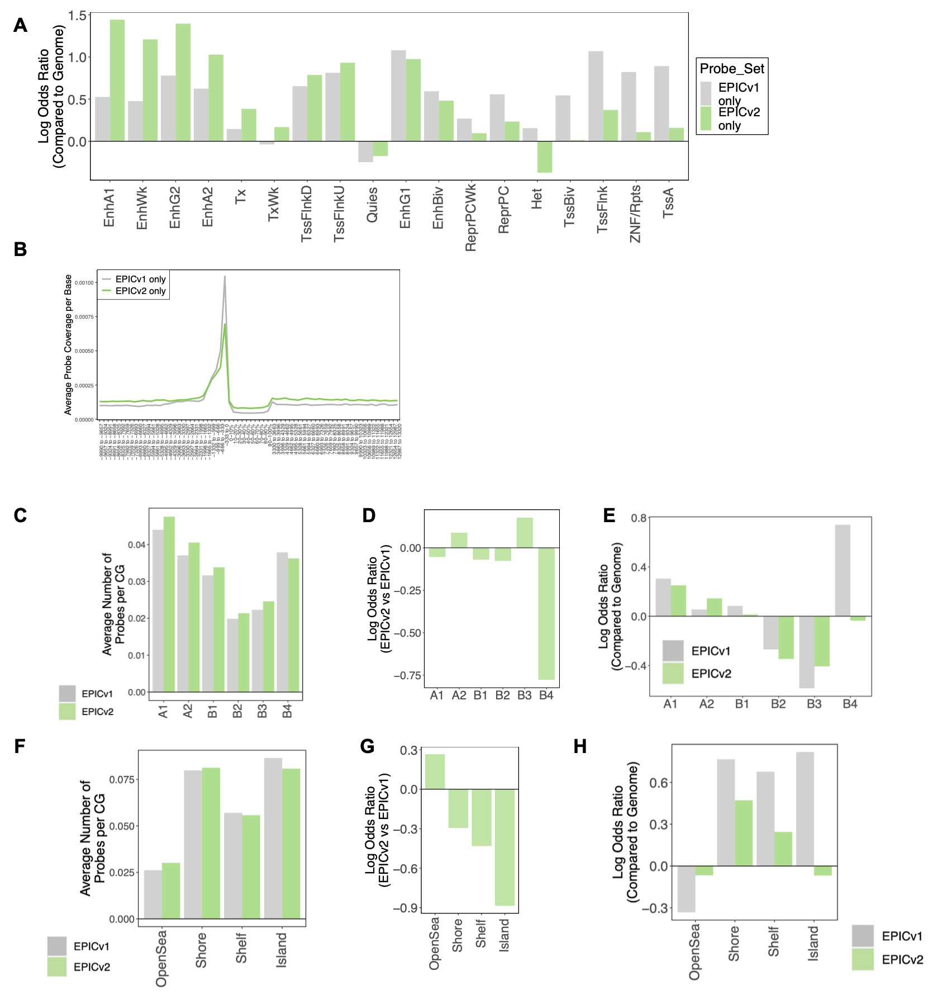

Supplemental Figure S5: (A) Log odds ratio comparison of EPICv1-only and EPICv2-only probes relative to the genome average across different ChromHMM chromatin states. (B) Meta gene plot for EPICv1-only and EPICv2-only probes. (C) CpG inclusion rates in EPICv1 and EPICv2 arrays across various chromatin A/B compartments. (D) Log odds ratio comparison between EPICv1 and EPICv2 probes in different chromatin A/B compartments. (E) Log odds ratio comparison of EPICv1 and EPICv2 relative to the genome average in different A/B compartments. (F) CpG inclusion rates in EPICv1 and EPICv2 arrays across diverse chromatin CpG island/short/shelf/open seas. (G) Log odds ratio comparison between EPICv1 and EPICv2 probes in various CpG island/short/shelf/open seas. (H) Log odds ratio comparison of EPICv1 and EPICv2 relative to the genome average in different CpG island/short/shelf/open seas.

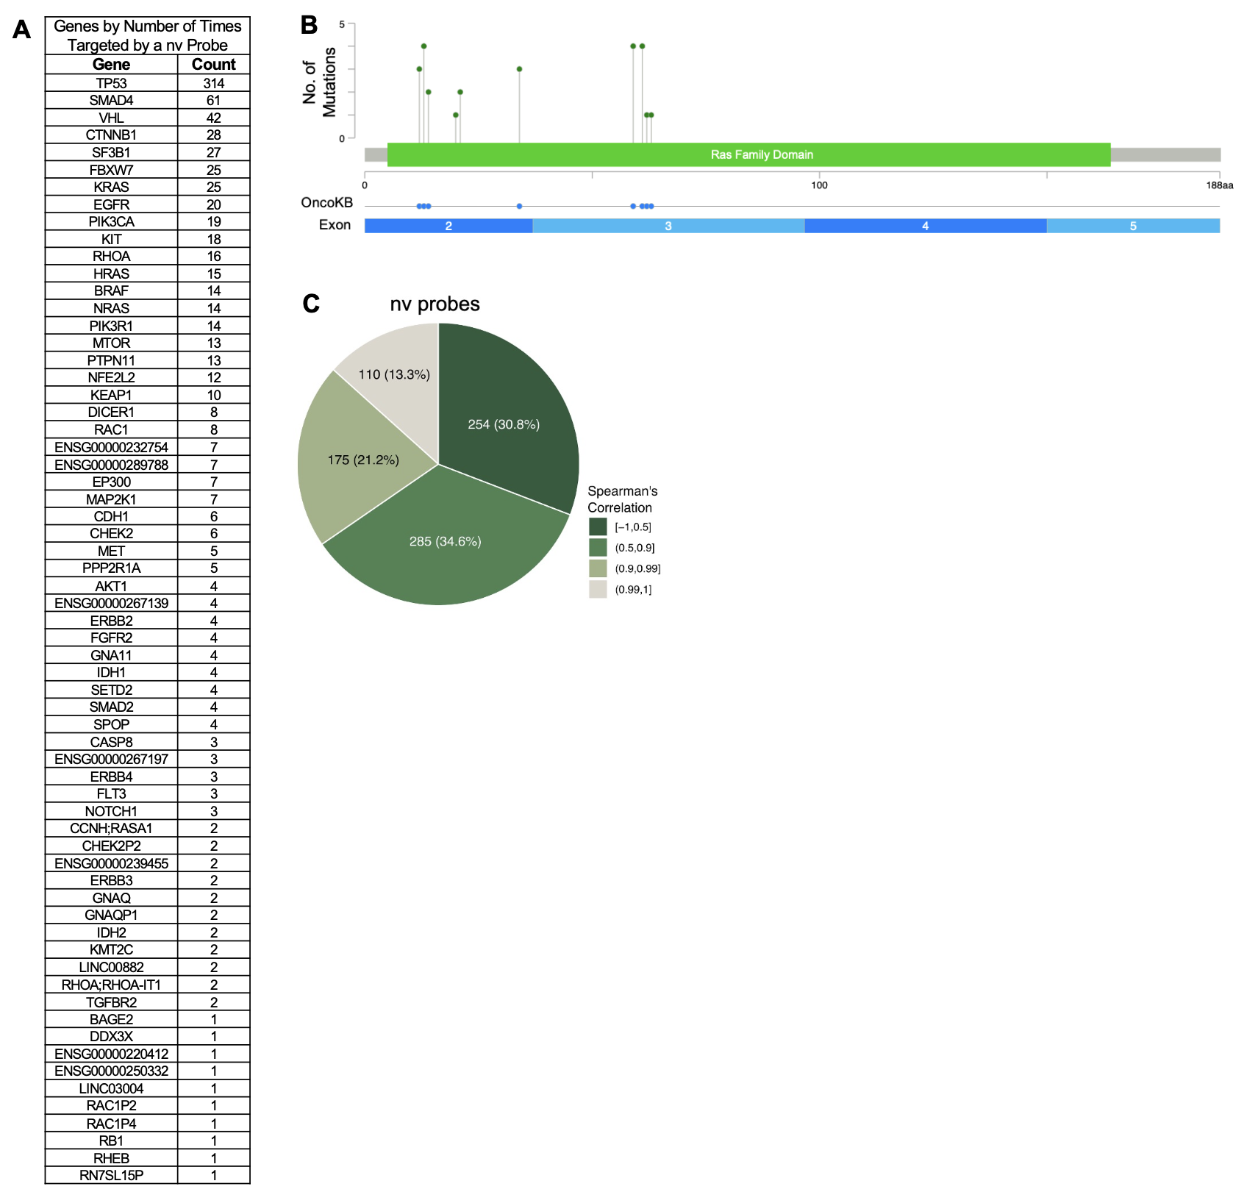

Supplemental Figure S6: (A) Table displaying genes and the number of nv probes targeting their mutations. (B) Location of KRAS mutations targeted by nv probes. (C) Classification of nv probes based on Spearman's correlation with titrated methylation levels.

