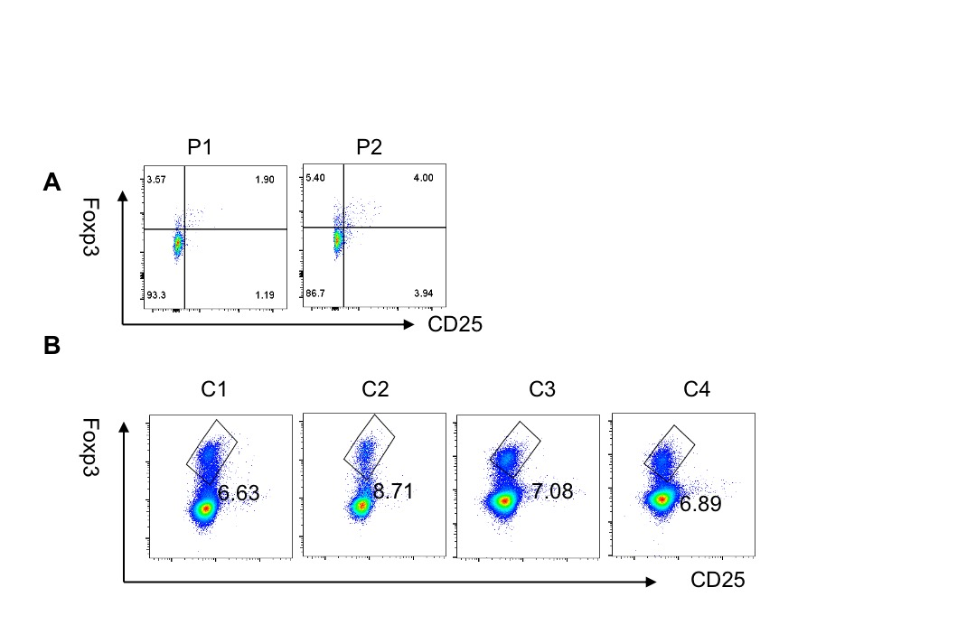
Supplementary Figure 1 Treg percentage of CD4+T cells in APDS2 patients and healthy controls.
- CD25+Foxp3+Treg percentage of CD4+T cells in P1 and P2 as measured by flow cytometry. B. CD25+Foxp3+Treg percentage of CD4+T cells in 4 healthy controls(C1, C2, C3, C4) as measured by flow cytometry.

Supplementary Figure 2 Schematic diagram of PI3K-pAKT-Mtor-Foxo1 pathway.

