SUPPLEMENTARY INFORMATION

Low Coverage of Long Graphene Nanoribbons by On-surface Double Layer Polymerization on Au(111)
Umamahesh Thupakula,^{1,*} We-Hyo Soe,^{1,†} Christian Joachim,^{1,2} and Erik Dujardin,^{1,3}
¹Centre d’Élaboration de Matériaux et d’Études Structurales (CEMES), Centre National de la Recherche Scientifique (CNRS), Université de Toulouse, 29 Rue J. Marvig, BP 94347, 31055 Toulouse Cedex, France.
²International Center for Materials Nanoarchitectonics (WPI-MANA), National Institute for Materials Science (NIMS), 1-1 Namiki, Tsukuba, Ibaraki 305-0044, Japan.
³Laboratoire Interdisciplinaire Carnot de Bourgogne, CNRS UMR 6303, Université de Bourgogne Franche-Comté, 9 Av. A. Savary, 21078 Dijon, France.

†Present Address: Center for Quantum Nanoscience, Institute for Basic Science (IBS), Seoul 03760, Korea
Ewha Womans University, Seoul 03760, Korea
* Corresponding author Email: umamahesh.thupakula@cemes.fr
umamahesh.thupakula@gmail.com

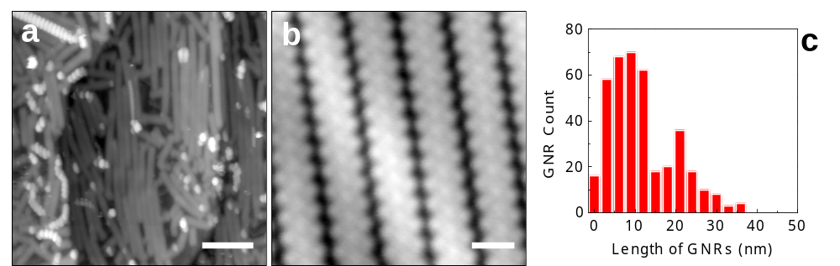

Fig. S1. Effect of higher initial DBBA coverage on the final GNR lengths. (a) Large-scale and (b) high-resolution STM topographs showing the close packed assembly of GNRs obtained after annealing the sample with more than 2 monolayers (MLs) of DBBA monomers on the Au(111) surface. (c) GNR length distribution histogram revealing the maximum length of GNRs is ~40 nm. STM set-parameters are –0.4 V/100 pA. Scale bars are 10 nm for (a) and 1 nm for (b).

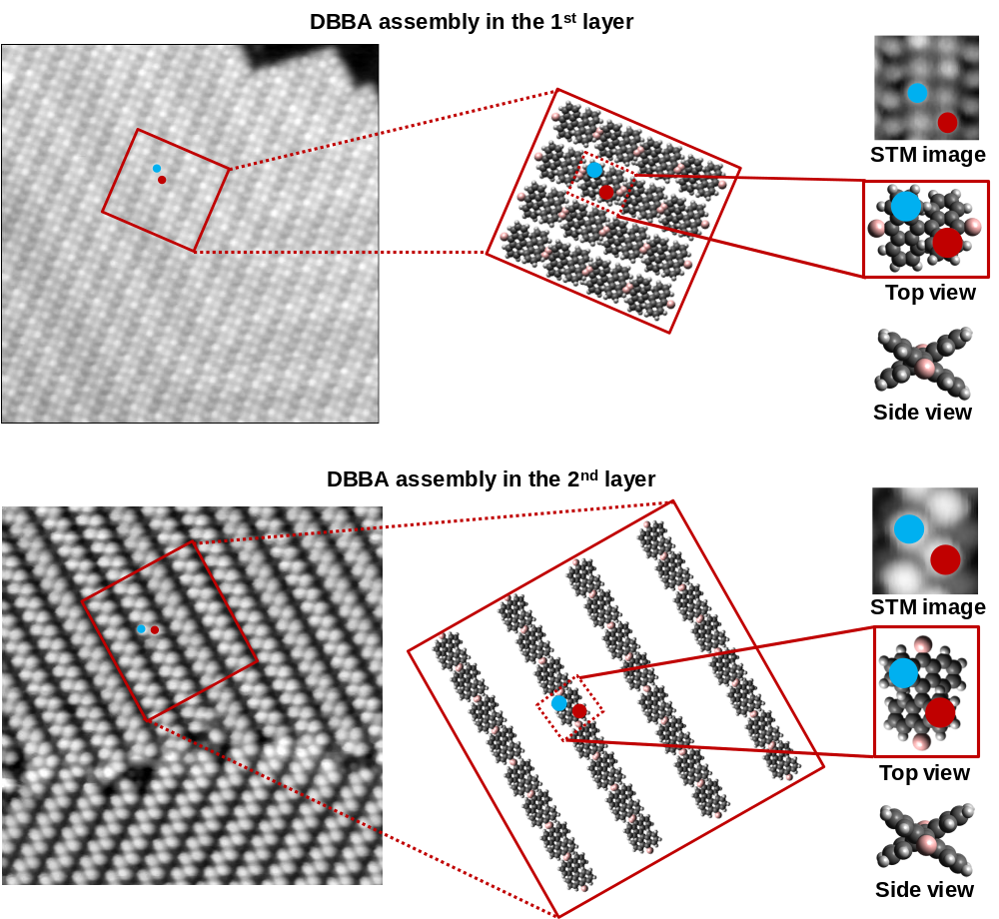

Fig. S2. Molecular model interpretation of the DBBA assembly on Au(111) surface. Top panel: Starting from the original LT-UHV STM image (left, from Fig. 2b of main text), the schematic molecular model reconstructing the interdigitated DBBA self-assembly in the 1st layer (middle) and single molecule representations (right). Bottom Panel: Similar molecular model reconstruction of the linear chain like self-assembly of DBBA in the 2nd layer on Au(111) surface, comparing the STM image (from Fig. 2c of main text) with single molecule model representations. Large scale STM images (left): 25 nm × 25 nm (scan parameters are +2 V/10 pA). High-resolution STM images (top right): 2 nm × 2 nm (scan parameters are +2 V/10 pA) The high conductance spots (blue and red dots) corresponding to the up tilted phenyls of DBBA. In the DBBA assembly of 2nd layer, only the 2nd layer side view is indicated.

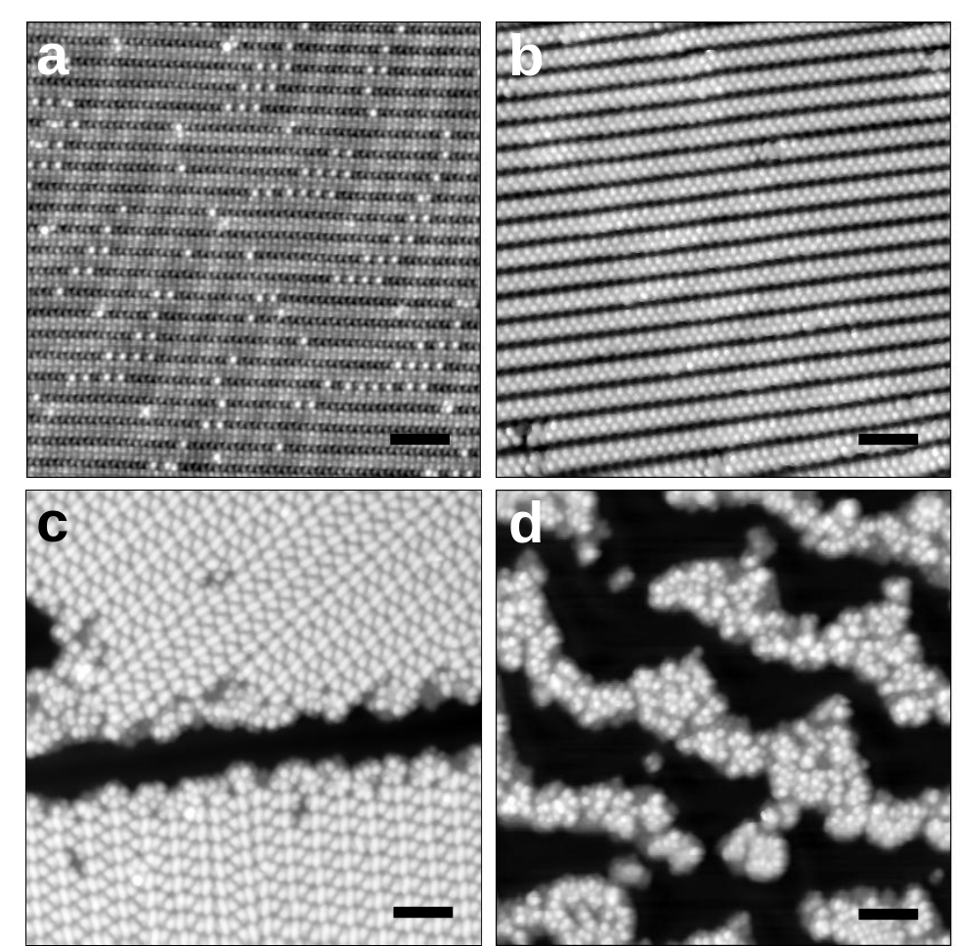

Fig. S3. Surface morphology after the 100 °C annealing step. STM topographs revealing DBBA assembly patterns in (a) ML and (b-d) BL regions after annealing the 1.5 ML DBBA/Au(111) sample surface at 100 °C for 30 minutes. ML regions show atomic-defect-like protrusions, which originate from the physical conformational changes of individual DBBA molecules within the assembly. BL regions presented in (c) and (d) show partial reorganization of DBBA assembly differing from the initial 1D chain like structure shown in (b). STM set-parameters are +2 V/10 pA. Scale bars are 5 nm.

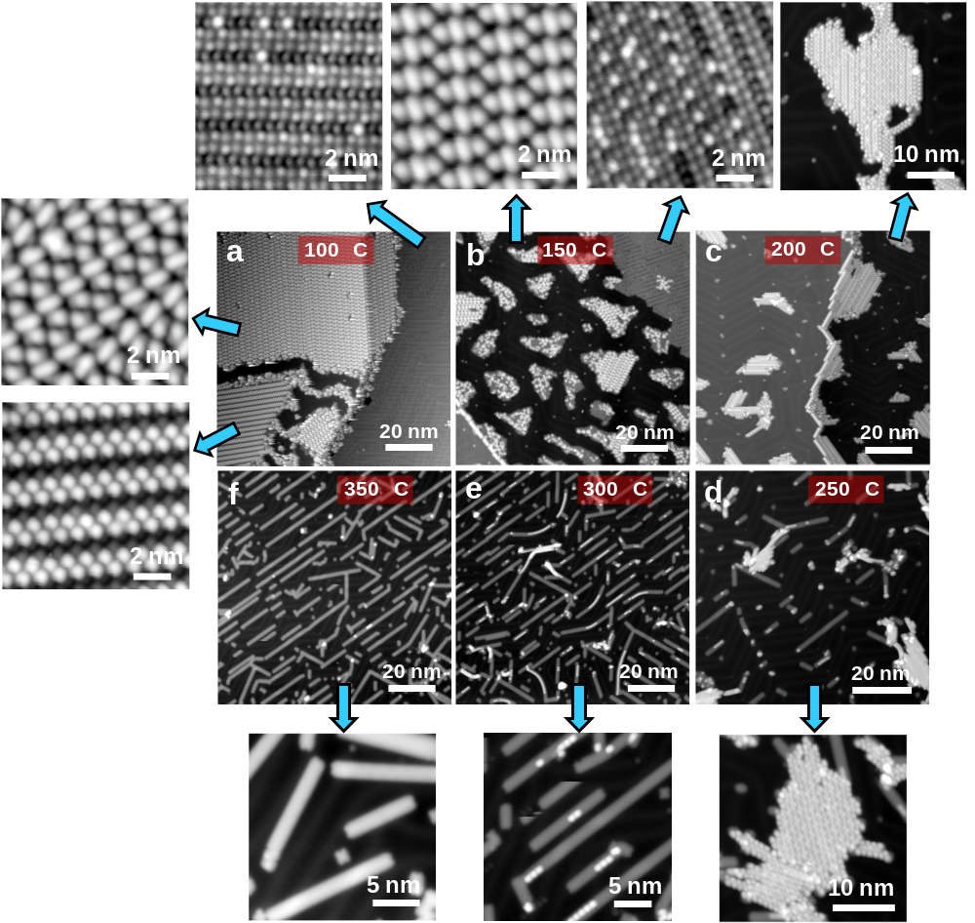

Fig. S4. High-resolution STM topographs capturing the on-surface chemical reaction in the step-by-step annealing experiments of 1.5 ML DBBA on the Au(111) surface at (a) 100 °C, (b) 150 °C, (c) 200 °C, (d) 250 °C, (e) 300 °C, and (f) 350 °C. Each STM image is the zoom-in of the corresponding large scale STM images presented in Fig. 3 of main text. The high-resolution panels surrounding the figure highlight the characteristic STM appearance of progressive intermediates of on-surface chemical reaction at their respective annealing temperature.

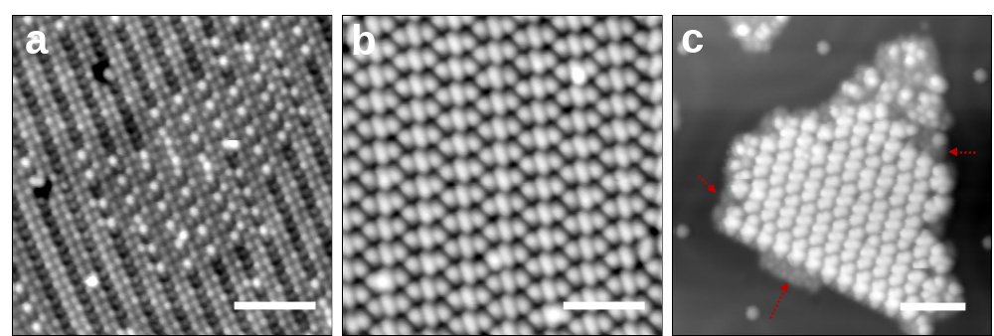
Fig. S5. Surface morphology after the 150 °C annealing step. (a) STM topograph showcasing the point-defect-like protrusions in the ML regions of DBBA on the Au(111) surface. (b) STM topograph showing a BL region revealing the fully reorganized 2nd layer of DBBA on the Au(111) surface. (c) STM topograph of a BL DBBA island showing the intact 1st layer (red arrows) below the reorganized 2nd layer. STM set-parameters are +1 V/10 pA for (a, c) and +2 V/10 pA for (b). Scale bars are 5 nm.

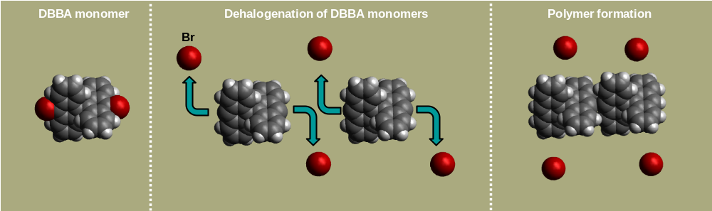
Fig. S6. Ullmann type coupling chemical reaction of DBBA monomers. Molecular model schematics showing the individual DBBA monomer unit (left), dehalogenation of monomers (middle) and polyanthryl oligomer formation (right). Carbon, bromine and hydrogen are indicated with gray, red and white balls, respectively.

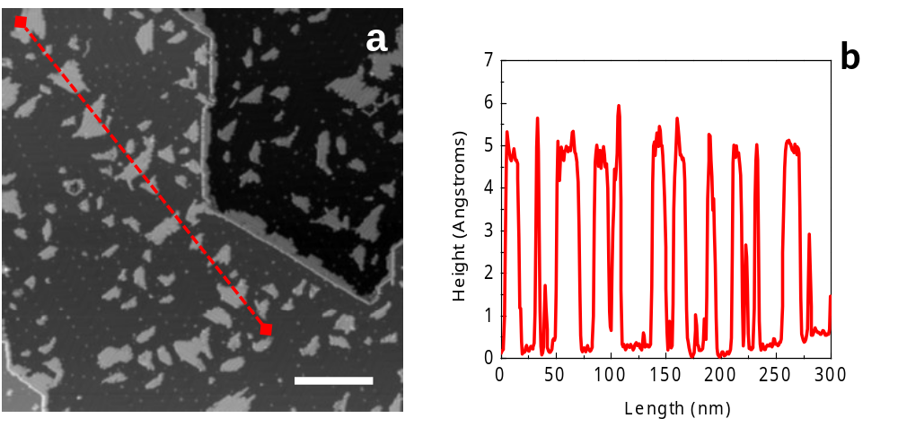

Fig. S7. Surface morphology after the 200 °C annealing step. (a) Large-scale STM topograph and (b) height profile along the dashed line in (a) showing the uniform thickness of oligomer nano-islands on the Au(111) surface. STM set-parameters are +2 V/10 pA. Scale bar is 60 nm.
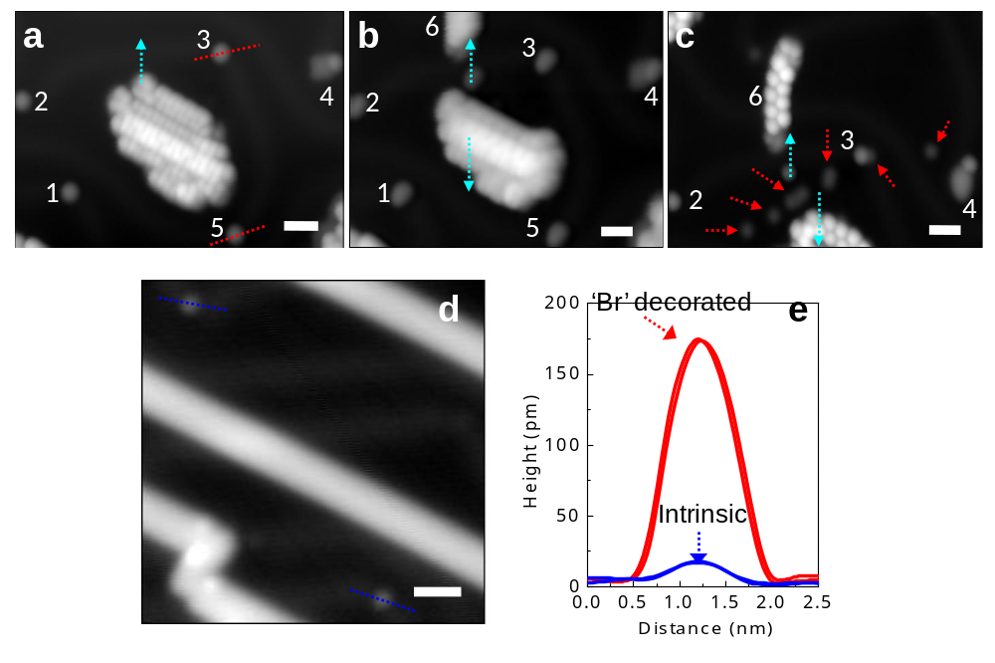

Fig. S8. (a-c) STM topographs showing the manipulation sequence and underlying atomic features below the manipulated polymer island. Markers 1 to 6 are indicated in the STM images (a-c) to facilitate the visualization of the molecule displacements. Cyan arrows indicate the polymer island manipulation direction. Red arrows indicate the atomic features appearing after the manipulation process. We attribute these atomic features to the bromine released from the monomers at the onset of Ullmann coupling reaction. (d) STM topograph showing the typical herringbone Au(111) kink defects after the 350 °C annealing step. (e) Height profiles across the kink defects after the 200 °C (red corresponding to the dotted lines in (a)) and 350 °C (blue corresponding to the dotted lines in (d)) annealing steps. The apparent enlargement of defect sizes after the 200 °C annealing step (red) is clearly identified and can be attributed to the bromine decoration. STM set-parameters are –2 V/10 pA for (a, b and d) and +2 V/10 pA for (c). Scale bars are 2 nm.

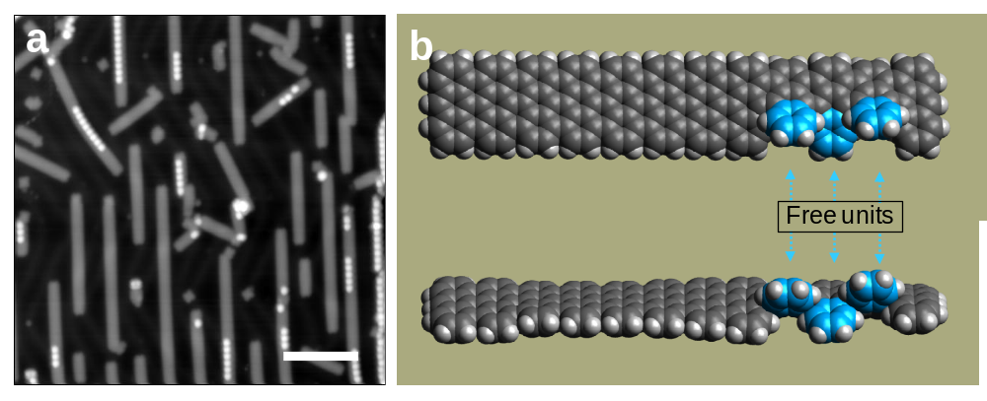
Fig. S9. Surface morphology after the 300 °C annealing step. (a) STM topograph showcasing the partially transformed GNRs with un-reacted benzene rings on one side of the ribbon. STM set-parameters are –2 V /10 pA. Scale bar is 5 nm. (b) Molecular model schematic showing the planar (top) and the side (bottom) views of a partially transformed GNR. Un-reacted benzene rings are indicated in blue color.

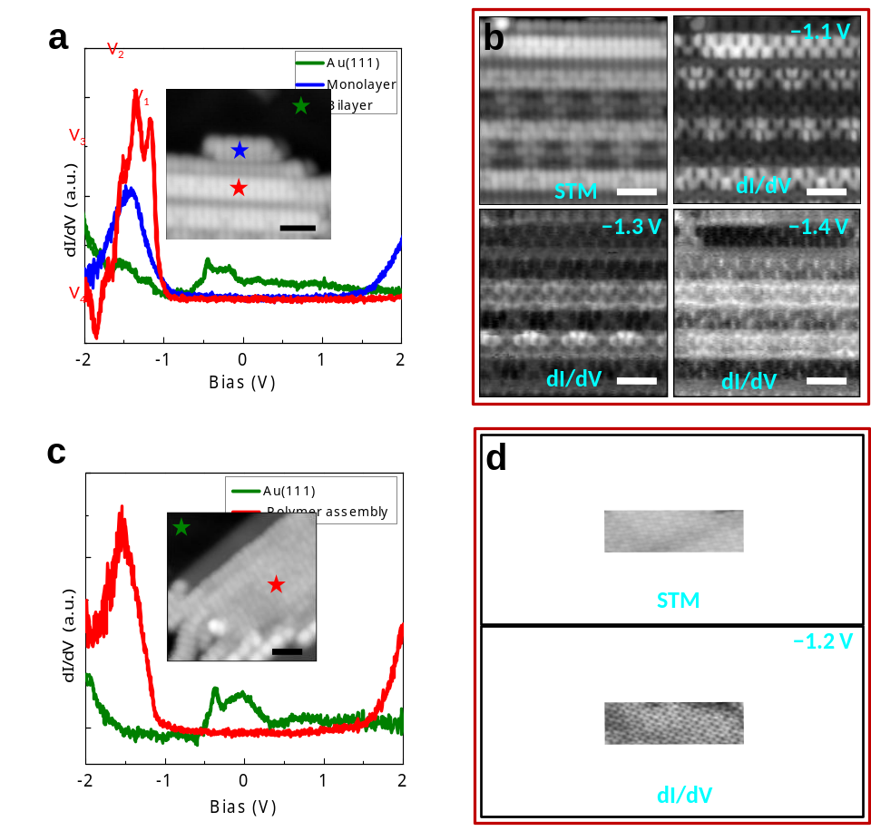

Fig. S10. Scanning tunneling spectroscopy of a polyanthyl oligomer island. (a) dI/dV spectra recorded on top of the 1st layer (blue line) and the 2nd layer (red line) oligomer chains of an island observed after the 200 °C annealing step. The reference dI/dV spectrum recorded on the bare Au(111) surface region is presented with a dark green line. Corresponding STS positions are marked with respective colored stars in the STM topograph presented in the inset. The vibronic satellite tunneling resonances (V₁, V₂, V₃, and V₄) from the 2nd layer oligomer chain are labeled in the dI/dV plot. (b) dI/dV maps recorded at three different voltages (−1.1 V, −1.3 V and −1.4 V) suggest the vibronic origin of the satellite peaks. (c) dI/dV spectrum (red) and (d) map recorded from a polyanthyl oligomer island after the 250 °C annealing step. The reference dI/dV spectrum in green is identical to the green plot in (a). No vibronic satellite peaks from oligomer chains are observed but the spectrum is identical to the blue plot in (a), implying that the oligomer island has converted to a single layer configuration. STM set-parameters are –2 V/10 pA for the STM images given in the insets of (a) and (c), –1.1 V/100 pA for (b) and –1.2 V/100 pA for (d). Scale bars are 2 nm.
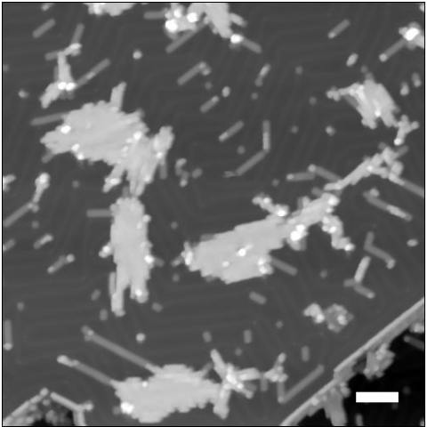

Fig. S11. Surface morphology after the 250 °C annealing step. STM topograph showing the cyclodehydrogenation process occurring for the oligomer chains located at the periphery of the island. The transformed part of the GNR can be found away from the island. STM scanning set-parameters are –2 V/10 pA. Scale bar is 10 nm.

