Supplementary information (SI)
An on-demand bioresorbable neurostimulator

Dong-Min Lee^{1,9}, Minki Kang^{1,9}, Inah Hyun^{2,3,9}, Byung Joon Park¹, Hye Jin Kim⁴, Soo Hyun Nam⁵, Hong-Joon Yoon⁶, Hanjun Ryu⁷, Byung-Ok Choi^{4,5,8}*, Sang-Woo Kim^{2,3}*

¹School of Advanced Materials Science and Engineering, Sungkyunkwan University (SKKU), Suwon 16419, Republic of Korea
²Department of Materials Science and Engineering, Yonsei University, Seoul 03722, Republic of Korea
³Center for Human-oriented Triboelectric Energy Harvesting, Yonsei University, Seoul 03722, Republic of Korea
⁴Department of Neurology, Samsung Medical Center, Sungkyunkwan University School of Medicine, Seoul 06351, Republic of Korea
⁵Cell and Gene Therapy Institute (CGTI), Samsung Medical Center, Seoul 06351, Republic of Korea
⁶Department of Electronic Engineering, Gachon University, Seongnam 13120, Republic of Korea
⁷Department of Advanced Materials Engineering, Chung-Ang University, Anseong 17546, Republic of Korea
⁸Samsung Advanced Institute for Health Sciences & Technology (SAIHST), Seoul 06351, Republic of Korea
⁹These authors contributed equally: Dong-Min Lee, Minki Kang, Inah Hyun

*e-mail: bochoi@skku.edu; kimsw1@yonsei.ac.kr
Contents

Supplementary Fig. 1│Fabrication process of the on-demand bioresorbable neurostimulator.
Supplementary Fig. 2│Images of the PHBV/PEG:ChCl membranes with different ChCl composition.
Supplementary Fig. 3│Surface potential characterization of the PHBV/PEG:ChCl membranes.
Supplementary Fig. 4│Underlying mechanism of attaining high surface potential along the ChCl addition.
Supplementary Fig. 5│ Material characterization of the PHBV/PEG:ChCl membranes.
Supplementary Fig. 6│ Electrical characterization of the PHBV/PEG:ChCl membranes.
Supplementary Fig. 7│ Acoustic transmission properties of a bare PHBV and a PHBV/PEG:ChCl membrane (thickness: 50 μm).
Supplementary Fig. 8│Step-by-step mechanism of ultrasound-driven triboelectric energy generation.
Supplementary Fig. 9│Simulated acoustic pressure field and displacement level of the triboelectric layer.
Supplementary Fig. 10│In vitro experimental setup to measure ultrasound-driven triboelectric output performances of the ACT−TENG.
Supplementary Fig. 11│Electrical characteristics of the ACT−TENG measured through the in vitro experimental setup.
Supplementary Fig. 12│Field emission scanning electron microscope (FE-SEM) images of the PHBV/PEG:ChCl membranes.
Supplementary Fig. 13│Underlying mechanism of the ultrasound-mediated transient process.
Supplementary Fig. 14│Hydrolytic processes of PHBV and PEG.
Supplementary Fig. 15│HIU-triggered transient performances of the PHBV and PHBV/PEG:ChCl membranes (20 mm width, 10 mm length, 50 μm thickness).
Supplementary Fig. 16│Transient performances of PHBV and PHBV/PEG:ChCl without HIU-triggering events.
Supplementary Fig. 17│Micro-CT images captured at the top and side views.
Supplementary Fig. 18│Surgical procedure to implant the neurostimulator.
Supplementary Fig. 19│Magnified view of the sciatic nerve.
Supplementary Fig. 20│Experimental setup for the in vivo demonstration of peripheral nerve electrotherapy.
Supplementary Fig. 21│Experimental setup for in vitro demonstration of the iPSC-driven motor neuron growth upon electrical impulses.
Supplementary Fig. 22│Axon length plots after 72 h of culturing time upon different electric field intensities.
Supplementary Fig. 23│Optical microscopic images of iPSC-driven motor neuron.
Supplementary Fig. 24│Detailed procedure for preparing C22 mouse model.
Supplementary Fig. 25│In vivo electrical characterization of the ACT−TENG.
Supplementary Fig. 26│NCS results to evaluate the biosafety of the HIU to the sciatic nerve.
Supplementary Fig. 27│Characterization of pH change upon the HIU treatment.
Supplementary Fig. 28│Behavior analysis of the device-implanted mouse.
Supplementary Fig. 29│Characterization of degradation time at different ultrasound intensities.

Supplementary Note
Supplementary Note 1│Fundamental background of the localization of acoustic pressure inside the PHBV encapsulation layer

References

Supplementary Video
Supplementary Video 1 (separate file)│In vitro ultrasound-driven triboelectric output performance.
Supplementary Video 2 (separate file)│In vitro HIU-triggered on-demand transient process.
Supplementary Video 3 (separate file)│In vivo ultrasound-driven triboelectric output performance.
Supplementary Video 4 (separate file)│In vivo ultrasound-driven triboelectric output performance at different implant locations.
Supplementary Video 5 (separate file)│ Footprint analysis to verify the biosafety of device implantation.
Supplementary Video 6 (separate file)│ Nerve conduction study (NCS) experiments: Methods.
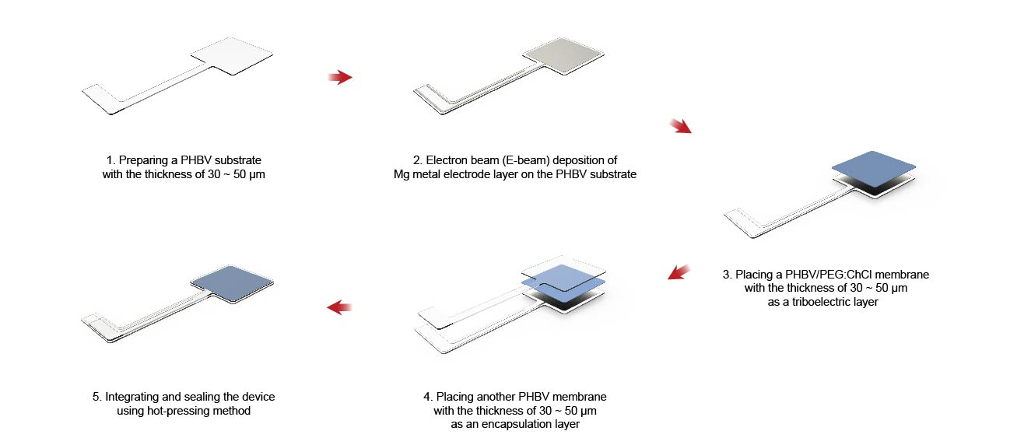

Supplementary Fig. 1│Fabrication process of the on-demand bioresorbable neurostimulator. Schematic displaying the fabrication process of the on-demand bioresorbable neurostimulator. The thickness of the Mg electrode layer is 100 nm.

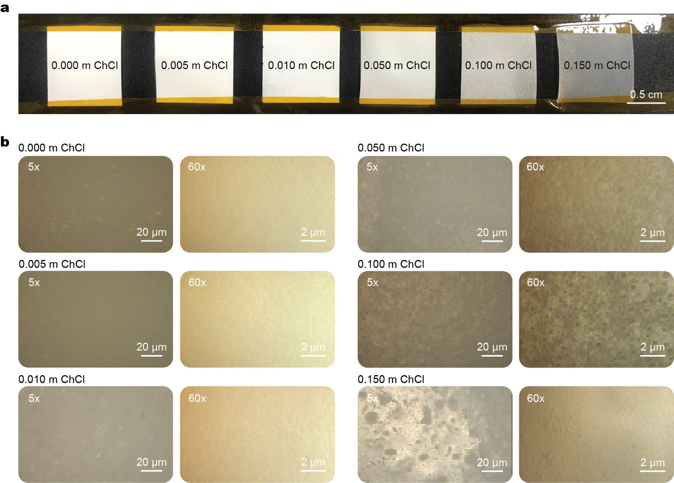
Supplementary Fig. 2│Images of the PHBV/PEG:ChCl membranes with different ChCl composition. a, Real image of the PHBV/PEG:ChCl membranes. b, Optical microscopic images of the PHBV/PEG:ChCl membranes. The membranes with high ChCl concentration (≥ 0.100 m) exhibit high porosity that results in mechanical instability.
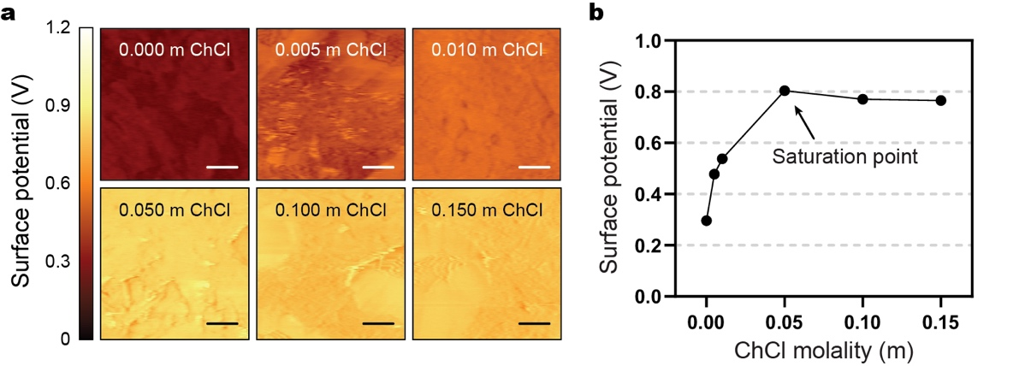
Supplementary Fig. 3│Surface potential characterization of the PHBV/PEG:ChCl membranes. a, Kelvin probe force microscopy (KPFM) imagery displaying the surface potential for each PHBV/PEG:ChCl membrane. The scale bars represent 1 μm. b, The summation plot for the measured surface potential. The surface potential level reached the highest value at 0.05 m of ChCl concentration, and remained saturated at the higher ChCl molality.

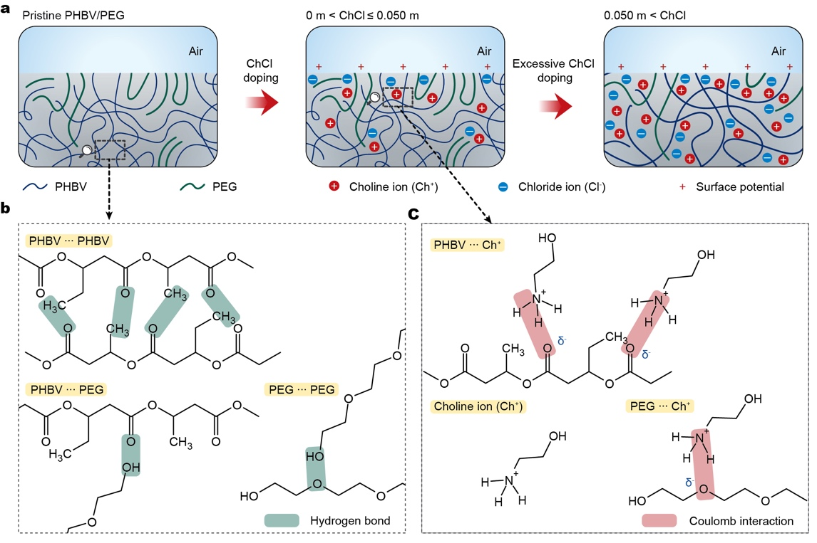
Supplementary Fig. 4│Underlying mechanism of attaining high surface potential along the ChCl addition. a, Schematic describing the change in the chain network of PHBV/PEG:ChCl along the ChCl addition. When ChCl ions are introduced, Ch⁺ ions make intermolecular interactions with PHBV/PEG networks. Meanwhile, the mobile Cl⁻ ions are attracted to the surface to compensate the tribo-positive nature of the air¹. Due to the presence of Cl⁻ ions at the surface, the PHBV/PEG/ChCl membrane exhibits improved surface potential. However, the excessive content of ChCl (more than 0.050 m) causes mechanical instability by mitigating the interactions between polymer chains. b, Intermolecular interactions between the polymer chains. c, Coulombic interactions between Ch⁺ ions and polymer chains.

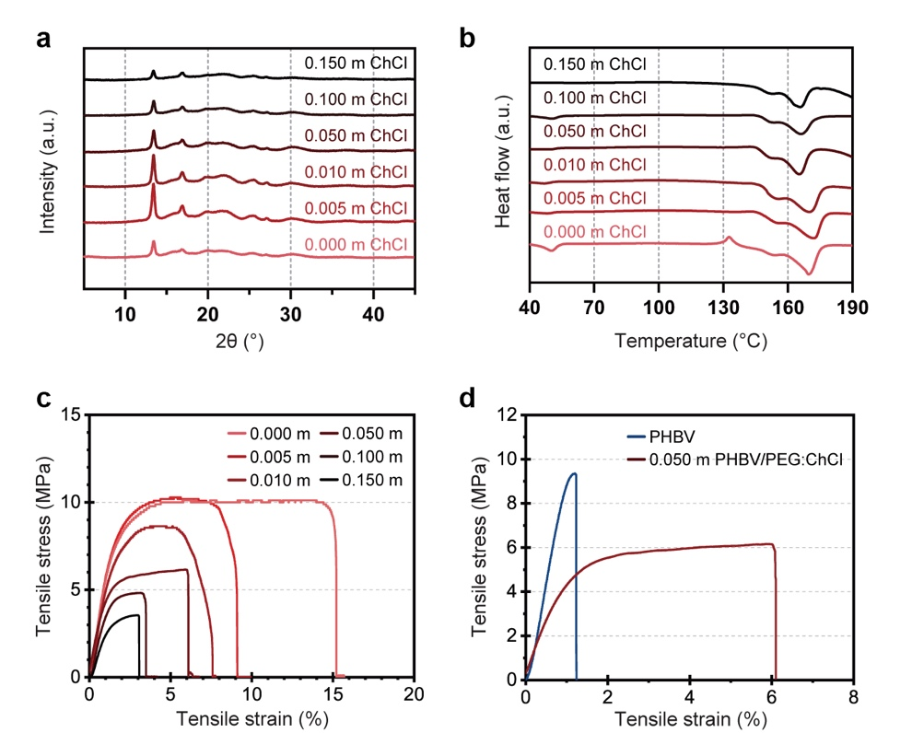
Supplementary Fig. 5│ Material characterization of the PHBV/PEG:ChCl membranes. a, X-ray diffraction (XRD) patterns of the PHBV/PEG:ChCl membranes with different ChCl concentration. b, Differential scanning calorimetry (DSC) patterns of the PHBV/PEG:ChCl membranes. The membranes with high ChCl concentration have lower crystallinity, implying their mechanical instability. c, Stress–strain curves of the membranes, showing that the highly ChCl-doped composites are prone to plastic deformation with low resilience. d, Comparison of mechanical characteristics between the bare PHBV and the optimized composite material.

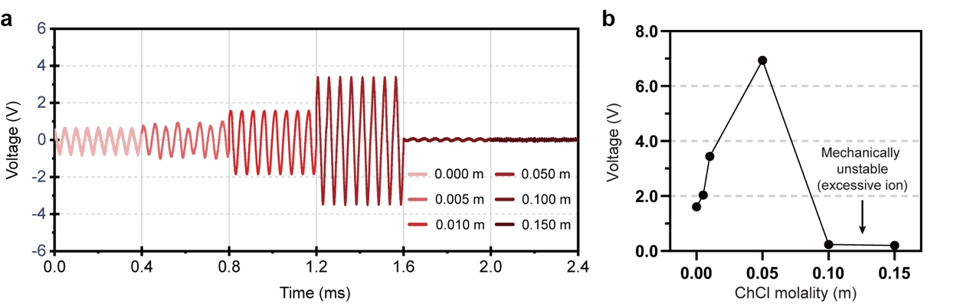
Supplementary Fig. 6│Electrical characterization of the PHBV/PEG:ChCl membranes. a, Measured triboelectric voltage at 40 megohm impedance by the ACT−TENG submerged into the water with 5 mm probe distance. b, The summation plots of the triboelectric voltage output values. The ACT−TENGs with high ChCl concentration barely generate electrical output, due to the mechanical instability of the triboelectric layer.

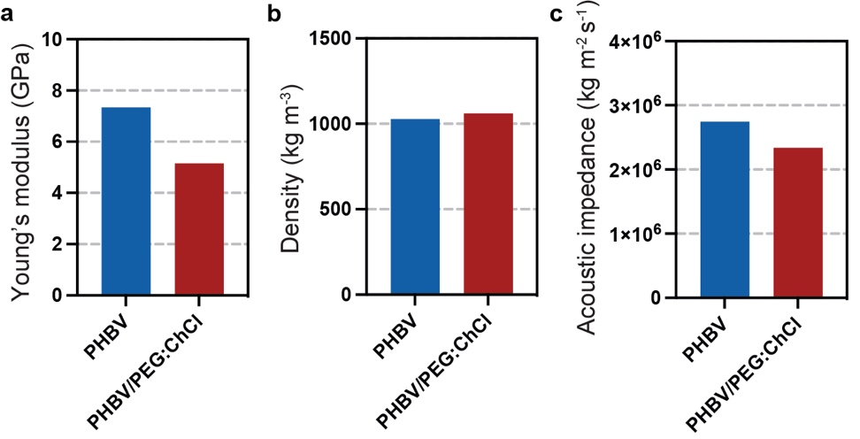
Supplementary Fig. 7│Acoustic transmission properties of a bare PHBV and a PHBV/PEG:ChCl membrane (thickness: 50 μm). a, Young’s modulus value for each membrane. The values were obtained by the stress–strain curve shown in Supplementary figure 5. b, Measured density values using a specific gravity scale. c, Calculated values of acoustic impedance derived from the Young’s modulus and density.

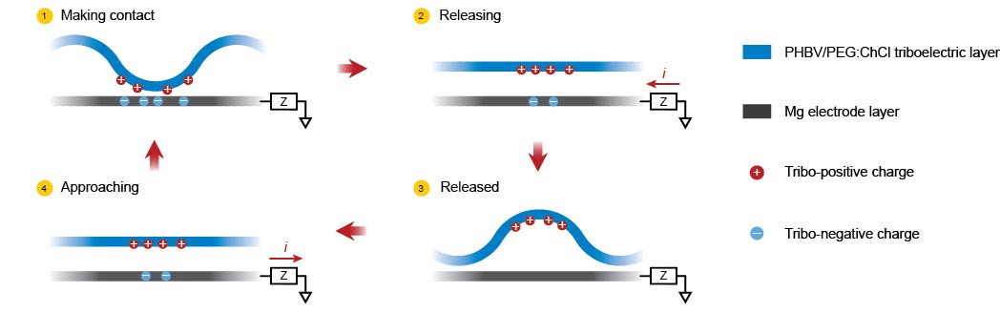
Supplementary Fig. 8│Step-by-step mechanism of ultrasound-driven triboelectric energy generation. The ACT−TENG generates electrical potential based on the high frequency vibration of the PHBV/PEG:ChCl triboelectric layer.
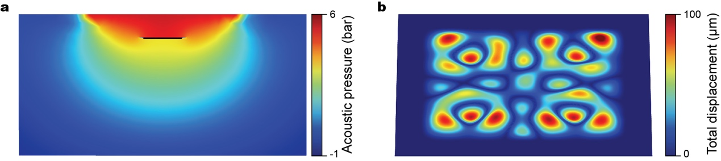

Supplementary Fig. 9│Simulated acoustic pressure field and displacement level of the triboelectric layer. a, Simulated acoustic pressure field upon applying a low-intensity ultrasound (20 kHz, 0.5 W cm⁻²), confirming that the incident ultrasound was reflected by the 100 nm thick Mg electrode layer of the ACT−TENG. The diameter of the ultrasound probe is 3 cm. b, Simulated displacement level of the PHBV/PEG:ChCl triboelectric layer (0.8 cm width, 0.8 cm length, 50 μm thickness) on the ACT−TENG.

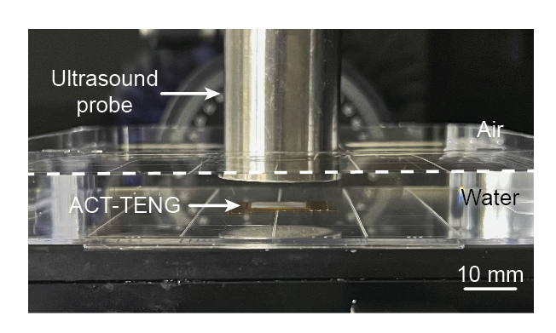
Supplementary Fig. 10│In vitro experimental setup to measure ultrasound-driven triboelectric output performances of the ACT−TENG. The ACT−TENG was submerged into the deionized water with 5 mm probe distance.

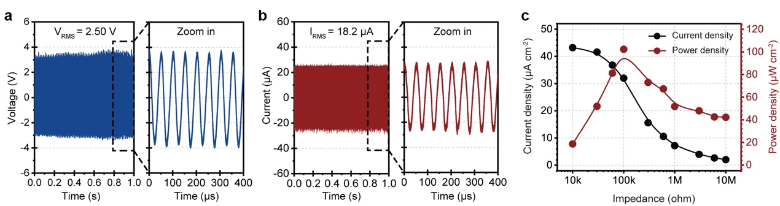
Supplementary Fig. 11│ Electrical characteristics of the ACT−TENG measured through the in vitro experimental setup. a, Triboelectric voltage at 40 megohm impedance, and b, current at 1 ohm impedance measured by the ACT−TENG. c, Measured power and current density along the electrical impedance variation. The units of “k” and “M” refer to “kilo-” and “mega-”, respectively.

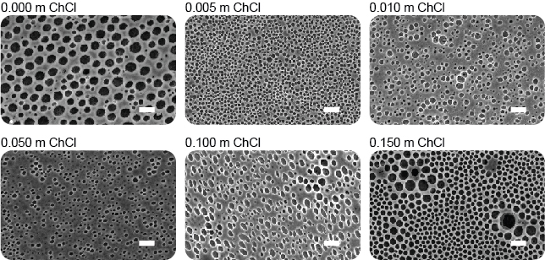
Supplementary Fig. 12│ Field emission scanning electron microscope (FE-SEM) images of the PHBV/PEG:ChCl membranes. The FE-SEM images support that the membranes exhibit highly porous microstructure, allowing for the localization of acoustic pressure inside their structure. The scale bars represent 20 μm.

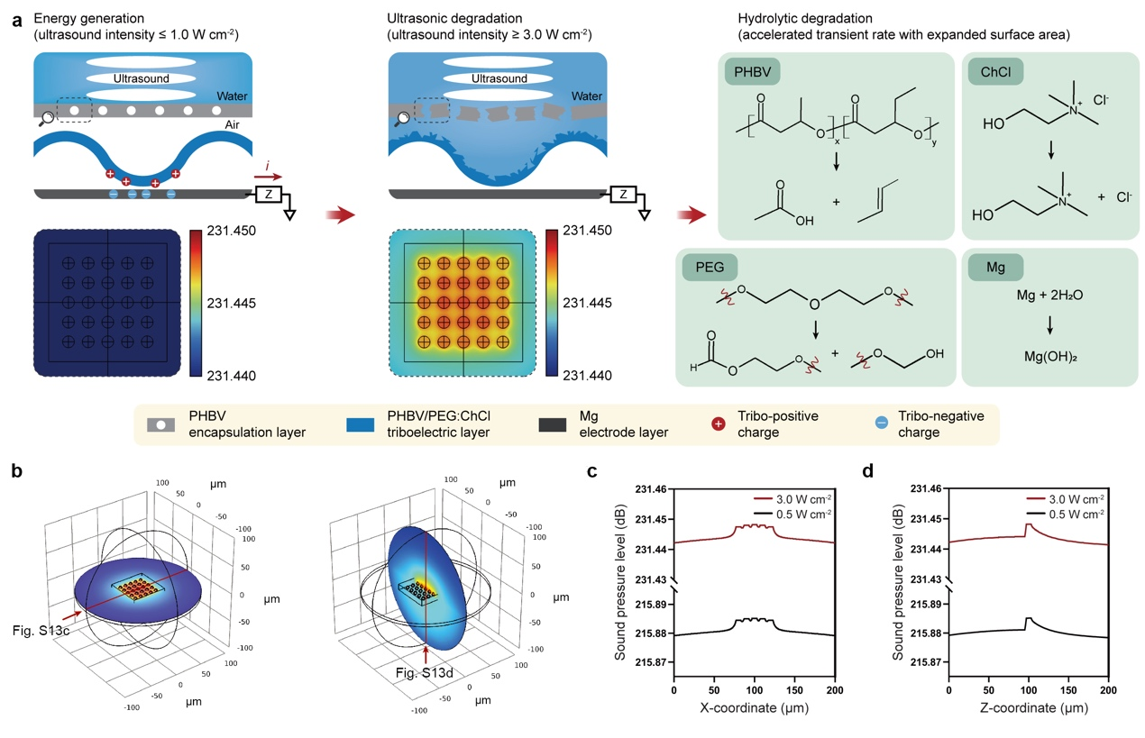
Supplementary Fig. 13│Underlying mechanism of the ultrasound-mediated transient process. a, Schematics describing the ultrasound-mediated transient process and simulated acoustic pressure field inside the PHBV encapsulation structure. The ACT−TENG generates reliable energy generating performances upon a low-intensity ultrasound (less than 1.0 W cm⁻²), while it starts the biodegradation process upon HIU-driven triggering events (more than 3.0 W cm⁻²). The locally intensified acoustic pressure in the porous structure of the PHBV membrane triggers its mechanical disintegration. The HIU-triggered disintegration results in the enlarged surface area of the constituent materials, which facilitates hydrolytic processes upon contact with biofluid. b, 3D plotted simulation results of the acoustic pressure field. c,d, The plotted acoustic pressure along the x-coordinates (c), and the z-coordinates (d), of a PHBV membrane.

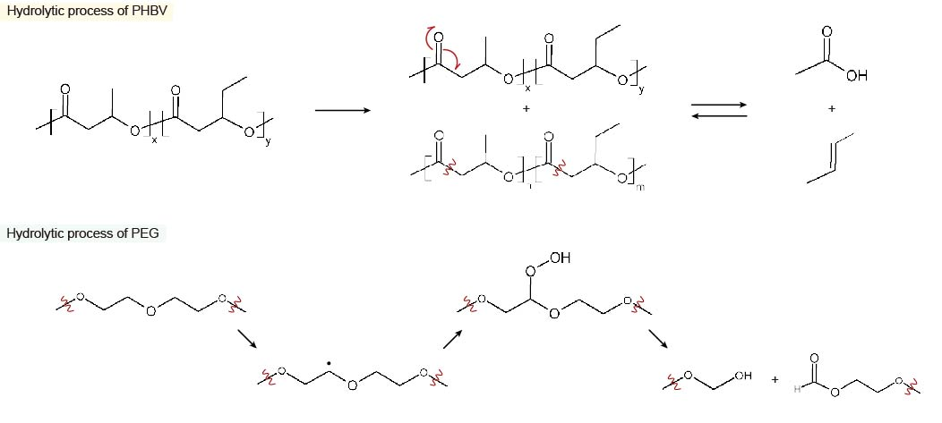
Supplementary Fig. 14│Hydrolytic processes of PHBV and PEG. Chemical formula showing the hydrolytic degradation of PHBV and PEG.

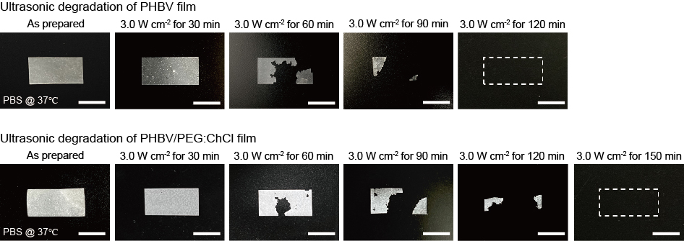
Supplementary Fig. 15│HIU-triggered transient performances of the PHBV and PHBV/PEG:ChCl membranes (20 mm width, 10 mm length, 50 μm thickness). The PHBV and PHBV/PEG:ChCl membranes were piled up to mimic the ACT−TENG structure. The PHBV membrane was fully disintegrated in 120 min upon the HIU event, while the PHBV/PEG:ChCl membrane was eliminated in 150 min. The scale bars represent 10 mm.

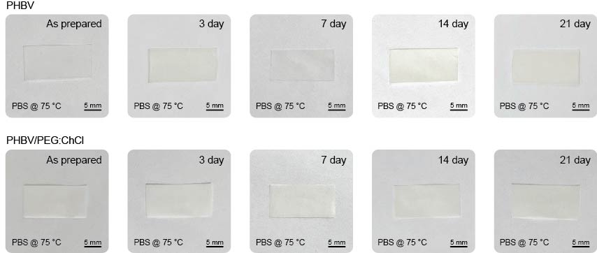
Supplementary Fig. 16│Transient performances of PHBV and PHBV/PEG:ChCl without HIU-triggering events. Both membranes were immersed in PBS solution (pH 7.4, 75 °C) for 21 d, with the barely degraded structures representing their low transient rate.

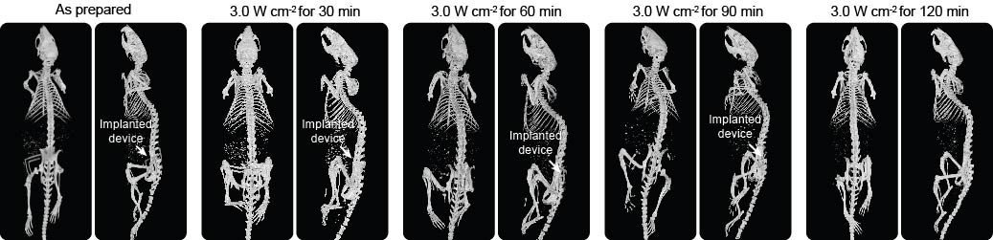
Supplementary Fig. 17│Micro-CT images captured at the top and side views. The on-demand bioresorbable neurostimulator was fully disintegrated in 120 min upon the HIU events.

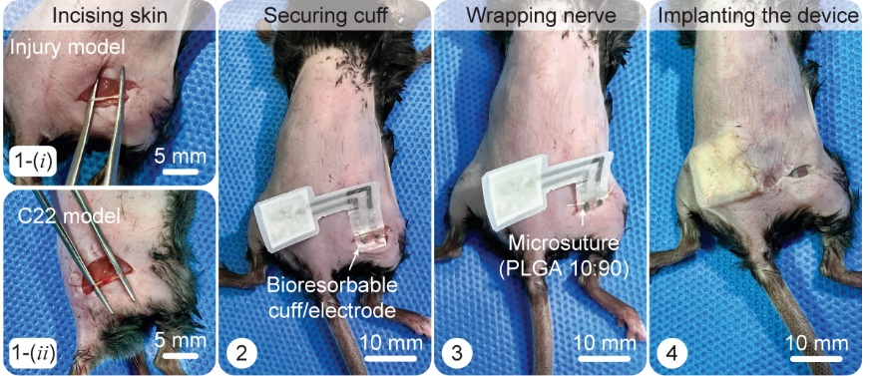
Supplementary Fig. 18 | Surgical procedure to implant the on-demand bioresorbable neurostimulator. The bioresorbable cuff electrode was wrapped around the sciatic nerve. Then, the ACT−TENG was implanted beneath the dermis.

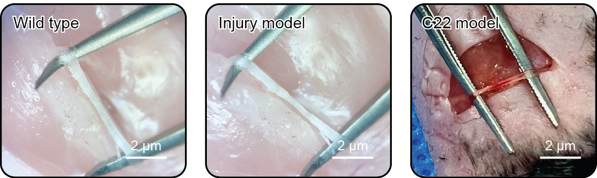
Supplementary Fig. 19 | Magnified view of the sciatic nerve. The images represent the nerve conditions of the wild type, acquired peripheral nerve injury model, and C22 model, respectively.
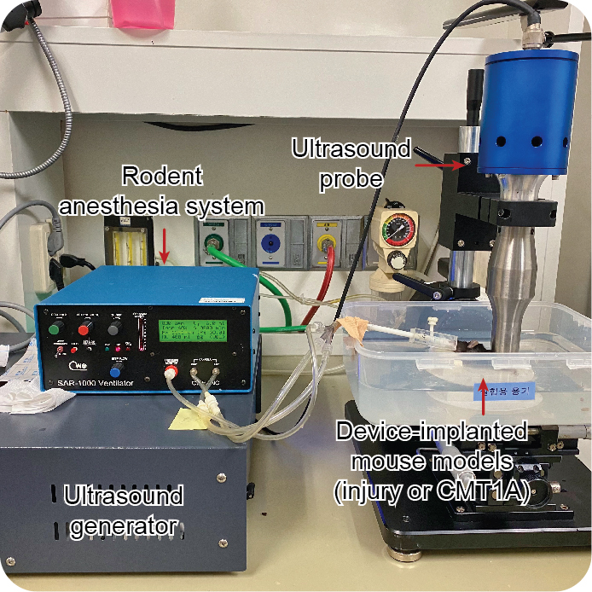
Supplementary Fig. 20 | Experimental setup for the in vivo demonstration of peripheral nerve electrotherapy. The device-implanted mouse was anesthetized during the ultrasound application time.
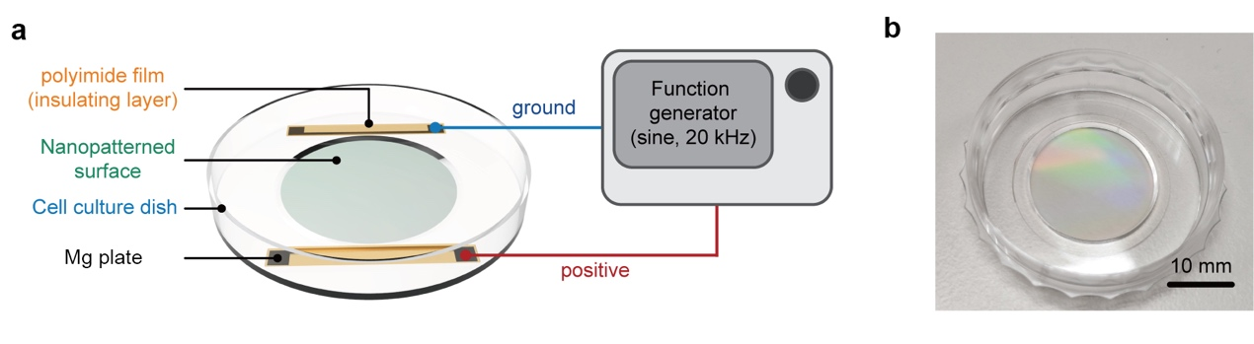
Supplementary Fig. 21 | Experimental setup for in vitro demonstration of the iPSC-driven motor neuron growth upon electrical impulses. a, Schematic describing the experimental setup for the in vitro cell experiments. A pair of Mg plates (20 mm width, 2 mm length, 100 μm thickness) was attached to the nanopatterned cell culture dish to apply electrical impulses. Insulating layers (polyimide films) were introduced to prevent the Mg plates from making contact with cell culturing medium. The iPSC-driven motor neuron cells were cultured on the nanopatterned surface to measure their axon length. b, Real image of the nanopatterned cell culture dish.
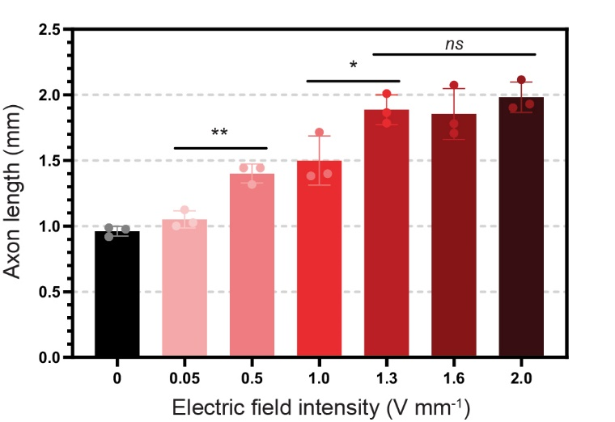
Supplementary Fig. 22 | Axon length plots after 72 h of culturing time upon different electric field intensities. The axon length exhibited saturated level at the 1.3 V mm⁻¹ of electric field intensity, providing the electrical impulse condition for effective electrotherapy. P values are evaluated through two-sided t test; ns = non significant; *P < 0.05; **P < 0.01.
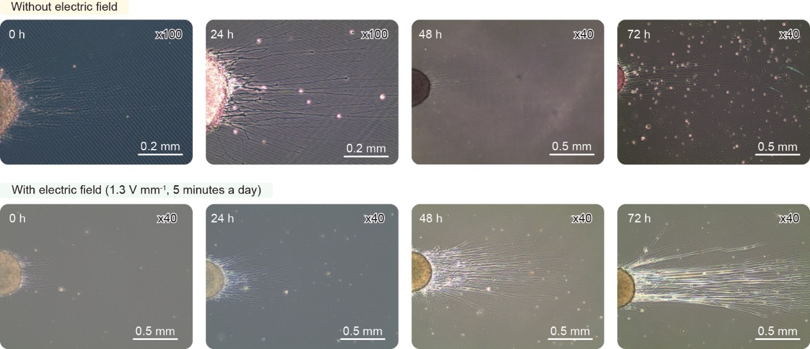
Supplementary Fig. 23 | Optical microscopic images of iPSC-driven motor neuron. The electrically treated iPSC-driven motor neuron cells exhibit longer axon length than the untreated cells.
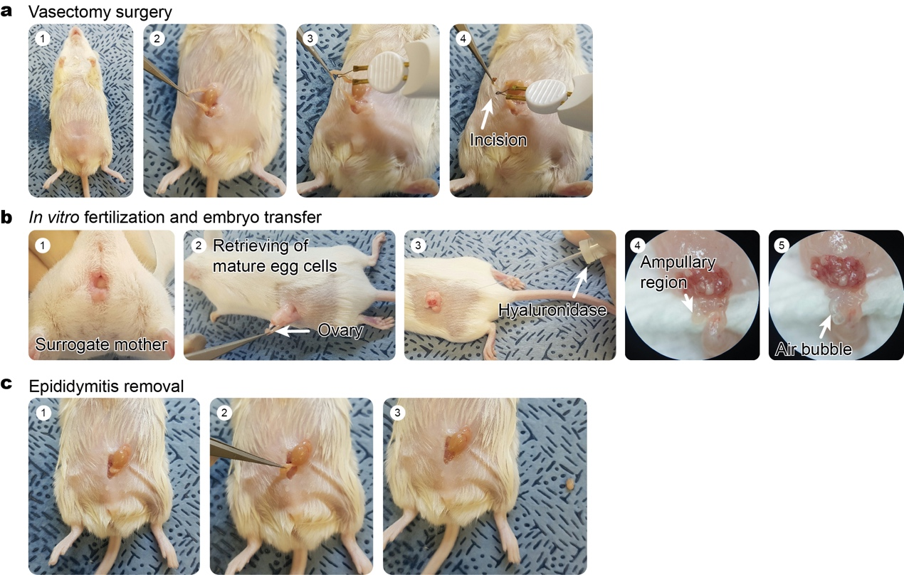
Supplementary Fig. 24 | Detailed procedure for preparing C22 mouse model. The preparation procedure of C22 mouse model can be divided into three steps: a, vasectomy surgery, b, in vitro fertilization with embryo transfer, and c, epididymitis removal.
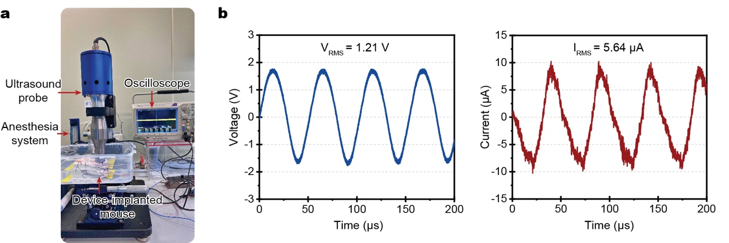
Supplementary Fig. 25 | In vivo electrical characterization of the ACT−TENG. a, Experimental setup to characterize in vivo electrical output performances. b, Triboelectric voltage at 40 megohm impedance, and c, current at 1 ohm impedance by the ACT−TENG implanted in a mouse.
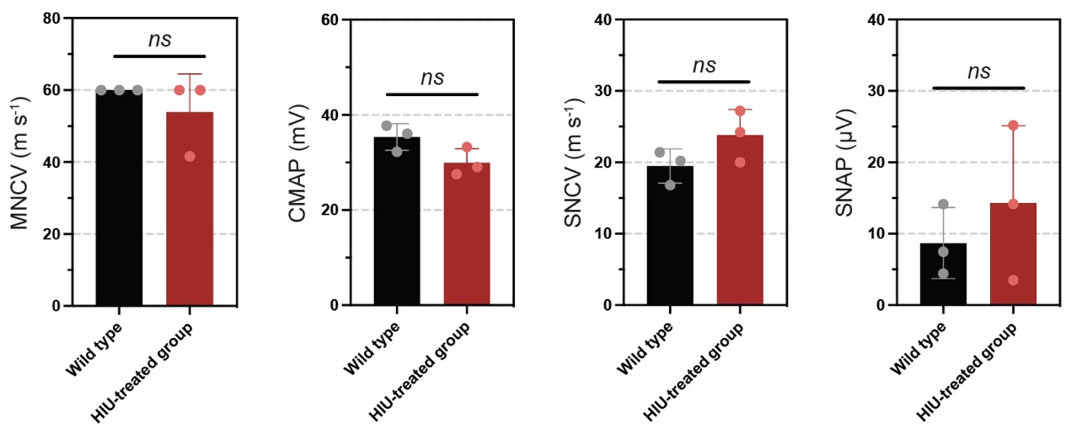
Supplementary Fig. 26 | NCS results to evaluate the biosafety of the HIU to the sciatic nerve. Here, the HIU-treated group represents the mouse model that encountered HIU treatments for 120 min (Wild type: n = 3. HIU-treated group: n = 3). All the parameters of the nerve conditions indicate that the HIU treatment does not induce any biological damage to the sciatic nerve. P values are evaluated through two-sided t test; ns = non significant.
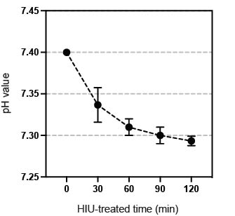
Supplementary Fig. 27 | Characterization of pH change upon the HIU treatment. PHBV membranes (n = 3) were immersed in diluted PBS solution (pH 7.4, 35 ºC). Upon the HIU treatment, the mechanically disintegrated PHBV membranes did not cause any significant change in pH of the diluted PBS solution.
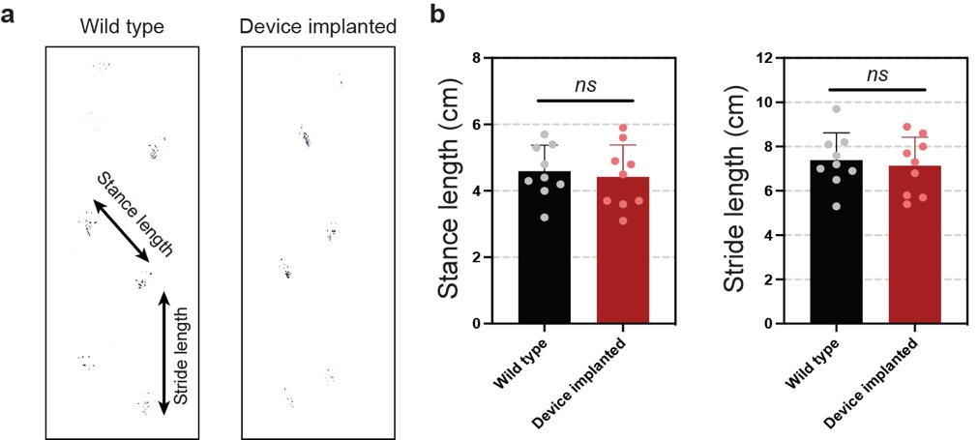
Supplementary Fig. 28 | Behavior analysis of the device-implanted mouse. a, Footprints of the device-implanted mouse were obtained to verify if the device implantation causes any physical harm to the sciatic nerve. b, The device-implanted mouse has comparable values of both stance length and stride length, the two main parameters for quantitative analysis of the footprints (Wild type: n = 9, Device implanted: n = 9). P values are evaluated through two-sided t test; ns = non significant.
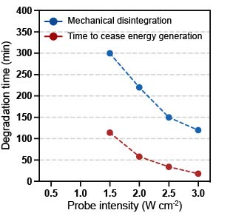
Supplementary Fig. 29 | Characterization of degradation time at different ultrasound intensities. The ACT−TENG was immersed in diluted PBS solution (pH 7.4, 25 °C) for electrical characterization. Then, we observed the following degradation time at different ultrasound intensities: i) time to cease energy generation, and ii) mechanical disintegration. Upon a low-intensity ultrasound (less than 1.0 W cm⁻²), the ACT−TENG barely initiated its transient processes for several hours.
Supplementary Note
Supplementary Note 1. Fundamental background of the localization of acoustic pressure inside the PHBV encapsulation layer
Acoustic impedance, defined as the ratio of the acoustic pressure to the sound velocity in a medium, provides a key to characterize the ultrasound transmission properties of materials². Acoustic impedance can be derived from the Young’s modulus and density of the medium, as shown below:
(1)
where, Z represents the acoustic impedance (unit: kg m⁻² s⁻¹), v represents the sound of speed in a specific medium (unit: m s⁻¹), ρ represents the density of the medium (unit: kg m⁻³), and E represents the Young’s modulus of the medium (unit: kg m⁻¹ s⁻²)³.
As displayed in fig. S7 of the SI, we obtained the acoustic impedance value of the PHBV membrane through Eq. (1). The Young’s modulus of the PHBV membrane (10 cm width, 1 cm length, 50 μm thickness) was measured using a universal testing machine (UTM) to identify its stress–strain curve. The density of the PHBV membrane was evaluated by a specific gravity scale. The measured Young’s modulus and density were 7.34 GPa and 1,026.68 kg m⁻³, respectively. Thus, we obtained the acoustic impedance of 2.75 × 10⁶ for the PHBV encapsulation layer.
Due to the significant mismatch in the acoustic impedance between the PHBV membrane and the air medium (present in the porous structure of the PHBV, Z_{air} = 0.0004 × 10⁶ kg m⁻² s⁻¹), reflection of the acoustic wave is dominant at the interface of the PHBV and the air⁴. The reflection coefficient can be calculated as follows:
(2)
where, a represents the reflection coefficient at the interface of material 1 and material 2, and Z₁ and Z₂ represent the acoustic impedance of material 1 and material 2, respectively. The reflection coefficient at the interface of the PHBV and the air was calculated to be 0.9994 based on Eq. (2), implying that 99.94 % of the acoustic wave is reflected. Therefore, most of the acoustic wave is reflected when it encounters the porous structure of the PHBV membrane, producing the localization of acoustic pressure field inside the PHBV porous structure.

References
- Wang, X., Wang, S., Yang, Y. & Wang, Z. L. Hybridized electromagnetic-triboelectric nanogenerator for scavenging air-flow energy to sustainably power temperature sensors. ACS Nano 9, 4553-4562 (2015).
- Regtien, P. P. L. Sensors for Mechatronics (Elsevier, Amsterdam, Netherlands, 2012).
- Mattoon, J. S. & Nyland, T. G. Small Animal Diagnostic Ultrasound (Elsevier Saunders, St. Louis, MO, 2020).
- Gomez, T. E. & Montero, F. Bridging the gap of impedance mismatch between air and solid materials. IEEE Int. Ultrason. Symp. 2, 1069-1072 (2000).

