A
B

Supplementary Figure 1. Effects of curcumin and resveratrol on cell viability on Vero E6 cells. (A) Curcumin for 24 h. (B) Resveratrol for 24 h. Results are expressed as mean ± SD.

Supplementary Figure 2. SARS-CoV-2 S protein induced cytokine storm via mediating over activation of NFKB. (A) SARS-CoV-2 S protein-mediated the activation of NFKB. (B) SARS-CoV-2 S protein induced the cytokine storm. Results are expressed as mean±SD.

Supplementary Figure 3. SARS-CoV-2 S protein induced oxidative stress. (A) SOD. (B) CAT. (C) MDA, (D) ROS. Results are expressed as mean±SD.

Supplementary Figure 4. Scavenging effect of Curcumin and Resveratrol on DPPH. (A) Curcumin. (B) Resveratrol. Results are expressed as mean±SD.

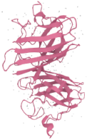
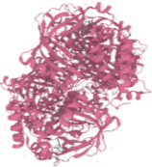
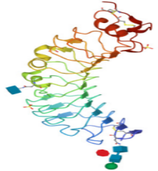
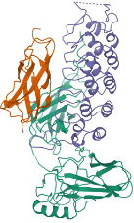
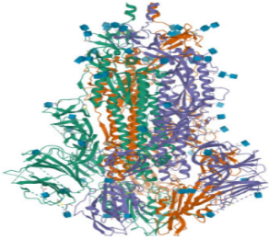
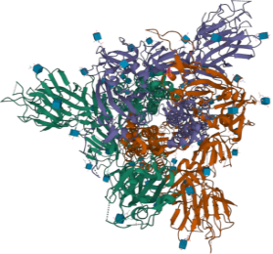
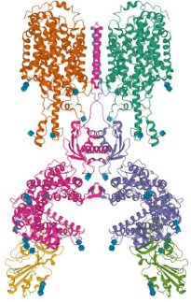
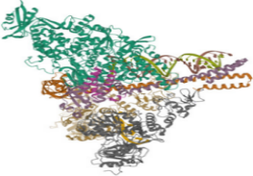
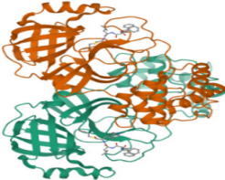
Medicine and Herbs of Yi Nationality
Scavenge ROS
SARS-CoV-2 cell entry
Curcumin
Resveratrol+Curcumin
Resveratrol
SOD2
CAT
Anti-oxidation system activity↓
Oxidation system
activity↑
Oxidative stress
Active
Transcription Translation ↑
Toll-like
receptor 4
Bind
IKAPPABALPHA/NFKB COMPLEX
Cytokine storm
SARS-CoV-2 S protein (closed state)
SARS-CoV-2 S
protein (open state)
SARS-CoV-2 S protein RBD/ACE2 complex
Phagocytosis
endocytosis
Active
Transcription and
replication of viral RNAs
SARS-CoV-2
replication and transcription
complex
SARS-CoV-2 3CLpro
Cleavage
12 mature nonstructural proteins
Yield
Active
Inhibit
Inhibit
Inhibit
Active
Bind & Inhibit
Turmericy
Red grape
Isolated

Supplementary Figure 5. Single or combined treatments with curcumin and resveratrol can inhibit SARS-CoV-2 3C-like proteinase activity and spike protein-mediated cell entry, cytokine storm, and oxidative stress.

