Supplementary materials for “Association of endotoxaemia with low grade inflammation, metabolic syndrome and distinct response to LPS in type 1 diabetes”

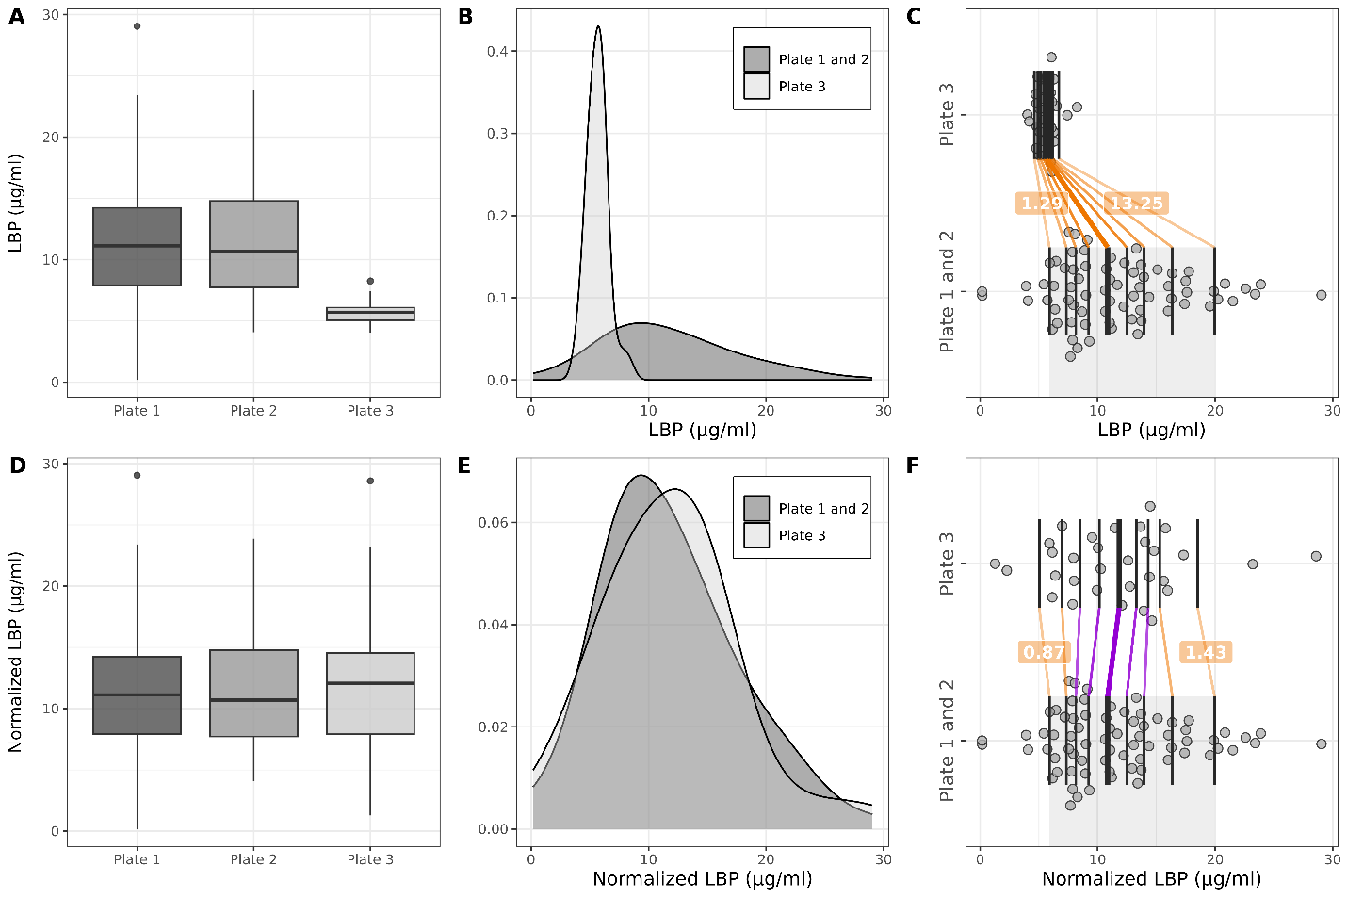
Supplemental figure 1. Illustrations for LBP before and after the normalization. Boxplots by plates, density plots and scatterplots with deciles for LBP raw data (upper panels) and after normalization using location-scale transformation between pooled plates 1 and 2 and plate 3 (lower panels), location parameter $\hat{μ}=-24.83$, scale parameter $\hat{σ}=6.475$ were used for transformation of plate 3.
Phenotype | Control (N=33) | T1D (N=74) | p
Male gender, N (%) | 14 (42.4 %) | 28 (37.8 %) | 0.81
Age, years | 35 (30 - 44) | 43 (34 - 51) | 0.013
BMI, kg/m² | 24.3 (22.3 - 27.9) | 24.9 (22.6 - 28.4) | 0.39
Waist/height ratio | 0.47 (0.44 - 0.51) | 0.49 (0.44 - 0.56) | 0.16
Smokers, N (%) | 9 (27.3 %) | 20 (27.0 %) | 1.00
Hypertension, N (%) | 7 (21.2 %) | 35 (47.3 %) | 0.019
Length of diabetes, Years | - | 21 (13 - 32) | -
Retinopathy, N (%) | - | 32 (43.2 %) | -
CVD, N (%) | 0 (0 %) | 9 (12.2 %) | 0.086
On ACEI/ARB, N (%) | 0 (0 %) | 15 (20.3 %)
On lipid lowering medication, N (%) | 2 (6.1 %) | 17 (23.0 %) | 0.066
Autoimmune thyroid disease, N (%) | 1 (3 %) | 19 (25.7 %) | 0.012
Hemoglobin A1C, % | 5.2 (5.0 - 5.5) | 7.7 (6.9 - 9.3) | <0.001
Hemoglobin A1C mmol/mol | 31.4 (29.3 – 34.5) | 56.5 (49.1 – 73.6) | <0.001
Estimated glomerular filtration rate, ml/min/1.73m² | 106 (94 - 113) | 108 (91 - 117) | 0.39
Albumin/creatinine ratio in urine, mg/mmol | 0.32 (0.11 - 0.76) | 0.57 (0.23 - 1.84) | 0.013
Faecal calprotectine, µg/g | 6.4 (3.9 - 10.3) | 6.3 (2.8 - 19.2 | 0.95
Faecal calprotectine>50 µg/g, N (%) | 0 (0 %) | 6 (9.0 %) | 0.22
Total cholesterol, mmol/l | 4.7 (4.5 - 5.1) | 5.0 (4.5 - 5.8) | 0.14
Low density lipoproteins, mmol/l | 2.8 (2.4 - 3.2) | 3.0 (2.3 - 3.4) | 0.77
High density lipoproteins, mmol/l | 1.43 (1.27 - 1.61) | 1.5 (1.3 - 1.9) | 0.05
Triglycerides, mmol/l | 0.98 (0.79 - 1.65) | 1.2 (0.9 - 1.5) | 0.21
Alanine transaminase, U/l | 21 (17 - 29) | 19 (15 - 28) | 0.18
Aspartate aminotransferase, U/l | 25 (22 - 29) | 22 (19 - 31) | 0.13
Gamma-glutamyltransferase, U/l | 16 (14 - 22) | 16 (13 - 23) | 0.93
Bilirubin, µmol/l | 10.5 (7.1 – 15.0) | 9.3 (7.0 – 12.0) | 0.37
CRP, mg/l | 0.5 (0.5 - 0.5) | 0.9 (0.5 - 2.9) | <0.001
Haemoglobin, g/l | 140 (127 - 152) | 140 (132 - 149) | 0.84
Erythrocytes, 10x12\L | 4.6 (4.2 - 5.1) | 4.7 (4.4 – 5.0) | 0.62
Leukocytes, 10x9/L | 6.2 (5.2 - 6.9) | 6.2 (5.1 - 7.3) | 0.90
Thrombocytes, 10x9/L | 269 (225 - 301) | 260 (230 - 288) | 0.86
eGDR | 7.1 (5.5 - 7.7) | 3.3 (1.6 - 5.7) | <0.001
FLI | 17.8 (6.6 - 34.6) | 21.7 (9.9 - 48.2) | 0.19
HSI | 34.3 (30.8 - 40.2) | 33.4 (29.9 - 39.5) | 0.30
Metabolic syndrome | 4 (12.1 %) | 31 (41.9 %) | 0.005
Supplemental Table 1. Characteristics of subjects.For categorical variables data are presented as counts (%), the equality of proportions in control and T1D group was tested using chi-square test for equality of proportions. For continuous variables data are presented as medians (IQR), the comparisons between control and T1D group was performed using Wilcoxon test. BMI – body mass index. CVD – cardiovascular disease. ACEI – angiotensin converting enzyme inhibitors. ARB angiotensin receptor blockers. eGDR – estimated glucose disposal rate. FLI – fatty liver index. HSI – hepatic steatosis index.

Variable | No metabolic syndrome (N = 43) | Metabolic syndrome (N = 31) | P Wilcoxon | P Lepage | P KS test
CRO, mg/l | 0.5 (0.5 - 1.7) | 1.9 (0.6 - 4.5) | 0.004 | <0.001 | <0.001
hsCRP, mg/l | 0.80 (0.49 - 1.53) | 1.23 (0.38 - 2.17) | 0.41 | 0.55 | 0.39
LPS, EU/ml | 0.34 (0.30 - 0.40) | 0.42 (0.35 - 0.56) | 0.009 | 0.018 | 0.009
EndoCAb IgG, GMU/ml | 89.5 (67.1 - 150.2) | 96.0 (59.1 - 141.6) | 0.84 | 0.88 | 0.85
Endo CAb IgM, MMU/ml | 46.6 (34.2 - 85.2) | 43.7 (31.3 - 60.4) | 0.33 | 0.24 | 0.18
LBP, µg/ml | 11.1 (7.9 - 16.3) | 11.1 (7.9 - 13.3) | 0.89 | 0.20 | 0.54
LPS/HDL | 0.22 (0.17 - 0.26) | 0.28 (0.24 - 0.38) | 0.001 | 0.004 | 0.003
Calprotectin, µg/g | 3.8 (2.7 - 8.6) | 12.5 (3.2 - 18.4) | 0.18 | 0.40 | 0.057
Supplemental Table 2. Inflammatory marker analysis in patients with T1D stratified by metabolic syndrome.
KS – Kolmogorov-Smirnov test for equality of two distributions.

Variable | n | m | Decile 1  (10%) | Decile 2  (20%) | Decile 3  (30%) | Decile 4  (40%) | Decile 5  (50%) | Decile 6  (60%) | Decile 7  (70%) | Decile 8  (80%) | Decile 9  (90%)
hsCRP, mg/l | 42 | 28 | -0.09 (-0.28,0.15), p=0.44 | 0 (-0.24,0.33), p=0.971 | 0.09 (-0.22,0.53), p=0.595 | 0.2 (-0.21,0.76), p=0.371 | 0.34 (-0.22,1.01), p=0.25 | 0.48 (-0.22,1.34), p=0.182 | 0.62 (-0.29,1.67), p=0.159 | 0.78 (-1.24,2.49), p=0.414 | 0 (-2.14,2.83), p=0.998
LPS, EU/ml | 42 | 29 | 0.01 (-0.03,0.05), p=0.78 | 0.03 (-0.01,0.08), p=0.193 | 0.05 (0,0.1), p=0.044 | 0.07 (0.02,0.13), p=0.01 | 0.09 (0.03,0.17), p=0.002 | 0.11 (0.04,0.21), p=0.002 | 0.15 (0.05,0.24), p=0.004 | 0.17 (0.05,0.26), p=0.013 | 0.16 (-0.02,0.27), p=0.091
EndoCAb IgG, GMU/ml | 41 | 29 | -11.74 (-30.66,7.65), p=0.232 | -8.35 (-29.38,14.77), p=0.472 | -5.21 (-27.25,19.49), p=0.666 | -1.08 (-24.89,24.83), p=0.931 | 3.4 (-24.59,31.71), p=0.804 | 6.61 (-37.38,39.49), p=0.701 | 0.76 (-47.83,47.57), p=0.978 | -8.9 (-55.47,50.36), p=0.72 | -5.56 (-151.01,130.5), p=0.869
EndoCAb IgM, MMU/ml | 42 | 28 | 1.37 (-8.72,11.15), p=0.791 | -0.23 (-10.52,9.65), p=0.964 | -1.78 (-12.92,8.83), p=0.738 | -3.67 (-18.01,8.55), p=0.555 | -6.77 (-25.8,7.96), p=0.391 | -12.6 (-33.33,5.95), p=0.206 | -19.83 (-41.22,1.08), p=0.063 | -27.32 (-54.53,14.25), p=0.15 | -25 (-141.55,75.6), p=0.281
LBP, µg/ml | 42 | 29 | 2.45 (0.56,4.99), p=0.01 | 1.49 (-0.45,3.71), p=0.134 | 0.92 (-1.25,3.11), p=0.404 | 0.43 (-2.02,2.7), p=0.722 | -0.14 (-2.9,2.28), p=0.914 | -0.91 (-4.18,1.79), p=0.523 | -2.02 (-5.84,1.34), p=0.233 | -3.54 (-7.34,2.49), p=0.16 | -3.64 (-9.13,4.79), p=0.395
LPS/HDL ratio | 42 | 29 | 0.04 (0,0.08), p=0.079 | 0.05 (0,0.09), p=0.037 | 0.06 (0.01,0.1), p=0.018 | 0.06 (0.02,0.11), p=0.007 | 0.07 (0.02,0.13), p=0.003 | 0.08 (0.03,0.17), p=0.001 | 0.1 (0.03,0.3), p=0.002 | 0.19 (0.04,0.35), p=0.004 | 0.28 (0.09,0.48), p=0.004
Calprotectin, µg/g | 35 | 27 | -0.88 (-2.77,1.58), p=0.441 | 0.61 (-1.73,4.13), p=0.656 | 2.22 (-0.78,7.25), p=0.172 | 4.3 (0.23,9.98), p=0.036 | 6.9 (1.24,11.81), p=0.014 | 8.72 (2.47,13.13), p=0.011 | 9.39 (-13.65,13.98), p=0.18 | 5.35 (-18.29,14.99), p=1 | -9.99 (-21.82,25.46), p=0.218
Supplemental Table 3. Comparisons of deciles of inflammatory markers in T1D patients stratified according to the presence of metabolic syndrome.
n – complete cases in T1D patients without metabolic syndrome; m – complete cases in T1D patients with metabolic syndrome.

Variable | CRO, mg/l | hsCRP, mg/l | LPS, EU/ml | endoCAb IgG, GMU/ml | endoCAb IgM, MMU/ml | LBP, µg/ml | LPS/HDL | Calprotectin, µg/g
Serum glucose | 0.03, (-0.2, 0.26), p=0.786 | 0.12, (-0.12, 0.34), p=0.337 | 0.04, (-0.2, 0.27), p=0.742 | 0, (-0.23, 0.24), p=0.976 | -0.08, (-0.31, 0.16), p=0.512 | 0.12, (-0.12, 0.34), p=0.336 | 0.19, (-0.05, 0.41), p=0.109 | 0.08, (-0.16, 0.32), p=0.496
HbA1c | 0.03, (-0.2, 0.25), p=0.825 | 0.11, (-0.13, 0.34), p=0.368 | -0.03, (-0.26, 0.21), p=0.833 | 0.27, (0.03, 0.47), p=0.026 | 0.11, (-0.13, 0.34), p=0.366 | 0.05, (-0.19, 0.28), p=0.707 | 0.05, (-0.19, 0.28), p=0.706 | 0.03, (-0.21, 0.27), p=0.783
eGFR | -0.24, (-0.45, -0.01), p=0.038 | -0.02, (-0.26, 0.21), p=0.861 | -0.06, (-0.29, 0.18), p=0.614 | -0.1, (-0.33, 0.13), p=0.391 | -0.21, (-0.43, 0.03), p=0.079 | 0.07, (-0.17, 0.29), p=0.584 | 0.08, (-0.16, 0.31), p=0.5 | 0.11, (-0.13, 0.34), p=0.377
Albumine/creatinine ratio in urine | 0.13, (-0.11, 0.35), p=0.277 | 0.12, (-0.13, 0.35), p=0.342 | -0.19, (-0.41, 0.06), p=0.128 | -0.03, (-0.27, 0.21), p=0.809 | -0.07, (-0.31, 0.17), p=0.544 | -0.03, (-0.26, 0.21), p=0.807 | -0.11, (-0.34, 0.13), p=0.352 | 0.1, (-0.15, 0.33), p=0.436
Weight | 0.38, (0.16, 0.57), p=0.001 | 0.07, (-0.17, 0.3), p=0.568 | 0.04, (-0.2, 0.27), p=0.751 | -0.08, (-0.31, 0.16), p=0.496 | 0.02, (-0.21, 0.25), p=0.862 | -0.01, (-0.25, 0.22), p=0.916 | 0.06, (-0.18, 0.29), p=0.617 | -0.07, (-0.3, 0.18), p=0.595
Body mass index | 0.55, (0.35, 0.7), p=0 | 0.17, (-0.07, 0.39), p=0.155 | 0.14, (-0.09, 0.37), p=0.23 | 0.01, (-0.22, 0.25), p=0.917 | 0.01, (-0.22, 0.25), p=0.918 | 0.05, (-0.19, 0.28), p=0.697 | 0.1, (-0.14, 0.33), p=0.412 | -0.01, (-0.25, 0.23), p=0.916
Waist/height ratio | 0.47, (0.26, 0.64), p=0 | 0.23, (-0.01, 0.44), p=0.057 | 0.14, (-0.1, 0.36), p=0.243 | -0.08, (-0.31, 0.16), p=0.508 | -0.11, (-0.34, 0.12), p=0.345 | 0.03, (-0.2, 0.26), p=0.781 | 0.16, (-0.08, 0.38), p=0.193 | -0.09, (-0.32, 0.15), p=0.473
eGDR | -0.26, (-0.46, -0.03), p=0.027 | -0.28, (-0.48, -0.04), p=0.02 | 0.01, (-0.23, 0.24), p=0.967 | -0.05, (-0.28, 0.18), p=0.664 | 0.07, (-0.17, 0.3), p=0.572 | 0.06, (-0.18, 0.29), p=0.632 | -0.06, (-0.29, 0.18), p=0.63 | 0.04, (-0.2, 0.28), p=0.743
HSI | 0.52, (0.31, 0.68), p=0 | 0.21, (-0.03, 0.43), p=0.088 | 0.13, (-0.11, 0.36), p=0.283 | 0.04, (-0.21, 0.27), p=0.77 | 0.04, (-0.2, 0.28), p=0.728 | -0.03, (-0.26, 0.21), p=0.832 | 0.14, (-0.1, 0.37), p=0.25 | -0.06, (-0.3, 0.19), p=0.624
FLI | 0.48, (0.27, 0.64), p=0 | 0.22, (-0.02, 0.43), p=0.07 | 0.24, (0.01, 0.45), p=0.04 | -0.08, (-0.31, 0.16), p=0.514 | -0.06, (-0.29, 0.17), p=0.603 | 0.06, (-0.18, 0.29), p=0.63 | 0.23, (-0.01, 0.44), p=0.053 | -0.06, (-0.29, 0.18), p=0.641
ALT | 0.02, (-0.21, 0.25), p=0.859 | -0.04, (-0.27, 0.2), p=0.742 | -0.07, (-0.3, 0.17), p=0.575 | -0.09, (-0.32, 0.15), p=0.445 | -0.07, (-0.3, 0.16), p=0.543 | -0.07, (-0.29, 0.17), p=0.585 | -0.04, (-0.27, 0.19), p=0.726 | -0.02, (-0.26, 0.22), p=0.883
AST | 0, (-0.23, 0.23), p=0.996 | -0.07, (-0.31, 0.17), p=0.568 | -0.1, (-0.33, 0.14), p=0.424 | 0, (-0.24, 0.24), p=0.976 | -0.14, (-0.37, 0.1), p=0.257 | 0.03, (-0.21, 0.27), p=0.789 | -0.19, (-0.41, 0.05), p=0.115 | 0.07, (-0.17, 0.32), p=0.556
GGT | 0.14, (-0.09, 0.36), p=0.239 | 0.05, (-0.19, 0.28), p=0.689 | -0.04, (-0.27, 0.2), p=0.771 | -0.21, (-0.43, 0.03), p=0.076 | -0.06, (-0.29, 0.17), p=0.6 | -0.01, (-0.24, 0.23), p=0.954 | -0.07, (-0.3, 0.17), p=0.568 | -0.05, (-0.29, 0.19), p=0.659
Transglutaminase IgA | -0.04, (-0.27, 0.19), p=0.738 | -0.21, (-0.43, 0.03), p=0.081 | 0.07, (-0.16, 0.3), p=0.541 | 0.01, (-0.22, 0.25), p=0.913 | 0.11, (-0.13, 0.34), p=0.379 | 0.04, (-0.19, 0.28), p=0.717 | 0.05, (-0.18, 0.28), p=0.666 | -0.28, (-0.49, -0.04), p=0.022
Total bilirubin | -0.18, (-0.4, 0.05), p=0.117 | -0.16, (-0.38, 0.08), p=0.182 | 0, (-0.24, 0.23), p=0.968 | -0.1, (-0.33, 0.14), p=0.399 | 0.03, (-0.2, 0.27), p=0.779 | 0, (-0.24, 0.23), p=0.967 | -0.06, (-0.28, 0.18), p=0.648 | -0.14, (-0.37, 0.1), p=0.251
Erythrocytes | -0.03, (-0.25, 0.2), p=0.816 | 0, (-0.24, 0.23), p=0.991 | 0.2, (-0.03, 0.42), p=0.091 | -0.04, (-0.27, 0.2), p=0.765 | 0.1, (-0.14, 0.33), p=0.393 | -0.01, (-0.24, 0.22), p=0.92 | 0.26, (0.02, 0.47), p=0.03 | 0.09, (-0.16, 0.32), p=0.494
Hemoglobin | -0.15, (-0.37, 0.08), p=0.207 | -0.06, (-0.29, 0.18), p=0.623 | 0.18, (-0.06, 0.4), p=0.14 | -0.2, (-0.42, 0.04), p=0.1 | 0.04, (-0.19, 0.28), p=0.715 | -0.07, (-0.3, 0.16), p=0.549 | 0.33, (0.1, 0.53), p=0.005 | 0.03, (-0.21, 0.27), p=0.792
Leukocytes | 0.1, (-0.13, 0.32), p=0.391 | 0.18, (-0.06, 0.4), p=0.13 | -0.06, (-0.29, 0.18), p=0.62 | -0.07, (-0.3, 0.17), p=0.589 | -0.06, (-0.29, 0.17), p=0.605 | 0.15, (-0.09, 0.37), p=0.211 | 0.04, (-0.19, 0.27), p=0.723 | -0.07, (-0.3, 0.18), p=0.588
Total cholesterol | 0.29, (0.06, 0.49), p=0.013 | 0.13, (-0.11, 0.36), p=0.276 | 0.04, (-0.2, 0.27), p=0.746 | 0.18, (-0.06, 0.4), p=0.137 | 0.07, (-0.17, 0.3), p=0.555 | 0.2, (-0.04, 0.42), p=0.092 | -0.18, (-0.39, 0.06), p=0.142 | 0.14, (-0.11, 0.37), p=0.263
High density cholestrol | 0.16, (-0.07, 0.38), p=0.171 | 0.13, (-0.1, 0.36), p=0.267 | -0.17, (-0.39, 0.06), p=0.146 | 0.32, (0.09, 0.52), p=0.006 | 0.26, (0.02, 0.47), p=0.028 | 0.12, (-0.12, 0.34), p=0.324 | -0.7, (-0.81, -0.54), p=0 | -0.06, (-0.3, 0.18), p=0.614
Low density cholesterol | 0.21, (-0.02, 0.42), p=0.075 | 0.04, (-0.19, 0.28), p=0.723 | -0.08, (-0.31, 0.15), p=0.48 | 0.04, (-0.19, 0.27), p=0.729 | -0.05, (-0.28, 0.19), p=0.683 | 0.17, (-0.07, 0.39), p=0.164 | -0.01, (-0.24, 0.23), p=0.95 | 0.22, (-0.03, 0.44), p=0.08
Tryglicerides | 0.12, (-0.11, 0.34), p=0.312 | 0.13, (-0.11, 0.36), p=0.282 | 0.49, (0.28, 0.66), p=0 | -0.08, (-0.31, 0.16), p=0.537 | 0, (-0.23, 0.24), p=0.982 | -0.01, (-0.24, 0.22), p=0.929 | 0.52, (0.31, 0.68), p=0 | 0.04, (-0.21, 0.27), p=0.776
Diabetes duration | 0.14, (-0.09, 0.36), p=0.224 | 0.15, (-0.09, 0.37), p=0.226 | -0.09, (-0.32, 0.15), p=0.463 | -0.07, (-0.3, 0.17), p=0.576 | 0.11, (-0.13, 0.34), p=0.354 | -0.09, (-0.31, 0.15), p=0.478 | -0.22, (-0.43, 0.02), p=0.069 | 0.02, (-0.22, 0.26), p=0.845
CRP | - | 0.61, (0.42, 0.75), p=0 | 0.13, (-0.11, 0.35), p=0.296 | 0.16, (-0.08, 0.38), p=0.192 | 0.01, (-0.23, 0.24), p=0.951 | 0.18, (-0.06, 0.4), p=0.137 | -0.04, (-0.27, 0.2), p=0.767 | -0.16, (-0.39, 0.09), p=0.197
hsCRP | 0.61, (0.42, 0.75), p=0 | - | 0.18, (-0.06, 0.4), p=0.14 | 0.22, (-0.02, 0.44), p=0.07 | 0, (-0.24, 0.23), p=0.972 | 0.36, (0.13, 0.55), p=0.002 | 0.01, (-0.23, 0.24), p=0.932 | -0.15, (-0.38, 0.11), p=0.256
LPS | 0.13, (-0.11, 0.35), p=0.296 | 0.18, (-0.06, 0.4), p=0.14 | - | 0.07, (-0.17, 0.3), p=0.566 | 0.13, (-0.11, 0.36), p=0.268 | 0.04, (-0.2, 0.27), p=0.771 | 0.78, (0.64, 0.86), p=0 | -0.02, (-0.27, 0.22), p=0.853
EndoCAb IgG | 0.16, (-0.08, 0.38), p=0.192 | 0.22, (-0.02, 0.44), p=0.07 | 0.07, (-0.17, 0.3), p=0.566 | - | 0.23, (-0.01, 0.45), p=0.052 | 0.23, (-0.01, 0.45), p=0.054 | -0.14, (-0.36, 0.1), p=0.258 | 0.13, (-0.12, 0.37), p=0.296
EndoCAb IgM | 0.01, (-0.23, 0.24), p=0.951 | 0, (-0.24, 0.23), p=0.972 | 0.13, (-0.11, 0.36), p=0.268 | 0.23, (-0.01, 0.45), p=0.052 | - | -0.14, (-0.36, 0.1), p=0.263 | -0.14, (-0.37, 0.09), p=0.231 | -0.05, (-0.29, 0.2), p=0.695
LBP | 0.18, (-0.06, 0.4), p=0.137 | 0.36, (0.13, 0.55), p=0.002 | 0.04, (-0.2, 0.27), p=0.771 | 0.23, (-0.01, 0.45), p=0.054 | -0.14, (-0.36, 0.1), p=0.263 | - | -0.02, (-0.25, 0.21), p=0.854 | -0.05, (-0.29, 0.2), p=0.721
LPS/HDL | -0.04, (-0.27, 0.2), p=0.767 | 0.01, (-0.23, 0.24), p=0.932 | 0.78, (0.64, 0.86), p=0 | -0.14, (-0.36, 0.1), p=0.258 | -0.14, (-0.37, 0.09), p=0.231 | -0.02, (-0.25, 0.21), p=0.854 | - | -0.04, (-0.29, 0.2), p=0.733
Calprotectin | -0.16, (-0.39, 0.09), p=0.197 | -0.15, (-0.38, 0.11), p=0.256 | -0.02, (-0.27, 0.22), p=0.853 | 0.13, (-0.12, 0.37), p=0.296 | -0.05, (-0.29, 0.2), p=0.695 | -0.05, (-0.29, 0.2), p=0.721 | -0.04, (-0.29, 0.2), p=0.733 | -
Supplemental Table 4. Correlations in the type 1 diabetes group. Spearman correlation coefficient (95% CI) was calculated.

Variable | CRO, mg/l | hsCRP, mg/l | LPS, EU/ml | endoCAb IgG, GMU/ml | endoCAb IgM, MMU/ml | LBP, µg/ml | LPS/HDL | Calprotectin, µg/g
Serum glucose | 0.2, (-0.15, 0.51), p=0.256 | -0.05, (-0.4, 0.31), p=0.778 | -0.13, (-0.46, 0.23), p=0.48 | -0.28, (-0.58, 0.08), p=0.119 | -0.24, (-0.55, 0.12), p=0.183 | 0.17, (-0.19, 0.49), p=0.343 | -0.21, (-0.52, 0.16), p=0.255 | -0.14, (-0.48, 0.23), p=0.449
HbA1c | 0.34, (-0.02, 0.62), p=0.056 | 0.5, (0.16, 0.74), p=0.004 | -0.13, (-0.46, 0.23), p=0.483 | 0.15, (-0.21, 0.48), p=0.404 | 0.24, (-0.12, 0.55), p=0.183 | 0.18, (-0.18, 0.5), p=0.318 | -0.13, (-0.46, 0.23), p=0.487 | 0.17, (-0.21, 0.5), p=0.373
eGFR | -0.22, (-0.53, 0.13), p=0.208 | -0.21, (-0.53, 0.16), p=0.249 | -0.11, (-0.44, 0.25), p=0.538 | 0.09, (-0.27, 0.43), p=0.619 | 0.06, (-0.29, 0.4), p=0.737 | -0.21, (-0.52, 0.15), p=0.248 | -0.09, (-0.43, 0.27), p=0.624 | -0.06, (-0.41, 0.31), p=0.772
Albumine/creatinine ratio in urine | -0.26, (-0.56, 0.09), p=0.138 | -0.32, (-0.61, 0.05), p=0.081 | 0.02, (-0.33, 0.36), p=0.925 | 0.1, (-0.26, 0.44), p=0.578 | -0.19, (-0.51, 0.17), p=0.287 | -0.03, (-0.38, 0.32), p=0.865 | -0.02, (-0.37, 0.33), p=0.898 | 0.2, (-0.18, 0.52), p=0.298
Weight | 0.39, (0.04, 0.65), p=0.026 | 0.19, (-0.18, 0.52), p=0.296 | 0.23, (-0.14, 0.54), p=0.211 | 0.04, (-0.31, 0.39), p=0.811 | -0.44, (-0.69, -0.09), p=0.012 | 0.12, (-0.24, 0.45), p=0.498 | 0.35, (-0.01, 0.63), p=0.05 | -0.02, (-0.38, 0.34), p=0.904
Body mass index | 0.42, (0.07, 0.67), p=0.016 | 0.38, (0.02, 0.66), p=0.034 | 0.13, (-0.23, 0.46), p=0.476 | 0.08, (-0.27, 0.42), p=0.654 | -0.15, (-0.48, 0.21), p=0.405 | 0.16, (-0.2, 0.48), p=0.387 | 0.27, (-0.09, 0.57), p=0.136 | -0.1, (-0.45, 0.27), p=0.586
Waist/height ratio | 0.37, (0.02, 0.64), p=0.034 | 0.33, (-0.04, 0.62), p=0.074 | 0.19, (-0.18, 0.5), p=0.309 | 0.08, (-0.28, 0.42), p=0.661 | -0.2, (-0.52, 0.16), p=0.267 | 0.27, (-0.1, 0.57), p=0.141 | 0.23, (-0.14, 0.54), p=0.21 | -0.15, (-0.49, 0.22), p=0.422
eGDR | -0.34, (-0.62, 0.01), p=0.051 | -0.26, (-0.57, 0.11), p=0.16 | -0.25, (-0.56, 0.11), p=0.16 | -0.1, (-0.44, 0.26), p=0.574 | 0.14, (-0.22, 0.47), p=0.444 | -0.13, (-0.46, 0.23), p=0.479 | -0.32, (-0.61, 0.04), p=0.077 | -0.12, (-0.46, 0.25), p=0.534
HSI | 0.46, (0.12, 0.7), p=0.007 | 0.43, (0.07, 0.69), p=0.016 | 0.09, (-0.26, 0.43), p=0.605 | 0.07, (-0.28, 0.41), p=0.697 | -0.08, (-0.42, 0.28), p=0.671 | 0.14, (-0.22, 0.46), p=0.456 | 0.24, (-0.12, 0.55), p=0.178 | -0.2, (-0.52, 0.18), p=0.3
FLI | 0.38, (0.02, 0.64), p=0.031 | 0.24, (-0.13, 0.55), p=0.198 | 0.49, (0.16, 0.73), p=0.004 | 0.01, (-0.34, 0.36), p=0.958 | -0.42, (-0.68, -0.07), p=0.017 | 0.27, (-0.1, 0.57), p=0.14 | 0.54, (0.21, 0.76), p=0.002 | 0.01, (-0.35, 0.37), p=0.953
ALT | 0.49, (0.16, 0.73), p=0.003 | 0.32, (-0.04, 0.61), p=0.076 | 0.12, (-0.24, 0.45), p=0.524 | 0.06, (-0.3, 0.4), p=0.764 | -0.1, (-0.43, 0.26), p=0.605 | 0.23, (-0.14, 0.54), p=0.215 | 0.31, (-0.06, 0.6), p=0.087 | -0.13, (-0.47, 0.24), p=0.48
AST | 0.31, (-0.05, 0.59), p=0.081 | -0.02, (-0.38, 0.33), p=0.895 | 0, (-0.35, 0.35), p=0.986 | 0.33, (-0.03, 0.62), p=0.063 | -0.04, (-0.39, 0.31), p=0.819 | 0.18, (-0.18, 0.5), p=0.311 | 0.13, (-0.23, 0.46), p=0.493 | -0.13, (-0.47, 0.25), p=0.506
GGT | 0.36, (0.01, 0.64), p=0.037 | 0.29, (-0.08, 0.59), p=0.119 | 0.16, (-0.2, 0.49), p=0.368 | 0.41, (0.05, 0.67), p=0.021 | 0.13, (-0.23, 0.46), p=0.486 | 0.21, (-0.15, 0.53), p=0.238 | 0.3, (-0.06, 0.59), p=0.097 | -0.02, (-0.38, 0.34), p=0.901
Transglutaminase IgA | -0.4, (-0.66, -0.05), p=0.021 | -0.33, (-0.62, 0.04), p=0.07 | -0.11, (-0.44, 0.25), p=0.557 | 0.22, (-0.15, 0.53), p=0.235 | 0.07, (-0.28, 0.41), p=0.696 | -0.12, (-0.45, 0.24), p=0.518 | -0.02, (-0.37, 0.33), p=0.907 | 0.37, (0, 0.65), p=0.041
Total bilirubin | -0.24, (-0.55, 0.11), p=0.173 | 0.04, (-0.32, 0.39), p=0.84 | 0.09, (-0.26, 0.43), p=0.609 | 0.35, (-0.01, 0.63), p=0.052 | 0.03, (-0.32, 0.38), p=0.863 | -0.13, (-0.46, 0.23), p=0.484 | -0.02, (-0.36, 0.33), p=0.921 | -0.19, (-0.52, 0.19), p=0.318
Erythrocytes | 0.12, (-0.24, 0.44), p=0.511 | 0.02, (-0.33, 0.38), p=0.899 | 0.45, (0.1, 0.7), p=0.01 | 0.03, (-0.32, 0.38), p=0.855 | -0.37, (-0.64, -0.01), p=0.039 | 0.31, (-0.05, 0.6), p=0.084 | 0.5, (0.16, 0.73), p=0.004 | 0.17, (-0.2, 0.51), p=0.355
Hemoglobin | -0.04, (-0.38, 0.31), p=0.839 | -0.19, (-0.51, 0.18), p=0.312 | 0.43, (0.08, 0.69), p=0.014 | -0.1, (-0.44, 0.26), p=0.579 | -0.4, (-0.67, -0.05), p=0.022 | 0.32, (-0.04, 0.61), p=0.074 | 0.51, (0.18, 0.74), p=0.003 | 0.21, (-0.16, 0.53), p=0.26
Leukocytes | -0.2, (-0.51, 0.16), p=0.276 | -0.09, (-0.43, 0.27), p=0.614 | 0.32, (-0.04, 0.61), p=0.075 | -0.2, (-0.52, 0.16), p=0.273 | -0.05, (-0.4, 0.3), p=0.77 | 0.34, (-0.02, 0.62), p=0.057 | 0.33, (-0.03, 0.62), p=0.062 | 0.3, (-0.07, 0.6), p=0.103
Total cholesterol | -0.06, (-0.39, 0.29), p=0.746 | -0.23, (-0.54, 0.14), p=0.221 | 0.07, (-0.29, 0.41), p=0.721 | -0.12, (-0.45, 0.24), p=0.515 | -0.17, (-0.5, 0.19), p=0.339 | 0.01, (-0.34, 0.36), p=0.95 | -0.12, (-0.45, 0.24), p=0.505 | -0.1, (-0.44, 0.27), p=0.615
High density cholestrol | -0.24, (-0.55, 0.11), p=0.17 | -0.15, (-0.48, 0.21), p=0.409 | -0.32, (-0.61, 0.04), p=0.073 | -0.19, (-0.51, 0.17), p=0.302 | 0.18, (-0.19, 0.5), p=0.336 | -0.21, (-0.52, 0.15), p=0.245 | -0.68, (-0.84, -0.4), p=0 | -0.27, (-0.58, 0.1), p=0.144
Low density cholesterol | -0.09, (-0.42, 0.27), p=0.637 | -0.21, (-0.52, 0.16), p=0.267 | -0.04, (-0.38, 0.31), p=0.836 | -0.05, (-0.4, 0.3), p=0.77 | -0.18, (-0.5, 0.18), p=0.322 | -0.01, (-0.36, 0.34), p=0.951 | -0.03, (-0.37, 0.32), p=0.872 | 0.16, (-0.21, 0.49), p=0.395
Tryglicerides | 0.28, (-0.07, 0.57), p=0.112 | 0.06, (-0.31, 0.4), p=0.767 | 0.79, (0.57, 0.9), p=0 | -0.09, (-0.43, 0.27), p=0.614 | -0.6, (-0.8, -0.29), p=0 | 0.28, (-0.08, 0.58), p=0.118 | 0.67, (0.39, 0.84), p=0 | 0.17, (-0.2, 0.5), p=0.363
CRP | - | 0.42, (0.06, 0.68), p=0.018 | 0.05, (-0.31, 0.39), p=0.796 | -0.02, (-0.37, 0.33), p=0.895 | -0.01, (-0.35, 0.34), p=0.973 | -0.02, (-0.36, 0.33), p=0.92 | 0.14, (-0.22, 0.46), p=0.455 | -0.22, (-0.54, 0.16), p=0.241
hsCRP | 0.42, (0.06, 0.68), p=0.018 | - | 0.23, (-0.14, 0.54), p=0.217 | 0.1, (-0.26, 0.44), p=0.584 | 0.19, (-0.18, 0.51), p=0.308 | 0.21, (-0.16, 0.53), p=0.254 | 0.2, (-0.17, 0.52), p=0.269 | -0.22, (-0.55, 0.17), p=0.252
LPS | 0.05, (-0.31, 0.39), p=0.796 | 0.23, (-0.14, 0.54), p=0.217 | - | -0.09, (-0.43, 0.27), p=0.627 | -0.41, (-0.67, -0.06), p=0.021 | 0.36, (0, 0.64), p=0.045 | 0.86, (0.71, 0.94), p=0 | 0.15, (-0.23, 0.49), p=0.432
EndoCab IgG | -0.02, (-0.37, 0.33), p=0.895 | 0.1, (-0.26, 0.44), p=0.584 | -0.09, (-0.43, 0.27), p=0.627 | - | 0.11, (-0.25, 0.44), p=0.565 | -0.29, (-0.59, 0.07), p=0.103 | -0.02, (-0.37, 0.33), p=0.897 | 0, (-0.36, 0.37), p=0.984
EndoCab IgM | -0.01, (-0.35, 0.34), p=0.973 | 0.19, (-0.18, 0.51), p=0.308 | -0.41, (-0.67, -0.06), p=0.021 | 0.11, (-0.25, 0.44), p=0.565 | - | -0.05, (-0.39, 0.3), p=0.775 | -0.28, (-0.58, 0.08), p=0.117 | -0.21, (-0.54, 0.17), p=0.267
LBP | -0.02, (-0.36, 0.33), p=0.92 | 0.21, (-0.16, 0.53), p=0.254 | 0.36, (0, 0.64), p=0.045 | -0.29, (-0.59, 0.07), p=0.103 | -0.05, (-0.39, 0.3), p=0.775 | - | 0.39, (0.03, 0.66), p=0.03 | -0.08, (-0.44, 0.29), p=0.673
LPS/HDL | 0.14, (-0.22, 0.46), p=0.455 | 0.2, (-0.17, 0.52), p=0.269 | 0.86, (0.71, 0.94), p=0 | -0.02, (-0.37, 0.33), p=0.897 | -0.28, (-0.58, 0.08), p=0.117 | 0.39, (0.03, 0.66), p=0.03 | - | 0.21, (-0.18, 0.54), p=0.284
Calprotectin | -0.22, (-0.54, 0.16), p=0.241 | -0.22, (-0.55, 0.17), p=0.252 | 0.15, (-0.23, 0.49), p=0.432 | 0, (-0.36, 0.37), p=0.984 | -0.21, (-0.54, 0.17), p=0.267 | -0.08, (-0.44, 0.29), p=0.673 | 0.21, (-0.18, 0.54), p=0.284 | -
Supplemental Table 5. Correlations in the control group. Spearman correlation coefficient (95% CI) was calculated.

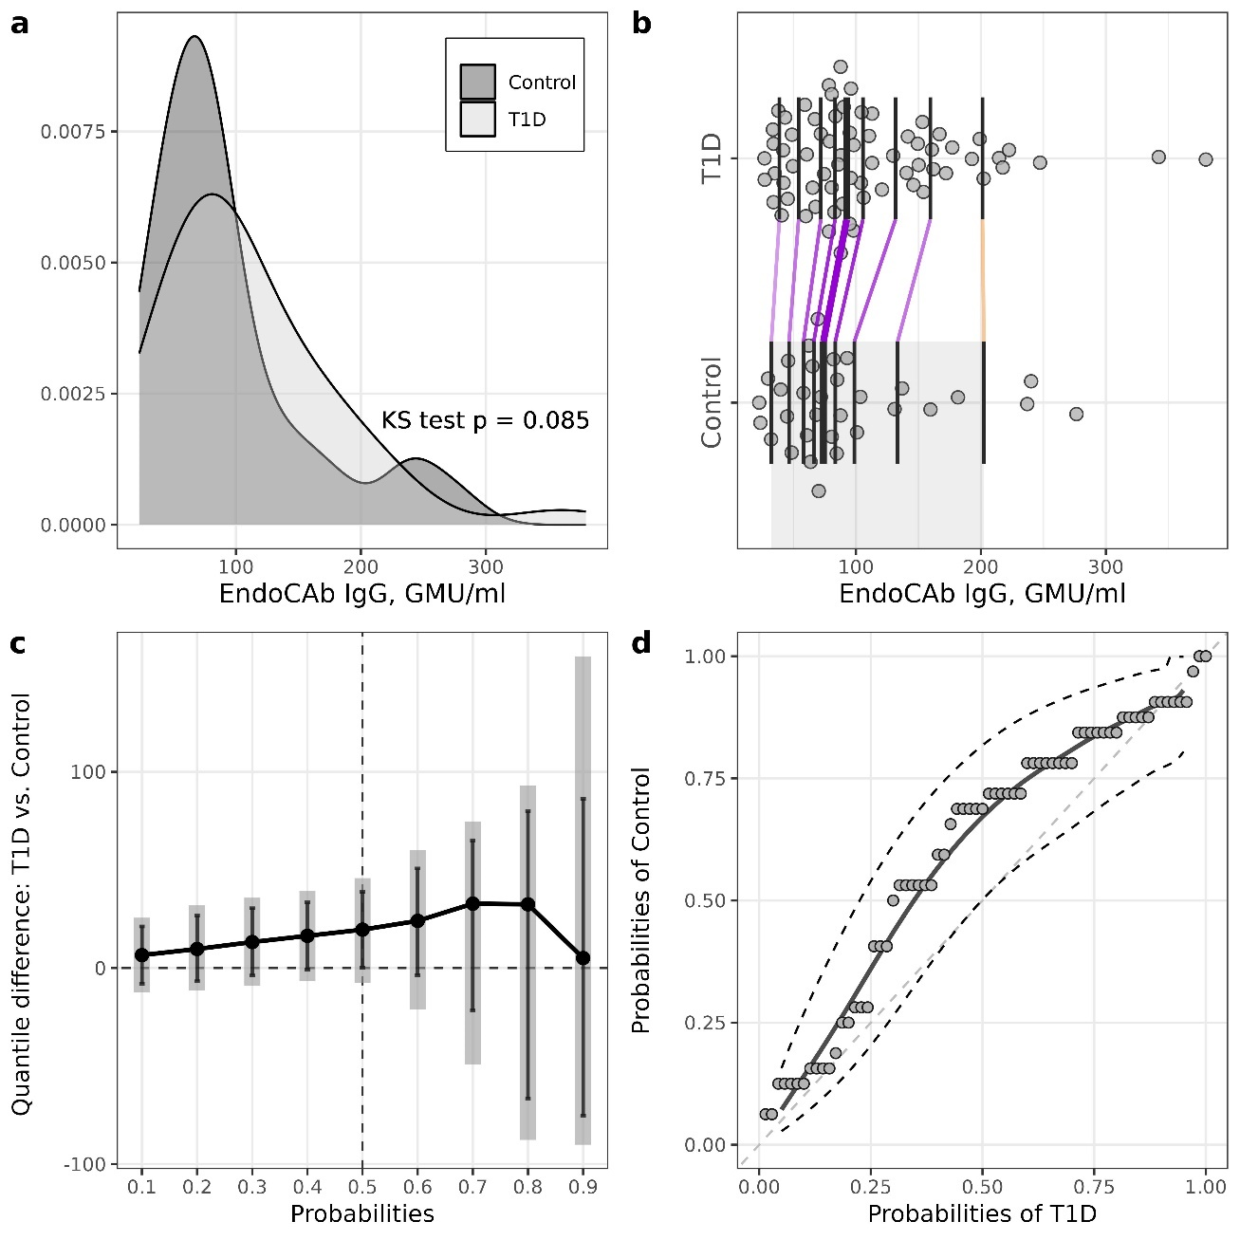
Supplemental Figure 2. Illustrations for comparison of EndoCAb IgG levels between control and T1D groups. a – plots of densities in control and T1D, p-value of Kolmogorov-Smirnov (KS) test for the equality of distributions; b – one-dimensional scatterplots for control and T1D, vertical bars represents deciles of both groups (R library rogme); c – quantile difference (T1D - control) plot constructed at deciles, estimates obtained using two-sample smoothed empirical likelihood method (R library EL), error bars represent 95% pointwise CI’s, shaded bars representing 95% simultaneous confidence bands for 9 deciles; d – probabilities of T1D versus probabilities of control (PP-plot) with estimate and 95% pointwise CI’s obtained by two-sample smoothed empirical likelihood method (R library EL). Bandwidths for kernel estimation in c and d were selected using method by Sheather and Jones (function bw.SJ in R).

