Adjusting N-doping to balance conductivity and polarization for superb electromagnetic wave absorption properties of SiO₂
Yunfei He¹, Xinyu Li¹, Dongdong Liu¹, Wenbo Fu¹, Qiang Su¹, Bo Zhong¹, Long Xia¹, Xiaoxiao Huang^{2,3}
¹ School of Materials Science and Engineering, Harbin Institute of Technology at Weihai, Weihai 264009, P. R. China
² School of Materials Science and Engineering, Harbin Institute of Technology, Harbin 150001, China
³ MIIT Key Laboratory of Advanced Structural-Functional Integration Materials & Green Manufacturing Technology, Harbin Institute of Technology, Harbin 150001, China

Corresponding Author
E-mail:
zhongbo@hit.edu.cn (Bo Zhong)
liudongdonghit@163.com (Dongdong Liu)

Supporting Information

2 Experimental Section
2.2 Preparation of SiO₂-N_{x} and p-SiO₂
According to the traditional Stöber method, 50 mL of ethanol absolute was mixed with 2 mL of NH₄OH and 1 mL of deionized water at 200 rpm for 5 minutes. Next, 1.5 mL of TEOS was added drop by drop, and the mixture was stirred and allowed to react for 12 hours at room temperature before being centrifuged. The final product was dried at 60°C, and ground to white powder (SiO₂). As shown in the Fig.1e, SiO₂ is formed by hydrolysis and condensation of TEOS, in which water comes from the reaction of monohydrazine hydrochloride with oxygen. The reaction equations involved are as follows [1]:
${\text{N}}_{\text{2}}{\text{H}}_{\text{4}}\text{+}{\text{O}}_{\text{2}}\text{→}{\text{N}}_{\text{2}}\text{+2}{\text{H}}_{\text{2}}\text{O}$ (S1)
$\text{Si(O}{\text{C}}_{\text{2}}{\text{H}}_{\text{5}}{\text{)}}_{\text{4}}\text{+4}{\text{H}}_{\text{2}}\text{O→Si}\text{(OH}{\text{)}}_{\text{4}}\text{+4}{\text{C}}_{\text{2}}{\text{H}}_{\text{5}}\text{OH}$ (S2)
$\text{Si(OH}{\text{)}}_{\text{4}}\text{→Si}{\text{O}}_{\text{2}}\text{+2}{\text{H}}_{\text{2}}\text{O}$ (S3)

Table S1 Specific proportions of raw materials for different groups of samples.
Sample | Monohydrazine hydrochloride/g | TEOS/mL | DMF/mL
SiO₂-N₁ | 0.685 | 2.2 | 20
SiO₂-N₂ | 1.370 | 2.2 | 20
SiO₂-N₃ | 2.055 | 2.2 | 20
SiO₂-N₄ | 2.740 | 2.2 | 20

2.3 Characterization
2.3.1 Materials Studio simulation
All density general function theory (DFT) based calculations were done using Materials Studio's CASTEP module. OTFG Ultrasoft pseudopotential method was adopted to describe the interaction between valence electrons and ion cores. The generalized gradient approximation (GGA) with Perdew-Burker-Ernzerhof (PBE) functional was used to describe the exchange-correlation effects. For geometrical optimization, the convergence criterion for energy, maximum force, maximum stress, plane-wave energy cutoff and vacuum gap were set at 1.0e-6 eV/atom, 0.03 eV/Å, 0.05 GPa, 400 eV, 15 Å, respectively [2]. When performing characteristic calculation, the paths of the k-point was chosen from the Ref. [3]. The structure optimization of SiO₂ (Scheme S1a) was performed, and simulated band structure diagram was shown in Scheme S1b. After that, the surface structure optimization of SiO₂ was based on the above operation.
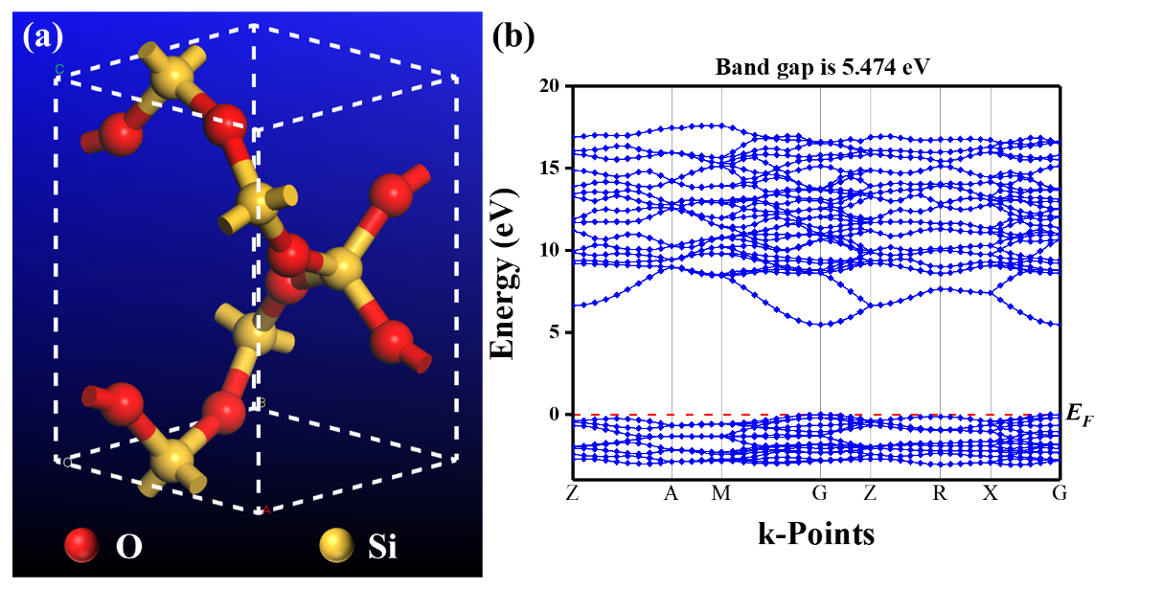
Scheme S1 (a) SiO₂ crystal structure model, (b) schematic diagram of the energy band structure of SiO₂.
2.3.2 COMSOL simulation
Based on the electromagnetic parameters of SiO₂-N₄, the macroscopic electromagnetic field of SiO₂-N_{x} is simulated with the main model shown in Scheme S2a and the thickness of the simulated layer is 2.5 mm. The Z-axis negative direction is set as the EMW incidence direction. The electric field mode and the electric energy density distribution at the frequency point of 13.68 GHz are calculated respectively. At the same time, the RL variation law from 2~18 GHz is simulated to verify the correctness of the model establishment (Scheme S2b).
According to the characterization and analysis results, the model of SiO₂-N_{x} is simplified here as an N-layer clad SiO₂ (Scheme S2c), i.e., the overall rectangular block with a scale of 20*20*2 μm. SiO₂ core volume is 15*15*1 μm. Meanwhile, the block is uniformly distributed, and a suitable interfacial distance is set in order to avoid error reporting in meshing.
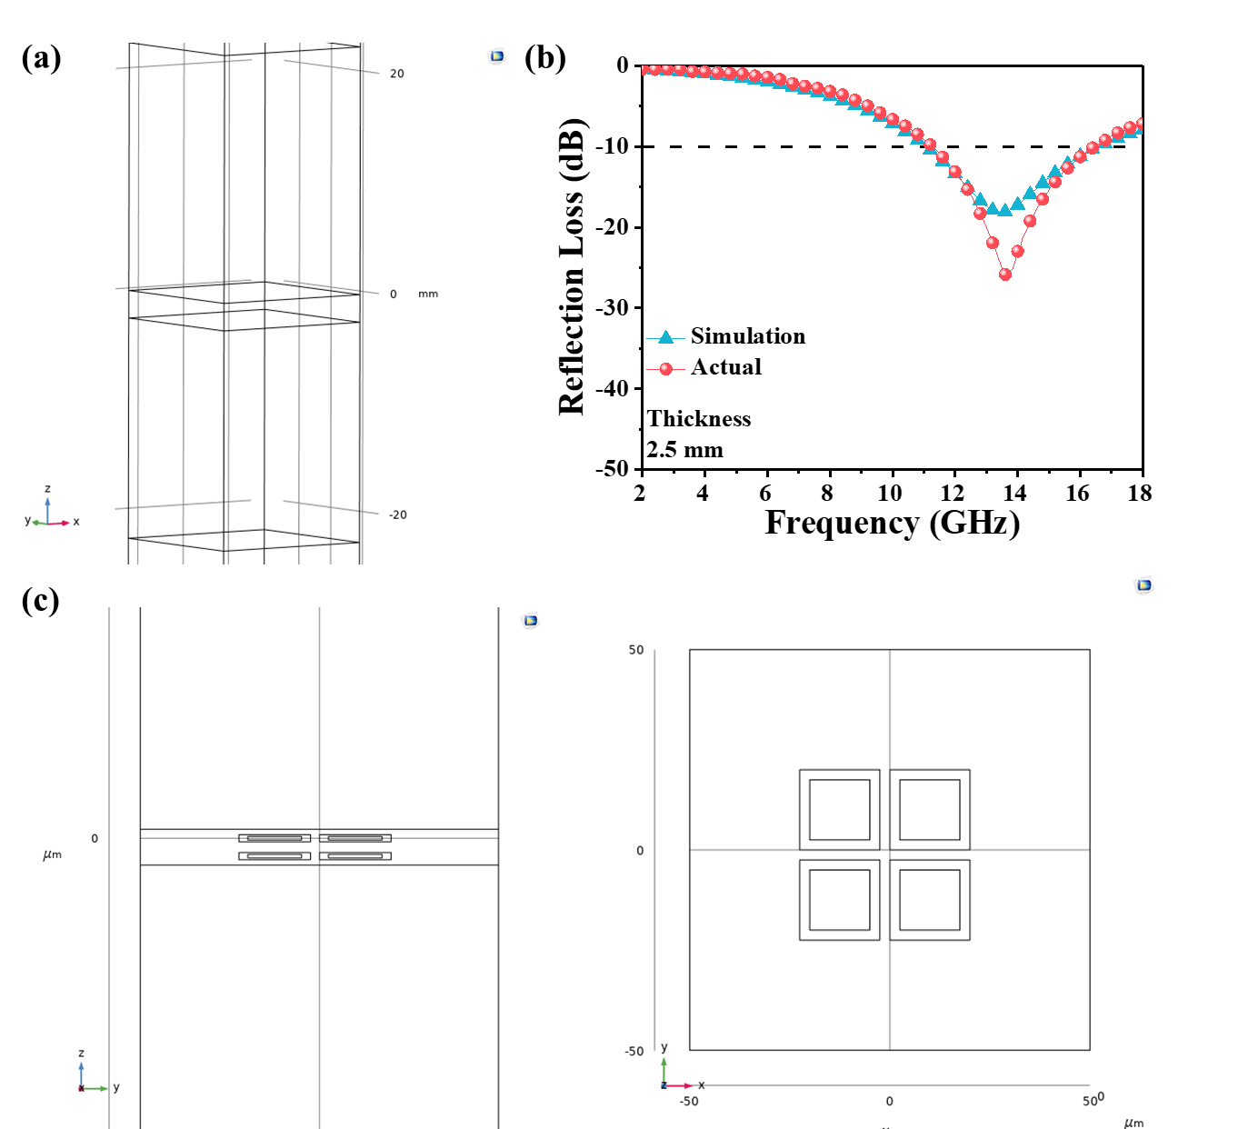
Scheme S2 (a) SiO₂-N₄ macroscopic model, (b) comparison of simulated and actual RL curves of SiO₂-N₄ at 2.5 mm thickness, (c) microscopic left view and top view of SiO₂-N₄.

3 Results and discussion
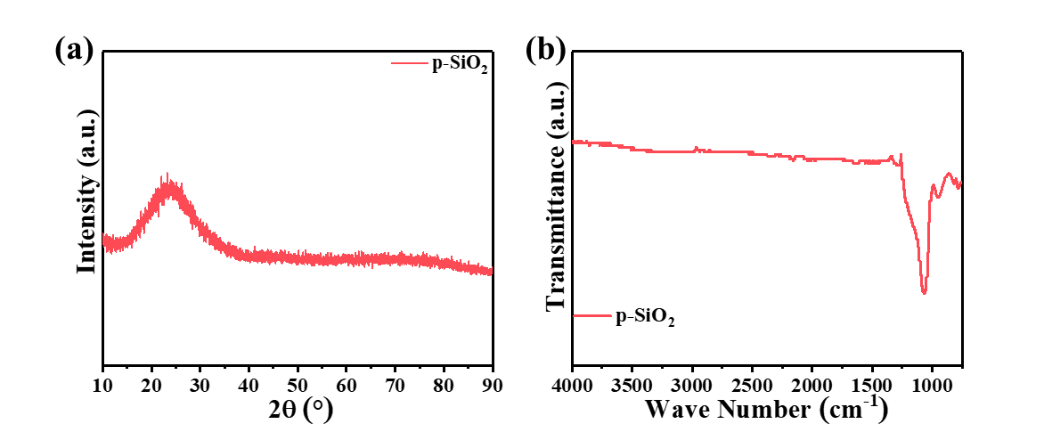
Fig.S1 (a) XRD and (b) FT-IR patterns of p-SiO₂.
The presence of insignificant Si-N absorption peaks for p-SiO₂ results from the influence of NH₄OH.
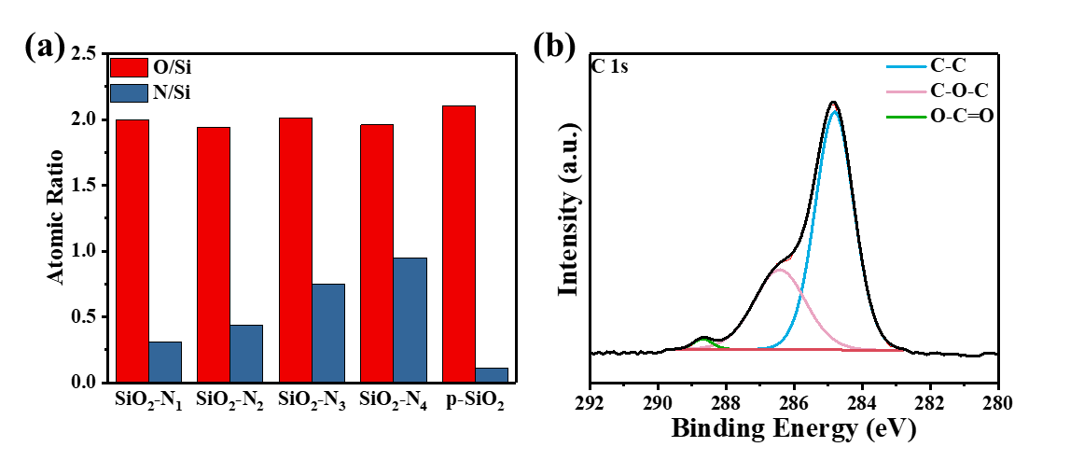
Fig.S2 (a) Atomic ratio statistic diagram of SiO₂-N_{x} and p-SiO₂, (b) C 1s region XPS spectra of SiO₂-N₄.
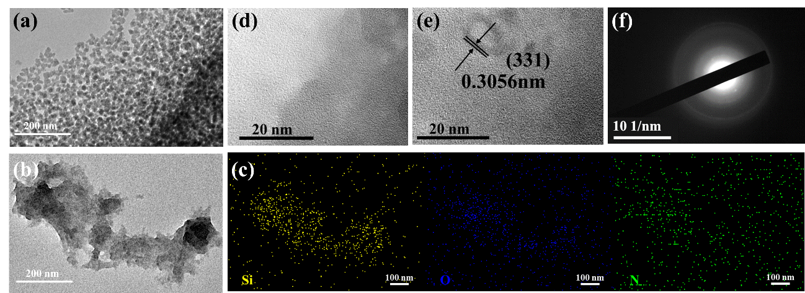
Fig.S3 TEM images of (a) p-SiO₂ and (b) SiO₂-N₄, (c) corresponding Si,O,N element maps of SiO₂-N₄, (d,e) HRTEM and (f) SAED image of SiO₂-N₄.
0.3056 nm lattice spacing of SiO₂-N₄ corresponds to the (331) crystal plane of SiO₂ (Fig.S4e), which again confirms the XRD and previous characterization results. As shown in Fig.S4f, the selected area electron diffraction (SAED) pattern taken from Fig.S4e exhibits multiple diffraction rings, indicating the amorphous state of SiO₂-N₄.
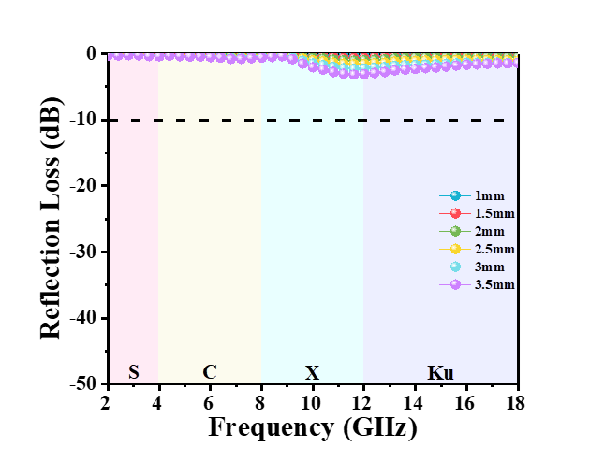
Fig.S4 2D reflection loss graph of p-SiO₂ with absorber thickness from 1 mm to 3.5 mm at a filler loading of 60 wt.%.

Table S2 Summary of EMW absorption characteristics of all samples.
Sample | RL_{min}/dB | The thickness corresponding to RL_{min}/mm | EAB/GHz | The thickness corresponding to EAB/mm
p-SiO₂ | -3.17 | 3.5 | - | -
SiO₂-N₁ | -7.00 | 3.5 | - | -
SiO₂-N₂ | -32.20 | 3.5 | 5.20 | 2.5
SiO₂-N₃ | -32.41 | 3.5 | 4.72 | 3
SiO₂-N₄ | -34.48 | 3 | 5.28 | 2.5

Fig.S5 The real and imaginary part of relative complex permittivity, dielectric loss tangent of p-SiO₂.
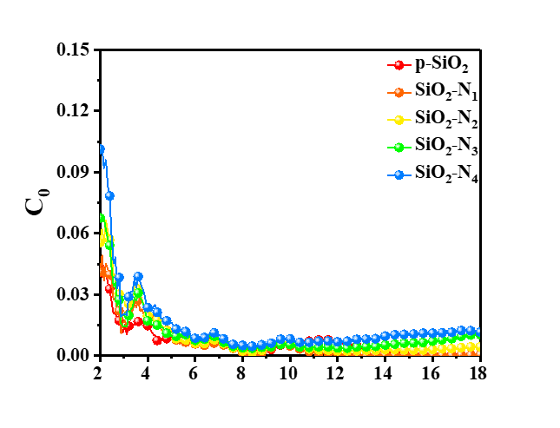
Fig.S6 C₀ - frequency function graph of SiO₂-N_{x} and p-SiO₂.
Combined with the analysis of the SiO₂-N_{x} eddy current coefficients (C₀), as shown in Fig.S6, the trend of C₀ with frequency is almost the same for the four groups of absorbers. The existence of obvious fluctuations before 4 GHz indicates that the eddy current loss is not the dominant magnetic loss [4-6], while the change of C₀ tends to flatten out after 4 GHz, indicating that the magnetic loss present at high frequencies is dominated by eddy current loss. Meanwhile, the C₀ coefficient of p-SiO₂ is compared, which are consistent with the above analysis. When evaluated along with the samples' magnetic parameters, the magnetic loss of p-SiO₂ and SiO₂-N_{x} is negligible in comparison to the dielectric loss.
Fig.S7 ε’’ c and ε’’ p plots of p-SiO₂.
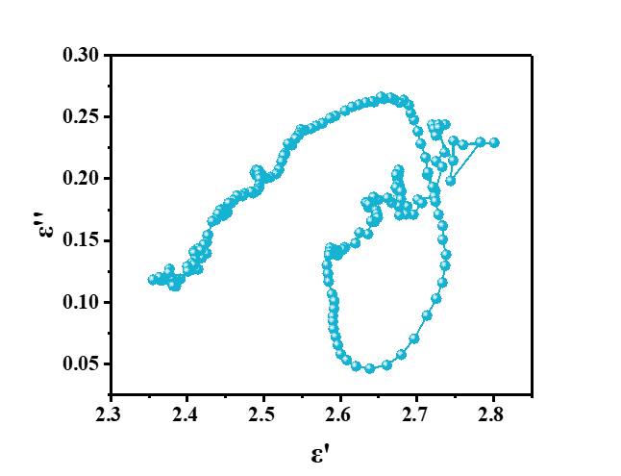
Fig.S8 Cole-Cole plot of p-SiO₂.
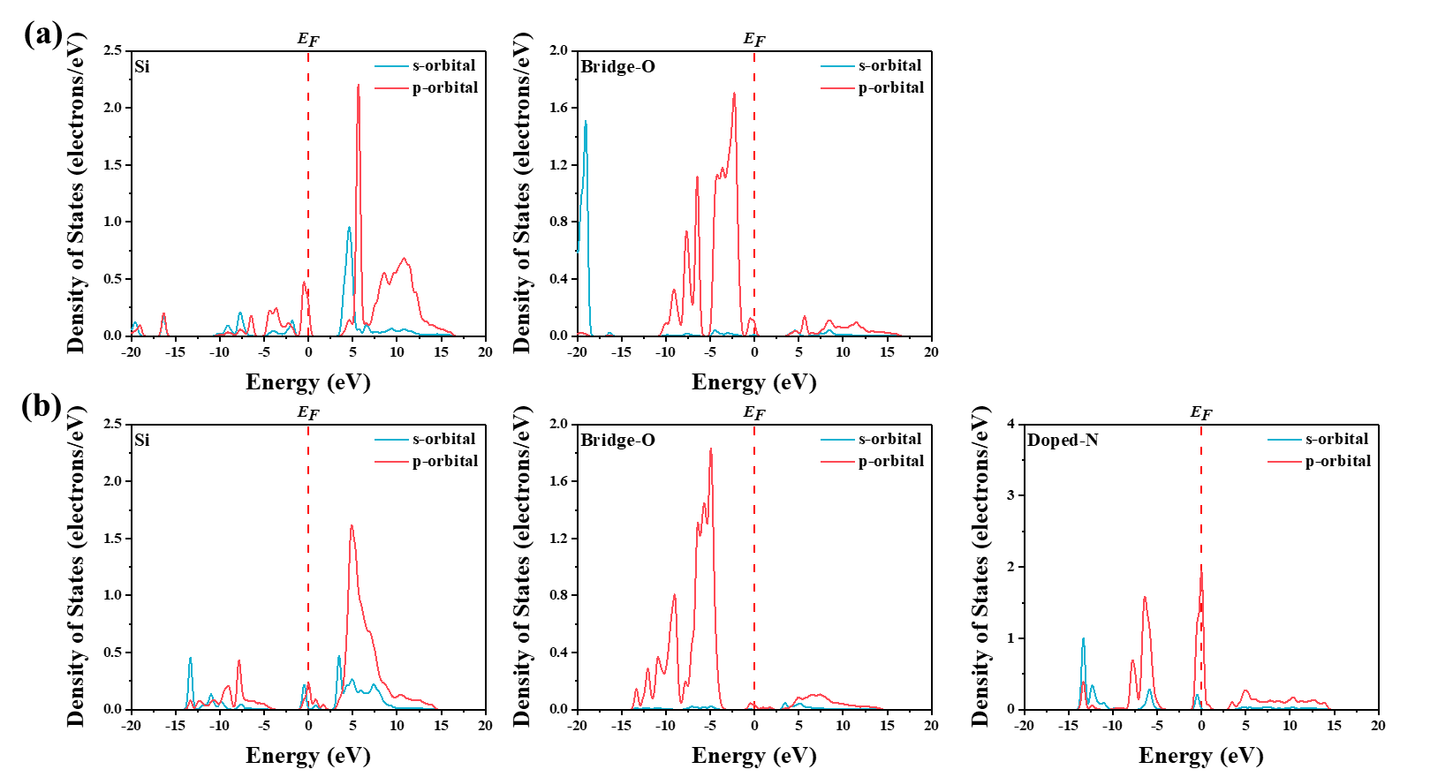
Fig.S9 (a) Schematic of PDOS of Si and Bridge-O on SiO₂ surface, (b) schematic of PDOS of Si, Bridge-O and surface N on SiO₂-N_{x} surface.
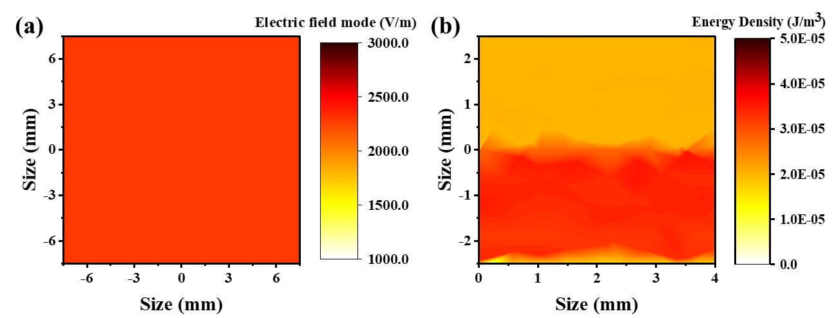
Fig.S11 When p-SiO₂ is macroscopic monoliths, (a) the electric field mode distribution on the upper surface of the material and (b) the electricity density distribution on the cross section along the direction of EMW propagation.

References
[1] Niu H, Tu X, Zhang S, Li Y, Wang H, Shao G, et al. Engineered core-shell SiO₂@Ti₃C₂Tx composites: Towards ultra-thin electromagnetic wave absorption materials. Chem Eng J. 2022;446:137260.
[2] Zhang W, Xiao D, Ding D. A first-principles investigation of interfacial properties and electronic structure of SiO₂/Al interface. Computational Materials Science. 2021;188.
[3] Setyawan W, Curtarolo S. High-throughput electronic band structure calculations: Challenges and tools. Computational Materials Science. 2010;49(2):299-312.
[4] Zhao B, Zhao W, Shao G, Fan B, Zhang R. Morphology-control synthesis of a core–shell structured NiCu alloy with tunable electromagnetic-wave absorption capabilities. ACS Applied Materials & Interfaces. 2015;7(23):12951-60.
[5] Cheng H, Pan Y, Wang X, Liu C, Shen C, Schubert DW, et al. Ni Flower/MXene-Melamine Foam Derived 3D Magnetic/Conductive Networks for Ultra-Efficient Microwave Absorption and Infrared Stealth. Nano-micro letters. 2022;14(1):63.
[6] Liang L, Li Q, Yan X, Feng Y, Wang Y, Zhang HB, et al. Multifunctional Magnetic Ti3C2Tx MXene/Graphene Aerogel with Superior Electromagnetic Wave Absorption Performance. ACS Nano. 2021;15(4):6622-32.

