Supporting information

Structure and variation of root-associated bacterial communities of Cyperus rotundus L. in the contaminated soils around Pb/Zn mine sites

Pin Gao¹, Benru Song¹, Rui Xu, Xiaoxu Sun, Hanzhi Lin, Fuqing Xu, Baoqin Li, Weimin Sun*

National-Regional Joint Engineering Research Center for Soil Pollution Control and Remediation in South China, Guangdong Key Laboratory of Integrated Agro-environmental Pollution Control and Management, Institute of Eco-environmental and Soil Sciences, Guangdong Academy of Sciences, Guangzhou 510650, China

*Correspondence to:
Dr. Weimin Sun
808 Tianyuan Road, Guangzhou, Guangdong, China
Phone: 86-020-87024633
Fax: 86-020-87024123
Email: wmsun@soil.gd.cn
¹ These authors contribute equally to this paper.

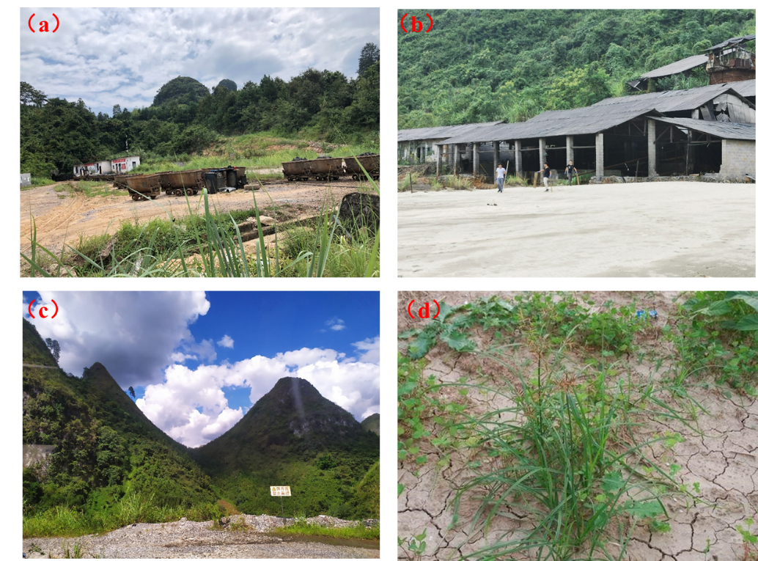
Fig. S1. Pictures of sampling sites including (a) GD, (b) SL, (c) SD, and (d) Cyp plants.

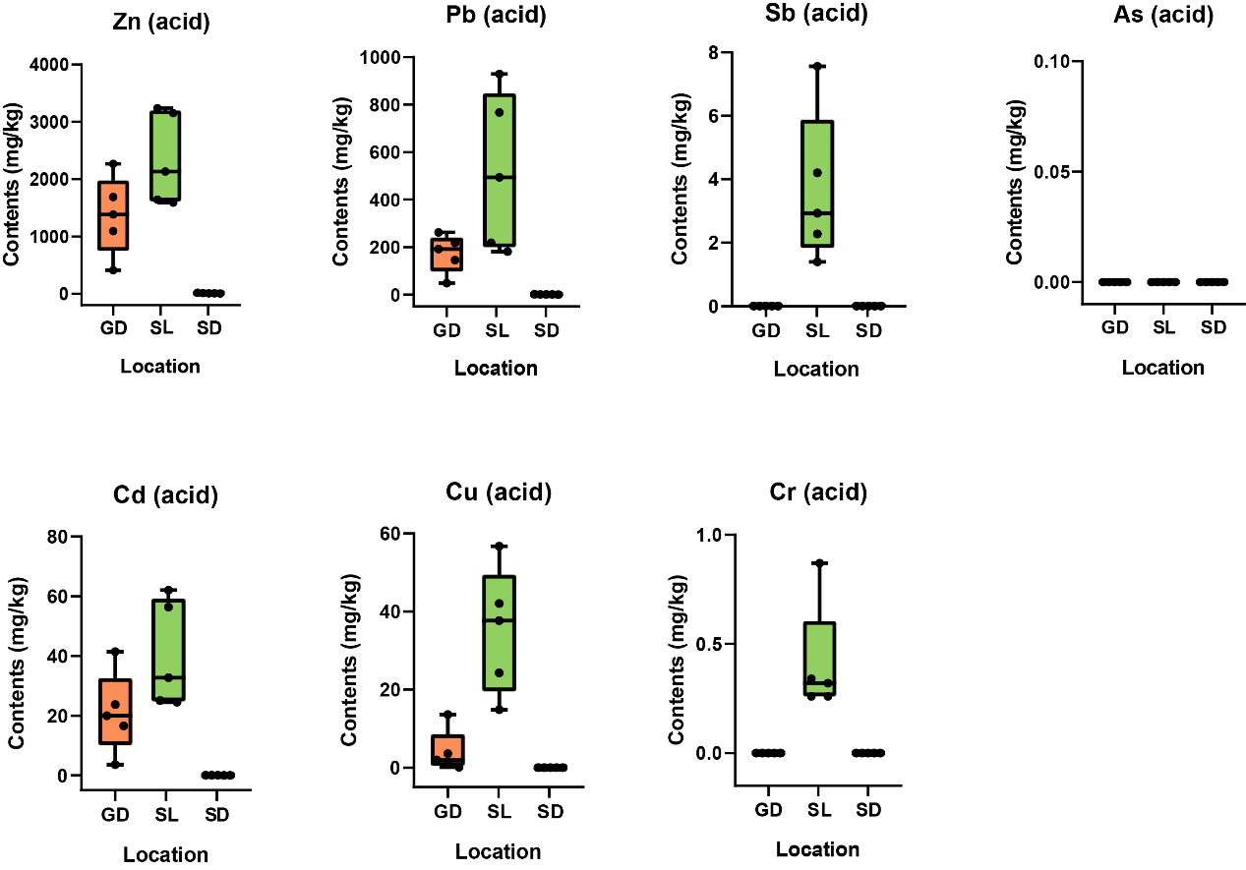
Fig. S2. Acid-soluble fractions of heavy metal(loid)s concentrations in the GD, SL, and SD bulk soil.

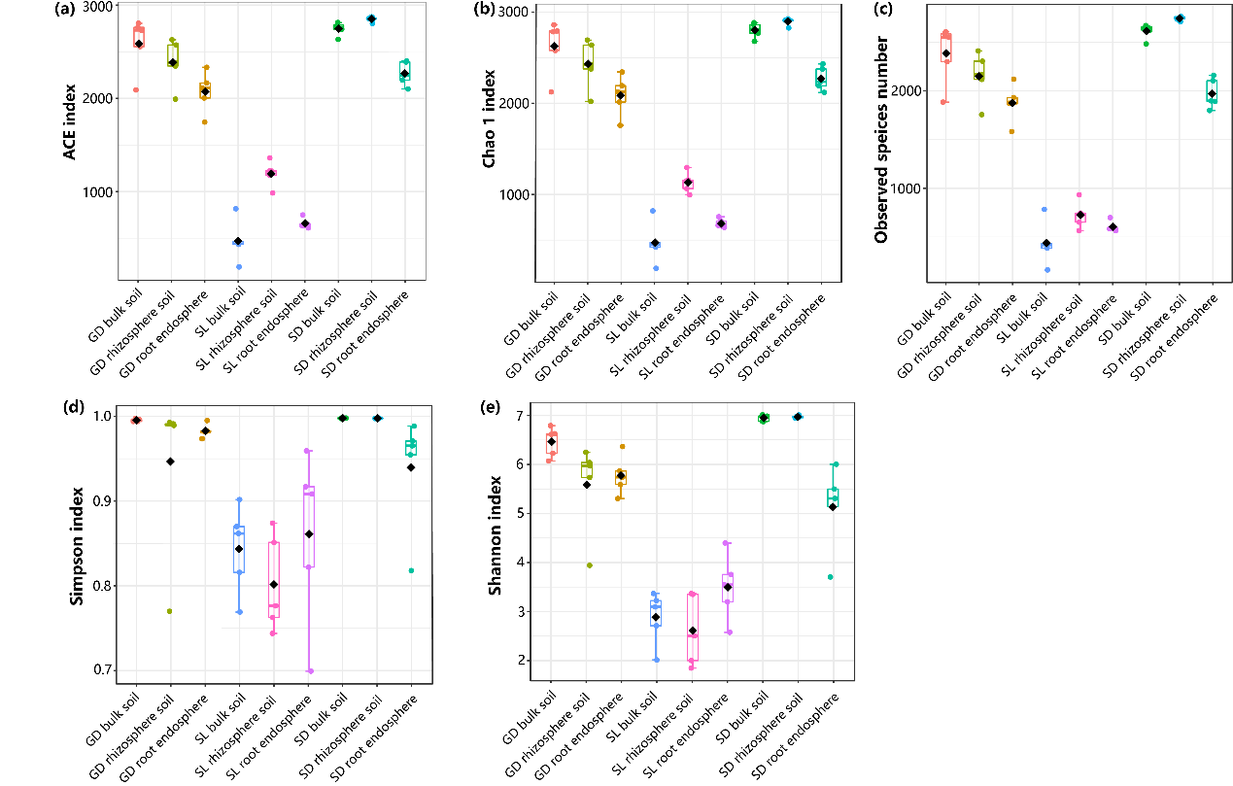
Fig. S3. Alpha diversity estimates of the bacterial communities in the bulk soil, rhizosphere soil, and root endosphere in the GD, SL, and SD sites. (a) ACE; (b) Chao1; (c) Observed species number; (d) Shannon; (e) Simpson index. Samples marked as Bul, Rhi, and End represent bulk soil, rhizosphere soil, and root endosphere, respectively.

