Table 1. Optimization of Enantioselective Copper-Catalyzed Chan-Lam Coupling of Sulfenamide (1a) with 4-tert-Butyl Phenylboronic Acid (2a)ª
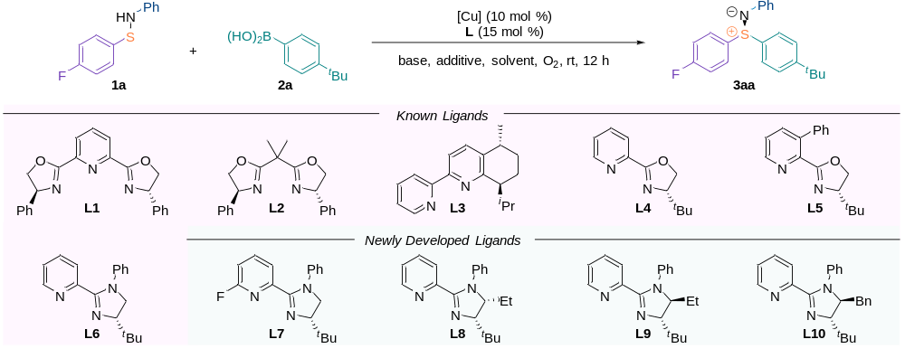
entry | ligand | assay yield^{b}/% | ee^{c}/% | entry | ligand | assay yield^{b}/% | ee^{c}/%
1^{d} | L1 | 8 | 18 | 8e | L7 | 20 | 13
2^{d} | L2 | 11 | 18 | 9^{e,f} | L6 | 87 | 80
3^{d} | L3 | trace | / | 10^{e,f} | L8 | 85 | 82
4^{d} | L4 | 25 | 43 | 11^{e,f} | L9 | 86 | 90
5e | L4 | 50 | 58 | 12^{e,f} | L10 | 85 | 92
6e | L5 | 60 | 71 | 13^{e,f,g} | L10 | 88(83^{h}) | 92
7e | L6 | 44 | 80
ªReaction conditions unless stated otherwise: 1a (0.1 mmol), 2a (2.0 equiv), copper catalyst (10 mol %), ligand (15 mol %), base (2.0 equiv) and solvent (1.0 mL), at rt for 12 h under an O₂ atmosphere. ^{b}Assay yields determined by ¹H NMR spectroscopy of unpurified reaction mixtures using 0.1 mmol (7.0 μL) of CH₂Br₂ as internal standard. ^{c}Enantiomeric excess (ee) was determined by HPLC with a Daicel Chiralpak AS-H column (^{i}PrOH:hexane = 05:95, 0.3 mL/min), 254 nm, t_{R} (major) = 17.66 min, t_{R} (minor) = 20.13 min. ^{d}Cu(OAc)₂H₂O (10 mol %), Et₃N (2.0 equiv) and CH₂Cl₂ (1.0 mL). ^{e}CuTc (10 mol %), ^{i}Pr₂NEt (2.0 equiv) and DME (1.0 mL). ^{f}CsF (50 mol %). ^{g}Na₂CO₃ (2.0 equiv) instead of ^{i}Pr₂NEt. ^{h}Isolated yield.

Table 2. Scope of the Substrates
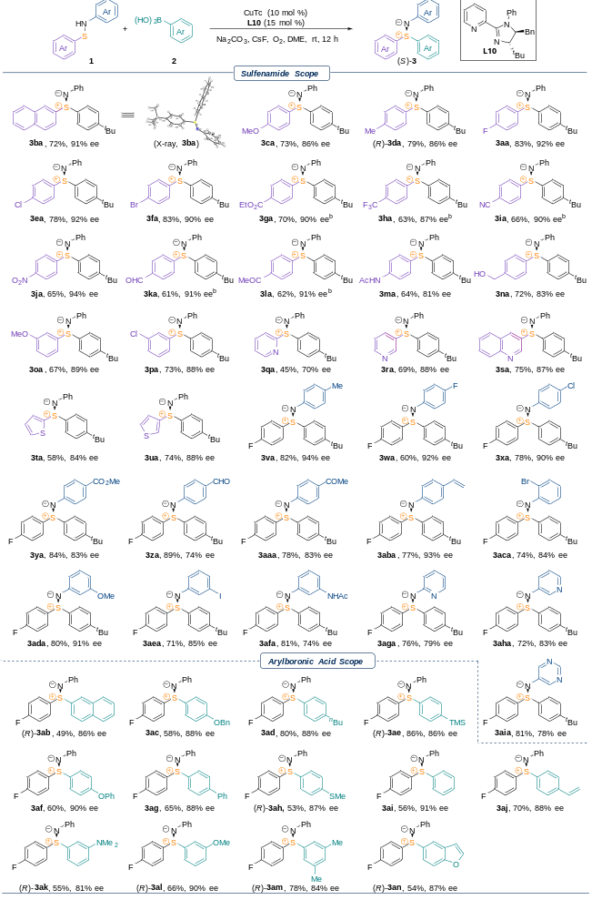
ªReaction conditions: 1 (0.1 mmol), 2 (2.0 equiv), CuTc (10 mol %), L10 (15 mol %), Na₂CO₃ (2.0 equiv), CsF (50 mol %) and DME (1.0 mL), at rt for 12 h under an O₂ atmosphere. ^{b}18 h.

