Additional file 2: figures

Figure S1. Scatter plots(a) and Leave-one-out plots(b) and forest plot(c) and Funnel plots (d) of MVPA on Keen OA
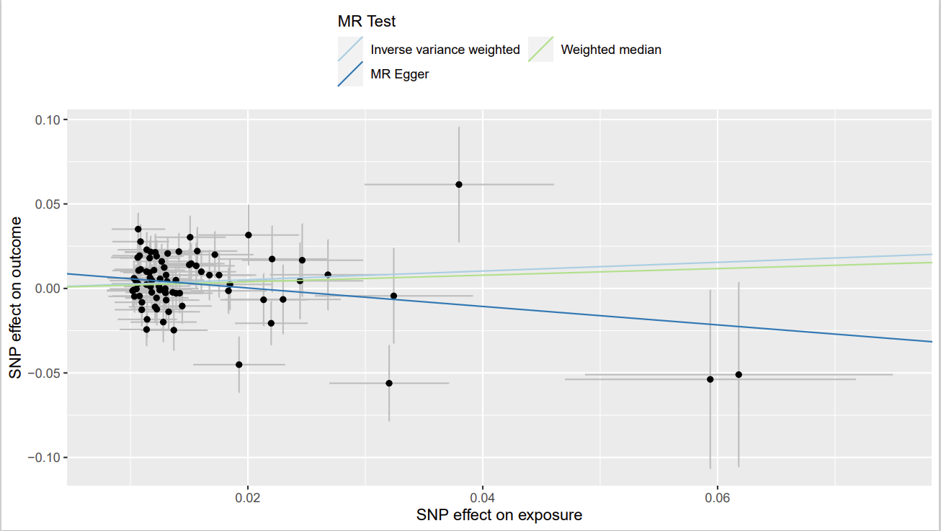
a

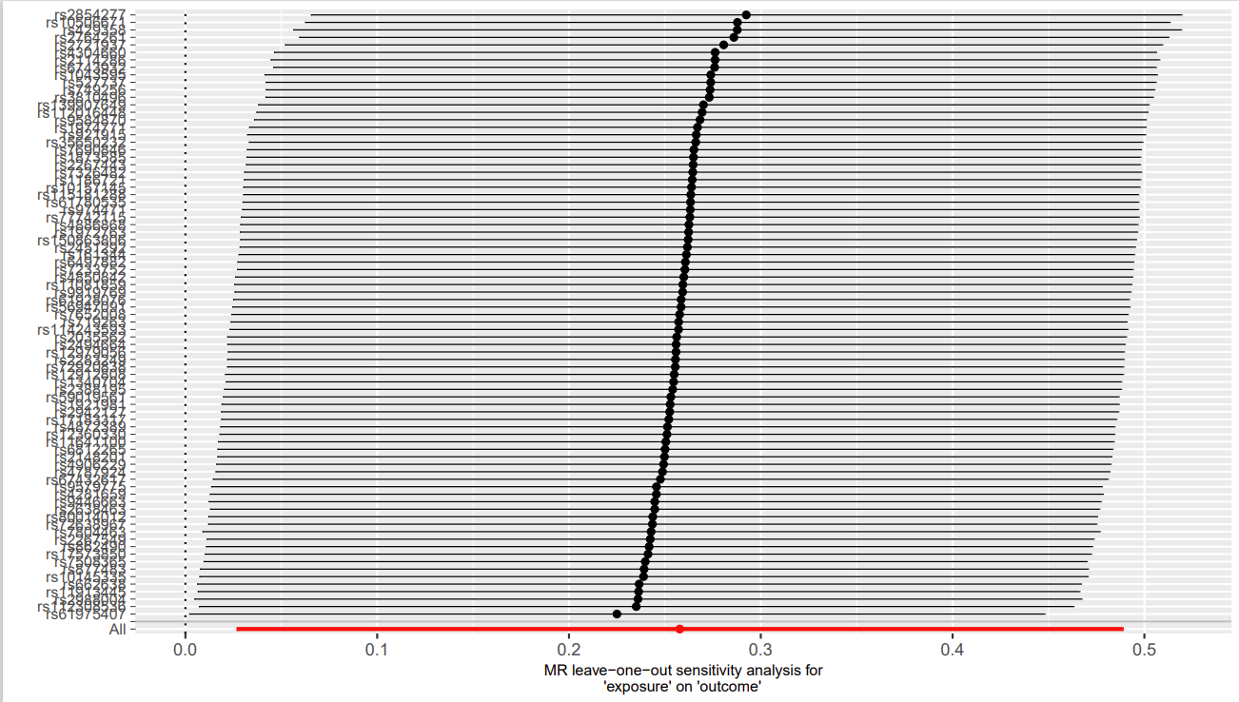
b

c
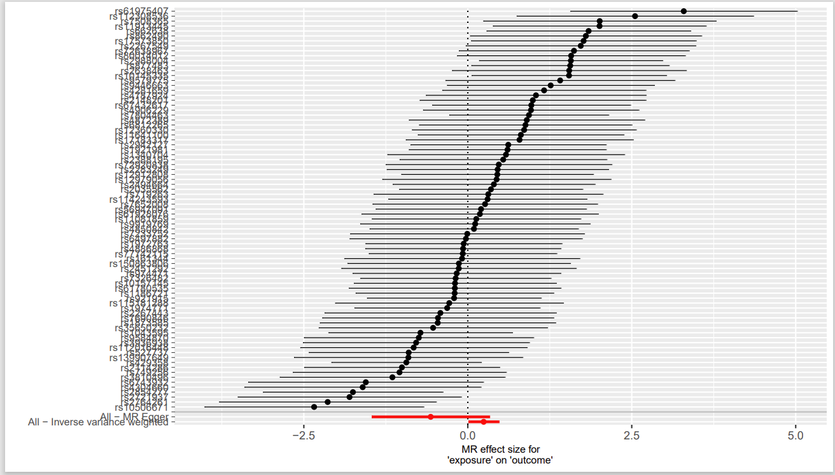

d
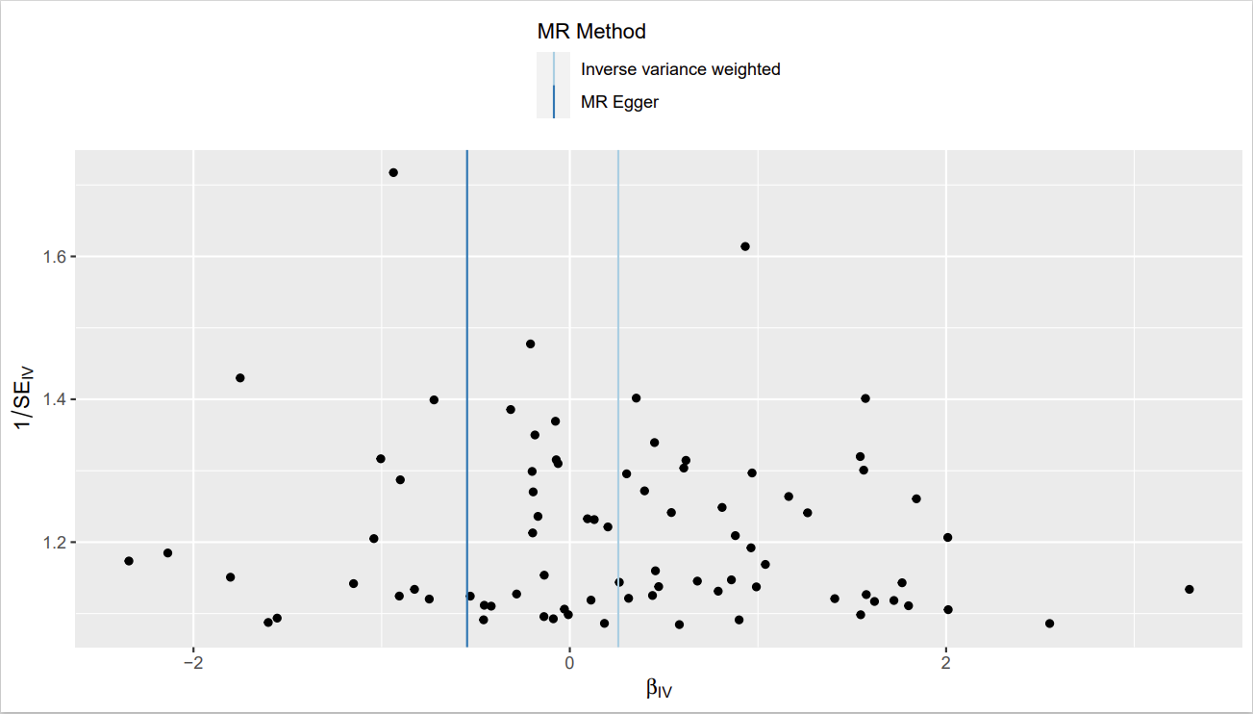

Figure S2. Scatter plots(a) and Leave-one-out plots(b) and forest plot(c) and Funnel plots (d) of leisure television watching on Hip OA
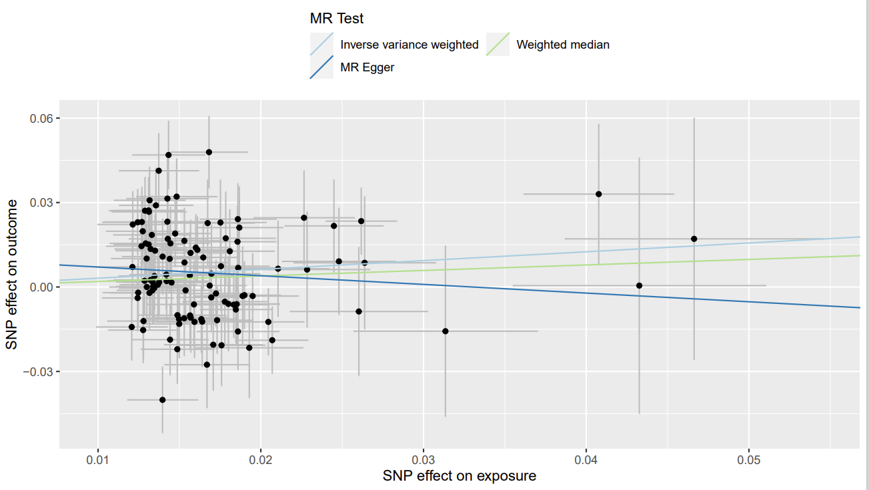
b
a

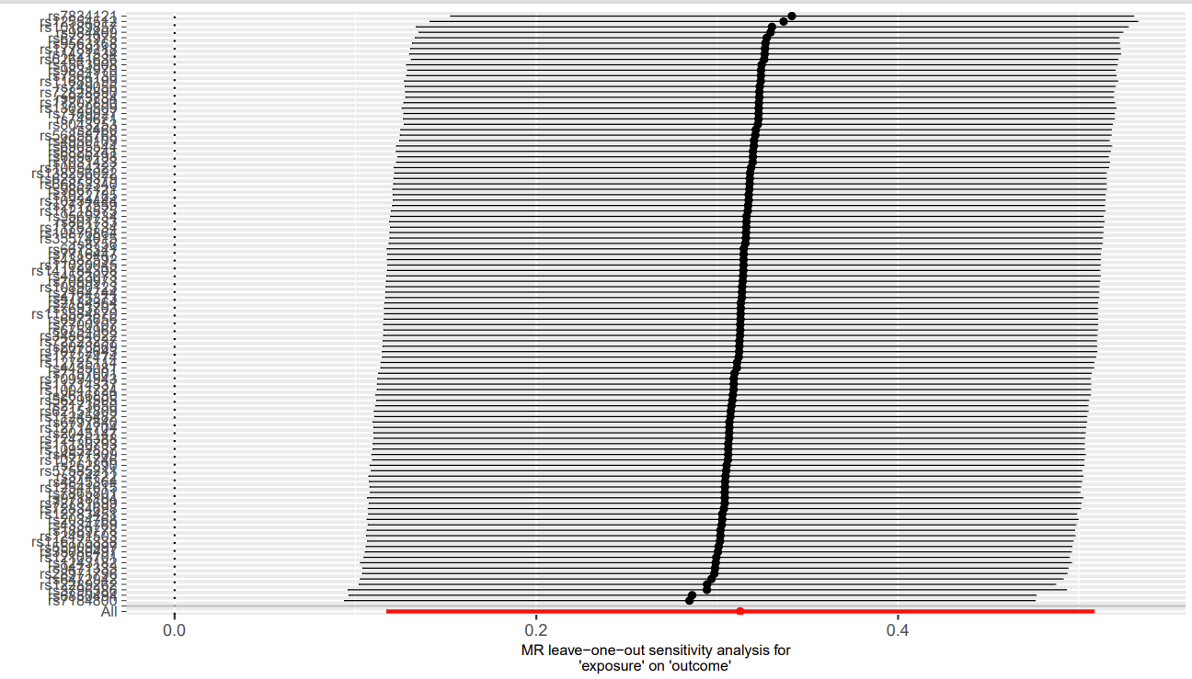

c
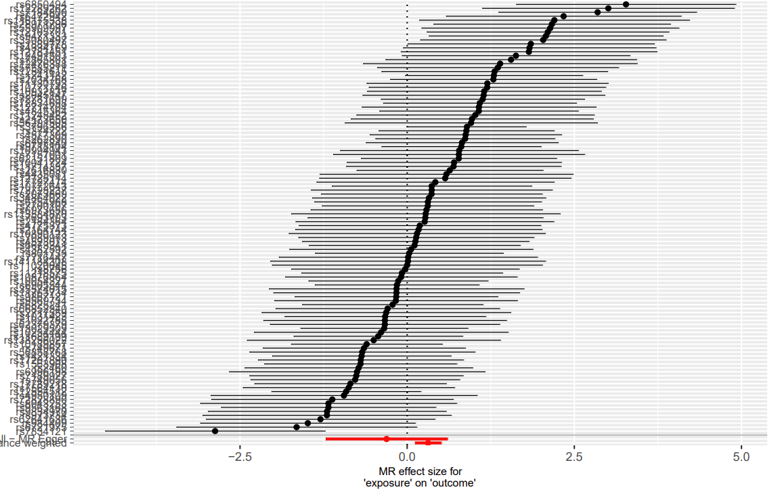
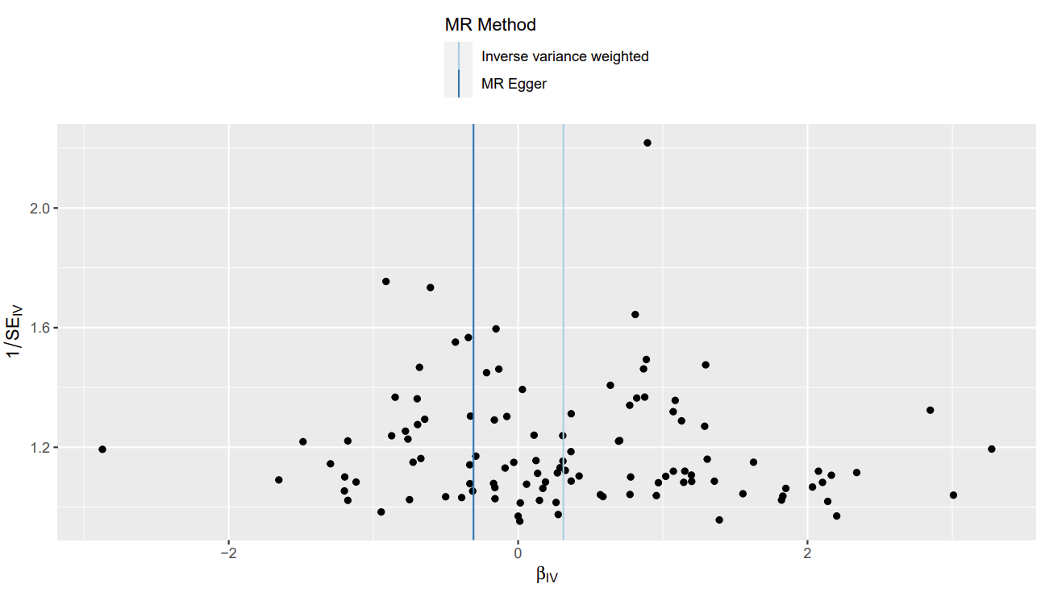
d
Figure S3. Scatter plots(a) and Leave-one-out plots(b) and forest plot(c) and Funnel plots (d) of leisure television watching on Keen OA

a
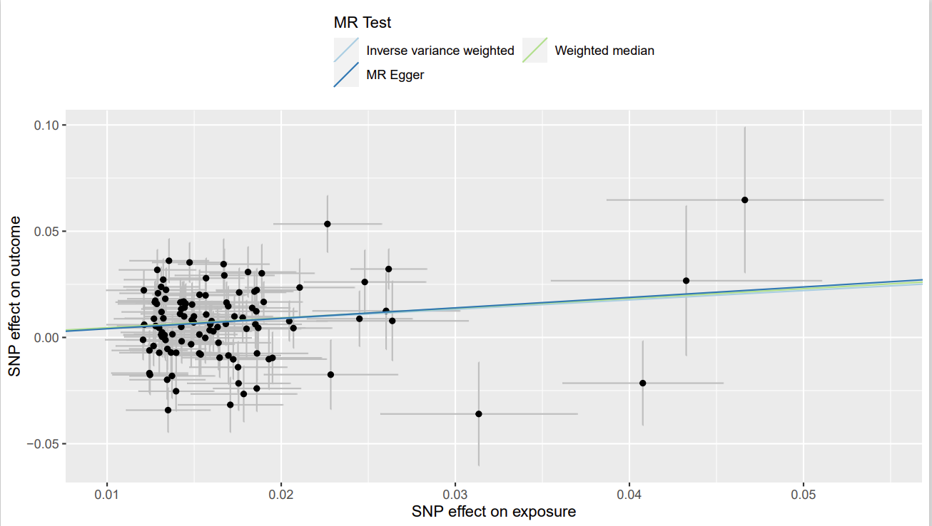
b
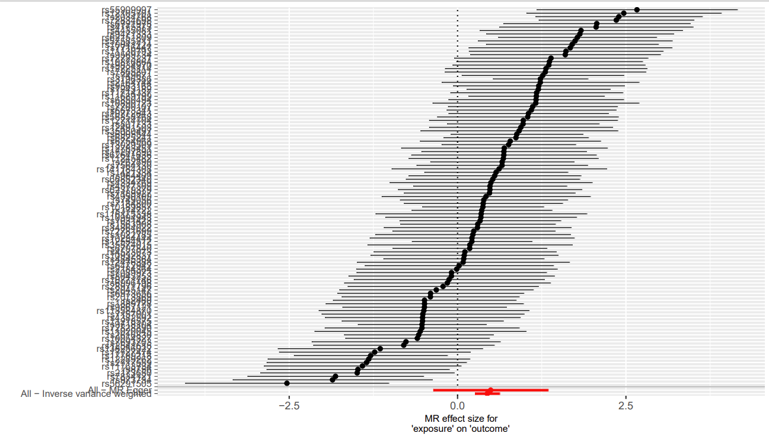

c

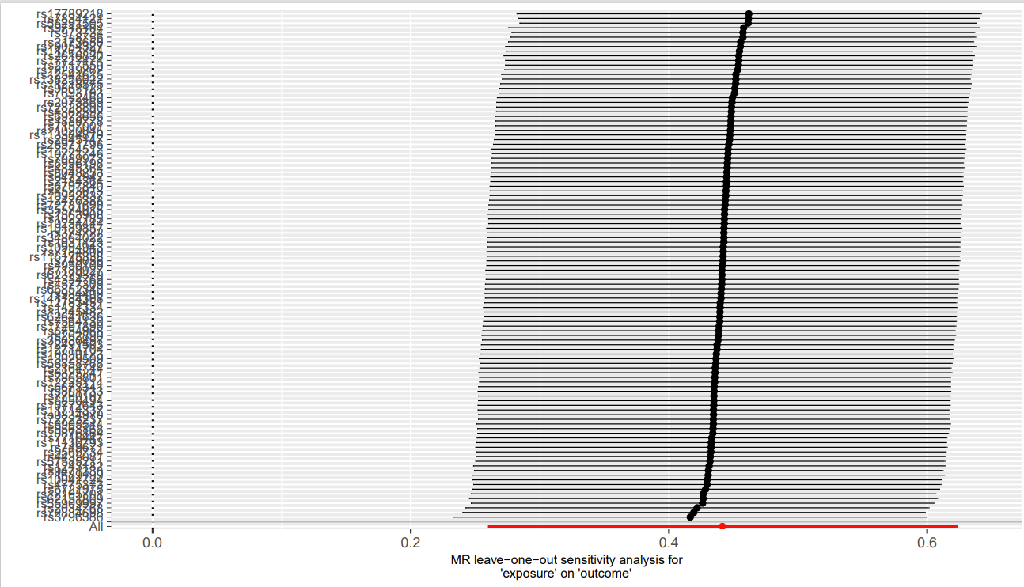

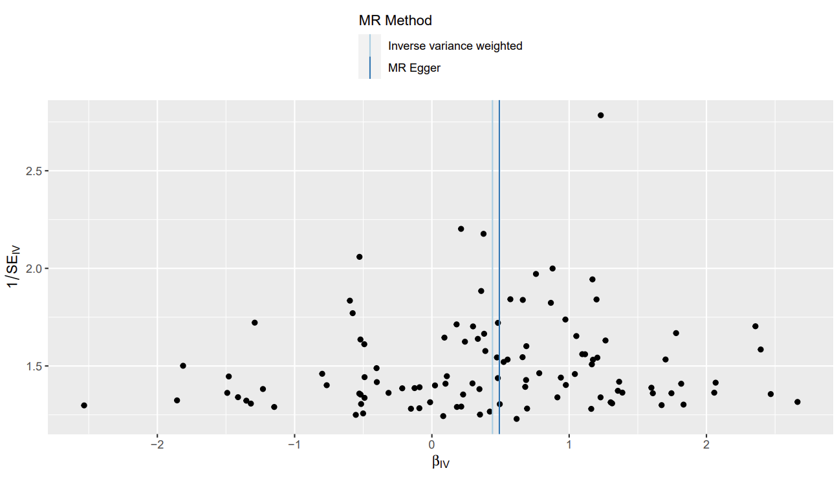
d

Figure S4. Scatter plots(a) and Leave-one-out plots(b) and forest plot(c) and Funnel plots (d) of leisure television watching on Hip and(or) Keen OA
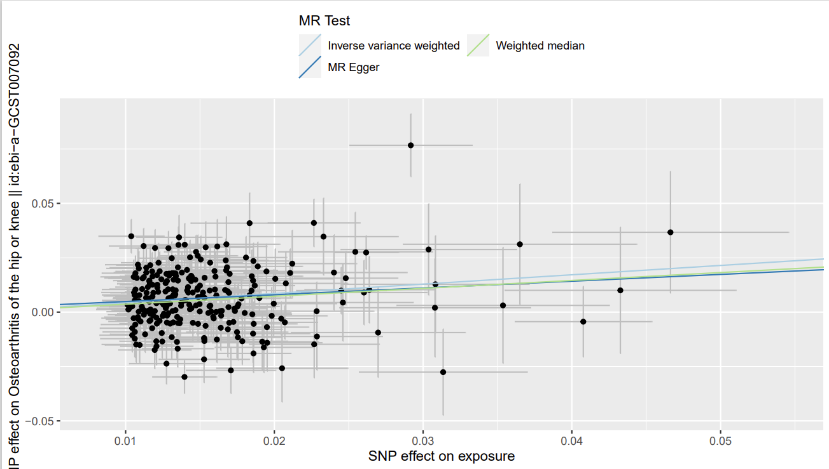
a

b
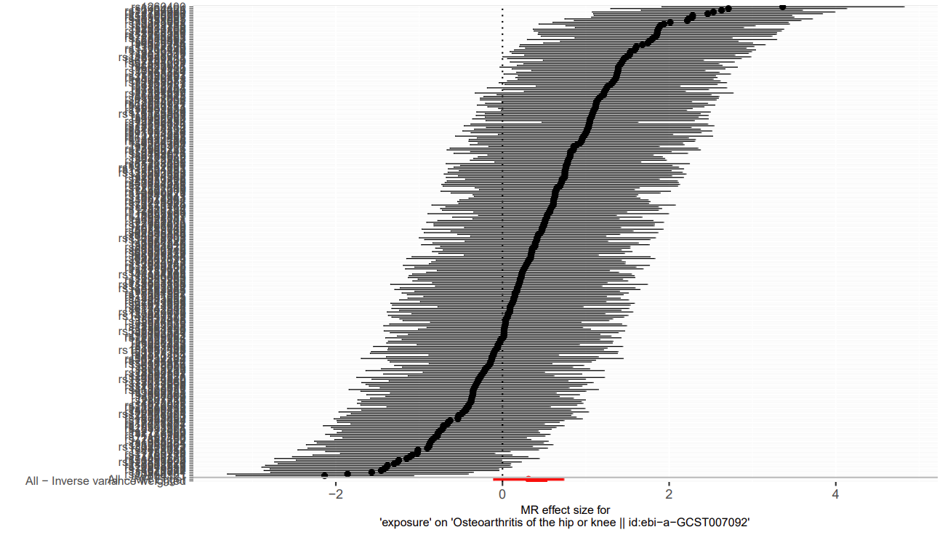

c
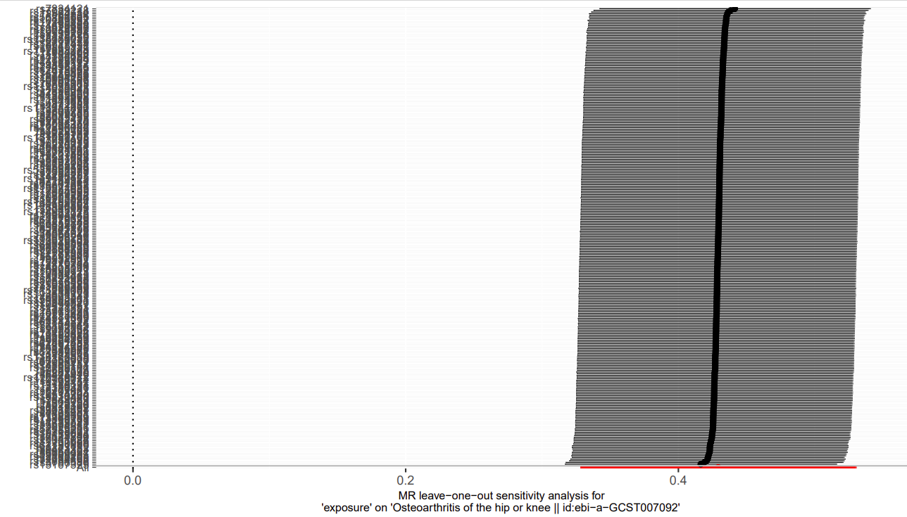
d
