Supplementary
New South Wales
 | Sydney Airport AMO (066037) | Bathurst Agricultural (063005)
Northern Territory
 | Darwin Airport (014015) | Alice Springs Airport (015590)
Western Australia
 | Perth Airport (009021) | Kalgoorlie-Boulder Airport (012038)
Queensland
 | Amberley AMO (040004) | Barcaldine Post Office (036007)
South Australia
 | Ceduna AMO (018012) | Adelaide Airport (023034)
Victoria
 | Laverton RAAF (087031) | Walpeup Research (076064)
Figure S1. Temporal trend in the Annual Maximum Temperature during 1969 to 2021.
New South Wales | 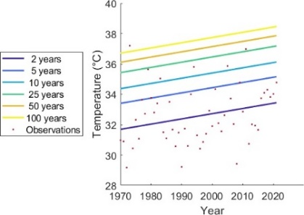 | 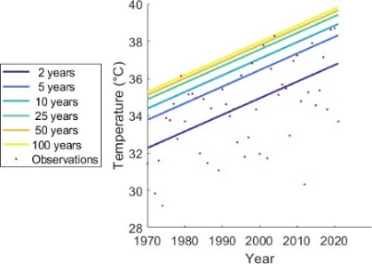
 | Sydney Airport AMO (066037) | Bathurst Agricultural (063005)
Northern Territory | 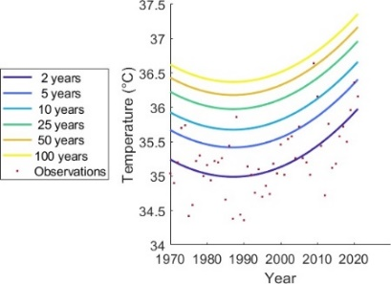 | 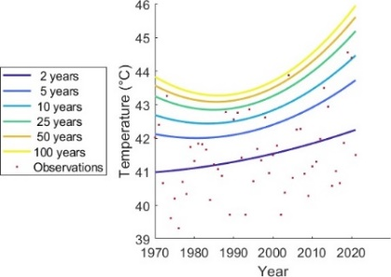
 | Darwin Airport (014015) | Alice Springs Airport (015590)
Western Australia | 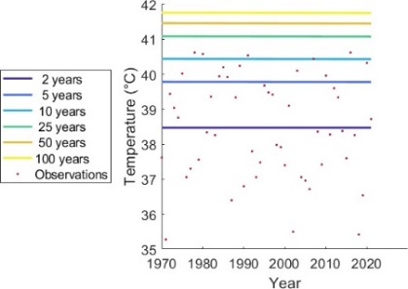 | 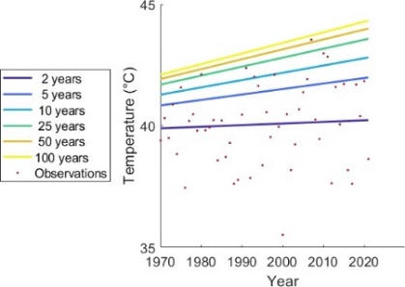
 | Perth Airport (009021) | Kalgoorlie-Boulder Airport (012038)
Queensland | 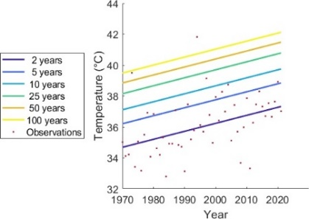 | 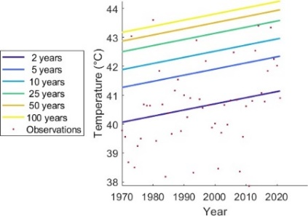
 | Amberley AMO (040004) | Barcaldine Post Office (036007)
South Australia | 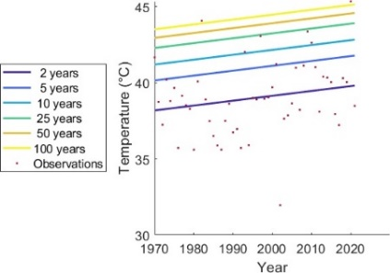 | 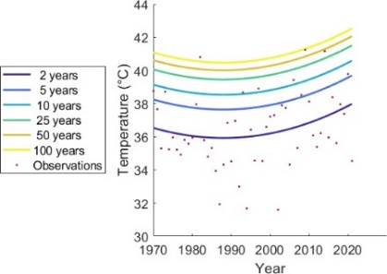
 | Ceduna AMO (018012) | Adelaide Airport (023034)
Victoria | 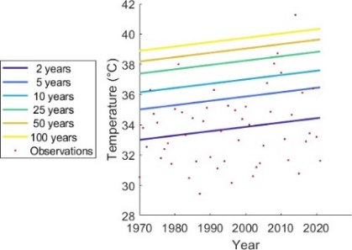 | 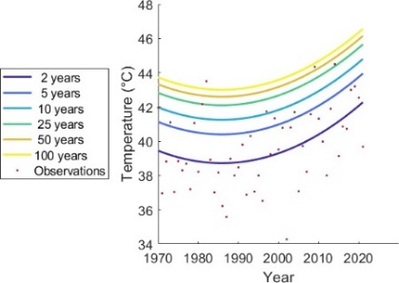
 | Laverton RAAF (087031) | Walpeup Research (076064)
Figure S2. Non-stationary TDF surfaces with Time covariates for 5-day duration.
New South Wales | 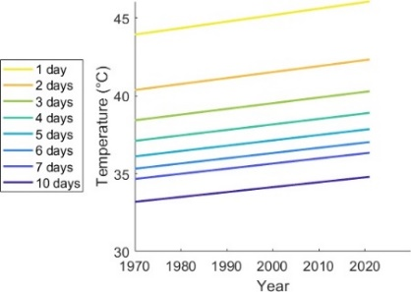 | 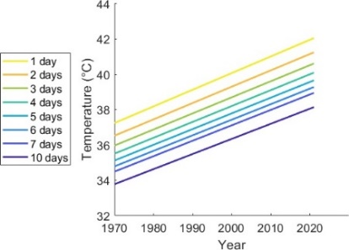
 | Sydney Airport AMO (066037) | Bathurst Agricultural (063005)
Northern Territory | 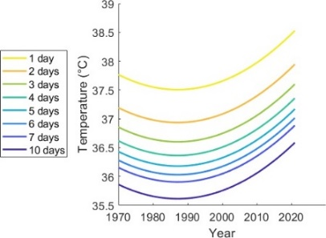 | 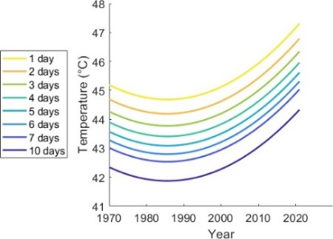
 | Darwin Airport (014015) | Alice Springs Airport (015590)
Western Australia | 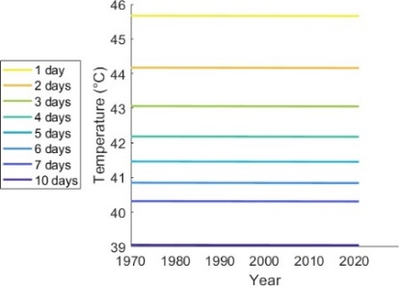 | 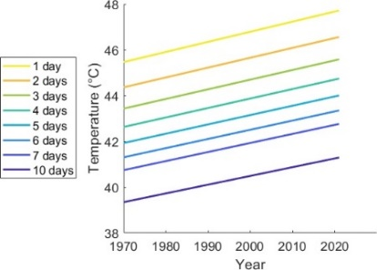
 | Perth Airport (009021) | Kalgoorlie-Boulder Airport (012038)
Queensland | 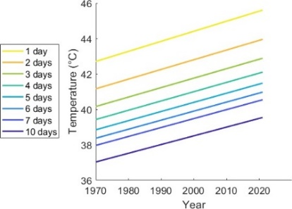 | 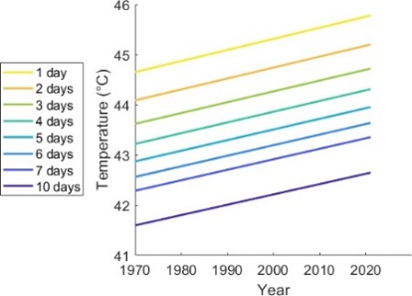
 | Amberley AMO (040004) | Barcaldine Post Office (036007)
South Australia | 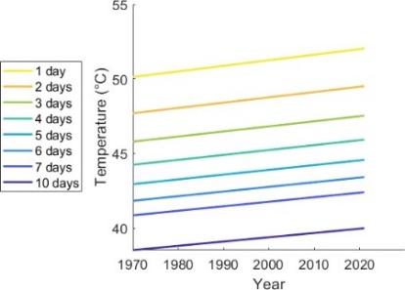 | 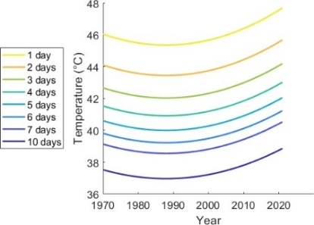
 | Ceduna AMO (018012) | Adelaide Airport (023034)
Victoria | 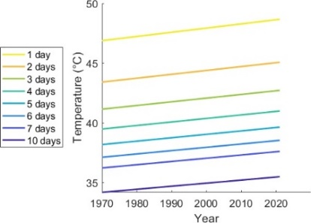 | 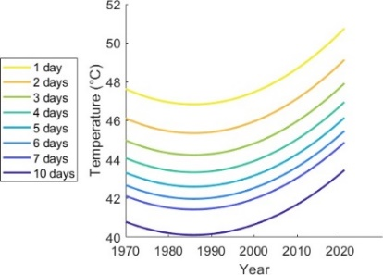
 | Laverton RAAF (087031) | Walpeup Research (076064)
Figure S3. Non-stationary TDF surfaces with Time covariates for 50-years return period.
New South Wales | 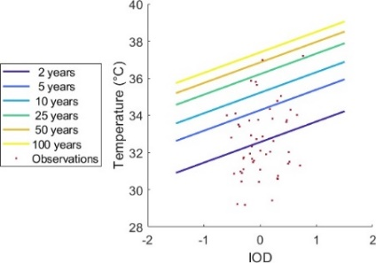 | 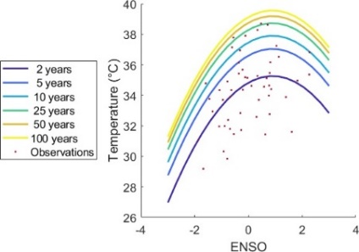
 | Sydney Airport AMO (066037) | Bathurst Agricultural (063005)
Northern Territory | 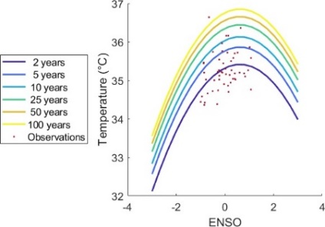 | 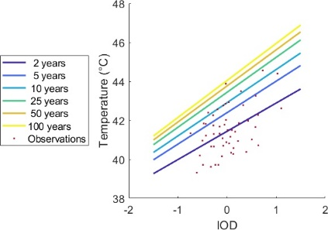
 | Darwin Airport (014015) | Alice Springs Airport (015590)
Western Australia | 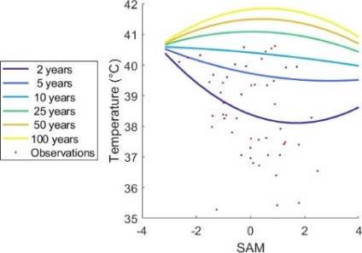 | 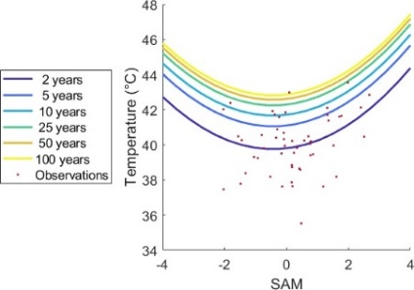
 | Perth Airport (009021) | Kalgoorlie-Boulder Airport (012038)
Queensland | 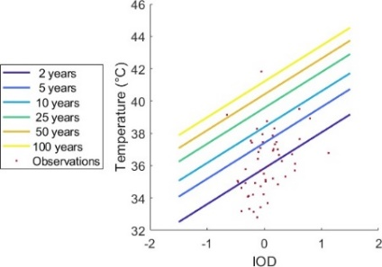 | 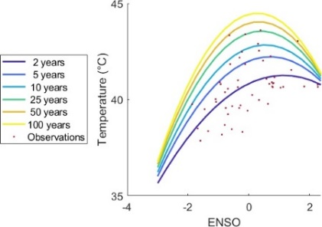
 | Amberley AMO (040004) | Barcaldine Post Office (036007)
South Australia | 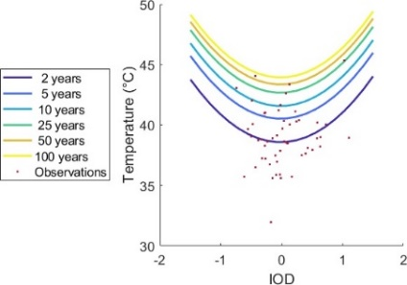 | 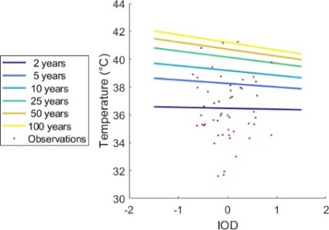
 | Ceduna AMO (018012) | Adelaide Airport (023034)
Victoria | 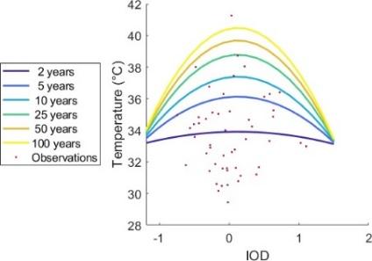 | 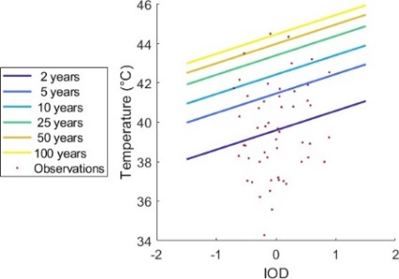
 | Laverton RAAF (087031) | Walpeup Research (076064)
Figure S4. Non-stationary TDF curves with climate driver covariates for 5-day duration.
New South Wales | 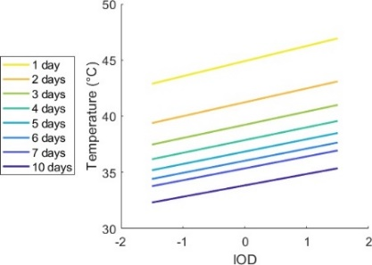 | 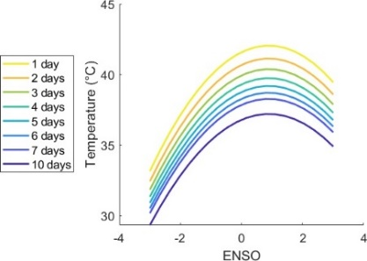
 | Sydney Airport AMO (066037) | Bathurst Agricultural (063005)
Northern Territory | 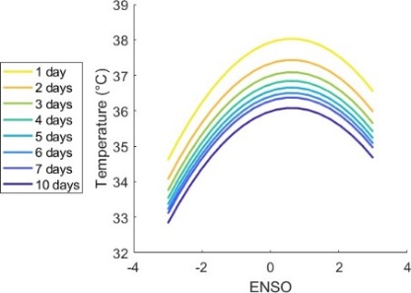
 | Darwin Airport (014015) | Alice Springs Airport (015590)
Western Australia | 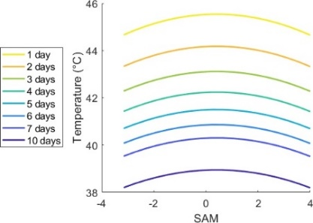 | 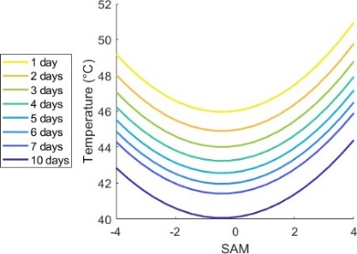
 | Perth Airport (009021) | Kalgoorlie-Boulder Airport (012038)
Queensland | 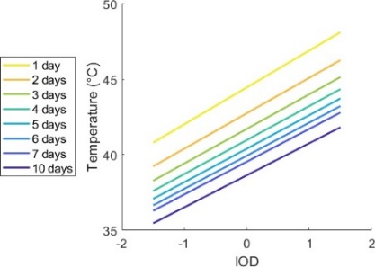 | 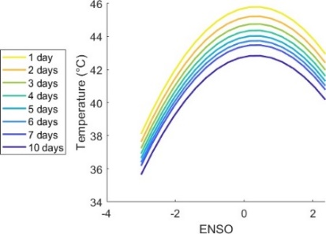
 | Amberley AMO (040004) | Barcaldine Post Office (036007)
South Australia | 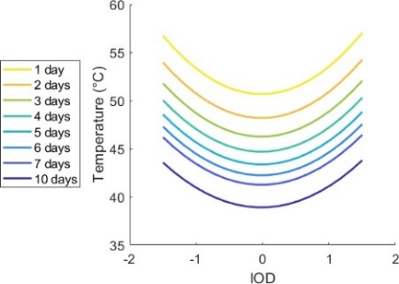 | 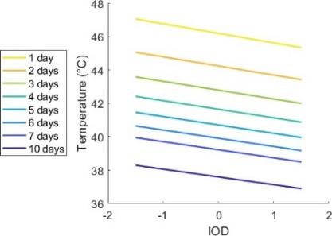
 | Ceduna AMO (018012) | Adelaide Airport (023034)
Victoria | 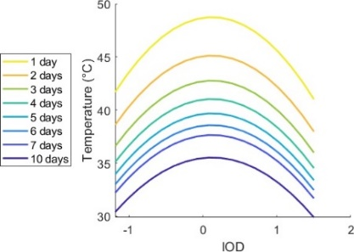 | 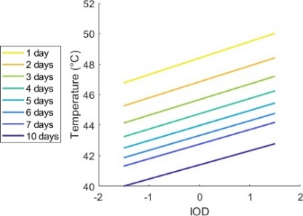
 | Laverton RAAF (087031) | Walpeup Research (076064)
Figure S5. Non-stationary TDF curves with climate driver covariates for 50-years return period
New South Wales | 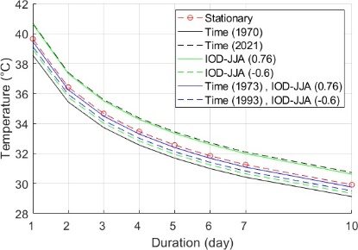 | 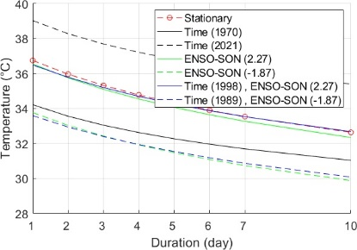
 | Sydney Airport AMO (066037) | Bathurst Agricultural (063005)
Northern Territory | 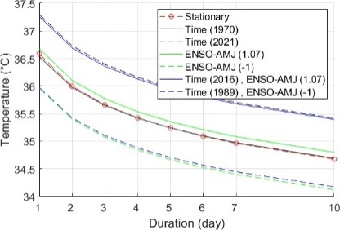 | 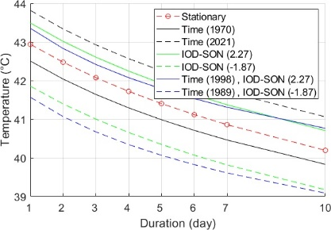
 | Darwin Airport (014015) | Alice Springs Airport (015590)
Western Australia | 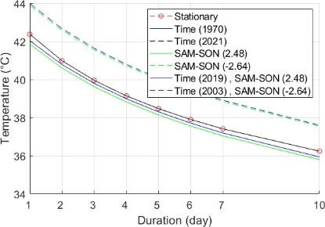 | 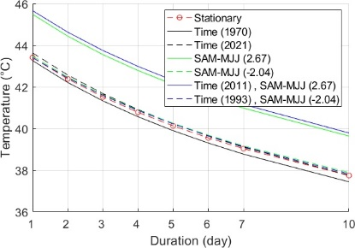
 | Perth Airport (009021) | Kalgoorlie-Boulder Airport (012038)
Queensland | 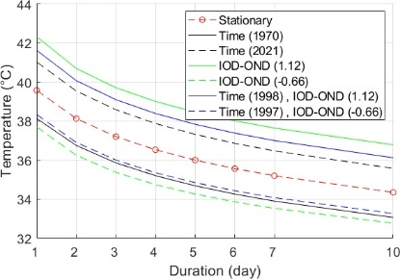 | 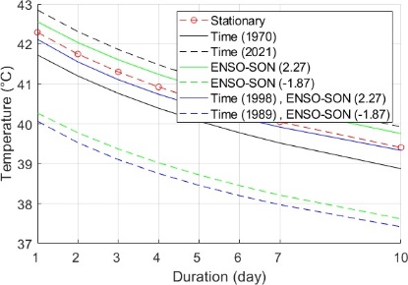
 | Amberley AMO (040004) | Barcaldine Post Office (036007)
South Australia | 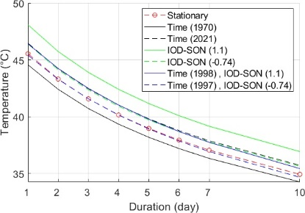 | 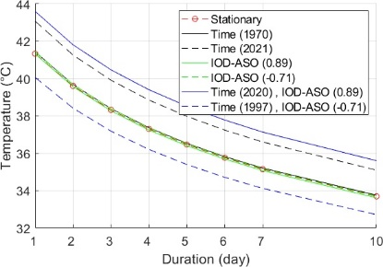
 | Ceduna AMO (018012) | Adelaide Airport (023034)
Victoria | 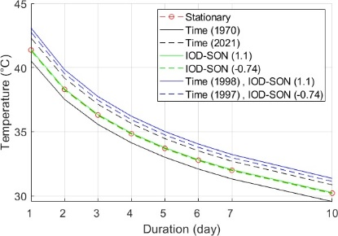 | 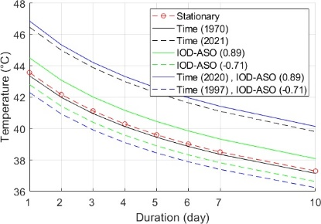
 | Laverton RAAF (087031) | Walpeup Research (076064)
Figure S6. Comparison between stationary and non-stationary TDF curves 2-year quantiles.
New South Wales | 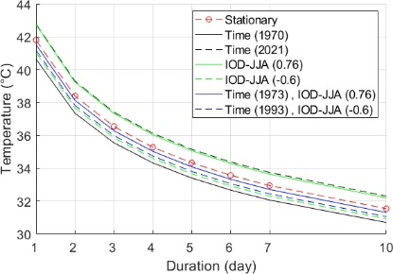 | 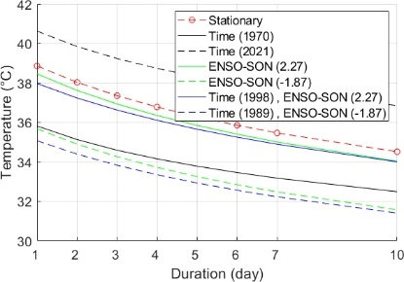
 | Sydney Airport AMO (066037) | Bathurst Agricultural (063005)
Northern Territory | 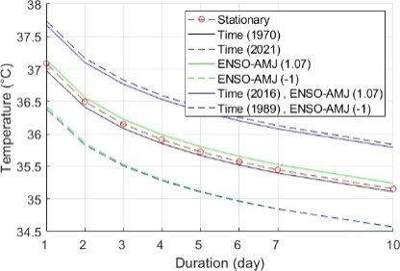 | 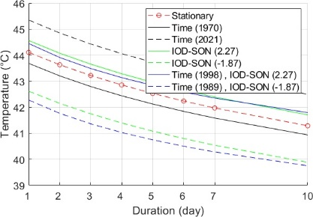
 | Darwin Airport (014015) | Alice Springs Airport (015590)
Western Australia | 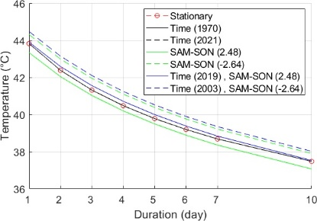 | 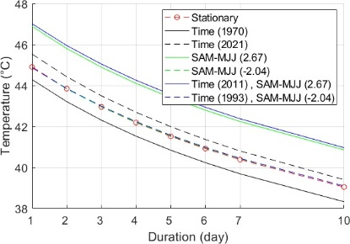
 | Perth Airport (009021) | Kalgoorlie-Boulder Airport (012038)
Queensland | 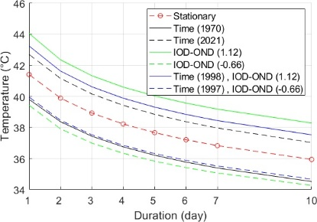 | 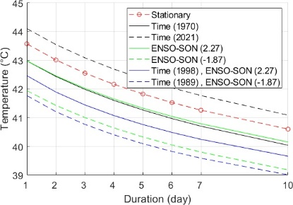
 | Amberley AMO (040004) | Barcaldine Post Office (036007)
South Australia | 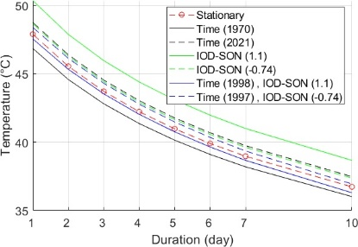 | 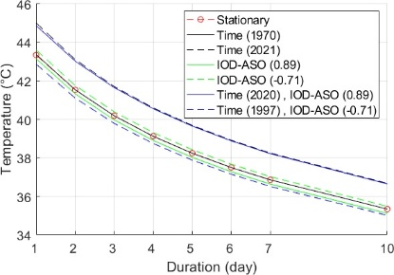
 | Ceduna AMO (018012) | Adelaide Airport (023034)
Victoria | 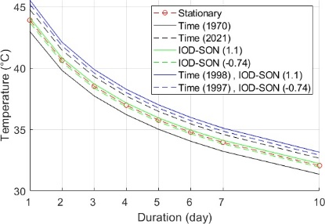 | 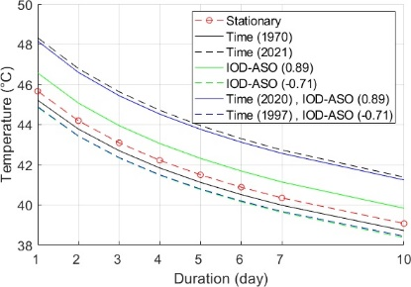
 | Laverton RAAF (087031) | Walpeup Research (076064)
Figure S7. Comparison between stationary and non-stationary TDF curves 5-year quantiles.
New South Wales | 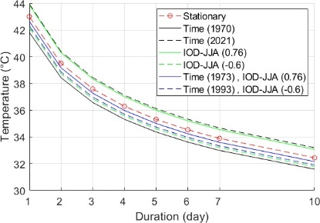 | 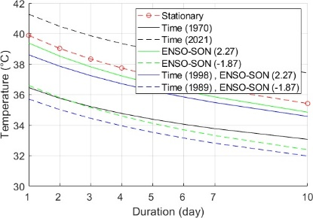
 | Sydney Airport AMO (066037) | Bathurst Agricultural (063005)
Northern Territory | 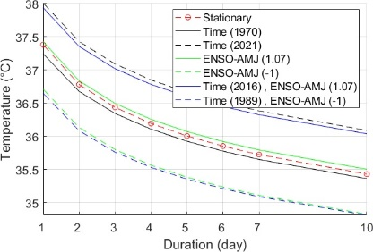 | 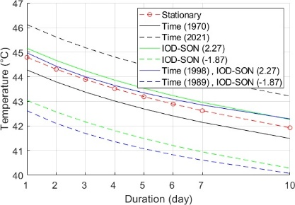
 | Darwin Airport (014015) | Alice Springs Airport (015590)
Western Australia | 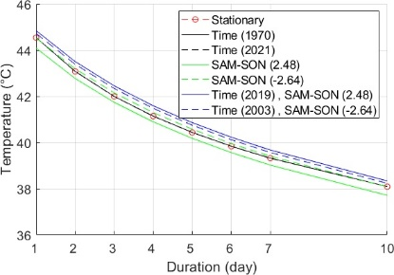 | 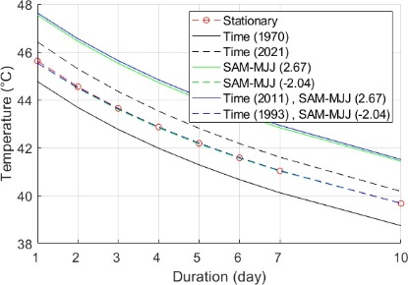
 | Perth Airport (009021) | Kalgoorlie-Boulder Airport (012038)
Queensland | 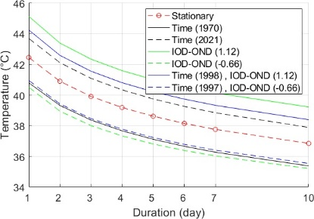 | 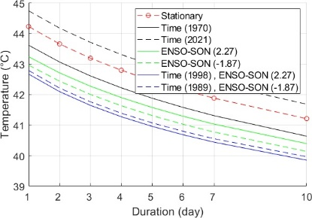
 | Amberley AMO (040004) | Barcaldine Post Office (036007)
South Australia | 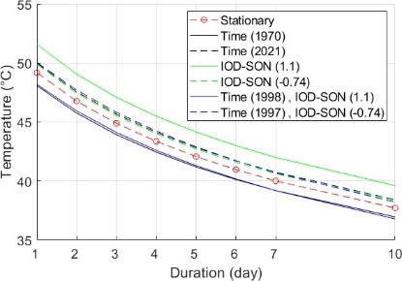 | 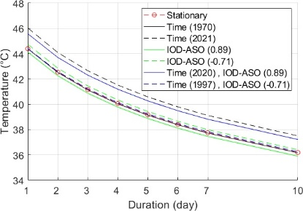
 | Ceduna AMO (018012) | Adelaide Airport (023034)
Victoria | 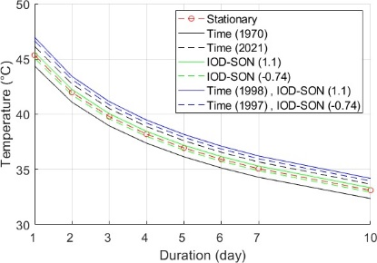 | 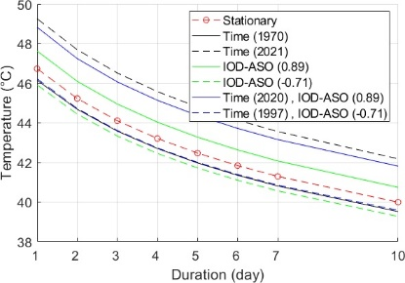
 | Laverton RAAF (087031) | Walpeup Research (076064)
Figure S8. Comparison between stationary and non-stationary TDF curves 10-year quantiles.
New South Wales | 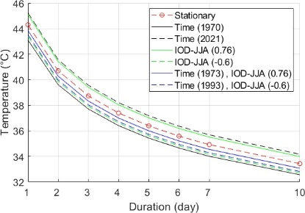 | 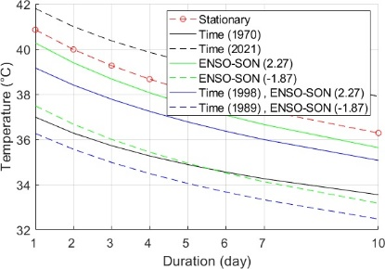
 | Sydney Airport AMO (066037) | Bathurst Agricultural (063005)
Northern Territory | 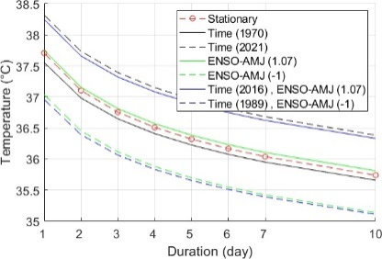 | 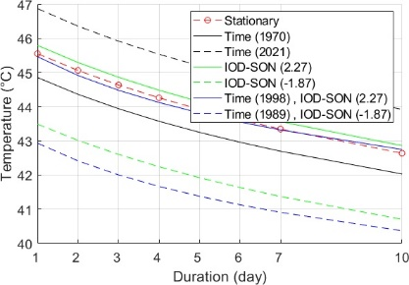
 | Darwin Airport (014015) | Alice Springs Airport (015590)
Western Australia | 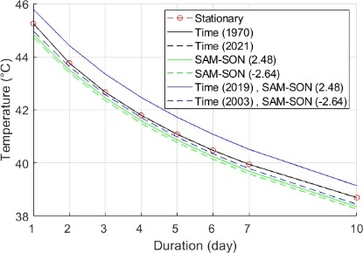 | 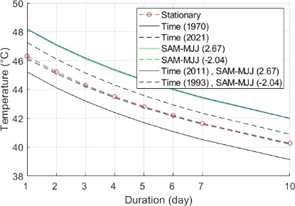
 | Perth Airport (009021) | Kalgoorlie-Boulder Airport (012038)
Queensland | 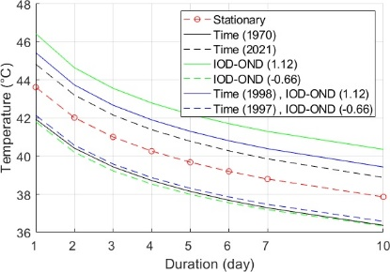 | 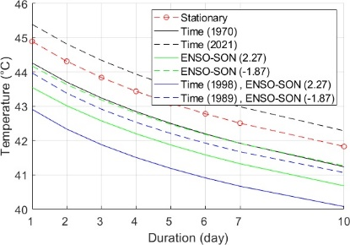
 | Amberley AMO (040004) | Barcaldine Post Office (036007)
South Australia | 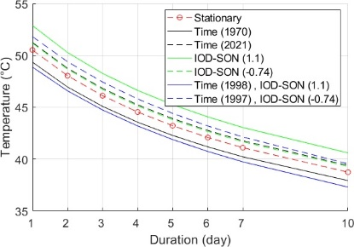 | 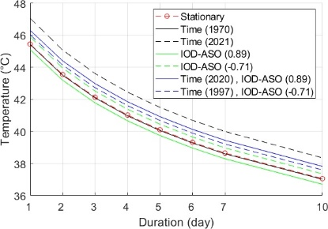
 | Ceduna AMO (018012) | Adelaide Airport (023034)
Victoria | 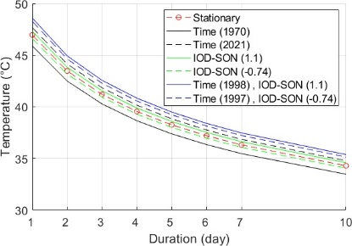 | 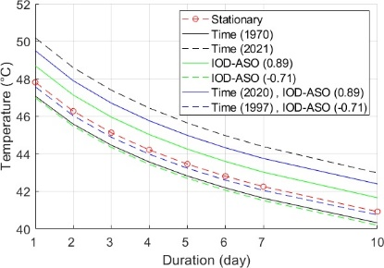
 | Laverton RAAF (087031) | Walpeup Research (076064)
Figure S9. Comparison between stationary and non-stationary TDF curves 25-year quantiles.
New South Wales | 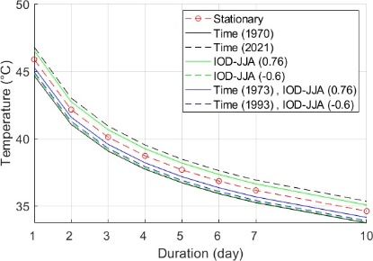 | 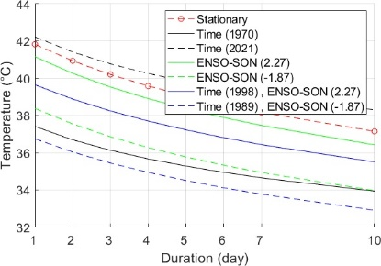
 | Sydney Airport AMO (066037) | Bathurst Agricultural (063005)
Northern Territory | 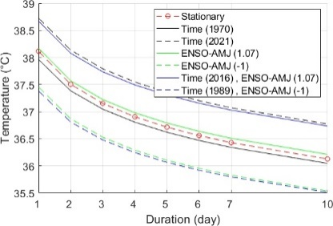 | 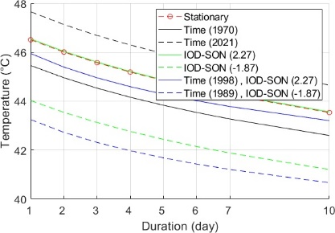
 | Darwin Airport (014015) | Alice Springs Airport (015590)
Western Australia | 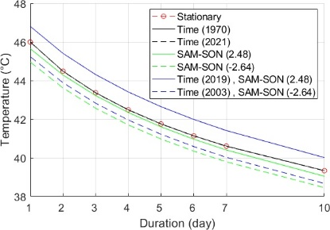 | 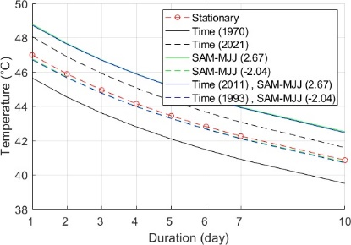
 | Perth Airport (009021) | Kalgoorlie-Boulder Airport (012038)
Queensland | 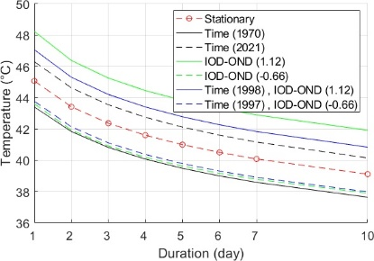 | 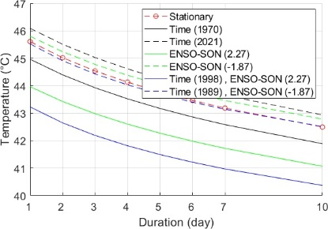
 | Amberley AMO (040004) | Barcaldine Post Office (036007)
South Australia | 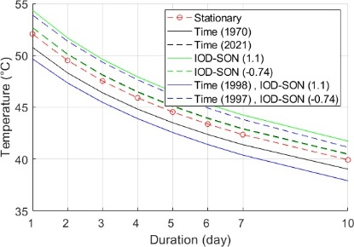 | 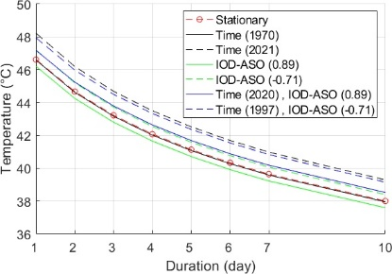
 | Ceduna AMO (018012) | Adelaide Airport (023034)
Victoria | 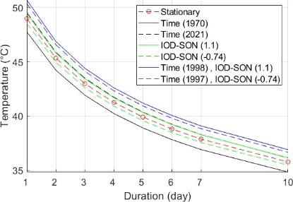 | 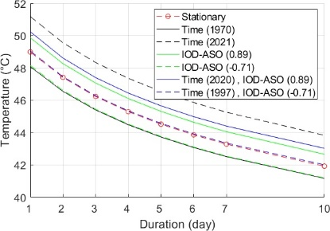
 | Laverton RAAF (087031) | Walpeup Research (076064)
Figure S10. Comparison between stationary and non-stationary TDF curves 100-year quantiles.

