Supplementary Information

Title: Supporting people and nature across neighboring nations with land-sea planning at multiple scales

Jade M.S. Delevaux^{1,2}, Jess Silver¹, Samantha G. Winder³, Nadia Bood⁴, Luis Chevez⁴, Pilar Velásquez⁴, Alejandra Calzada Vázquez Vela⁴, Ryan Barlett⁵, Maria Amalia Porta⁵, Stacie A. Wolny¹, Allison Bailey¹, Melanie McField⁶, Aarón Israel Muñiz-Castillo⁶, Katie K. Arkema^{1,7}

Affiliations:
¹The Natural Capital Project, Stanford University, 371 Serra Mall, Stanford, CA, USA 94305
²Seascape Solutions LLC, 95-390 Kuahelani Ave. 3AC-1144, HI, USA 96789
³Outdoor Recreation and Data Lab, University of Washington, Seattle, WA, USA 98195
⁴World Wildlife Fund-Mesoamerica, Belize City, Belize
⁵World Wildlife Fund, Washington, DC, USA, 20037
⁶Healthy Reefs for Healthy People, Fort Lauderdale, FL, United States; Puerto Morelos, Mexico
⁷Pacific Northwest National Laboratory, 1100 Dexter Ave N, Seattle, WA, USA 98109

*Correspondence to: jademd@stanford.edu; (ph) 808-372-5794

Supplementary Tables

Supplementary Table 1: Countries’ profile

Geography | Belize | Guatemala | Honduras
Land area (km2) | 21,174.5 | 26,076.2 | 44,299.4
Forest area (km2) | 15,429.7 | 13,366.9 | 25,294.8
Mangrove area (km2) | 744.7 | 748.4 | 77.4
Agriculture, aquaculture, and pasture (km2) | 4,724.3 | 11,718.2 | 18,180.2
Urban (km2) | 275.9 | 423.8 | 569.1
TPA area (km2) | 9,203 | 4,996 | 8,966
Territorial sea (km2) | 19,859 | 1,498 | 24,295
Coral area (km2) | 738.4 | 20.2 | 209.8
MPAs area (km2) | 6,549 | 1,114 | 9,949
Watershed (#) | 68 | 15 | 74
Watershed average size (km2) | 544 | 1,777 | 565
Maximum elevation (m) | 1,133 | 3,343 | 2,852
Average slope (degree) | 5 | 15 | 15
Average yearly precipitation (mm/yr) | 1,952 | 2,743 | 1,946
Coastline length (km) | 1477 | 186 | 666
Present land use cover type (natural % total modeled area) | 79 | 57 | 59
Present land use cover type (anthropogenic % total modeled area) | 21 | 43 | 44
Population within study area* | 405,167 | 5,819,779 | 5,498,067
* Source: Worldpop 2020

Supplementary Table 2. Tourism model variables and relationships. All variables were significant at 𝛼 = .05, adjusted R²=0.45, n = 7793.

Variable | Description | Variable treatment | Coefficient | p-value
Visitors (Response) | Estimated annual visitors per grid cell, based on Flickr, Twitter, and national tourism statistics. | Log transformed | NA | NA
(Intercept) | NA | NA | 1.054 | < 0.0001
Mangroves | Proportion of the grid cell covered by healthy mangrove | NA | 1.959 | < 0.0001
Coral | Proportion of the grid cell covered by healthy coral | NA | 4.615 | < 0.0001
Beach | Sandy beaches | Presence/Absence | 1.870 | < 0.0001
Coastal forest | Proportion of the grid cell covered by coastal forest (as defined Supp Table 4) | NA | 0.846 | < 0.0001
Wildlife | Key habitat or tourism destination for flamingos, manatees, sharks, whale sharks, sea turtles. Created in collaboration with local partners | Presence/Absence | 0.492 | < 0.0001
Archeological sites | Key archeological sites in the region, from OSM | Presence/Absence | 2.691 | < 0.0001
Development | “Developed” land class from national LULC raster | Presence/Absence | 1.877 | < 0.0001
Roads | Major local roads, from OSM | Presence/Absence | 1.805 | < 0.0001
Airports / Ports | Minimum distance to the nearest major airport or port, compiled from OSM and local sources | Rescaled to fall between 0 and 1 | - 4.467 | < 0.0001
Temperature | Average annual temperature | Rescaled to fall between 0 and 1. Quadratic | Temp: 2.586  Temp²: -3.103 | < 0.0001  < 0.0001
Hot Days | Number of days/year > 35C | Rescaled to fall between 0 and 1 | - 0.417 | 0.0168
Precipitation | Total annual precipitation | Rescaled to fall between 0 and 1 | 0.689 | < 0.0001
Country | Country in which a grid cell occurred | Factor, Belize is the baseline | Guatemala: -1.891  Honduras: -0.889  Mexico: -0.246 | < 0.0001  < 0.0001  0.006
Cell area | Control for variable sized cells | Rescaled to fall between 0 and 1 | 1.829 | < 0.0001

Supplementary Table 3: The individual LULC classes that were used to define “coastal forest” in the tourism model.
Country | Land use/cover type
Honduras | Área Húmeda Continental  Bosque de Conífera Denso  Bosque de Conífera Ralo  Bosque Latifoliado Deciduo  Bosque Latifoliado Húmedo  Tique (Acoelorraphe wright)  Vegetación Secundaria Húmeda
Guatemala | Bosque latifoliado  Bosque mixto  Humedal con bosque
Belize | Lowland borad-leaved wet forest  Lowland broad-leaved dry forest  Lowland broad-leaved moist forest  Lowland broad-leaved moist forest: Steep  Lowland broad-leaved moist scrub forest  Lowland broad-leaved moist scrub forest: Steep  Lowland broad-leaved wet forest  Lowland broad-leaved wet forest: Steep  Lowland pine forest
Mexico | Bosque de pino  Selva húmeda  Selva seca

Supplementary Table 4: Targeted reef fish family by country, including the common names and feeding behavior.
Common Name | Family name | Feeding type | bz | gt | hn
Surgeonfishes | Acanthuridae | Herbivore | X |  | X
Jacks | Carangidae | Piscivore | X | X | X
Groupers | Epinephelidae | Piscivore | X | X | X
Grunts | Haemulidae | Piscivore | X | X | X
Chubs | Kyphosidae | Herbivore |  |  | X
Wrasses | Labridae | Herbivore | X | X | X
Snappers | Lutjanidae | Piscivore | X | X | X
Porgies | Sparidae | Piscivore | X |  | X
Barracudas | Sphyraenidae | Piscivore | X | X | X

Supplementary Table 5: Coral reef model geospatial predictors. Each metric is classified by type (terrestrial or marine predictor). Each metric was coded for modeling. The table below indicates the data source and analytical tool used to generate each metric. (Adapted from Delevaux et al. 2018 & Stamoulis et al. 2018).
Type | Predictorª | Description | Analytical tool | Unit | Code
Geography | Depth^{b} | Mean seafloor depth | ArcGIS Aggregate (ESRI 2011) | m | depth
Habitat topography | BPI^{b} | Relative topographic position of a point based its elevation and the mean elevation within a 100 m neighborhood | Benthic Terrain Modeler tool (Wright et al. 2005) | m | bpi
Habitat topography | Slope^{b} | Maximum rate of change in seafloor depth between each grid cell and its neighbors | ArcGIS Slope tool, ArcGIS Focal Statistics tool (ESRI 2011) | Degrees | slp
Habitat complexity | Slope of slope^{b} | Second derivative of slope. | ArcGIS Spatial Analyst tools (ESRI 2011) | Degrees | slpslp
Habitat complexity | Planar curvature^{b} | Seafloor curvature perpendicular to the direction of the maximum slope (mean). Value indicates whether flow will converge or diverge over a point. | DEM Surface Tools Curvature tool (cite) | Radians.m⁻¹ | curv_plan
Habitat complexity | Profile curvature^{b} | Seafloor curvature in the direction of the maximum slope (mean). Value indicates whether flow will accelerate or decelerate over the curve. | DEM Surface Tools Curvature tool (cite) | Radians.m⁻¹ | curv_pro
Habitat exposure | Aspect^{b} | Downslope direction of maximum rate of change in seafloor depth between each grid cell and its neighbors (sine circular mean, cosine circular mean, circular standard deviation) | ArcGIS Aspect tool, ArcGIS Spatial Analyst tools (sine and cosine function) | Degrees | asp_sin, asp_cos, asp_std
Wave energy | Wave power | Derived from ERA5 | ArcGIS IDW tool |  | wave
Water quality | TSS | Derived from the water quality model | R | t/yr | tss
ª The marine drivers were generated at 30 x 30 m resolution
^{b} Bathymetry at 10 m native resolution

Supplementary Table 6: Inputs used in the Restoration Opportunities Optimization Tool (ROOT)*
ROOT inputs | Details
Activity mask  (identified areas of opportunity) | 1. Forest restoration opportunity:  - Belize = 473,044 ha  - Guatemala = 1,017,174 ha  - Honduras = 1,835,801 ha  2. Forest protection opportunity:  - Belize = 704,377 ha  - Guatemala = 792,649 ha  - Honduras = 2,162,938 ha  3. Sustainable agriculture opportunity:  - Belize = 472,430 ha  - Guatemala = 443,207 ha  - Honduras = 1,514,020 ha
ES impact potential maps | Sediment export (t/yr)  Terrestrial recreation opportunity (# of people/year)
Servicesheds/Spatial weighted map | Watershed important to marine ES provisioning (targeted reef fish biomass, coral-based recreation, and coastal protection)
Composite factors | Sediment export & Watershed important to marine ES provisioning  Recreation opportunity & Watershed important to marine ES provisioning
Objectives | 1. Forest restoration:  - Direct: Minimize sediment export; Maximize forest-based tourism  - Indirect: Maximize targeted fish biomass, coastal protection, and coral-based tourism  2. Forest protection:  - Direct: Maximize sediment export; Minimize forest-based tourism  - Indirect: Maximize targeted fish biomass, coastal protection, and coral-based tourism  3. Sustainable agriculture:  - Direct: Minimize sediment export; Maximize forest-based tourism  - Indirect: Maximize targeted fish biomass, coastal protection, and coral-based tourism
Targets | 1. Forest restoration:  - Belize = 50,000 ha (11%) (NDC)  - Guatemala = 70,000 ha (7%)  - Honduras = 468,000 ha (25%) (NDC)  2. Forest protection:  - Belize = 10,000 ha (1%) (NDC)  - Guatemala = 70,000 ha (9%)  - Honduras = 525,900 ha (24%) (NDC)  3. Sustainable agriculture:  - Belize = 88,200 ha (19%) (NDC)  - Guatemala = 100,000 ha (23%)  - Honduras = 400,000 ha (26%) (NDC)
*All inputs were projected to NAD83 Z16N. All analyses were performed using ArcGIS 10.8.1 & R.

Supplementary Table 7: SDR erosion factors.
Country | Value | Land cover type | usle_c | Source
BZ | 301 | Agricultural uses | 0.75 | Agricultura de temporal (rainfed)⁵⁹
BZ | 302 | Coral reef | 0
BZ | 303 | Lowland borad-leaved wet forest | 0.007 | Lowland Broad-leaved wet forest⁶⁰
BZ | 304 | Lowland broad-leaved dry forest | 0.007 | Lowland Broad-leaved wet forest⁶⁰
BZ | 305 | Lowland broad-leaved moist forest | 0.007 | Lowland Broad-leaved wet forest⁶⁰
BZ | 306 | Lowland broad-leaved moist forest: Steep | 0.007 | Lowland Broad-leaved wet forest⁶⁰
BZ | 307 | Lowland broad-leaved moist scrub forest | 0.007 | Lowland Broad-leaved wet forest⁶⁰
BZ | 308 | Lowland broad-leaved moist scrub forest: Steep | 0.007 | Lowland Broad-leaved wet forest⁶⁰
BZ | 309 | Lowland broad-leaved wet forest | 0.007 | Lowland Broad-leaved wet forest⁶⁰
BZ | 310 | Lowland broad-leaved wet forest: Steep | 0.007 | Lowland Broad-leaved wet forest⁶⁰
BZ | 311 | Lowland pine forest | 0.009 | Lowland pine forest⁶⁰
BZ | 312 | Lowland savanna | 0.54 | Sabana⁵⁹
BZ | 313 | Mangrove and littoral forest | 0.1 | Mangrove and littoral forest is 0.37⁶⁰, lowered based on others work in tropical regions
BZ | 316 | Shrubland | 0.008 | shrub land⁶⁰
BZ | 317 | Submontane broad-leaved moist forest | 0.003 | Submontane Broad-leaved wet forest⁶⁰
BZ | 318 | Submontane broad-leaved moist forest: Steep | 0.003 | Submontane Broad-leaved wet forest⁶⁰
BZ | 319 | Submontane broad-leaved wet forest | 0.003 | Submontane Broad-leaved wet forest⁶⁰
BZ | 320 | Submontane broad-leaved wet forest: Steep | 0.003 | Submontane Broad-leaved wet forest⁶⁰
BZ | 321 | Submontane pine forest | 0.009 | Lowland pine forest⁶⁰
BZ | 322 | Submontane pine forest: Steep | 0.009 | Lowland pine forest⁶⁰
BZ | 323 | Urban | 0.13 | Urban⁶⁰
BZ | 324 | Wasteland | 0.85 | Deserts and dunes⁵⁹
BZ | 325 | Water | 0 | Water⁶⁰
BZ | 326 | Wetland | 0.04 | Wetland⁶⁰
BZ | 327 | Agroforestry (i.e., fruit trees) - North Belize (Corozal & Orange Walk Districts) | 0.275 | Average value of cultivos permanentes no densos⁶¹
BZ | 328 | Agroforestry (i.e., fruit trees + corn + rice) - Central Belize (Cayo & Belize Districts) | 0.238 | Average value of cultivos permanentes no densos⁶¹, rice (wetland⁶⁰), and Granos basicos⁶²
BZ | 329 | Agroforestry (i.e., fruit trees + cacao) – South Belize (Stann Creek & Toledo Districts) | 0.1625 | Average value of cultivos permanentes no densos⁶¹ and Cacao⁶¹
GT | 201 | Developed - international airport | 0.005 | Zona urbana⁵⁹
GT | 202 | Agriculture - industrial | 0.4175 | Average value of cultivos anuales⁶¹
GT | 203 | Agriculture - Avocado | 0.275 | Average value of cultivos permanentes no densos⁶¹
GT | 204 | Scattered trees | 0.465 | Average of Bosque mixto and Espacio con vegetacion escasa⁶¹
GT | 205 | Tourist/archeological areas | 0.005 | Zona urbana⁵⁹
GT | 206 | Agriculture - Rice | 0.04 | Wetland⁶⁰
GT | 207 | Agriculture - Banana | 0.062 | Banano⁶¹
GT | 208 | Developed - military base | 0.005 | Zona urbana⁵⁹
GT | 210 | Forest - conifer | 0.08 | Bosque mixto⁶²
GT | 211 | Forest - broadleaf | 0.08 | Bosque latifoliado⁶²
GT | 212 | Mangrove | 0.1 | Manglar⁵⁹
GT | 213 | Forest - mixed | 0.08 | Bosque mixto⁶²
GT | 214 | Agriculture - Chocolate | 0.05 | Cacao⁶¹
GT | 215 | Agriculture - Coffee | 0.09 | Café⁶¹
GT | 216 | Agriculture - Coffee and banana | 0.09 | Café⁶¹
GT | 217 | Agriculture - Coffee and cardamom | 0.09 | Café⁶¹
GT | 218 | Agriculture - Coffee and macadamia | 0.09 | Café⁶¹
GT | 219 | Agriculture - Sugarcane | 0.263 | Caña⁶¹
GT | 220 | Agriculture - Cardamom | 0.0825 | Cultivos perennes - average of values⁶¹
GT | 221 | Developed - Cemetery | 0 | Cementerio⁶²
GT | 222 | Developed - Commercial | 0.005 | Zona urbana⁵⁹
GT | 223 | Agriculture - Citrus | 0.275 | Average value of cultivos permanentes no densos⁶¹
GT | 224 | Agriculture - Coconut | 0.275 | Average value of cultivos permanentes no densos⁶¹
GT | 225 | Developed - industrial complex | 0.005 | Zona urbana⁵⁹
GT | 226 | Developed - Landfill/treatment plant | 0.005 | Zona urbana⁵⁹
GT | 227 | Bare | 0.85 | Deserts and dunes⁵⁹
GT | 229 | Agriculture - flowers | 0.83 | Hortaliza - ornamental⁶²
GT | 231 | Agriculture - Decidious fruit trees | 0.275 | Average value of cultivos permanentes no densos⁶¹
GT | 232 | Agriculture - basic grains (corn and beans) | 0.4 | Granos basicos⁶²
GT | 234 | Developed - Hospital | 0.005 | Zona urbana⁵⁹
GT | 235 | Agriculture - orchard | 0.6 | Average value of Huertos de subsistencia⁶²
GT | 236 | Agriculture - Rubber | 0.275 | Average value of cultivos permanentes no densos⁶¹
GT | 237 | Wetland with forest | 0.04 | Wetland⁶⁰
GT | 238 | Wetland with other veg | 0.04 | Wetland⁶⁰
GT | 239 | Developed - Sports/recreation | 0.005 | Zona urbana⁵⁹
GT | 240 | Developed - Education | 0.005 | Zona urbana⁵⁹
GT | 241 | Agriculture - Jocote | 0.275 | Average value of cultivos permanentes no densos⁶¹
GT | 242 | Lake/lagoon | 0 | Water⁶⁰
GT | 243 | Agriculture - Loroco | 0.275 | Average value of cultivos permanentes no densos⁶¹
GT | 244 | Developed - subdivisions | 0.005 | Zona urbana⁵⁹
GT | 246 | Agriculture - Mango | 0.275 | Average value of cultivos permanentes no densos⁶¹
GT | 248 | Sea/ocean | 0 | Water⁶⁰
GT | 250 | Agriculture - Melon | 0.4175 | Average value of cultivos anuales⁶¹
GT | 251 | Agriculture - Blackberry | 0.275 | Average value of cultivos permanentes no densos⁶¹
GT | 252 | Agriculture - mosaic | 0.34625 | Average value of cultivos anuales and cultivos permanentes no densos⁶¹
GT | 253 | Agriculture - other vegetables | 0.4175 | Average value of cultivos anuales⁶¹
GT | 254 | Other commercial and services | 0.005 | Zona urbana⁵⁹
GT | 255 | Agriculture - permanent tree crops | 0.275 | Average value of cultivos permanentes no densos⁶¹
GT | 256 | African palm | 0.75 | Palmar natural⁵⁹
GT | 257 | Agriculture - Papaya | 0.275 | Average value of cultivos permanentes no densos⁶¹
GT | 259 | Pasture - cultivated | 0.0215 | Average value of Pastizal cultivado (manejado) ⁶¹
GT | 260 | Pasture - natural | 0.12 | Average value of Pastizal natural pastoreado⁶¹
GT | 262 | Agriculture - Pineapple | 0.4175 | Average value of cultivos anuales⁶¹
GT | 263 | Developed - landing track (airport) | 0.005 | Zona urbana⁵⁹
GT | 264 | Plantation - conifer | 0.08 | Bosque mixto⁶²
GT | 265 | Plantation - broadleaf | 0.08 | Bosque latifoliado⁶²
GT | 266 | Beach/dunes | 0.85 | Vegetación de dunas costeras⁵⁹
GT | 267 | Marshy meadow | 0.04 | Wetland⁶⁰
GT | 268 | Prison | 0.005 | Zona urbana⁵⁹
GT | 271 | River | 0 | Water⁶⁰
GT | 272 | Rock or lava | 0.001 | Set to a low value since there will be little to no erosion
GT | 273 | Agriculture - Aloe vera | 0.275 | Average value of cultivos permanentes no densos⁶¹
GT | 275 | Agriculture - Watermelon | 0.4175 | Average value of cultivos anuales⁶¹
GT | 276 | Agriculture - Tobacco | 0.4175 | Average value of cultivos anuales⁶¹
GT | 277 | Agriculture - Tea | 0.155 | Average value of cultivos permanentes asociados (densos), assuming that they grow tea like others do, planted densely⁶¹
GT | 278 | Developed - Urban | 0.005 | Zona urbana⁵⁹
GT | 279 | Agriculture - Tomato | 0.4175 | Average value of cultivos anuales⁶¹
GT | 280 | Shrubland | 0.08 | Arbustos - matorrales⁶²
GT | 281 | Agriculture (?) - Nursery | 0.275 | Average value of cultivos permanentes no densos⁶¹
GT | 282 | Burned | 0.85 | Deserts and dunes⁵⁹
GT | 283 | Mining/quarry | 0.85 | Deserts and dunes⁵⁹
GT | 284 | Floodplain | 0.85 | Deserts and dunes⁵⁹
GT | 285 | Port | 0.005 | Zona urbana⁵⁹
GT | 286 | Zoos | 0.005 | Zona urbana⁵⁹
GT | 287 | Agroforestry (i.e., mix of corn, cacao with fruit trees) | 0.241 | Average value of cultivos permanentes no densos⁶¹, cacao⁶¹, and granos basicos⁶²
HN | 101 | Commercial agriculture | 0.4175 | Average value of Cultivos anuales⁶¹
HN | 102 | Scattered trees | 0.465 | Average of Bosque mixto and Espacio con vegetacion escasa⁶¹
HN | 103 | Contintental wetland | 0.04 | Wetland⁶⁰
HN | 104 | Beach | 0.85 | Deserts and dunes⁵⁹
HN | 105 | Forest - dense conifer | 0.0065 | Average of Bosque denso values⁶¹
HN | 106 | Forest - thin conifer | 0.055 | Average of Bosque claro, subestrato herbáceo degradado⁶¹
HN | 107 | Mangroves - tall | 0.1 | Manglar⁵⁹
HN | 108 | Bosque de Mangle Bajo | 0.1 | Manglar⁵⁹
HN | 109 | Forest - broadleaf deciduous | 0.08 | Bosque latifoliado⁶¹
HN | 110 | Forest - broadleaf wet | 0.08 | Bosque latifoliado⁶¹
HN | 112 | Forest - mixed | 0.08 | Bosque mixto⁶¹
HN | 113 | Coffee | 0.09 | Café⁶¹
HN | 115 | Water bodies - artificial | 0 | Water⁶⁰
HN | 116 | Water bodies - natural | 0 | Water⁶⁰
HN | 117 | Water - other | 0 | Water⁶⁰
HN | 118 | Palm - African | 0.75 | Palmar natural⁵⁹
HN | 119 | Pasture/crops | 0.2195 | Average of HN commercial agriculture and Pastizal cultivado (manejado)⁶¹
HN | 121 | Bare | 0.85 | Deserts and dunes⁵⁹
HN | 122 | Palm - Tique | 0.75 | Palmar natural⁵⁹
HN | 123 | Secondary vegetation deciduous | 0.007 | Bosque secundario from Costa Rica
HN | 124 | Secondary vegetation wet | 0.007 | Bosque secundario from Costa Rica
HN | 125 | Urban - continuous | 0.005 | Zona urbana⁵⁹
HN | 126 | Urban - discontinuous | 0.005 | Zona urbana⁵⁹
HN | 127 | Agroforestry or silvopasture | 0.234 | Average value of pastos/cultivos and cacao⁶¹
MX | 402 | Agriculture | 0.75 | Agricultura de temporal⁵⁹
MX | 403 | Forest - plantation | 0.01 | Bosque de pino ⁵⁹
MX | 405 | Forest - pine | 0.01 | Bosque de pino⁵⁹
MX | 406 | Water body | 0 | Water⁶⁰
MX | 407 | Mangrove | 0.1 | Manglar⁵⁹
MX | 408 | Palm grove | 0.75 | Palmar natural⁵⁹
MX | 409 | Pasture | 0.07 | Pastizal natural⁵⁹
MX | 410 | mangrove patches | 0.1 | Manglar⁵⁹
MX | 412 | Savanna | 0.54 | Sabana⁵⁹
MX | 413 | Evergreen rainforest | 0.001 | Selva virgen⁶⁰ (Definition: subperenlifolias (25 50% of species lose leaves) , subcaducifolies (50 to 75% of species lose leaves)
MX | 414 | Jungle - dry | 0.001 | Selva virgen⁶¹
MX | 415 | Bare | 0.85 | Deserts and dunes⁵⁹
MX | 417 | Tule wetland? | 0.1 | Tular⁵⁹
MX | 418 | Coastal dune veg | 0.85 | Vegetación de dunas costeras⁵⁹
MX | 421 | Urban | 0.005 | Zona urbana⁵⁹

Supplementary Table 8: Coral reef models calibration and cross-validation (CV) percent deviance explained (PDE), final number of predictors (Xi), moran I index, and p-value from ground truthing predicted values against empirical surveys.
Reef indicators | Tree complexity | Learning rate | Bag fraction | # of Trees | PDE (%) | CV PDE (%) | Xi | Moran I | p-value
Corals | 10 | 0.0005 | 0.75 | 5100 | 56.9 | 33.1 | 3 | 0.00 | <0.001
BZ: Targeted - herbivore | 5 | 0.001 | 0.75 | 5750 | 59.9 | 33.4 | 3 | 0.00 | <0.001
BZ: Targeted - piscivore | 4 | 0.001 | 0.75 | 3500 | 40.5 | 22.1 | 3 | 0.26 | <0.001
GT: Targeted - herbivore | 3 | 0.0005 | 0.5 | 6050 | 41.6 | 30.2 | 3 | 0.05 | <0.001
GT: Targeted - piscivore | 3 | 0.001 | 0.75 | 4450 | 41.1 | 22.7 | 4 | 0.13 | <0.001
HN: Targeted - herbivore | 10 | 0.001 | 0.75 | 2450 | 49.3 | 21.7 | 4 | 0.85 | <0.001
HN: Targeted - piscivore | 2 | 0.001 | 0.75 | 5200 | 37.6 | 20.9 | 3 | 0.13 | <0.001
BZ = Belize, GT = Guatemala, HN = Honduras

Supplementary Table 9. Data inputs/sources for all the models
Models | Data input | Source | Type | Resolution | URL | Reference
interventions  SDR  REC  CV | Belize land cover | Map of the Ecosystems of Belize | vector | na | http://www.biodiversity.bz/ | Meerman 2017
interventions  SDR  REC  CV | Guatemala land cover | Mapa de cobertura vegetal y use de la tierra 2010 | vector | 1:50,000 |  | DIGEGR 2015
interventions  SDR  REC  CV | Honduras land cover | Mapa de Cobertura Forestal 2014 | vector | na |  | ICF Forest Sector Geoportal
interventions  SDR  REC  CV | Mexico land cover | Inventario estatal forestal y de suelos Quintana Roo 2013. | vector | na |  | SEMARNAT 2014
interventions  SDR  CV | DEM | SRTM | grid | 30 m  90 m | https://www2.jpl.nasa.gov | Farr et al. 2007
SDR | Rainfall | UC | grid | 25 km | https://www.worldclim.org | Fick & Hijmans 2017
SDR | Soil % sand content | ISRIC | grid | 250 m | https://data.isric.org | Hengl et al. 2017
SDR | Soil % silt content | ISRIC | grid | 250 m | https://data.isric.org | Hengl et al. 2017
SDR | Soil % clay content | ISRIC | grid | 250 m | https://data.isric.org | Hengl et al. 2017
SDR | Soil % organic carbon | ISRIC | grid | 250 m | https://data.isric.org | Hengl et al. 2017
interventions  SDR  WQ | Streams | OSM | vector | na | www.openstreetmap.org | OSM 2020
WQ  Corals  Fish | Depth | GEBCO | grid | 400 m | www.gebco.net | Weatherall et al. 2015
WQ  Corals  Fish | Depth | TNC | grid | 30 m |  | Li et al. 2019
WQ | Wave | ERA5 | vector | 30 km | https://www.ecmwf.int
WQ  CV | Wind | WWIII | point | 50 km | https://polar.ncep.noaa.gov | Tolman 2009
Coral  Fish | Marine habitat | MCRMP | vector | 30 m | http://www.imars.usf.edu | Andréfouët et al. 2006
Coral  Fish | Belize coral habitat |  | vector | na |  | Mumby & Harborne 1999
Coral  Fish | Honduras coral habitat |  | vector | na |  | Lotte 2016
CV | Seagrass |  | vector | 1:110,000 |  | UBC 2007
CV  REC | Shoreline type | na | vector | na |  | Google Earth imagery
CV | Surge potential |  | vector | na |  | COMARGE and Census of Marine Life
REC | Wildlife (flamingos, manatees, sea turtles, sharks, and whale sharks) | Data are a variety of observations, habitat, and tourism destinations | vector | na | na | WWF and the Natural Capital Project
REC | Archeological sites | OSM | vector | na | www.openstreetmap.org | Open Street Map
REC | Roads | Map Cruzin | vector | na | www.mapcruzin.com
REC | Airports & Ports | Natural Earth, Mexico port layer | vector | na | www.humdata.org
REC | Temperature  Extreme heat days (>35C)  Precipitation | Columbia University | grid | 25 km |  | De Mel et al 2021

Supplementary Figures

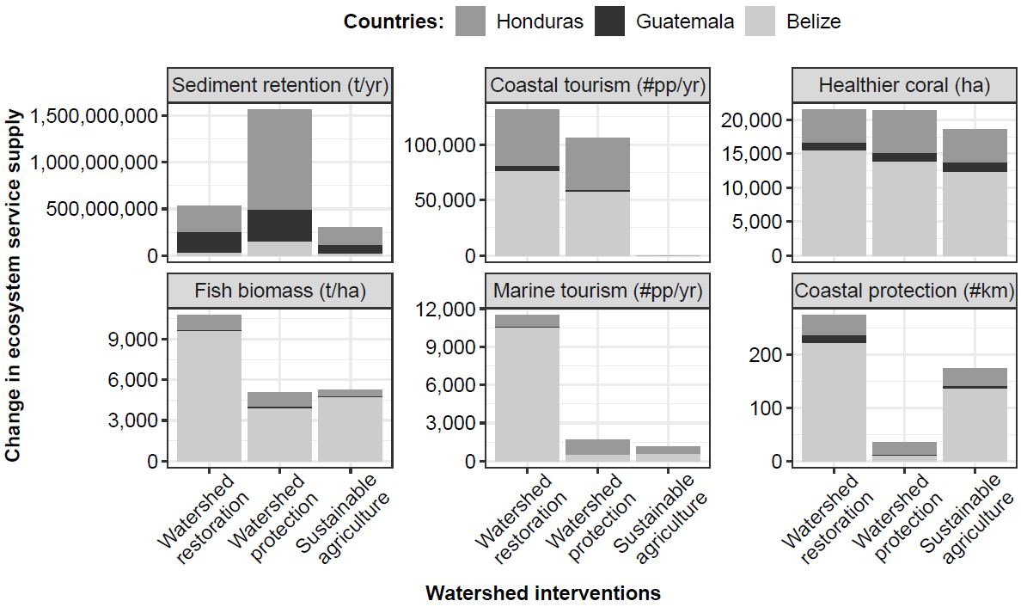Supplementary Figure 1: Change in sediment retention, coastal tourism, extent of healthy coral habitat (coral percent cover > 10%, ha), targeted fish biomass, marine tourism, and coastal protection provided by full potential area of watershed restoration, watershed protection, or sustainable agriculture. (Note: Coastal tourism under sustainable agriculture was not modeled. Marine tourism was modeled for the three countries).

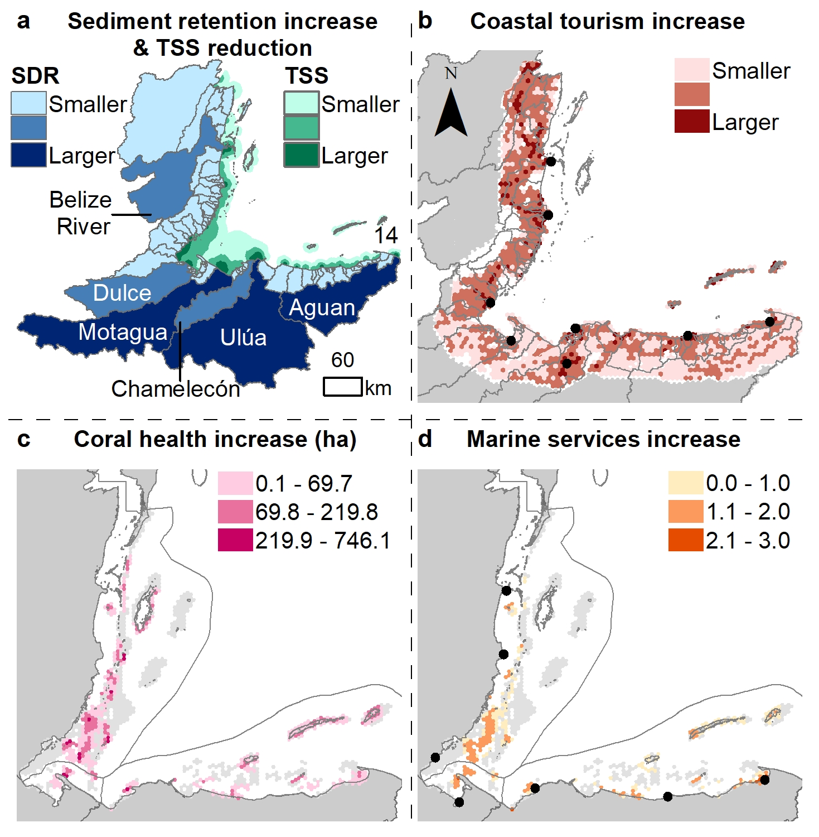

Supplementary Figure 2: Mapping change of ecosystem services from ridge to reef across the region under the watershed protection intervention. (a) Increase in sediment retention in response to the watershed protection intervention at the watershed scale (with darker blue representing greatest sediment retention), and associated reduction in Total Suspended Sediment (TSS) in the marine environment (with darker green representing greatest reduction in TSS); (b) increase in coastal tourism, (c) increase in area (ha) of healthy coral habitat (>10% coral cover) (summarized at 1,000 ha), relative to current conditions, (d) reef areas where the delivery of one or more marine ecosystem services increases, including targeted fish biomass, marine tourism, and coastal risk reduction (expressed here as a composite value for all three services averaged at 1,000 ha, ranging from 0-3 with 3 indicating an increase in delivery of the 3 services).

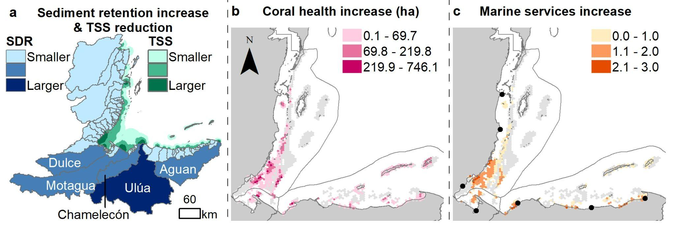Supplementary Figure 3: Mapping change of ecosystem services from ridge to reef across the region under the sustainable agriculture intervention. (a) Increase in sediment retention in response to the sustainable agriculture intervention at the watershed scale (with darker blue representing greatest sediment retention), and associated reduction in Total Suspended Sediment (TSS) in the marine environment (with darker green representing greatest reduction in TSS); (b) increase in area (ha) of healthy coral habitat (>10% coral cover) (summarized at 1,000 ha), relative to current conditions; (c) reef areas where the delivery of one or more marine ecosystem services increases, including targeted fish biomass, marine tourism, and coastal risk reduction (expressed here as a composite value for all three services averaged at 1,000 ha, ranging from 0-3 with 3 indicating an increase in delivery of the 3 services). Note that coastal tourism was not modeled for this intervention (see Supplementary methods).
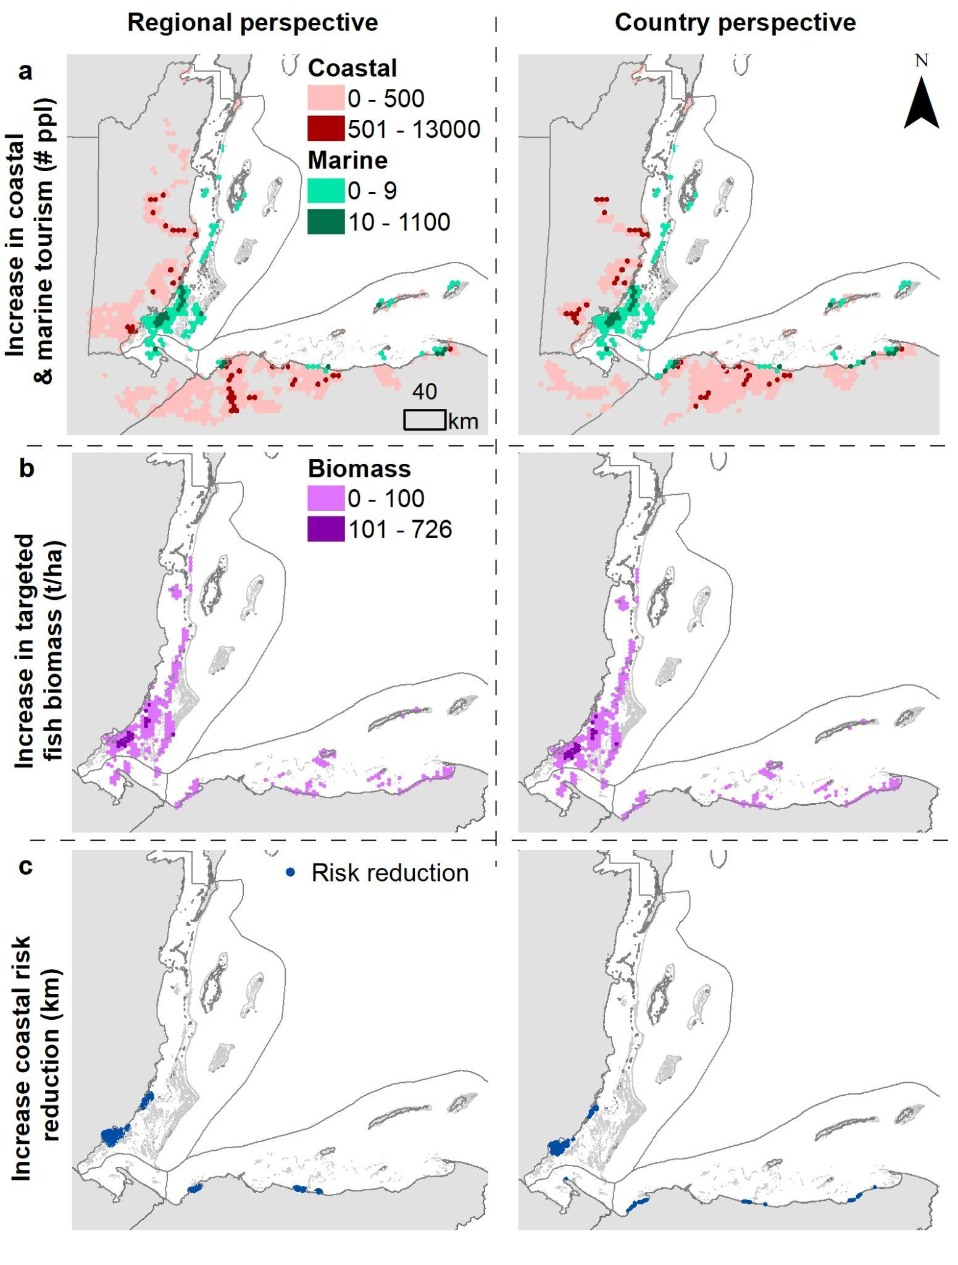

Supplementary Figure 4: Mapping the change of coastal and marine ecosystem services from the implementation of optimal watershed interventions under a regional and country level land-sea planning approach. (a) increase coastal and marine tourism (number of people), relative to current conditions, (b) increase targeted fish biomass (t/ha), relative to current conditions, and (c) increase coastal risk reduction, relative to current conditions.

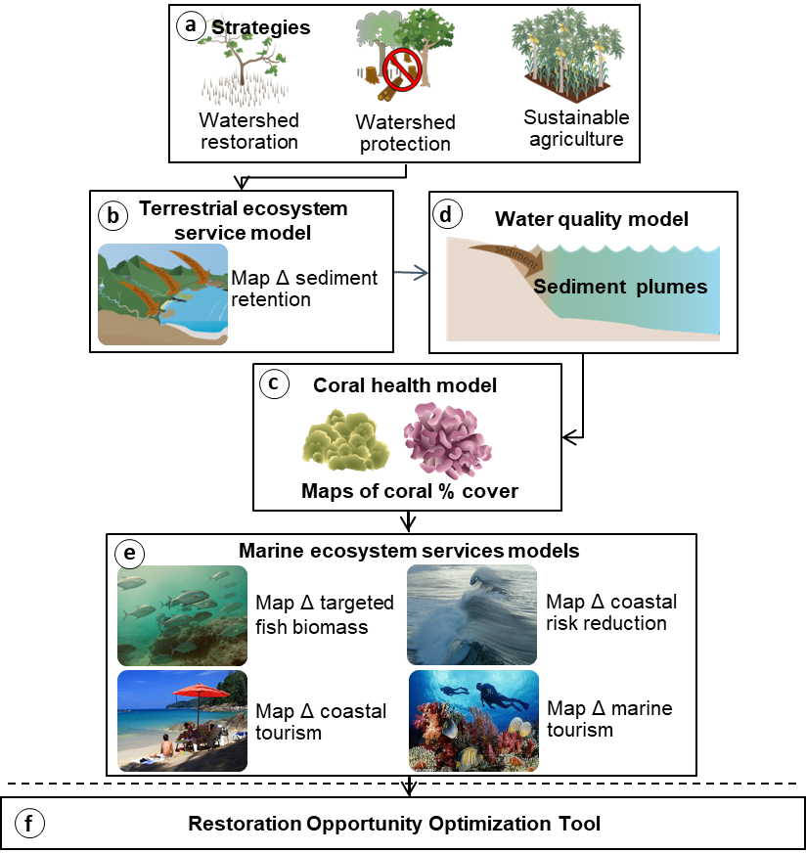

Supplementary Figure 5. Overview of modeling framework. (a) Watershed management interventions(watershed restoration, watershed protection, and sustainable agriculture); (b) terrestrial ecosystem service model (InVEST Sediment Delivery Ratio model); (c) Water Quality Model diffuses sediment loads into the marine environment. (d) A Coral health model generates maps of coral % cover as a function of water quality and marine conditions and is used to (e) model change in marine ecosystem services (targeted fish biomass by country, coastal risk reduction, and coastal and marine tourism). (f) The ROOT model couples ecosystem services and beneficiaries spatial data with management objectives to identify areas on land to prioritize for management that maximize terrestrial and marine services.

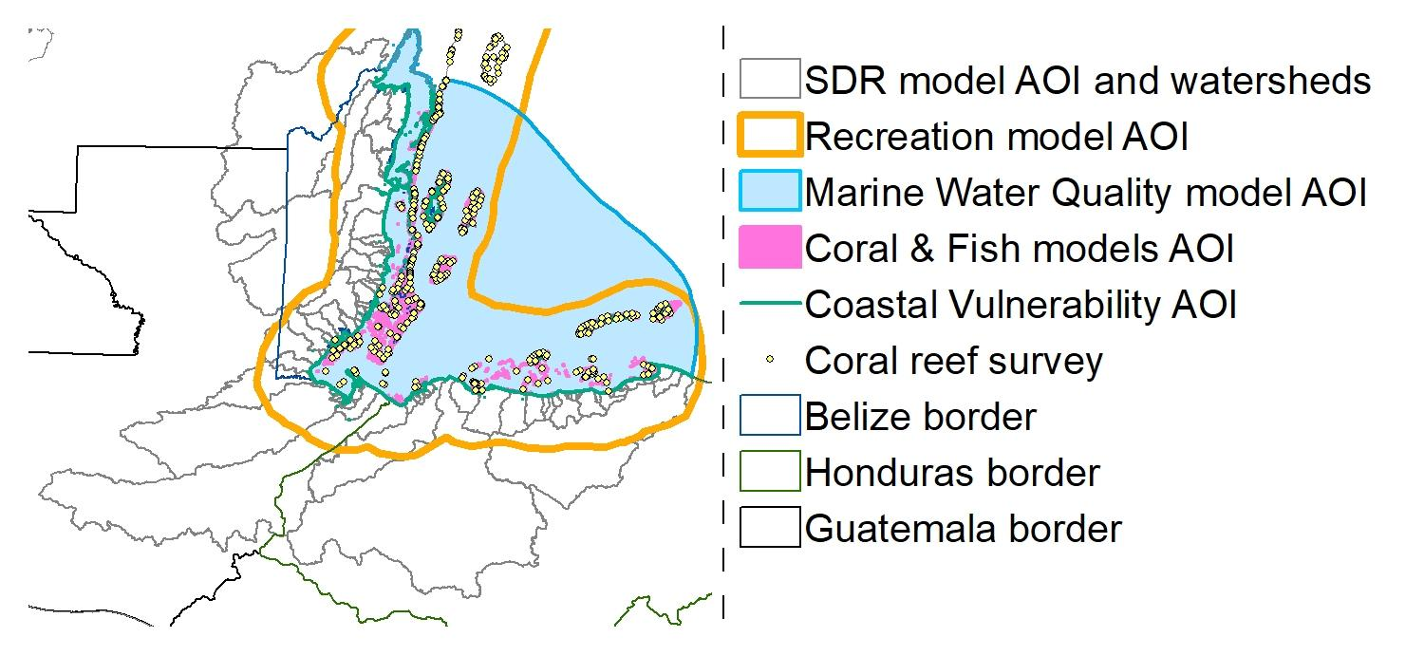Supplementary Figure 6. Ecosystem services models area of interest (AOI).
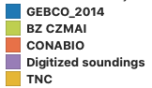
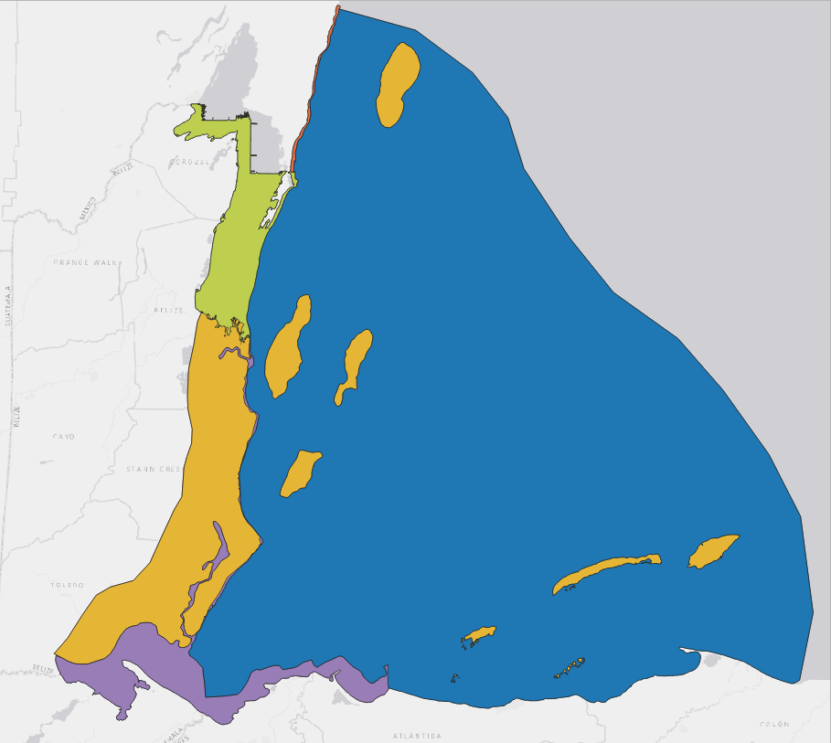

Supplementary Figure 7. Spatial extents used to mask the input bathymetry data sources to create the final bathymetry mosaic.

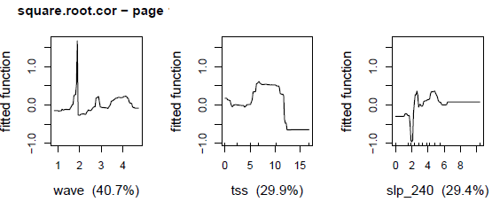

Supplementary Figure 8. Partial plots representing the ecological relationships of corals as a function of TSS, wave power, and habitat characteristics

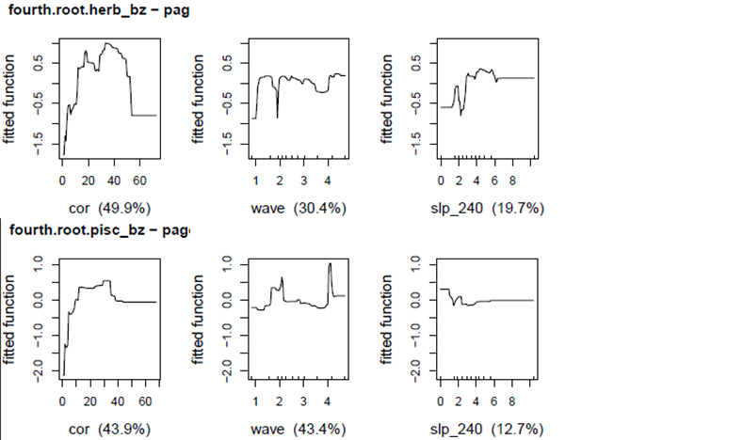Supplementary Figure 9. Partial plots representing the ecological relationships of targeted fish species selected by Belize, modeled by diet, as a function of TSS, wave power, and habitat characteristics

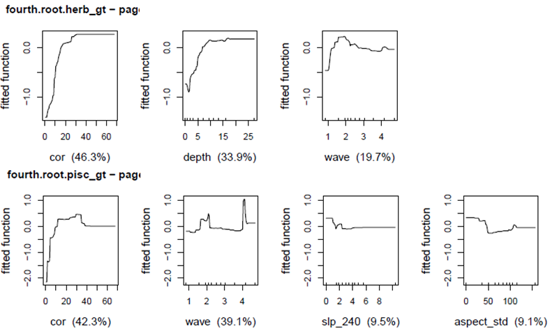Supplementary Figure 10. Partial plots representing the ecological relationships of targeted fish species selected by Guatemala, modeled by diet, as a function of TSS, wave power, and habitat characteristics

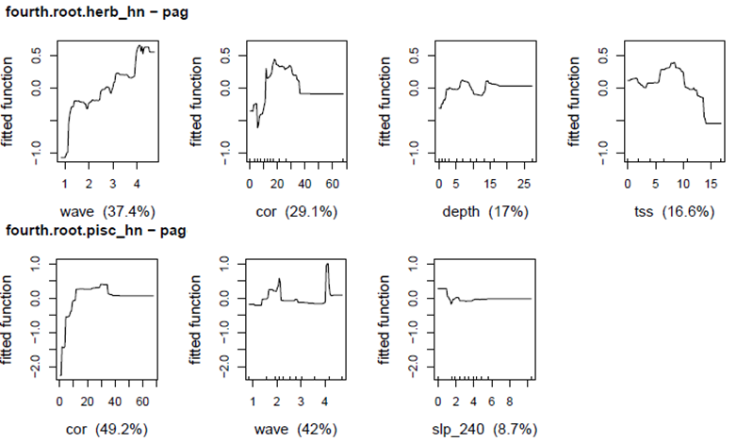Supplementary Figure 11. Partial plots representing the ecological relationships of targeted fish species selected by Honduras, modeled by diet, as a function of TSS, wave power, and habitat characteristics

Supplementary Methods - Summary of ecosystem service modeling

Sediment Delivery Ratio model
To estimate the sediment retention (t.yr⁻¹) and indirectly the change in sediment export to the coast by watershed, we applied the simple, open source, spatially-explicit InVEST SDR model (version 3.9)⁵⁵, which operates at the DEM resolution (30m x 30m) obtained from Shuttle Radar Topography Mission (SRTM)^{63,64}. At the pixel-scale, SDR computes (1) the amount of sediment erosion using the Revised Universal Soil Loss Equation (RUSLE) (equation 1), (2) the sediment delivery ratio (i.e., proportion of soil eroded from a given area) that will travel to the stream mouth at the shoreline, and (3) aggregates the sediment export pixel values at the watershed scale⁵⁵. After testing a range of streamflow accumulation thresholds on the DEM, we selected 1,000 to delineate stream network and watershed boundaries using RouteDEM from the InVEST toolbox³¹. Given the lack of empirical data for the region, the connectivity of SDR and the watershed boundaries were verified by comparing predicted stream outputs to the available stream map and local watershed maps.

The RUSLE equation estimates the overland gross erosion per pixel (see equation 1)⁶⁵ (see supplement table 9 for more details in model inputs):

$Soil loss= R×K×LS×C×P$(1)

Where $R$ = rainfall erosivity factor (MJ.mm.ha⁻¹.hr⁻¹), represent the ability of rainfall to cause erosion and was derived using historical annual precipitation (P)⁴⁵ and elevation (E)⁶⁴ (R = 3786.6 + 1.5679 x P – 1.9809 x E)²⁵, $K$ = soil erodibility factor (tons⋅ha⋅h⋅(ha⋅MJ⋅mm)⁻¹) represent the rate of soil loss per rainfall erosion index unit, derived from ISRIC soil global database⁶⁶ and William’s method (equation S1b)^{67,68}, $LS$ = slope-length and gradient factor, $C$ = Cover management factors (C-factor) represent the effect of vegetation cover on soil erosion rates and $P$ = Conservation practice factors (P-factors) represent the impact of management practices on soil erosion rates. C-factors and P-factors were assigned to each land cover use/type and derived from literature applying to each country where possible or neighboring geographical regions containing comparable land uses (supplement table 7).

SDR applies the concept of hydrological connectivity, which uses local topography derived from the DEM, to model the sediment transport across the landscape and determine the ratio exported to the shoreline⁶⁹, and therefore does not require hydrological modeling. To do so, SDR first computes a connectivity index (IC_{i}) for each pixel i based on the upslope area and downslope flow path⁶⁹. The sediment delivery ratio is derived for each pixel i based on the connectivity index⁵⁵. SDR model connectivity index (IC₀) and the K parameters were set to 0.5 and 2.0, respectively, and the maximum allowable SDR parameter, which defines the shape of the relationship between the SDR and the connectivity index, was set to 0.8³¹. Although the modeling results could not be validated against local datasets and were parameterized with values from other regions in some places, which can differ in terms of climate and soil conditions⁷⁰, this approach still allows us to explore the relative change between management interventions and present conditions at the watershed scale³¹. It is worth noting that we may have underestimated sediment export due to erosion processes not accounted for by SDR, including major sources of sediment such as landslides and stream bank erosion⁷¹. Future field work focusing on in situ measurements at catchment outlets can be compared to SDR outputs^{72,73}.

Marine water quality model
To link the sediment model to the marine ecosystem services models, we modeled marine water quality by diffusing the sediment load from all the watersheds discharging into the MAR into coastal waters as point-source discharge, for each land-use scenario. To do so, we assigned pourpoints at the shoreline as proxies for stream mouths using available satellite imagery, stream map, open street maps, and bathymetry data (OSM 2019). The sediment load from each watershed was assigned to each pourpoint. To avoid data gaps between the terrestrial and marine realms, we created a seamless topo-bathymetry layer using the SRTM DEM (30m) and a mosaiced bathymetry (30m), which combined a bathymetry layer built by TNC (10m) spanning 0-30m deep and the GEBCO waters beyond 30m deep. To represent the impedance of sediment moving planimetrically through water (i.e, each cell) from each pour point, we created a diffusion factor surface layer (c) using a composite of three marine factors known to affect sediment diffusion: depth (m), wave power (kW/m), and wind exposure index (kW). Note, that this water quality model does not account for tidal-driven current influence, which may impact the dispersion of TSS in some regions by over- or under-estimating the TSS value. Future investigations can compare modeled water quality to local knowledge, satellite imagery, and/or in-situ data as those become available^{27,34}.

Annual wave power was derived from ERA5, latest release from the European Center, and following⁷⁴. Wind exposure was represented by the Relative Exposure Index (REI) (Keddy 1982) and computed by dividing the 360 degrees compass into 16 equiangular sectors and combining the highest 10% wind speeds and fetch characteristics in these sectors from Wavewatch III spanning 1999 – 2010 (see Coastal Vulnerability model user guide³¹ for more details). The wave power and wind exposure point data were interpolated and resampled at 30m to align with the bathymetry raster. For depth, we assumed that shallow water has a high diffusion effect because sediment settles out of water column more slowly due to resuspension compared to deeper waters, while low wind and wave areas have a low diffusion effect because sediment settles out of the water column more quickly in waters sheltered from high wind and wave energy. Based on those assumptions, we rescaled the three marine factors between (>0 low diffusion – 1 high diffusion) to make them unitless and comparable. The three unitless layers were summed into a total diffusion factor surface layer, rescaled (>0 low diffusion – 1 high diffusion) and ran through the cost allocation tool from ArcGIS for each pourpoint to derive a diffusion factor per watershed.

The sediment spread into coastal waters is modeled for each pour point by applying a non-linear decay function over the diffusion factor surface layer pertaining to each watershed until a maximum distance of 20-25 km from the shoreline is reached (see Equation 8). This threshold was based on the distance measured in ArcGIS between river mouths and satellite imagery showing the spatial extent of Kd-490, a proxy for riverine inputs into the ocean (Soto et al. 2009, Ocean Colour CCI).
$$TSS= \sum_{n=1}^{412}{s_{p}}×e^{-c^{2}/D_{c}} (2)$$
where $TSS$= Total Suspended Sediment per grid cell value (t/yr),$s_{p}$ = Sediment load (t/yr) at each pourpoint of watershed i (obtained from SDR InVEST), $c$ = diffusion factor surface (unitless) represents the impedance of moving planimetrically through each cell from each pourpoint using a composite of three oceanographic drivers known to affect sediment dispersion: depth (m), wind exposure (unitless), current (degree and seconds) (Fabricius 2005; Rude et al. 2016; Delevaux et al. 2018), $D_{c}$ = diffusion threshold distance from the shore for each decayed sediment plume per watershed (set to not exceed 25 km from the shoreline).

The modeled plume for the baseline was compared to Kd-490 obtained from satellite imagery (https://oceandata.sci.gsfc.nasa.gov/). We downloaded the monthly averaged Kd-490 values from January 2010 to December 2017 to align with the land cover maps from the three countries. The monthly values were averaged into yearly values and the 7 years were average into 1 period. We randomly assigned 280 points across the marine water quality AOI and extracted the values to points from the baseline TSS and the Kd-490. The R² was computed to compare the two.

Coral reef models
We linked the effect of land cover change on marine ecosystem services through impact of total suspended sediment on scleractinian coral (% cover), which are known to support multiple coral-associated marine services in the Caribbean’s, including fisheries, coastal protection and attract tourism^{56,75}. Fish taxa, identified as important for subsistence and commercial fisheries by partners in each country (Supplementary Table 4), were modeled by feeding behavior (i.e., herbivore and piscivore biomass) and as a function of habitat conditions (Supplementary Table 5) to increase the models performance (Supplementary Table 7). We derived the empirical coral % cover and targeted fish biomass (g/100m²) from reef survey data collected by Healthy Reef Initiative (HRI), which comprised 517 survey locations, collected between 2006–2018 (Supplementary Figure 6).

Model calibration
We used boosted regression trees (BRTs) as the coral reef models because they are effective at modeling nonlinearities and threshold effects between variables⁷⁶. We considered a range of learning rate, tree complexity, and bag fraction value combinations for the model fitting process⁷⁶. We selected the best model with the highest PDE, and the model parameter values and optimal number of trees were used in the simplification process to avoid overfitting and to make spatial predictions. To simplify the models, we used the dismo package in R to identify the number of predictors to remove by evaluating how many predictors could be dropped without resulting in a reduction in predictive performance (see ⁷⁶ Appendix B for detailed description). Following model simplification, a final model was fitted using the simplified set of predictor variables.

We modeled coral cover and targeted fish biomass as a function of water quality (modeled TSS), wave power derived from ERA5 wave model, and habitat characteristics computed from fine-scale bathymetry, which have all been shown to be important predictors of coral cover and fish biomass in other tropical regions (Supplementary Table 5). Habitat characteristics are measured by metrics of depth, topography, complexity, and exposure. Habitat topography metrics, such as Bathymetric Position Index (BPI) and slope, describe the position of the reef relative to the surrounding area. Habitat complexity metrics describe the fine-scale topographic structure through slope of slope, planar curvature, and profile curvature. Slope and slope of slope were computed for two neighborhood sizes (30 and 240 m radii) to capture habitat characteristics at multiple spatial scales. Habitat exposure metrics characterized the direct and indirect effects of water flow due to fine-scale seafloor topography and directionality. These metrics were derived by computing seafloor aspect (the steepest downslope direction of the seafloor) and were measured in degrees. We also estimated exposure to winds by calculating the circular mean and standard deviation of aspect and converted the circular mean into measures of northness and eastness using the sine and cosine functions, respectively, in ArcGIS. We assessed the spatial autocorrelation of those predictors (r > 0.3) and removed the slope of slope (240m radius) (see ⁷⁷ for more details on processing methods).

The bathymetry map was created by mosaicking the best available, highest resolution data sources for various regions in the study area (Supplementary Figure 7 shows the spatial extents used to mask the input bathymetry data sources to create the final mosaic). Most of the higher resolution data were only available for the nearshore regions of individual countries, such as Mexico⁷⁸ and Belize (Belize Coastal Zone Management Authority and Institute (CZMAI) and Belize Port Authority (2019). Outside of these areas, The Nature Conservancy (TNC) provided a data set derived from Sentinel-2 satellite imagery⁷⁹ for shallow areas (< 20 m depth) across the entire region. To supplement these data sets, soundings for some highly turbid nearshore regions were digitized from digital nautical charts. Finally, for deeper depths, GEBCO_2014 (version 20150318, http://www.gebco.net) was used to fill in depths for all other regions of the study area. All source data were projected to UTM Zone 18N WGS-84, resampled to 30 m spatial resolution, and harmonized to represent depths as negative values prior to mosaicking.

The response variables (i.e., the coral % cover and targeted reef fish biomass indicators) were transformed prior to modeling (square root for coral cover and fourth root for fish biomass) to approximate normality. The BRTs were independently calibrated for each coral reef indicator as a function of the terrestrial (i.e., TSS) and marine predictors (i.e., habitat and wave) at the survey point level to identify the most important predictors, their relative influence, and their ecological relationships (Supplementary Figs 8-11). First the coral model was calibrated, followed by the fish models, which included coral as a predictor (see ⁷⁶ for more details on the calibration process). The optimal model was selected based on the most variation explained using the percent deviance explained (PDE) and validated using the internal ten-fold cross validation PDE (CV PDE) (Supplementary Table 7). Spatial autocorrelation of the response variables was tested using Moran’s I Index for the ecological model residuals⁸⁰.

Spatial predictive mapping
The calibrated models were used to predict at the pixel-level (30m) the abundance of coral (% cover) and targeted fish biomass (g/100m²) as a function of the terrestrial and marine predictors, using the geospatial layers covering the coral reef model AOI. The coral reef layer includes the extent and distribution of coral reefs present in the MAR region. The data layers were collated by the AGRRA and HRI teams. This was an effort made with the compilation of different sources of information available in the region, including the Millennium Coral Reef Mapping Project^{81,82}, new benthic habitat mapping effort through HRI, Smithsonian, Purkis Partnership in Guatemala, Belize and Honduras⁸³, a new benthic habitat mapping realized by CONABIO in Mexico⁷⁸, and researchers work^{22,84}. Different benthic habitats present in the classifications and characterizations carried out were considered coral reefs, among these habitats are Coral framework, Coral framework with algae, Individual patch reefs, Pavement with gorgonians, and Spur and groove. Different collaborating partners who carry out monitoring and research work on coral reefs in the region reviewed the layer resulting from this compilation of information. It should be noted that this new information layer includes many reefs, not previously identified in global information layers, such as the Cayman Crown reefs in Guatemala and several coral reef areas in Honduras. The habitat classes for each map corresponding to hard bottom or habitat types with corals were merged into a habitat footprint.

First, we spatially predicted the coral habitat layer as a function of its key predictors, followed by the spatial predictions of the targeted fish biomass indicators as a function of their respective final predictors, including the predicted distribution of the coral indicator. A key limitation with this modeling approach is the ability to predict change in coral cover and fish biomass are bounded by the range of the predictors under current conditions (i.e., the calibration data). When the scenarios’ predictors range exceeds the calibration range, the model will extrapolate coral cover or fish biomass at a constant value, which corresponds to the highest values of the predictors under current conditions⁸⁵. Consequently, the potential increase in coral cover or fish biomass in response to improved environmental conditions, such as TSS, caused by the considered scenarios may be underestimated. To ground-truth the predictions under current conditions (baseline), the predicted values of the coral reef indicators were sampled using bilinear interpolation at the location of the reef survey and compared to the empirical coral reef indicators values using the p-value of a linear regression. The predicted maps were also overlaid with the survey point values for each indicator using the same color ramp scale for the legend for visual comparison. All this ecological modeling was implemented in the R software with the gbm and dismo packages^{86,87}.

Coastal Vulnerability model
To model coastal risk reduction, we used the InVEST Coastal Vulnerability model. The Coastal Vulnerability model utilizes an index-based approach to understand the relative risk of exposure to coastal hazards along a stretch of coastline and identifies where coastal and marine habitats have the greatest potential for providing coastal protection. The model computes the relative exposure of the shoreline to flooding and erosion based on the following characteristics: habitat type and extent, coastal elevation, exposure to wind and waves, shoreline geomorphology, and storm surge potential^{31,88,89}.

We considered coral with at least 10% live coral cover to be healthy enough to provide coastal protection services, but coral with less than 10% coral cover was considered too degraded to provide services. There is evidence that the ability for coral reefs to provide coastal protection services is influenced by factors including coral health and rugosity^{90–92}, and the 10% threshold used in this study was chosen based on the Healthy Reef Initiative.

We modeled coastal protection for each 250m shoreline segment across the three countries. Our scenarios reflected changes in the extent of healthy coral (>= 10% live coral cover) resulting from each management action, with all other variables (i.e. coastal relief, geomorphology, etc.) remaining the same. For each shoreline segment the model produced a coastal exposure index, ranging from 1-5 with 5 representing the greatest potential risk of exposure to coastal hazards and 1 the least. The metrics reported were calculated by taking the difference between the baseline and scenario coastal exposure values for each management scenario. This isolates the role that changes in coral health and extent, resulting from watershed management related improvements to water quality, play in providing coastal protection services for the shoreline.

Tourism model
We used a two-step approach to model the effects of the adaptation interventions on nature-based tourism, building on the InVEST Recreation model^{31,93}. First, we created spatially explicit maps of tourism across the MAR region using the locations of posts to the social media platforms Flickr and Twitter, as well as national statistics on total tourism to each country^{13,56,94}. Then, we estimated the relative importance of healthy ecosystems (including coastal forests and coral) to tourism in the region using a revealed preference approach^{94–97}. Using these relationships, we quantified the expected change in coastal (forest-based) and marine (coral-based) tourism under each watershed intervention.

We estimated tourism across the entire coastal zone (roughly 50 km inland to 75 km offshore) of the MAR region, stretching from the northern tip of the Yucatan Peninsula to the northern coast of Honduras. For each country (Mexico, Belize, Guatemala, and Honduras), we estimated the number of tourists who visited the coastal zone by apportioning the number of total international visitors reported by the official tourism statistics in 2017 according to the proportion of total Flickr user-days (PUD) that were posted from within the coastal zone. Then, we further disaggregated these data to create estimates of visitation to 5 km grid cells throughout the region using the distribution of PUD and Twitter user-days (TUD), giving each equal weight. For each platform, we calculated the average annual number of user-days from each grid cell (Flickr 2005-2018, Twitter 2012-2018). Flickr images were retrieved from January 1-2, 2019 by querying the Flickr API, while Tweets were retrieved in real-time from Twitter’s “statuses/filter” streaming API.

After mapping visitation across the region, we related the distribution of visitors to a suite of landscape features which we expected to drive patterns in visitation, including natural ecosystems, cultural features, accessibility, and climatic conditions using multiple linear regression¹³ (Supplementary Table 2). In particular, we quantified the impact of healthy coastal forests and healthy coral reefs on visitation in this region. We extracted several forest types from the LULC layer (Supplementary Table 3) to create a footprint of coastal forests. We created a footprint of healthy coral using the coral model described above and 10% as the threshold according to the Healthy Reef Initiative. We only included areas of coral with greater than 10% coral cover, assuming that these corals were healthy enough to draw tourists. For both coastal forests and coral, we calculated the proportion of the 5 km grid cell that was covered by the healthy ecosystem footprint and related this proportion to the number of visitors in that cell. We found that both coastal forest and coral extent had significant positive relationships with the number of visitors to the grid cell (β = 0.85, p-value < 0.0001; β = 4.61, p-value < 0.0001, respectively). The full set of features are described in Supplementary Table 2. Together, they explained 45% of the variability in visitation across the region (Adjusted R² = 0.454, Supplementary Table 2).

We estimated the impact of each management intervention on coastal and marine tourism individually. To quantify the direct impacts of changes in land cover type (under the watershed restoration and protection interventions) on coastal tourism, we modeled the marginal effect of changes in coastal forest footprints. The sustainable agriculture intervention did not involve changes in land cover type (only changes in agriculture and pasture), so we were unable to estimate the impact of this intervention on coastal tourism. To quantify the indirect impacts, we looked at how changes in coral health lead to changes in healthy coral footprint (>10% coral cover), and thus to predicted changes in marine tourism by modeling the marginal effect of coral on tourism. In each case, these marginal effects on tourism reflected the change in the number of annual visitors who would be expected to visit the area if the healthy forest or healthy coral footprint changed according to the management intervention.

Finally, we multiplied our estimates of change in tourism by the average daily expenditures of international tourists to each country in 2017 as reported by their official tourism boards (Belize US$148, Guatemala US$81, Honduras US$60) to calculate the economic contribution of the tourists drawn by healthy ecosystems.

Supplementary cited literature
59. Frenken, K. Aquastat. Irrig. Water Requir. Water Withdrawal Ctry. (2012).
60. Chicas, S. & Omine, K. Forest Cover Change and Soil Erosion in Toledo’s Rio Grande Watershed. ISPRS-Int. Arch. Photogramm. Remote Sens. Spat. Inf. Sci. 40, 353–358 (2015).
61. Lianes, E., Marchamalo, M. & Roldán, M. Evaluación del factor C de la RUSLE para el manejo de coberturas vegetales en el control de la erosión en la cuenca del río Birrís, Costa Rica. Agron. Costarric. 33, 217–235 (2009).
62. Argueta Medina, J. C. Estimación de los riesgos y niveles de erosión hídrica en la microcuenca del Río Negro, Chimaltenango. (Universidad de San Carlos de Guatemala, 2010).
63. DeVantier, B. A. & Feldman, A. D. Review of GIS applications in hydrologic modeling. J. Water Resour. Plan. Manag. 119, 246–261 (1993).
64. Farr, T. G. et al. The Shuttle Radar Topography Mission. Rev. Geophys. 45, (2007).
65. Renard, K. G., Foster, G. R., Weesies, G. A., McCool, D. K. & Yoder, D. C. Predicting soil erosion by water: a guide to conservation planning with the Revised Universal Soil Loss Equation (RUSLE). vol. 703 (United States Department of Agriculture Washington, DC, 1997).
66. Hengl, T. et al. SoilGrids250m: Global gridded soil information based on machine learning. PLOS ONE 12, e0169748 (2017).
67. Williams, J. R. The EPIC model. Comput. Models Watershed Hydrol. 909–1000 (1995).
68. Wawer, R., Nowocien, E. & Podolski, B. Real and calculated kusle erobility factor for selected Polish soils. Pol. J. Environ. Stud. 14, 655–658 (2005).
69. Borselli, L., Cassi, P. & Torri, D. Prolegomena to sediment and flow connectivity in the landscape: a GIS and field numerical assessment. Catena 75, 268–277 (2008).
70. Gholami, L., Sadeghi, S. H. R. & Darvishan, A. V. K. Modeling storm-wise sediment delivery ratio model in Chehelgazi watershed by using climatic and hydrologic characteristics. J. Agric. Sci. Nat. Resour. 16, 253–260 (2009).
71. Olley, J. et al. Remnant riparian vegetation, sediment and nutrient loads, and river rehabilitation in subtropical Australia. Hydrol. Process. 29, 2290–2300 (2015).
72. Merritt, W. S., Letcher, R. A. & Jakeman, A. J. A review of erosion and sediment transport models. Environ. Model. Softw. 18, 761–799 (2003).
73. Rude, J. et al. Ridge to reef modelling for use within land–sea planning under data-limited conditions. Aquat. Conserv. Mar. Freshw. Ecosyst. 26, 251–264 (2016).
74. Reguero, B. G., Losada, I. J. & Méndez, F. J. A recent increase in global wave power as a consequence of oceanic warming. Nat. Commun. 10, 1–14 (2019).
75. Arkema, K. K. et al. Assessing habitat risk from human activities to inform coastal and marine spatial planning: a demonstration in Belize. Environ. Res. Lett. 9, 114016 (2014).
76. Elith, J., Leathwick, J. R. & Hastie, T. A working guide to boosted regression trees. J Anim Ecol 77, 802–813 (2008).
77. Stamoulis, K. A. et al. Seascape models reveal places to focus coastal fisheries management. Ecol. Appl. 28, 910–925 (2018).
78. Cerdeira-Estrada, S. et al. Cobertura Bentónica de los Ecosistemas Marinos del Caribe Mexicano: Cabo Catoche-Xcalak. 2018. http://www.conabio.gob.mx/informacion/gis/ (2017).
79. Li, J. et al. Adaptive bathymetry estimation for shallow coastal waters using Planet Dove satellites. Remote Sens. Environ. 232, 111302 (2019).
80. Miller, J. A. Species distribution models: Spatial autocorrelation and non-stationarity. Prog Phys. Geogr 36, 681–692 (2012).
81. Institute for Marine Remote Sensing, University of South Florida (IMaRS/USF), Institut de Recherche pour le Développement (IRD), UNEPWCMC, The WorldFish Center & WRI. Global coral reefs composite data set compiled from multiple sources, incorporating products from the Millennium Coral Reef Mapping. (2011).
82. Andréfouët, S. et al. Global assessment of modern coral reef extent and diversity for regional science and management applications: a view from space. in Proceedings of the 10th International Coral Reef Symposium vol. 2 1732–1745 (Japanese Coral Reef Society Okinawa, Japan, 2006).
83. Purkis, L. Summary report of satellite mapping of morphological and benthic habitats for the Honduran North Shore. (2016).
84. Mumby, P. J. & Harborne, A. R. Classification scheme for marine habitats of Belize. UNDPGEF Belize Coast. Zone Manag. Proj. (1999).
85. Elith, J. Reasons for differing performances of species distribution models. 43 (2008).
86. Ridgeway, G. Generalized Boosted Models: A guide to the gbm package. Update 1, 2007 (2007).
87. Hijmans, R. J., Phillips, S., Leathwick, J. & Elith, J. R package, dismo: Species distribution modeling. (2014).
88. Silver, J. M. et al. Advancing Coastal Risk Reduction Science and Implementation by Accounting for Climate, Ecosystems, and People. Front. Mar. Sci. 6, (2019).
89. Arkema, K. K. et al. Coastal habitats shield people and property from sea-level rise and storms. Nat. Clim. Change 3, 913–918 (2013).
90. Sheppard, C., Dixon, D. J., Gourlay, M., Sheppard, A. & Payet, R. Coral mortality increases wave energy reaching shores protected by reef flats: examples from the Seychelles. Estuar. Coast. Shelf Sci. 64, 223–234 (2005).
91. Quataert, E., Storlazzi, C., Van Rooijen, A., Cheriton, O. & Van Dongeren, A. The influence of coral reefs and climate change on wave-driven flooding of tropical coastlines. Geophys. Res. Lett. 42, 6407–6415 (2015).
92. Reguero, B. G., Beck, M. W., Agostini, V. N., Kramer, P. & Hancock, B. Coral reefs for coastal protection: A new methodological approach and engineering case study in Grenada. J. Environ. Manage. 210, 146–161 (2018).
93. Wood, S. A., Guerry, A. D., Silver, J. M. & Lacayo, M. Using social media to quantify nature-based tourism and recreation. Sci. Rep. 3, 2976 (2013).
94. Fisher, D. M., Wood, S. A., Roh, Y.-H. & Kim, C.-K. The geographic spread and preferences of tourists revealed by user-generated information on Jeju Island, South Korea. Land 8, 73 (2019).
95. Hamstead, Z. A. et al. Geolocated social media as a rapid indicator of park visitation and equitable park access. Comput. Environ. Urban Syst. 72, 38–50 (2018).
96. Keeler, B. L. et al. Recreational demand for clean water: evidence from geotagged photographs by visitors to lakes. Front. Ecol. Environ. 13, 76–81 (2015).
97. Arkema, K. K., Fisher, D. M., Wyatt, K., Wood, S. A. & Payne, H. J. Advancing sustainable development and protected area management with social media-based tourism data. Sustainability 13, 2427 (2021).

