Table 1. The key features and drawbacks of developed liver-on-a-chip systems.
 | Design | Key features | Drawbacks
v1 | 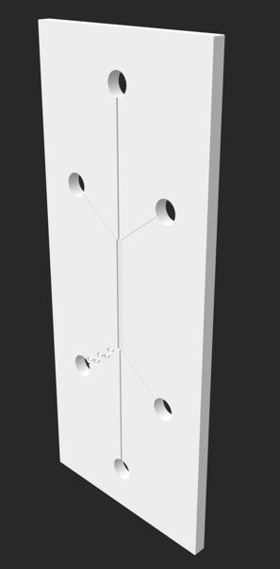 | - Tesla valve  - μm scale channels  - Small volumes of substances required  - 1 cm length reaction zone | - Sharp corners  - Long filling lines  - Complicated filling procedure due to undesired air bubbles
v2 | 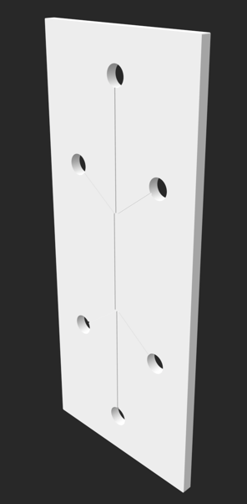 | - μm scale channels  - Small volumes of substances required  - 1 cm length reaction zone | - Sharp corners  - Long filling lines  - Complicated filling procedure due to undesired air bubbles
v3 | 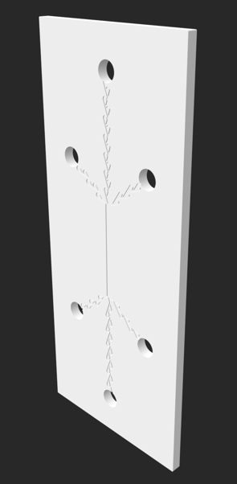 | - Tesla valve - stops substances flowing out of the chip.  - μm scale channels  - Small volumes of substances required.  - 1 cm length reaction zone | - Sharp corners  - Long filling lines  - Complicated filling procedure due to undesired air bubbles
v4 | 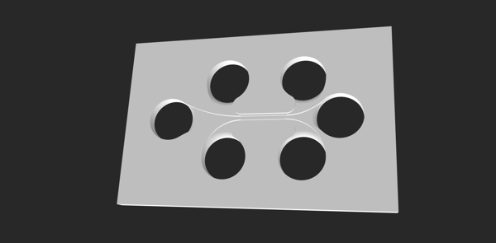 | - Short filling channels  - Wide filling ports  - Short filling lines  - Smooth edges, no dead ends or microwells | - Shorter 5 mm reaction zone

