Supplemental information: extended data

Regional differences in fishing behavior determine whether a marine reserve network enhances fishery yield

Hunter S. Lenihan¹, Daniel C. Reed¹, Maria Vigo², Callie Leiphardt¹, Jennifer K.K. Hofmiester³, Jordan P. Gallagher¹, Chris Voss⁴, Peyton Moore¹, and Robert J. Miller¹

¹Marine Science Institute, University of California, Santa Barbara, California, USA

²Institut de Ciències del Mar, CSIC, Barcelona, Spain

³California Department of Fish and Wildlife, San Diego, CA

⁴California Lobster and Trap Fishermen’s Association

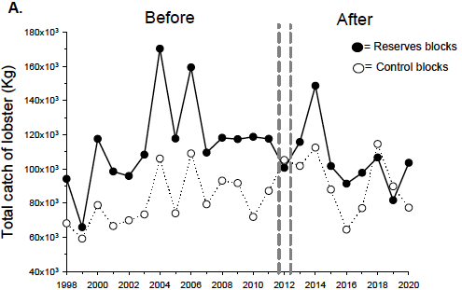

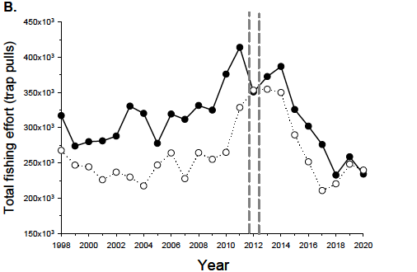

Figure S1. Annual summed values of the commercial mainland spiny lobster fishery in California for (A) lobster catch (kg) and (B) fishing effort (trap pulls) for reserve (solid circles) and control (open circles) fishing blocks. These data are for entire fishery (north and south regions combined). Reserve blocks (n = 13) are jurisdictional fishing blocks with marine reserves and control blocks (n = 21) are fishing blocks without reserves. The vertical dotted lines designate when the reserves were established and include a transitional year (2012) not used in the calculations of the Delta values shown in Figures 2-4.

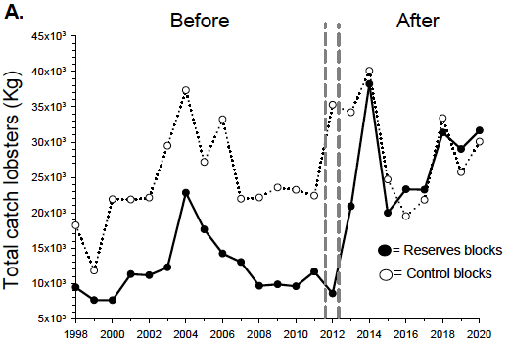

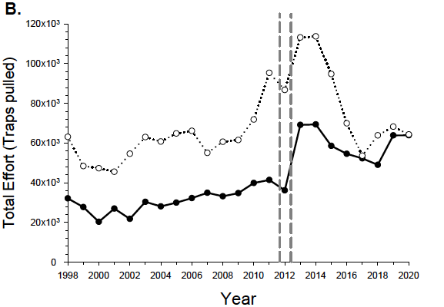
Figure S2. Annual summed values of the commercial mainland spiny lobster fishery in northern portion of the fishery (See Figure 1) for (A) lobster catch (kg) and (B) effort (trap pulls) for fishing blocks with reserves (n = 5) and fishing blocks without reserves (control blocks, n = 10).

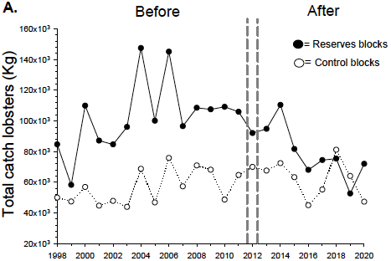

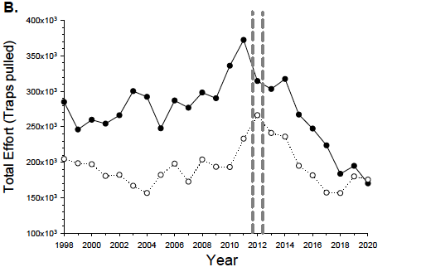

Figure S3. Annual summed values of the commercial mainland spiny lobster fishery in southern portion of the fishery (see Figure 1) for (A) lobster catch (kg) and (B) effort (trap pulls) for fishing blocks with reserves (n = 8) and fishing blocks without reserves (control blocks, n = 11).

