Table 3
Heat map illustrating the individual severity of the different UHDRS domains at baseline, week 8 and week 12.
The items of UHDRS motor scale were summarised in subscales (sum of corresponding values and divided by the number of questions regarding the problem) by preserving the range between 0 and 4. Patients in columns and subscales in rows were ranked in descending order according to the sum of baseline values among patients and subscales, respectively (On the two heatmaps the patients in columns follow the same order for comparison). The highest (2<=) and virtually lacking (0,1>) cells were highlighted for better comparison of the two time points.
0: no symptoms; 1: mild symptoms; 2: moderate symptoms; 3: moderately severe; 4: severe symptoms
BL: baseline; W8: week 8; W12: W12; P: participant
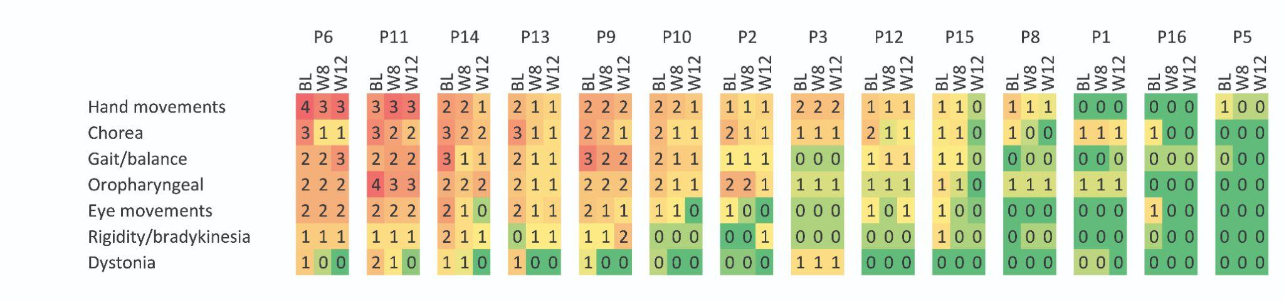

Table 4
Individual scores on different motor subscales at baseline, week 8 and week 12.
BL: baseline; W8: week 8; W12: W12; P: participant
 | P1 |  |  | P2 |  |  | P3 |  |  | P5 |  |  | P6 |  |  | P7 |  |  | P8 |  |  | P9 |  |  | P10 |  |  | P11 |  |  | P12 |  |  | P13 |  |  | P14 |  |  | P15 |  |  | P16
 | BL | W8 | W12 | BL | W8 | W12 | BL | W8 | W12 | BL | W8 | W12 | BL | W8 | W12 | BL | W8 | W12 | BL | W8 | W12 | BL | W8 | W12 | BL | W8 | W12 | BL | W8 | W12 | BL | W8 | W12 | BL | W8 | W12 | BL | W8 | W12 | BL | W8 | W12 | BL | W8 | W12
Hand movements | 0 | 0 | 0 | 7 | 5 | 6 | 8 | 8 | 8 | 3 | 2 | 2 | 18 | 15 | 17 | 2 | 1 | 1 | 7 | 4 | 3 | 11 | 11 | 9 | 9 | 8 | 7 | 13 | 17 | 16 | 7 | 6 | 6 | 9 | 7 | 6 | 12 | 11 | 7 | 5 | 4 | 2 | 0 | 0 | 0
Chorea | 8 | 8 | 6 | 13 | 8 | 7 | 9 | 9 | 9 | 0 | 0 | 0 | 20 | 7 | 6 | 0 | 0 | 0 | 6 | 3 | 0 | 16 | 13 | 8 | 12 | 7 | 7 | 20 | 16 | 11 | 11 | 4 | 5 | 18 | 10 | 7 | 18 | 14 | 11 | 5 | 6 | 1 | 5 | 0 | 0
Gait/balance | 0 | 0 | 1 | 2 | 2 | 2 | 1 | 1 | 1 | 1 | 0 | 0 | 6 | 6 | 8 | 2 | 0 | 0 | 0 | 1 | 1 | 9 | 7 | 7 | 5 | 4 | 4 | 6 | 7 | 7 | 2 | 3 | 3 | 5 | 3 | 3 | 9 | 3 | 4 | 2 | 2 | 1 | 1 | 1 | 1
Oropharyngeal | 1 | 1 | 1 | 4 | 4 | 2 | 1 | 1 | 1 | 0 | 0 | 0 | 4 | 4 | 4 | 0 | 0 | 0 | 1 | 1 | 1 | 3 | 3 | 3 | 3 | 2 | 2 | 7 | 5 | 5 | 1 | 1 | 1 | 3 | 2 | 2 | 4 | 3 | 4 | 2 | 1 | 0 | 0 | 0 | 0
Eye movements | 0 | 0 | 0 | 4 | 2 | 0 | 2 | 2 | 2 | 0 | 0 | 0 | 12 | 12 | 12 | 0 | 0 | 0 | 0 | 0 | 0 | 9 | 8 | 6 | 6 | 4 | 0 | 12 | 10 | 10 | 4 | 2 | 4 | 10 | 6 | 7 | 14 | 6 | 2 | 4 | 2 | 1 | 6 | 0 | 0
Rigidity/bradykinesia | 0 | 0 | 0 | 0 | 0 | 2 | 1 | 1 | 1 | 0 | 0 | 0 | 4 | 4 | 4 | 0 | 0 | 0 | 0 | 1 | 1 | 2 | 2 | 5 | 1 | 1 | 1 | 3 | 3 | 3 | 1 | 1 | 1 | 1 | 2 | 2 | 5 | 3 | 2 | 3 | 1 | 1 | 1 | 0 | 0
Dystonia | 2 | 2 | 0 | 1 | 1 | 0 | 5 | 5 | 5 | 0 | 0 | 0 | 7 | 2 | 0 | 0 | 0 | 0 | 0 | 0 | 0 | 3 | 0 | 0 | 2 | 0 | 0 | 8 | 4 | 1 | 0 | 0 | 0 | 7 | 0 | 0 | 5 | 3 | 0 | 0 | 0 | 0 | 0 | 0 | 0

