Large-scale genomic analyses with machine learning uncover predictive patterns associated with fungal phytopathogenic lifestyles and traits – Supplementary Information

Supplementary Results

Results of statistical analyses run on DendroNet AUCs
DendroNet’s ability to predict fungal lifestyles varied greatly depending on the lifestyle and genomic features included in the model, with a range in AUC scores from 0.204 ± 0.185 (endomycorrhizal fungi using SMCs+transporters+transfactors feature set) to 1.000 ± 0.000 (obligate biotrophs in 26 feature sets) (Data S3). Statistical analysis with a Friedman test on the lifestyle prediction results showed a significant difference in DendroNet’s AUC scores depending on the genomic feature set used (χ² = 128.361, p = 3.932e-14). However, post-hoc analysis with a Nemenyi test revealed that these significant differences arose only between a few of the best- and worst-performing feature sets; the differences in DendroNet results between most of the 31 genomic feature sets were not statistically significant (Data S5). Two consistent patterns emerged from the Nemenyi test: the first was that the SMCs alone produced significantly lower AUC scores from DendroNet when compared to the top eight feature sets, and the second was that these top eight feature sets all included the CAZyme annotation data (Data S5).

DendroNet’s performance in predicting fungal phytopathogenic traits also varied greatly, with AUC scores ranging from 0.294 ± 0.015 (gymnosperm pathogens using SMCs+transfactors feature set) to 0.961 ± 0.004 (foliar pathogens using the CAZymes+MEROPS+SMCs feature set) (Data S4). As with the lifestyles, statistical analysis with a Friedman test on the trait predictions showed a significant difference in AUC scores depending on the genomic feature set used (χ² = 59.584, p = 0.001), though the Nemenyi post-hoc test showed that these differences arose only between the poorest feature set (SMCs alone) and the top three feature sets (Data S5).

Supplementary Tables
Table S1. The list of 25 lifestyles to which fungal species were assigned in FunLifeDB based on a literature search.
Lifestyles (Abbreviation)
Saprotroph (S) | Lichenicolous (L)
Necrotroph (N) | Lichenized (LF)
Biotroph (B) | Endolichenic (EL)
Obligate Biotroph (OB) | Coprophilous (C)
Hemibiotroph (HB) | Pyrophilous (PY)
Mycoparasite (MP) | Black Yeast (BY)
Parasitic (P) | Thermophile (T)
Opportunistic/Latent Pathogen (O) | Acidophile (A)
Ectomycorrhizal (ECM) | Alkaliphilic (AL)
Endomycorrhizal (ENM) | Hyphomycete (HY)
Orchid Mycorrhizal (ORM) | Brown Rot (BR)
Endophyte (E) | White Rot (WR)
Epiphyte (EP)

Table S2. The ecological traits assigned to pathogenic fungi in FunLifeDB; host type was assigned to all pathogens whereas only plant pathogens received additional assignments for plant host information and infected/inoculated tissues.
Ecological Traits
Host Type | Plant  Fungus  Vertebrate  Invertebrate
Plant Host Information | Gymnosperms  Angiosperms
Infected/Diseased Tissues | Main Stem  Leaves  Roots

Table S3. The balance of genomes across pathogenic groups as well as the tested lifestyles and traits in both the original FunLifeDB and the reduced dataset of published genomes used for analyses.
 | Number of Genomes in Original Database | Number of Genomes in Reduced Database
Pathogens | 251 | 177
Non-pathogens | 265 | 177
Pathogenicity unknown | 66 | 33
Plant pathogens | 196 | 138
Saprotrophs | 369 | 241
Ectomycorrhizae | 36 | 32
Endomycorrhizae | 7 | 7
Necrotrophs | 80 | 56
Hemibiotrophs | 78 | 52
Facultative biotrophs | 43 | 37
Obligate biotrophs | 24 | 21
Gymnosperm pathogens | 34 | 24
Angiosperm pathogens | 181 | 128
Stem pathogens | 131 | 99
Foliar pathogens | 134 | 103
Root pathogens | 64 | 40
Total species | 533 | 355
Total genomes | 582 | 387  (362 published, 8 genomes from R.H. as PI, 17 genomes from F.M. as PI)

Supplementary Figures
Figure S1. Principal component analysis (PCA) biplots for all five annotation groups showing the separation of the Ascomycota and Basidiomycota phyla on the first two principal components (PCs). The two phyla are differentiated by colour, and the four subphyla are differentiated by shape. The black arrows represent the loadings of the variables included in each PCA; only the top ten variables contributing to PC1 and PC2 are shown.

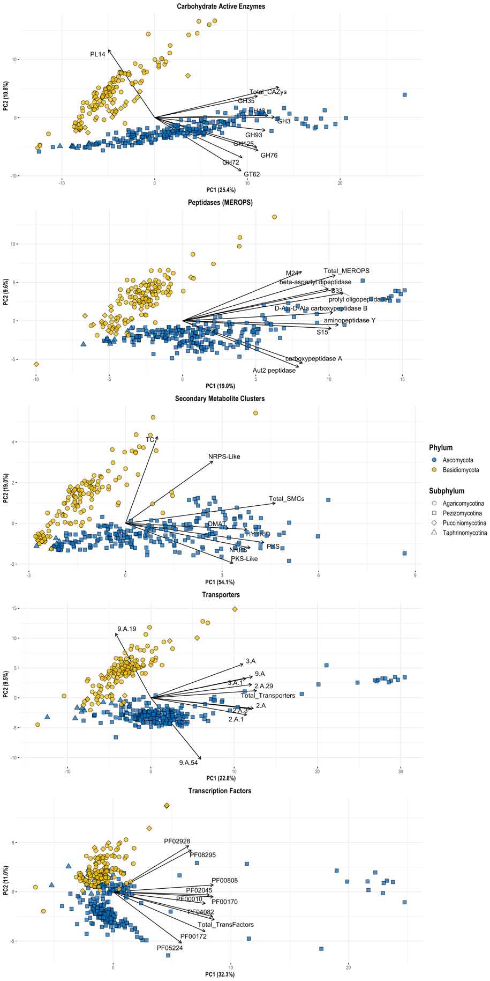

Figure S2. Principal component analysis (PCA) biplots for carbohydrate active enzymes (CAZymes) and peptidases showing the clustering of obligate biotroph (OB) genomes. The four subphyla are differentiated by colour, and the obligate biotroph genomes are differentiated by shape. A statistical ellipse was drawn at a 95% confidence level around the OB genomes. The black arrows represent the loadings of the variables included in each PCA; only the top ten variables contributing to PC1 and PC4 (CAZyme PCA), or PC1 and PC3 (peptidase PCA), are shown.

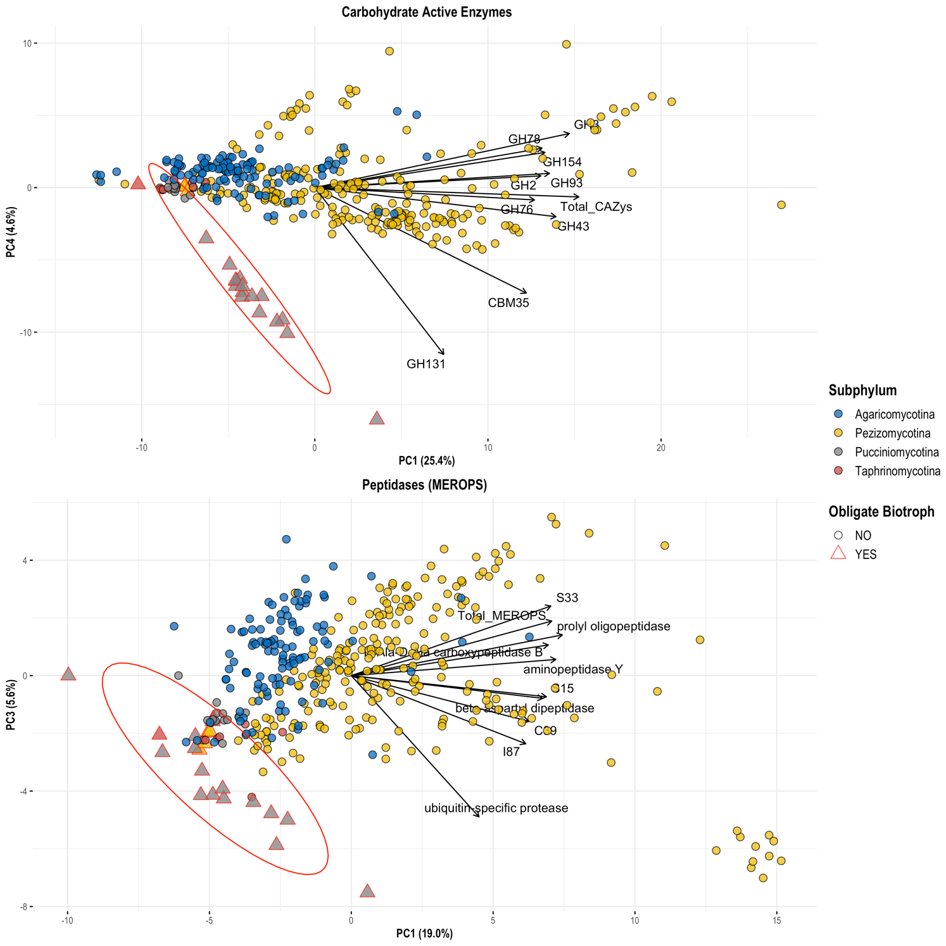

Figure S3. Clustered heatmap of the CAZyme enzyme classes associated with DendroNet’s predictions of phytopathogenic lifestyles and traits. Also included is the ‘Total_CAZys’ feature, which is the total number of CAZyme genes annotated in each genome regardless of enzyme class. The values in the heatmap are the correlation directions for each CAZyme class input into DendroNet as a machine learning feature, which indicate whether an increase (positive correlation, red) or decrease (negative correlation, blue) in the number of genes in a CAZyme class was associated with a lifestyle or trait. Abbreviations: S, saprotrophs; ECM, ectomycorrhizal; ENM: endomycorrhizal; P, pathogens; PP, plant pathogens; N, necrotrophs; HB, hemibiotrophs; B, biotrophs; OB, obligate biotrophs; AP, angiosperm pathogens; GP, gymnosperm pathogens; FP, foliar pathogens; SP, stem pathogens; RP, root pathogens.

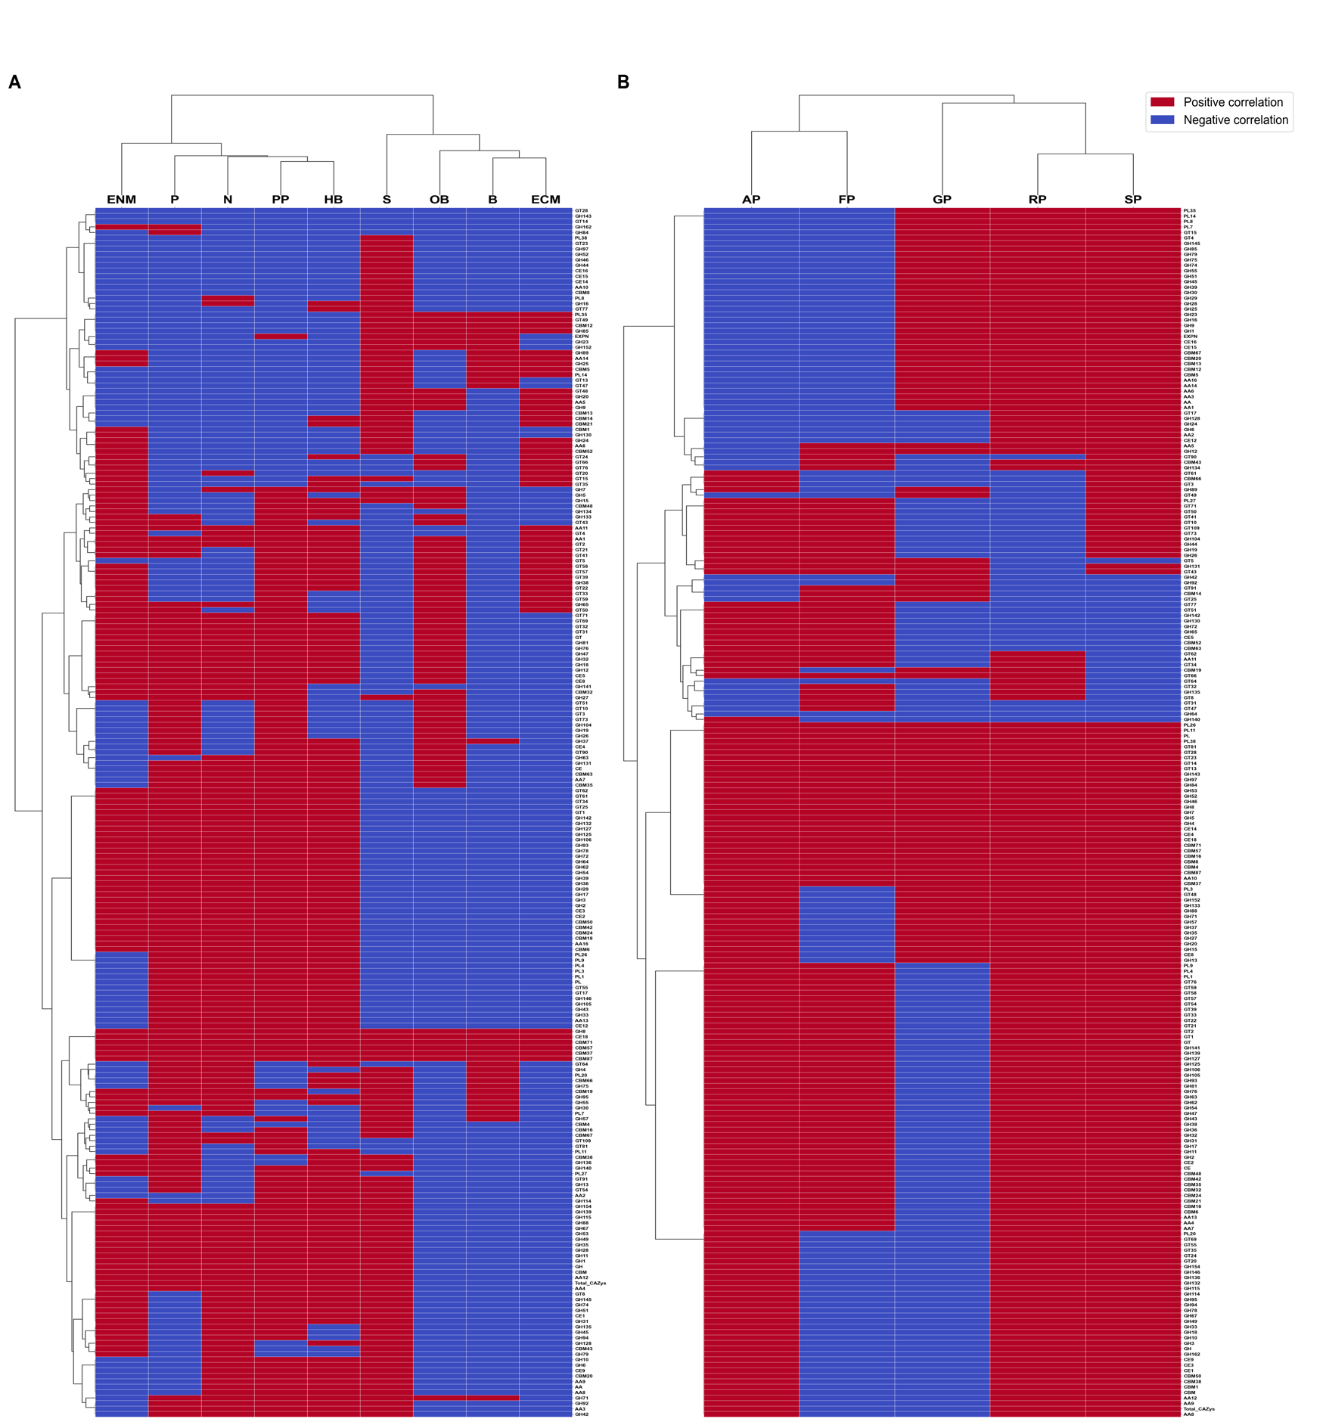
Figure S4. Clustered heatmap of the peptidase (MEROPS) clans and families associated with DendroNet’s predictions of phytopathogenic lifestyles and traits. Also included is the ‘Total_MEROPS’ feature, which is the total number of peptidase genes annotated in each genome regardless of clan or family. The values in the heatmap are the correlation directions for each MEROPS clan/family input into DendroNet as a machine learning feature, which indicate whether an increase (positive correlation, red) or decrease (negative correlation, blue) in the number of genes in a group was associated with a lifestyle or trait. Abbreviations: S, saprotrophs; ECM, ectomycorrhizal; ENM: endomycorrhizal; P, pathogens; PP, plant pathogens; N, necrotrophs; HB, hemibiotrophs; B, biotrophs; OB, obligate biotrophs; AP, angiosperm pathogens; GP, gymnosperm pathogens; FP, foliar pathogens; SP, stem pathogens; RP, root pathogens.

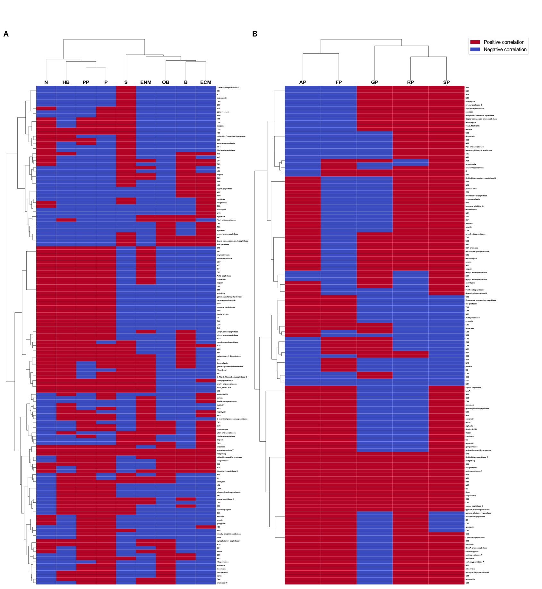

Figure S5. Clustered heatmap of the secondary metabolite cluster (SMC) classes associated with DendroNet’s predictions of phytopathogenic lifestyles and traits. Also included is the ‘Total_SMCs’ feature, which is the total number of SMC genes annotated in each genome regardless of class. The values in the heatmap are the correlation directions for each SMC class input into DendroNet as a machine learning feature, which indicate whether an increase (positive correlation, red) or decrease (negative correlation, blue) in the number of genes in a class was associated with a lifestyle or trait. Abbreviations: S, saprotrophs; ECM, ectomycorrhizal; ENM: endomycorrhizal; P, pathogens; PP, plant pathogens; N, necrotrophs; HB, hemibiotrophs; B, biotrophs; OB, obligate biotrophs; AP, angiosperm pathogens; GP, gymnosperm pathogens; FP, foliar pathogens; SP, stem pathogens; RP, root pathogens.

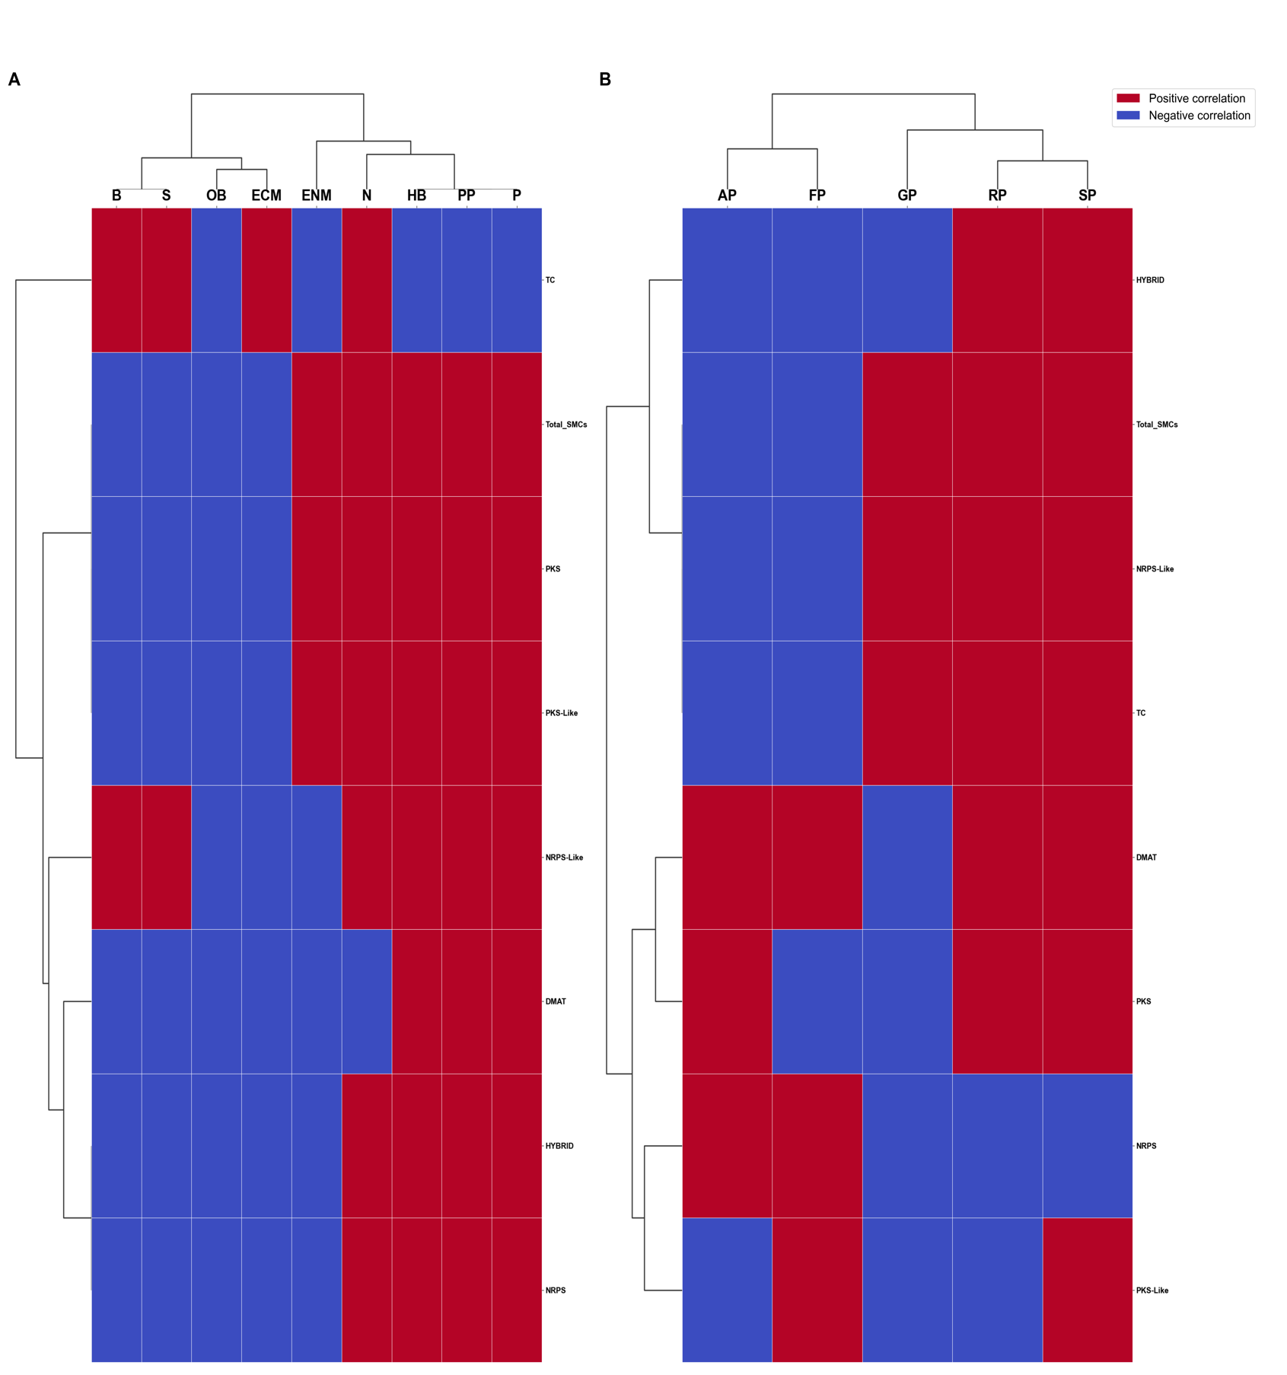

Figure S6. Clustered heatmap of the transporter superfamilies and families associated with DendroNet’s predictions of phytopathogenic lifestyles and traits. Also included is the ‘Total_Transporters’ feature, which is the total number of SMC genes annotated in each genome regardless of family. The values in the heatmap are the correlation directions for each transporter family input into DendroNet as a machine learning feature, which indicate whether an increase (positive correlation, red) or decrease (negative correlation, blue) in the number of genes in a family was associated with a lifestyle or trait. Abbreviations: S, saprotrophs; ECM, ectomycorrhizal; ENM: endomycorrhizal; P, pathogens; PP, plant pathogens; N, necrotrophs; HB, hemibiotrophs; B, biotrophs; OB, obligate biotrophs; AP, angiosperm pathogens; GP, gymnosperm pathogens; FP, foliar pathogens; SP, stem pathogens; RP, root pathogens.

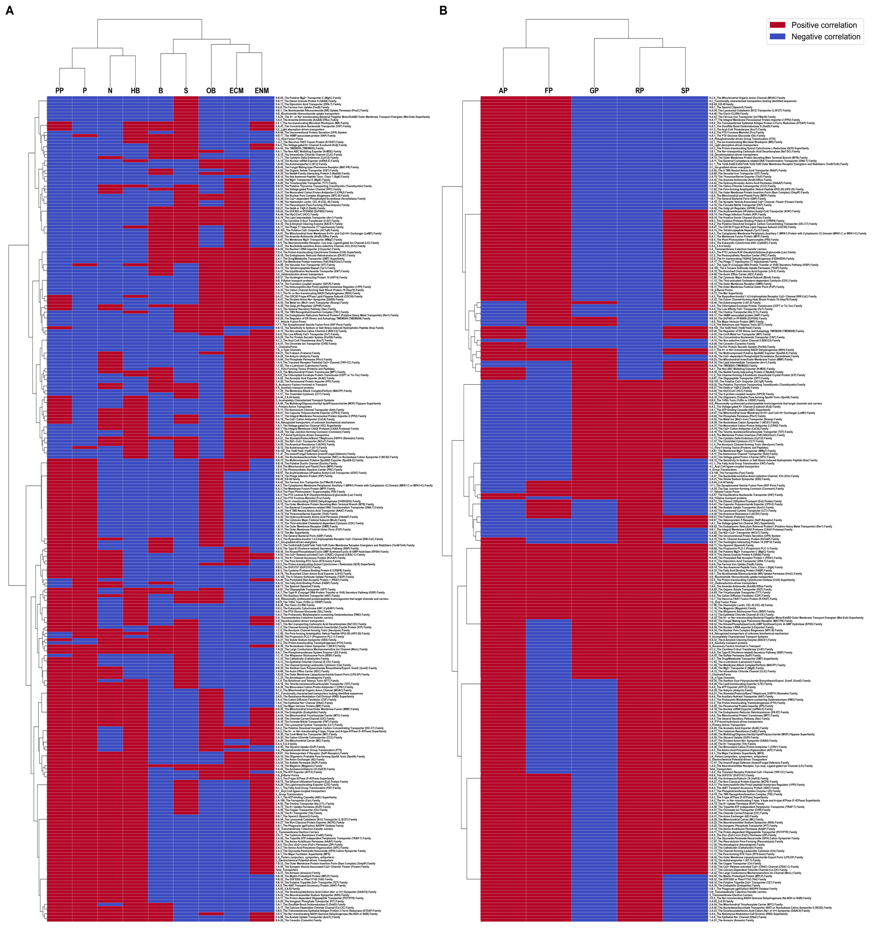

Figure S7. Clustered heatmap of the transcription factor (TF) families associated with DendroNet’s predictions of phytopathogenic lifestyles and traits. Also included is the ‘Total_TransFactors’ feature, which is the total number of TF genes annotated in each genome regardless of family. The values in the heatmap are the correlation directions for each TF family input into DendroNet as a machine learning feature, which indicate whether an increase (positive correlation, red) or decrease (negative correlation, blue) in the number of genes in a family was associated with a lifestyle or trait. Abbreviations: S, saprotrophs; ECM, ectomycorrhizal; ENM: endomycorrhizal; P, pathogens; PP, plant pathogens; N, necrotrophs; HB, hemibiotrophs; B, biotrophs; OB, obligate biotrophs; AP, angiosperm pathogens; GP, gymnosperm pathogens; FP, foliar pathogens; SP, stem pathogens; RP, root pathogens.

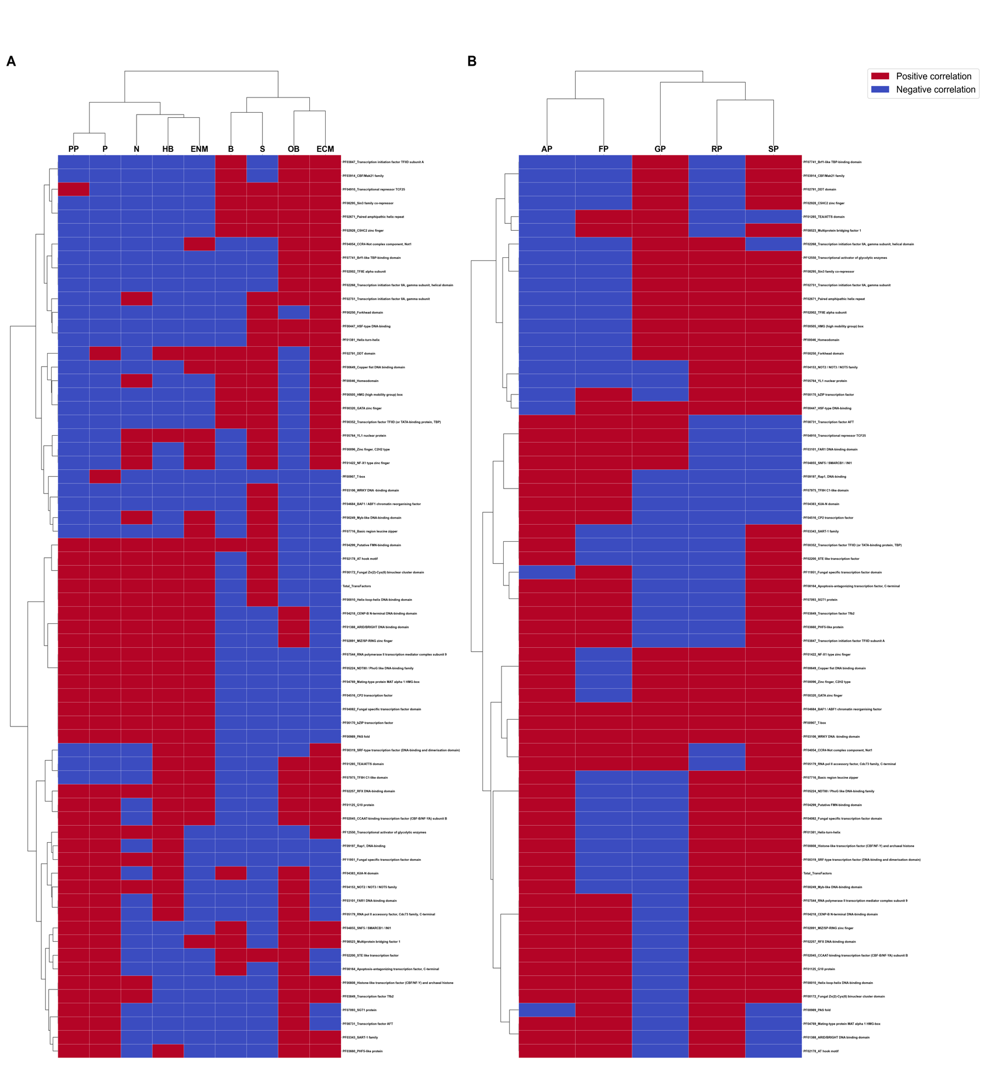

Supplementary Data Descriptions
Supplementary Data S1. Reduced version of FunLifeDB with the 387 genomes (355 species) used for analyses in this study.

Supplementary Data S2. Baseline AUC scores from DendroNet parsimony models (phylogenetic placement only, no genome annotation data) for all lifestyles and phytopathogenic traits tested.

Supplementary Data S3. AUC scores from DendroNet feature+parsimony models (includes phylogenetic placement and genome annotation data) from all 31 feature sets and for the lifestyles tested. The mean and standard deviation of the AUCs from each feature set were calculated, and the results are listed from highest mean to lowest mean AUC.

Supplementary Data S4. AUC scores from DendroNet feature+parsimony models (includes phylogenetic placement and genome annotation data) from all 31 feature sets and for the phytopathogenic traits tested. The mean and standard deviation of the AUCs from each feature set were calculated, and the results are listed from highest mean to lowest mean AUC.

Supplementary Data S5. Results from all statistical analyses on DendroNet AUCs for both the lifestyles and phytopathogenic traits.

Supplementary Data S6. DendroNet feature importances from the feature+parsimony models for all five genome annotation groups. The raw, fraction, and correlation values for the individual genomic features (gene families) that improved DendroNet’s predictive performance of a lifestyle or trait over the parsimony model are reported for each annotation. A fraction value greater than 1.0 for a feature indicates that a DendroNet model using only that individual feature produced better AUC scores than a model using a combination of all features from an annotation group.

Supplementary Data S7. Correlation directions for all genomic features (gene families) included in the DendroNet feature+parsimony models, regardless of prediction performance relative to the parsimony model, for all five genome annotation groups. A positive correlation (+) indicates that a lifestyle or trait was associated with an increased number of genes relative to other lifestyles and traits, and a negative correlation (-) indicates that a lifestyle or trait was associated with a decreased number of genes.

