Journal’s name: Food Security
Surveillance of the Field-Incurred Pesticide Residues in Kinnow Mandarin and Evaluation of Acute, Chronic and Cumulative Exposure Risks to the Consumers
Aasma Bibi^{a,c}, Nazia Rafiqueª, Sofia Khalid^{c,d}, Karam Ahad^{b}, Abdul Samadª, Farrakh Mehboob^{a*}
ªEcotoxicology Research Program, IPEP, NARC, Pakistan Agricultural Research Council (PARC), Islamabad 44000, Pakistan
^{b}Institute of Plants and Environment Protection (IPEP), NARC, Pakistan Agricultural Research Council (PARC), Islamabad 44000, Pakistan
^{c}Department of Environmental Sciences, Fatima Jinnah Women University, The Mall, Rawalpindi 46000, Pakistan
^{d}Department of Environmental Sciences, Faculty of Sciences, Allama Iqbal Open University, Sector H-8, Islamabad 44000, Pakistan

*Corresponding Author: Farrakh Mehboob, Email address: farrakhmehboob@parc.gov.pk

Supplementary Information

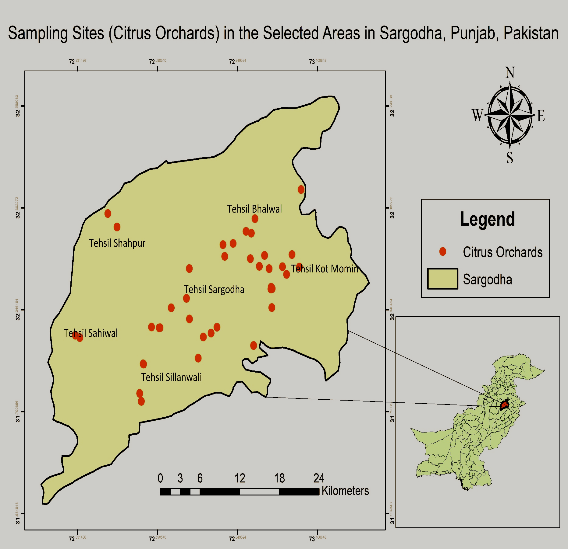
Fig. S1 Map of the study area i.e. district Sargodha, Punjab, Pakistan

Fig. S2 Pesticides and their modes of application in the surveyed Kinnow Mandarin orchards

Table S1 Details of the studied compounds; i.e. compound name, chemical and general class, EU and CAC MRLs (mgKg⁻¹), PHI i.e. pre-harvest interval (in days), and WHO (World Health Organization) toxicity classification
Compound name | Chemical class | General class | EU-MRL  (mg/Kg) | Codex-MRL  (mg/Kg) | PHI  (number of days) | WHO toxicity class
Acetamiprid | Neonicotinoid | Insecticide | 0.9 | 1 | 7 to 14 | n.e
Atrazine | Triazine | Herbicide | 0.05 | n.e | n.a | III
Azoxystrobin | Methoxyacrylate | Fungicide | 15 | 15 | 0 | U
Bifenthrin | Pyrethroid | Insecticide | 0.05 | 0.05 | 1 | II
Carbaryl | Carbamate | Insecticide | 0.01 | 15 | 3 to 14 | II
Carbendazim | Benzimidazole | Fungicide | 0.7 | 1 | 1 to 15 | U
Carbofuran | Carbamate | Insecticide, acaricide | 0.01 | 0.5 | 45 to 104 | Ib
Carbosulfan | Carbamate ester | Insecticide | 0.01 | 0.1 | 7 to 60 | II
Carfentrazone-ethyl | Triazolinone | Herbicide | 1.5 | n.e | 7 | n.e
Chlorpyrifos | Organophosphate | Insecticide | 1.5 | 1 | 21 | II
DDT (all isomers) | Organochlorine | Insecticide | 0.05 | n.e | n.a | II
Deltamethrin | Pyrethroid | Insecticide | 0.04 | 0.02 | n.a | II
Diazinon | Organophosphate | Insecticide, acaricide | 0.01 | n.e | 14 to 20 | II
Difenoconazole | Azole | Fungicide | 0.6 | 0.6 | 0 | II
Dimethoate | Organophosphate | Insecticide, acaricide | 0.01 | 5 | 7 | II
Endosulfan (all isomers) | Organochlorine | Insecticide, acaricide | 0.05 | n.e | n.a | II
Endrin | Organophosphate | Insecticide | 0.01 | n.e | n.a | n.e
Ethion | Organophosphate | Insecticide, acaricide | 0.01 | n.e | 20 to 28 | II
Fipronil | Phenylpyrazole | Insecticide, acaricide | 0.005 | n.e | n.a | II
HCH (all isomers) | Organochlorine | Insecticide | 0.01 | n.e | n.a | II
Heptachlor (all isomers) | Organochlorine | Insecticide | 0.01 | 0.01 | n.a | II
Hexaconazole | Azole | Fungicide | 0.01 | n.e | n.a | III
Imazalil | Enilconazole (imidazole) | Fungicide | 5 | 5 | post-harvest application | II
Imidacloprid | Neonicotinoid | Insecticide | 1 | 1 | 14 to 30 | II
Indoxacarb | Oxadiazine | Insecticide | 0.02 | n.e | n.a | II
Malathion | Organophosphate | Insecticide, acaricide | 2 | 7 | 3 | III
Metalaxyl | Acylalanine | Fungicide | 0.5 | 5 | 30 | II
Monocrotophos | Organophosphate | Insecticide, acaricide | 0.01 | n.e | 21 | Ib
Prochloraz | Azole | Fungicide | 0.01 | 10 | 7 | II
Profenofos | Organophosphate | Insecticide | 0.01 | n.e | 30 | II
Propiconazole | Azole | Fungicide | 5 | 10 | 360 | II
Pyraclostrobin | Methoxycarbamate | Fungicide | 1 | 2 | 10 to 14 | n.e
Pyriproxyfen | Phenyl ether | Insecticide | 0.6 | 0.5 | 14 to 90 | U
Spiromesifen | Tetronic acid | Insecticide, acaricide | 0.02 | n.e | n.a | n.e
tau-Fluvalinate | Pyrethroid | Insecticide, acaricide | 0.01 | n.e | n.a | III
Tebuconazole | Triazole | Fungicide | 5 | n.e | 20 to 175 | II
Thiabendazole | Benzimidazole | Fungicide | 7 | 7 | post-harvest application | III
Thiamethoxam | Neonicotinoid | Insecticide | 0.15 | 0.5 | 0 to 49 | n.e
Thiophanate-methyl | Benzimidazole precursor | Fungicide, wound protectant | 6 | n.e | 1 | U
Triadimefon | Triazole | Fungicide | 0.01 | n.e | 21 | II
Triadimenol | Triazole | Fungicide | 0.01 | n.e | 21 | II
Triazophos | Organophosphate | Insecticide, acaricide, nematicide | 0.01 | n.e | 40 | Ib
Trichlorfon | Organophosphate | Insecticide | 0.01 | n.e | 10 to 28 | II
α-Cypermethrin | Pyrethroid | Insecticide | 2 | 0.3 | 1 | II
λ-Cyhalothrin | Pyrethroid | Insecticide | 0.01 | 0.2 | n.a | II
*n.e: not established, n.a: not available, WHO (World Health Organization) toxicity classification: Ia: extremely hazardous, Ib: highly hazardous, II: moderately hazardous, III: slightly hazardous, U: product unlikely to present acute hazard in normal use (Turner, 2018)

Table S2 Analytical method’s validation parameters for the studied compounds in Kinnow Mandarin: compound name, retention time, selected quantifier and qualifier ions, accuracy (%recovery), precision (%RSD) and %matrix effect
Compound name | Retention time  (minutes) | Precursor/quantifier ion  (product/qualifier ions)  m/z | R² |  | Range of  measurement  (mg/Kg) | Accuracy (%Recovery)  ± Precision (%RSD) | Matrix  effect  (%)
Compound name | Retention time  (minutes) | Precursor/quantifier ion  (product/qualifier ions)  m/z | solvent | matrix | Range of  measurement  (mg/Kg) | at EU-MRL level  concentration (mg/Kg) | Matrix  effect  (%)
Analyzed on LC-MS/MS
Carbendazim | 4.014 | 192.1 (160, 132.1) | 0.999 | 0.998 | 0.35 - 1.4 | 108.5 ± 2.8 | 7.2
Thiomethoxam | 4.141 | 292 (211, 131.9) | 0.993 | 0.999 | 0.075 - 0.3 | 95.4 ± 27 | 9.2
Thiabendazole | 4.235 | 202 (175, 131) | 0.999 | 0.999 | 0.875 - 3.499 | 96.8 ± 0 | -3.9
Trichlorfon | 4.317 | 256.9 (221, 109, 136.2) | 0.996 | 0.999 | 0.005 - 0.02 | 102.6 ± 37.6 | 0.5
Imidacloprid | 4.647 | 256.1 (209, 175) | 0.999 | 0.999 | 0.01 - 0.04 | 97.9 ± 12.8 | -2.2
Monocrotophos | 4.798 | 224.1 (193, 127) | 0.993 | 0.999 | 0.005 - 0.02 | 90.2 ± 21.4 | -9.5
Dimethoate | 4.804 | 230 (198.8, 125) | 0.999 | 0.999 | 0.005 - 0.021 | 85.8 ± 2.4 | 1.6
Acetamiprid | 4.808 | 223.1 (126, 90) | 0.999 | 0.999 | 0.45 - 1.8 | 91.6 ± 14.1 | 5.4
Thiophanate-methyl | 5.809 | 343.06 (151.1, 93.1) | 0.991 | 0.999 | 0.75 - 3.0 | 85.4 ± 30.2 | 0.1
Carbofuran | 6.192 | 222.1 (165.1, 123.1) | 0.999 | 0.999 | 0.005 - 0.02 | 105.2 ± 6.5 | -0.3
Carbaryl | 6.387 | 202.1 (145.1, 127.1) | 0.999 | 0.994 | 0.095-0.0380 | 100.6 ± 20 | -4.9
Metalaxyl | 6.565 | 280.1 (220, 160.2) | 0.999 | 0.999 | 0.005 - 0.02 | 92.6 ± 1.6 | -3.9
Triadimenol | 7.201 | 296.2 (227, 70.2) | 0.999 | 0.999 | 0.005 - 0.02 | 116.7 ± 3.1 | -11.8
Azoxystrobin | 7.554 | 404.1 (372.1, 344.1) | 0.997 | 0.999 | 1.392 - 5.568 | 94.3 ± 11.5 | 3.9
Imazalil | 7.704 | 297.1 (159, 69.1) | 0.999 | 0.999 | 0.5 - 2.0 | 70.6 ± 0.5 | 5.5
Triadimefon | 7.821 | 294.2 (225, 197.1) | 0.999 | 0.999 | 0.005 - 0.02 | 77.3 ± 4.7 | 15
Tebuconazole | 8.072 | 308.1 (124.9, 70) | 0.989 | 0.999 | 0.005 - 0.021 | 94.2 ± 17.4 | -0.4
Malathion | 8.21 | 331 (126.9, 99) | 0.999 | 0.998 | 0.25 - 1.0 | 89.9 ± 3.4 | 1.3
Triazophos | 8.248 | 314.1 (162.1, 97.1) | 0.999 | 0.999 | 0.005 - 0.02 | 87.1 ± 16.1 | 2.1
Hexaconazole | 8.429 | 314 (159, 70.1) | 0.999 | 0.999 | 2.5 - 10.001 | 88.5 ± 19.3 | -0.3
Propiconazole | 8.626 | 342 (159, 69) | 0.992 | 0.999 | 0.125 - 0.5 | 93.8 ± 17.3 | 5.1
Fipronil* | 8.643 | 435 (335, 250) | 0.998 | 0.999 | 0.003 - 0.01 | 86.3 ± 18.0 | -0.3
Prochloraz | 8.678 | 376 (308, 265.9) | 0.999 | 0.999 | 0.625 - 2.5 | 76.8 ± 13.3 | 5.2
Carfentrazone-ethyl | 8.691 | 412.1 (365.9, 345.9) | 0.998 | 0.999 | 0.75 - 3.0 | 99.6 ± 10.1 | 9.4
Difenconazole | 9.004 | 406, 251.1, 188.1 | 0.999 | 0.999 | 0.3 - 1.2 | 89.5 ± 36.7 | -0.7
Pyraclostrobin | 9.223 | 388.1 (193.8, 163.1) | 0.999 | 0.999 | 0.3 - 1.2 | 94.2 ± 38.6 | -7.5
Diazinon | 9.431 | 305.1 (169.1, 153.1) | 0.999 | 0.999 | 0.005 - 0.02 | 81.5 ± 8.5 | -0.2
Indoxacarb | 9.519 | 528.1 (203, 150) | 0.999 | 0.999 | 1.0 - 4.0 | 90.2 ± 12 | -9
Pyriproxyfen | 10.645 | 322.2 (96.1, 78.1) | 0.999 | 0.999 | 0.01 - 0.041 | 89.2 ± 19.8 | 7.3
Ethion | 10.805 | 384.9 (199.1, 170.9) | 0.999 | 0.999 | 0.005 - 0.02 | 109 ± 19.1 | -10.4
Spiromesifen | 11.797 | 388 (273, 255) | 0.997 | 0.996 | 0.625 - 2.5 | 63.4 ± 0 | 0.7
tau-Fluvalinate | 12.35 | 503.1 (208, 181) | 0.999 | 0.996 | 0.005 - 0.021 | 95.6 ± 12.0 | 0.8
Carbosulfan | 13.324 | 381.2 (160, 118) | 0.999 | 0.999 | 0.005 - 0.02 | 9 ± 13.0 | 9
Analyzed on GC-µECD and GC-MSD
α-HCH | 6.933 (6.033) | 181 (219, 183, 217) | 0.999 | 0.999 | 0.005 - 0.536 | 71.5 ± 0.6 | 1.8
Atrazine | 7.461 (6.606) | 200 (215, 202, 173) | 0.999 | 0.999 | 0.025 - 0.536 | 104 ± 4.2 | -22.1
Lindane | 7.638 (6.725) | 183 (181, 219, 111) | 0.999 | 0.999 | 0.005 - 0.536 | 71.3 ± 0.8 | 20.5
Heptachlor | 9.305 (8.387) | 100 (272, 274, 270) | 0.999 | 0.999 | 0.005 - 0.536 | 82.4 ± 6.8 | 21.5
Chlorpyrifos | 10.46 (9.643) | 97 (197, 314, 199) | 0.999 | 0.999 | 0.067- 1.998 | 75.6 ± 4.7 | 0.4
Triadimefon | 10.531 (9.731) | 57 (208, 85, 210) | 0.999 | 0.999 | 0.005 - 0.536 | 81 ± 8.2 | -14.9
Heptachlor exo-epoxide isomer-B | 11.225 (10.371) | 353 (355, 351, 357) | 0.999 | 0.999 | 0.005 - 0.536 | 74 ± 2.4 | -8.3
Heptachlor epoxide isomer-A | 11.339 (10.493) | 81 (237, 135, 289) | 0.999 | 0.999 | 0.005 - 0.536 | 71 ± 1.0 | -8.5
Triadimenol | 11.591 (10.902) | 112 (128, 168, 70) | 0.998 | 0.999 | 0.005 - 0.536 | 106 ± 8.3 | 12.9
α-Endosulfan | 12.023 (11.326) | 195 (241, 239, 237) | 0.999 | 0.999 | 0.025 - 0.536 | 78.4 ± 3.7 | 24.8
Imazalil | 12.454 (11.924) | 215 (41, 173, 217) | 0.999 | 0.998 | 0.625 - 50.004 | 90 ± 8.5 | 24
Profenofos | 12.569 (11.952) | 139 (208, 206, 339) | 0.999 | 0.999 | 0.005 - 0.4056 | 73 ± 1.4 | 31.4
4,4-DDE | 12.724 (12.035) | 246 (318, 316, 248) | 0.999 | 0.999 | 0.025 - 1.982 | 70.7 ± 1 | 7.1
Endrin | 12.934 (12.388) | 317 (263, 245, 265) | 0.999 | 0.999 | 0.005 - 0.536 | 85.4 ± 6.7 | 46.7
β-Endosulfan | 13.111 (12.601) | 241 (195, 207, 237) | 0.999 | 0.999 | 0.025 - 0.536 | 70.1 ± 0.7 | 11.4
Ethion | 13.412 (13) | 125 (231, 153, 97) | 0.999 | 0.999 | 0.005 - 0.536 | 108 ± 1.5 | 20.4
Endosulfan sulfate | 13.808 (13.414) | 272 (274, 229, 237) | 0.999 | 0.999 | 0.025 - 0.536 | 76 ± 1.8 | 58.4
Bifenthrin | 14.684 (14.468) | 165 (181, 166, 182) | 0.999 | 0.999 | 0.025 - 0.536 | 101.7 ± 10.2 | 9.2
λ-Cyhalothrin-I | 15.396 (15.351) | 181 (197, 208, 209) | 0.999 | 0.999 | 0.005 - 0.536 | 79.7 ± 4.9 | -1.2
α-cypermethrin-I | 16.644 (16.6) | 163 (181, 165, 209) | 0.999 | 0.999 | 0.067 - 8.006 | 74.6 ± 4.0 | 34.8
Deltamethrin | 18.05 (18.13) | 251 (181, 253, 255) | 0.998 | 0.999 | 0.02 - 0.536 | 94.1 ± 9.3 | 34.2
*ESI (-) for fipronil only, while ESI (+) for all other LC compounds, RT for GC compounds as µECD-RT (MSD-RT), the italicized compounds were analyzed on all the techniques used (i.e. GC-µECD, GC-MSD and LC-MS/MS)

