Supplementary Information
Investigating the synergistic effect of UV/PS/TiO₂ and UV/PI/TiO₂ processes on paraquat herbicide degradation in media aqueous: statistical optimization, kinetic study, and estimation of electrical energy consumption

Azam Ghavi ^{a*}, Ghadamali Bagherian ª, Hadi Rezaei Vahidian ^{b}

ª Faculty of Chemistry, Shahrood University of Technology, P.O. Box 316-3619995181, Shahrood, Iran
^{b} Space transportation research institute, Iranian space research center, Tehran, Iran.

*Corresponding author: azamghavi@ymail.com
Research Laboratory of Faculty Chemistry, Shahrood University of Technology, P.O. Box 316-3619995181, Shahrood, Iran

1. Paraquat
Paraquat discovered in 1882 and has been used as an oxidation-reduction indicator under the name of methyl virologen since 1932 and was registered in the United States in 1964 for use as a nonselective contact herbicide to control or suppress a broad spectrum of emerged weeds. The solubility of paraquat in water is 625 g/L at 25 °C (Bromilow 2004). It has been marketed under the brand name Gramoxone by different manufacturers sold under different names as well. It is a green liquid with a boiling point 175 – 180˚C and is easily soluble in water and is relatively stable at normal temperature, pressure, and pH, to stay longer in the soil. Its molecular structure is shown in Fig. 1(Jafarinejad 2015, U.S.E.P. Agency 1997).

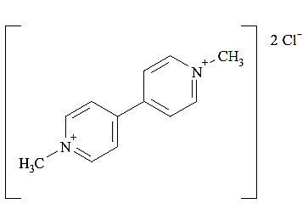
Fig. 1: Molecular structure of PQ (Watts 2011)

2. Characterization of the TiO₂ nanoparticles
The TiO₂ particles were characterized using TEM and XRD analyses. TEM analysis was performed that the relevant image has been demonstrated in the Fig. 2. It reveals a widespread size distribution in the range of 10–25 nm.
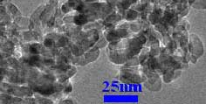
Fig. 2: TEM image of the TiO₂ nanoparticles

The crystal phase TiO₂ nanoparticles were examined by XRD pattern. Fig. 3 shows XRD pattern of the synthesized nanoparticles in comparison with the anatase Titania pattern. Formation of the TiO₂ is confirmed via good accordance of the XRD pattern with the anatase (Reference code: 01-073-1764) cases.

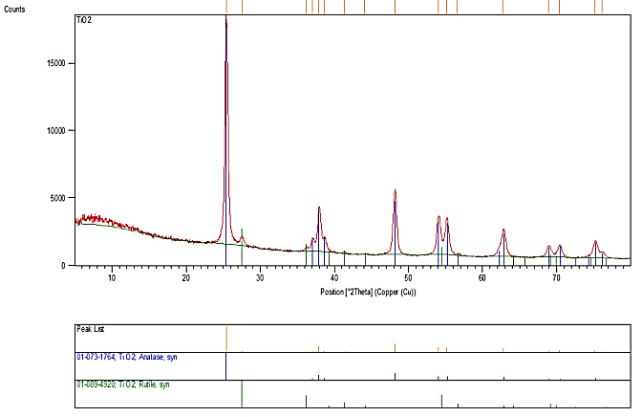

Fig 3: XRD pattern of the nanoparticles anatase TiO₂

3. Mineralization study
To investigate the mineralization, total organic carbon (TOC) test should be used. This test was performed on the treated PQ solution by the photocatalytic processes. So, results of measuring the TOC analysis of the samples were compared with measuring the TOC graph of the PQ initial concentration (30 mgL⁻¹) that it is shown in Fig. 6.
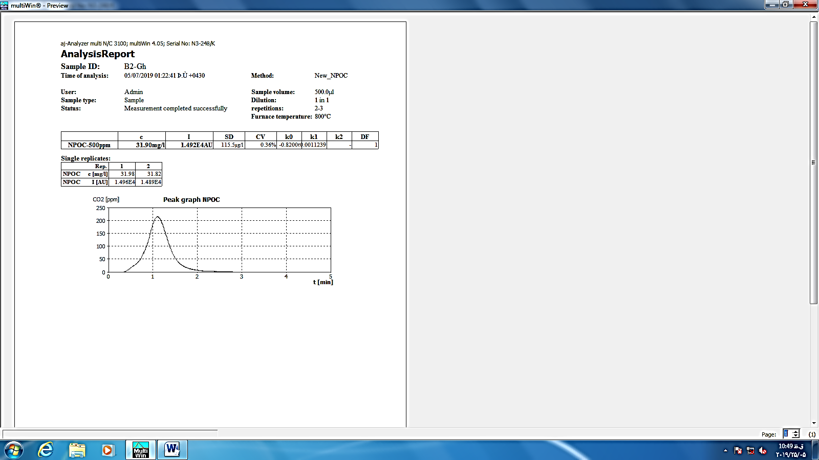
Fig.6: TOC graph of [PQ]= 30 mgL⁻¹

4. Evaluation of model adequacy by diagnostic plots
To evaluate the adequacy of the model graphically, diagnostic plots could be utilized. Most of the plots display residuals, which show the difference between experimental and predicted responses. In the DOE software, normal probability, residuals versus predicted, residuals versus run, and actual versus predicted are widely used to evaluate the adequacy of the model. The diagnostic plots for PQ degradation model were demonstrated in Fig. 7. The normal probability plot indicates whether the residuals follow a normal distribution, in which case the points will follow a straight line. The plot, that it has definite pattern like an "S-shaped" indicates that a transformation of the response may provide a better analysis. Residuals versus predicted is a plot of the residuals versus the ascending predicted response values. It tests the assumption of constant variance. The plot should be a random scatter. The plot of residuals versus run is a plot of the residuals versus the experimental run order. It checks for lurking variables that may have influenced the response during the experiment. The plot should show a random scatter. Trends indicate a time-related variable lurking in the background. Blocking and randomization provide insurance against trends ruining the analysis. The plot of actual versus predicted detects a value, or group of values, that are not easily predicted by the model. As can be seen from the diagnostic plots approve well adequacy of the PQ degradation model (Montgomery 2017).

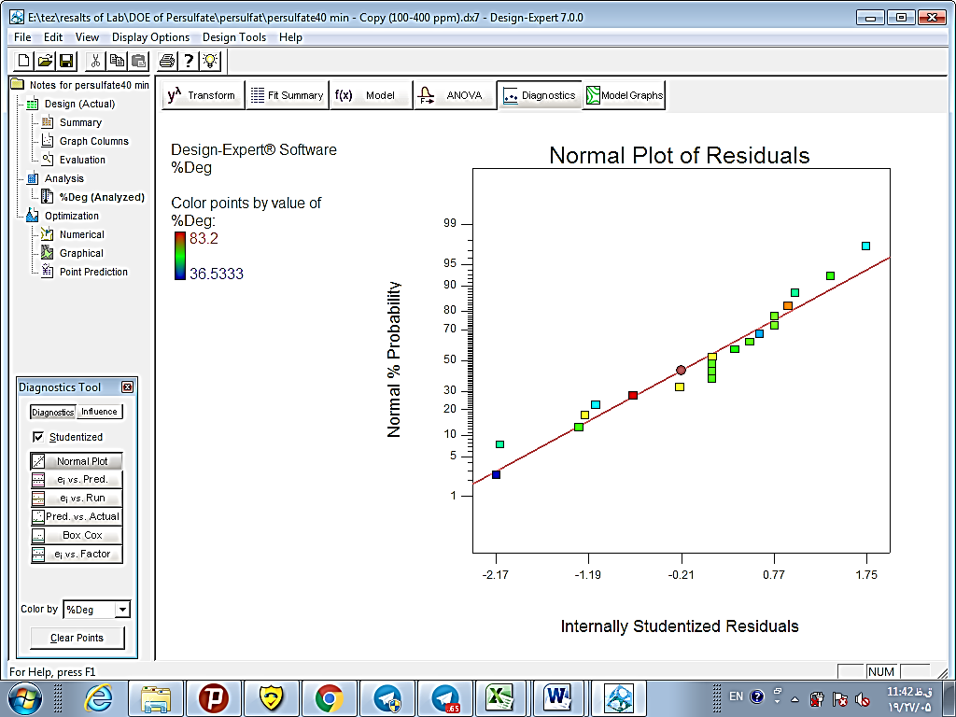 |  | 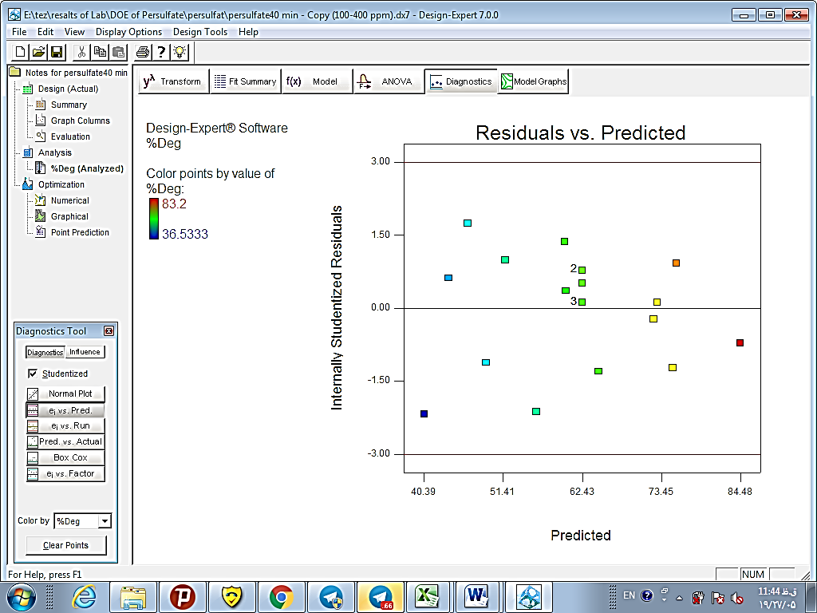
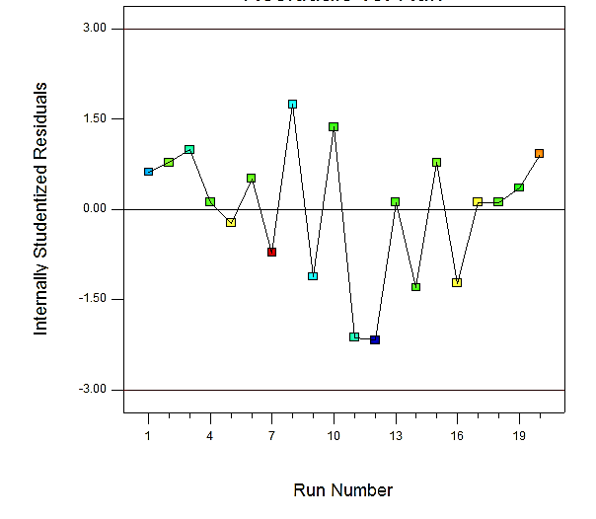 |  | 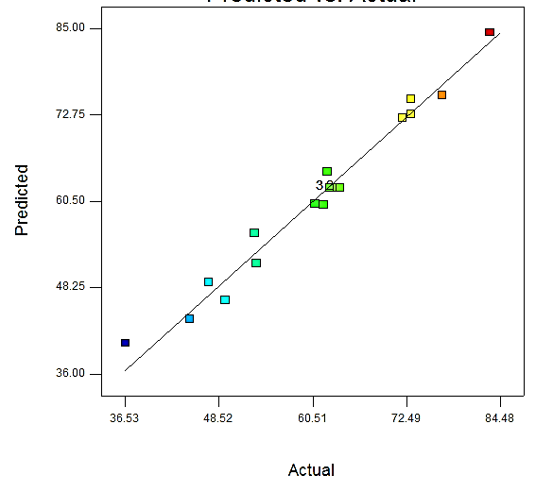
- PS process

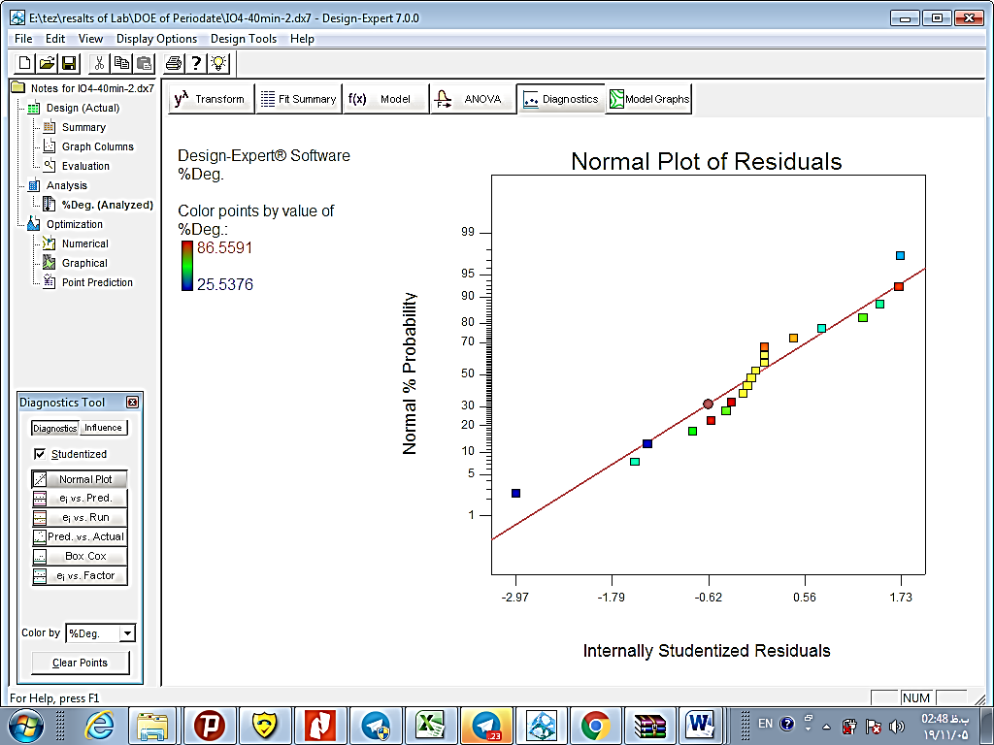 | 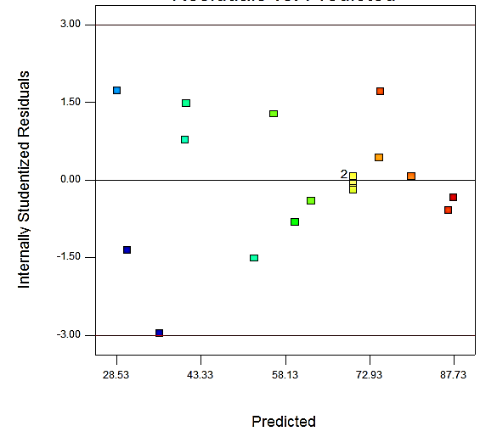
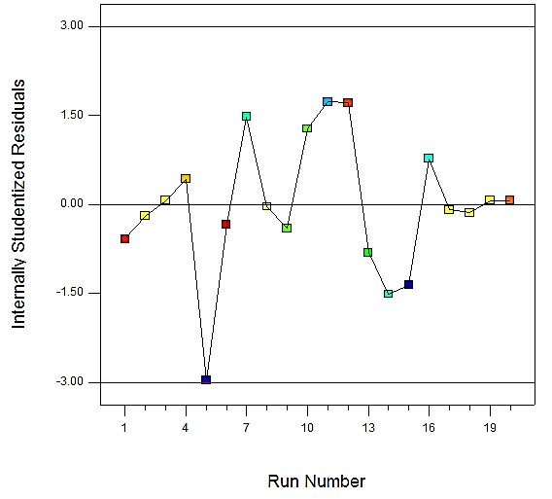 | 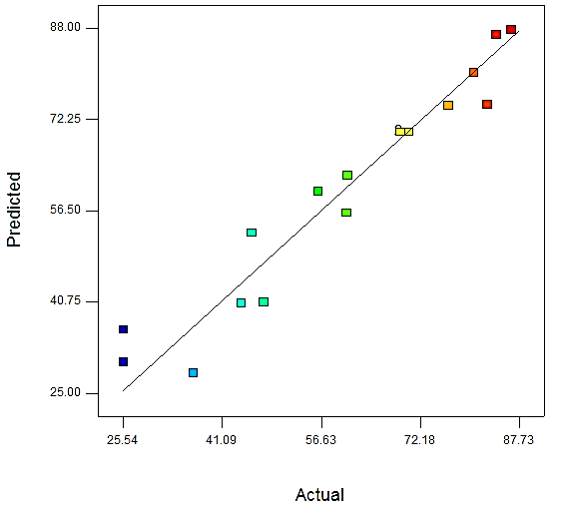
- PI process

Fig. 7: Adequacy diagnostic plots of normal probability, Residuals versus predicted, Residuals versus run and Actual versus predicted for (a): PS process and (b) PI process.

5. Optimum condition
The predicted optimum values were 400 mgL⁻¹, 150 mgL⁻¹and 6.3 for the PS dose, TiO₂NPs dose and initial pH respectively for PS process. Under the conditions a degradation efficiency equal to 77% was predicted by the model. To assess accuracy of the model prediction, under the supposed values of the parameters, the photocatalytic degradation efficiency reached to 83% empirically (i.e. -6% error). Also, the predicted optimum values were 88 mgL⁻¹, 125 mgL⁻¹and 7.5 for the PI dose, TiO₂NPs dose and initial pH respectively for PI process. Under the conditions a degradation efficiency equal to 87% was predicted by the model. To assess accuracy of the model prediction, under the supposed values of the parameters, the photocatalytic degradation efficiency reached to 90% empirically (i.e. -3% error) (Fig.10, 11).
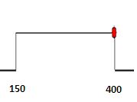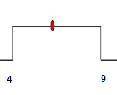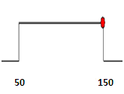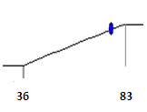
[PS]=400mgL⁻¹ pH=6.3 [TiO₂NP]=150 mgL⁻¹ %DE=77
Fig. 10: Desirability ramp for the numerical optimization for PS process

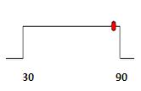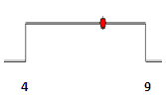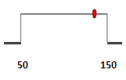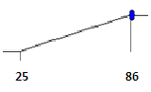
[PI]=88mgL⁻¹ pH=7.5 [TiO₂NP]=125 mgL⁻¹ %DE=86
Fig. 11: Desirability ramp for the numerical optimization for PI process

References
Bromilow RH (2004) Paraquat and sustainable agriculture, Pest management science 60 : 340-349.
Jafarinejad S. (2015) Recent advances in determination of herbicide paraquat in environmental waters and its removal from aqueous solutions: A review, Int Res J App Basic Sci 9: 1758-1774.
Montgomery DC (2017) Design and Analysis of Experiments, 9 ed., Wiley Arizona State University.
U.S.E.P. Agency (1997) Paraquat Dichloride, in: Reregistration Eligibility Decision(RED), Washington, D.C. 20460.
Watts M (2011) Paraquat, in: P.A.N.A.a.t. Pacifi (Ed.), Malaysia.

