Supplementary Information
Computational model and simulations of contact angle and geometry effects on centrifugal microfluidic step-emulsification.

Maximilian Fahland¹ and Rohit Mishra

Fraunhofer Project Centre for Embedded Bioanalytical Systems, Dublin City University

Section S1: Inlet Static Pressure Model
A secondary simulation is designed to ascertain the inlet-pressure condition applied as the inlet boundary condition for the droplet formation simulation model. In the experimental setup, this pressure is generated by the water column of the supply channel as a function of the angular velocity. Additionally, it accounts for the geometrical conditions of our model (inlet in the simulation is after 0.6 mm of the nozzle). Typically, the pressure balance in a centrifugal system follows:
$$ΔP_{water}=\frac{1}{2}*ρ_{disp}*ω^{2}*\left(r_{2}^{2}-r_{1}^{2}\right) (S1)$$
Here, the pressure depends on the density of the dispersed phase, the angular velocity, and the radial distances between the inlet chamber and the outlet of the nozzle. Pressure losses due to hydraulic resistance, diversions of the supply channel, and the change in cross-section between the supply channel and the nozzle are not considered. Therefore, Equation S1 is not suitable for the calculation of the pressure at the inlet in our model. We use a numerical simulation to account for these conditions. The geometry of this simulation can be seen in Figure S1.

This simulation also offers advantages by its separation from the droplet formation simulation allowing for significant reduction of computational time in a centrifugal frame. The droplet formation simulation is a non-steady state process; the fluid flow from the inlet chamber to the collection chamber can be simulated as a steady-state flow, as it can be assumed that there is no change in the velocity profile over time.

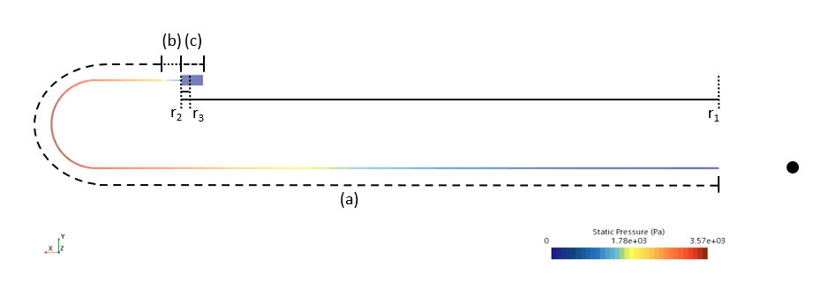
Figure S1: Geometry for the inlet pressure calculation. Section (a)- supply channel design based on Figure 1 and has a total length of 38.4 mm. Section b- Nozzle with a length of 0.9 mm; Section c- Collection chamber with a length of 1 mm. Note: The supply line from the inlet chamber is radially outward in our model which is however unclear from the experimental data. r1, r2 and r3 describe the distance to the centre of rotation in the x-direction (compare Figure 1 of Schulz et al. (2019)). Please note that the liquid head in the chamber is included in the distance r1 from the radial centre (inlet chamber is not shown).

Section S2: Mesh independence study
For the verification of numerical errors due to discretization, a Mesh Independence Study (MIS) was conducted. Different simulations with the same assumptions and input parameters but different meshes were compared. In this case the experimental parameters (Table 1) are used, the pressure inlet is set to 500 Pa, and the system is rotating with 10 Hz. The comparison criterion is the averaged droplet diameter of the second droplet. In Figure S2 you can see the droplet size and the computing time for five different meshes.

In general, smaller cell sizes increase the total number of cells, thus reducing discretization errors and improving mesh quality. On the other hand, the necessary computing time increases due to the higher number of cells. The MIS optimizes the mesh in terms of discretization errors and computation time (Paschedag, 2004). The aim is to determine a mesh for which further refinements would no longer improve the results and would only increase the computing time.

Star CCM+ provides hexahedral, tetrahedral and polyhedral meshes. Sosnowski et al. (2018) has compared these types of mesh and concluded that a polyhedral mesh is most suitable. Compared to hexahedral and tetrahedral cells, polyhedrons have more neighbour cells, which improves the calculation of gradients, allowing one to interchange the mass over numerous faces. In addition, the numerical diffusion effects caused by flows that are not perpendicular to any of the cell faces are reduced. These advantages are helpful for simulations of droplet generation as a result of the occurrence of reverse flows.

For our following simulations we have chosen the second coarsest mesh (72.000 cells), since the droplet size is in the middle to the two finest meshes (176.000 cells and 241.000 cells) and the computing time significantly lower.
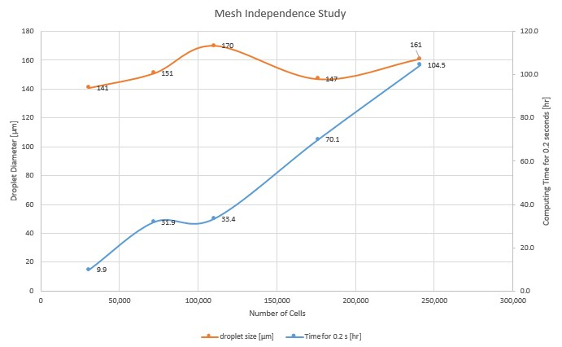
Figure S2: The Mesh Independence Study compares the droplet diameter and the computing time for different refined meshes. The second coarsest mesh is chosen for the investigations due to optimal computing conditions.

References
Paschedag, A. R. (2004). CFD in der Verfahrenstechnik. Weinheim: Wiley-VCH.
Sosnowski, M. a. (2018). Polyhedral meshing in numerical analysis of conjugate heat transfer. EPJ Web of Conferences, DOI: 10.1051/epjconf/201818002096.

