Advancing Understanding on Greenspace and Mental Health in Young People

Supplemental Materials
For children ages 14 and under, this association was most pronounced for anxiety, with a 1.82 (CI:1.72-1.91, p<0.001) higher prevalence of anxiety in ZCTAs with the least amount of greenspace (T1), compared to those with the greatest amount of public greenspace (T3). Among 15-17 year olds, ZCTAs with moderate quantities of greenspace (T2) were associated with the highest PRRs; mood disorders saw the greatest increase in prevalence , 1.39 (CI:1.34-1.43, p<0.001) higher PRR compared to ZCTAs with the most amount of greenspace (T3). Among 18-24 year olds, ZCTAs with moderate greenspace quantity (T2) were associated with a higher prevalence of anxiety, depression and mood disorders; mood disorders were associated with the largest PRR (PRR:1.34, CI:1.31-1.36, p<0.001). ZCTAs with the lowest quantities of greenspace (T1) were associated with higher PRRs for mental and behavioral disorders, self-injury and substance use disorders; substance use disorders were associated with the highest PRR (PRR :1.29, CI: 1.28-1.30, p<0.001).
Across all three age groups, residence in a ZCTA with moderate greenspace accessibility (T2) was associated with higher PRRs for all mental health outcomes, except for substance use disorders among individuals 14 and younger, and self-injury among individuals 18-24. For all three age groups, anxiety was associated with the highest PRRs, 1.12 (CI:1.08-1.16, p<0.001) for children 14 and under, 1.15 (CI:1.11-1.19, p<0.001) for adolescents aged 15-17, and 1.18 (CI:1.16-1.20, p<0.001) among young adults 18-24 years old. Among young adults ages 18-24, residence in a ZCTA with moderate greenspace quality (T2) was associated with higher PRRs for all health outcomes, compared to ZCTAs with the best greenspace quality. This increase in PRR was most substantial for self-injury, with a 1.18 (CI:1.15-1.21, p<0.001) higher PRR in ZCTAs with moderate greenspace quality (SM Table 1).
For both males and females, residence in a ZCTA with less greenspace quantity (T1 & T2) was associated with higher PRRs for all mental health outcomes, compared to residence in ZCTAs with the highest greenspace quantity (T3) (SM Table 2). Among males, mood disorders were associated with the most substantial increase in PRR, 1.76 (CI:1.71-1.81, p<0.001), and among females, anxiety was associated with the most substantial increase in PRR , 1.8 (CI:1.76-1.84, p<0.001). Among both males and females, residence in ZCTAs with moderate greenspace accessibility (T2), was significantly associated with higher PRRs compared to ZCTAs with the best greenspace accessibility (T1). The increase in PRRs was highest for anxiety; males were associated with 1.12 (CI:1.09-1.15, p<0.001) higher PRR of anxiety, and females were associated with a 1.18 (CI:1.16-1.20, p<0.001) higher PRR of anxiety, compared to ZCTAs with the best greenspace accessibility.
SM Table 1: Age-stratified GLM results investigating the relationship between greenspace quantity, quality and accessibility, and mental health-related ED visits with consideration of three age categories: childhood (ages 0-14), adolescence (ages 15-17), and young adulthood (ages 18-24) in NC (2016-2019).
Childhood: Ages 14 and Under
 | Anxiety |  |  | Depression |  |  | Mood |  |  | Mental and Behavioral Disorders |  |  | Substance Use Disorder
 | PRR | CI | P | PRR | CI | P | PRR | CI | P | PRR | CI | P | PRR | CI | P
Area/Person
T1 (0 - 45.38m2) | 1.82 | 1.72-1.91 | <0.001 | 1.71 | 1.63-1.79 | <0.001 | 1.75 | 1.67-1.82 | <0.001 | 1.57 | 1.55-1.60 | <0.001 | 1.75 | 1.60-1.92 | <0.001
T2 (45.92-1,129 m2) | 1.54 | 1.46-1.63 | <0.001 | 1.46 | 1.39-1.53 | <0.001 | 1.54 | 1.48-1.61 | <0.001 | 1.35 | 1.32-1.37 | <0.001 | 1.62 | 1.48-1.78 | <0.001
Reference: T3 (1,147 - 2,249,938m2)
Distance
T2 (1.23-4.06km) | 1.12 | 1.08-1.16 | <0.001 | 1.07 | 1.03-1.11 | 0.001 | 1.07 | 1.04-1.11 | <0.001 | 1.15 | 1.13-1.16 | <0.001 | 1.00 | 0.94-1.08 | 0.89
T3 (4.09-21.6km) | 0.91 | 0.86-0.96 | <0.001 | 0.88 | 0.84-0.92 | <0.001 | 0.88 | 0.84-0.92 | <0.001 | 1.01 | 0.99-1.03 | <0.001 | 0.79 | 0.72-0.86 | <0.001
Reference T1 (0-1.22km)
Perimeter:Area Ratio
T2 (0.01-0.035) | 1.01 | 0.97-1.05 | 0.582 | 0.97 | 0.93-1.00 | 0.068 | 0.95 | 0.92-0.98 | 0.798 | 0.89 | 0.87-0.90 | <0.001 | 1.03 | 0.96-1.10 | 0.446
T3 (0.035-1.13) | 0.72 | 0.69-0.76 | <0.001 | 0.72 | 0.69-0.75 | <0.001 | 0.71 | 0.68-0.74 | <0.001 | 0.70 | 0.69-0.72 | <0.001 | 0.77 | 0.70-0.84 | <0.001
Reference: T1 (0-0.01)
ICE:Income
T1: Low Income | 1.31 | 1.24-1.38 | <0.001 | 1.31 | 1.25-1.38 | <0.001 | 1.42 | 1.36-1.48 | <0.001 | 1.69 | 1.65-1.73 | <0.001 | 2.27 | 2.07-2.49 | <0.001
T2: Mixed Income | 1.48 | 1.42-1.55 | <0.001 | 1.52 | 1.46-1.58 | <0.001 | 1.59 | 1.54-1.65 | <0.001 | 1.76 | 1.73-1.79 | <0.001 | 2.08 | 1.93-2.25 | <0.001
Reference: T3 (High Income)
ICE:Race
T1: Predominately Black | 0.71 | 0.68-0.75 | <0.001 | 0.88 | 0.83-0.92 | 0.206 | 0.96 | 0.92-1.00 | 0.052 | 1.13 | 1.10-1.15 | <0.001 | 0.62 | 0.56-0.67 | <0.001
T2: Mixed Race | 1.00 | 0.95-1.05 | 0.94 | 1.11 | 1.06-1.16 | <0.001 | 1.16 | 1.12-1.21 | <0.001 | 1.31 | 1.28-1.33 | <0.001 | 0.86 | 0.79-0.93 | <0.001
Reference: T3 (Predominately White)
MHPSA | 1.49 | 1.30-1.71 | <0.001 | 1.50 | 1.32-1.72 | <0.001 | 1.56 | 1.39-1.77 | <0.001 | 1.49 | 1.41-1.59 | <0.001 | 1.29 | 1.01-1.67 | 0.05
Observations: 808
Adolescence: Ages 15-17
 | Anxiety |  |  | Depression |  |  | Mood |  |  | Mental and Behavioral Disorders |  |  | Substance Use Disorder
 | PRR | CI | P | PRR | CI | P | PRR | CI | P | PRR | CI | P | PRR | CI | P
Area/Person
T1 (0 - 45.38m2) | 1.15 | 1.11-1.20 | <0.001 | 1.18 | 1.14-1.22 | <0.001 | 1.16 | 1.13-1.20 | <0.001 | 1.11 | 1.09-1.13 | <0.001 | 1.15 | 1.11-1.18 | <0.001
T2 (45.92-1,129 m2) | 1.38 | 1.32-1.43 | <0.001 | 1.35 | 1.30-1.40 | <0.001 | 1.39 | 1.34-1.43 | <0.001 | 1.31 | 1.28-1.33 | <0.001 | 1.36 | 1.31-1.41 | <0.001
Reference: T3 (1,147 - 2,249,938m2)
Distance
T2 (1.23-4.06km) | 1.15 | 1.11-1.19 | <0.001 | 1.13 | 1.09-1.16 | <0.001 | 1.13 | 1.10-1.16 | <0.001 | 1.12 | 1.10-1.14 | <0.001 | 1.06 | 1.03-1.10 | <0.001
T3 (4.09-21.6km) | 0.87 | 0.83-0.91 | <0.001 | 0.82 | 0.78-0.85 | <0.001 | 0.85 | 0.82-0.88 | <0.001 | 0.91 | 0.89-0.93 | <0.001 | 0.94 | 0.90-0.97 | 0.001
Reference T1 (0-1.22km)
Perimeter:Area Ratio
T2 (0.01-0.035) | 1.02 | 0.98-1.05 | 0.39 | 0.98 | 0.95-1.01 | 0.183 | 0.97 | 0.94-1.00 | 0.024 | 0.96 | 0.94-0.97 | <0.001 | 0.98 | 0.96-1.01 | 0.312
T3 (0.035-1.13) | 0.79 | 0.76-0.83 | <0.001 | 0.77 | 0.74-0.80 | <0.001 | 0.75 | 0.73-0.78 | <0.001 | 0.77 | 0.76-0.79 | <0.001 | 0.72 | 0.69-0.75 | <0.001
Reference: T1 (0-0.01)
ICE:Income
T1: Low Income | 1.32 | 1.26-1.38 | <0.001 | 1.19 | 1.14-1.25 | <0.001 | 1.25 | 1.20-1.30 | <0.001 | 1.52 | 1.49-1.56 | <0.001 | 1.79 | 1.71-1.86 | <0.001
T2: Mixed Income | 1.6 | 1.54-1.66 | <0.001 | 1.52 | 1.47-1.58 | <0.001 | 1.55 | 1.51-1.60 | <0.001 | 1.75 | 1.72-1.79 | <0.001 | 1.97 | 1.90-2.04 | <0.001
Reference: T3 (High Income)
ICE:Race
T1: Predom Black | 0.92 | 0.87-0.96 | <0.001 | 1.02 | 0.97-1.06 | 0.47 | 1.1 | 1.06-1.14 | <0.001 | 1.15 | 1.12-1.18 | <0.001 | 0.84 | 0.81-0.87 | <0.001
T2: Mixed Race | 1.08 | 1.03-1.13 | <0.001 | 1.16 | 1.12-1.21 | <0.001 | 1.2 | 1.16-1.24 | <0.001 | 1.21 | 1.18-1.23 | <0.001 | 0.95 | 0.92-0.99 | 0.011
Reference: T3 (Predom White)
MHPSA | 1.53 | 1.34-1.74 | <0.001 | 1.4 | 1.25-1.57 | <0.001 | 1.39 | 1.26-1.54 | <0.001 | 1.33 | 1.25-1.42 | <0.001 | 1.57 | 1.39-1.78 | <0.001
Observations: 808
Young Adulthood: Ages 18-24
 | Anxiety |  |  | Depression |  |  | Mood |  |  | Mental and Behavioral Disorders |  |  | Substance Use Disorder
 | PRR | CI | P | PRR | CI | P | PRR | CI | P | PRR | CI | P | PRR | CI | P
Area/Person
T1 (0 - 45.38m2) | 1.24 | 1.22-1.26 | <0.001 | 1.27 | 1.24-1.29 | <0.001 | 1.24 | 1.22-1.27 | <0.001 | 1.27 | 1.26-1.28 | <0.001 | 1.29 | 1.28-1.30 | <0.001
T2 (45.92-1,129 m2) | 1.31 | 1.28-1.34 | <0.001 | 1.29 | 1.26-1.32 | <0.001 | 1.34 | 1.31-1.36 | <0.001 | 1.26 | 1.25-1.27 | <0.001 | 1.28 | 1.27-1.30 | <0.001
Reference: T3 (1,147 - 2,249,938m2)
Distance
T2 (1.23-4.06km) | 1.18 | 1.16-1.20 | <0.001 | 1.09 | 1.07-1.11 | <0.001 | 1.08 | 1.07-1.10 | <0.001 | 1.09 | 1.09-1.10 | <0.001 | 1.09 | 1.09-1.10 | <0.001
T3 (4.09-21.6km) | 0.69 | 0.67-0.71 | <0.001 | 0.61 | 0.59-0.62 | <0.001 | 0.63 | 0.62-0.65 | <0.001 | 0.7 | 0.69-0.70 | <0.001 | 0.72 | 0.72-0.73 | <0.001
Reference T1 (0-1.22km)
Perimeter:Area Ratio
T2 (0.01-0.035) | 1.13 | 1.11-1.15 | <0.001 | 1.12 | 1.10-1.14 | <0.001 | 1.1 | 1.08-1.11 | <0.001 | 1.07 | 1.07-1.08 | <0.001 | 1.07 | 1.06-1.08 | <0.001
T3 (0.035-1.13) | 0.63 | 0.62-0.64 | <0.001 | 0.67 | 0.66-0.69 | <0.001 | 0.65 | 0.63-0.66 | <0.001 | 0.62 | 0.62-0.63 | <0.001 | 0.61 | 0.61-0.62 | <0.001
Reference: T1 (0-0.01)
ICE:Income
T1: Low Income | 0.98 | 0.96-1.00 | 0.12 | 0.93 | 0.90-0.95 | <0.001 | 1 | 0.98-1.02 | 0.97 | 1.2 | 1.18-1.21 | <0.001 | 1.29 | 1.28-1.31 | <0.001
T2: Mixed Income | 1.3 | 1.28-1.33 | <0.001 | 1.27 | 1.25-1.30 | <0.001 | 1.33 | 1.30-1.35 | <0.001 | 1.55 | 1.54-1.56 | <0.001 | 1.67 | 1.66-1.69 | <0.001
Reference: T3 (High Income)
ICE:Race
T1: Predom Black | 1.53 | 1.50-1.56 | <0.001 | 1.67 | 1.63-1.71 | <0.001 | 1.8 | 1.77-1.84 | <0.001 | 1.91 | 1.89-1.92 | <0.001 | 1.82 | 1.80-1.83 | <0.001
T2: Mixed Race | 1.52 | 1.49-1.55 | <0.001 | 1.57 | 1.53-1.61 | <0.001 | 1.6 | 1.57-1.64 | <0.001 | 1.59 | 1.58-1.61 | <0.001 | 1.53 | 1.51-1.55 | <0.001
Reference: T3 (Predom White)
MHPSA | 1.24 | 1.17-1.33 | <0.001 | 1.26 | 1.18-1.36 | <0.001 | 1.3 | 1.22-1.38 | <0.001 | 1.45 | 1.41-1.49 | <0.001 | 1.57 | 1.52-1.63 | <0.001
Observations: 808

SM Table 2: Sex-stratified GLM results investigating the relationship between greenspace quantity, quality and accessibility, and mental health-related ED visits among individuals aged 24 and under for males and females in NC (2016-2019).
Male
 | Anxiety |  | Depression |  | Mood |  | Mental and Behavioral Disorders |  | Substance Use Disorder
 | PRR | CI | PRR | CI | PRR | CI | PRR | CI | PRR | CI
Area/Person
T1 (0 - 45.38m2) | 1.72 | 1.66-1.78 | 1.73 | 1.67-1.79 | 1.76 | 1.71-1.81 | 1.6 | 1.58-1.62 | 1.62 | 1.60-1.64
T2 (45.92-1,129 m2) | 1.51 | 1.45-1.56 | 1.46 | 1.41-1.51 | 1.56 | 1.51-1.61 | 1.37 | 1.36-1.39 | 1.39 | 1.37-1.41
Reference: T3 (1,147 - 2,249,938m2)
Distance
T2 (1.23-4.06km) | 1.12 | 1.09-1.15 | 1.08 | 1.05-1.11 | 1.07 | 1.05-1.10 | 1.1 | 1.09-1.11 | 1.07 | 1.06-1.09
T3 (4.09-21.6km) | 0.81 | 0.78-0.83 | 0.77 | 0.74-0.80 | 0.81 | 0.79-0.83 | 0.89 | 0.88-0.9 | 0.89 | 0.88-0.91
Reference T1 (0-1.22km)
Perimeter:Area Ratio
T2 (0.01-0.035) | 1.03 | 1.00-1.06 | 0.98 | 0.96-1.01 | 0.96 | 0.94-0.98 | 0.95 | 0.94-0.95 | 0.95 | 0.94-0.96
T3 (0.035-1.13) | 0.72 | 0.69-0.74 | 0.74 | 0.72-0.77 | 0.73 | 0.71-0.75 | 0.72 | 0.71-0.72 | 0.7 | 0.69-0.71
Reference: T1 (0-0.01)
ICE:Income
T1: Low Income | 1.37 | 1.32-1.42 | 1.23 | 1.18-1.27 | 1.34 | 1.30-1.38 | 1.66 | 1.64-1.68 | 1.8 | 1.77-1.83
T2: Mixed Income | 1.41 | 1.38-1.45 | 1.35 | 1.31-1.39 | 1.41 | 1.37-1.44 | 1.66 | 1.64-1.68 | 1.79 | 1.77-1.81
Reference: T3 (High Income)
ICE:Race
T1: Predom Black | 0.84 | 0.81-0.87 | 0.98 | 0.94-1.01 | 1.1 | 1.07-1.13 | 1.18 | 1.17-1.20 | 1.09 | 1.08-1.11
T2: Mixed Race | 1.12 | 1.09-1.16 | 1.17 | 1.13-1.21 | 1.22 | 1.19-1.26 | 1.23 | 1.21-1.24 | 1.15 | 1.13-1.16
Reference: T3 (Predom White)
MHPSA | 1.47 | 1.34-1.61 | 1.48 | 1.35-1.63 | 1.52 | 1.40-1.65 | 1.51 | 1.46-1.56 | 1.58 | 1.51-1.66
Observations: 808
Female
 | Anxiety |  | Depression |  | Mood |  | Mental and Behavioral Disorders |  | Substance Use Disorder
 | PRR | CI | PRR | CI | PRR | CI | PRR | CI | PRR | CI
Area/Person
T1 (0 - 45.38m2) | 1.8 | 1.76-1.84 | 1.78 | 1.74-1.82 | 1.79 | 1.76-1.83 | 1.69 | 1.67-1.71 | 1.73 | 1.71-1.76
T2 (45.92-1,129 m2) | 1.53 | 1.50-1.57 | 1.48 | 1.44-1.52 | 1.53 | 1.50-1.57 | 1.44 | 1.42-1.46 | 1.47 | 1.45-1.49
Reference: T3 (1,147 - 2,249,938m2)
Distance
T2 (1.23-4.06km) | 1.18 | 1.16-1.20 | 1.1 | 1.08-1.13 | 1.1 | 1.08-1.12 | 1.13 | 1.12-1.14 | 1.12 | 1.11-1.14
T3 (4.09-21.6km) | 0.88 | 0.86-0.90 | 0.79 | 0.77-0.81 | 0.81 | 0.79-0.82 | 0.9 | 0.89-0.91 | 0.92 | 0.91-0.94
Reference T1 (0-1.22km)
Perimeter:Area Ratio
T2 (0.01-0.035) | 1.01 | 0.99-1.03 | 1 | 0.98-1.02 | 0.98 | 0.97-1.00 | 0.96 | 0.95-0.96 | 0.96 | 0.95-0.97
T3 (0.035-1.13) | 0.72 | 0.70-0.73 | 0.74 | 0.72-0.76 | 0.71 | 0.70-0.73 | 0.7 | 0.69-0.71 | 0.68 | 0.67-0.69
Reference: T1 (0-0.01)
ICE:Income
T1: Low Income | 1.42 | 1.39-1.45 | 1.32 | 1.28-1.35 | 1.43 | 1.40-1.46 | 1.76 | 1.75-1.78 | 2.11 | 2.08-2.14
T2: Mixed Income | 1.46 | 1.43-1.49 | 1.4 | 1.38-1.43 | 1.47 | 1.45-1.50 | 1.72 | 1.70-1.73 | 2 | 1.98-2.03
Reference: T3 (High Income)
ICE:Race
T1: Predom Black | 0.85 | 0.83-0.87 | 0.92 | 0.89-0.94 | 0.97 | 0.95-0.99 | 1.05 | 1.04-1.07 | 0.96 | 0.95-0.97
T2: Mixed Race | 1.06 | 1.03-1.08 | 1.11 | 1.09-1.14 | 1.13 | 1.11-1.15 | 1.16 | 1.15-1.18 | 1.09 | 1.07-1.10
Reference: T3 (Predom White)
MHPSA | 1.4 | 1.32-1.50 | 1.39 | 1.31-1.49 | 1.42 | 1.34-1.51 | 1.49 | 1.45-1.55 | 1.72 | 1.64-1.80
Observations: 808

Supplemental Figure 1 - Distribution of ICE Metrics, computed as tertiles. Map (A) corresponds to the ICE:Income metric and map (B) corresponds to the ICE:Race metric. Tertile 1 corresponds to predominately low income (ICE: Income) and predominately Black (ICE: Race); Tertile 2 corresponds to mixed income (ICE: Income) and mixed race (ICE: Race), and Tertile 3 corresponds to predominantly high income (ICE: Income) and predominantly White (ICE: Race)
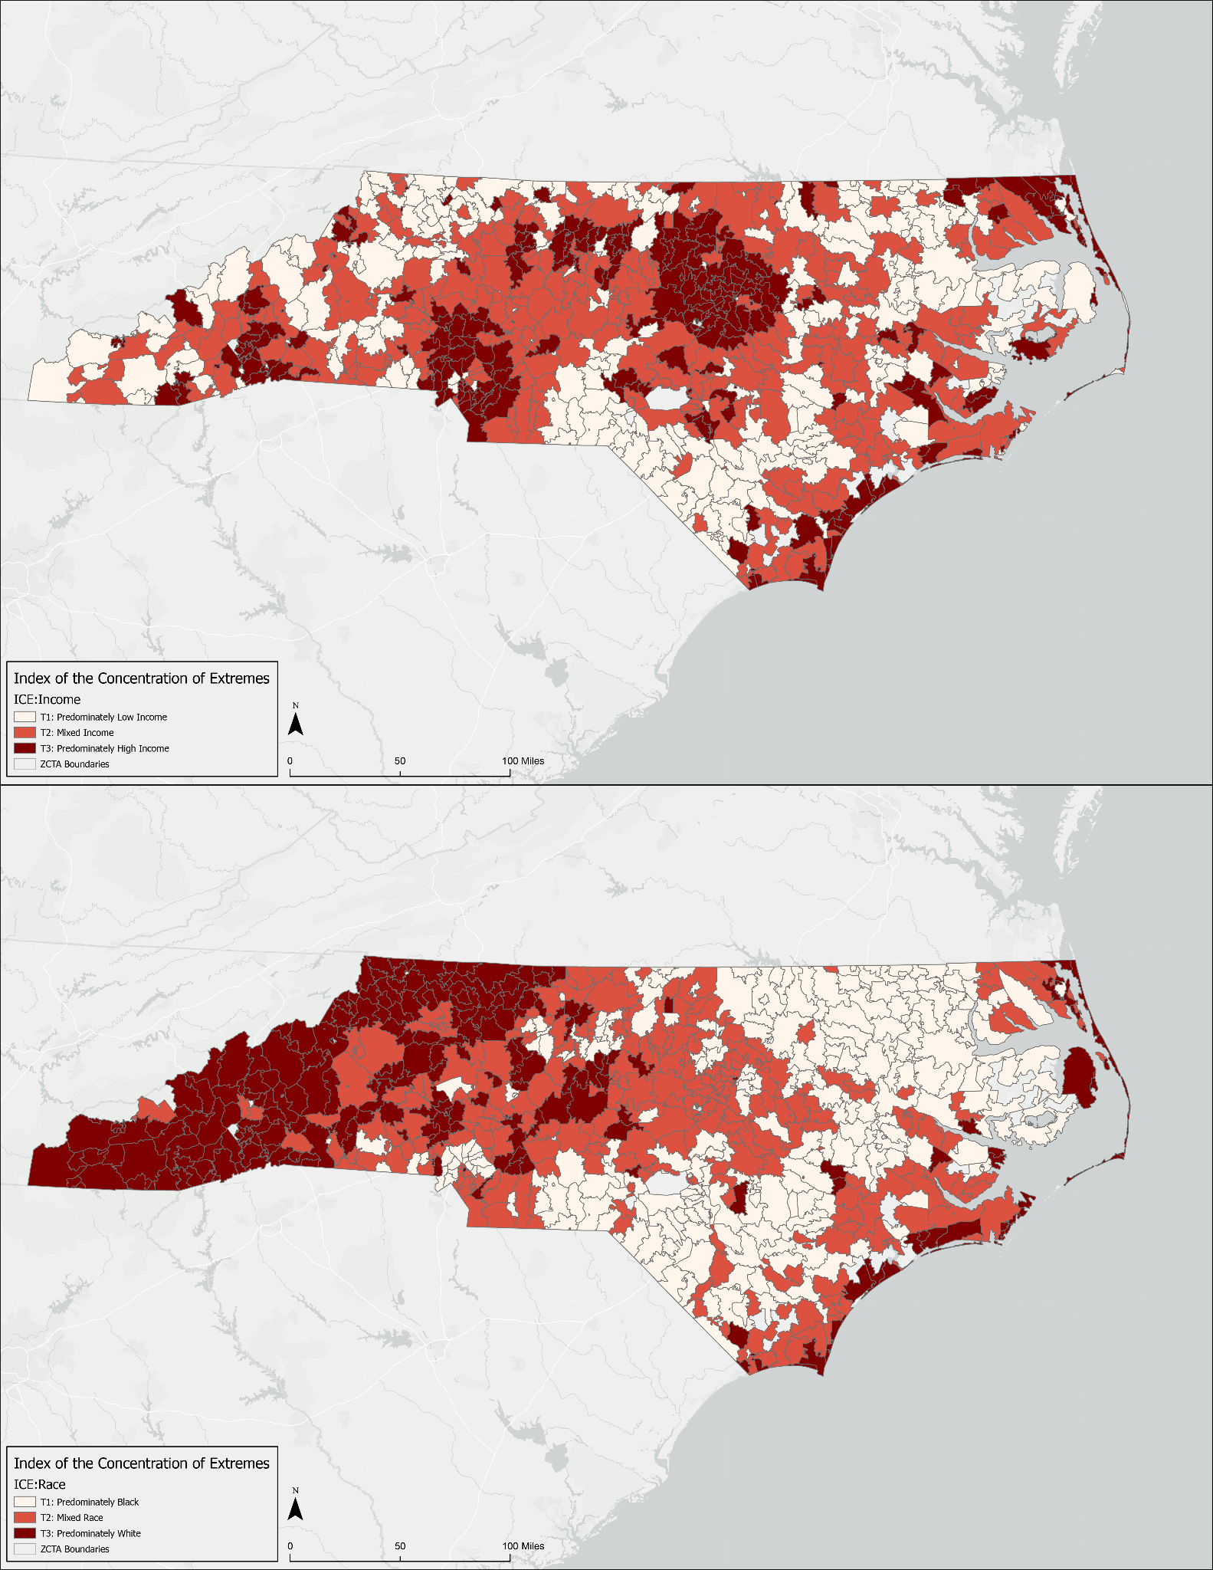
Supplemental Figure 2 - Distribution of Mental Health Professional Shortage Area (MHPSA) designations.
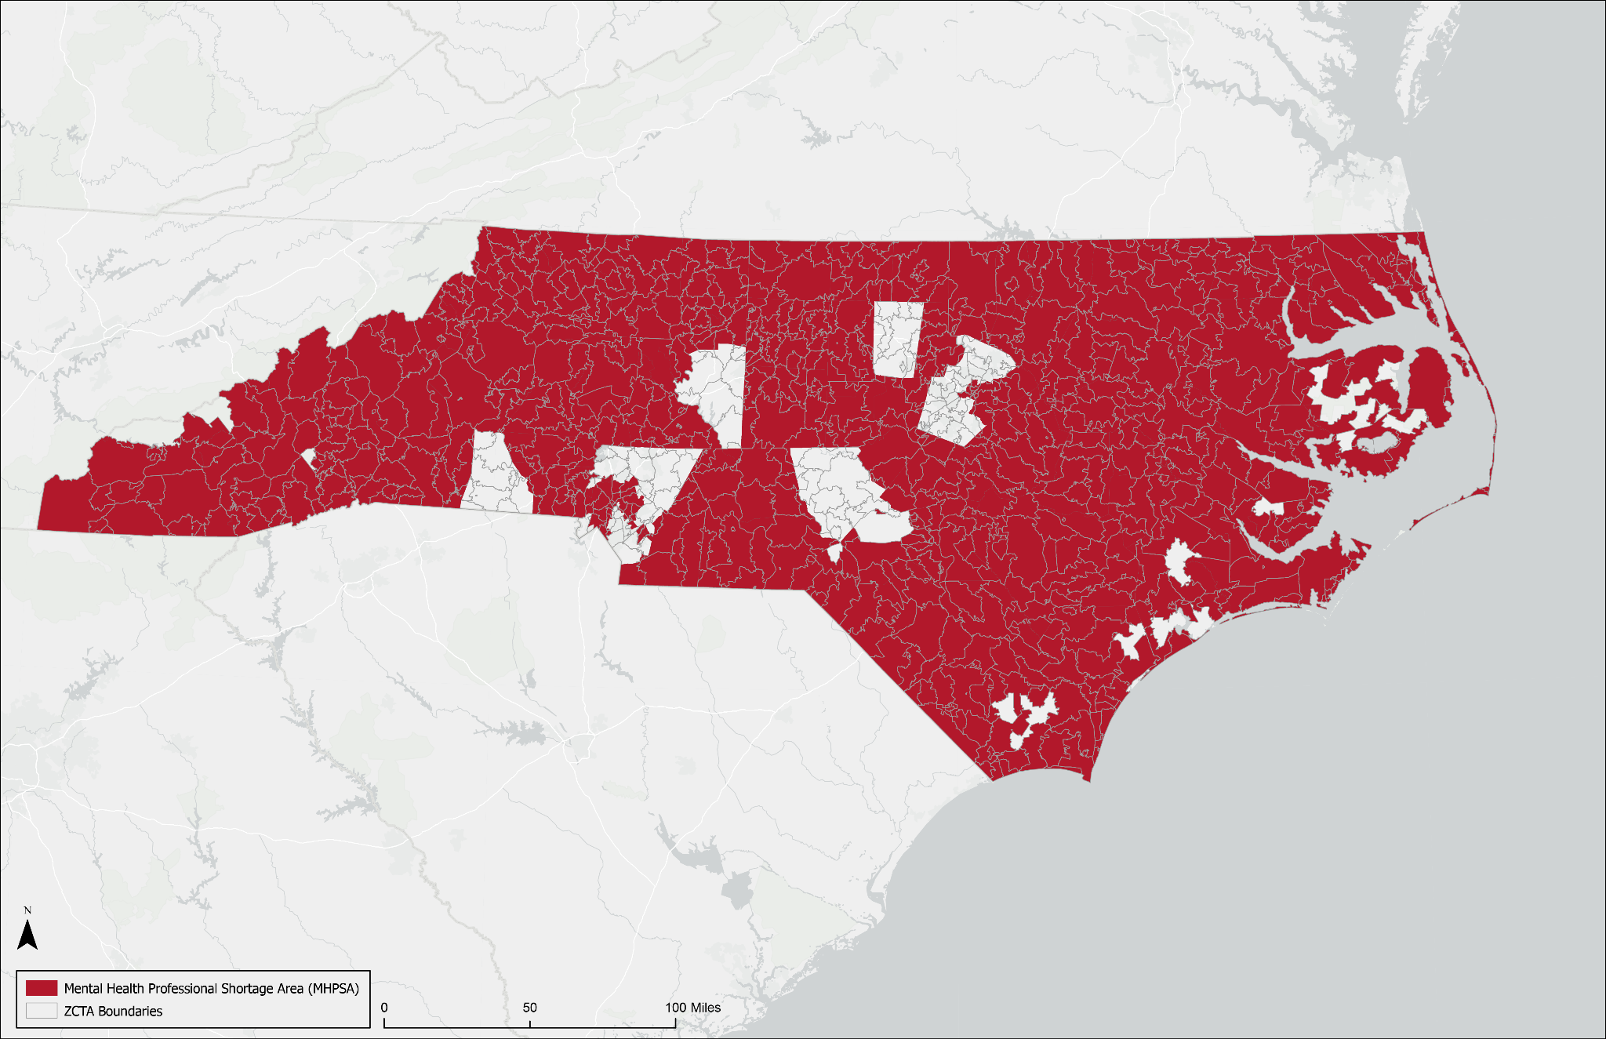

Supplemental Figure 3 - Distribution of greenspace google review data; computed as tertiles.
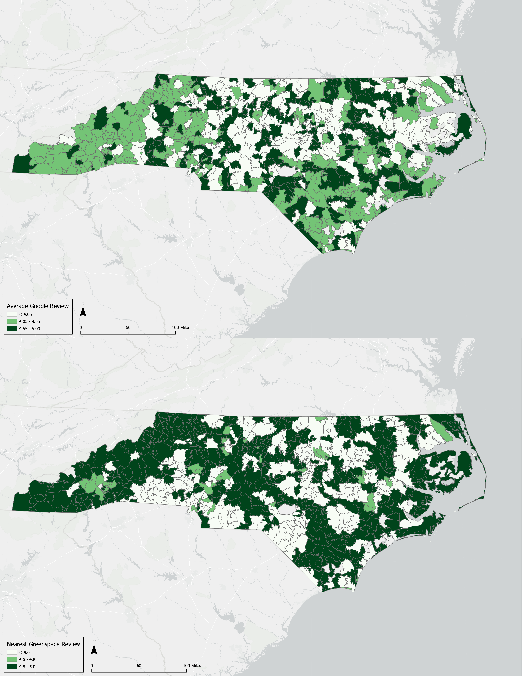

Supplemental Figure 4 - Elastic net regression results indicating greenspace metric importance for (A) the state-wide GLM, (B) the urban-stratified GLM, (C) the suburban-stratified GLM, (D) the small town-stratified GLM, (E) the rural/isolated-stratified GLM, (F) the 14 and under-stratified GLM, (G) the 15-17 year old-stratified GLM, (H) the 18-24 year old-stratified GLM, (I) the male-stratified GLM, and (J) the female-stratified GLM.
