Supplementary Material #1
to the paper
Removal of Methylene Blue Dye Using Crushed Walnut Shell Adsorbent –Determining Comminution Energy and Optimal Operational Conditions

List of Tables:
Table S1. Band test worksheet, sample
Table S2. Design of Experiments
List of Figures:
Fig. S1. Resonance forms of Methylene Blue Cation (MB⁺)
Fig. S2. Hydrated (a) and Dimer (b) structures of MB
Fig. S3: Calibration curve of MB
Fig. S4: MB’s Spectrophotometry spectrum (10 mg/L)
Fig. S5: Walnut Shell’s Spectrophotometry spectrum (2.5 g/L), (a): type I; (b): type II; and (c): type III
Fig. S6: Non-linear Freundlich isotherm modeling of MB adsorption on Walnut Shell, (a): type I; (b): type II; and (c): type III
Fig. S7: Non-linear Langmuir isotherm modeling of MB adsorption on Walnut Shell, (a): type I; (b): type II; and (c): type III
Fig. S8. The results of the complete sieve analysis for fines produced in the last three replicates
Fig. S9. Mesh plot of MB removal efficiency for adsorbent type I with respect to adsorbent to dye ratio and WS dosage

Table S1. Band test worksheet, sample
Note: the user fills highlighted cells.

Table S2. Design of Experiments
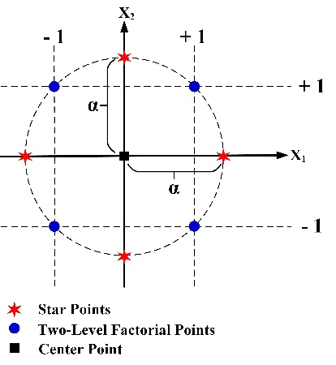

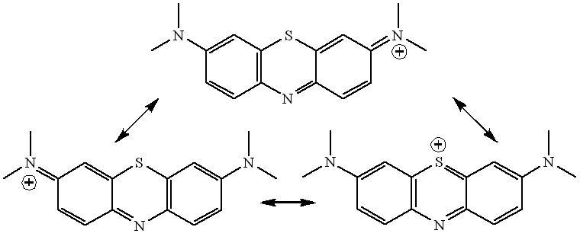
Fig. S1. Resonance forms of Methylene Blue Cation (MB⁺) (Ovchinnikov et al. 2016)

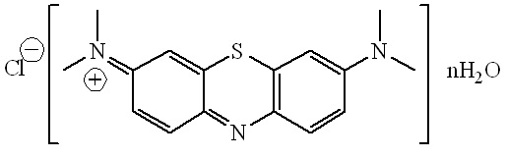
(a)
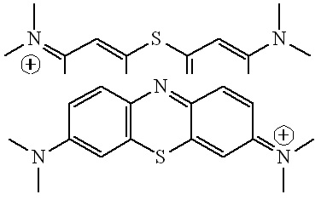
(b)
Fig. S2. Hydrated (a) and Dimer (b) structures of MB (Ovchinnikov et al. 2016)

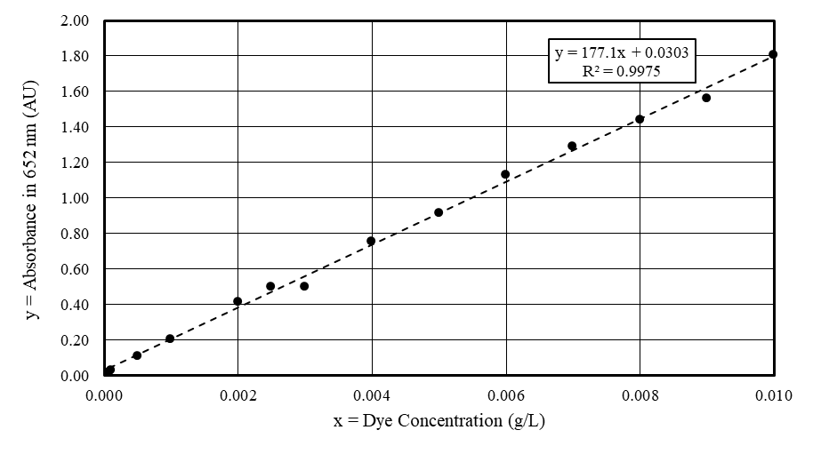
Fig. S3: Calibration curve of MB

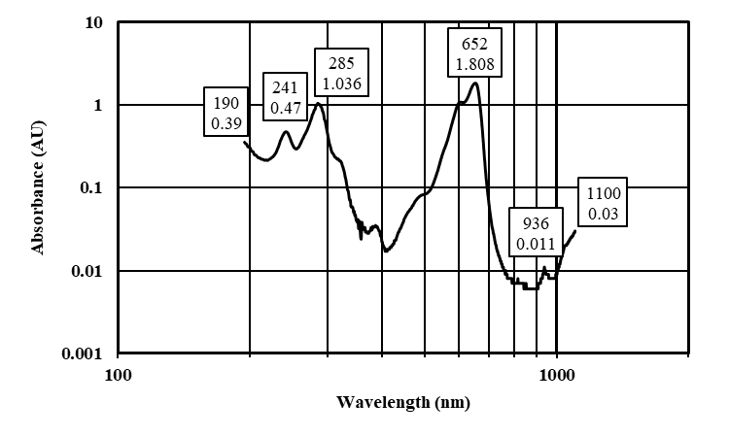
Fig. S4: MB’s Spectrophotometry spectrum (10 mg/L)

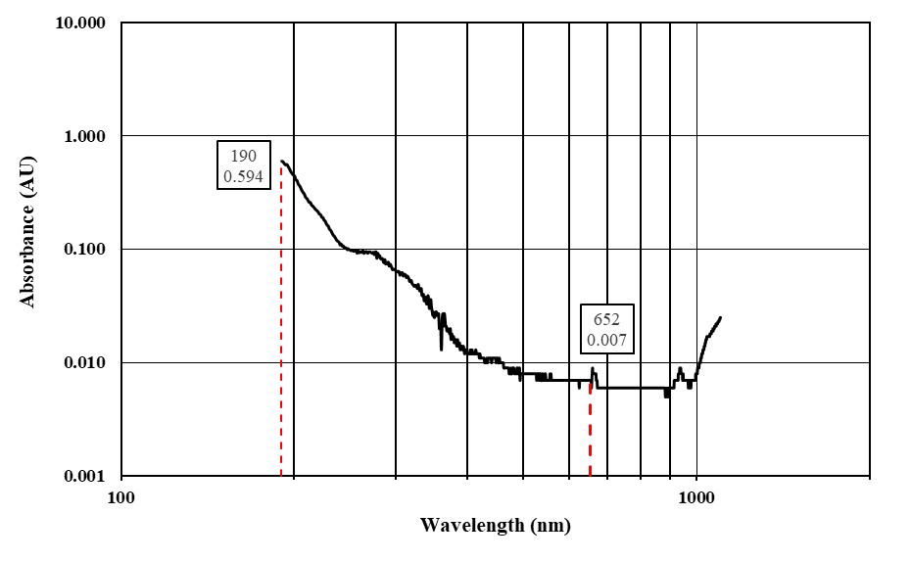
(a)
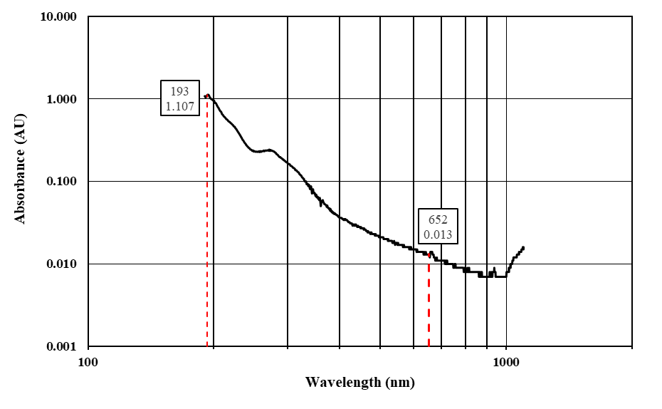
(b)
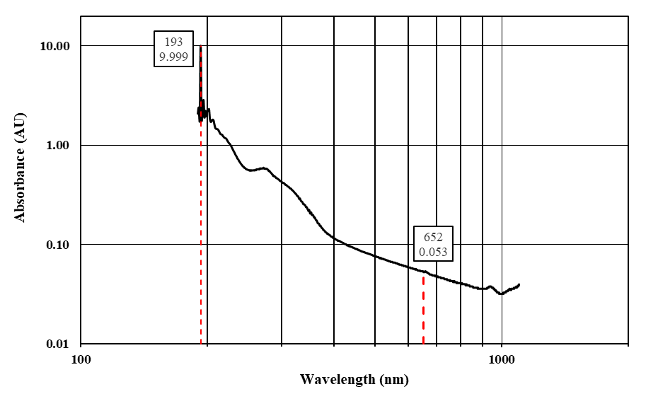
(c)
Fig. S5: Walnut Shell’s Spectrophotometry spectrum (2.5 g/L), (a): type I; (b): type II; and (c): type III

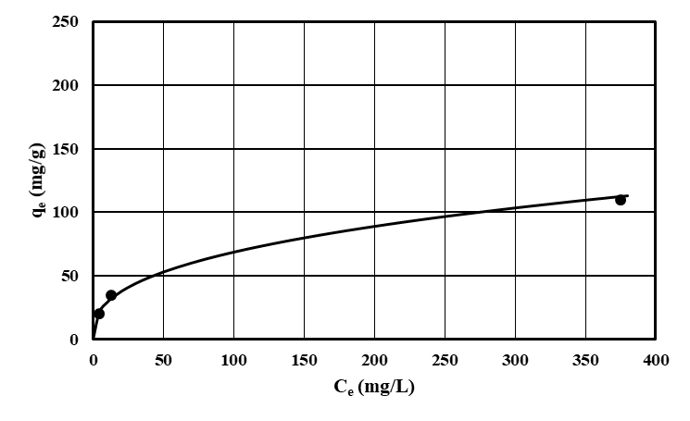 |  | K_{F} = 12.29  n_{F} = 2.68  R² = 0.9902  Significance F = 0.06  ARE = 0.19  EABS = 7.17  χ² = 0.46  MSPD = 12.00
(a)
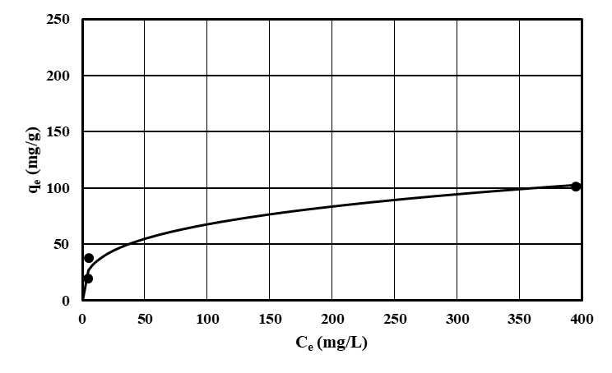 |  | K_{F} = 16.81  n_{F} = 3.30  R² = 0.8699  Significance F = 0.23  ARE = 0.61  EABS = 17.76  χ² = 4.84  MSPD = 42.64
(b)
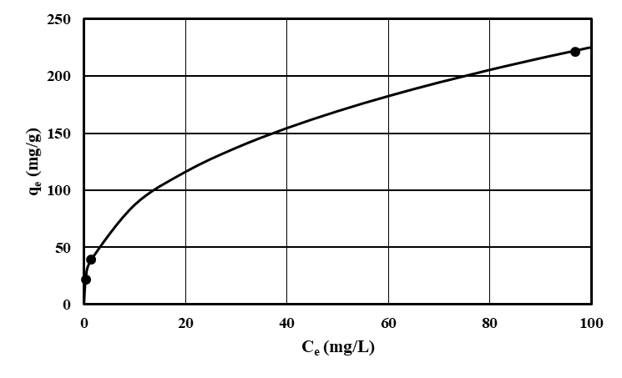 |  | K_{F} = 33.74  n_{F} = 2.43  R² = 0.9998  Significance F = 0.01  ARE = 0.04  EABS = 2.19  χ² = 0.03  MSPD = 2.53
(c)
Notes:
Non-linear Freundlich equation: ${\text{q}}_{\text{e}}\text{=} {\text{K}}_{\text{F}} {{\text{C}}_{\text{e}} }^{\frac{\text{1}}{{\text{n}}_{\text{F}}}}$
Linearized equation: $\text{Ln}\left({\text{q}}_{\text{e}}\right) \text{= }\frac{\text{1}}{{\text{n}}_{\text{F}}}\text{ Ln}\left({\text{C}}_{\text{e}}\right)\text{+ Ln}\left({\text{K}}_{\text{F}}\right)$

Fig. S6: Non-linear Freundlich isotherm modeling of MB adsorption on Walnut Shell, (a): type I; (b): type II; and (c): type III

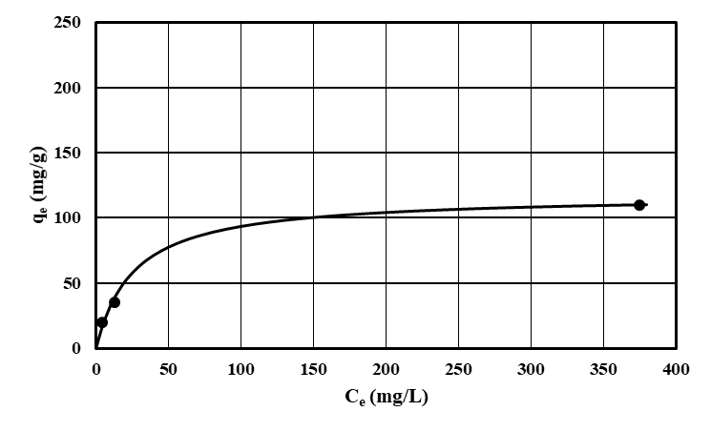 |  | q_{m} = 117.34  K_{L} = 0.04  R² = 0.9996  Significance F = 0.01  ARE = 0.25  EABS = 6.60  χ² = 0.80  MSPD = 17.60
(a)
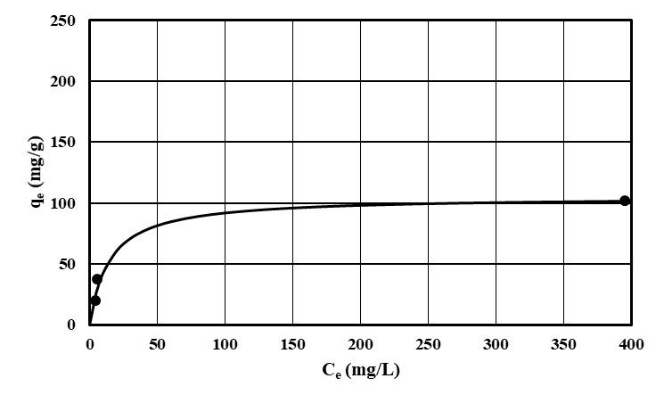 |  | q_{m} = 105.30  K_{L} = 0.07  R² = 0.9995  Significance F = 0.01  ARE = 0.51  EABS = 14.55  χ² = 3.67  MSPD = 35.90
(b)
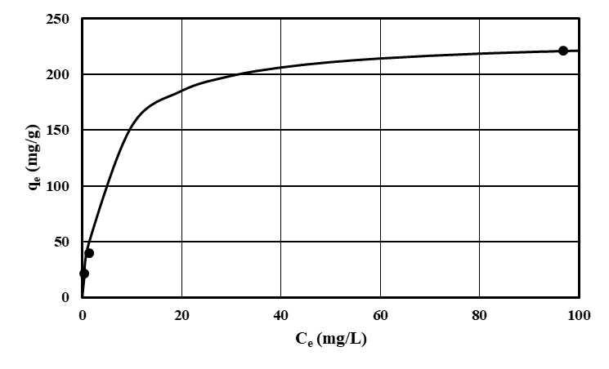 |  | q_{m} = 232.66  K_{L} = 0.20  R² = 0.9991  Significance F = 0.02  ARE = 0.57  EABS = 17.07  χ² = 4.79  MSPD = 40.61
(c)
Notes:
Non-linear Langmuir equation: ${\text{q}}_{\text{e}}\text{= }\frac{{\text{q}}_{\text{m}} {\text{K}}_{\text{L}} {\text{C}}_{\text{e}}}{\text{1} \text{+ }{\text{K}}_{\text{L}} {\text{C}}_{\text{e}}}$
Linearized equation: $\frac{{\text{C}}_{\text{e}}}{{\text{q}}_{\text{e}}}\text{ = }\frac{\text{1}}{{\text{K}}_{\text{L}}{\text{q}}_{\text{m}}}\text{ + }\frac{{\text{C}}_{\text{e}}}{{\text{q}}_{\text{m}}}$
Average Relative Error (ARE): $\frac{\text{100}}{\text{n}} \sum_{\text{i} \text{=} \text{1}}^{\text{n}}{\left|\frac{{\text{q}}_{\text{e,} \text{measured }}\text{- }{\text{q}}_{\text{e,} \text{calculated}}}{{\text{q}}_{\text{e,} \text{measured}}}\right|}$
Sum of Absolute Error (EABS): $\sum_{\text{i = 1}}^{\text{n}}{\left|{\text{q}}_{\text{e,} \text{measured }}\text{- }{\text{q}}_{\text{e,} \text{calculated}}\right|}$
Chi-square test (χ²): $\sum_{\text{i = 1}}^{\text{n}}{\frac{{\left({\text{q}}_{\text{e, measured }}\text{- }{\text{q}}_{\text{e, calculated}}\right)}^{\text{2}}}{{\text{q}}_{\text{e, measured}}}}$
Marquardt’s Percent Standard Deviation: $\text{100}\sqrt{\frac{\text{1}}{\text{n} \text{-} \text{p}}\sum_{\text{i = 1}}^{\text{n}}{{\left(\frac{{\text{q}}_{\text{e, measured }}\text{- }{\text{q}}_{\text{e, calculated}}}{{\text{q}}_{\text{e, measured}}}\right)}^{\text{2}}}}$
Where q_{e, measured} is the experimental value while q_{e, calculated} is the calculated value, n is the number of data points in the experiment (here = 3), and p is the number of parameters of the model (here = 2).

Fig. S7: Non-linear Langmuir isotherm modeling of MB adsorption on Walnut Shell, (a): type I; (b): type II; and (c): type III

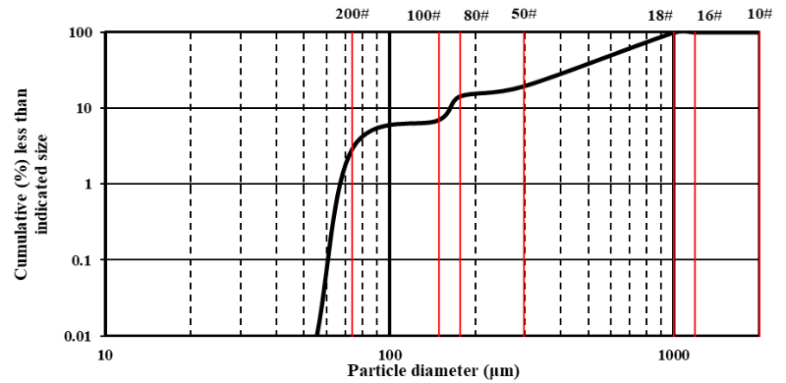
Fig. S8. The results of the complete sieve analysis for fines produced in the last three replicates

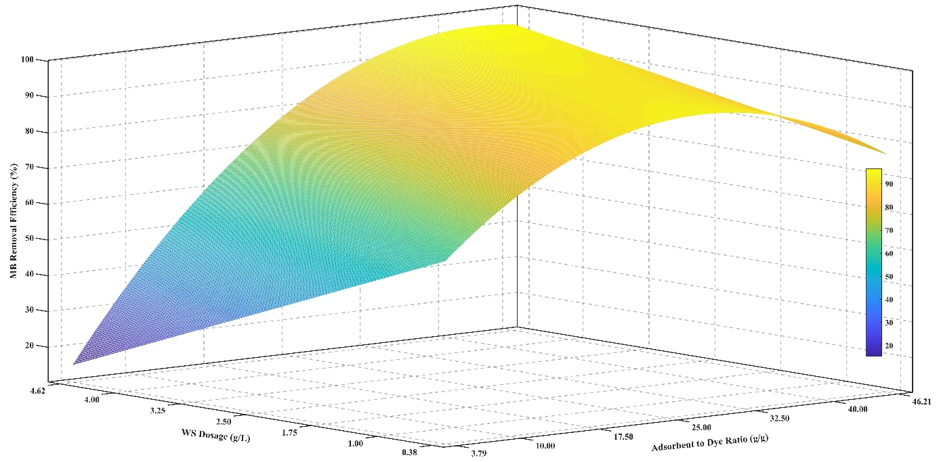
Fig. S9. Mesh plot of MB removal efficiency for adsorbent type I with respect to adsorbent to dye ratio and WS dosage

References:
Ovchinnikov, O. V., Evtukhova, A. V., Kondratenko, T. S., Smirnov, M. S., Khokhlov, V. Y., & Erina, O. V. (2016). Manifestation of intermolecular interactions in FTIR spectra of methylene blue molecules. Vibrational Spectroscopy, 86, 181-189. https://doi.org/10.1016/j.vibspec.2016.06.016

