Supplemental File S1

Supplemental Figure 1: Risk of Bias
Supplemental Figure 2. Worldwide distribution of reported cases of LVNC in pregnancy

Supplemental Figure 3a. Reporting of Echocardiographic findings
Supplemental Figure 3b. Differences of median averages of ejection fraction in patients with LVNC

Supplemental Table 1. Reported EKG and Echocardiographic Characteristics of LVNC

Supplemental Figure 1: Risk of Bias
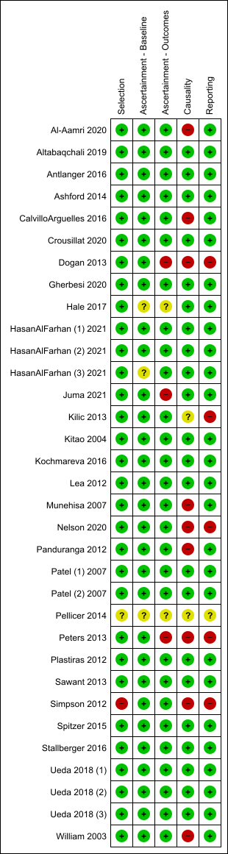
Supplemental Figure 2. Worldwide distribution of reported cases of LVNC in pregnancy
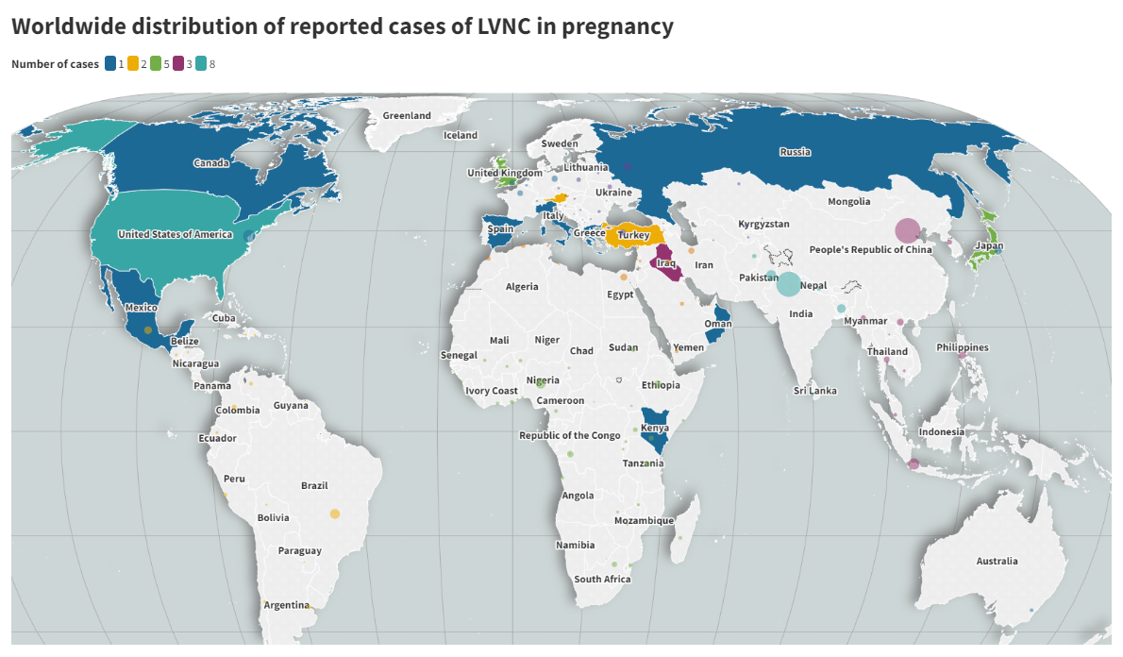

Supplemental Figure 3a. Reporting of Echocardiographic findings
Supplemental Figure 3b. Differences of median averages of ejection fraction in patients with LVNC

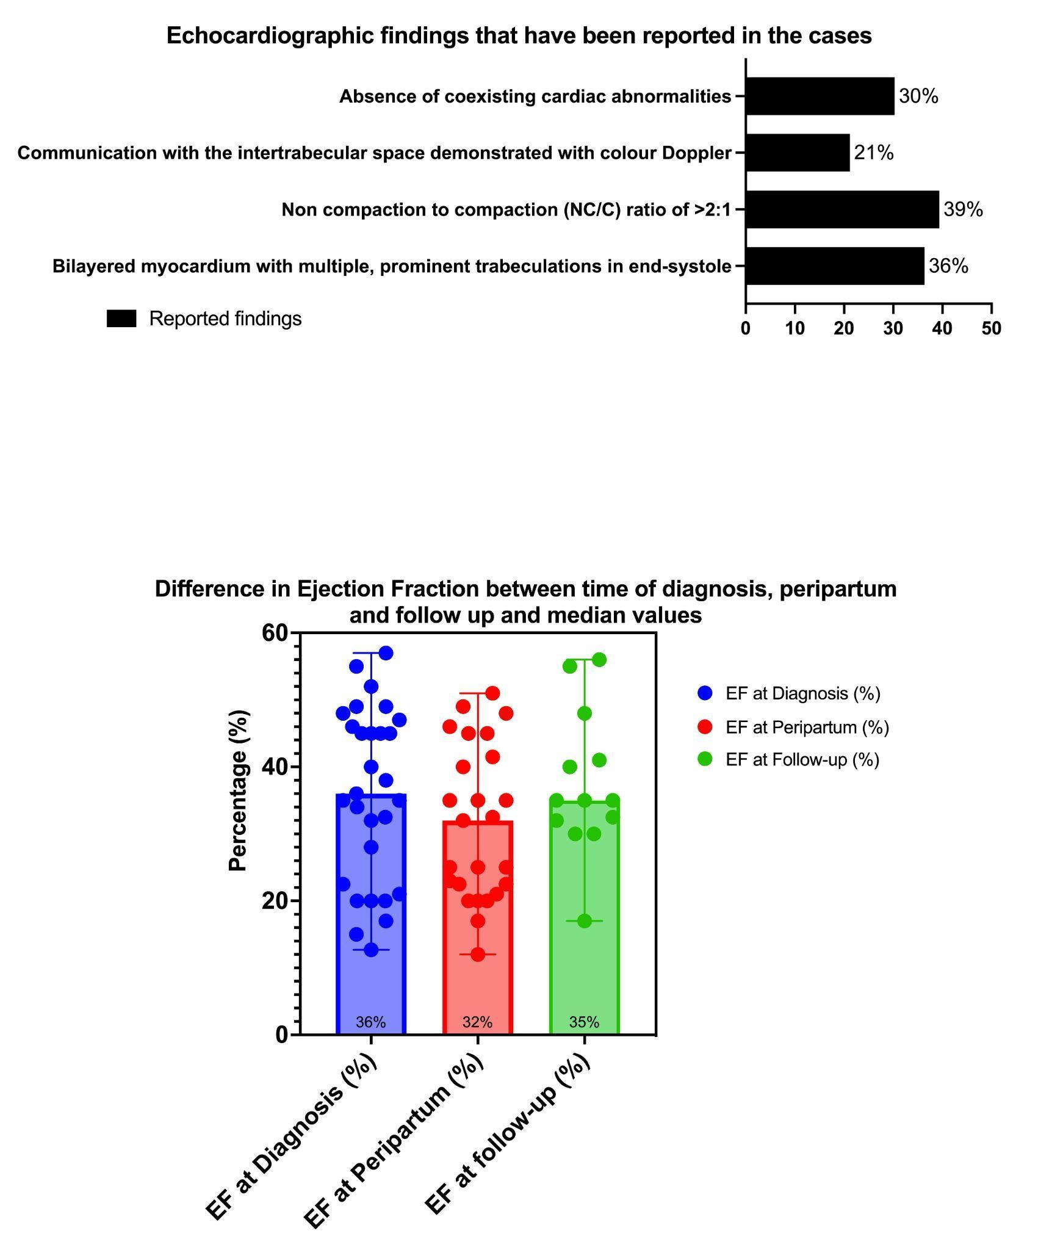

Supplemental Table 1. Reported EKG and Echocardiographic Characteristics of LVNC
Author | Notable EKG Characteristics | ST-T changes | PVCs | Jenni 1-Bilayered myocardium with multiple, prominent trabeculations in end-systole | Jenni 2-Non compaction to compaction (NC/C) ratio of >2:1 | Jenni 3-Communication with the intertrabecular space demonstrated with color Doppler | Jenni 4-Absence of coexisting cardiac abnormalities
Williams (2003) | Sinus rhythm with low voltages inferiorly and poor R-wave progression | N | N | Y | - | - | -
Ueda (2017) | - | - | - | Y | - | - | -
Ueda (2017) | NSVT | - | - | - | - | - | -
Ueda (2017) | NSVT | - | - | - | - | - | -
Stollberger (2016) | - | - | - | - | - | - | -
Spitzer (2014) | - | - | - | - | - | - | -
Simpson (2012) | - | - | - | - | - | - | -
Sawant (2013) | Ambulatory ECG monitoring revealed non-sustained ventricular tachycardia | N | N | - | - | - | -
Plastrias (2012) | - | - | - | Y | Y | Y | Y
Peters (2013) | - | - | - | Y | Y | Y | Y
Patel (2009) | A.Flutter,PVC, PAC, Bundle branch reentry Vtach | Y | N | - | Y | - | -
Patel (2009) | - | - | - | - | N | - | -
Panduranga (2011) | Complete LBBB | N | N | Y | Y | Y | N
Nelson (2020) | Ventricular Tachycardia | N | N | - | - | - | -
Munehisa (2017) | WPW | - | N | Y | Y | Y | Y
Lea (2011) | - | - | - | Y | - | - | N
Kochmareva (2016) | - | - | - | - | - | - | -
Kitao (2005) | Sinus rhythm, with signs of left ventricular hypertrophy and left atrial enlargement | N | N | Y | Y | Y | Y
Kilic (2013) | Non-specific T-wave changes | Y | N | Y | - | Y | N
Juma (2021) | - | - | - | - | - | - | -
Farhan (2021) | - | - | - | - | Y | - | -
Farhan (2021) | - | - | - | - | Y | - | -
Farhan (2021) | - | - | - | - | Y | - | -
Hale (2017) | - | - | - | - | - | - | Y
Gherbesi (2020) | - | - | - | - | - | - | -
Dogan (2013) | Non-specific intraventricular conduction block | N | N | Y | - | - | -
Crousillat (2019) | normal sinus rhythm without any abnormalities  Ambulatory electrocardiogram monitoring demonstrated rare premature ventricular contractions without sustained supra or ventricular tachyarrhythmias. | N | N | - | Y | - | -
Arguelles (2016) | Low voltage in limb leads (2/2 pericardial effusion) | N | N | Y | Y | - | N
Pellicer (2019) | NORMAL | - | - | - | - | - | -
Ashford (2014) | normal sinus rhythm with premature ventricular contractions, T wave abnormalities, and prolonged QT interval. | Y | Y | - | - | - | -
Antlanger (2016) | new occurrence of negative T waves in leads I, II, and V4-6 | Y | N | - | - | - | -
Altabaqchali (2019) | - | - | - | - | - | - | -
Al-aamri (2020) | PVCs | - | Y | Y | Y | N | Y

