Episodic transient deformation in the Noto Peninsula, central Japan, revealed by the analysis of multiple GNSS networks

Takuya Nishimura*¹, Yoshihiro Hiramatsu², and Yusaku Ohta³

¹Disaster Prevention Research Institute, Kyoto University, Gokasho, Uji, Kyoto Prefecture 611-0011, Japan
²Institute of Science and Engineering, Kanazawa University, Kanazawa, Kadoma-cho, Ishikawa Prefecture 920-1192, Japan
³Graduate School of Science, Tohoku University, Aramaki-aza-aoba 6-6, Aoba-ku, Sendai, Miyagi Prefecture 980-8578, Japan

*Corresponding author (nishimura.takuya.4s@kyoto-u.ac.jp)

Contents:
Figure S1: Temporal depth sequence of earthquakes in Cluster S.
Figure S2: The weekly number of M≥1 earthquakes in Clusters NE, N, W, and S (Fig. 1b).
Figure S3: Vertical cross-section of relocated hypocenters in N60ºE direction.
Figure S4: Observed and pre-processed time-series of GNSS daily positions.
Figure S4: Distribution of GNSS stations used in this study.
Figure S5: Displacement during and after the M5.4 earthquake on June 19, 2022.
Figure S6: Displacement predicted by a point inflation source, opening sub-horizontal crack, and reverse fault slip.
Figure S7: Seismic station distribution and velocity structure used in this study.
Figure S8: Distribution of GNSS stations used in this study.
Figure S9: Time series of BR16 before and after a site-specific correction.

Table S1: Parameters for deformation sources in Fig. S4.
Table S2: Initial parameters and their prior constraints for deformation sources in three periods.
Movie S1: Cumulative and 4-week displacements at GNSS stations.

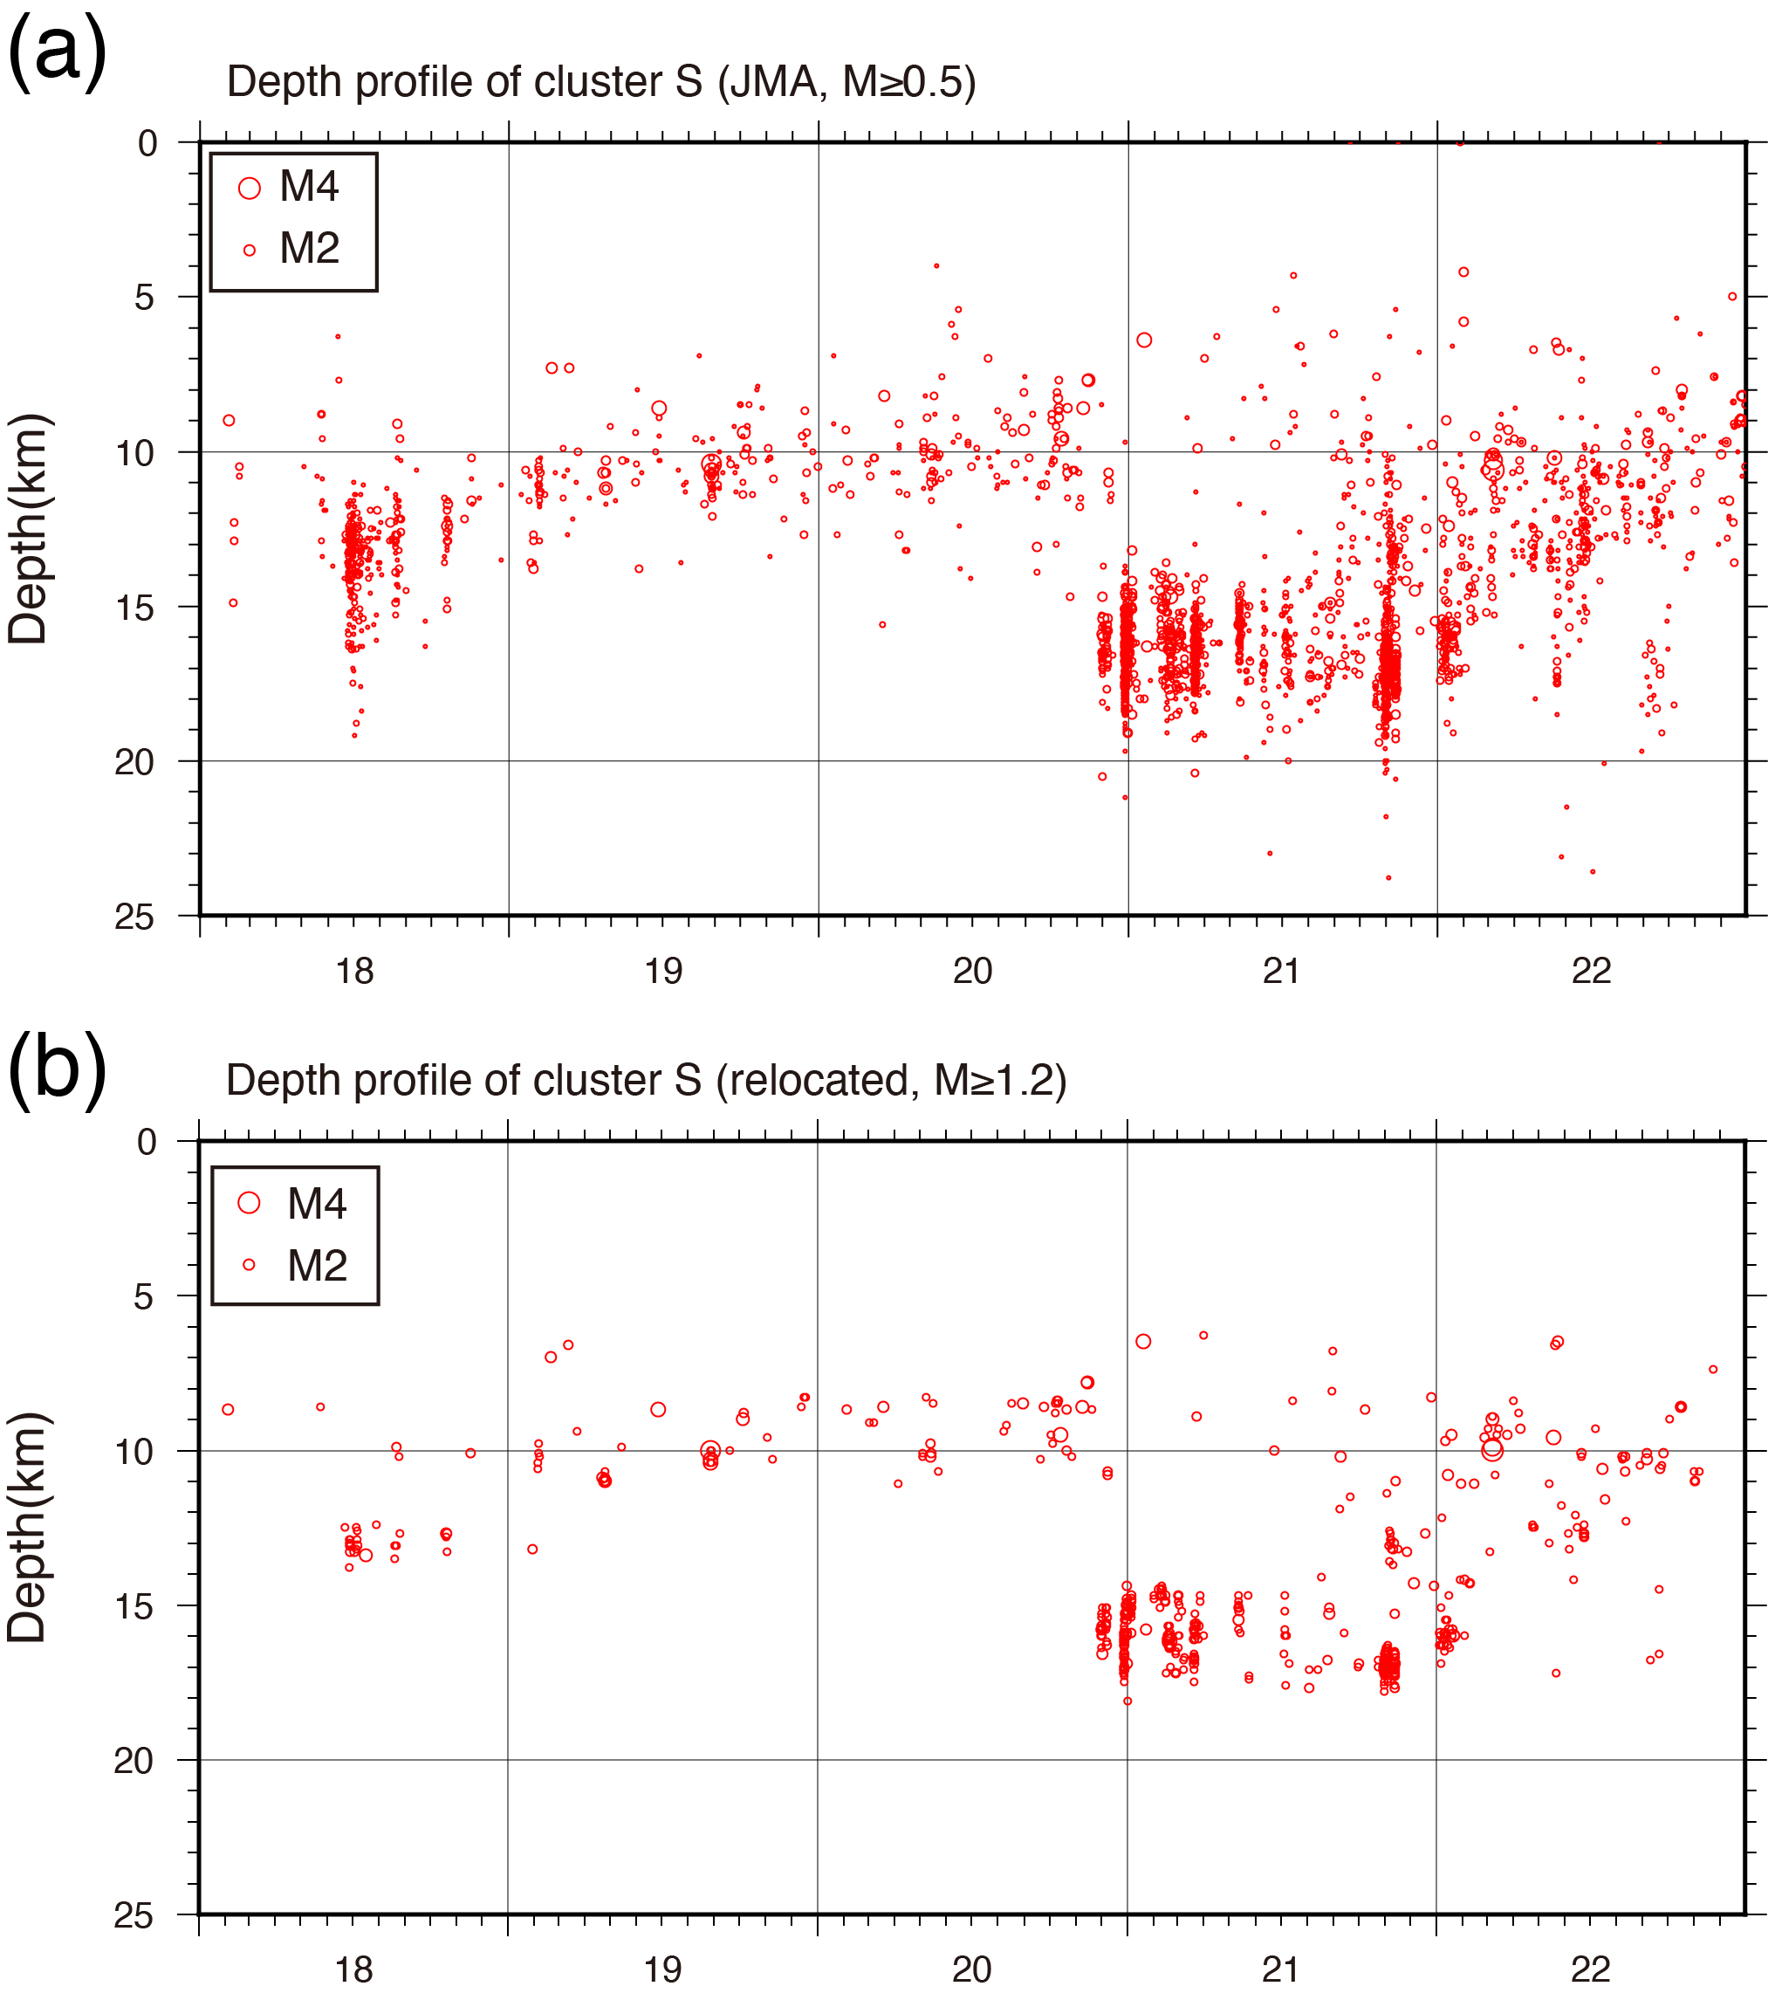
Fig. S1 Temporal depth sequence of earthquakes in Cluster S. (a) M≥0.5 earthquakes using the JMA catalog. (b) M≥1.2 earthquakes using the relocated catalog.

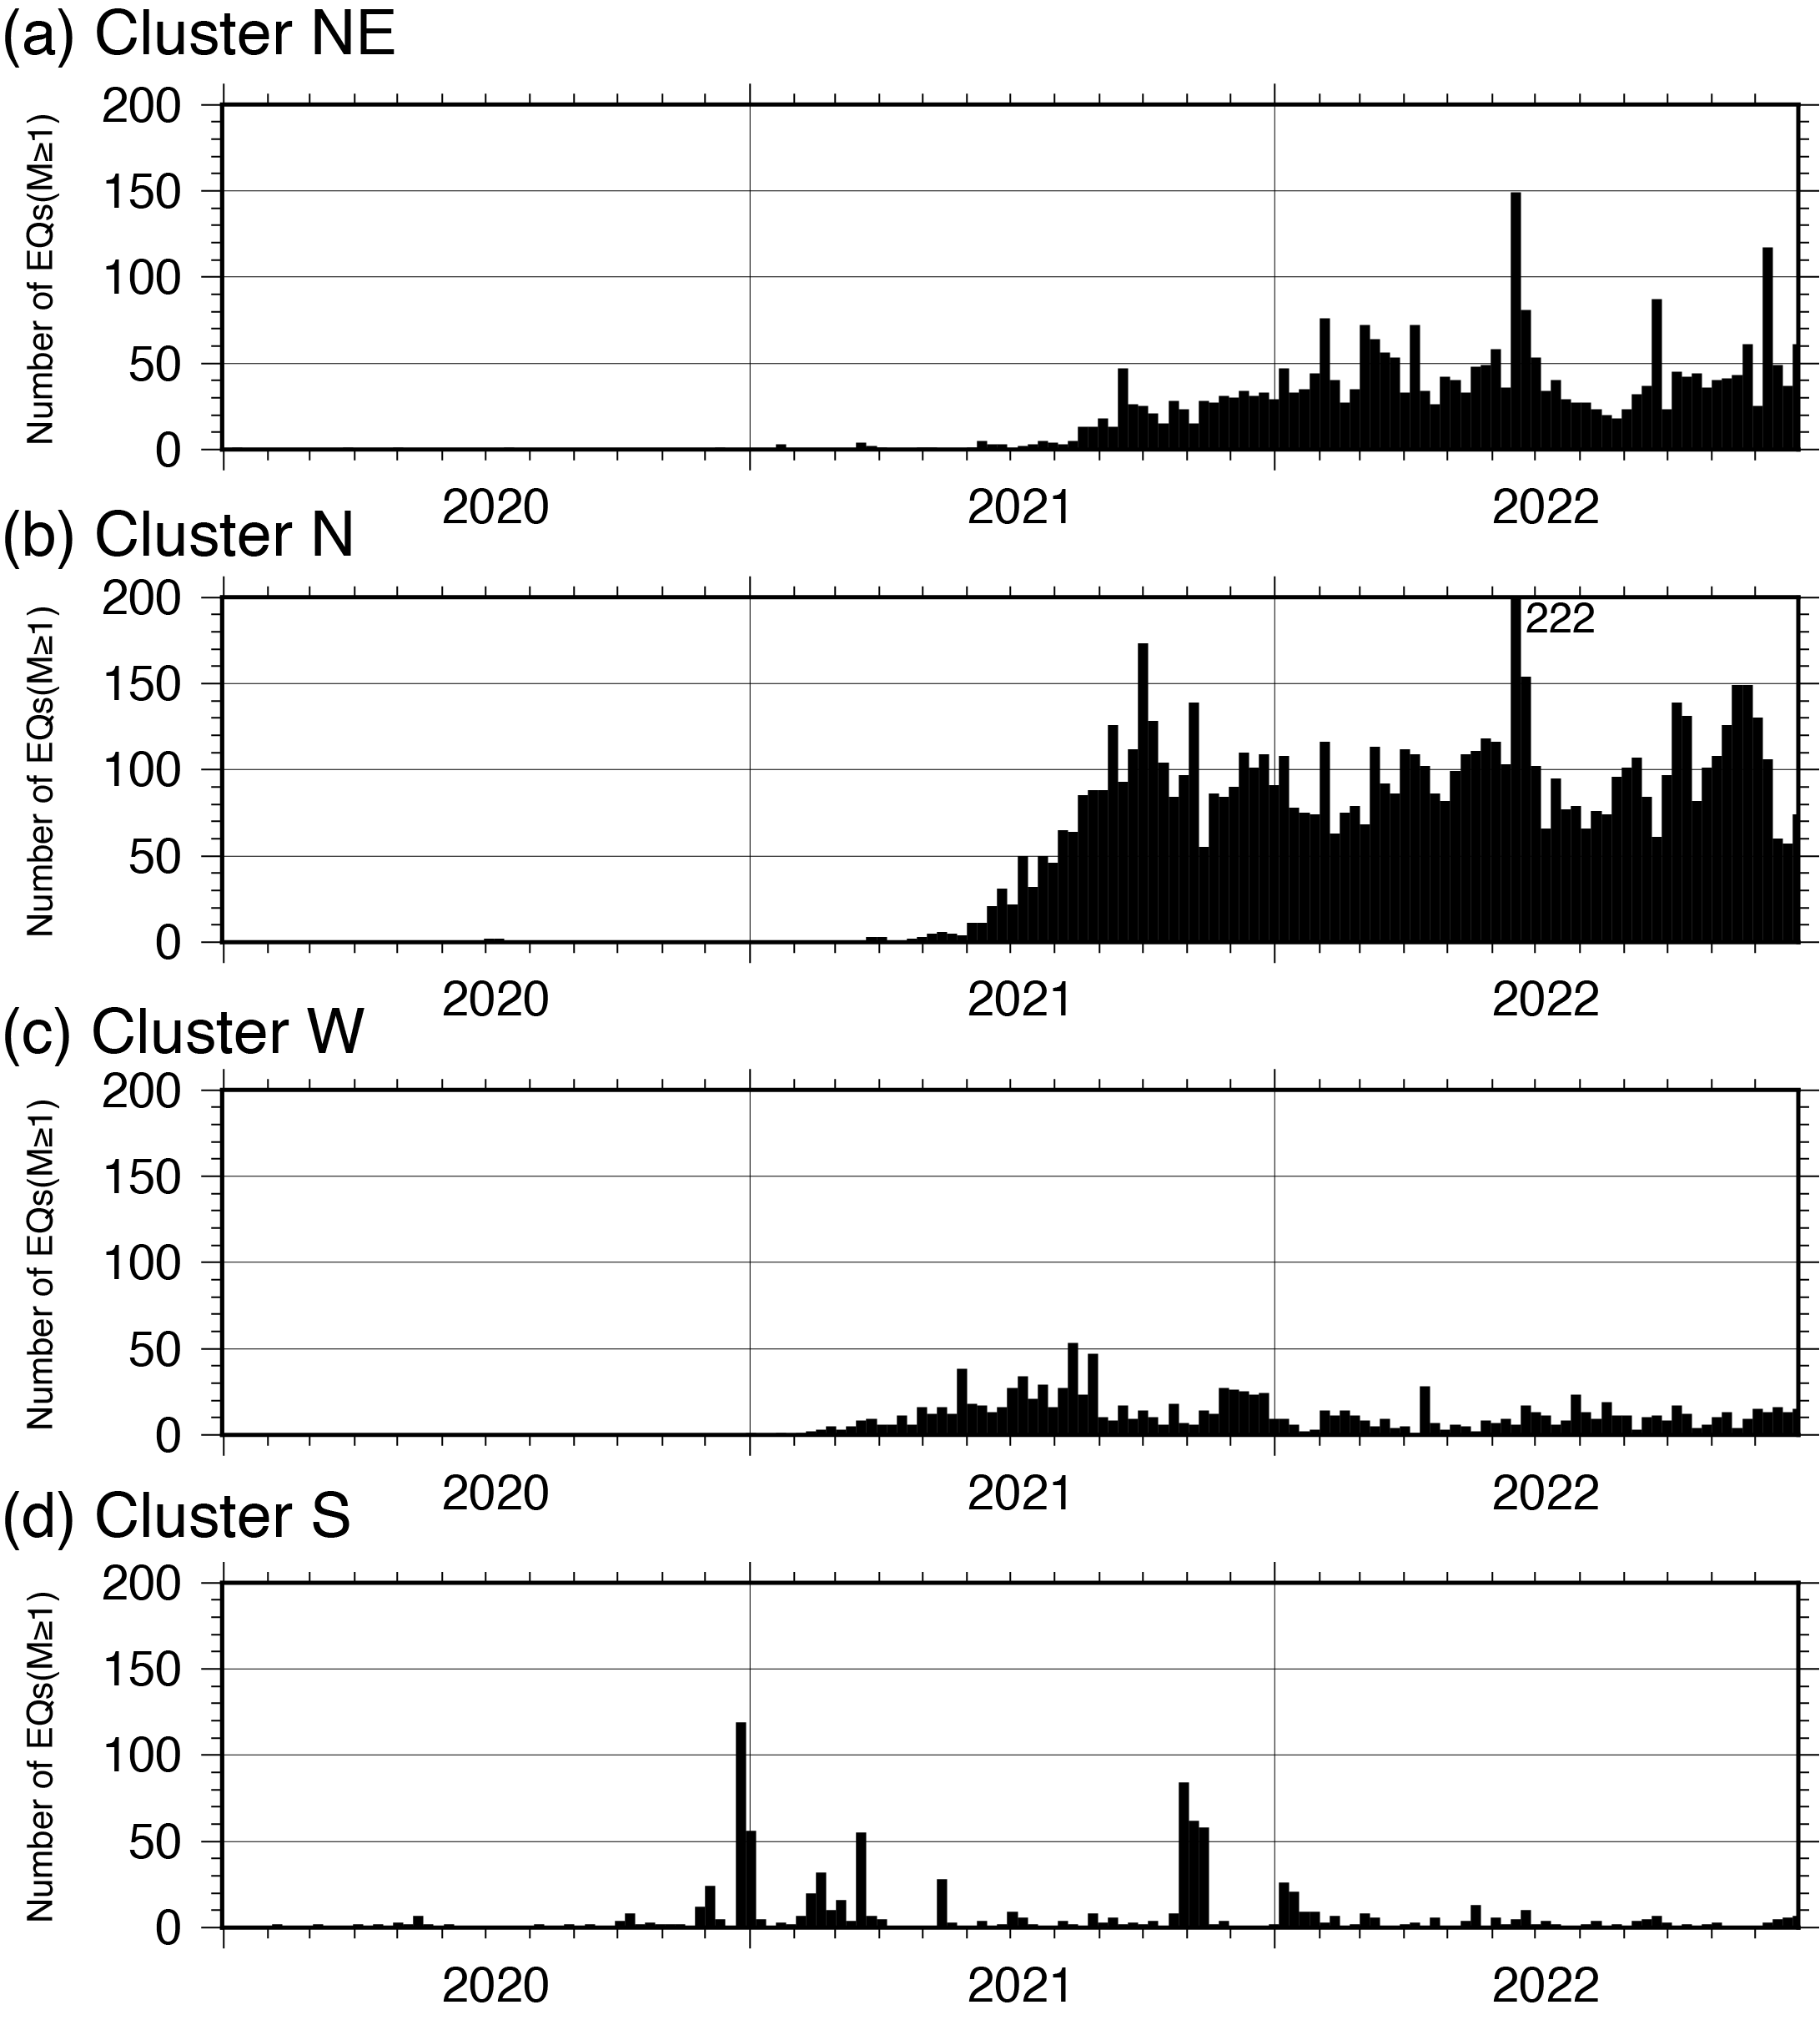
Fig. S2 The weekly number of M≥1 earthquakes in Clusters NE, N, W, and S (Fig. 1b).

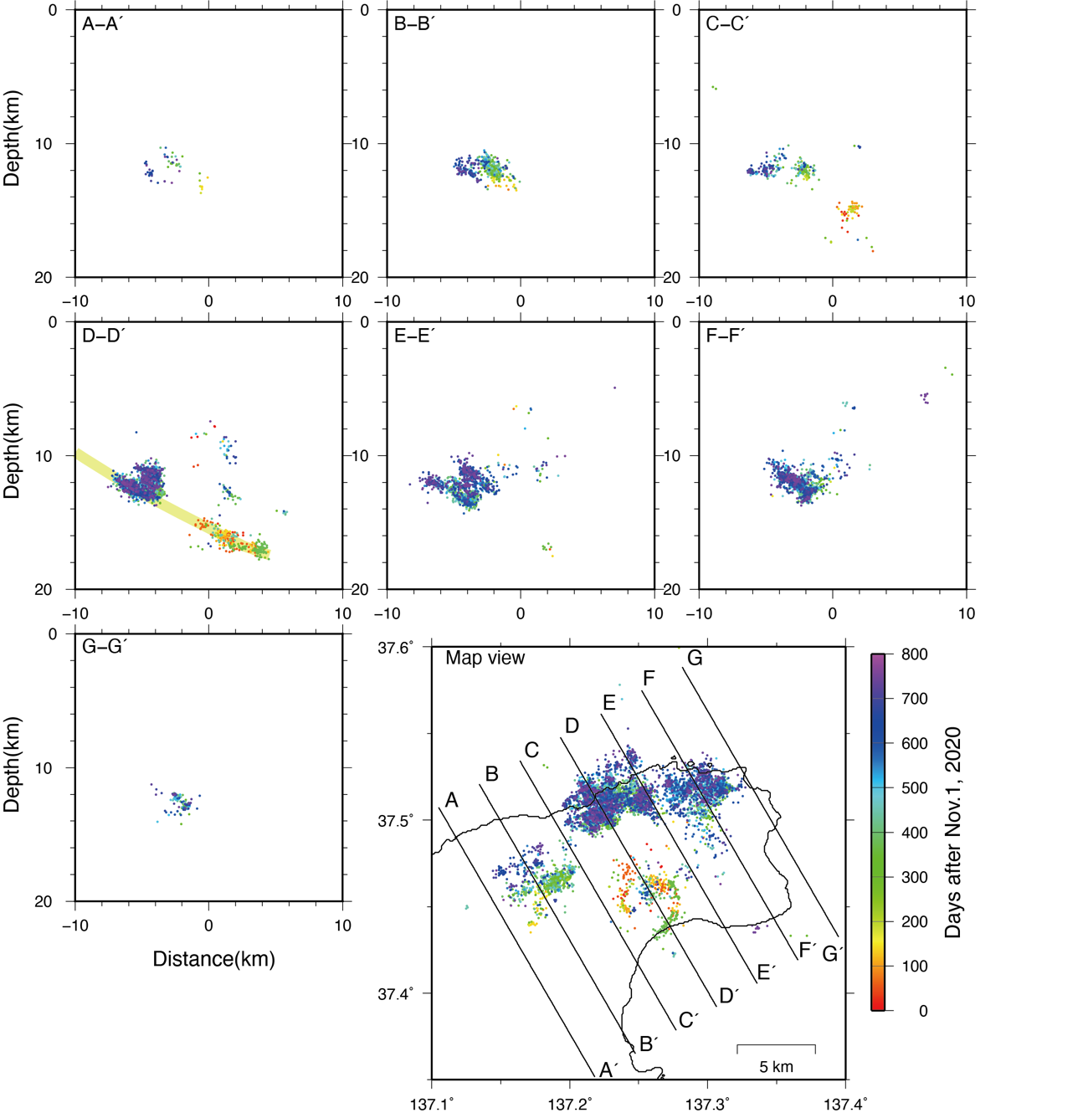Fig. S3 Vertical cross-section of relocated hypocenters in N60ºE direction. The color represents days after November 1, 2020. A possible southeast-dipping listric fault zone is indicated in the cross-section D-D´.

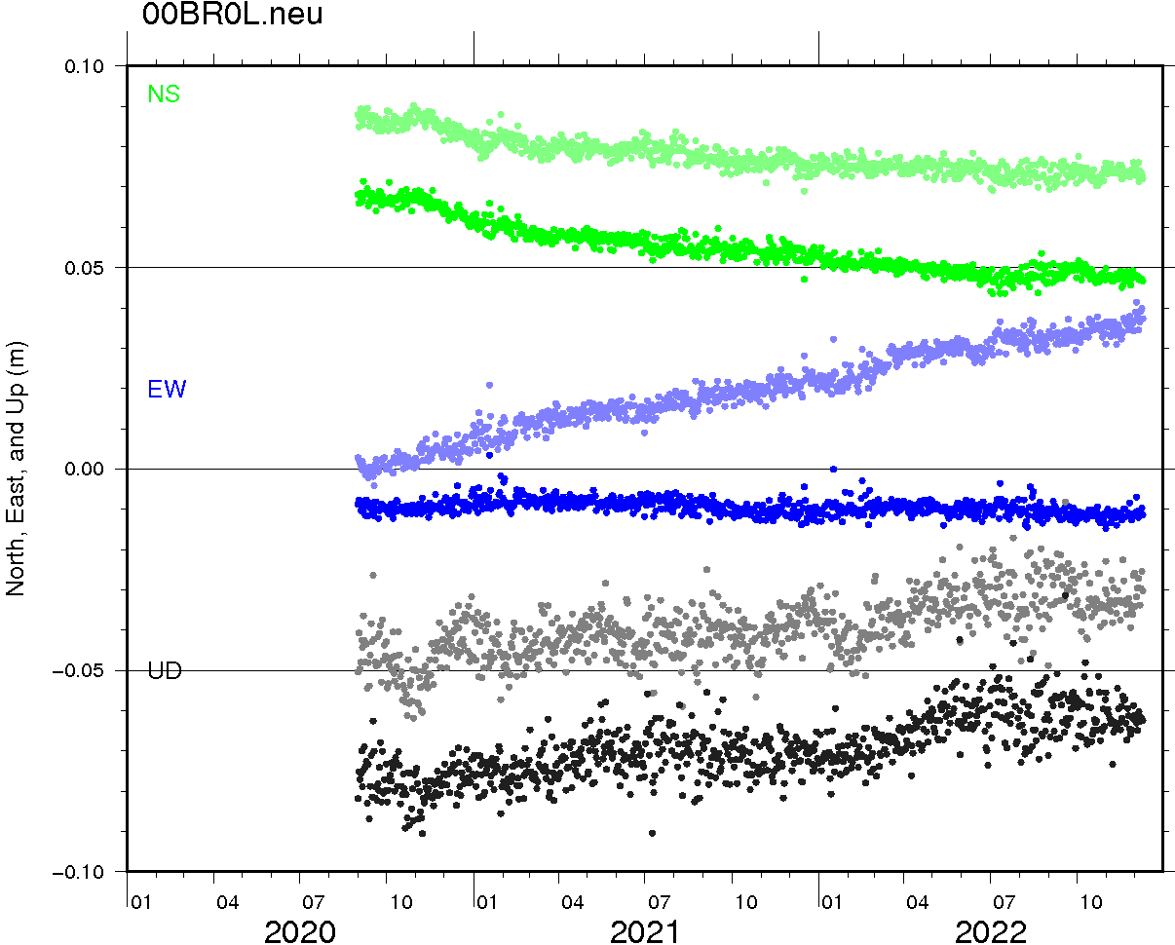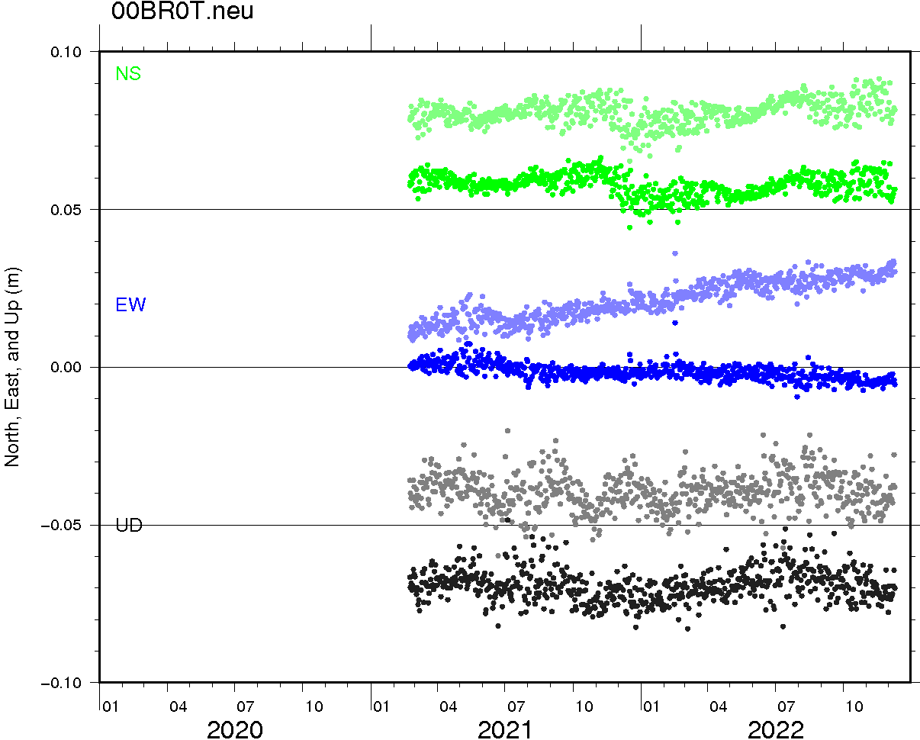
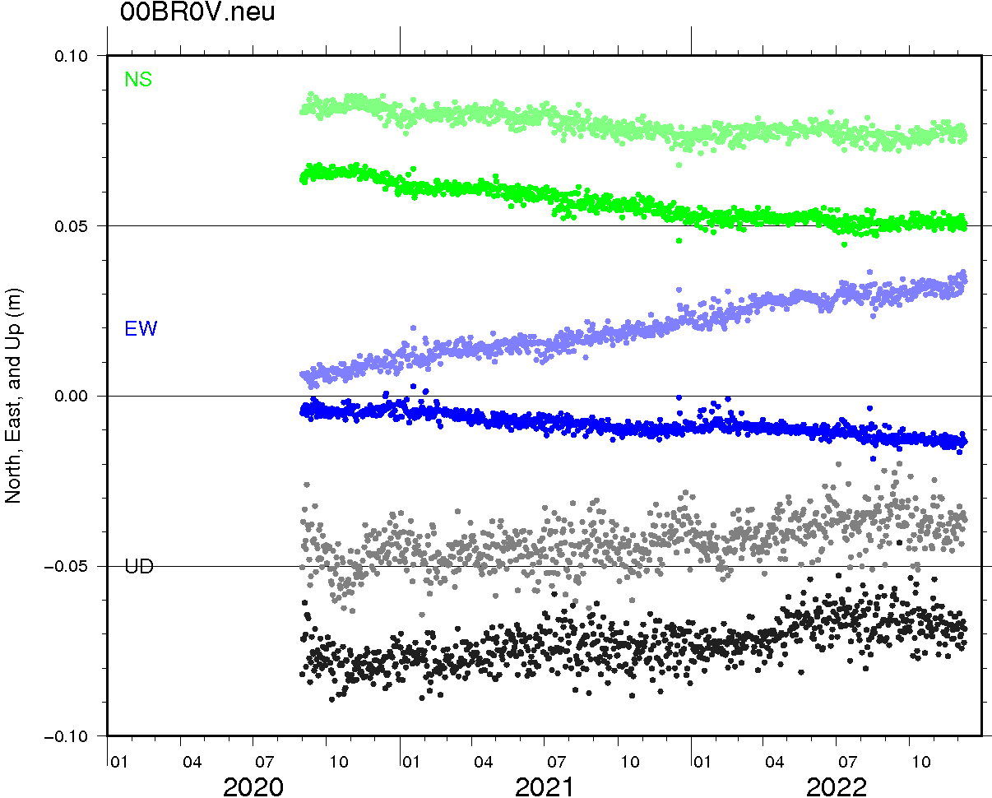
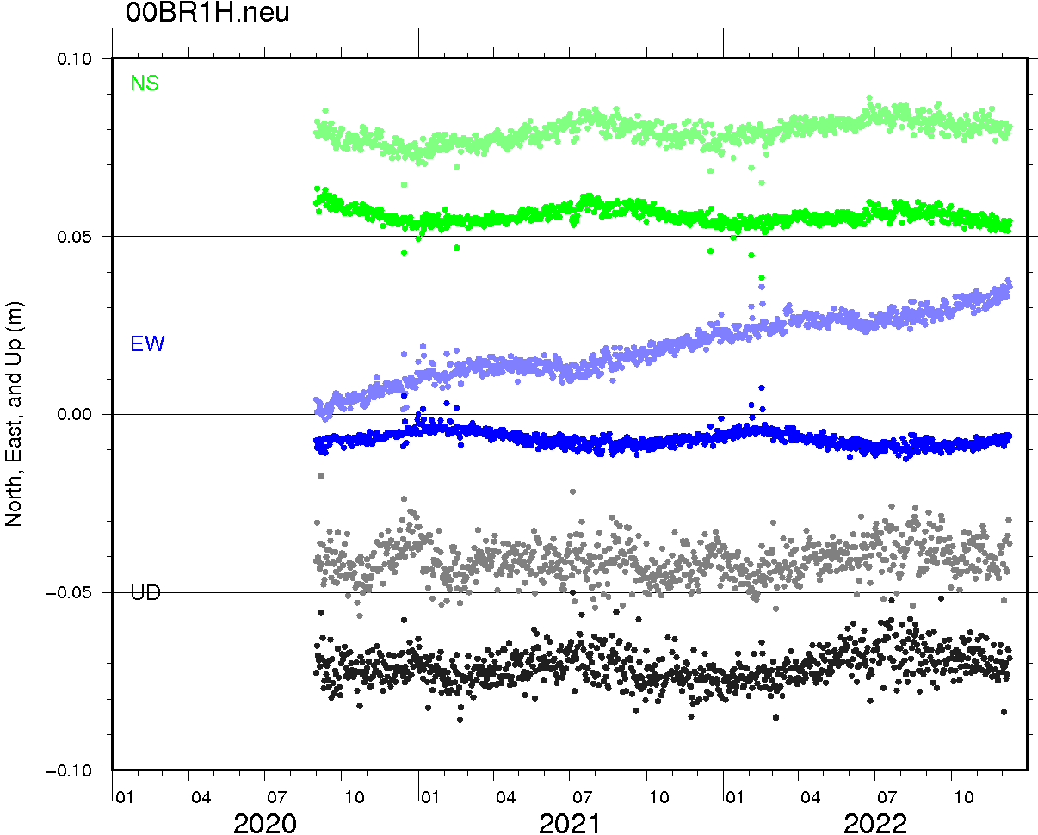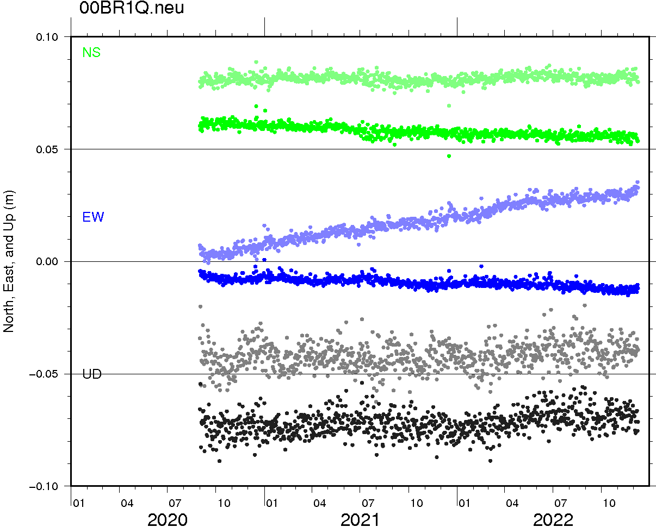

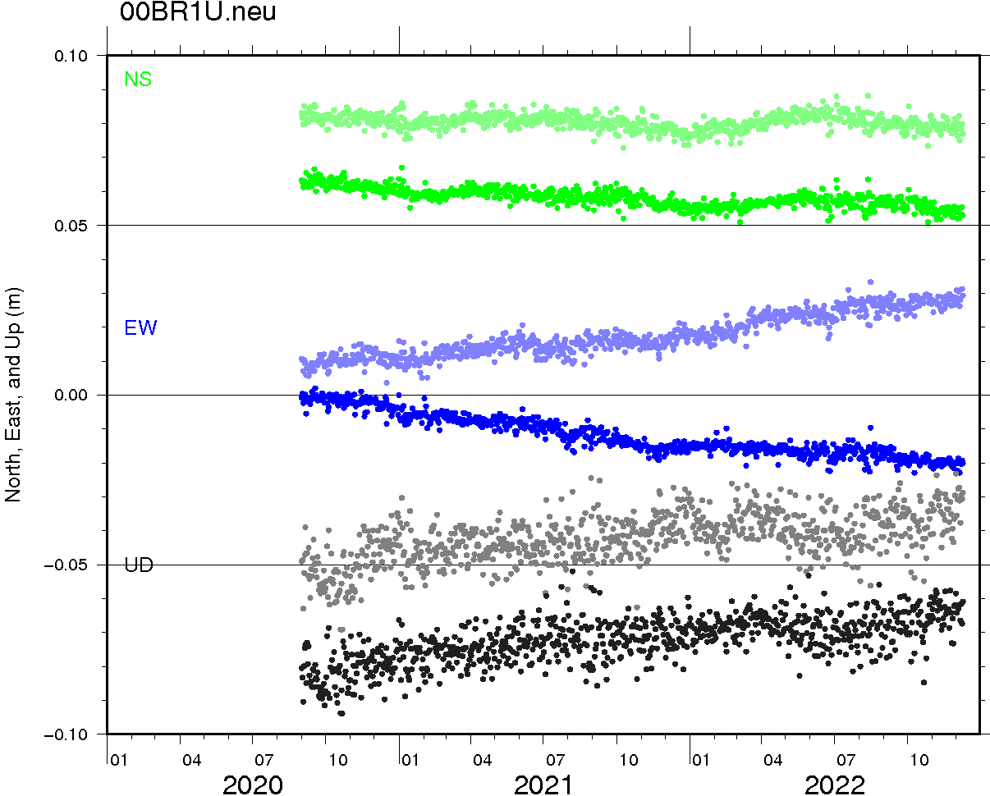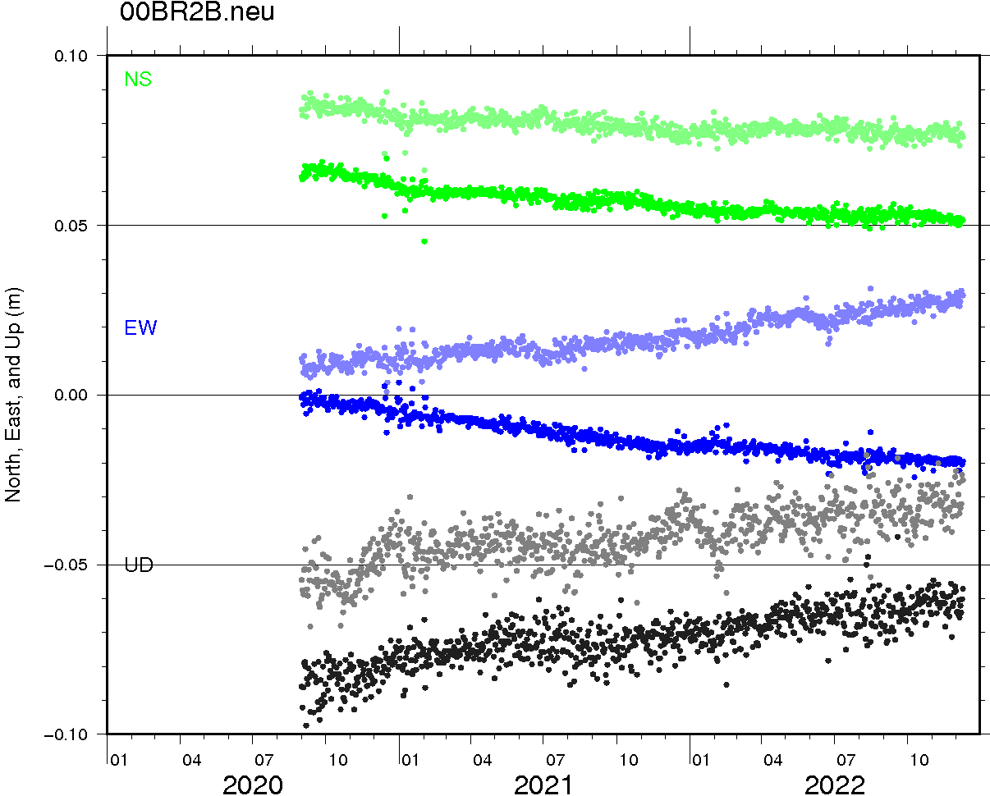
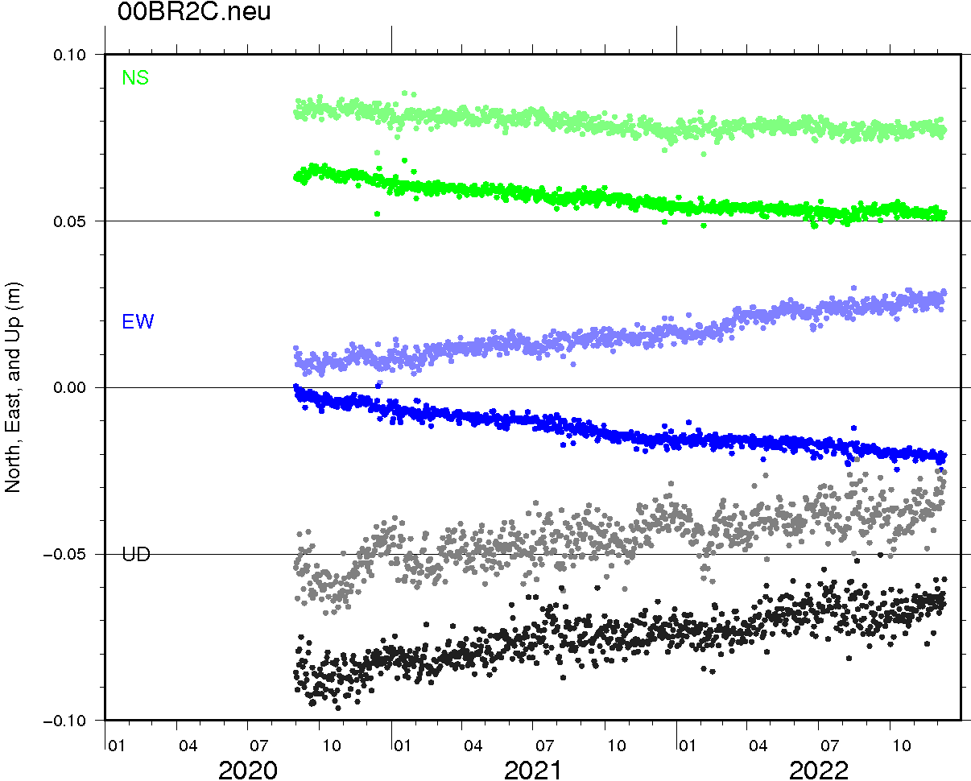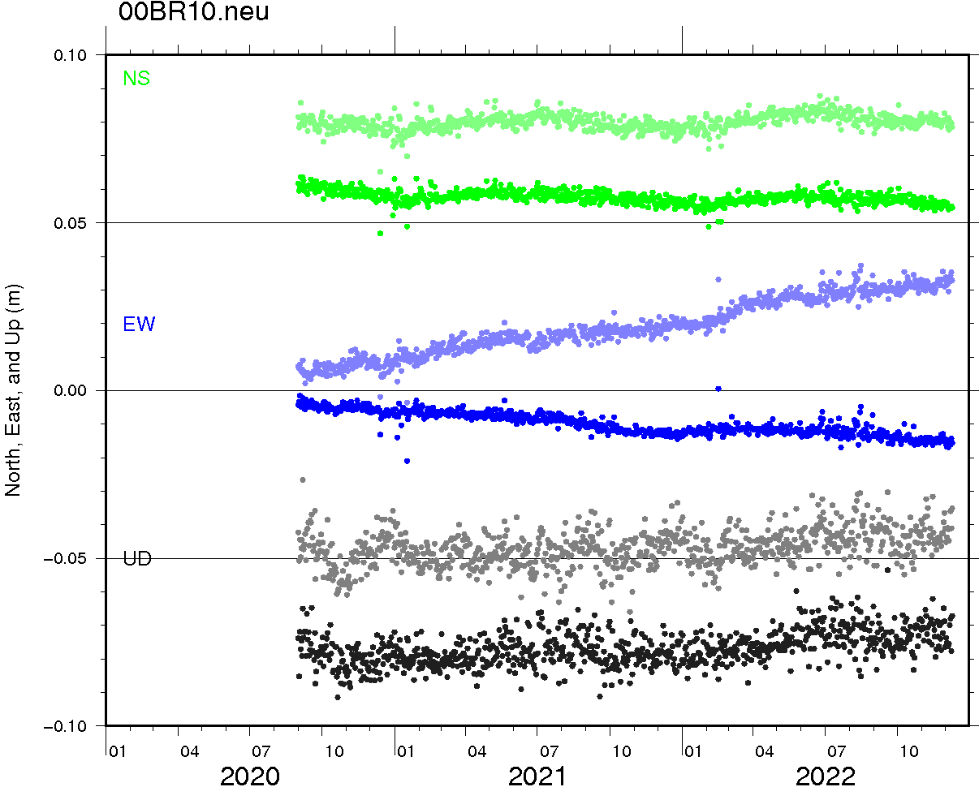
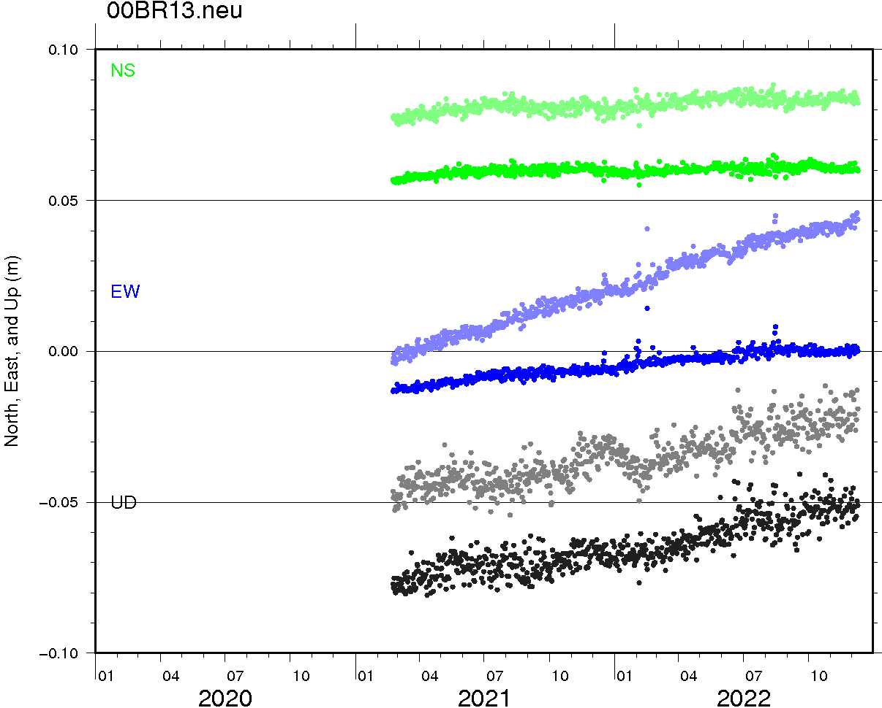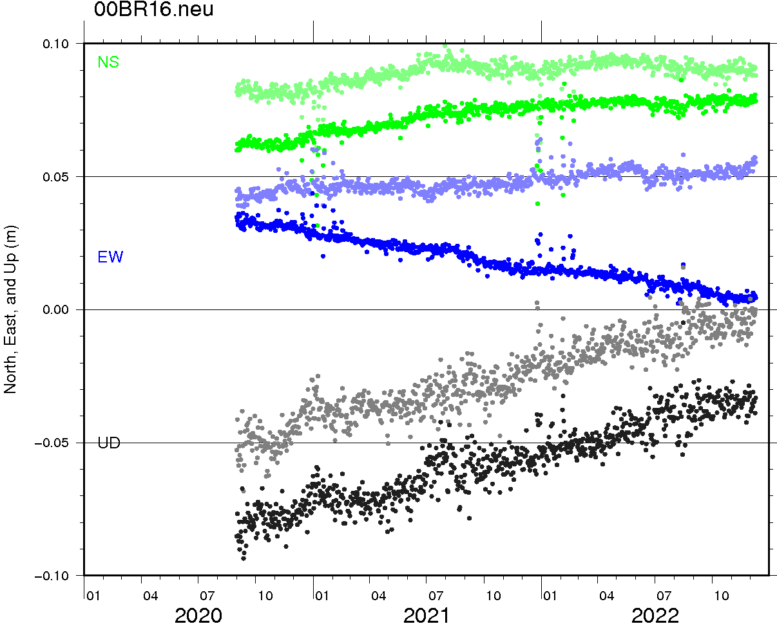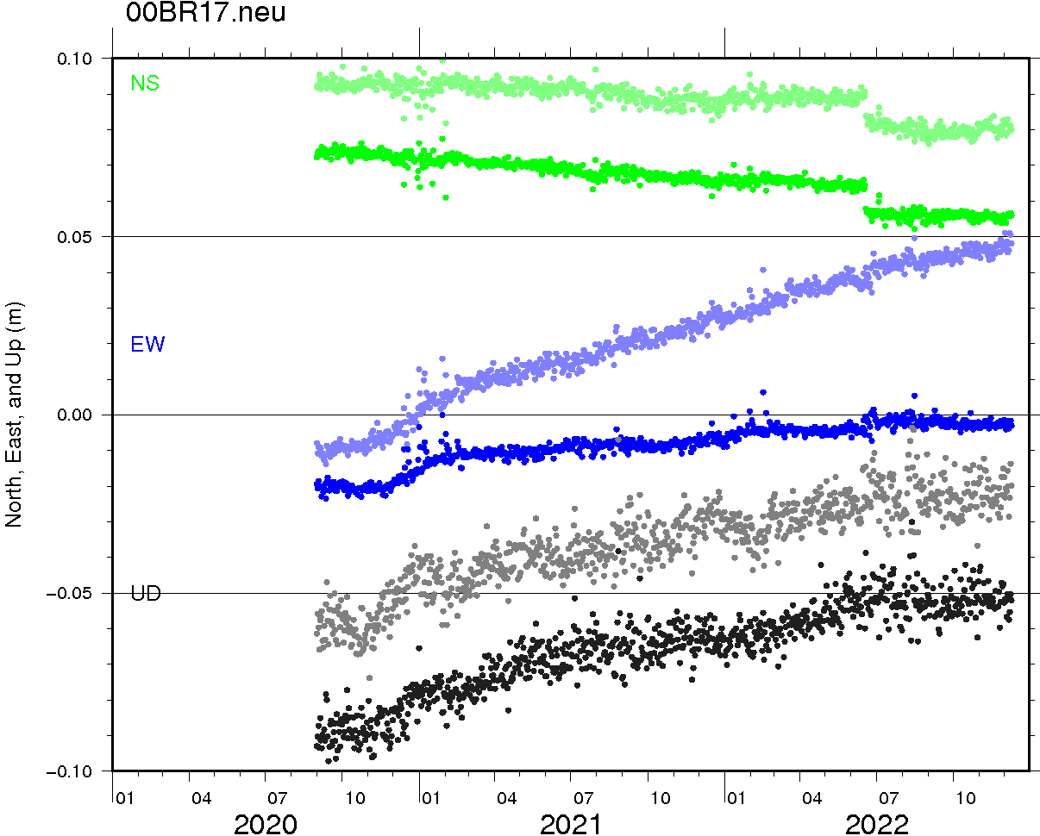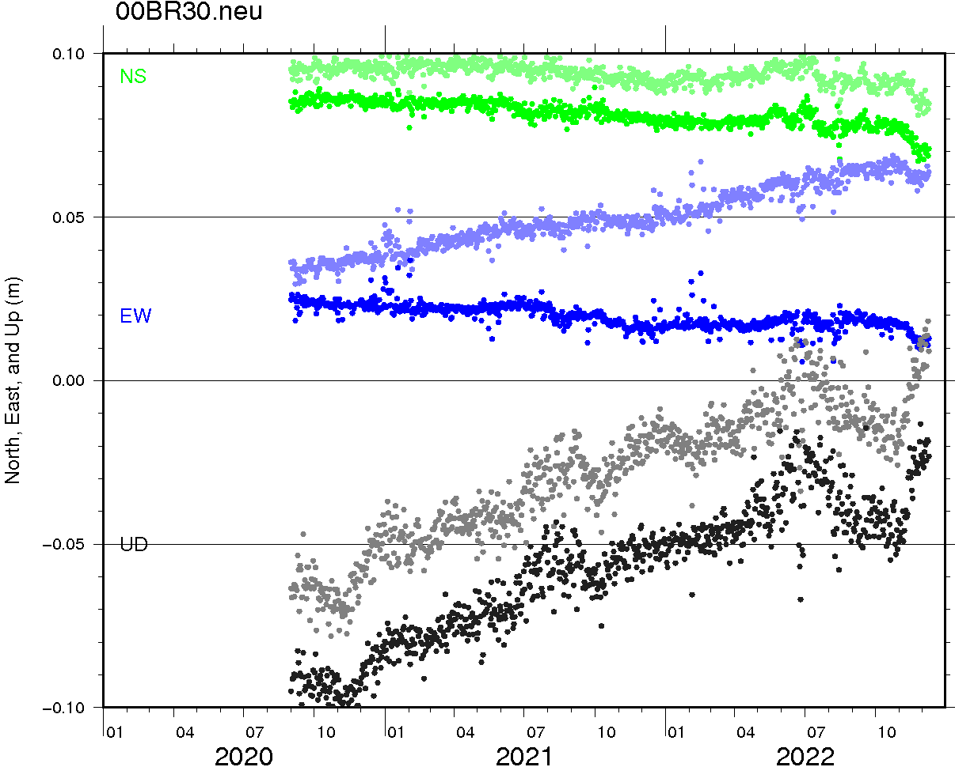
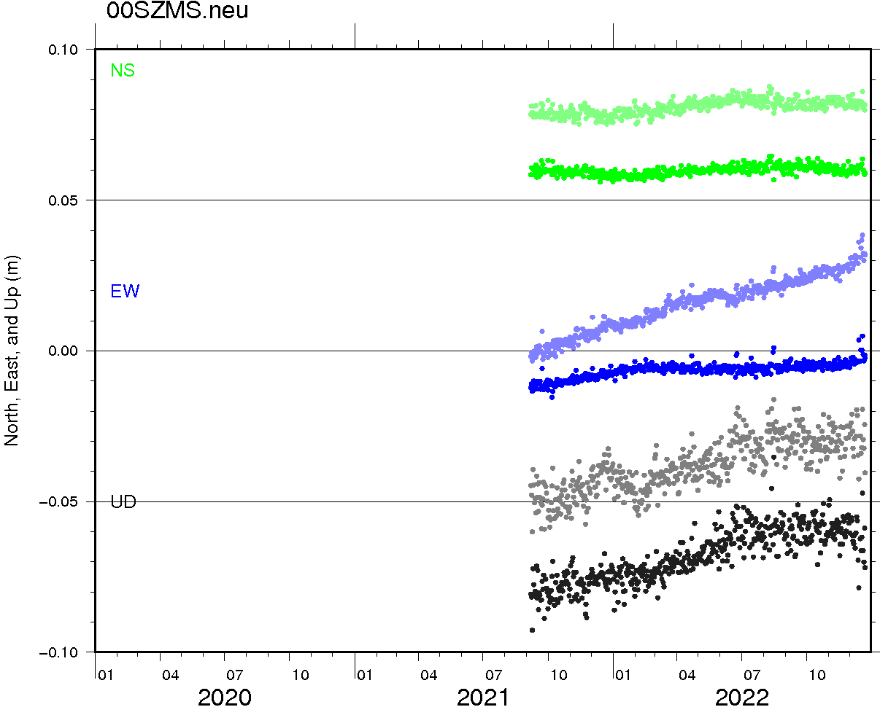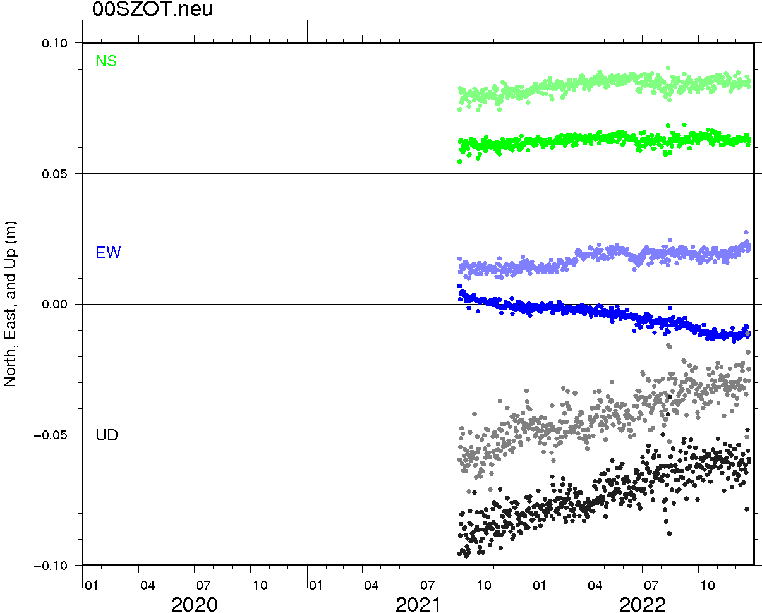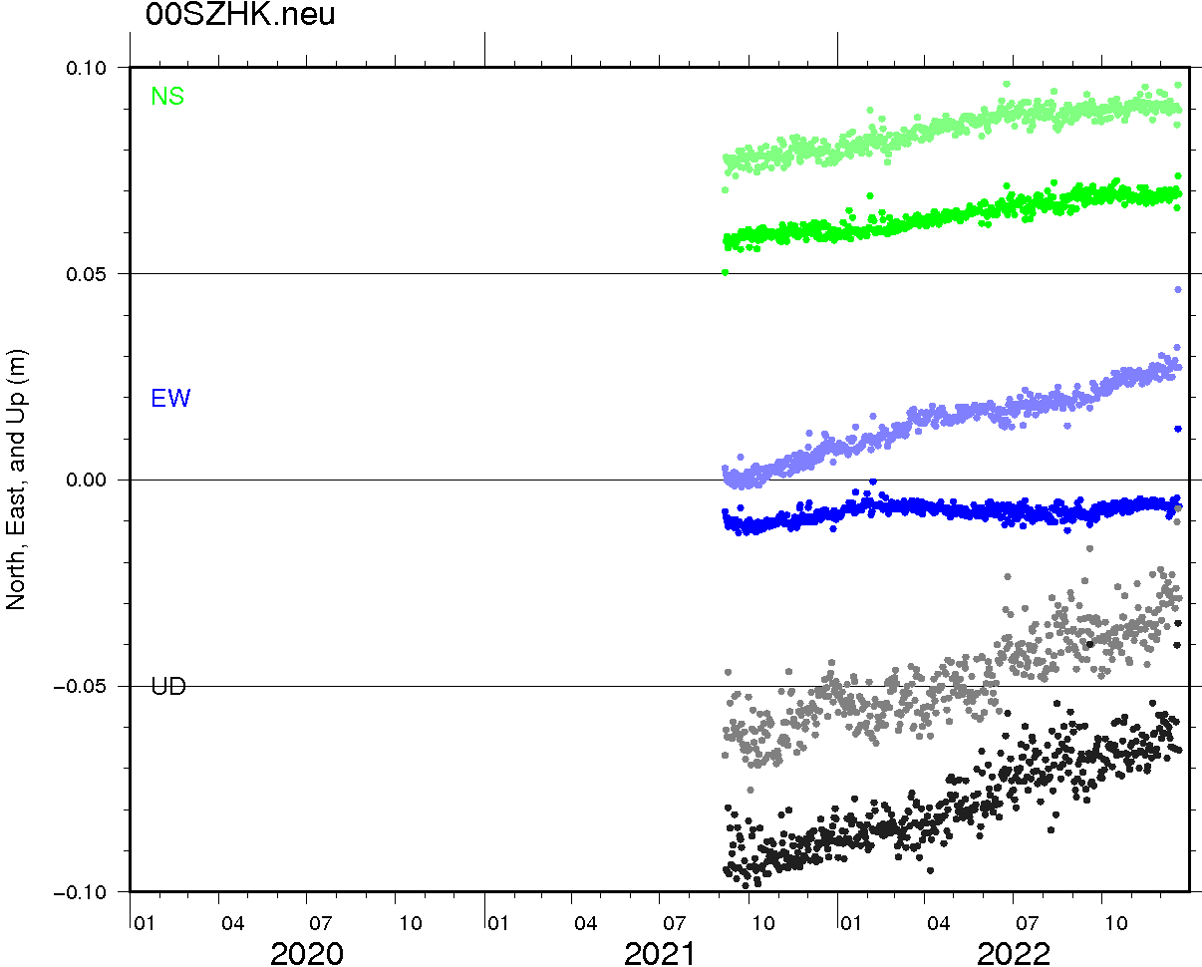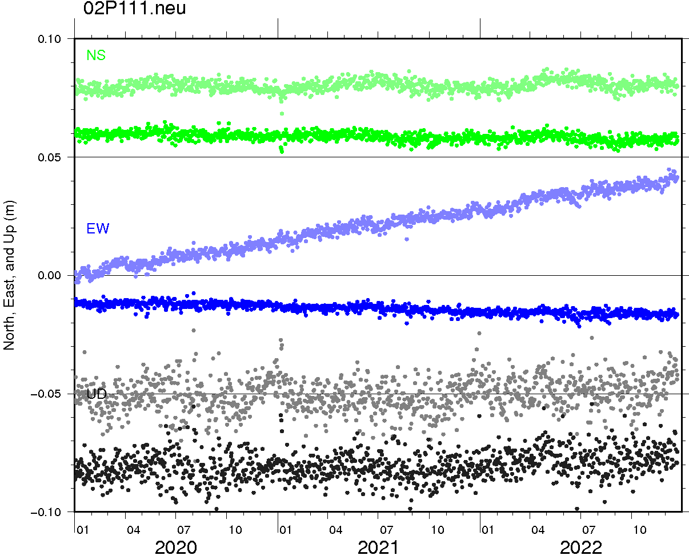
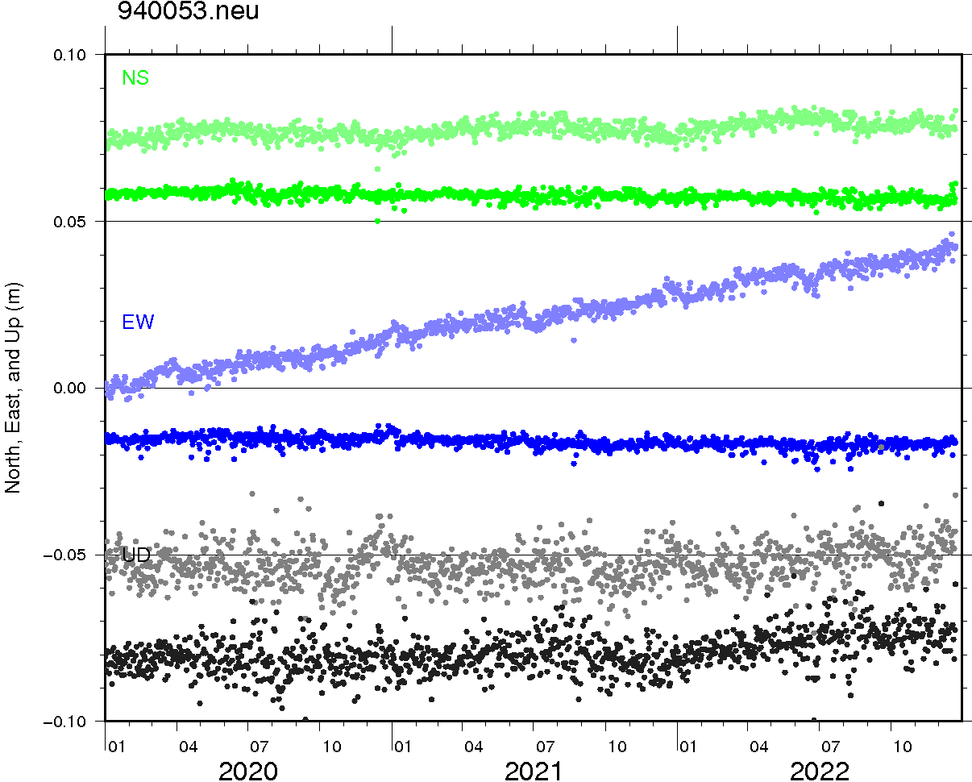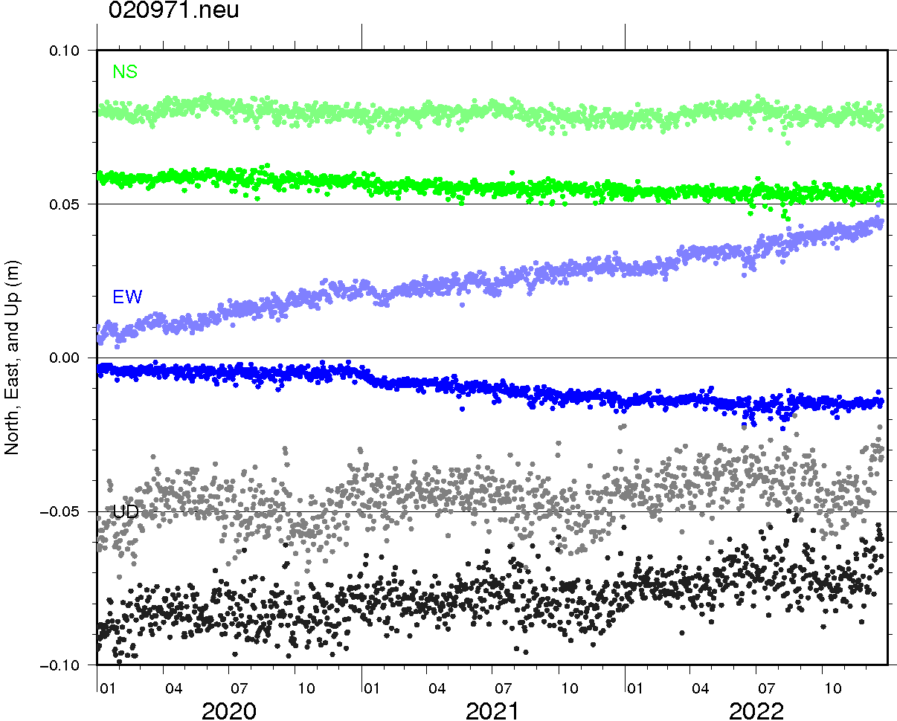
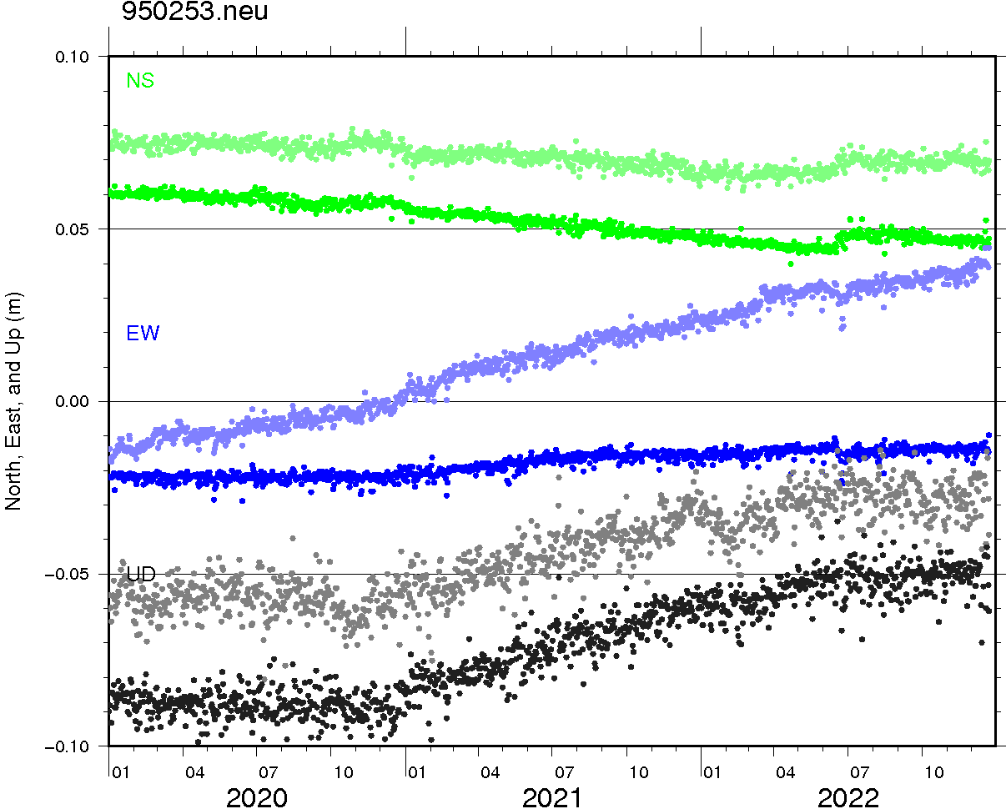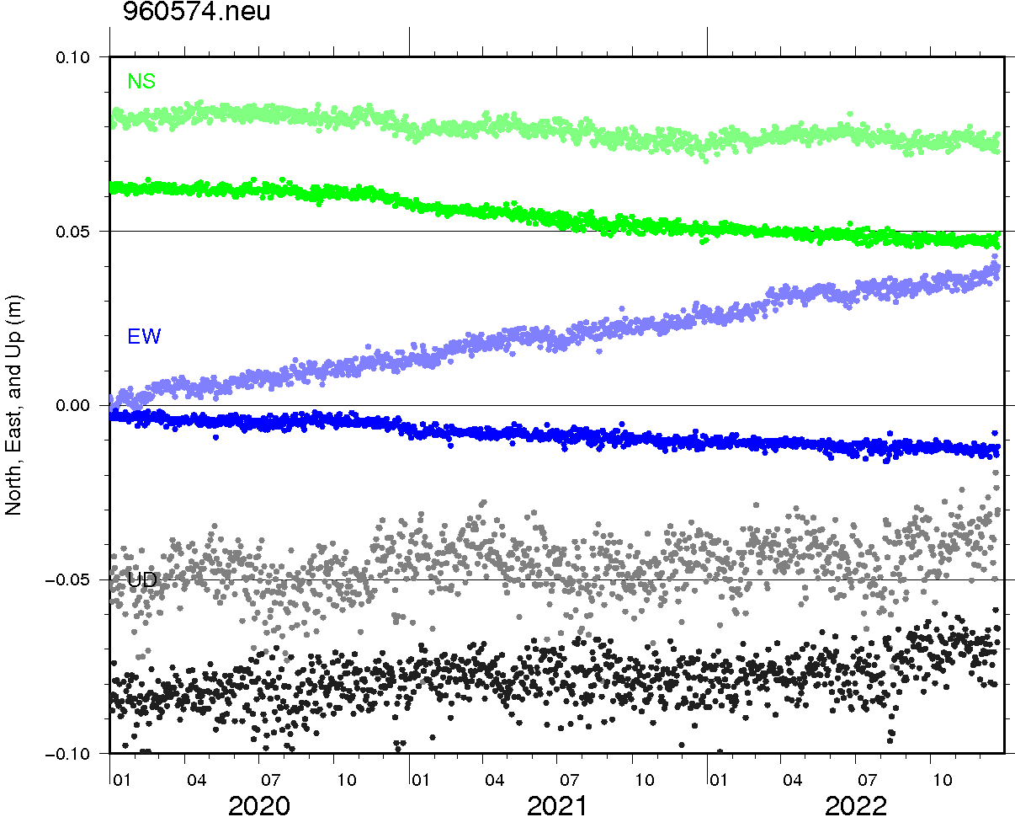
Fig. S4 Observed and pre-processed time-series of GNSS daily positions. Thin and thick dots show the original AM-referenced and pre-processed daily positions of each component.
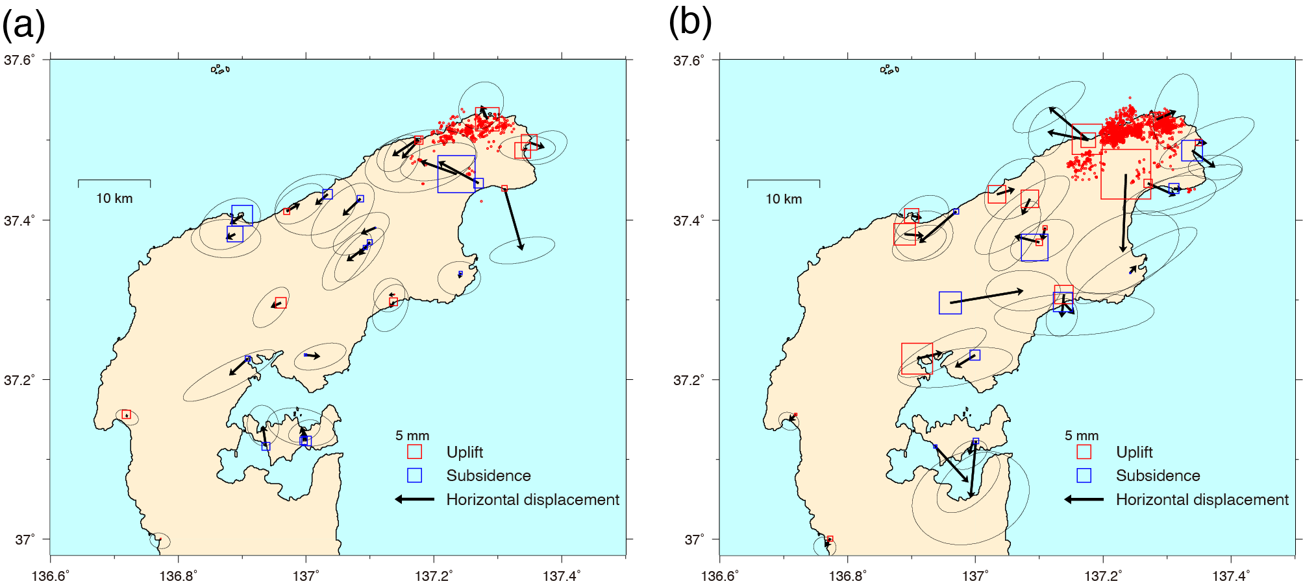Fig. S5 Displacement during and after the M5.4 earthquake on June 19, 2022. (a) Displacement from June 9-18 to June 21-30, 2022. Red dots show relocated epicenters of M≥1.2 earthquakes from June 9 to June 30, 2022. (b) Displacement from June 21-30 to December 22-31, 2022. Red dots show relocated epicenters of M≥1.2 earthquakes from June 21 to November 30, 2022.

(a)
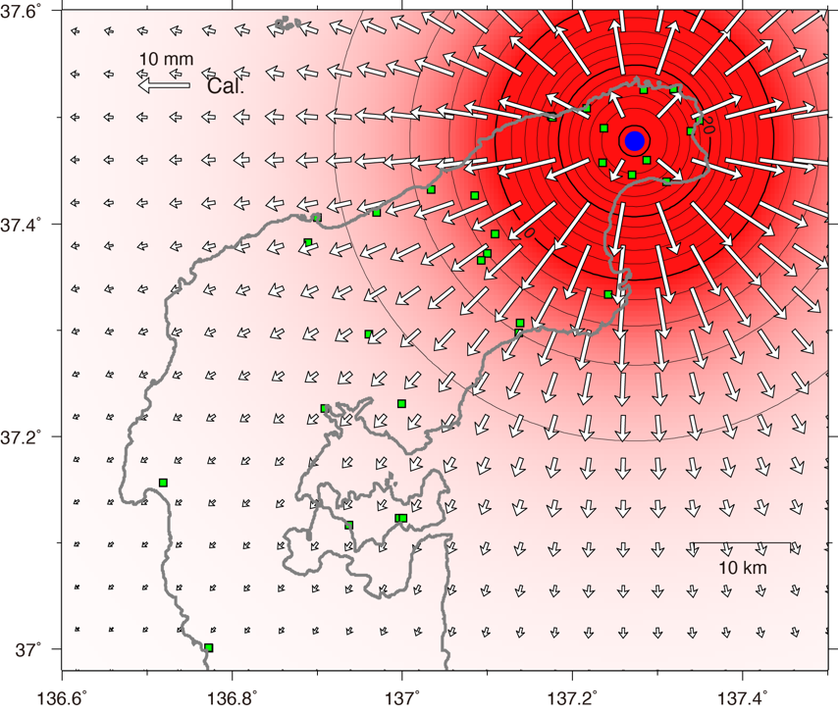

(b)
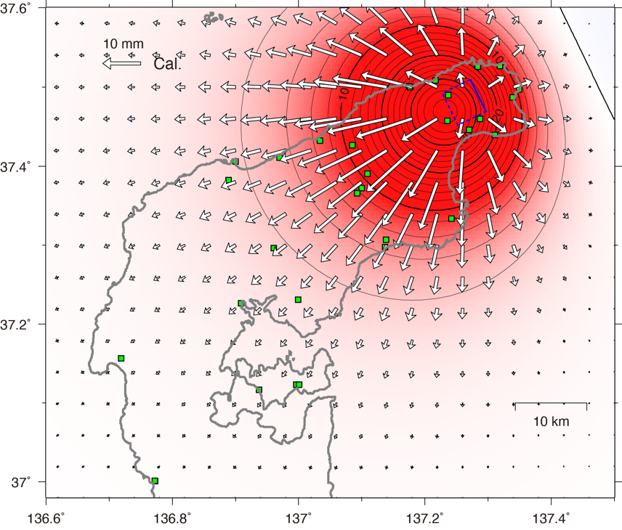

(c)
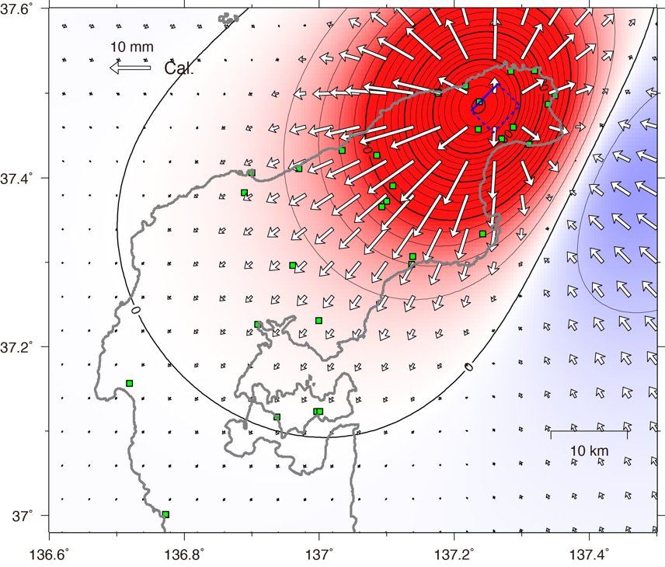
Fig. S6 Displacement predicted by a point inflation source (a), opening of a sub-horizontal crack (b), and a reverse fault slip (c). These models roughly reproduce the displacement observed from February 2021 to February 2022. Green squares indicate GNSS stations. Fault parameters are shown in Table S1.

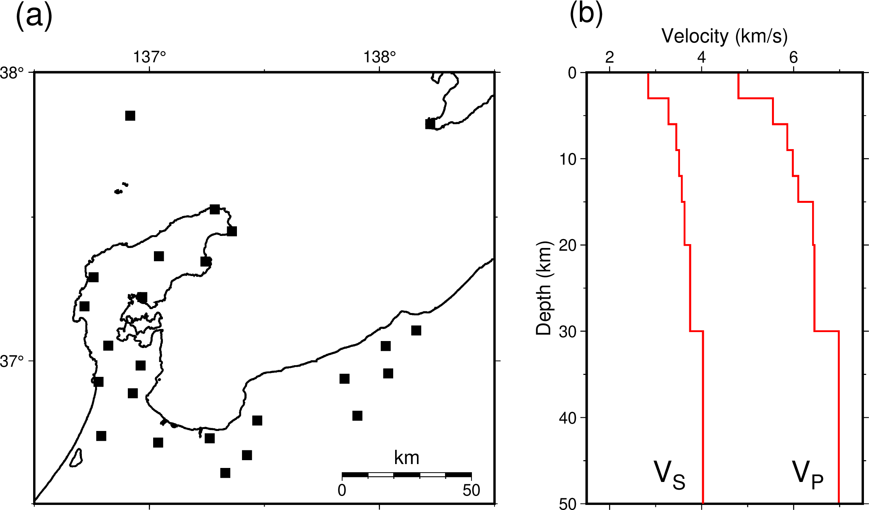Fig. S7 Seismic station distribution (a) and velocity structure (b) used in this study.

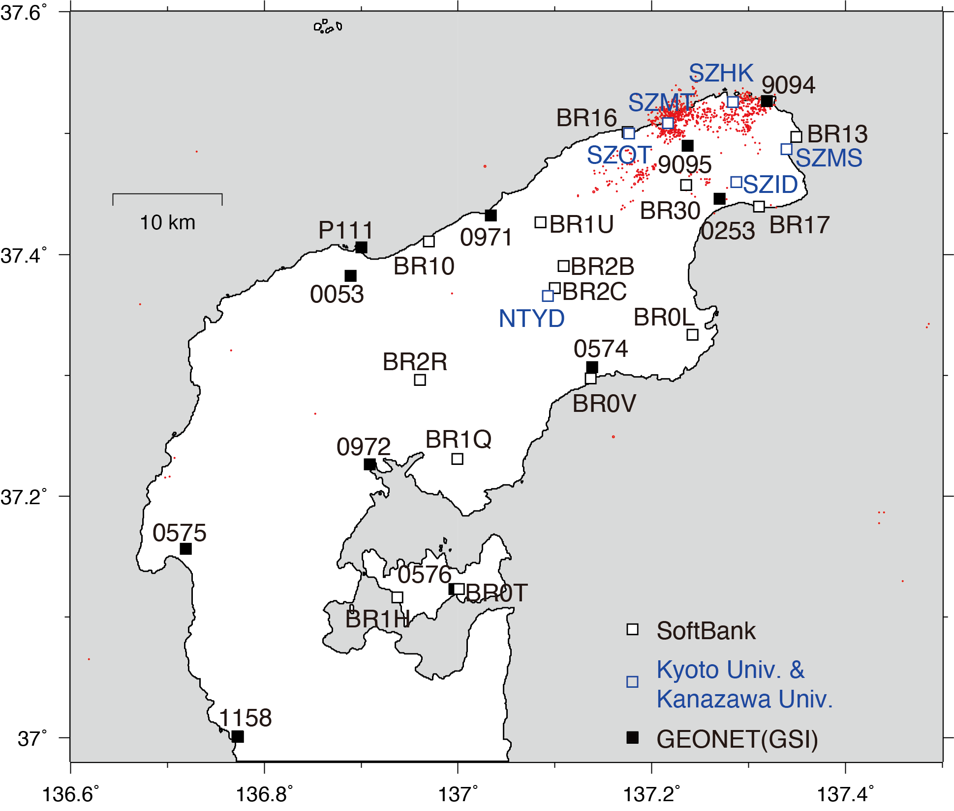
Fig. S8 Distribution of GNSS stations used in this study. Four-digit codes indicate GNSS station ID. Red dots show epicenters of M≥2 earthquakes with a depth of ≤20 km from November 2020 to December 2022.

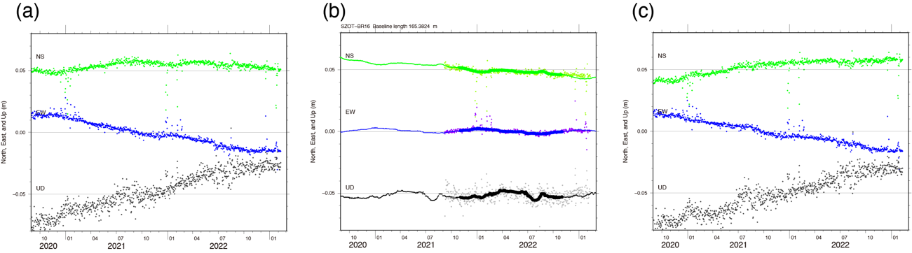
Fig. S9 Time-series of BR16 before and after a site-specific correction. (a) Pre-processed time-series of BR16 before the correction. (b) Time-series of relative coordinates between BR16 and SZOT. Dots are daily relative coordinates. Thick lines represent 14-day moving median of daily relative coordinates from November 1, 2021 to October 31, 2022. Thin lines represent presumed local site-specific movements of BR16. (c) Corrected time-series of BR16.

Table S1 Parameters for deformation sources in Fig. S4.
 | Longitude  (º) | Latitude  (º) | Depth  (km) | Length  (km) | Width  (km) | Strike  (º) | Dip  (º) | Rake  (º) | Slip  (m) | Open  (m) | ΔV  (x10⁷m³)
Point inflation | 137.273 | 37.478 | 13.8 |  |  |  |  |  |  |  | 2.42
Opening crack | 137.272 | 37.509 | 13.6 | 5.0 | 5.0 | 154 | 29 |  |  | 0.84 | 2.11
Reverse fault | 137.225 | 37.479 | 16.3 | 5.0 | 5.0 | 45 | 36 | 105 | 2.10

Table S2 Initial parameters and their prior constraints for deformation sources in three periods.
 | Longitude  (º) | Latitude  (º) | Depth  (km) | Length  (km) | Width  (km) | Strike  (º) | Dip  (º) | Rake  (º) | Slip  (m) | Open  (m)
Period A | 137.250  ±9.9 | 37.470  ±9.9 | 16.0  ±3.0 | 3.0  ±5.0 | 3.0  ±5.0 | 50  ±99 | 0  ±99 |  |  | 0.00  ±99.9
Period B | 137.230  ±9.9 | 37.450  ±9.9 | 13.0  ±3.0 | 5.0  ±5.0 | 5.0  ±5.0 | 40  ±10 | 40  ±10 | 80  ±99 | 0.00  ±99.9 | 0.00  ±99.9
Period C | 137.200  ±9.9 | 37.480  ±9.9 | 13.0  ±3.0 | 5.0  ±5.0 | 5.0  ±5.0 | 50  ±10 | 40  ±10 | 120  ±99 | 0.00  ±99.9 | 0.00  ±99.9

