Table 1. Various alternatives for the current study
Scenario | Arrangement | Schematic
1st | Six 300 kW | 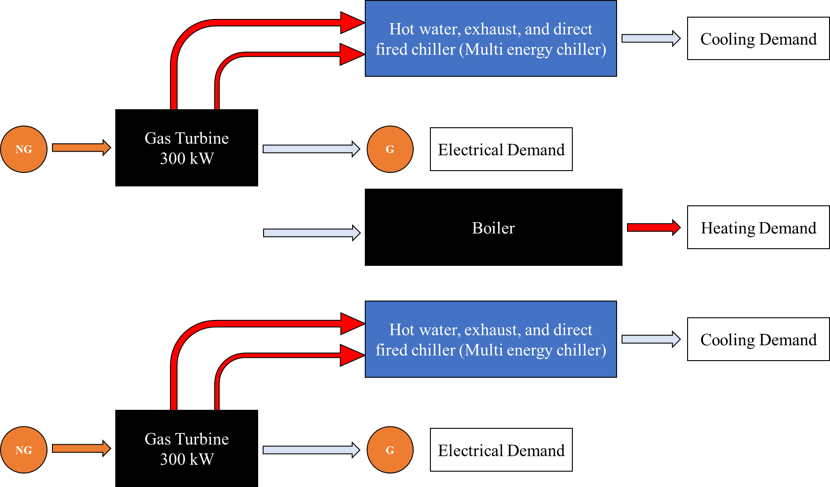
2nd | Six 200 kW | 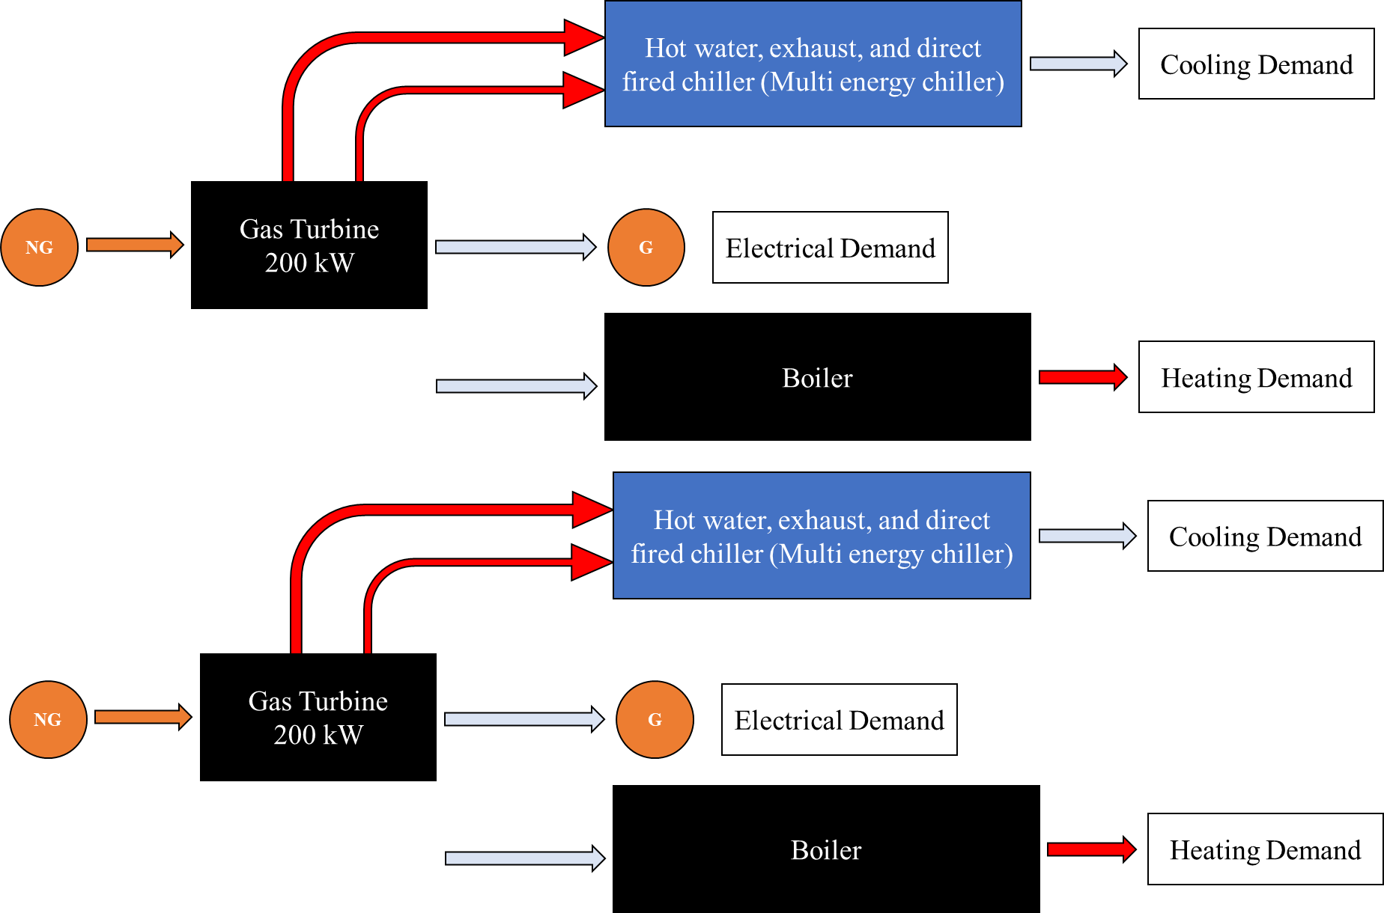
3rd | Nine 150 kW | 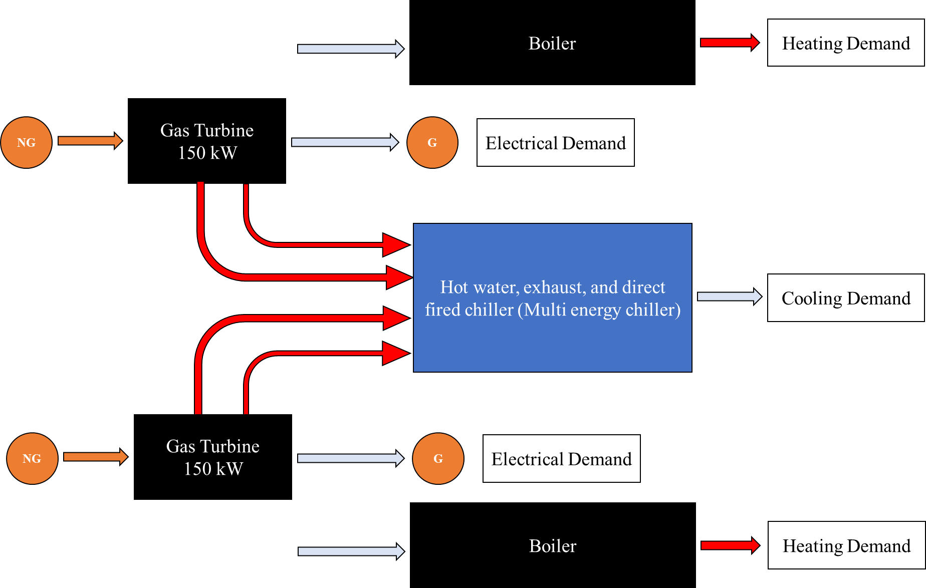
4th | Three 300 kW | 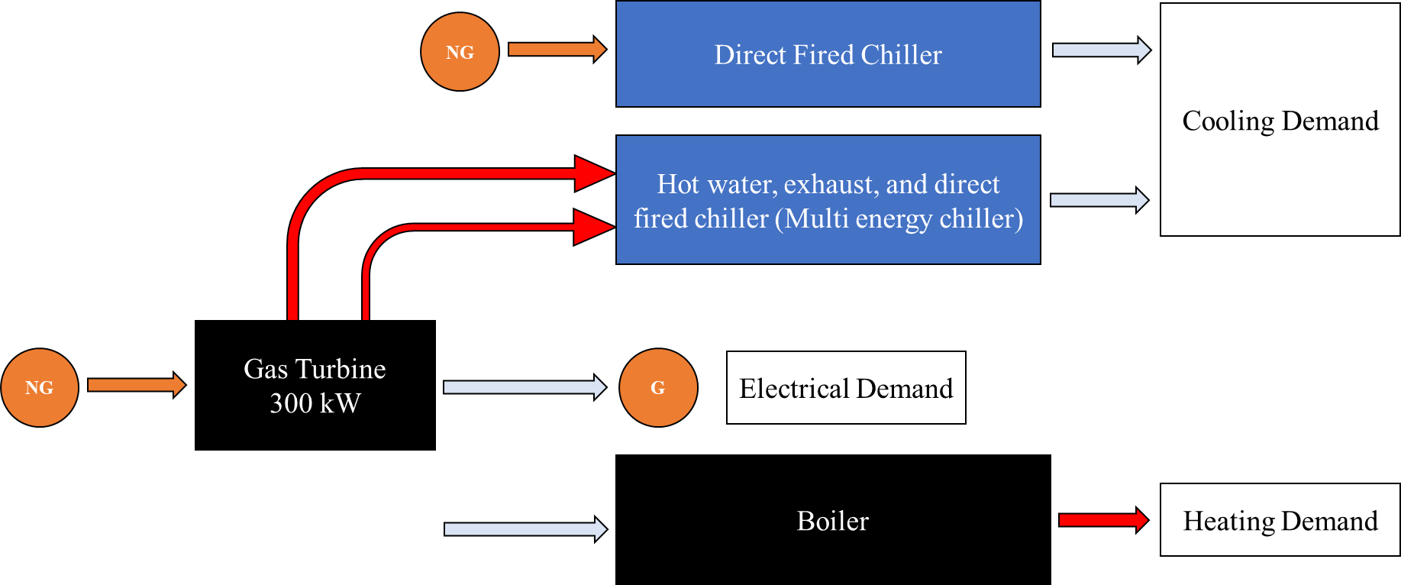
5th | Six 150 kW | 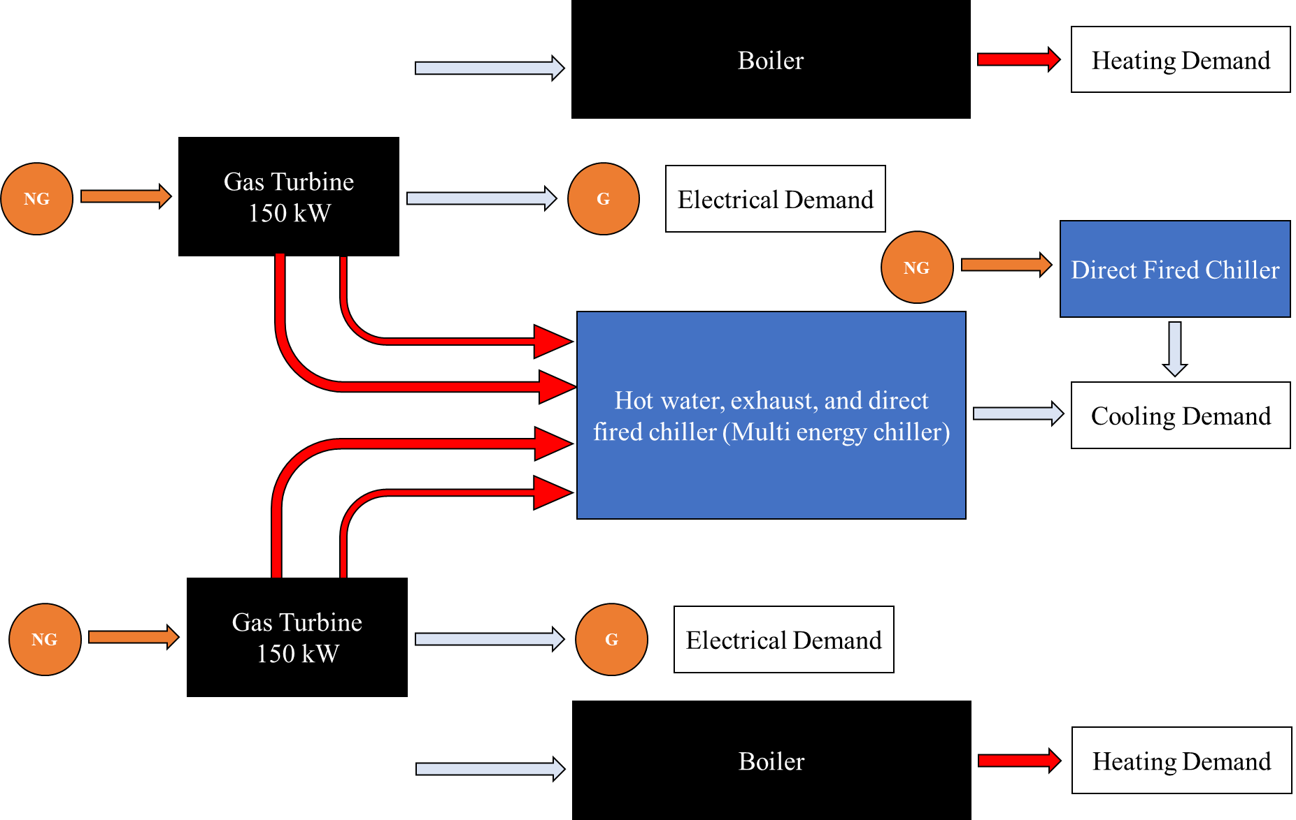
6th | Four 300 kW
7th | Three 200 kW | 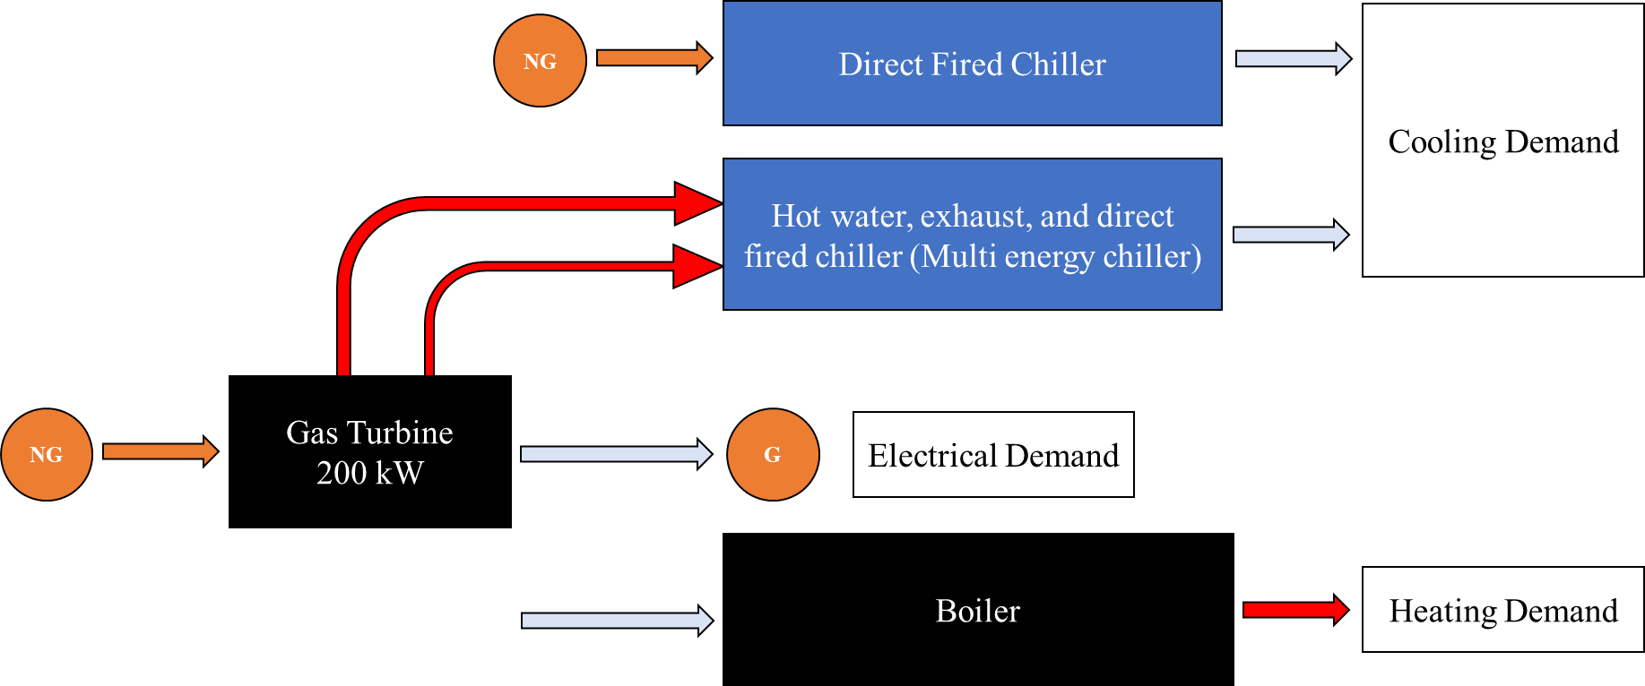
8th | Four 150 kW | 