Supplementary material

Table S.1 Arctic charr (Salvelinus alpinus) family structure, number, and male ID with the natural and delayed spawning.
Family no. | Dam ID | Sire ID | Male ID
Family no. | Dam ID | Sire ID | Natural spawning | Delayed spawning
1 | D1 | S9 | - | 44
2 | D2 | S37 | - | 33, 66
3 | D3 | S23 | 29, 33, 35, 36 | -
4 | D4 | S21 | 25, 39 | 30, 51
5 | D5 | S7 | 7 | 14, 25
6 | D6 | S17 | 20, 27 | -
7 | D7 | S36 | - | 27
8 | D8 | S33 | 59 | 59
9 | D9 | S29 | 42 | 17
10 | D10 | S25 | 32 | 26, 35, 37
11 | D11 | S39 | - | 64
12 | D12 | S2 | 28 | 32, 60
13 | D13 | S4 | - | 34
14 | D14 | S15 | 40, 49 | 19, 22, 39, 57
15 | D15 | S8 | 8, 9 | 5, 20, 65
16 | D16 | S27 | 43 | 15
17 | D17 | S12 | - | 16, 72
18 | D18 | S6 | 6 | -
19 | D19 | S33 | 55 | 49
20 | D20 | S34 | 62 | 54
21 | D21 | S30 | 45 | 9, 28, 46
22 | D22 | S9 | 10 | -
23 | D23 | S2 | 2 | 47
24 | D24 | S10 | 11 | 8, 29
25 | D25 | S35 | - | 23, 43, 62
26 | D26 | S27 | 38 | 18, 56
27 | D27 | S14 | 37 | 71, 73
28 | D28 | S1 | 1 | 3
29 | D29 | S19 | 23, 64 | -
30 | D30 | S38 | - | 63, 68
31 | D31 | S5 | 5, 14 | -
32 | D32 | S21 | 31, 48 | 58
33 | D33 | S12 | 13 | 1, 10, 11, 24, 40, 55, 61
34 | D34 | S32 | 50 | -
35 | D35 | S11 | 12, 21, 51 | 4
36 | D36 | S31 | 46, 58 | 38
37 | D37 | S13 | 15 | 7, 48
38 | D38 | S26 | 34, 57 | 42
39 | D39 | S32 | 56, 63 | 70
40 | D40 | S18 | 22, 66 | -
41 | D41 | S24 | 53 | 31, 69
42 | D42 | S20 | 24 | 36
43 | D43 | S15 | 18 | 53
44 | D44 | S19 | 65 | 52
45 | D45 | S3 | 3, 16 | -
46 | D46 | S28 | 41 | 2
47 | D47 | S14 | 17 | 6, 13
48 | D48 | S8 | 47 | 12
49 | D49 | S22 | 26 | 41, 50
50 | D50 | S16 | 19, 54, 61 | 21
51 | D51 | S22 | - | 67
52 | D52 | S4 | 4, 44 | -
53 | D53 | S24 | 30, 52, 60 | 45

Table S.2 Mean total progressive motility (PM, %) and standard deviations (SD) measured across the spawning period in individual Arctic charr (Salvelinus alpinus) males with the natural and delayed spawning in two consecutive spawning seasons.
Sampling 2021 |  |  |  |  |  | Sampling 2022
Natural spawning |  |  | Delayed spawning |  |  | Natural spawning
Male ID | Mean PM | SD | Male ID | Mean PM | SD | Male ID | Mean PM | SD
1 | 33 | 26 | 1 | 0 | 0 | 1 | 0 | 0
2 | 40 | 12 | 2 | 10 | 11 | 2 | 8 | 14
3 | 50 | 44 | 3 | 24 | 21 | 3 | 17 | 19
4 | 52 | 47 | 4 | 26 | 37 | 4 | 31 | 47
5 | 53 | 48 | 5 | 27 | 48 | 5 | 32 | 38
6 | 55 | 49 | 6 | 28 | 48 | 6 | 32 | 25
7 | 56 | 51 | 7 | 29 | 36 | 7 | 33 | 34
8 | 59 | 32 | 8 | 29 | 50 | 8 | 35 | 18
9 | 60 | 44 | 9 | 30 | 52 | 9 | 37 | 48
10 | 61 | 47 | 10 | 34 | 48 | 10 | 41 | 32
11 | 61 | 53 | 11 | 35 | 51 | 11 | 44 | 48
12 | 62 | 49 | 12 | 39 | 50 | 12 | 45 | 63
13 | 62 | 53 | 13 | 41 | 33 | 13 | 45 | 39
14 | 63 | 55 | 14 | 41 | 35 | 14 | 47 | 33
15 | 66 | 42 | 15 | 46 | 65 | 15 | 48 | 27
16 | 66 | 31 | 16 | 47 | 43 | 16 | 48 | 68
17 | 68 | 30 | 17 | 47 | 48 | 17 | 49 | 69
18 | 70 | 22 | 18 | 54 | 48 | 18 | 50 | 40
19 | 70 | 40 | 19 | 54 | 14 | 19 | 51 | 64
20 | 73 | 16 | 20 | 58 | 55 | 20 | 52 | 46
21 | 77 | 24 | 21 | 58 | 25 | 21 | 52 | 39
22 | 78 | 17 | 22 | 59 | 51 | 22 | 54 | 46
23 | 79 | 9 | 23 | 59 | 52 | 23 | 55 | 47
24 | 80 | 17 | 24 | 63 | 55 | 24 | 56 | 37
25 | 80 | 15 | 25 | 64 | 56 | 25 | 56 | 52
26 | 80 | 3 | 26 | 64 | 48 | 26 | 57 | 48
27 | 81 | 21 | 27 | 64 | 56 | 27 | 57 | 48
28 | 81 | 15 | 28 | 65 | 44 | 28 | 59 | 50
29 | 81 | 13 | 29 | 67 | 9 | 29 | 62 | 51
30 | 81 | 6 | 30 | 68 | 40 | 30 | 64 | 23
31 | 82 | 5 | 31 | 70 | 41 | 31 | 66 | 46
32 | 83 | 13 | 32 | 71 | 28 | 32 | 68 | 49
33 | 85 | 9 | 33 | 73 | 36 | 33 | 69 | 20
34 | 85 | 7 | 34 | 76 | 27 | 34 | 69 | 33
35 | 85 | 8 | 35 | 79 | 20 | 35 | 71 | 25
36 | 85 | 13 | 36 | 79 | 5 | 36 | 72 | 30
37 | 86 | 9 | 37 | 81 | 23 | 37 | 76 | 25
38 | 86 | 16 | 38 | 85 | 7 | 38 | 80 | 24
39 | 86 | 8 | 39 | 85 | 20 | 39 | 80 | 14
40 | 87 | 3 | 40 | 85 | 18 | 40 | 81 | 10
41 | 87 | 8 | 41 | 88 | 10 | 41 | 84 | 12
42 | 87 | 8 | 42 | 88 | 12 | 42 | 86 | 8
43 | 88 | 12 | 43 | 89 | 6 | 43 | 86 | 1
44 | 88 | 3 | 44 | 89 | 11 | 44 | 87 | 4
45 | 88 | 10 | 45 | 90 | 11 | 45 | 88 | 6
46 | 89 | 4 | 46 | 90 | 10 | 46 | 89 | 9
47 | 90 | 15 | 47 | 91 | 14 | 47 | 90 | 2
48 | 90 | 4 | 48 | 91 | 3 | 48 | 92 | 7
49 | 91 | 3 | 49 | 91 | 4 | 49 | 92 | 6
50 | 91 | 7 | 50 | 91 | 3 | 50 | 93 | 4
51 | 92 | 2 | 51 | 93 | 1 | 51 | 94 | 6
52 | 92 | 8 | 52 | 93 | 5 | 52 | 94 | 3
53 | 92 | 4 | 53 | 93 | 4 | 53 | 94 | 1
54 | 92 | 8 | 54 | 93 | 2 | 54 | 95 | 2
55 | 92 | 7 | 55 | 94 | 3 | 55 | 95 | 4
56 | 92 | 6 | 56 | 94 | 4 | 56 | 96 | 3
57 | 93 | 7 | 57 | 94 | 2 | 57 | 96 | 2
58 | 93 | 0 | 58 | 94 | 3 | 58 | 96 | 3
59 | 94 | 4 | 59 | 95 | 5 | 59 | 96 | 1
60 | 95 | 2 | 60 | 95 | 2 | 60 | 97 | 1
61 | 96 | 1 | 61 | 95 | 6 | 61 | 98 | 0
62 | 96 | 3 | 62 | 95 | 3 | - | - | -
63 | 97 | 2 | 63 | 95 | 5 | - | - | -
64 | 97 | 2 | 64 | 95 | 1 | - | - | -
65 | 97 | 3 | 65 | 95 | 7 | - | - | -
66 | 98 | 1 | 66 | 95 | 3 | - | - | -
- | - | - | 67 | 96 | 3 | - | - | -
- | - | - | 68 | 96 | 3 | - | - | -
- | - | - | 69 | 97 | 1 | - | - | -
- | - | - | 70 | 97 | 2 | - | - | -
- | - | - | 71 | 97 | 1 | - | - | -
- | - | - | 72 | 97 | 2 | - | - | -
- | - | - | 73 | 98 | 1 | - | - | -

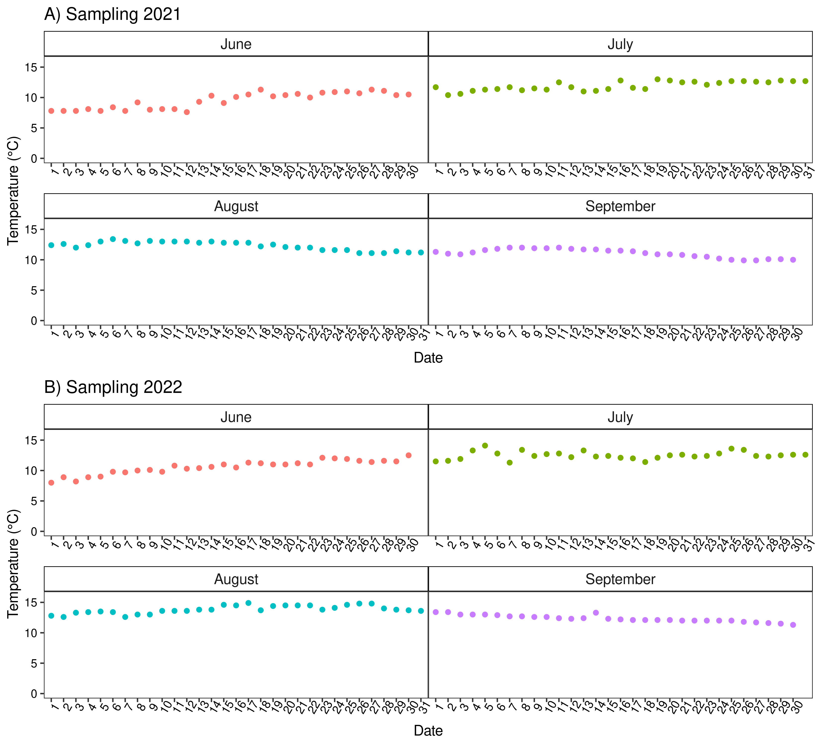
Figure S.1 Temperature regime during summer before the spawning season of farmed Arctic charr (Salvelinus alpinus) at sampling in 2021 (A) and 2022 (B).

