Supplementary Information
Organic electronics circuitry for in situ real-time processing of electrophysiological signals
Anna De Salvo (1,2), Federico Rondelli (1,2), Michele Di Lauro(2)*, Alice Tomassini (2), Pierpaolo Greco (1), Thomas Stieglitz (4), Luciano Fadiga(1,2) and Fabio Biscarini (2,3)
1) Sezione di Fisiologia, Dipartimento di Neuroscienze e Riabilitazione, Università di Ferrara, Via Fossato di Mortara 17-19, Ferrara Italy.
2) Center for Translational Neurophysiology of Speech and Communication, Fondazione Istituto Italiano di Tecnologia (IIT-CTNSC), Via Fossato di Mortara 17/19, Ferrara Italy.
3) Dipartimento di Scienze della Vita, Università di Modena e Reggio Emilia, Via Campi 103, Modena, 41125 Italy.
4) Department of Microsystems Engineering (IMTEK) and BrainLinks-BrainTools Center, IMBIT, Georges-Koehler-Allee 201, University of Freiburg, 79110 Freiburg, Germany
Correspondence should be addressed to : michele.dilauro@iit.it

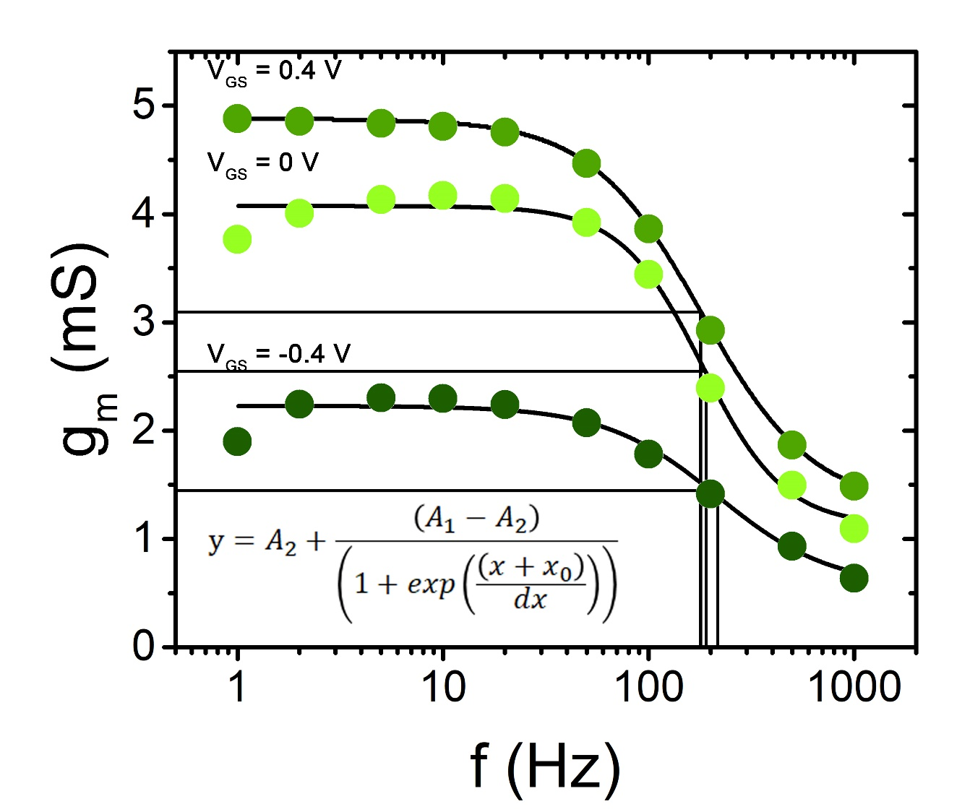
Supplementary Figure 1. Transconductance versus frequency. The bandwidth profiles are fitted with a curve fit model equation reported on the bottom of the graph. X₀ is used to evaluate the cut-off frequency. For V_{GS}= -0.4 V the cut-off frequency is 182 Hz, for V_{GS}= 0 V the cut-off frequency is 183 Hz and for V_{GS} = 0.4V the cut-off frequency is equal to218 Hz.

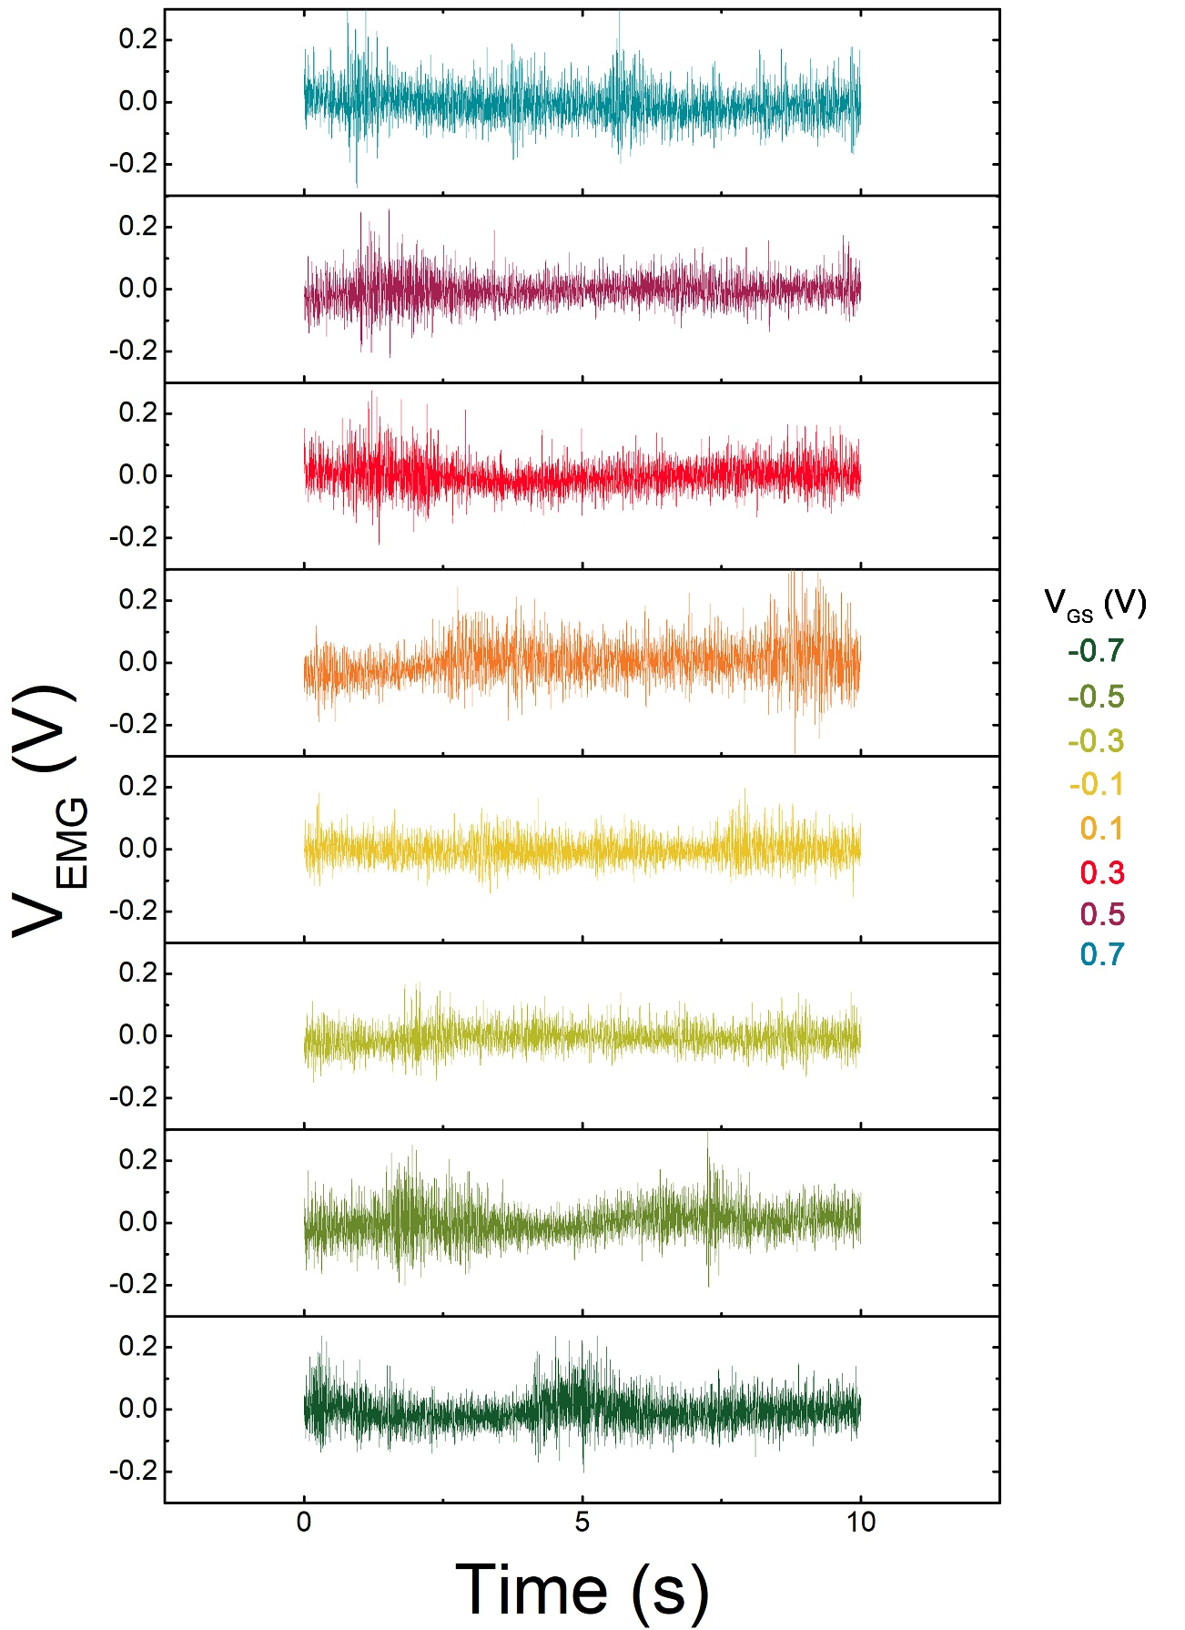
Supplementary Figure 2. Exemplary V_{EMG} vs time traces acquired upon isometric muscular contraction. As expected, no significant variation of V_{EGM} is excerpted by V_{GS} variation.

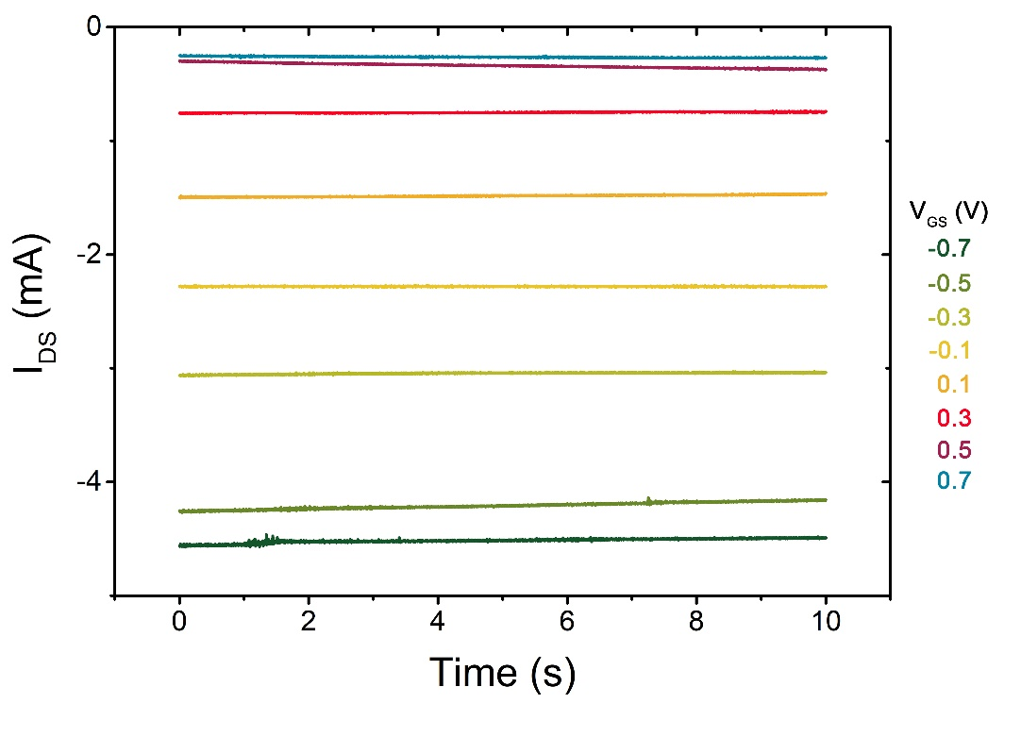
Supplementary Figure 3. Exemplary I_{DS} versus time traces acquired for each applied V_{GS.}
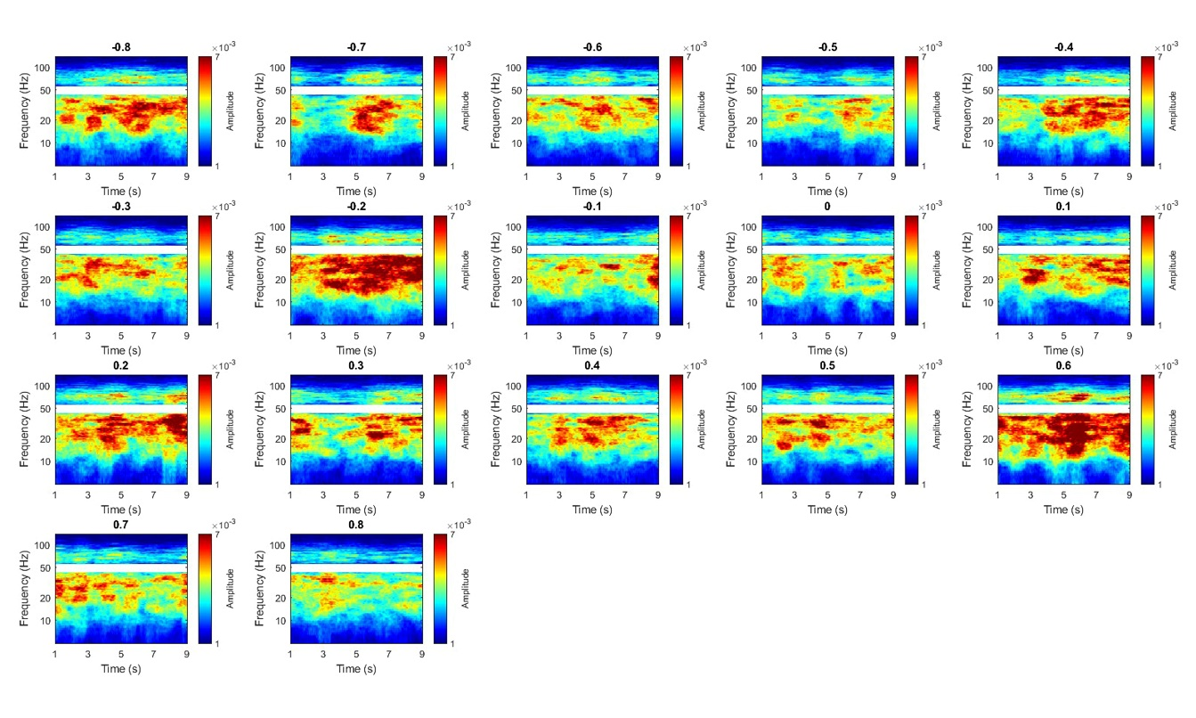
Supplementary Figure 4. Spectral amplitude of V_{EMG} versus time EMG acquisition for each V_{GS} applied.
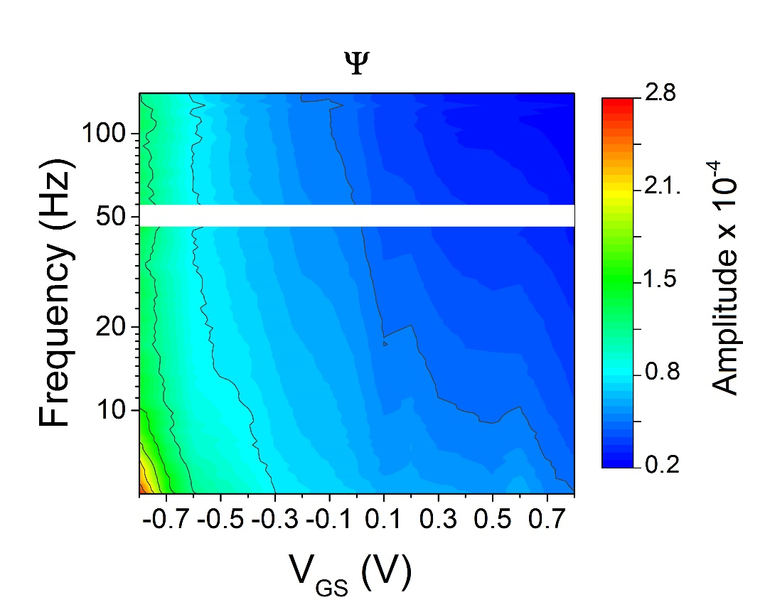
Supplementary Figure 5. Ψ evaluated as the ratio between the power of I_{DS} vs time traces and that of V_{EMG} voltage power, for each investigated frequency band and VGS value.
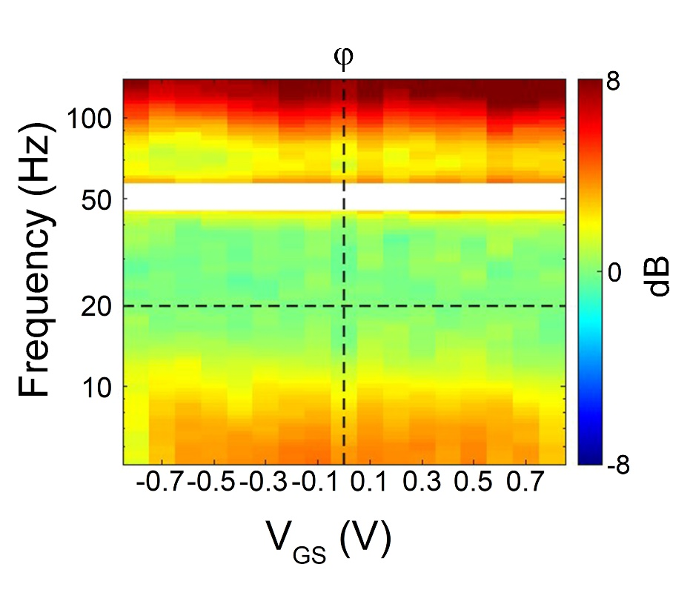
Supplementary Figure 6. ϕ current map as the ratio between the Ψ value of the 19Hz-21Hz band, Ψ ₂₀, and the Ψ value at each considered frequency band, Ψ _{fb}, and expressing this ratio in dB
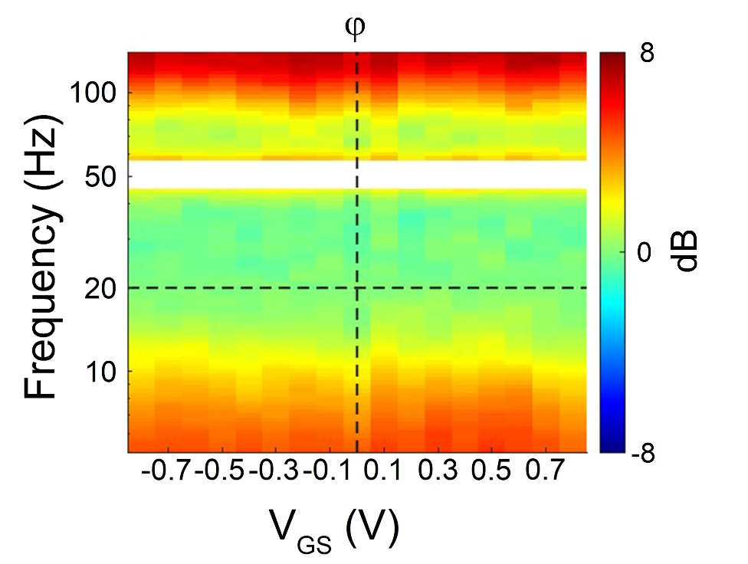
Supplementary Figure 7. ϕ voltage map as the ratio between the Ψ value of the 19Hz-21Hz band, Ψ ₂₀, and the Ψ value at each considered frequency band, Ψ _{fb}, and expressing this ratio in dB

