Supplementary information to “Continental Complementarity of Renewable Energy Mixes”

Authors:
Anders Wörman1*, Daniela Mewes¹, Ilias Pechlivanidis2, Joakim Riml¹, Cintia Bertacchi Uvo3^{,4}

Appendix 1: Time-series and map details of technical scenarios

The definition of potential power scenarios is based on historical data from Copernicus ECMWF data base and the monthly consumption pattern is based on that of the 19 EU countries between 2009 – 2022. The potential power scenarios are localized to the current locations of wind farms (Figure S1) and hydropower plants (Figure S2), whereas solar power is assumed to be uniformly distributed in the analyzed domain (Figure S2). Data used and produced in this paper and data reports are available in Zenodo using the following link: Solar, wind and hydropower data scenario.

Figure S3 shows the a historically-based power potential of 642 TWh/y of each of solar (red curve), wind (green curve) and hydropower (blue curve), aggregated over Europe and parts of the Middle East. The pink curve represents a consumption scenario with the same mean power as produced based on the historical fluctuations in electricity consumption data from 19 EU countries. The consumption data used in these analyses is shown in Figure S4.
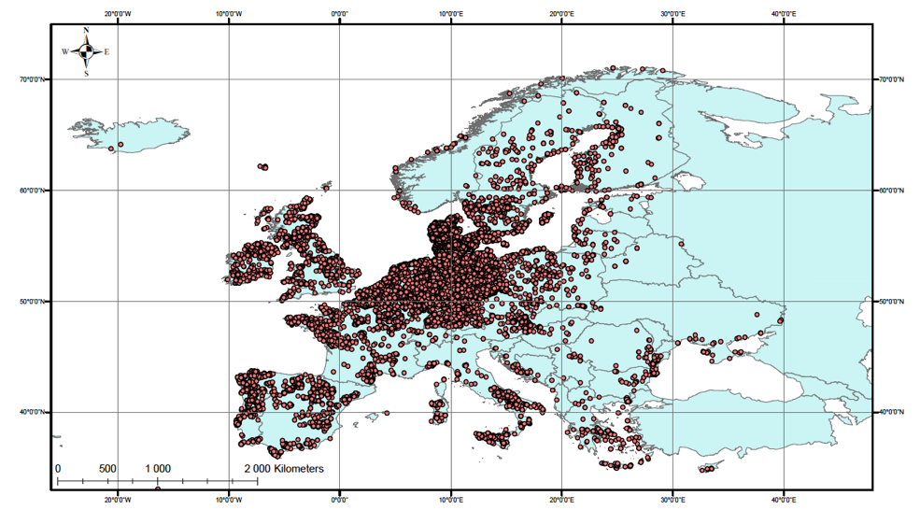
Figure S1 Locations of more than 15,000 onshore wind farms in Europe included in the World Wind Farm data base (https://www.thewindpower.net/index.php).
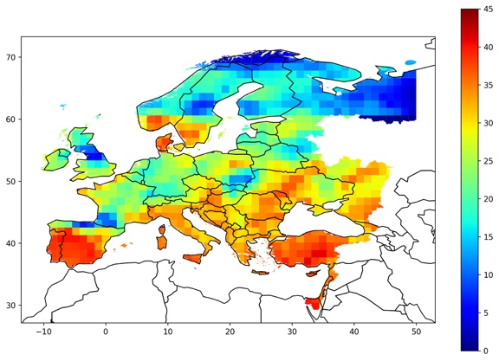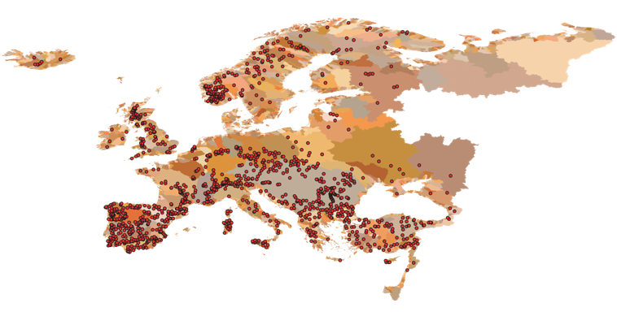
Figure S2 Area coverage for produced time-series of (a) PV solar power (left-hand side) and (b) hydropower (right-hand side). The left-hand side map (a) shows the principal distribution of potential for solar PV power in W/m² on a specific day. The “pixels” are used to average the data in 995 sub-areas in which time-series of potential PV solar power were determined based on historical data. The right-hand side map (b) shows the distribution of 1,377 hydropower stations in the GranD data base (Lehner et al., 2011) and at which the potential hydropower was also estimated from simulated water runoff and generalized to the same sub-areas as used for generalizing solar and wind power.
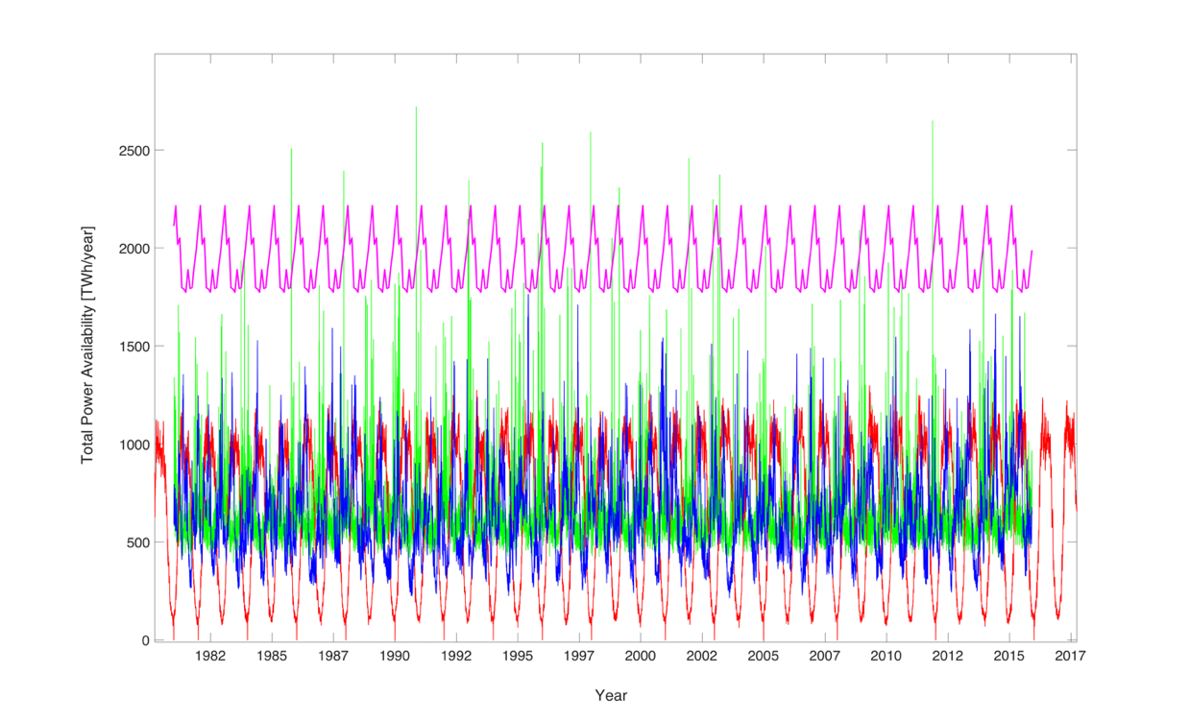

Figure S3 Daily time-series of potential power and electricity consumption for a basic scenario with equal power potential of 642 TWh/y of each of solar (red curve), wind (green curve) and hydropower (blue curve. The pink curve represents the daily consumption scenario 3 x 642 TWh/y, which has been derived from the monthly pattern in electricity consumption.

Figure S4 Monthly electricity consumption data for 19 European countries including Türkiye for the period 2009 – 2022 was obtained from Eurostat database over “Energy statistics – quantities”, as part of the theme “Environment and Energy”. The monthly data was aggregated for all countries and generalized with a daily resolution for the same period (red curve). To obtain a representative pattern of electricity consumption the monthly data was averaged between the 13 years, then aggregated and generalized with a daily basis for the period 1 January 1979 to 31 December 2015 (pink curve of Figure S1).

Appendix 2: Methods for analyzing time-series of mixed renewable power production

A2.1. Power spectra as indication of the variance in the power potential

For an energy system without export or import, a basic energy conservation representing the required energy storage can be expressed as ∂E/∂t = P – P_{C} – P_{dis} = P_{δ,} where E = stored energy (J), P = installed potential for power production (W), P_{dis} = dispatched energy due to spillage and export, P_{C} = power consumption (W), and P_{δ} = power production deviation resulting in an energy storage demand. The dispatch arises when the installed power capacity P is larger than the minimum level P_{min} needed to long-term match the average the consumption and can be used to reduce the fluctuations in P – P_{c}, hence, to reduce the need for energy storage. The energy balance can be equated as:

$\frac{∂E}{∂t}=αP_{min}-P_{C}-P_{dis}$ (A1)

where the excess installation coefficient α = P/P_{min} and the dispatch should satisfy the long-term expected value E[P_{dis}] = E[(1 – α) P_{min}], where E[…] denotes the expected value operator (not stored energy). While this paper focuses on zero excess installed capacity (α = 1), such technical capacity can be useful to reduce the energy storage demand.

For simple time-series, such as a single harmonic variation of P_{δ}, one can estimate the maximum required energy storage as $E_{max}=\sqrt{2 } Std\left(P_{δ}\right) T/π$, where the period T = 1/f (s) and f = frequency (s⁻¹). However, for a composite time-series, in this case reflecting a variety of different climate signals, the required energy storage E is estimated using a spectral transform of the basic energy conservation (Wörman et al., 2020):

$Std\left(E\right)= \sqrt{2\int_{f_{1}}^{f_{2}}{S(E(f)})df}=\sqrt{2\int_{f_{1}}^{f_{2}}{\frac{S\left(P_{δ}\right)}{{\left(2 π f\right)}^{2}}}df}$ (A2)

where S(E) = power spectral density of E, $S\left(P_{δ}\right)$ = power spectral density of $P_{δ}$, f₁ = the lower frequency (s⁻¹), and f₂ = the higher frequency (s⁻¹). Hence, by the use of power spectral transforms, Equation A2 allows estimating the standard deviation of the stored energy rather than its maximum value. In addition, the variance in the production signal itself can be expressed as:

$Var\left(P\right)= 2\int_{f_{1}}^{f_{2}}{S(P})df$ (A3)

A2.2 Covariance spectra of spatio-temporal coordinated power time-series

When different power stations of different energy sources are considered, the power spectrum density of a sum of time-series can generally be expressed as $S(\sum_{i=1}^{N}{P_{i}})=\sum_{i=1}^{N}{S(P_{i})}+\sum_{i≠j}^{N}{Re\left\{S(P_{i};P_{j})\right\}}$, where S(P_{i};P_{j}) is the cross-spectrum (or cross-covariance spectrum) between power capacities P_{i} and P_{j}. This expression assumes that cross-correlation between the power production deviation at two stations is considered in the power production coordination and that there is no electric transmission limitation to do so. Spatio-temporal coordination of the production implies that the cross-spectra between power stations are considered regardless of energy source. Hence, a general way to express the power spectral density of the power production with consideration of spatio-temporal coordination would be

$$S(\sum_{i=1}^{N}{P_{i}})=\sum_{i=1}^{N}{S\left(P_{i}\right)}+{\left.\sum_{i≠j}^{N}{Re\left\{S(P_{i};P_{j})\right\}}\right|}_{F\left(i,j\right)=1}+{\left.\sum_{i≠j}^{N}{\sqrt{S\left(P_{i}\right)S\left(P_{j}\right)}}\right|}_{F\left(i,j\right)=0}$$
(A4)

where Re denotes the real part of the spectra, $F\left(i,j\right)$ is a conditional function representing “bimodal coordination” that either takes the value 1 when the cross-correlation between two power sources is considered or the value 0 when the two production sources are operated independently. Equation (A4) reflects that independent operations leads to a maximization of the variance in power production and, hence, a maximization of the reserve power capacity or energy storage demand.

A2.3 Covariance spectra of aggregated solar power, wind power and hydropower

An assessment of the complementary characteristics between the renewable energy sources can be conducted from a spectral transform of the basic energy equation ∂E/∂t = P – P_{C}. Further, we separate the potential power on the renewable energy mixture $P=P_{mix}= P_{H}+P_{S}{+P}_{W}$, where the power production deviation $P_{δ}=P_{mix}-P_{C}$and the aggregated energy production of the individual sources can be expressed as $P_{H}={\left.\sum_{i=1}^{N}{P_{i}}\right|}_{H}$, $P_{S}={\left.\sum_{i=1}^{N}{P_{i}}\right|}_{S}$ and $P_{W}={\left.\sum_{i=1}^{N}{P_{i}}\right|}_{W}$. Further, if P_{C} is the aggregated electric consumption, the power spectral density of the power deviation is expressed as

$S\left(P_{δ}\right)=S\left(P_{Mix}-P_{C}\right)=S\left(P_{H})+S(P_{S}){+S(P}_{W}\right)+S\left(P_{C}\right)+ 2Re\left\{S\left(P_{H},{ P}_{S}\right)\right\}+2Re\left\{S\left(P_{H},{ P}_{W}\right)\right\}+2Re\left\{S\left(P_{S},{ P}_{W}\right)\right\}+2Re\left\{S\left(P_{H},{-P}_{C}\right)\right\}+2Re\left\{S\left(P_{S},{-P}_{C}\right)\right\}+2Re\left\{S\left(P_{W},{-P}_{C}\right)\right\}$ (A5)

To emphasize the covariance between potential production and consumption, one can employ an equal, rewritten form

$$S\left(P_{Mix}-P_{C}\right)=S\left(P_{H}+P_{S}{+P}_{W}\right)+S\left(P_{C}\right)- 2 Re\left\{S\left(\left(P_{H}+P_{S}{+P}_{W}\right),P_{C}\right)\right\}$$
(A6)

A2.4 Numerical implementation of spectral analyses

Before power-time series was subjected to spectral transforms, these were detrended and filtered using Hamming windowing on the entire time-series. Finally, the spectral analysis was conducted using the Welch’s method in the CPSD-function of MATLAB®. Frequencies are distributed over 256 unisized frequency steps from zero to half the data frequency (0.05 days⁻¹), which leads to a nonuniform distribution of period steps. This procedure assures that the energy storage demand identified from the 35-year data records does not depend on possible trends of the record, but on shorter-term fluctuations. Since Eq. (A4) accounted for 13,6 million cross-spectra, there was a need to reduce the computational efforts by averaging the daily power production time-series using 10-days steps. The monthly pattern of electricity consumption was also derived using a 10-days window.

Appendix 3: Statistical interpretation of the energy storage demand

In this study we assess the energy storage demand, E_{SD}, defined as the standard deviation of the instantaneous storage demand. There are two essential statistical aspects affecting the interpretation of E_{SD}:

- The maximum energy storage demand depends on it’s selected return period of occurrence defined by the distribution of the instantaneous energy storage demand, and
- The energy storage demand depends on the regulatory periods considered in balancing the power fluctuations, i.e. daily, monthly, seasonally or multi-annually.

The first point implies that the maximum energy storage demand is higher than E_{SD}, whereas the second point implies that a reduction of the period considered for regulation of the energy balance reduces the energy storage demand. Nevertheless, it follows from the below arguments that one can approximate the E_{SD} assessed for all regulatory periods (1/f₁ > 10 years) using the spectral method with the actual energy storage demand arising from a regulation operating on a multi-annual period of about 5 years.

A3.1 The maximum energy storage demand

For a sinusoidal variation of the energy storage demand over time the maximum energy storage demand is given by

$E_{max}=\sqrt{2 } Std\left(E\right)=\sqrt{2 } E_{SD}$ (A7)

For an unbounded distribution, such as a Gaussian, the interval of the storage variation, ∆E, is linearly proportional to the standard deviation in the storage, but they also depend on the exceedance probability of the bounds:

$E_{max}^{2} =a {Std}^{2}\left(E\right)$ (A8)
where a(p) is a proportionality coefficient that depends on the probability (1-p) that V_{i} exceeds the bounds (exceedance probability) of the distribution of V_{i}, and p is the quantile. For an unbounded distribution, we can use the cumulative distribution function of V_{i} to define the coefficient a = z_{p}², where z_{p} is the upper (positive) p-quantile associated with the exceedance probability (1-p). For the standard normal (Gaussian) distribution, we have $p\left(\left(E_{i}-μ_{E,i}\right)/σ_{E,i}<z_{p}\right)=1/2 \left[1-erf\left(z_{p}/\sqrt{2}\right)\right]$, where $\left(E_{i}-μ_{E,i}\right)/σ_{E,i} ∈ N\left(0,1\right)$ and erf denotes the error function. For example, the first millile of the daily data (p = 0.001 or a return period of 1,000 days, i.e. ≈ three years, for the non-exceedance event) is $z_{p}$ = 3.09, hence, $E_{max}^{}=3.09 E_{SD}$.

A3.2 E_{SD} as function of the regulatory period consideration in power fluctuations

The spectral decomposition of the energy storage demand allows us to separate the demand on the periods considered in regulating the power fluctuations. Specifically, the assessment of the energy storage demand according to Eq. (A2) express the cumulative contribution to the power spectral density of E, which can be cut at the lowest frequency f₁ considered for the regulation horizon, i.e. the longest regulatory period T₁ = 1/f₁ (Figures S5 and S6). The relative importance of spatio-temporal coordination on the percentage VESG is fairly equal 60 – 80% across the band of considered periods, 1/f₁ (Table 1).

Note that the longest regulatory period T_{max} possible to consider in the spectral analysis is half of the length of the considered time-series, which was here T_{max} = 35/2 = 17.5 years. For reasons related to the implementation of the Welch’s spectral method in Matlab® (Appendix A2.4), this period was further reduced to about 14 years (shown as > 10 years in Table S1 and Figures S5 – S6).

Figure S5 Energy storage demand decomposed on different regulatory periods considered for regulating the power balance in the solar-wind-hydro-1:1:1 scenario. Here, the demand has been set to a constant for the purpose of demonstrating the influence of periods on only the potential power production.

Table S1: Summary of E_{SD} and VESG assessed from Figures S5 and S6.
Regulatory period | E_{SD}(R=0) [TWh] | E_{SD}(R=∞) [TWh] | VESG | % VESG
Solar-wind-hydro 1:1:1 scenario (3 x 642 TWh/y)
> 10 years | 381.9 | 87.7 | 294.2 | 77.0
< 5 years | 174.7 | 55.1 | 119.6 | 68.5
< 1 year | 112.8 | 42.7 | 70.1 | 62.1
< 0.5 y | 33.9 | 8.57 | 25.3 | 74.6
< 1 month | 3.27 | 0.63 | 2.64 | 80.7
Only hydro (642 TWh/y)
> 10 years | 275.5 | 78.6 | 196.9 | 71.5
< 5 years | 103.0 | 27.7 | 75.3 | 73.1
< 1 year | 55.3 | 17.6 | 37.7 | 68.2
< 0.5 y | 22.7 | 9.0 | 13.7 | 60.3
< 1 month | 1.56 | 0.43 | 1.13 | 72.4

Figure S6 Energy storage demand decomposed on different regulatory periods considered for regulating the power balance in the Solar-wind-hydro-0:0:1 (only hydro) scenario. Here, the demand has been set to a constant for the purpose of demonstrating the influence of periods on only the potential power production.

A3.3 Maximum storage demand at 5-years regulatory and return periods

For a regulatory horizon of 5 years, we find for the scenario with 1:1:1 shares of solar-wind-hydropower (Table 1) that the energy storage demand accounting for the power fluctuations with longest duration is at least twice of the demand given by the 5-year regulatory period, i.e. $E_{SD,14}^{}=2.2 E_{SD,5}$ for the case R = 0. Furthermore, if the return period for the exceedance of the energy storage demand is also taken as five years (exceedance probability = 5.47 10⁻⁴) the maximum energy storage is given by $E_{max}^{}=E_{p=5.47∙{10}^{-4}}=3.265 E_{SD,5}$ = ${1.48 E}_{SD,14}$. Hence, qualitatively the energy storage demand E_{SD} assessed from the spectral approach applied to the 35-year long historical data records should be slightly smaller than the maximum energy storage demand. However, this relation depends on the distribution of the instantaneous energy storage, a condition not in focus of this study and not represented by the spectral method.

While the spectral approach neither facilitates assessment of the instantaneous energy storage demand nor the corresponding probability density function, as a demonstration we show the probability density function of the daily values of the aggregated power for the scenario with 1:1:1 shares of solar-wind-hydropower (Figure S7). It is clear that there are certain days (on the left-hand side part of the diagram) that exhibit very low power in solar, wind and hydropower, hence, requiring a significant amount of stored energy in, e.g., hydropower reservoirs. The non-exceedance power (i.e. energy drought) with a 5-year return period corresponds to 1,060 TWh/y as compared to the mean of 1,926 TWh/y. The probability density function has a significant degree of uncertainty at the extremes, which prevents reliable estimates of the return periods for energy droughts.

Figure S7 Probability density function of the aggregated daily power for the technical scenario with 1:1:1 shares of solar, wind and hydropower. Both dashed lines correspond to the five-year return periods for non-exceeding (red line) and exceeding (blue line) the aggregated power. Given the significant variance in the renewable energy distribution even over large areas, spatio-temporal coordination of production can offer an option to reduce the need for physical energy storages and to overcome events of energy droughts.

Figure S8 Numerical evaluation of the instantaneous energy storage for the power system with 1:1:1 shares of solar, wind and hydropower as an aggregated time-series across Europe. The solution is based on a finite difference integration of Eq. (A1) using both the potential power time-series and the consumption scenario described in the Methods and shown graphically in Appendix 1. The negative values of storage depend on the low initial value.
A3.4 Medium- to Long-term variations of the energy storage demand

The energy balance Eq. (A1) can be easily assessed by numerical integration of the aggregated power system, hence, providing a picture of the instantaneous energy storage demand over time (Figure S8). The standard deviation of the instantaneous energy storage demand is 139.9 TWh for the 35-year long time-series, but which is highly influenced by the long-term variability with 10 – 15 years periodicity modes. If the standard deviation is assessed in the window less affected by long-term modes of variability starting 1 January 1992 and ending 31 December 2000 the standard deviation is found to be 66.7 TWh when the variable consumption is taken into consideration and 53.0 TWh when it is taken as a constant; the latter value agrees relatively well with the result of the 5-year regulatory period of Table S1 (i.e. 55.1 TWh). A visual inspection of the curve in the figure suggests that the instantaneous energy storage varies in a range of about 100 – 300 TWh within a 5-year window depending on where along the time-axis this window is located.

Finally, we note that the long-term modes of variability of the energy storage demand is a challenge, since it may require either that there is a need for a variation of the potential power capacity over time or that the spatio-temporal coordination is conducted over an even larger area than considered in this study.

1 KTH – Royal Institute of Technology, Stockholm, Sweden
2 Swedish Meteorological and Hydrological Institute, Norrköping, Sweden
3 Finish Environmental Institute, Helsinki, Finland ⁴ Lund University, Sweden
This link will be replaced by a reference to a data repository at Zenodo.org that will be released in connection with publication of this paper

