Immunofluorescence identification
Hippocampal neuron cells first were washed by PBS for 3 min three times, fixed with 4% paraformaldehyde at 4°C for 15 min, permeabilized with 0.5% Triton X-100 at room temperature for 15 min, and blocked with 5% BSA at 37°C for 30 min; then, primary antibody NSE (1:20) was added and incubated at 4°C overnight, and washed with PBS for 3 min three times. After that, fluorescent secondary antibody CY3 (1:20) was added and incubated at 37°C for 45 min, and washed with PBS for 3 min three times; then, DAPI was added and incubated in the dark for 5 min, and the slides were mounted with 50% glycerol. Finally, 4 discontinuous fields were randomly selected under inverted fluorescence microscope for observation and the cells with a purity of ≥92%, as identified by immunofluorescence, were used in the experiments (Figure S1).

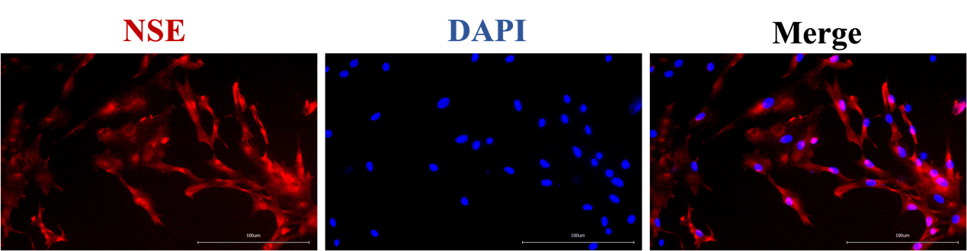

FIGURE S1 Hippocampal neuron cells were then immunostained using antibody specific for NSE (red). Nucleus is stained with DAPI (blue). Representative confocal images of the indicated neurons from two independent experiments. Scale bar, 100 µm.

