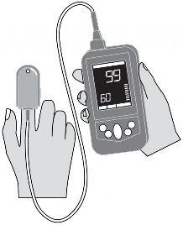
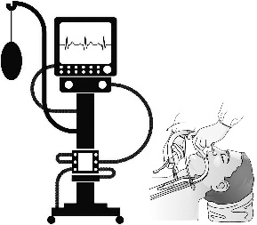
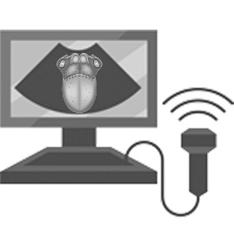
127 patients were evaluated as being eligible for the study
100 patients were analyzed
Study group (n=57)
Patients who were followed up on mechanical ventilation 4 days or more after ETI
27 of whom excluded
Control group (n=43)
Patients who were followed up on mechanical ventilation for 3 days or less after ETI
TSA¹ were measured on the 0th day of ETI [mean 1.75±0.43 cm²]
TSA¹ were measured on the 0th day of ETI [mean 1.60±0.45 cm²]
TSA² were measured on the 4th day of follow-up on mechanical ventilation [mean 1.97±0.51 cm²]
TSA² were measured just before the extubation
[mean 1.65±0.45 cm²]
↑ 12.5% (p<0.01)
p=0.206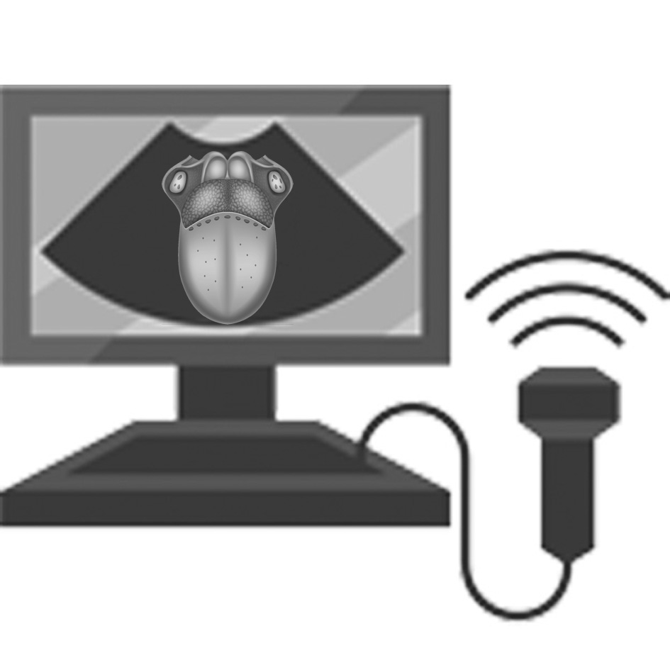)
TSA² – TSA¹ was defined as tongue edema
[mean 0.20±0.28 cm²]
TSA² – TSA¹ was defined as tongue edema
[mean 0.04±0.15 cm²]
p<0.01
The SpO₂ values 2 h after extubation were recorded
The effect of the tongue edema on oxygenation was investigated
SpO₂ ≥90% (n=23)
[mean TSA = -0.20±0.28 cm²]
SpO₂ <90% (n=20)
[mean TSA = 0.14±0.16 cm²]
p<0.01
Graphical abstract of the study
ETI: Endotracheal intubation
TSA: Tongue cross-sectional area

