Supporting Information
FeCl₃-Promoted Photocatalytic Cleavage of C_{α}–C_{β} Bond in Lignin Model Compounds and Native Lignin
XinweiLiu*, Liguo Wang, LianjingZhai, Fengxia Sun*, Yujuan Sun, Zhanzhan Liu, Jianing Liu
Table of Contents
1. General 2
1.1 Materials 2
1.2 Instrumentation 2
2. Experimental procedures 3
2.1 Synthesis of lignin models 3
2.2 Photocatalytic cleavage of lignin model compounds 3
3. Additional screening of reaction conditions 5
4. Mechanism study 6
5. Degradation of real lignin 7
6. ¹H NMR and ¹³C NMR spectra of compounds 9
7. References 27

1. General

1.1 Materials
All reagents and solvents were purchased from Accela, Adamas, Innochem, Psaitong and Aladdin. Unless otherwise noted, materials obtained from commercial suppliers were used without further purification. Blue LED lamps, radiators, fan, regulated DC power supplies and quartz reaction tubes used in the photocatalytic reaction were purchased from Shenzhen Xindaxin Photoelectric Technology Co., Ltd.

1.2 Instrumentation
Products were purified by flash chromatography on silica gel. Analysis of crude reaction mixture was performed on an Agilent 7820AGC System with a HP-INNOWAX capillary column (30 m×0.25 mm×0.32 μm) and an FID detector. The following GC temperature program was used: 60 °C is maintained for 2 minutes, rises to 150 °C at 10 °C/min, and finally rises to 300°C at a rate of 20°C/min, and hold for 4 minutes.
Nitrogen was used as a carrier gas. The injector temperature was held at 250 °C. GC-MS analysis was carried out on a SHIMADZU GC-MSQP2010 with a DB-5 capillary column (30 m×0.25 mm×0.32 μm).
¹H NMR spectra were recorded in CDCl₃ or DMSO using internal reference (the residue proton peaks of CDCl₃ at 7.26 ppm and DMSO at 2.5 ppm) on Bruker 400 spectrometer. Liquid ¹³C NMR was recorded at 100.6 MHz in CDCl₃ using residual CDCl₃ as internal reference (the residue proton peaks of CDCl₃ at 77.02 ppm and DMSO at 40.03 ppm).

2. Experimental procedures

2.1 Synthesis of lignin models
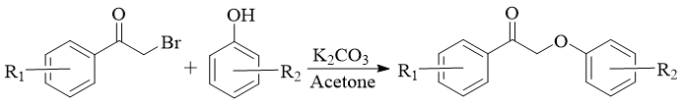
Scheme S1 synthetic ketone lignin model.
The synthesis reaction was carried out in a 150 mL round glass flask containing a condenser. 2-phenoxyacetophenone were synthesized by the reaction of the corresponding phenol with 2-bromoacetophenone according to the reported procedure.¹ Typically, 2-bromoacetophenone (5 mmol) is dissolved in a solution of K₂CO₃(7.5 mmol, 1.036 g) and phenol (5 mmol) in acetone (50 mL) and loaded in a reactor. The reaction mixture is then stirred at reflux temperature for 5 hours, filtered and vacuumized. The residue was purified by column chromatography with hexane: ethyl acetate a stirring. For the other methoxy substituted 2-phenoxy-1-phenylethanone, the preparation procedure is the same as described above, except of using different stating materials.
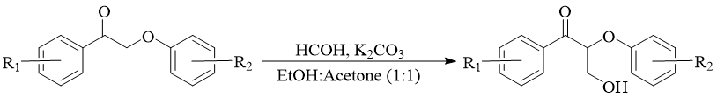
Scheme S2 synthetic 3-hydroxy-2-phenoxy-1-phenylpropan-1-one.
To a stirring suspension of K₂CO₃ (0.6 g, 4.3 mmol) in ethanol/acetone (v/v = 1/1, 20 mL) and 2-phenoxyacetophenones (0.78 g, 4 mmol) at rt, a water solution of formaldehyde (36.5~38wt%, 0.6 mL, 7.3 mmol) was added. After 4 h, the reaction mixture was filtered to remove K₂CO₃ and concentrated in vacuo to get a solid product. The crude product was purified with petroleum ether: ethyl acetate (3:1) to obtain the required 2-phenoxyacetophenone, on silica gel to obtain 3-hydroxy-1,2-diphenylpropan-1-one in 90% yield.
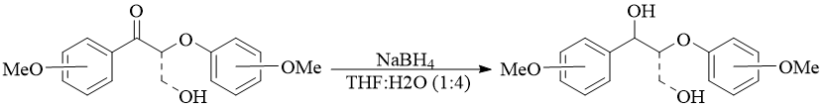
Scheme S3 synthetic lignin model compounds.
The resulting compound (3.5 mmol, 0.847 g) was dissolved in the mixture of THF:H₂O (5:1) (total 25 mL), and sodium borohydride (7 mmol, 0.26 g) was added portionwise to maintain a gentle evolution of gas. Then, the mixture was stirred for 6 h at room temperature. The reaction mixture was quenched with saturated aqueous NH₄Cl (50 mL) and diluted with 30 mL water. The aqueous portion was extracted with ethyl acetate (3×30mL). The organic parts were combined, dried over MgSO₄, filtered and concentrated under vacuum. The residue was purified by column chromatography with hexane:ethyl acetate (2:1).

2.2 Photocatalytic cleavage of lignin model compounds

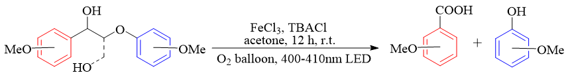
Scheme S4.Cleavage of lignin model compound.
The general procedure of the reaction: the photocatalytic equipment is composed of two 400-410 nm LED series. The constant voltage steady current power supply voltage is 32 V, the electric current is 1.25 A, and the power is 40 W. Feed was added to a 10mL quartz reaction tube and an oxygen balloon was mounted and stirred on a photocatalytic device while the device was cooled by a fan. After 12 hours, the reaction solution was diluted with dilute hydrochloric acid and extracted with dichloromethane. The yield of the obtained product was determined by GC with dodecane as internal standard.

3. Additional screening of reaction conditions
Table S1exploratory experiments.
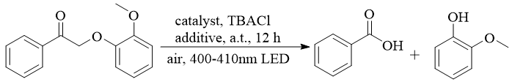
Entry | Additive | Yield%
1 | Aliquant-336 | --
2 | HCHO | --
3 | HCOOH | --
4 | ^{t}BuOK | --
5 | Ca(OH)₂ | 35
6 | CaO | 28
Standard condition: 0.1 mmol substrate, 0.2 eq FeCl₃, 0.2 eqTBACl, additive 1 eq, 2.0 mL acetone, air atmosphere, RT, 12 h, 20 W blue LED. The yield of guaiacol, measured by GC.

4. Mechanism study
4.1 Quenching experiments
Table S2Quenching experiments.

Trapping agents | Quenched material | Yield of benzoic acid % | Yield ofphenol %
L-tryptophan 1 eq | ¹O₂ | 35 | 40
Isopropyl alcohol 1 eq | .OH | 51 | 69
1,4-benzoquinone 1 eq | .O²⁻ | 61 | 67
Standard conditions: substrate (0.1 mmol), FeCl₃ (0.2 eq), TBACl (0.2 eq), 2.0 mL acetone, trapping agents 1 eq, O₂ atmosphere, RT, 12 h, 20 W blue LED.
4.2 Detection of CO₂
To detect the CO₂ evolution, we used Ca(OH)₂ solution to capture CO₂. A 10 mL Schlenk tube 1 was added 0.1mmol FeCl₃, 0.1mmol TBACl, substrate (0.5 mmol), and 8 mL acetone. The ice bath 2 is used to collect acetone volatilized during the reaction. O₂ is introduced into the closed system and air is discharged. Inject 0.1M clear Ca(OH)₂ aqueous solution into tube 3 with syringe to capture CO₂. The beaker 4 with silicone oil can prevent CO₂ in the air from entering the system. During the reaction the flow rate of oxygen was kept at 10 mL·min-1. After 15 hours of reaction, it was observed that the solution in the test tube 3 became turbid, and it was speculated that CO₂ was generated during the reaction.

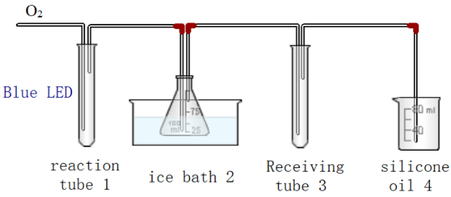
Figure S1. Experimental device diagram of CO₂ collection.

5. Degradation of real lignin
5.1 Extraction of lignin
We charged a round bottom flask with 10.3 g poplar sawdust, 50 mL 1,4-dioxane, and 1.75 mL HCl (37wt%), and heated to reflux at 85 °C in oil bath for 3 h. After cooling to rt, the mixture was added with 3.36 g sodium bicarbonate (NaHCO₃), stirred for another 30 min, after which it was filtered and washed with 10 mL of dioxane. Then the solution was concentrated at 40 °C under reduced pressure. The resulting dark-brown oil was diluted with 30 mL ethyl acetate (EtOAc) and added dropwise to 500 mL of hexane to precipitate the lignin. After filtration, the collected lignin was washed with hexane (50 mL). The recovered lignin was dried overnight at rt in a desiccator to afford 1.36 g poplar lignin.²
5.2 Depolymerization of lignin
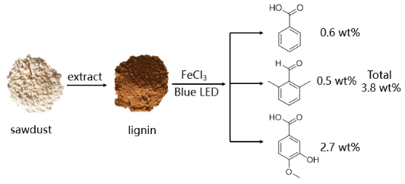
Figure S2.Photocatalytic depolymerization of natural lignin.
Put 100mg poplar lignin, 12mg FeCl₃, 27mg TBACI into four test tubes respectively, add 2mL acetone to each test tube, and irradiate the reaction system under two 400-410nm LEDs for 12 hours. After the reaction, acidify with HCl, remove the flocs with a sand core funnel, extract the reaction products with CH₂Cl₂, detect the products by GC-MS, and conduct quantitative analysis by GC.

5.3 GC-MS analysis
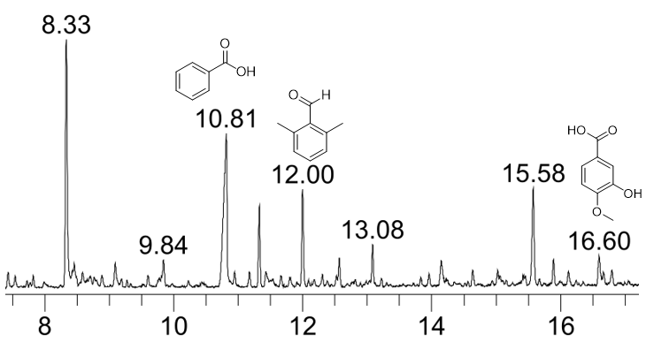
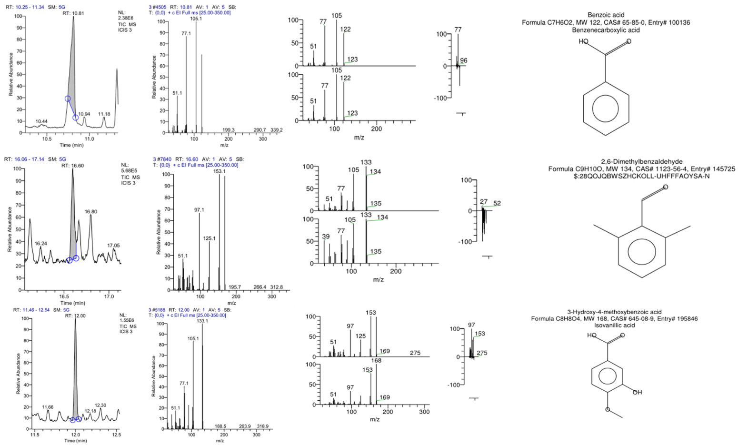
Figure S3 GC-MS analysis of natural lignin depolymerization.

6. ¹H NMR and ¹³C NMR spectra of compounds
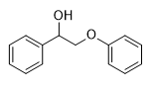
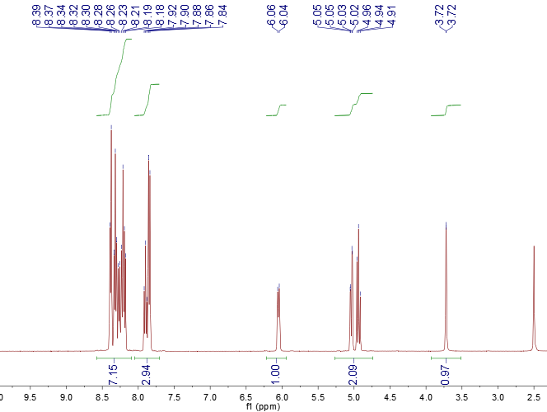
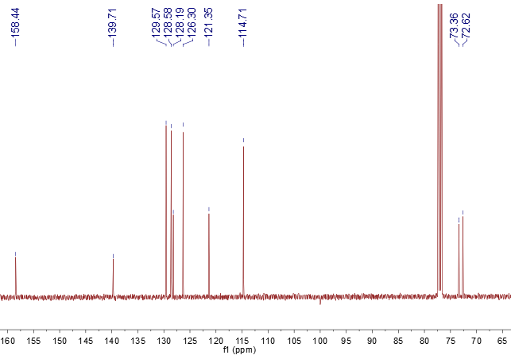
Figure S4 ¹H (top) and ¹³C (bottom) NMR spectra of 2-Phenoxy-1-phenyl-ethanol.

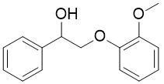
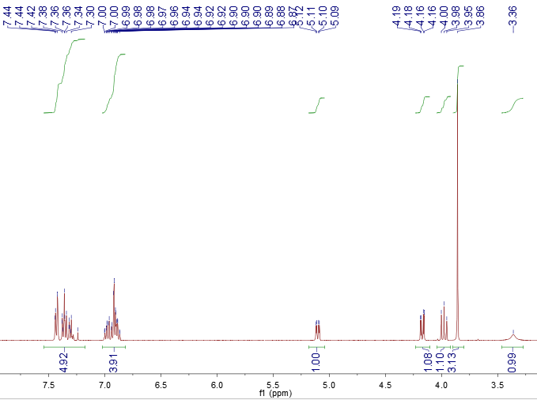
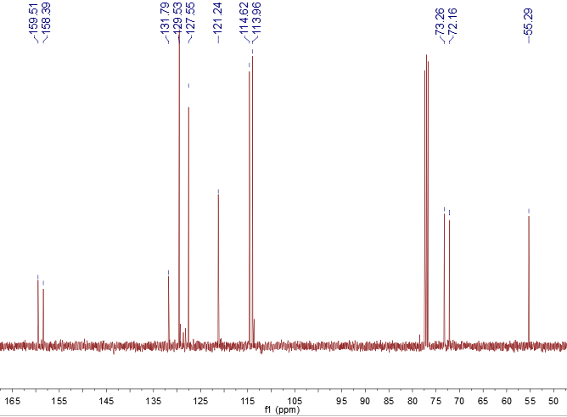
Figure S5 ¹H (top) and ¹³C (bottom) NMR spectra of 2-(2-methoxyphenoxy)-1-phenylethan-1-ol.

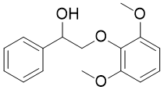
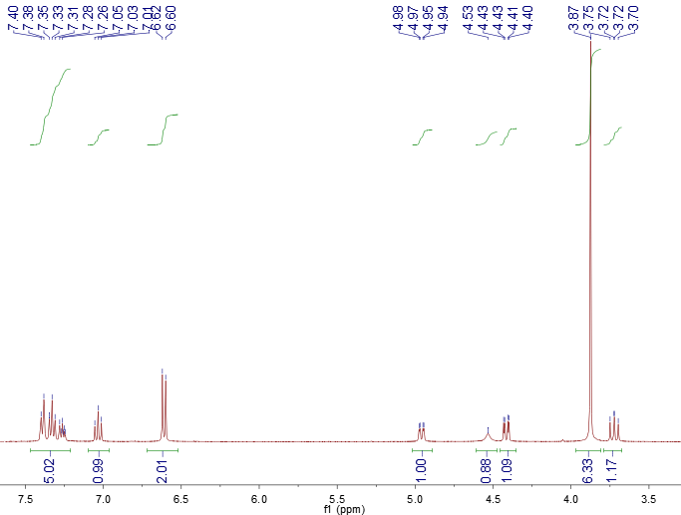
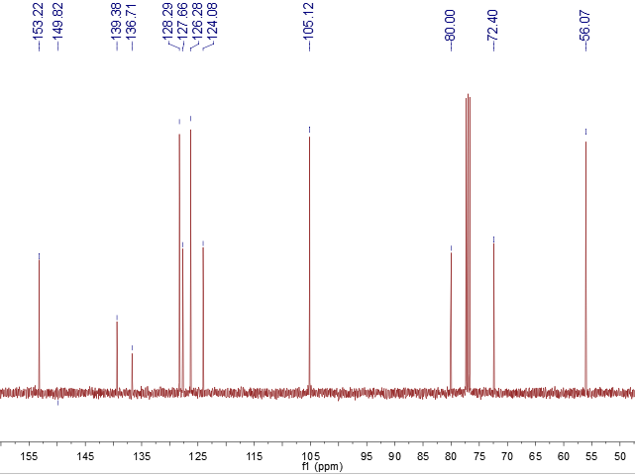

Figure S6 ¹H (top) and ¹³C (bottom) NMR spectra of 2-(4-chlorophenoxy)-1-phenylethan-1-ol.

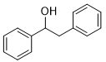
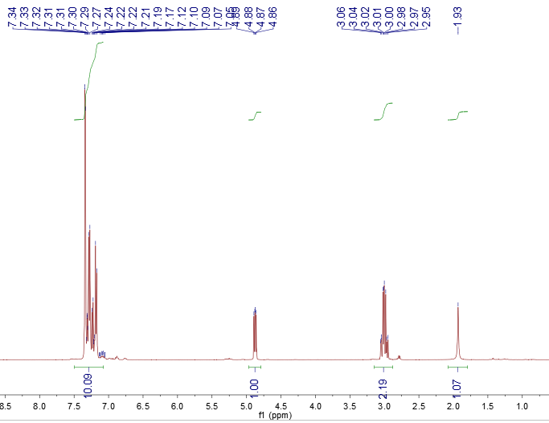
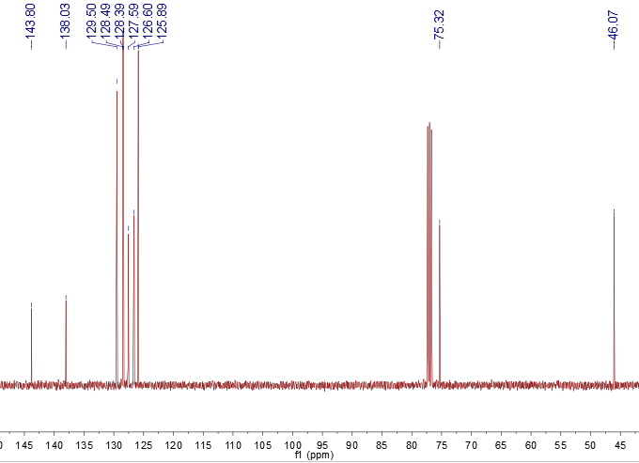
Figure S7 ¹H (top) and ¹³C (bottom) NMR spectra of 1,2-diphenylethan-1-ol.

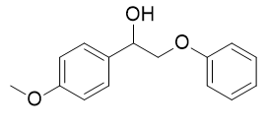
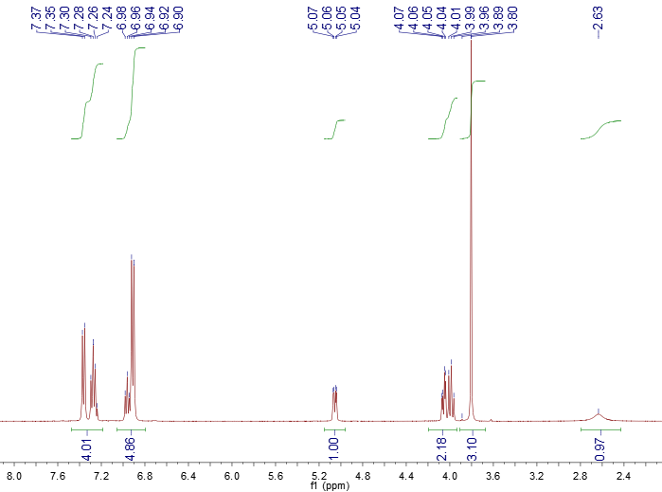
Figure S8 ¹H (top) and ¹³C (bottom) NMR spectra of 1-(4-methoxyphenyl)-2-phenoxyethan-1-ol.

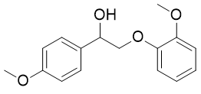
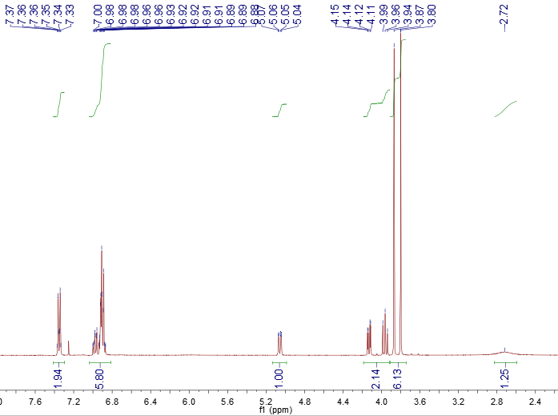
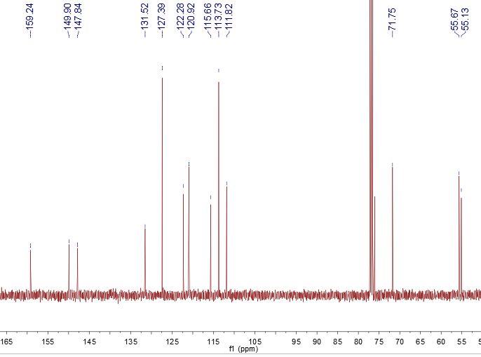
Figure S9 ¹H (top) and ¹³C (bottom) NMR spectra of 2-(2-methoxyphenoxy)-1-(4-methoxyphenyl) ethan-1-ol.

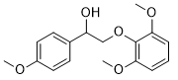
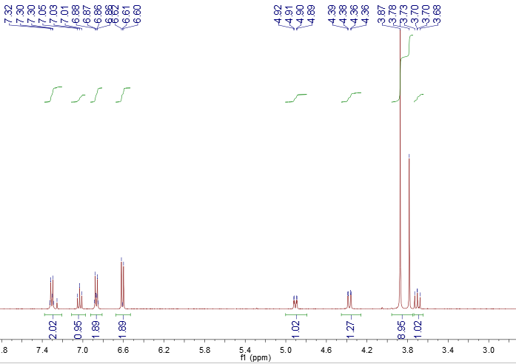
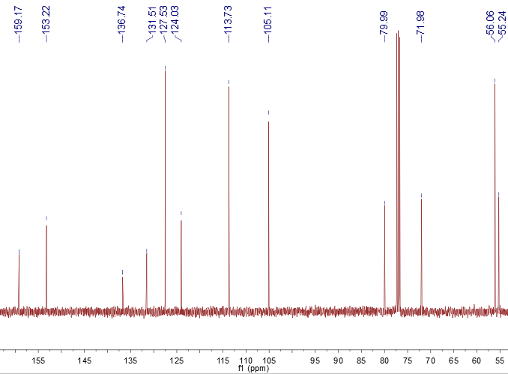
Figure S10 ¹H (top) and ¹³C (bottom) NMR spectra of 2-(2,6-dimethoxyphenoxy)-1-(4-methoxyphenyl) ethan-1-ol.

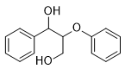
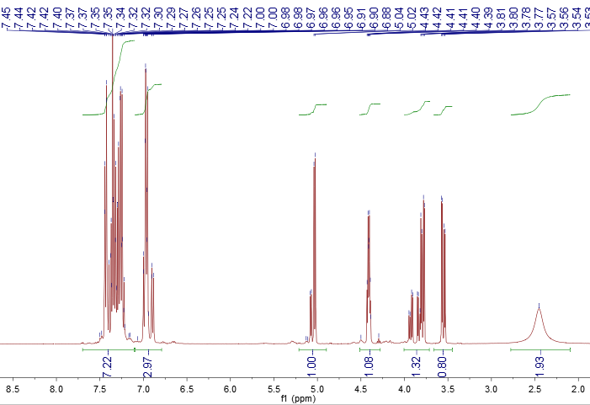
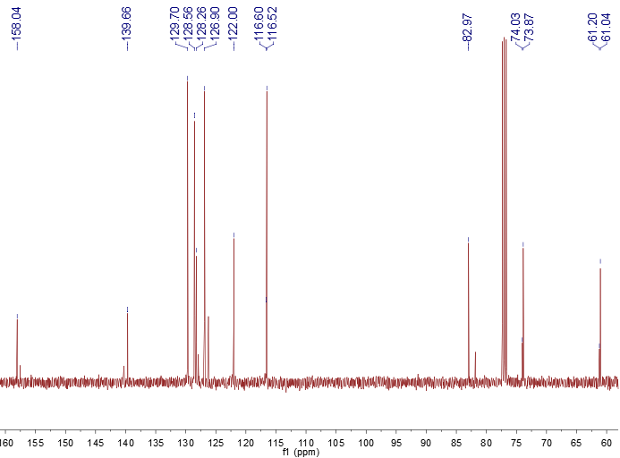
Figure S11 ¹H (top) and ¹³C (bottom) NMR spectra of 2-phenoxy-1-phenylpropane-1,3-diol.

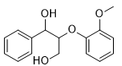
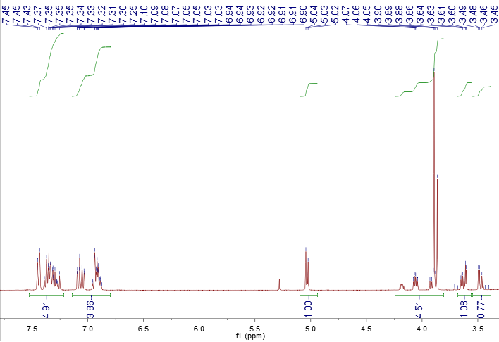
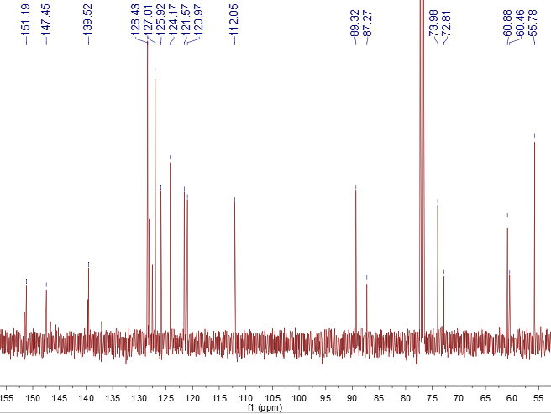
Figure S12 ¹H (top) and ¹³C (bottom) NMR spectra of 2-(2-methoxyphenoxy)-1-phenylpropane-1,3-diol.

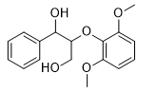
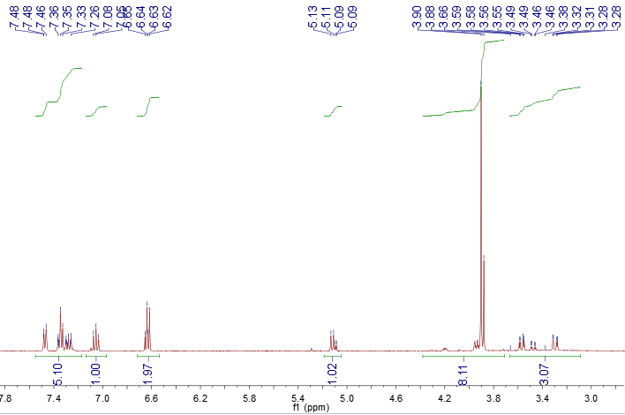
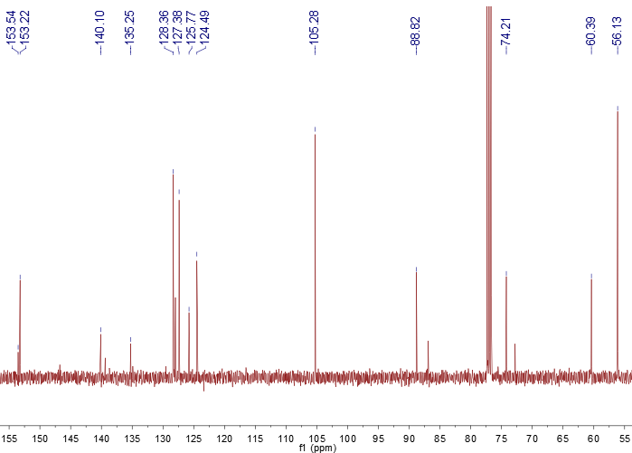
Figure S13 ¹H (top) and ¹³C (bottom) NMR spectra of 2-(2,6-dimethoxyphenoxy)-1-phenylpropane-1,3-diol.

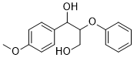
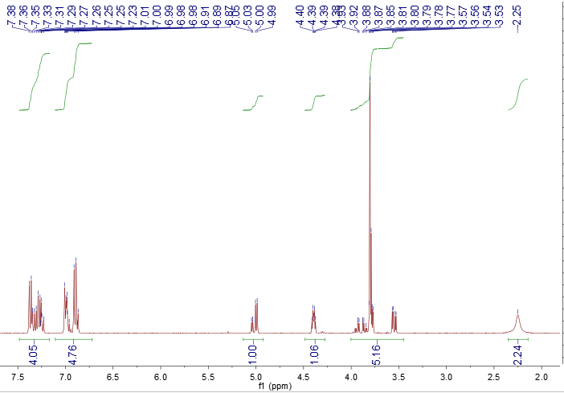
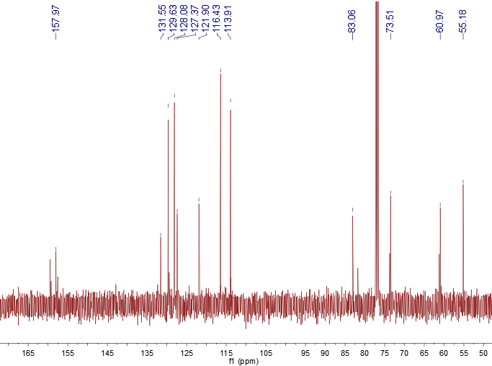
Figure S14 ¹H (top) and ¹³C (bottom) NMR spectra of 1-(4-methoxyphenyl)-2-phenoxypropane-1,3-diol.

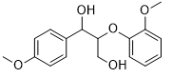
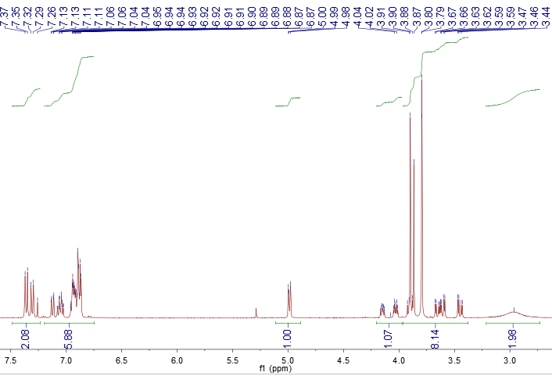
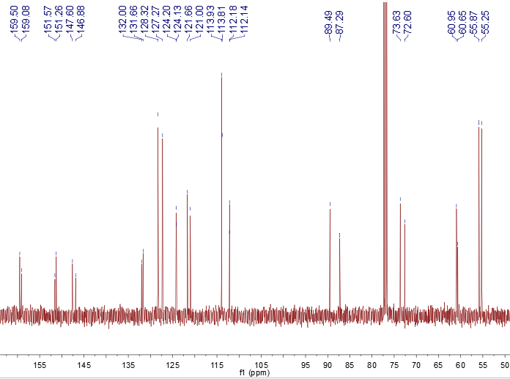
Figure S15 ¹H (top) and ¹³C (bottom) NMR spectra of 2-(2-methoxyphenoxy)-1-(4-methoxyphenyl) propane-1,3-diol.

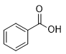
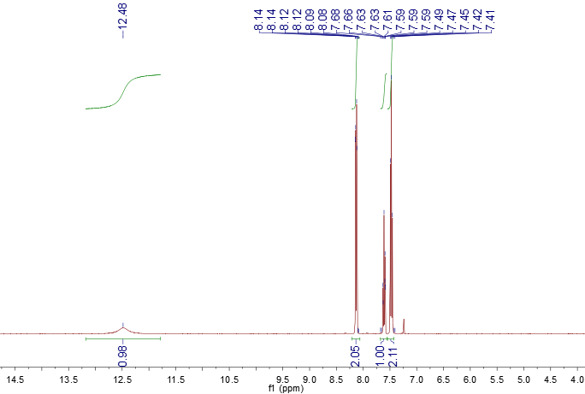
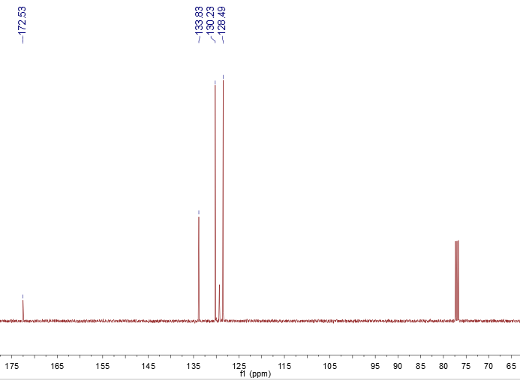
Figure S16 ¹H (top) and ¹³C (bottom) NMR spectra ofbenzoic acid.

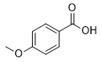
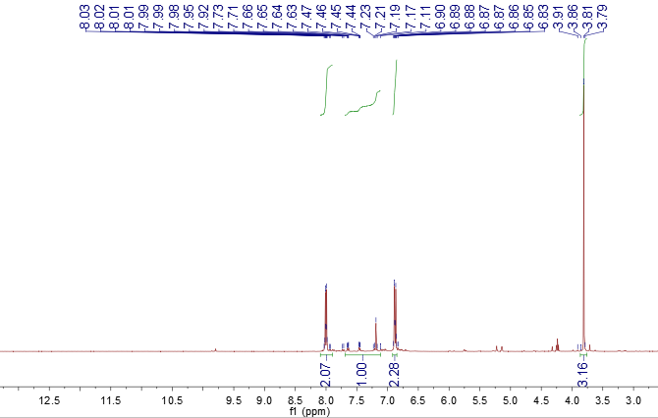
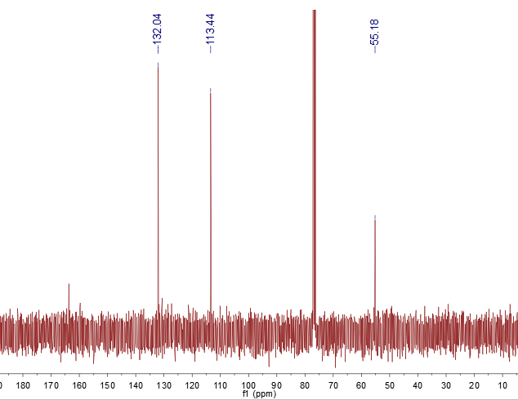
Figure S17 ¹H (top) and ¹³C (bottom) NMR spectra of4-methoxybenzoic acid.

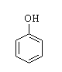
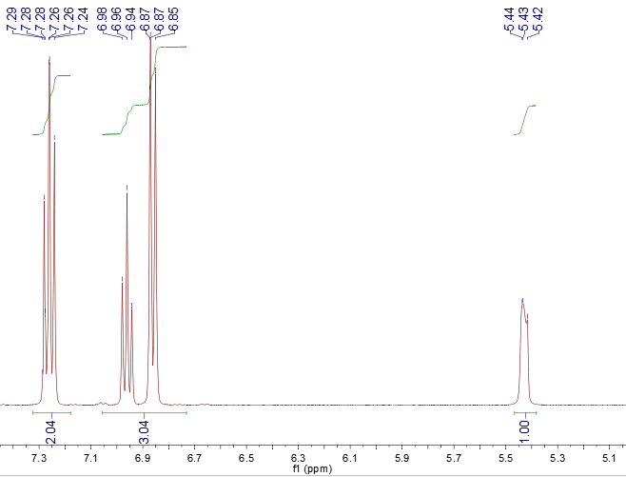
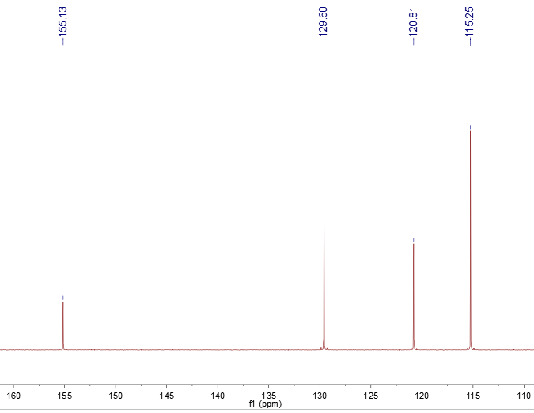
Figure S18 ¹H (top) and ¹³C (bottom) NMR spectra of phenol.

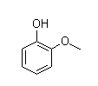
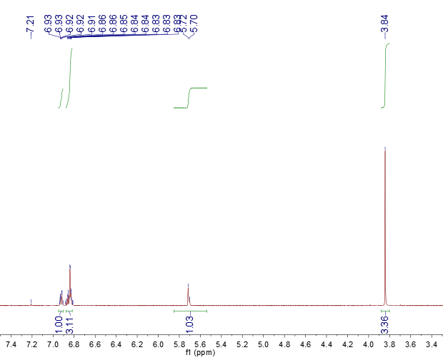
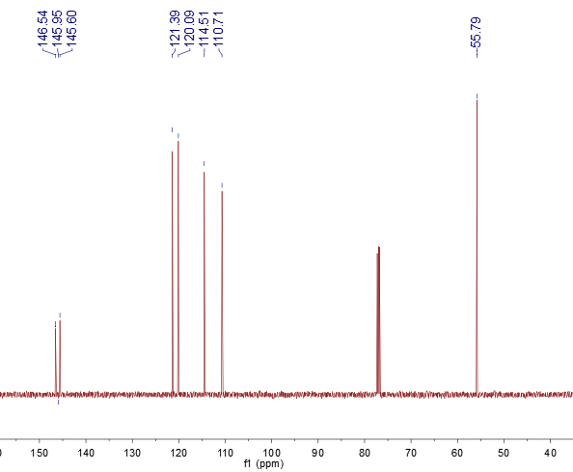
Figure S19 ¹H (top) and ¹³C (bottom) NMR spectra of 2-methoxyphenol.

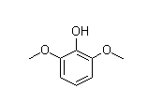
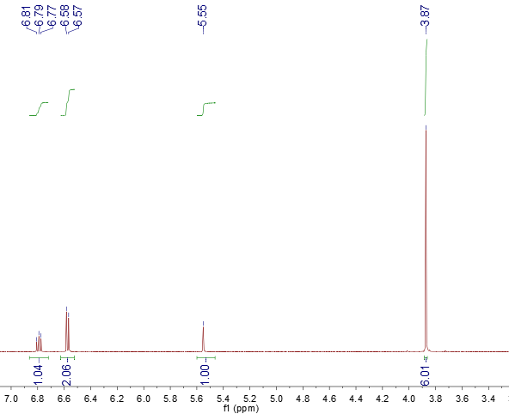
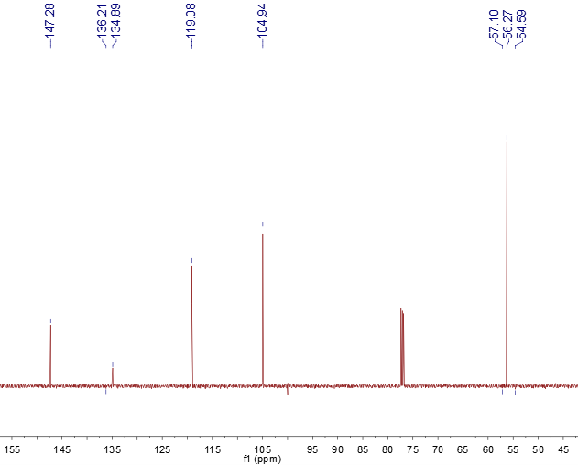
Figure S20¹H (top) and ¹³C (bottom) NMR spectra of 2,6-dimethoxyphenol.

7. References
[1] S. A. Kim, S. E. Kim, Y. K. Kim and H. Y. Jang, ACS Omega, 2020, 5, 31684-31691.
[2] Y. Wang, J. He and Y. Zhang, CCS Chemistry, 2020, 2, 107-117.

