Table 1. Optimization of depolymerization conditions of LMC 1a.
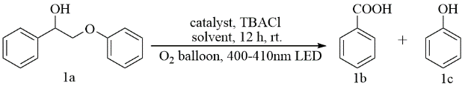

Entry | Catalyst | Solvent （2mL） |  | Yield 1b % | Yield 1c %
1 | FeCl₃ | CH₃CN |  | 87 | 71
2 | FeCl₂ | acetone |  | 76 | 80
3 | FeCl₂·4H₂O | acetone |  | 62 | 72
4 | Fe(OTf)₃ | acetone |  | 43 | 38
5 | CuCl₂ | acetone |  | 38 | 27
6 | CeCl₃ | acetone |  | 50 | 42
7 | NaCl | acetone |  | 20 | 15
8 | FeCl₃ | DCE |  | 69 | 48
9 | FeCl₃ | MeOH |  | 24 | 18
10 | FeCl₃ | acetone |  | 91 | 88
11 | FeCl₃ | H₂O |  | 0 | 0
12 | FeCl₃ | Acetic acid |  | 68 | 31
13 | FeCl₃ | acetone:H₂O(2:1) |  | 35 | 16
14ª | FeCl₃ | acetone | 77 |  | 78
15^{b} | FeCl₃ | acetone | 35 |  | 18
Reaction conditions: substrate 1a (0.1 mmol), catalyst (0.2 eq), TBACl (0.2 eq) solvent (2 mL), O₂ (1 atm), room temperature for 12 h and irradiated with blue LED (400-410 nm, 20W). ªAir instead of O₂, ^{b}N₂ instead of O₂. The yield was determined by GC with dodecane as the internal standard.

Table 2. Scope of lignin model substrates.
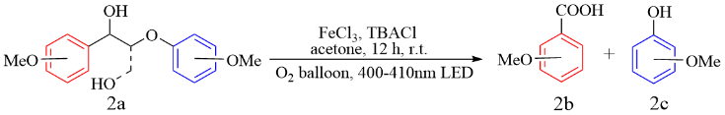
Entry | Substrate, yield % | Entry | Substrate, yield %
1 | 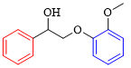  2b: 86 2c: 25 | 6 | 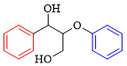  2b: 93 2c: 96
2 | 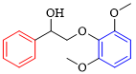  2b: 68 2c: 19 | 7 | 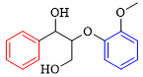  2b: 78 2c: 21
3 | 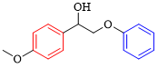  2b: 32 2c: 94 | 8 | 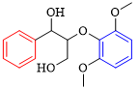  2b: 68 2c: 9
4 | 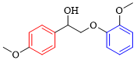  2b: 21 2c: 25 | 9 | 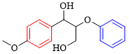  2b: 65 2c: 87
5 | 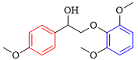  2b: 17 2c: 11
Standard condition: 0.1 mmol substrate 2a, 0.2 eq FeCl₃, 0.2 eq TBACl, 2.0 mL acetone, O₂ atmosphere, rt, 12 h, 20 W blue LED. The 2b was the yieldof benzoic acids, the 2c was the yield of phenols. The yields were measured by GC.

