Electronic Supplementary Material
for Cellulose

All-biomass Cellulose/Casein Adsorbent Fabricated via the "Green Solvent System" of Ionic Liquid for the Efficient Removal of Cu(II), Cd(II) and Pb(II)

Liwei Qian() · Haonan Chen · Sufeng Zhang() · Yuxuan Yang · Lulu Zhang · Miaoxiu Yang · Wenqi Song() · Valentin Nica

L. Qian() · H. Chen · S. Zhang() · Y. Yang
College of Bioresources Chemical and Materials Engineering, Shaanxi University of Science and Technology, Xi'an, 710021, China
e-mail : qianliwei@mail.nwpu.edu.cn
S. Zhang
e-mail : zhangsufeng@sust.edu.cn
L. Zhang
Institute of Land Engineering and Technology, Shaanxi Provincial Land Engineering Construction Group Co., Ltd, Xi'an, 710021, China
M. Yang
China National Pulp & Paper Research Institute Co.,Ltd., Beijing, 100102, China
W. Song()
Xi'an Key Laboratory of Advanced Photo-Electronics Materials and Energy Conversion Device, School of Electronic Information, Xijing University, Xi'an, 710123, China
e-mail :songwenqi0123@163.com
V. Nica
Department of Physics, “Alexandru Ioan Cuza” University of Iasi, Iasi, 700506, Romania

1. Experimental Methods and Details
1.1. Measurement of Mechanical Properties
Mechanical tests on cylindrical hydrogel samples (15 mm diameter, 30 mm height) were performed at room temperature using a 0.5 KN load cell at a compression rate of 10 mm min⁻¹. Rectangular hydrogel samples (15 mm wide, 3 mm deep and 35 mm long) were mechanically tested at room temperature using a 0.5 KN load cell with a tensile rate of 50 mm min⁻¹. At least three hydrogels were measured for each sample.
1.2. Adsorption Experiments
All adsorption experiments were conducted in glass bottles. Except for special instructions, adsorption experiments were carried out by adding 20 mg of adsorbent to 10 mL of aqueous heavy metal ion solutions. After the specified adsorption time, the samples were removed directly from the solutions, and the metal ion concentrations of the solutions were determined using inductively coupled plasma optical emission spectrometry (ICP-AES). The adsorption capacity at equilibrium (Q_{e}) was calculated using Eq. (1) given below:
$$Q_{e}=\frac{(C_{0}-C_{e})V}{m}$$ | (1)
where C₀ and C_{e} are the initial and equilibrium metal ion concentrations in solution (mg L ⁻¹); V is the solution volume; and m is the mass (g) of the adsorbent.
The 2000 mg L⁻¹ metal ion solutions with initial pH from 2 to 7.4 were prepared to clarify the impact of solution pH on Cu(II), Cd(II) and Pb(II) adsorption.
The kinetic and isotherm experiments for Cu(II), Cd(II) and Pb(II) were carried out at pH 6, 7 and 7, respectively. In the kinetic experiments, the adsorption time of heavy metal ion solution with an initial concentration of 2000 mg L⁻¹ ranged from 5 to 150 min. In the isotherm study, the initial concentrations ranged from 100 to 2400 mg L⁻¹ with 120 min.
In addition, to evaluate the removal effect of CE/CA at different concentrations, we performed adsorption at a starting concentration of heavy metal ions, and the remaining concentration in the solution was checked by ICP-AES.
Eight cycles of Cu(II), Cd(II) and Pb(II) adsorption and desorption were carried out to evaluate the reusability of CE/CA composite hydrogel, and the removal rate (Ƞ, %) was used to illustrate the separation ability of adsorbents. In each cycle, 20 mg the metal-loaded CE/CA composite was added to 0.1 M HCl to desorb heavy metal ions for 2 h at 30°C. Finally, the adsorbent was washed with deionized water until neutral for next cycle of adsorption experiment.
The removal rate (Ƞ, %) was calculated using the following equation:
$$η=\frac{(C_{0}-C_{e})}{C_{0}}×100\%$$ | (1)
where C₀ and C_{t} (mg/L) are the initial and total heavy metal ion concentrations, respectively.

2. Figures and Tables
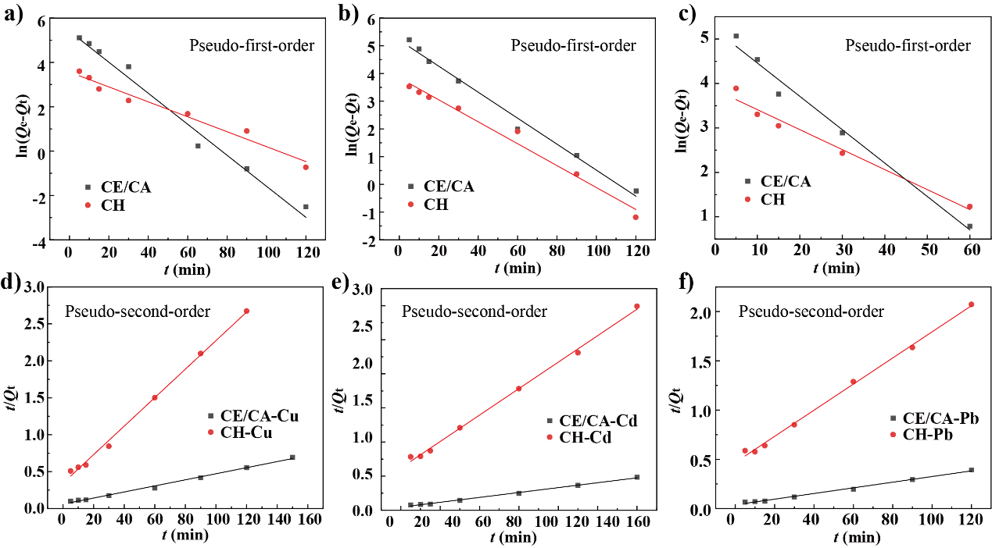
Figure S1. Pseudo-first-order (a-c), pseudo-second-order (d-e).

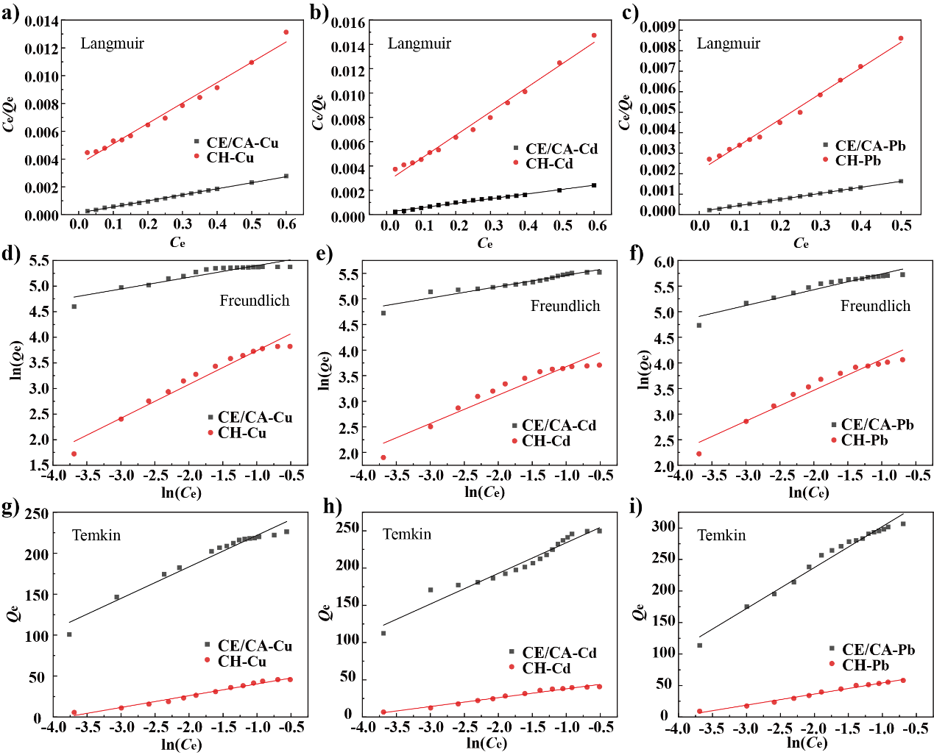
Figure S2. Langmuir (a-c), Freundlich (d-f), Temkin (g-i).

Table S1 Summary report of specific surface area and pore properties.
Adsorbents | Specific surface area (m² g⁻¹) | Total pore volume (cm³ g⁻¹) | Average pore diameter (nm)
CE | 154.97 | 0.53 | 11.85
CE/CA 1 | 129.42 | 0.40 | 11.98
CE/CA 2 | 126.09 | 0.37 | 12.28
CE/CA 3 | 109.54 | 0.33 | 13.75
Table S2 Comparison of Cu²⁺, Cd²⁺ and Pb²⁺ adsorption capacity from the literature by cellulose derivative adsorbents.
Adsorbents | Adsorption capacity (mg/g) |  |  | References
Adsorbents | Cu²⁺ | Cd²⁺ | Pb²⁺ | References
Guanyl modified cellulose | 83.0 | 68.0 | 52.0 | (Kenawy et al., 2018)
Chitosan/cellulose nanofibers | 112.6 | - | 57.3 | (Phan et al., 2018)
Waste paper/chitosan aerogel | 156.3 | - | - | (Li et al., 2018)
Ethylenediaminetetraacetic acid modified hydroxyethyl cellulose | 77.1 | - | 109.6 | (Jilal et al., 2018)
Carboxymethyl cellulose/ polyacrylamide composite hydrogel | 227.3 | 256.4 | 312.5 | (Godiya et al., 2019)
Graphene oxide/cellulose composite hydrogel | 65.1 | - | 80.9 | (Yao et al., 2019)
Cellulose-g-N-isopropylacrylamide-co-glycidyl methacrylate copolymer | 82.9 | - | 119.8 | (Kumar et al., 2019)
Thiol-functionalized cellulose nanofiber membrane | 49.0 | 45.9 | 22.0 | (Choi et al., 2020)
Polyethyleneimine-bacterial cellulose | 148.0 | - | 141.0 | (Jin et al., 2017)
Xanthate-functionalized cellulose | - | 151.51 | 295.2 | (Qu et al., 2020)
CE/CA composite hydrogels | 232.6 | 270.3 | 306.6 | This work

3. Reference
Choi, H.Y., Bae, J.H., Hasegawa, Y., An, S., Kim, I.S., Lee, H., and Kim, M. (2020). Thiol-functionalized cellulose nanofiber membranes for the effective adsorption of heavy metal ions in water. Carbohydr Polym 234, 115881. 10.1016/j.carbpol.2020.115881
Godiya, C.B., Cheng, X., Li, D., Chen, Z., and Lu, X. (2019). Carboxymethyl cellulose/polyacrylamide composite hydrogel for cascaded treatment/reuse of heavy metal ions in wastewater. J Hazard Mater 364, 28-38. 10.1016/j.jhazmat.2018.09.076
Jilal, I., El Barkany, S., Bahari, Z., Sundman, O., El Idrissi, A., Abou-Salama, M., Romane, A., Zannagui, C., and Amhamdi, H. (2018). New quaternized cellulose based on hydroxyethyl cellulose (HEC) grafted EDTA: Synthesis, characterization and application for Pb (II) and Cu (II) removal. Carbohydr Polym 180, 156-167. 10.1016/j.carbpol.2017.10.012
Jin, X., Xiang, Z., Liu, Q., Chen, Y., and Lu, F. (2017). Polyethyleneimine-bacterial cellulose bioadsorbent for effective removal of copper and lead ions from aqueous solution. Bioresour Technol 244, 844-849. 10.1016/j.biortech.2017.08.072
Kenawy, I.M., Hafez, M.A.H., Ismail, M.A., and Hashem, M.A. (2018). Adsorption of Cu(II), Cd(II), Hg(II), Pb(II) and Zn(II) from aqueous single metal solutions by guanyl-modified cellulose. Int J Biol Macromol 107, 1538-1549. 10.1016/j.ijbiomac.2017.10.017
Kumar, R., Sharma, R.K., and Singh, A.P. (2019). Grafting of cellulose with N-isopropylacrylamide and glycidyl methacrylate for efficient removal of Ni(II), Cu(II) and Pd(II) ions from aqueous solution. Separation and Purification Technology 219, 249-259. 10.1016/j.seppur.2019.03.035
Li, Z., Shao, L., Ruan, Z., Hu, W., Lu, L., and Chen, Y. (2018). Converting untreated waste office paper and chitosan into aerogel adsorbent for the removal of heavy metal ions. Carbohydr Polym 193, 221-227. 10.1016/j.carbpol.2018.04.003
Phan, D.-N., Lee, H., Huang, B., Mukai, Y., and Kim, I.-S. (2018). Fabrication of electrospun chitosan/cellulose nanofibers having adsorption property with enhanced mechanical property. Cellulose 26, 1781-1793. 10.1007/s10570-018-2169-5
Qu, J., Tian, X., Jiang, Z., Cao, B., Akindolie, M.S., Hu, Q., Feng, C., Feng, Y., Meng, X., and Zhang, Y. (2020). Multi-component adsorption of Pb(II), Cd(II) and Ni(II) onto microwave-functionalized cellulose: Kinetics, isotherms, thermodynamics, mechanisms and application for electroplating wastewater purification. J Hazard Mater 387, 121718. 10.1016/j.jhazmat.2019.121718
Yao, M., Wang, Z., Liu, Y., Yang, G., and Chen, J. (2019). Preparation of dialdehyde cellulose graftead graphene oxide composite and its adsorption behavior for heavy metals from aqueous solution. Carbohydr Polym 212, 345-351. 10.1016/j.carbpol.2019.02.052

