Supplementary Figures and Legends

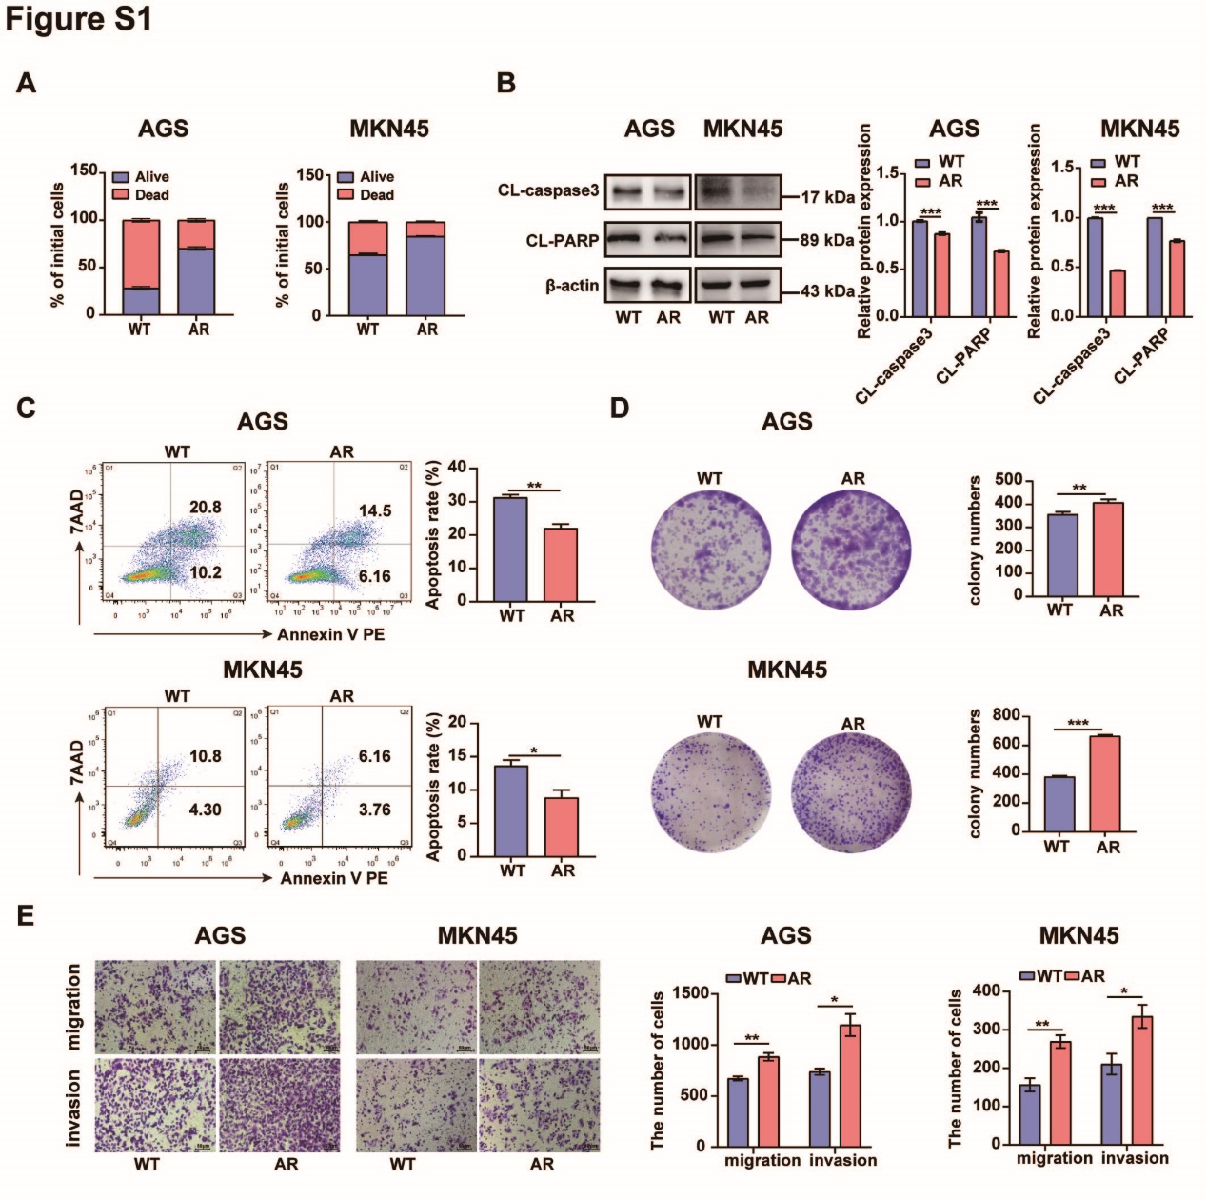
Figure S1 Anoikis-resistant GC cells were generated.
(A) Trypan blue exclusion assay was used to measure the viability of anoikis-resistant AGS and MKN45 cells in suspension culture. (B) Western blotting was used to measure the levels of cleaved caspase-3 and cleaved PARP in WT and AR AGS and MKN45 cells. β-Actin served as the loading control. The density of the western blot bands was quantified using ImageJ software. (C) Flow cytometric analysis of the apoptosis rate of WT and AR AGS and MKN45 cells in suspension culture. (D) Colony formation assay of the proliferative capacity of WT and AR AGS and MKN45 cells in low-serum medium (1% FBS). (E) Transwell migration and invasion assays of WT and AR AGS and MKN45 cells. Scale bar, 50 μm. Each experiment was performed in triplicate. The data are presented as the means ± SD and were analyzed by Student’s t test (*p< .05, **p< .01, ***p< .001).

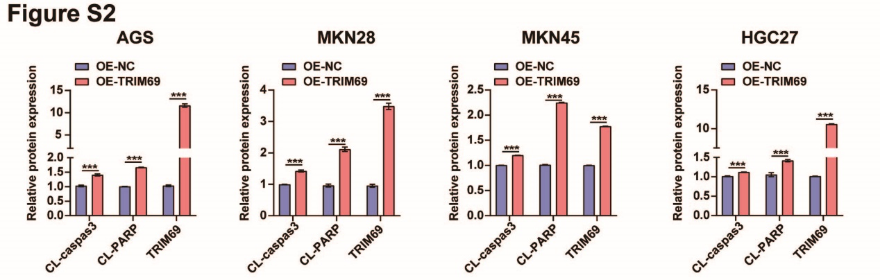
Figure S2 TRIM69 promoted apoptosis proteins expression in GC cells.
The density of western blot bands shown in Figure 2A was quantified using ImageJ software. Each experiment was performed in triplicate. The data are presented as the means ± SD and analyzed by student’s t test (***p< .001).

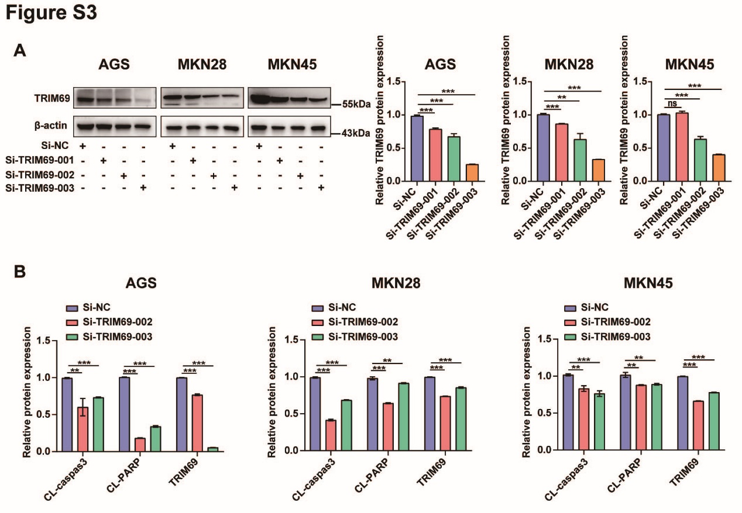
Figure S3 TRIM69 siRNA transfection reduced TRIM69 expression in GC cells.
(A) The protein expression of TRIM69 in AGS, MKN28 and MKN45 cells after transfection with si-NC, si-TRIM69-001, si-TRIM69-002, and si-TRIM69-003. β-Actin served as the loading control. The density of the western blot bands was quantified using ImageJ software. (B) The density of western blot bands shown in Supplementary Figure S4A was quantified using ImageJ software. Each experiment was performed in triplicate. The data are presented as the means ± SD and were analyzed by Student’s t test (*p< .05, **p< .01, ***p< .001).

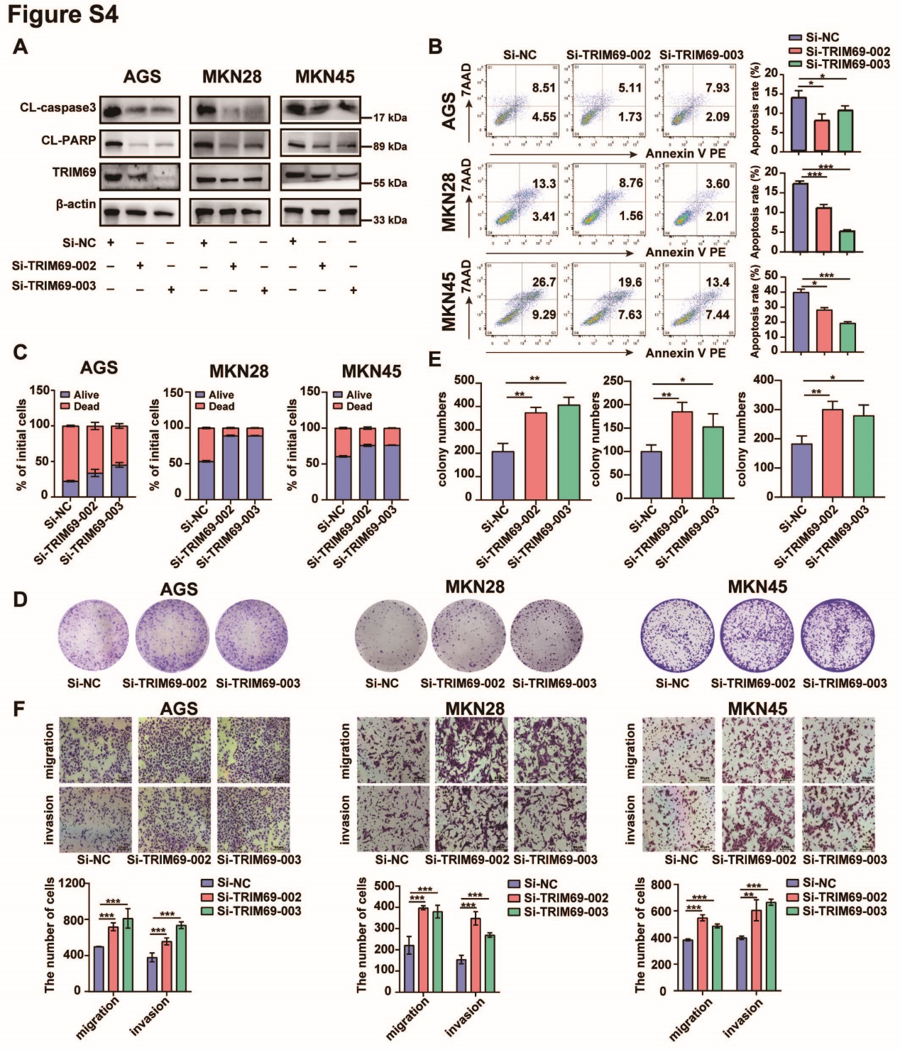
Figure S4 Inhibition of TRIM69 expression promoted the anoikis resistance and metastasis of GC cells.
(A) Western blotting was used to measure cleaved caspase3, cleaved PARP and TRIM69 protein levels in AGS, MKN28, and MKN45 cells after transfection with si-NC, si-TRIM69-002 or si-TRIM69-003. β-Actin served as a loading control. (B) Flow cytometry was used to measure the apoptosis rate of AGS, MKN28, and MKN45 cells after transfection with si-NC, si-TRIM69-002 or si-TRIM69-003 in suspension culture. (C) The viability of AGS, MKN28, and MKN45 cells after transfection with si-NC, si-TRIM69-002 or si-TRIM69-003 in suspension culture. (D-E) A colony formation assay was used to confirm the effects of TRIM69 knockdown on the proliferative capacity of GC cells in low-serum medium (1% FBS) (D); statistical results are presented (E). (F) Transwell assays were performed to determine the effects of TRIM69 knockdown on the migration and invasion abilities of GC cells. Scale bar, 50 μm. Each experiment was performed in triplicate. The data are presented as the means ± SD and were analyzed by Student’s t test (*p< .05, **p< .01, ***p< .001).

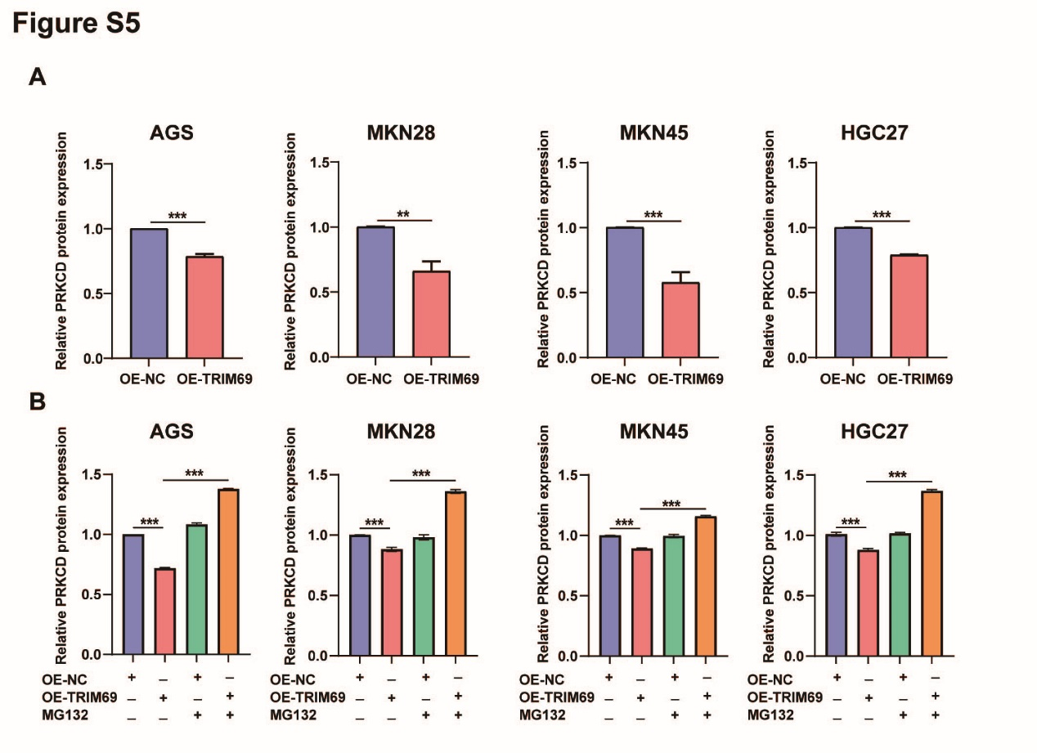
Figure S5 TRIM69 directly degraded PRKCD via the ubiquitin‒proteasome pathway.
(A) The densities of the western blot bands shown in Figure 4A was quantified using ImageJ software. (B) The density of the western blot bands shown in Figure 4C was quantified using ImageJ software. Each experiment was performed in triplicate. The data are presented as the means ± SD and were analyzed by Student’s t test (*p< .05, **p< .01, ***p< .001).

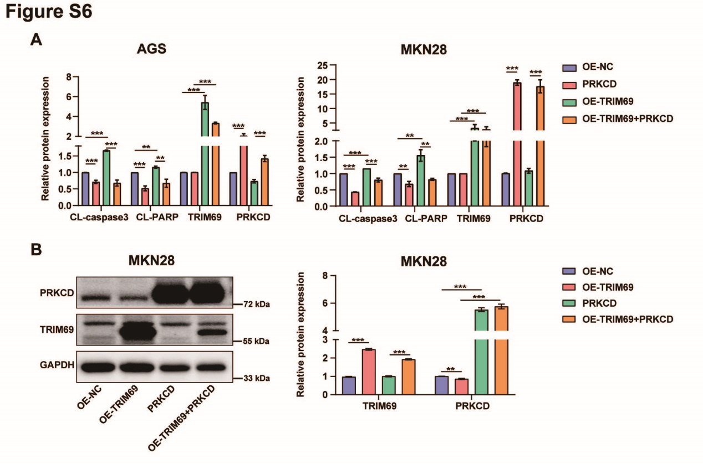
Figure S6 TRIM69 inhibited anoikis resistance and metastasis in GC cells via PRKCD downregulation.
(A) The density of the western blot bands shown in Figure 5A was quantified using ImageJ software. (B) Western blotting was used to measure the TRIM69 and PRKCD expression in OE-NC and OE-TRIM69 MKN28 cell treated with lentiviral vectors carrying human PRKCD cDNA. GAPDH served as the loading control. The density of western blot bands was quantified using ImageJ software. Each experiment was performed in triplicate. The data are presented as the means ± SD and were analyzed by Student’s t test (*p< .05, **p< .01, ***p< .001).
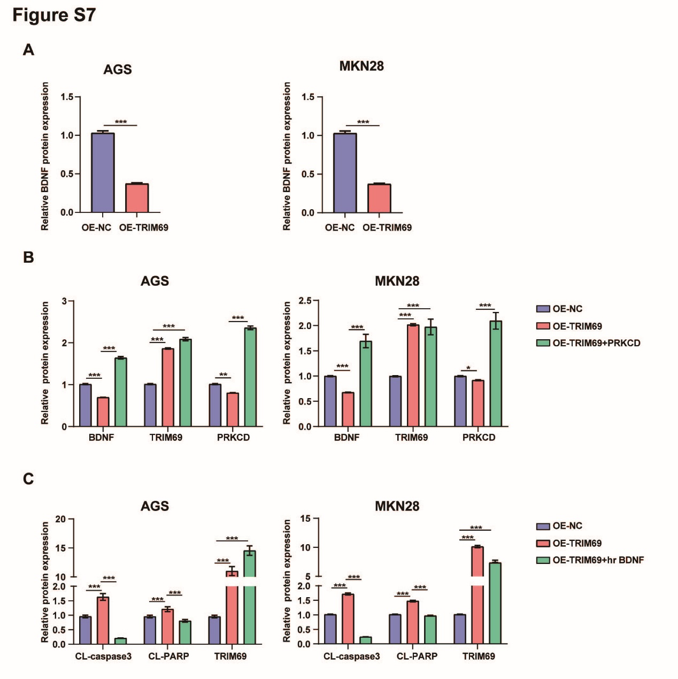
Figure S7 The TRIM69/PRKCD axis inhibited anoikis resistance and metastasis via BDNF in GC cells.
(A) The density of the western blot bands shown in Figure 6F was quantified using ImageJ software. (B) The density of the western blot bands shown in Figure 6I was quantified using ImageJ software. (C) The density of the western blot bands shown in Figure 6J was quantified using ImageJ software. Each experiment was performed in triplicate. The data are presented as the means ± SD and were analyzed by Student’s t test (*p< .05, **p< .01, ***p< .001).

