Supplementary information

Engineering electrode interfaces for telecom-band photodetection in MoS₂/Au heterostructures via sub-band light absorption
Chengyun Hong^{1,2}, Saejin Oh^{1,2}, Vu Khac Dat^{1,2}, Sangyeon Pak⁵, SeungNam Cha⁴, Kyung-Hun Ko^{1,2}, Gyung-Min Choi^{1,2}, Tony Low^{3*}, Sang-Hyun Oh^{3*}, and Ji-Hee Kim^{1,2*}

¹Department of Energy Science, Sungkyunkwan University, Suwon 16419, Republic of Korea
²Center for Integrated Nanostructure Physics (CINAP), Institute for Basic Science (IBS), Sungkyunkwan University, Suwon 16419, Republic of Korea
³Department of Electrical and Computer Engineering, University of Minnesota, Minneapolis, MN, 55455, USA
⁴Department of Physics, Sungkyunkwan University, Suwon 16419, Republic of Korea
⁵School of Electronic and Electrical Engineering, Hongik University, Seoul 04066, Republic of Korea

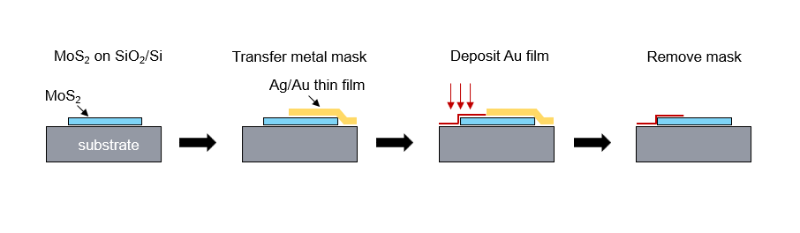
Fig. S1. Schematic of localized metal thin film deposition. Probe tip-assisted metal transfer method was use here for mask fabrication. Specifically, the Ag/Au (10 nm/120 nm) film was deposited onto a SiO₂/Si substrate using the thermal deposition method. The probe tip (ST-20-1, GGB industry) was used to cut the film to the desired size. The probe was pushed from one edge of the metal film and a hole was formed in the film to enable its removal from the substrate and transferred on top of the sample to function as a mask.¹After metal deposition, the mask could be easily removed by the probe tip. No impurities were present on the MoS₂ surface due to the low adhesion of Ag and MoS₂, as shown in Fig. S4.

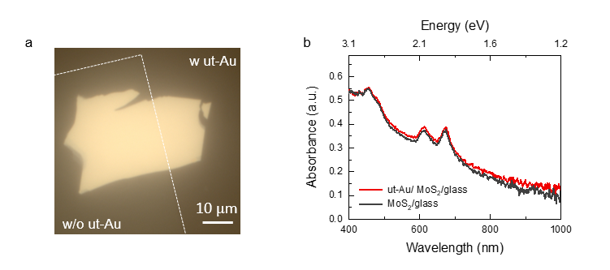
Fig. S2. a. Optical microscopy of MoS₂ on a transparent substrate, with part of its surface deposited with an ultra-thin Au (ut-Au). The white dashed line is the edge of the ut-Au region. b. Absorbance of the same MoS₂ flake with and without ut-Au deposition.

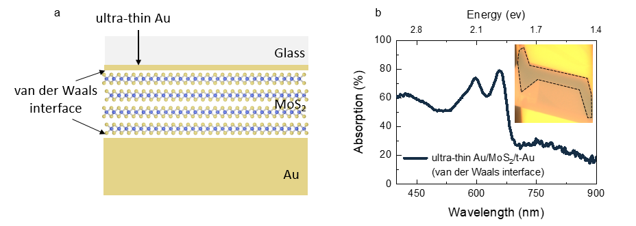
Fig. S3. a. A sample consisting of the same configuration as shown in Fig. 2a, but where the interface between the ultra-thin Au layer and MoS₂ is a van der Waals interface instead of a hybridized interface. b, The absorption spectrum of this sample. Inset shows an optical micrograph of the sample, where the measured region is marked by a dark dashed line.

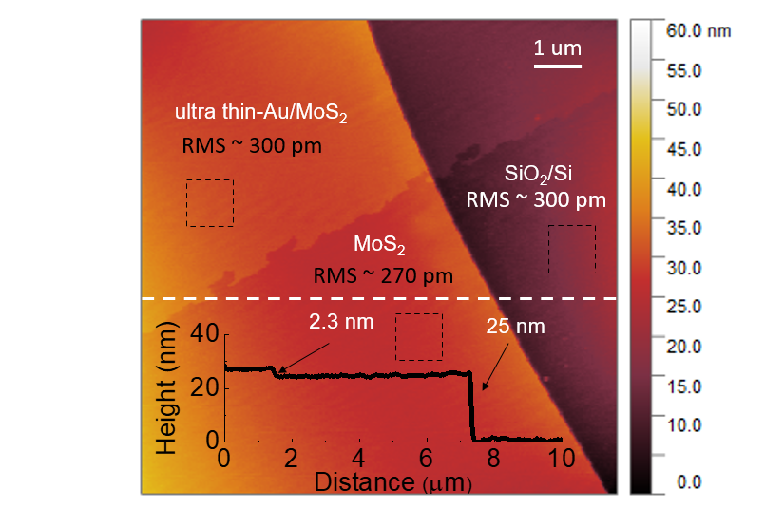
Fig. S4. AFM measurement of ultra-thin Au deposited onto MoS₂ on a SiO₂/Si substrate, demonstrating the ultra-flat Au surface. Inset shows the 2.3 nm thickness of the ultra-thin Au film as measured from the line profile shown by the white dashed line. The regions of dashed black rectangles are used to get the roughness information.

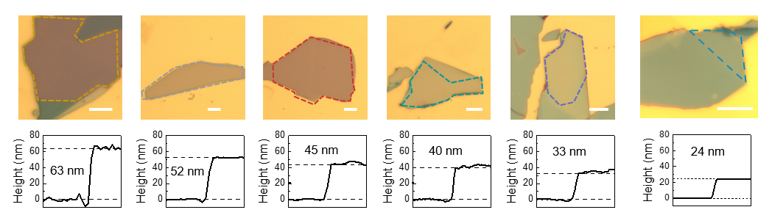
Fig. S5. Optical micrographs (top) and AFM height profiles (bottom) for five samples with thickness ranging from 24–63 nm, corresponding to the Fig.2a and Fig. 2b absorption data. The top MoS₂ layer was hybridized via deposition of ultra-thin Au, as in Fig. 2a. scale bar: 10 μm.

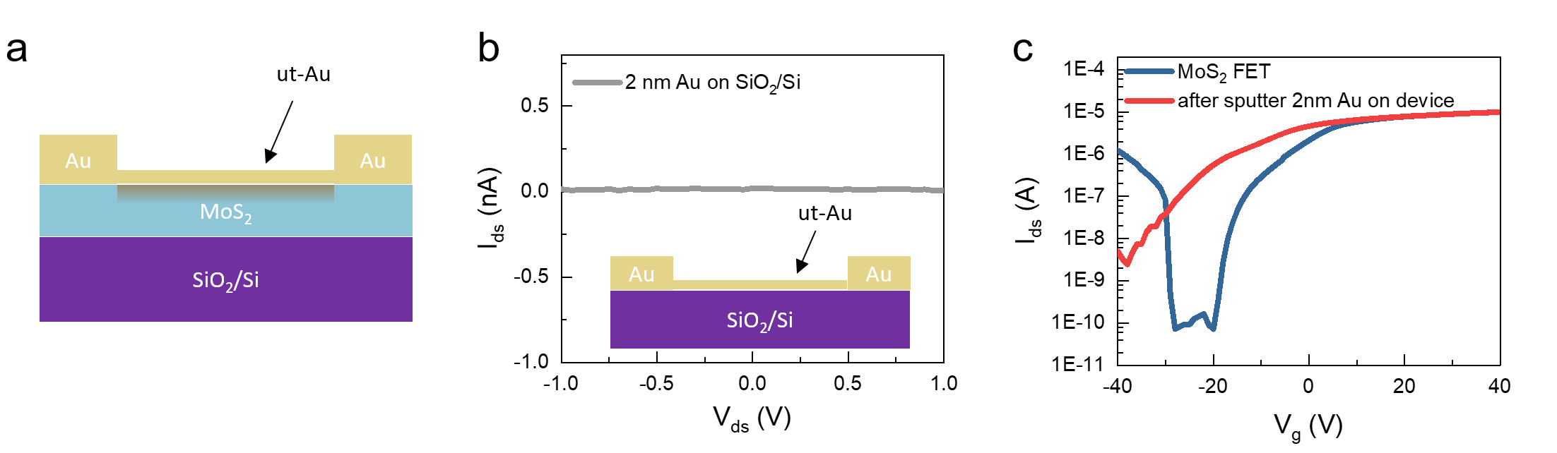
Fig. S6. a Schematic of a field effect transistor (FET) fabricated with MoS₂ after ultrathin Au deposition. b I-V curve of ultra-thin Au on the SiO₂/Si substrate, showing negligible current flow. c The transfer curve before and after ultrathin -Au deposition on the MoS₂ FET device, demonstrating strong n-doping after deposition.

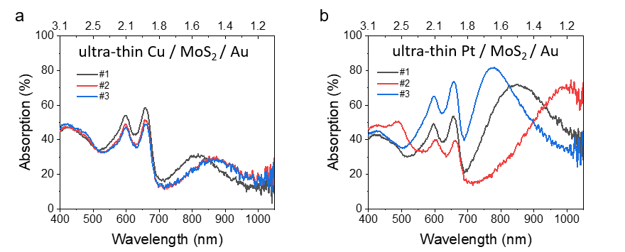
Fig. S7. Absorption spectra of a ultra-thin Cu/MoS₂/Au and b ultra-thin Pt/MoS₂/Au with different MoS₂.

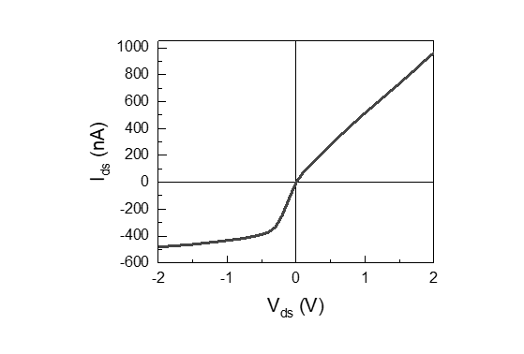
Fig. S8. Photocurrent mapping of the sample shown in Fig. 3a demonstrates an asymmetric shape, which can be attributed to the built-in junctions in the MoS₂ and different Schottky junctions in the two electrodes.

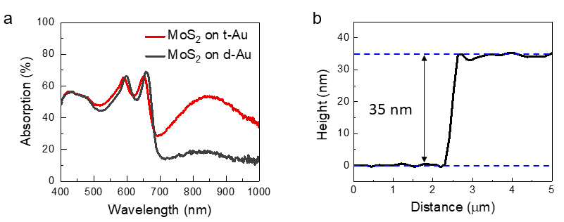
Fig. S9. a Absorption spectra of MoS₂ on top of transferred Au (t-Au) and sputter-deposited Au (d-Au) in the device shown in Fig. 3a. b The thickness of the MoS₂ consisted in the device in Fig. 3a.

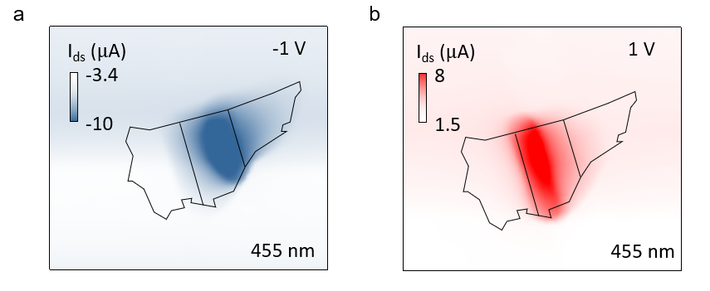
Fig. S10. Photocurrent mapping data of the sample from Fig. 3a under a 455-nm laser with a bias voltage of a, -1 V and b, 1 V.

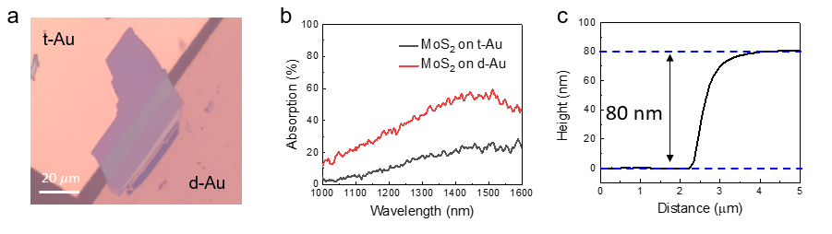
Fig. S11. a Optical micrograph of the sample measured in Fig. 4. b Absorption spectra from the MoS₂ on t-Au and d-Au of the device. c The thickness of the MoS₂ consisted in the device in Fig. S11a. Need to mention that the thickness of MoS₂ for 1550 nm absorption is 80 nm, and it is slightly larger than the thickness obtained in the Fig. 2c, which can be ascribed to the additional Glass/PMMA transparent substrate in the light path in our device.

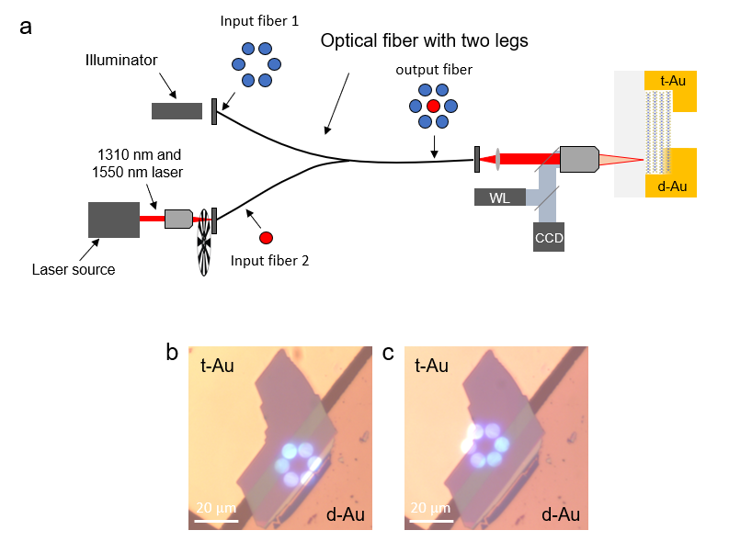
Fig. S12. a Experimental setup for localized 1,310-nm and 1,550-nm photocurrent measurement. An optical fiber with two legs was used to deliver the 1,310-nm and 1,550-nm illumination, which cannot be detected by the CCD camera on our optical microscope system. The six white light beam assists the position of NIR light. b, c Optical micrographs of the targeted NIR illumination on MoS₂/d-Au and MoS₂/t-Au, respectively.

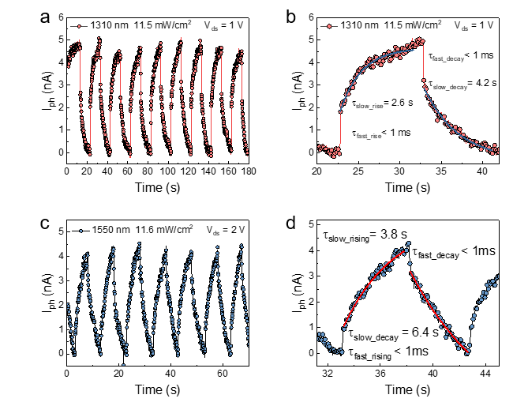
Fig. S13. a Time-dependent photocurrent of the sample from Fig. 4 exposed to 1,310 nm illumination at 11.5 mW/cm² power density. b Magnified waveform from panel a, demonstrating a fast response rate of < 1 ms and a slow response rate of several seconds. c Time-dependent photocurrent of the sample exposed to 1,550 nm illumination at 11.6 mW/cm² power density. d Magnified waveform from panel c, demonstrating a fast response rate of < 1 ms and a slow response rate of several seconds. The detectivity D* achieved in our device was 8.5*10⁷ Jones at 1550 nm calculated with the equation ${ D}^{*}={{RA}^{1/2}}/{{(2eI_{dark})}^{1/2}},$ where R is the responsivity, A is the active area, e is the unit electron charge, I_{dark} is the dark current. The relatively low detectivity in our device structure is primarily due to the high dark current, which is not reduced via special engineering as our primary focus was to demonstrate the electrode hybridization-induced photocurrent.

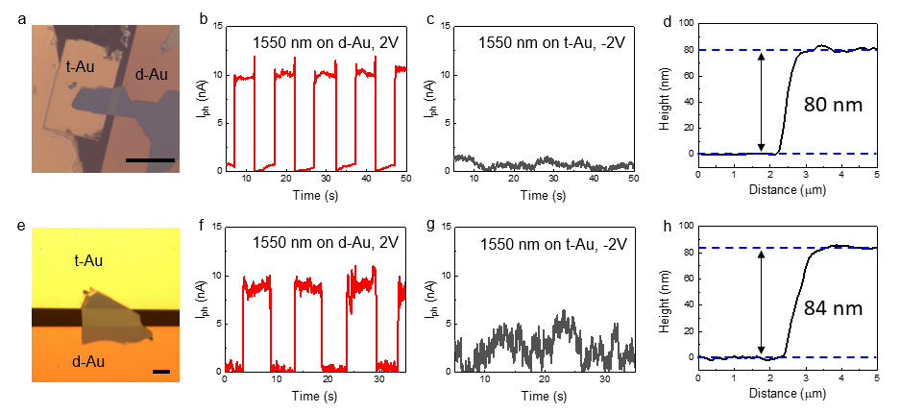
Fig. S14 The photocurrent response under 1550 nm in two additional device fabricated with different sizes of MoS₂ a The OM image of the device consisting of t-Au, d-Au and 80 nm MoS₂. b, c The time-dependent photocurrent under 1550 nm laser illumination on d-Au and t Au respectively. d the AFM thickness data of sample in Fig. 14a. e The OM image of the device consisting of t-Au, d-Au and 84 nm MoS₂. f, g The time-dependent photocurrent under 1550 nm laser illumination on d-Au and t Au respectively. d the AFM thickness data of sample in Fig. S14e. Scale bar: 20 𝜇m. The reproducibility of our results can be confirmed with the additional two devices with different sizes as shown in Fig. S14, which exhibited high photocurrent under 1550 nm light in d-Au and negligible photocurrent under t-Au side. We assert that our approach is highly robust since interface hybridization occurs inevitably during the deposition process, except the special deposition method is adopted², leading to an increase in photocurrent generation at the electrode interface and resulting in sub-bandgap photocurrent.

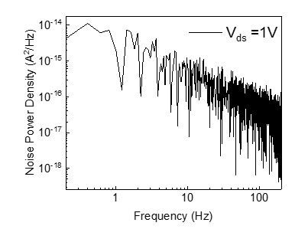
Fig. S15 Noise equivalent power of the device. The relatively high dark current is due to the lack of additional engineering such as electrical doping in our MSM device.³

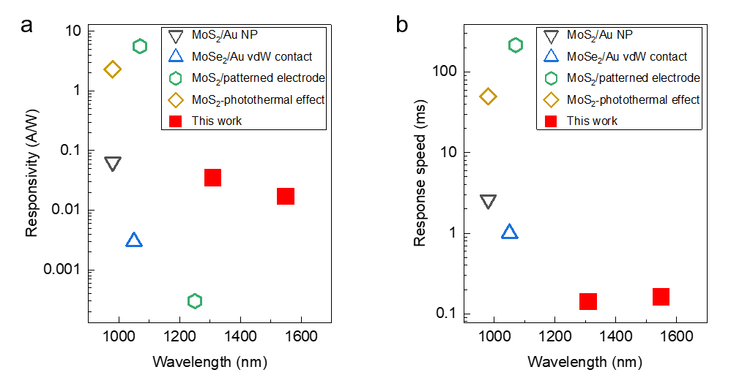
Fig. S16 Comparison of responsivity a and response speed b for various TMD material-based sub-bandgap photodetectors, including hot electron photodetectors and photothermal effect-induced photodetector, at different IR wavelengths⁴⁻⁷. We only included papers that showed both responsivity and photocurrent response speed.

Reference
1 Liu, X. et al. Highly efficient broadband photodetectors based on lithography-free Au/Bi2O2Se/Au heterostructures. Nanoscale 11, 20707-20714 (2019).
2 Wang, Y. et al. P-type electrical contacts for 2D transition-metal dichalcogenides. Nature 610, 61-66 (2022).
3 Pak, S. et al. Electrode-Induced Self-Healed Monolayer MoS(2) for High Performance Transistors and Phototransistors. Adv Mater 33, e2102091 (2021).
4 Guo, J. et al. Near-infrared photodetector based on few-layer MoS2 with sensitivity enhanced by localized surface plasmon resonance. Applied Surface Science 483, 1037-1043 (2019).
5 Li, X. et al. High performance sub-bandgap photodetection via internal photoemission based on ideal metal/2D-material van der Waals Schottky interface. Nanoscale 13, 16448-16456 (2021).
6 Wang, W. et al. Hot Electron-Based Near-Infrared Photodetection Using Bilayer MoS2. Nano Lett 15, 7440-7444 (2015).
7 Mao, Y. et al. Self‐Powered High‐Detectivity Lateral MoS2 Schottky Photodetectors for Near‐Infrared Operation. Advanced Electronic Materials 7, 2001138 (2021).

