Figure 1 SRI 4 at 24 weeks 4
Figure 2 SRI 4 at 52 weeks 5
Figure 3 SRI 5 at 24 weeks 6
Figure 4 SRI 5 at 52 weeks 6
Figure 5 SRI 6 at 24 weeks 7
Figure 6 SRI 6 at 52 weeks 8
Figure 7 SRI 7 at 24 weeks 8
Figure 8 SRI 7 at 52 weeks 9
Figure 9 SRI 8 at 24 weeks 9
Figure 10 SRI 8 at 52 weeks 10
Figure 11 BICLA at 24 weeks 10
Figure 12 BICLA at 52 weeks 11
Figure 13 Complete and partial renal remission at 1 year 12
Figure 14 Complete and partial renal remission at 2 years 12
Figure 15 Change in prednisone dosages to ≤10mg/day 13
Figure 16 Change in prednisone dosages to ≤7.5mg and >25% reduction from baseline dosage 14
Figure 17 Adverse events 16
Figure 18 Serious adverse events 18
Figure 19 Death 20
Figure 20 Infectious adverse events 22
Figure 21 Serious infectious adverse events 24
Figure 22 Grade 3 or higher infectious events 24
Figure 23 Infusion related adverse events 26
Figure 24 Withdrawal due to adverse events 28
Figure 25 Withdrawal due to serious adverse events 28
Figure 26 Treatment related adverse events 29
Figure 27 Serious treatment related adverse events 30

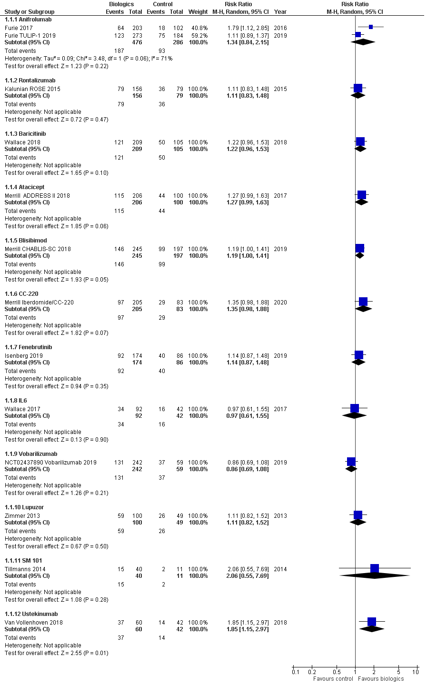
Figure 1 SRI 4 at 24 weeks

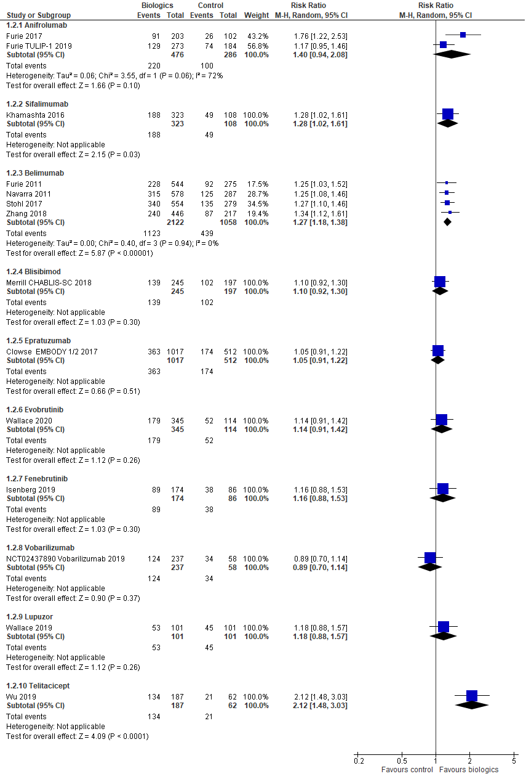
Figure 2 SRI 4 at 52 weeks
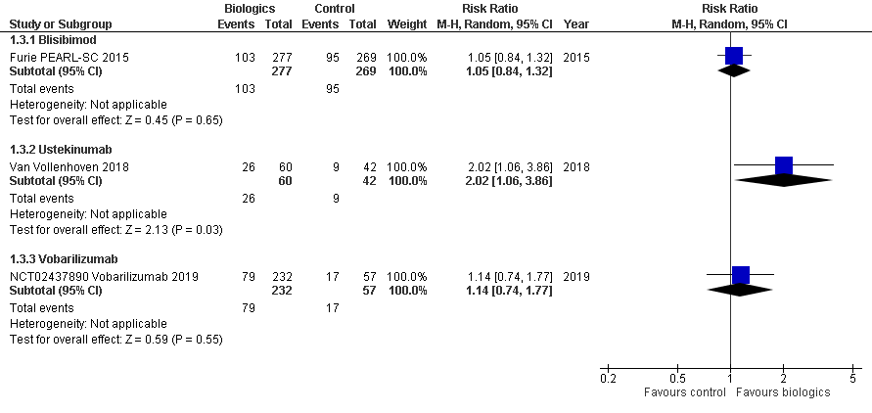
Figure 3 SRI 5 at 24 weeks

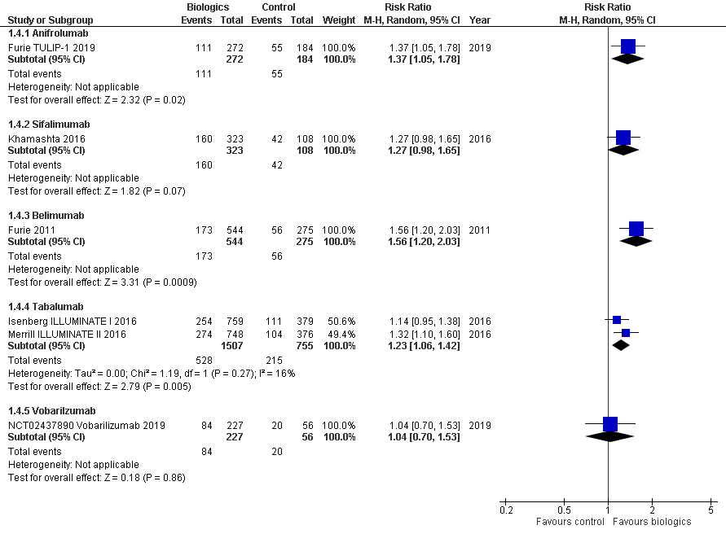
Figure 4 SRI 5 at 52 weeks

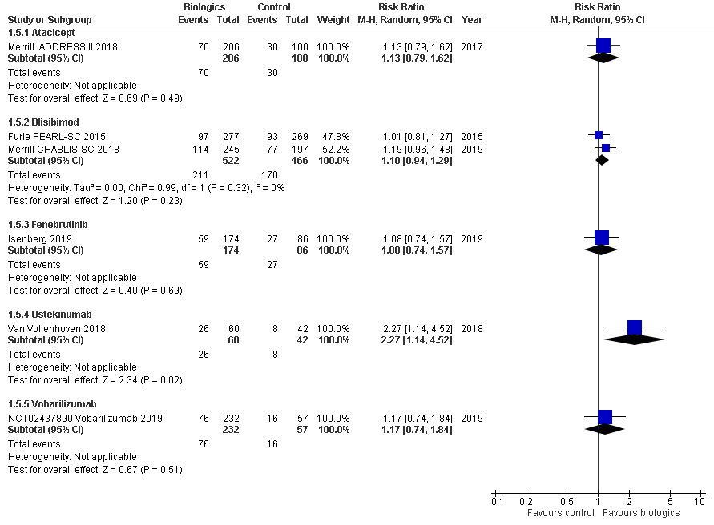
Figure 5 SRI 6 at 24 weeks

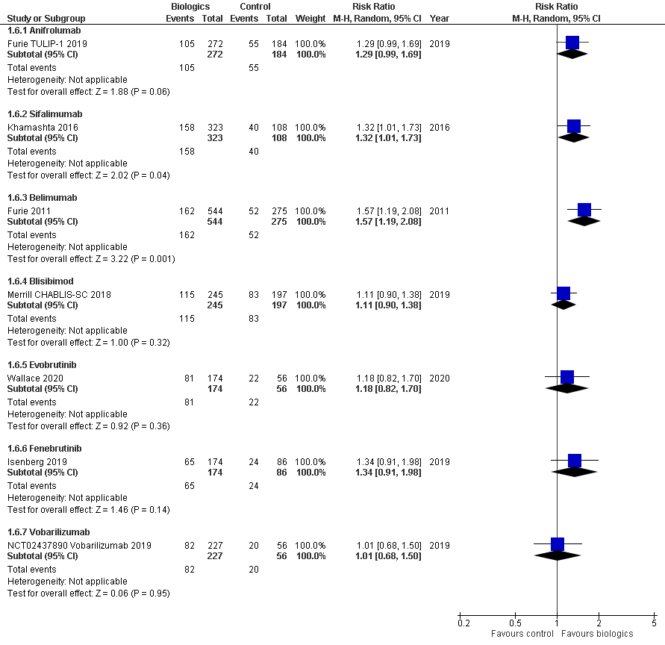
Figure 6 SRI 6 at 52 weeks

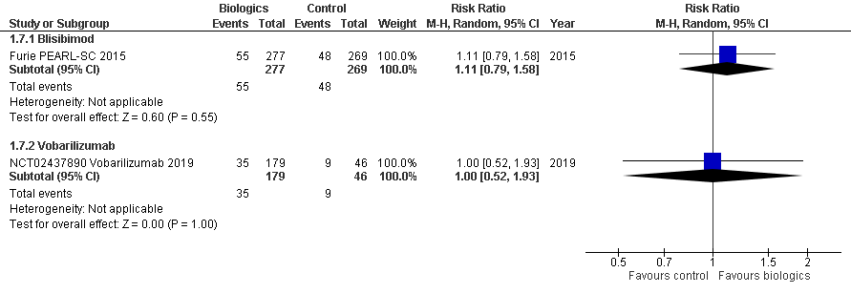
Figure 7 SRI 7 at 24 weeks

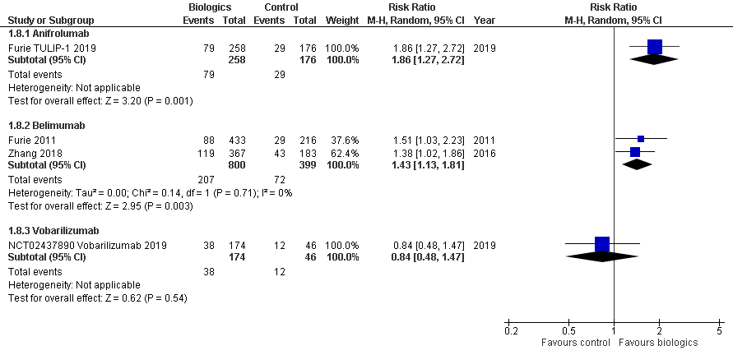
Figure 8 SRI 7 at 52 weeks

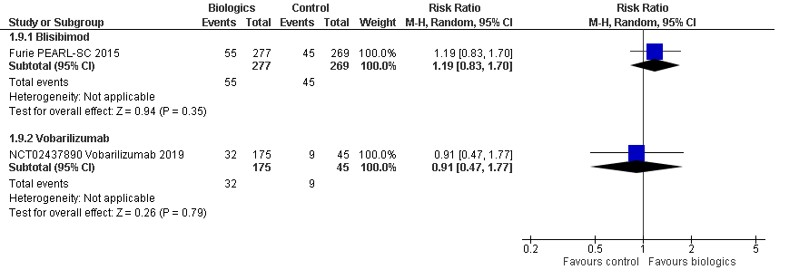
Figure 9 SRI 8 at 24 weeks

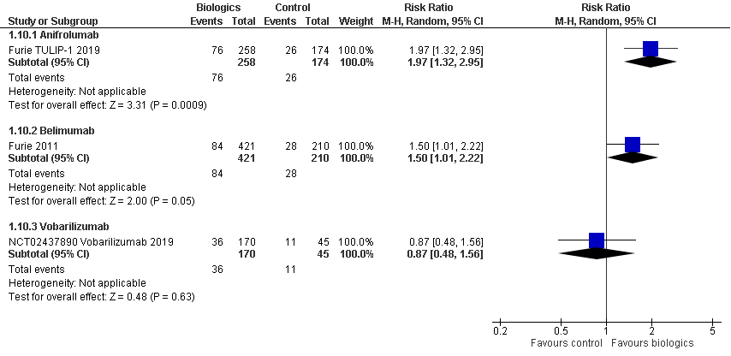
Figure 10 SRI 8 at 52 weeks

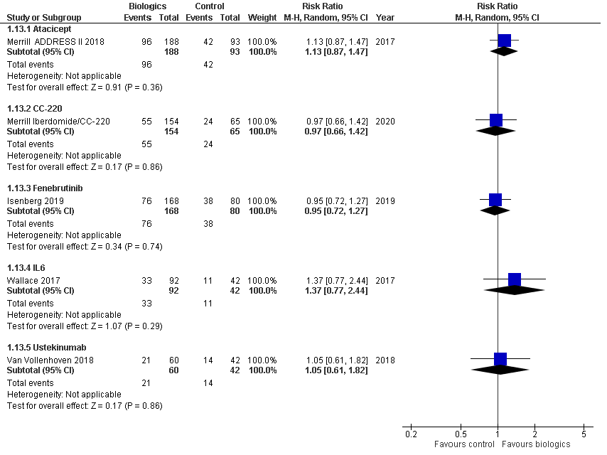
Figure 11 BICLA at 24 weeks

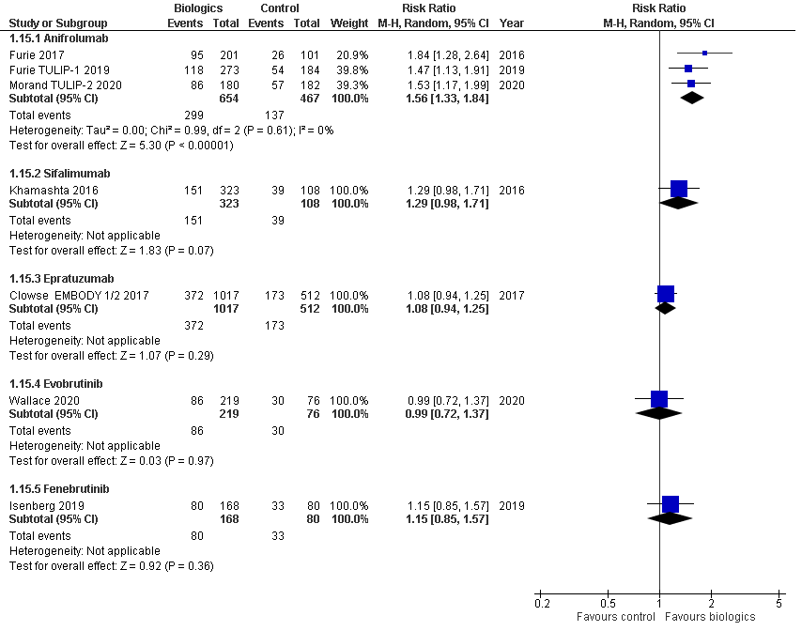
Figure 12 BICLA at 52 weeks

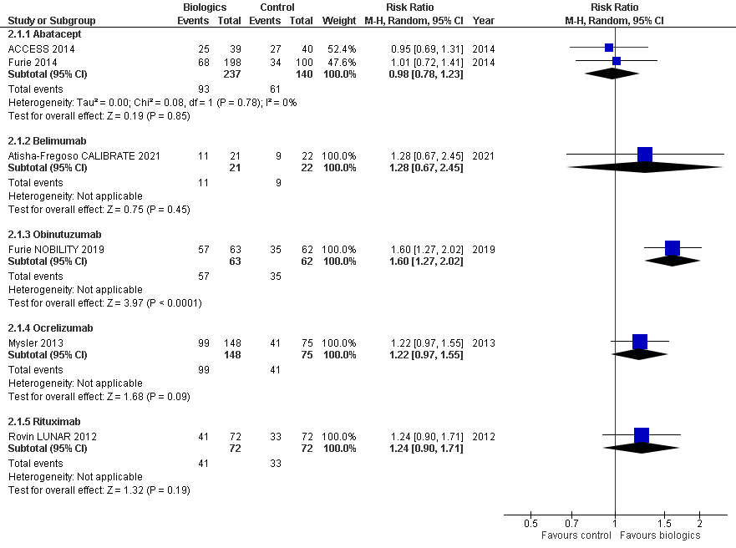
Figure 13 Complete and partial renal remission at 1 year

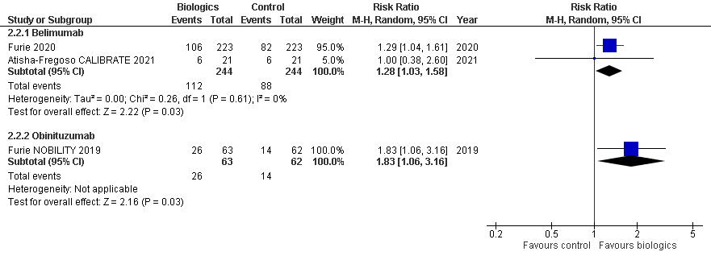
Figure 14 Complete and partial renal remission at 2 years

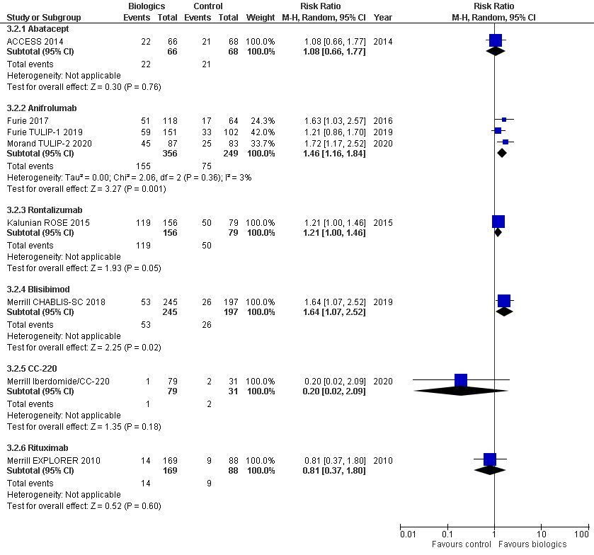
Figure 15 Change in prednisone dosages to ≤10mg/day

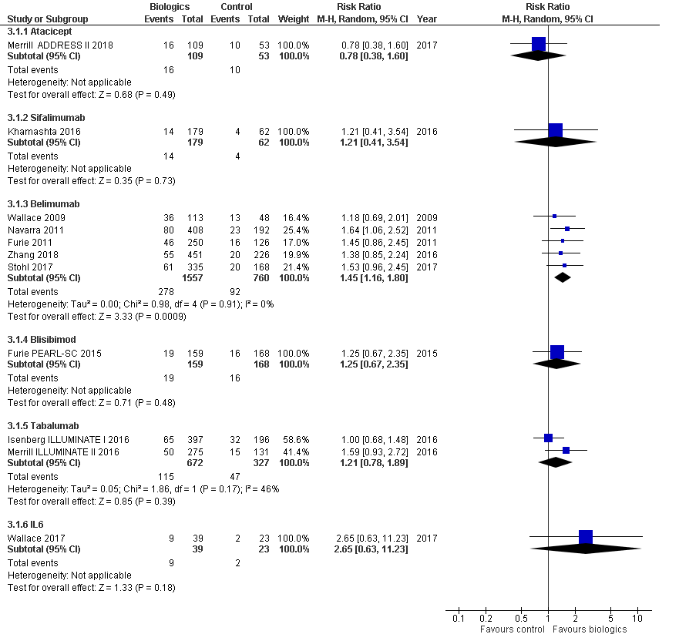
Figure 16 Change in prednisone dosages to ≤7.5mg and >25% reduction from baseline dosage

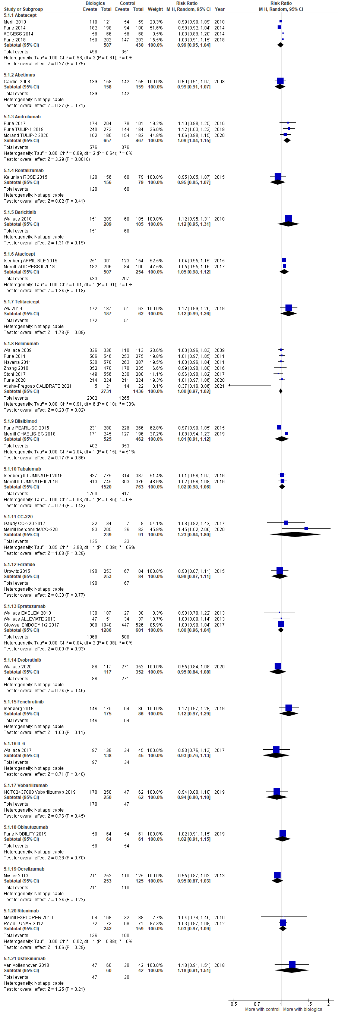
Figure 17 Adverse events

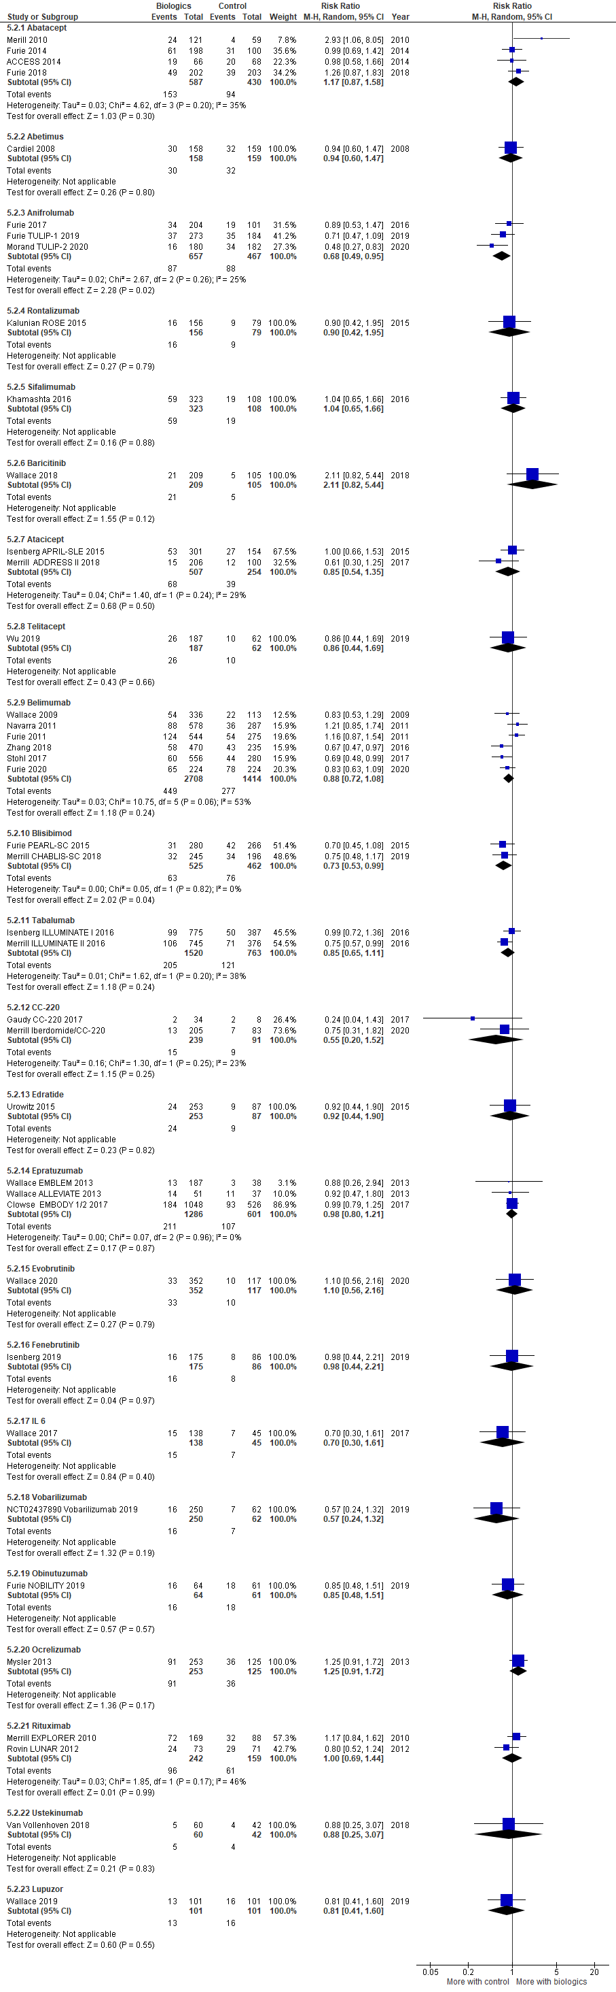
Figure 18 Serious adverse events

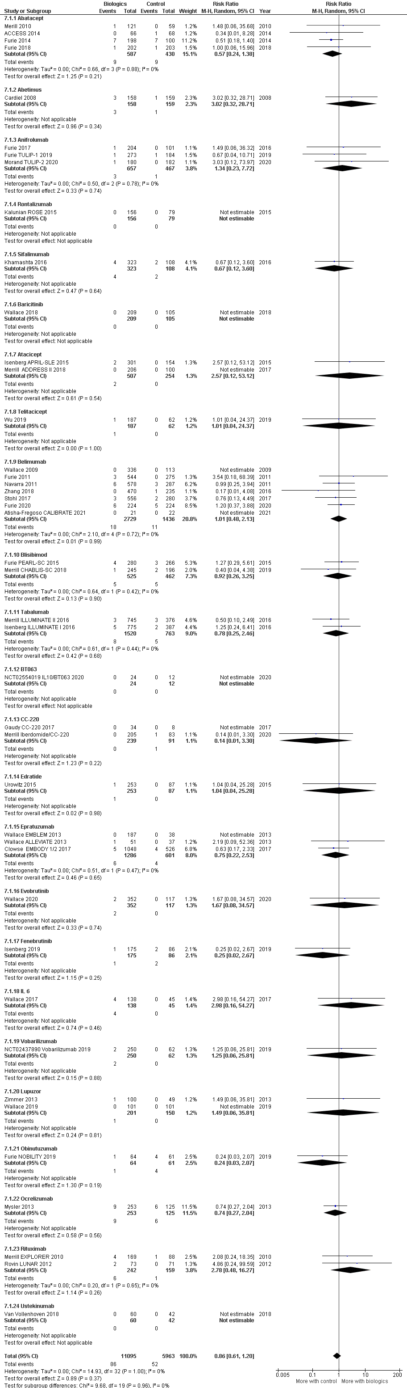
Figure 19 Death

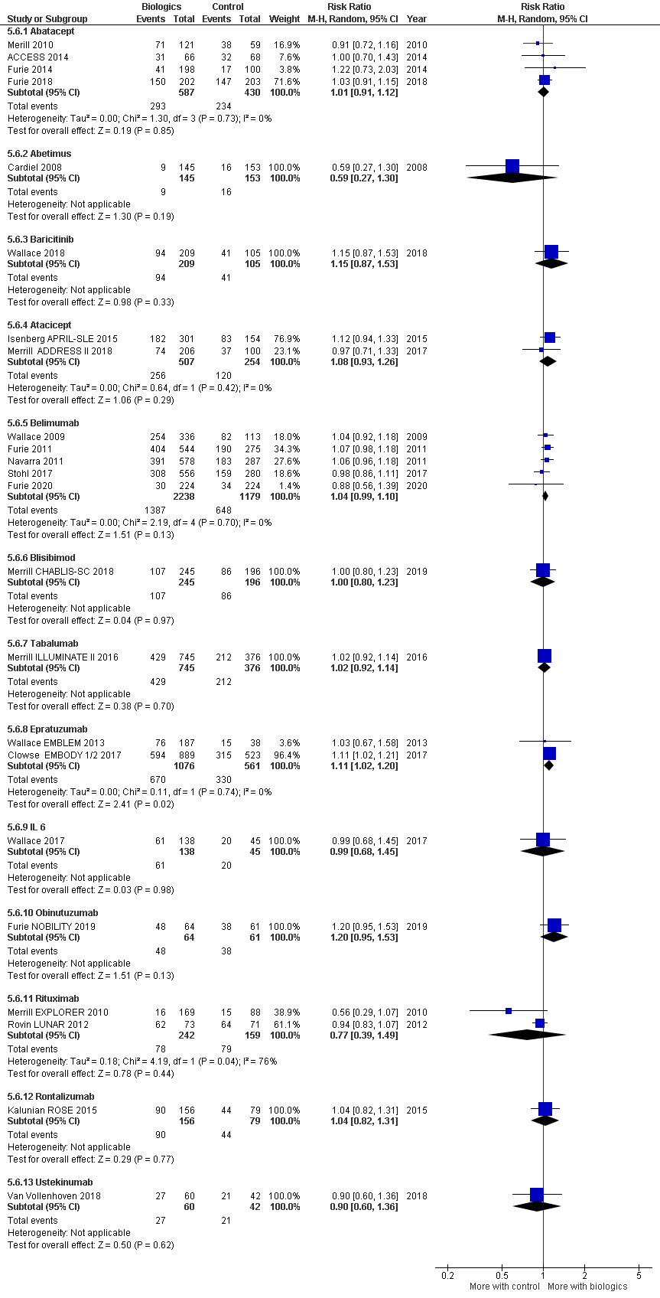
Figure 20 Infectious adverse events

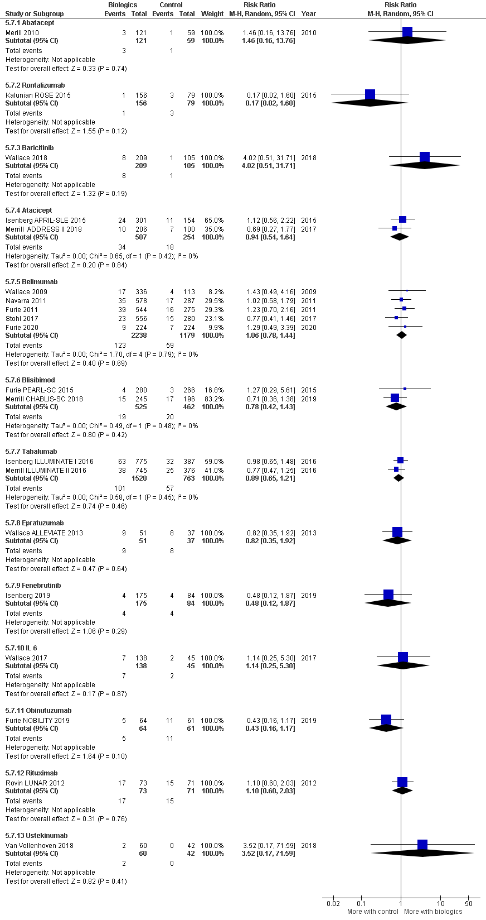
Figure 21 Serious infectious adverse events

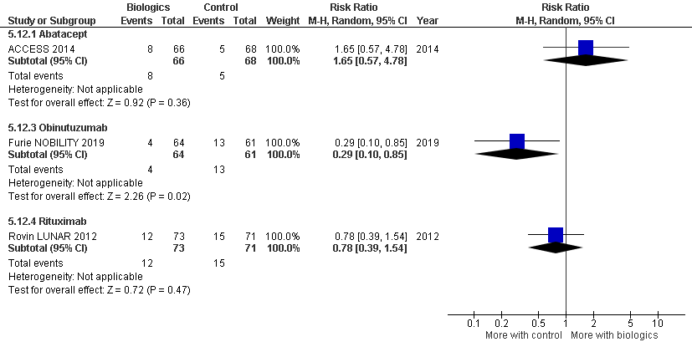
Figure 22 Grade 3 or higher infectious events

Figure 23 Infusion related adverse events

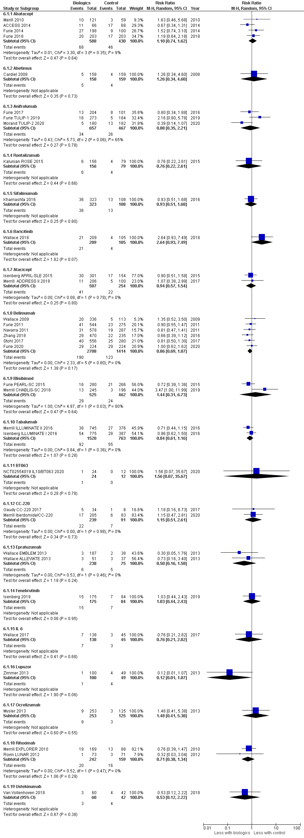
Figure 24 Withdrawal due to adverse events

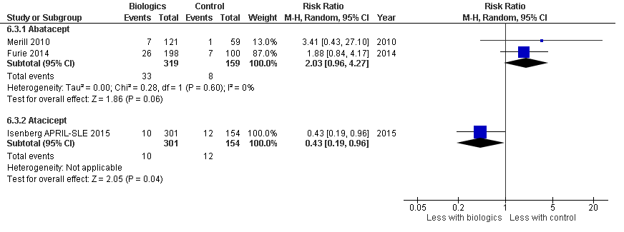
Figure 25 Withdrawal due to serious adverse events

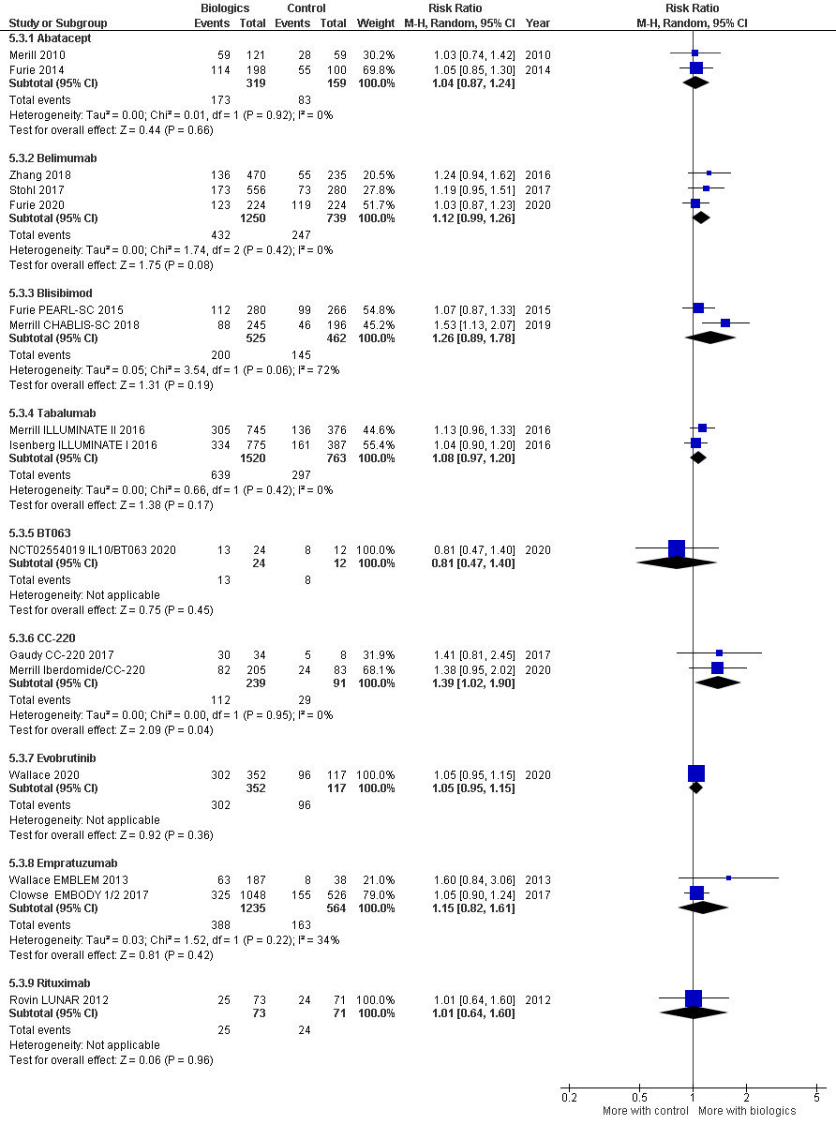
Figure 26 Treatment related adverse events

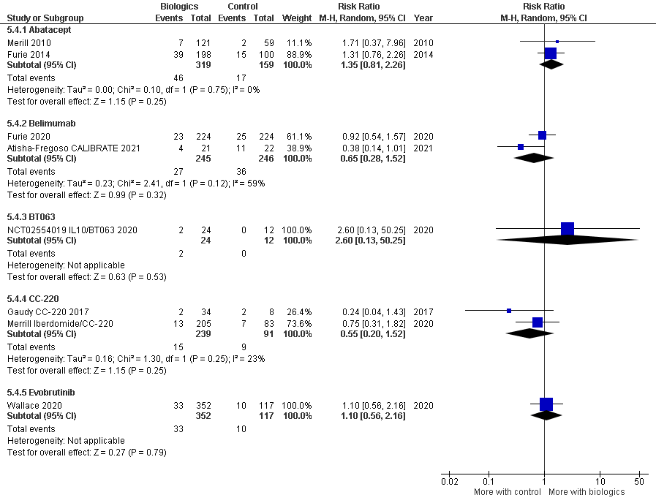
Figure 27 Serious treatment related adverse events

