Supplementary Information

Effectiveness of chelating agent-assisted Fenton-like processes on remediation of glucocorticoid contaminated soil using chemical and biological assessment: performance comparison of CaO₂ and H₂O₂

Yanan Liu¹, Quan Zhou¹, Zhenyu Li¹, Ai Zhang^{1,}*, Jiaxun Zhan¹, Andere Clement Miruka¹, Xiaoting Gao¹, Jie Wang²
(¹ College of Environmental Science and Engineering, Donghua University, 2999 North Renmin Road, Shanghai 201620, China.
² Fishery Machinery and Instrument Research Institute of Chinese Academy of Fishery Sciences, Shanghai 200092, China.)

*Corresponding author: Tel: +86 21 67792538; Fax: +86 21 67792522;
E-mail: aizhang@dhu.edu.cn

11 Pages
5 Texts (S1-S5)
3 Figures (S1-S3)
2 Tables (S1-S2)

Text S1

GC extraction
The soil slurry samples were freeze-dried. The dried pellets were dissolved in 20 mL of methanol and acetate buffer solution (pH 5.0) mixture (90:10, v/v) and ultrasonicated for 30 min and subsequently separated by centrifugation. This was done in triplicate. The supernatants were mixed and followed by solvent evaporation in a rotatory evaporator. After evaporation, the residue was dissolved in 300 mL of water and then extracted with solid phase extraction (SPE). The SPE was performed using an AutoTrace™ 280 SPE device (Dionex, Sunnyvale, CA). 300 mL of the sample was passed through the Oasis Hydrophilic-Lipophilic Balance (HLB, 500 mg/6cc) cartridge (Waters Corporation, Millford, MA), which was preconditioned with 5 mL of methyl tert-butyl ether (MTBE), 5 mL of methanol, and 5 mL of ultrapure water. The samples were loaded onto the cartridges at 10 mL/min, rinsed with 10 mL of ultrapure water, and then dried with a stream of nitrogen for 1 h. The cartridges were then eluted with 10 mL of methanol into a 15 mL glass conical vial.

Text S2

Analysis of GCs by UHPLC
A reversed-phase C-18 column (5 µm, 4.6 mm × 250 mm, Agilent, USA) was used for UHPLC analysis. For analysis of FA, TA, and CP, the injection volume of UHPLC was 50 μL and the flow rate was 1 mL min⁻¹. A wavelength of 240 nm was used for UV detection at a temperature of 40 ºC. The separation was performed under gradient elution conditions using (A) acetonitrile and (B) water. The solvent program used for GCs was as follows: initial conditions 72 % B kept isocratic for 3min, then linearly reduced to 40 % B over 1 min, then linearly decreased to 30 % B over 4 min, and then linearly decreased to 0 % over 0.5 min, and then kept isocratic for 1.5 min. The retention time of FA, TA and CP were about 6.2, 7.6 and 8.7 min, respectively. The concentrations of GCs were calculated using the equations derived from the calibration measurements for internal standards. The removal efficiency was calculated using the following relation:
$$\text{Removal Efficiency}\left(\text{\%}\right)\text{=}\frac{{\text{C}}_{\text{0}}\text{-}{\text{C}}_{\text{t}}}{{\text{C}}_{\text{0}}} \text{×} \text{100\%}$$
where C₀ and C_{t} are the initial and the final concentration of GCs, respectively.

Text S3

Molecular analysis of microbial communities
First, the samples were processed for DNA extraction using the E.Z.N.A.® Soil DNA kit (Omega Bio-Tek, USA). Amplicon liberates were constructed for pyrosequencing using the bacterial primer sets 338F (5′-ACTCCTACGGGAGGCAGCAG-3′) and 806R (5′-GGACTACHVGGGTWTCTAAT-3′) for the V3-V4 variable regions of the 16s RNA gene. After purification and quantification, the sample amplicons were sequenced on an Illumina Miseq platform (Majorbio Bio-Pharm Technology Co., Ltd., Shanghai, China). The raw sequences data have been deposited with the accession number SRP198736 (https://www.ncbi.nlm.nih.gov/Traces/sra_sub/). The high-quality sequences were clustered into operational taxonomic units (OTUs) using UPARSE (http://drive5.com/uparse). Rarefaction curves were based on OTUs for the comparison of each sample. Alpha diversity measurements including abundance-based coverage estimator (ACE), Chao, Sobs, Shannon, Simpson and Good’s coverage indexes were calculated in MOTHUR (http://www.mothur.org). Beta diversity was calculated by an unweighted pair-group method that used the arithmetic mean to obtain the distance matrix by QIIME (http://qiime.org). Beta diversity was visualized for hierarchical clustering analysis with R software.

Text S4

Seed germination analysis
The tested seeds were placed inside a germination chamber (Binder, KBWF 240, USA) equipped with day light fluorescent lamps (10000 Lux per light cassette) and incubated at constant temperature (20 ºC) and constant humidity (70 %). The first 48 h were carried out in darkness, followed by 16 h of light alternated with 8 h of darkness. The total germination period was 6 d, and on the sixth day the germination rate was recorded. Radicle protrusion for 1 mm was considered as germination. Simultaneously, the shoot length was measured with a vernier caliper by hand. Subsequently, the plants were dried overnight in an oven at 80 ºC and the dry weight was measured.

Text S5

EPR analysis
EPR was used for detection of free radicals. 5 μL of phosphate buffered saline (50 mM, pH = 7.4), 5 μL of DMPO (0.9 M), and 10 μL of soil samples were mixed and put in a quartz capillary and EPR measurements were conducted. The X-band EPR spectra were recorded in the original single TE₁₀₂ (ER 4102 ST) rectangular cavity using a field-modulated CW Bruker ER 200 D SRC EPR spectrometer coupled with an Aspect 2000 computer. The EPR spin trapping experiment using DMPO was performed at 290 K. The high-frequency modulation (100 kHz) was performed using two Helmholtz coils mounted in the left and right walls of the cavity. The sample was placed in thin-walled quartz EPR tubes (internal diameter of 3 mm, length of 150 mm, and wall thickness approximately 0.1 mm) to produce cylindrical samples with identical dimensions. The EPR spectra of the samples were recorded with modulation amplitude of 1 G and microwave power of 6.4 mW. The other EPR spectrometer settings in the spin trapping experiments were: center field 3337 G; sweep width, 500 G; sweep time, 60 s; microwave frequency, 9.37 GHz.

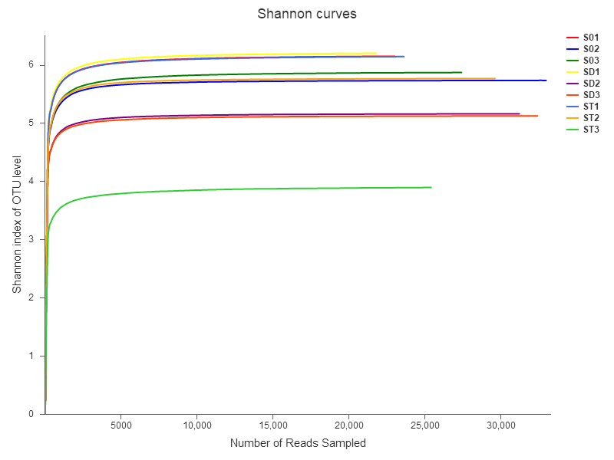

Fig. S1 Shannon curves based on OUT level

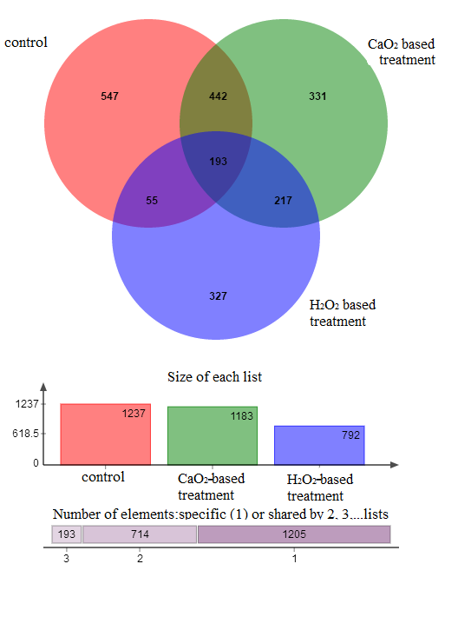

Fig. S2 Venn diagram based on OUT level from Control, H₂O₂/Fe(III)/CA (H₂O₂-based) and CaO₂/Fe(III)/CA (CaO₂-based) treatments (oxidant dosage = 1.11 mmol/g, Fe(III)= 0.28 mmol/g, CA= 0.56 mmol/g)
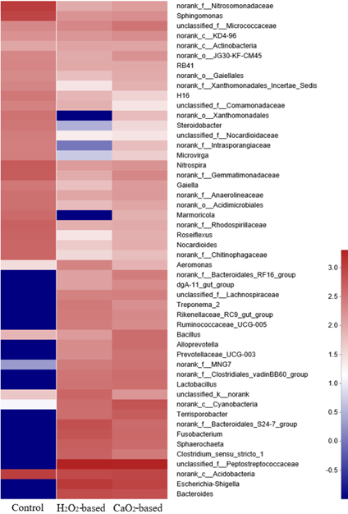
Fig. S3 The composition of microbial communities on genus level in soil samples of control, H₂O₂/Fe(III)/CA (H₂O₂-based) and CaO₂/Fe(III)/CA (CaO₂-based) treatments (oxidant dosage = 1.11 mmol/g, Fe(III)= 0.28 mmol/g, CA= 0.56 mmol/g)

Table S1 Experimental Design
Experimental objective | Experimental conditions
Effects of oxidant (H₂O₂ or CaO₂) type and treatment time on GC degradation | Adding H₂O₂ or CaO₂ dosages of 0.69 mmol/g into GC polluted soil slurries with molar ratio of oxidant (H₂O₂ or CaO₂):Fe(III):CA fixed at 4:1:2 for 0 - 24 h with pH unadjusted.
Effects of oxidant (H₂O₂ or CaO₂) dosage on GC degradation | Adding various dosages of H₂O₂ or CaO₂ (from 0 to 1.39 mmol/g) into GC polluted soil slurries with molar ratio of oxidant (H₂O₂ or CaO₂):Fe(III):CA fixed at 4:1:2 for 4 h with pH unadjusted.
Effects of CA and Fe(III) dosages on GC removal during CaO₂/Fe(III)/CA oxidation | Adding various molar ratios of CaO₂:Fe(III):CA (from 20:1:2 to 20:10:20) at fixed CaO₂ dosage (1.11 mmol/g) for 4 h with pH unadjusted.
Effects of H₂O₂/Fe(III)/CA and CaO₂/Fe(III)/CA on soil indigenous microorganisms, heavy metal redistribution, and phytotoxicity changes | Experiments were performed at oxidant dosage (H₂O₂ or CaO₂) of 1.11 mmol/g and molar ratio of oxidant (H₂O₂ or CaO₂):Fe(III):CA at 4:1:2 with pH unadjusted.

Table S2 Oxidation-reduction potential (ORP) of soil samples of the Blank, Control, H₂O₂/Fe(III)/CA and CaO₂/Fe(III)/CA treatments (oxidant dosage = 1.11 mmol/g, Fe(III)= 0.28 mmol/g, CA= 0.56 mmol/g)
Treatment | Blank | Control | H₂O₂/Fe(III)/CA | CaO₂/Fe(III)/CA
ORP (mV) | 119±2.0 | 115.5±2.5 | 559±3.0 | 120.5±4.5

