Supplemental data

Statistical post-processing method for evaluating bioaccumulation in fish due to dietary exposure in Japan

Yoshiyuki Inoue · Yuka Koga · Ryoko Takeshige, · Hidekazu Murakami · Takumi Takamura

* Yoshiyuki Inoue
inoue-yoshiyuki@ceri.jp

Chemicals Evaluation and Research Institute, Japan, CERI Kurume, 3-2-7 Miyanojin, Kurume-shi, Fukuoka 839-0801, Japan

R installation procedure and analysis for statistical post-processing method

1. Access the R homepage (https://www.r-project.org/) and click “CRAN” in the “Download” column on the top left of the homepage.
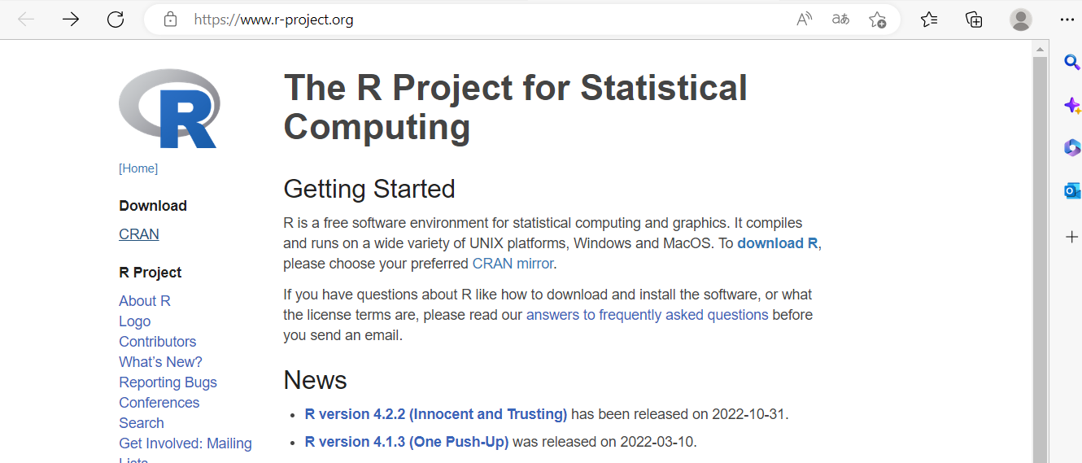

2. Choose a server to use when downloading R for your country.
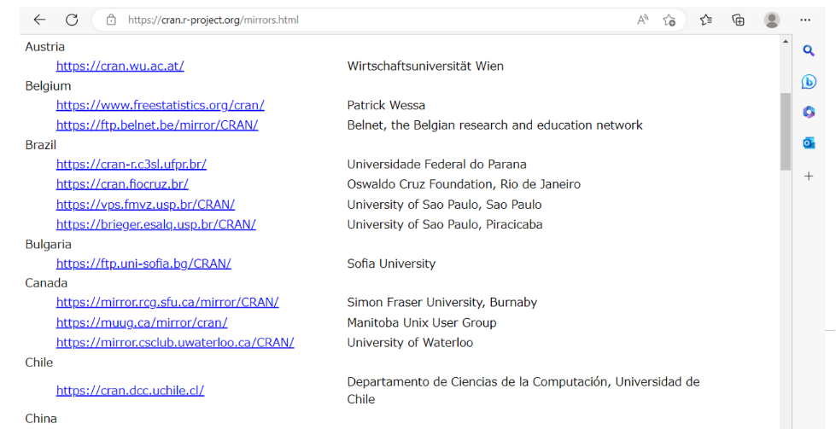

3. Click the download page corresponding to the OS of your PC.

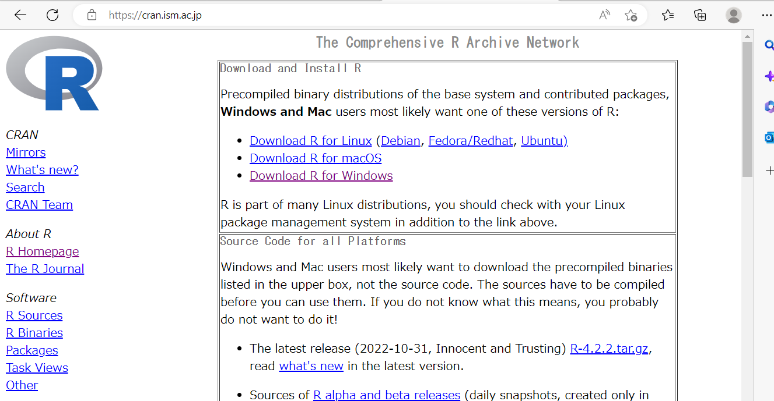

4. Click “install R for the first time” on the right side of the top subdirectory “base”.
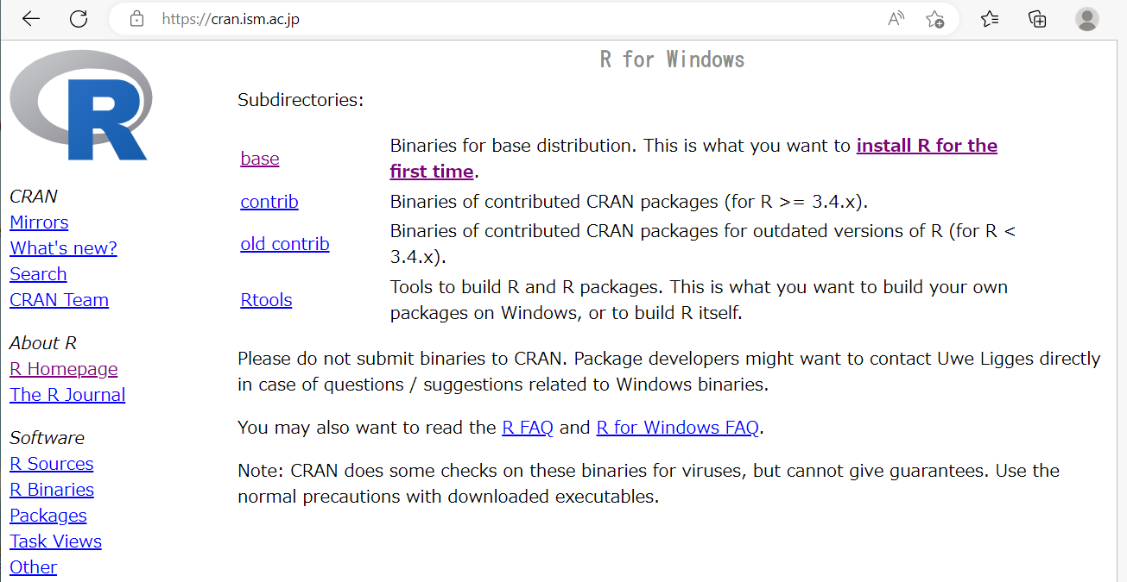

5 Click “Download R-4.2.2 for Windows”. The software for installation (.exe file) will be downloaded. Open it.
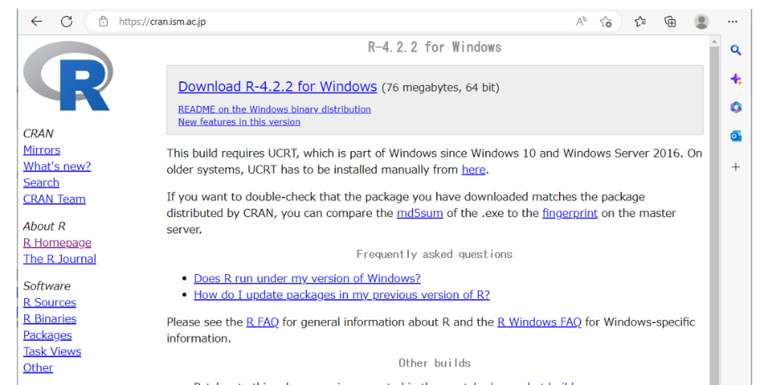

6. Click “Next” until you get to the “Start installation” screen.
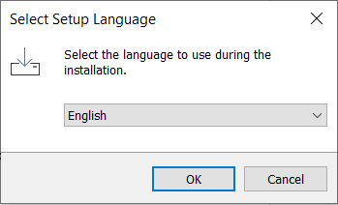

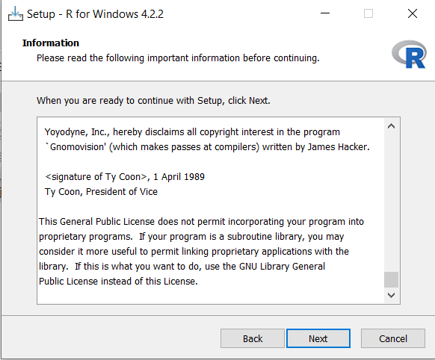

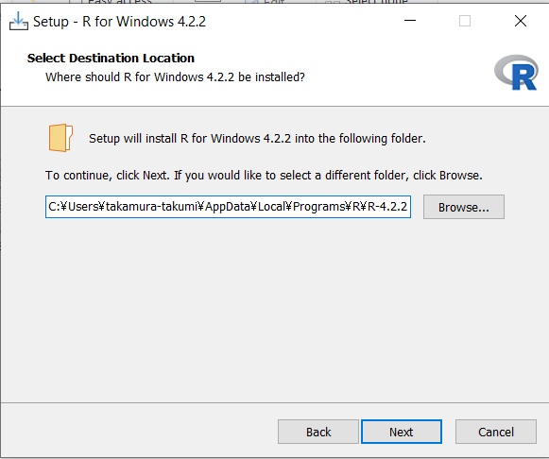

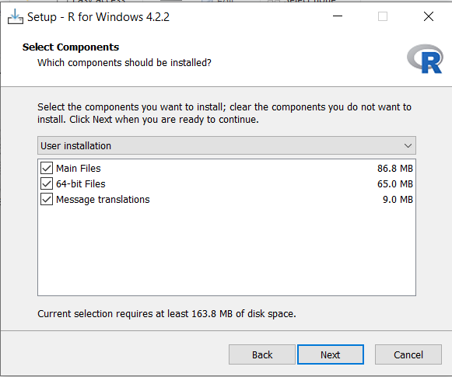

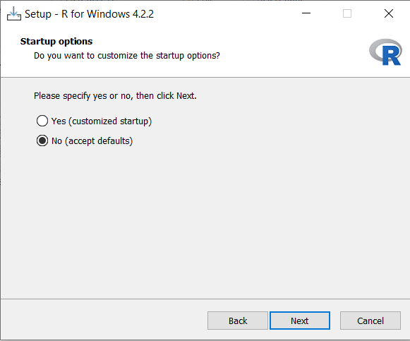

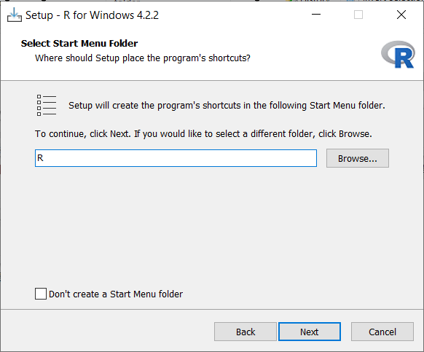

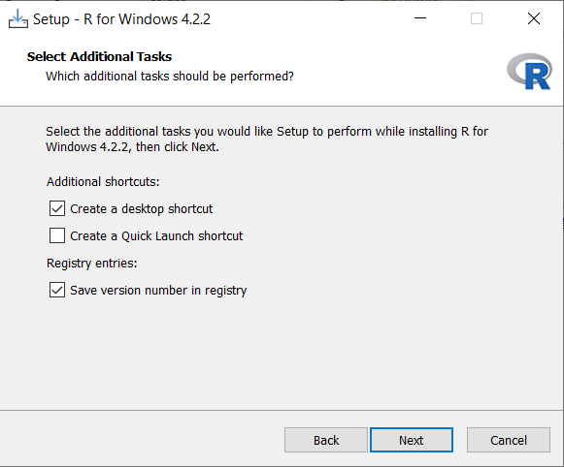

7. When the “Start installation” screen is obtained, perform the installation. When the “Installation complete” button appears, click it to close the screen.
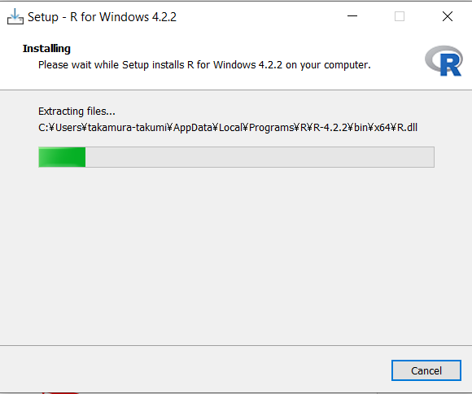

8. Start R, click “File” on the upper left of the toolbar, and click “Open script...”. Open each of the four scripts provided as supplemental data (e.g., “Supplemental data 2-BCF1000_script -Inoue. Y. -OA.R”) in this study.
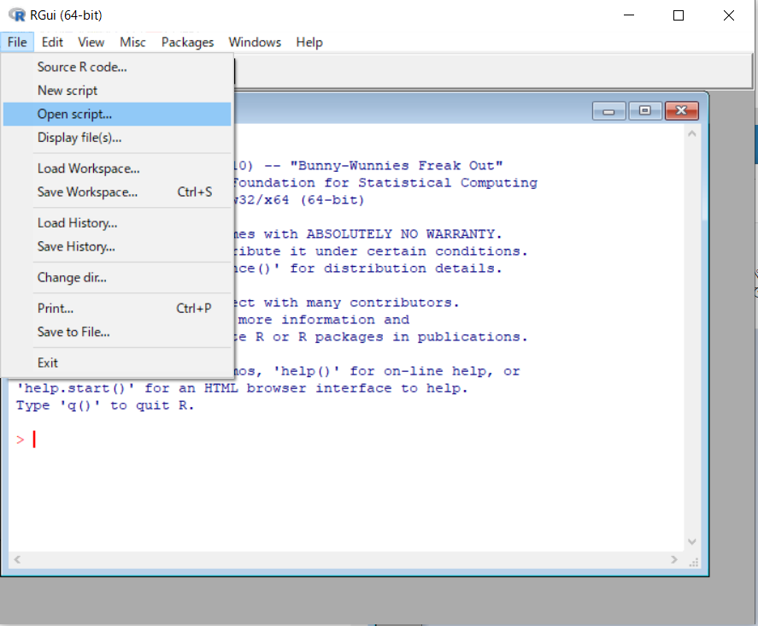

9. After opening the script, select the code to use as shown below, and click “Run line or selection” in the shortcut icon directly below the toolbar.
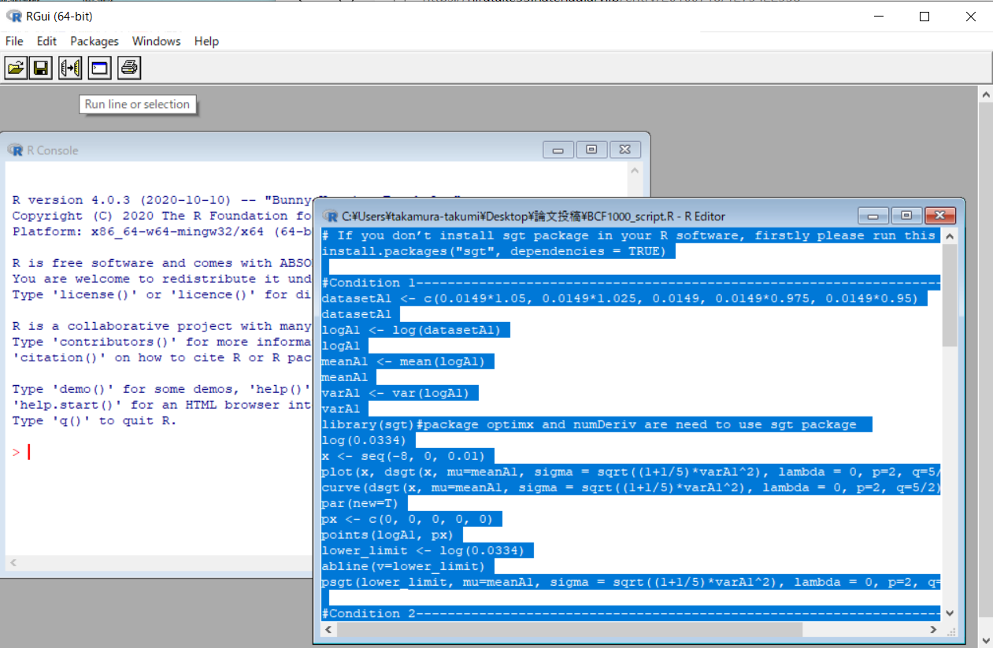

10. If the code of the script works normally, the result will be displayed on the screen as shown in the left
figure below. Red letters are commands, and blue letters are output results. A graph is displayed on the right side of the screen. This analysis is that the case of BMF_{L} = 0.0149 corresponding to BCF_{L} = 1000 L/kg under Condition 4.
