Synthesis of ultra pure Co₃Sn₂S₂ crystals

Senhao Lv^{1,2#}, Hui Guo^{1,3#}, Jiangang Yang^{1,3#}, Ke Zhu^{1,3}, Lin Zhao^{1,3}, Yan Li^{1,3}, Roger Guzman³, Xianghua Kong⁵, Guoyu Xian^{1,3}, Qiuzhen Cheng^{1,3}, Qi Zheng^{1,3}, Li Huang^{1,3}, Yuqing Xing^{1,3}, Hui Chen^{1,3}, Zhen Zhao^{1,3}, Qi Qi^{1,3}, Lulu Pan^{1,3}, Linxuan Song², Chengmin Shen^{1,3}, Dongliang Zhao², Xiao Lin³, Stephen J. Pennycook³, Wu Zhou³, Wei Ji⁶, Jun He²*, Xingjiang Zhou^{1,3}*, Haitao Yang^{1,3,4}*, and Hong-Jun Gao^{1,3,4}*

¹ Beijing National Center for Condensed Matter Physics and Institute of Physics, Chinese Academy of Sciences, Beijing 100190, PR China
² Division of Functional Material Research, Central Iron & Steel Research Institute, Beijing 100081, PR China
³ School of Physical Sciences, University of Chinese Academy of Sciences, Beijing 100049, PR China
⁴ Songshan Lake Materials Laboratory, Dongguan, 523808, PR China
⁵ College of Physics and Optoelectronic Engineering, Shenzhen University, Shenzhen 518060, PR China
⁶ Beijing Key Laboratory of Optoelectronic Functional Materials & Micro-Nano Devices, Department of Physics, Renmin University of China, 100872 Beijing, PR China

#These authors contributed equally to this work
*Correspondence to: hjgao@iphy.ac.cn, htyang@iphy.ac.cn, XJZhou@iphy.ac.cn, hejun@cisri.com.cn
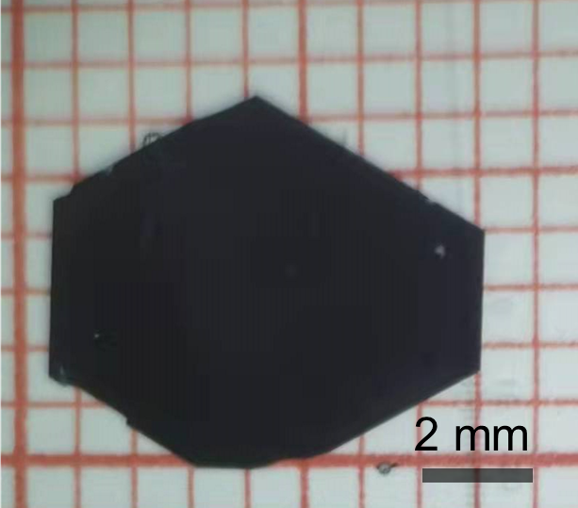

Fig. S1. The maximum size of the as-grown ultra pure Co₃Sn₂S₂ crystal can reach about 8 mm.

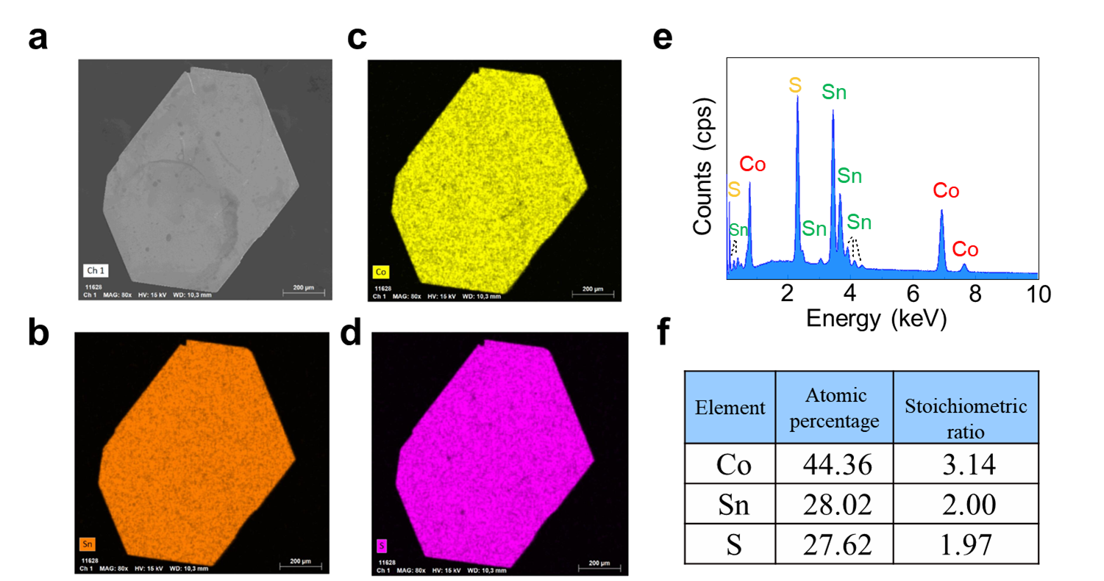

Fig. S2. Structure and element determination of Co₃Sn₂S₂ single crystals. SEM coupled with energy EDX are used to determine the composition of the Co₃Sn₂S₂ crystal obtained by the CS-CVT method. a, The SEM image of a typical hexagonal Co₃Sn₂S₂ crystal obtained by the CS-CVT method. b,d, The SEM-EDX elemental mapping of Co, Sn and S, respectively. e,f, The elemental analysis performed using the SEM-EDX. The EDX collected in multiple regions showing the chemical composition of Co:Sn:S close to 3:2:2.

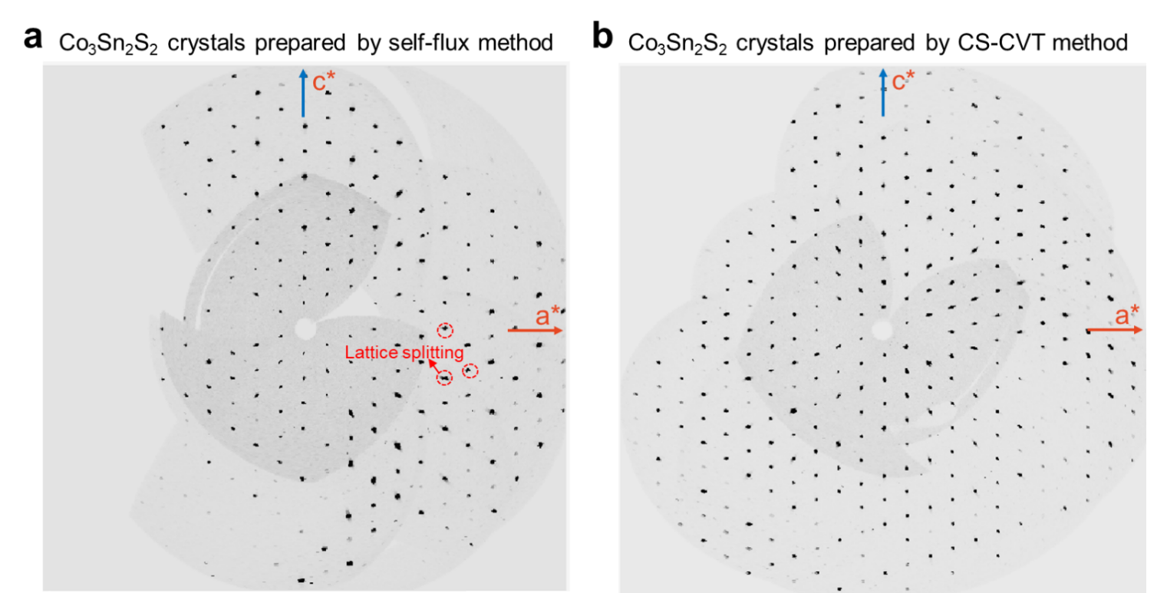

Fig. S3. X-ray single crystal diffraction. h0l plane diffraction patterns of the Co₃Sn₂S₂ crystals prepared by self-flux method (a) and the CS-CVT method (b), showing much more split diffraction spots in the Co₃Sn₂S₂ samples prepared by self-flux method and sharper diffraction spots in the Co₃Sn₂S₂ crystals prepared by CS-CVT method.

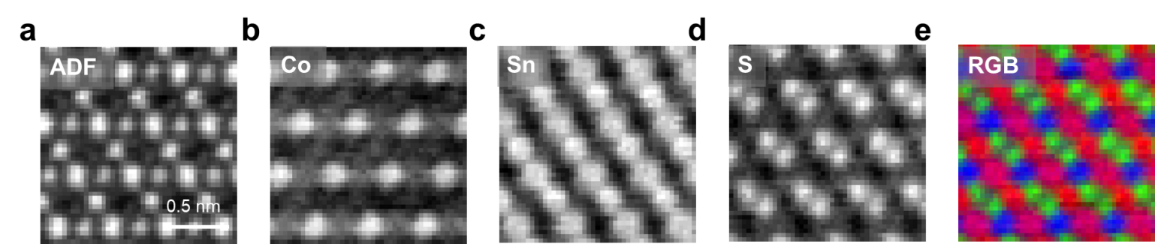

Fig. S4. EELS chemical mapping of Co₃Sn₂S₂ crystals. a-e, EELS chemical mapping of the Co-L, Sn-M and S-L edges simultaneously acquired with the ADF image, showing the elemental distribution. The RGB map is a false colored image including all the elements: Co (blue), Sn (red), S (green).

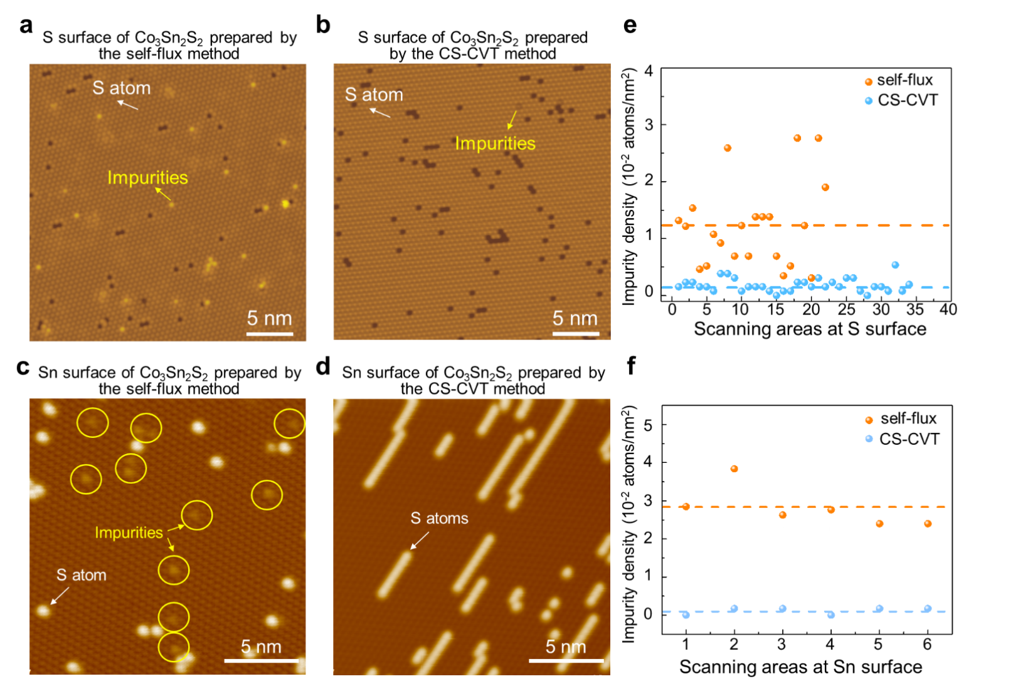Fig. S5. Typical STM images on the Sn and S surface of different Co₃Sn₂S₂ crystals. a,b, Typical STM images on the S surface of the Co₃Sn₂S₂ crystal obtained by the self-flux method (a) (30 nm × 30 nm, Scanning bias U= -4 V, current I= 1 nA) and the Co₃Sn₂S₂ crystal obtained by the CS-CVT method (b) (30 nm × 30 nm, Scanning bias U=-1 V, current I=1 nA). c,d Typical STM images on the Sn surface of the Co₃Sn₂S₂ crystal obtained by the self-flux method (c) and the Co₃Sn₂S₂ crystal obtained by the CS-CVT method (d) (Scanning bias U = -400 mV, current I = 0.1 nA). The S adatoms and impurities are labelled. e,f, Statistics of impurities in the two samples by calculating the impurities in the STM images obtained at randomly-selected regions. For the S surface (e): the average density of impurities in the Co₃Sn₂S₂ crystal obtained by the self-flux method is 1.2×10⁻² atoms/nm², which is 6.7 times higher than that of the Co₃Sn₂S₂ crystal obtained by the CS-CVT method (1.8×10⁻³ atoms/nm²). For the Sn surface (f): the average density of impurities in the Co₃Sn₂S₂ crystal obtained by the self-flux method is 2.8×10⁻² atoms/nm², which is 25.5 times higher than that of the Co₃Sn₂S₂ crystal obtained by the CS-CVT method (1.1×10⁻³ atoms/nm²).

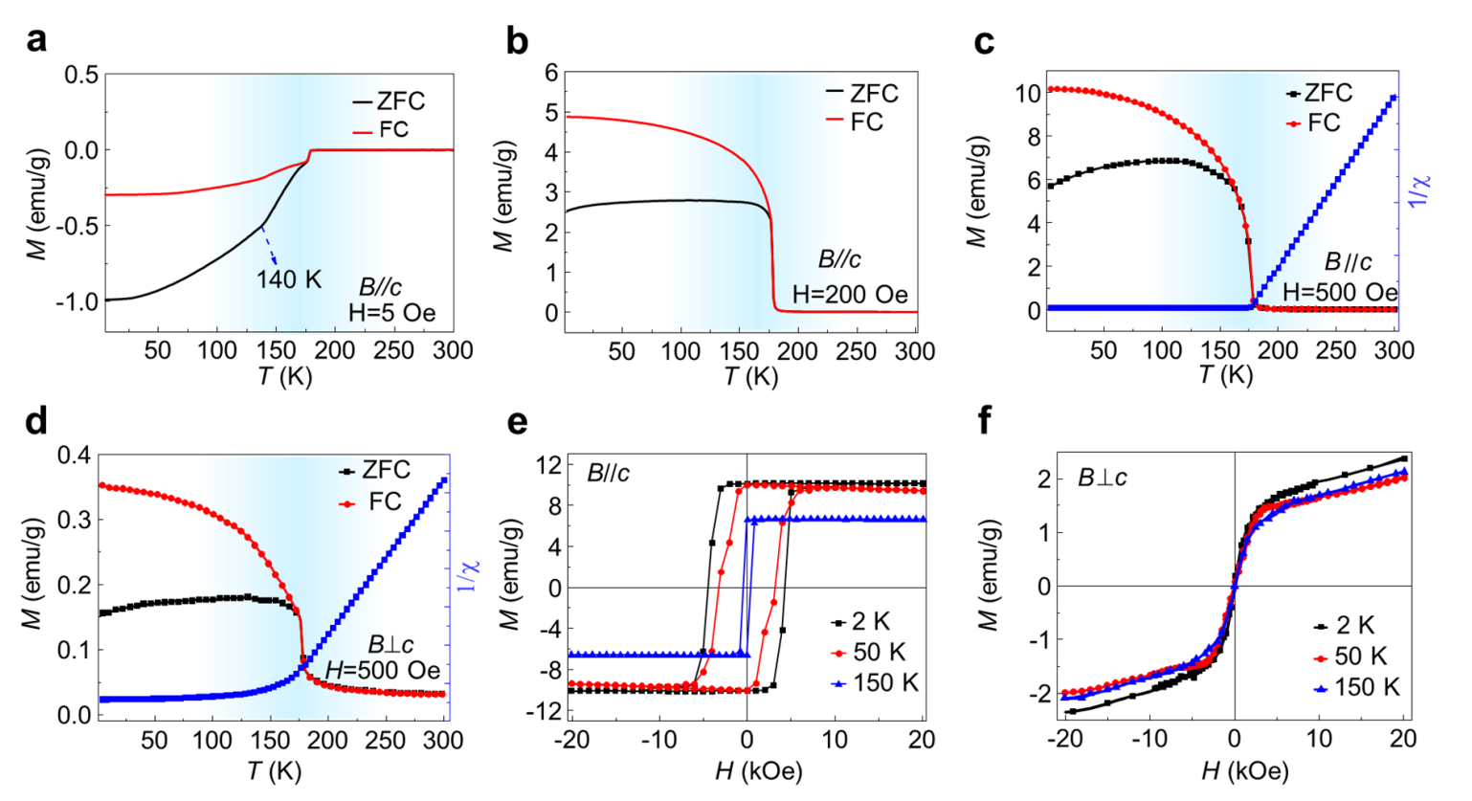
Fig. S6. Temperature-dependent magnetization measurements of Co₃Sn₂S₂ crystals. a-b, Temperature dependence of magnetization with ZFC and FC procedures of the Co₃Sn₂S₂ crystal obtained by the CS-CVT method under different magnetic fields paralleled to c axis, showing the different behaviors under 5 and 200 Oe. c,d, ZFC/FC measurements on the temperature dependence of magnetization under a field of 0.05 T (500 Oe) with the magnetic field along c axis and a axis, and the 1/χ vs temperature behavior for B//c and B⊥ab . 1/χ (T), from 180 to 300 K can be fitted by a modified Curie–Weiss law χ(T)= C/(T – θ_{p}) where C is the Curie constant and θ_{p} is the Weiss temperature. The positive θ_{p} for both B//c and B⊥ab indicates the ferromagnetic interaction in the Co₃Sn₂S₂ crystal obtained by the CS-CVT method. e,f ,The field dependence of magnetization with the field along c-(e) and a-(f) axis at 2 K, 50 K, and 150 K, respectively. The field dependence of out-of-plane magnetization reveals a fairly low saturation magnetization (M_{s}~10.35 emu/g) and a large coercivity (H_{c}~5000 Oe), while the in-plane magnetization shows no sign of saturation in magnetic fields up to 2 T and a small magnetization intensity (about 1/30 of in-plane M_{s} under 2 T at 2 K), suggesting that the Co₃Sn₂S₂ crystal has strong magnetic crystalline anisotropy and the axis of easy magnetization is parallel to the c-axis. The net saturation magnetic moment of 0.3 μ_{B} is calculated based on the out-of-plane M_{s} at 2 K. The field dependence of out-of-plane magnetization at 2, 50 and 150 K reveals a temperature-dependent magnetization behavior, in which M_{s} and coercivity at 150 K decrease to 6.52 emu/g and 500 Oe, respectively.
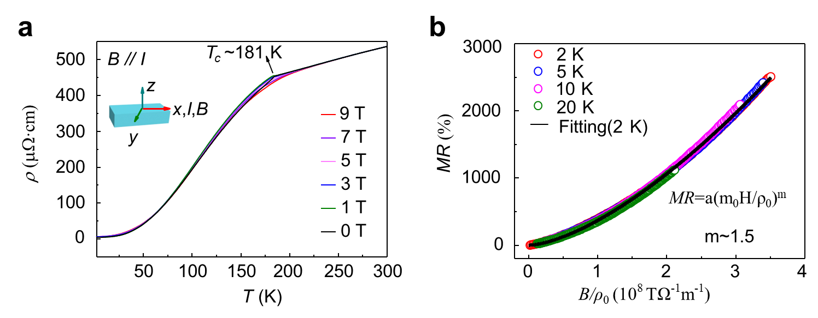

Fig. S7. Magnetoresistance at different temperatures. a, Temperature dependence of the resistivity under different magnetic fields of 0 T, 1 T, 3 T, 5 T, 7 T, and 9 T along the x axis, respectively. b, B/ρ₀ dependence of magnetoresistance at different temperatures, hollow circles with different colors and black solid line representing the experimental data and the fitting curve by Kohler’s rule at 2 K. The fitted m value is approximately 1.5, indicating the as-prepared single crystal has a semi-metallic characteristic.

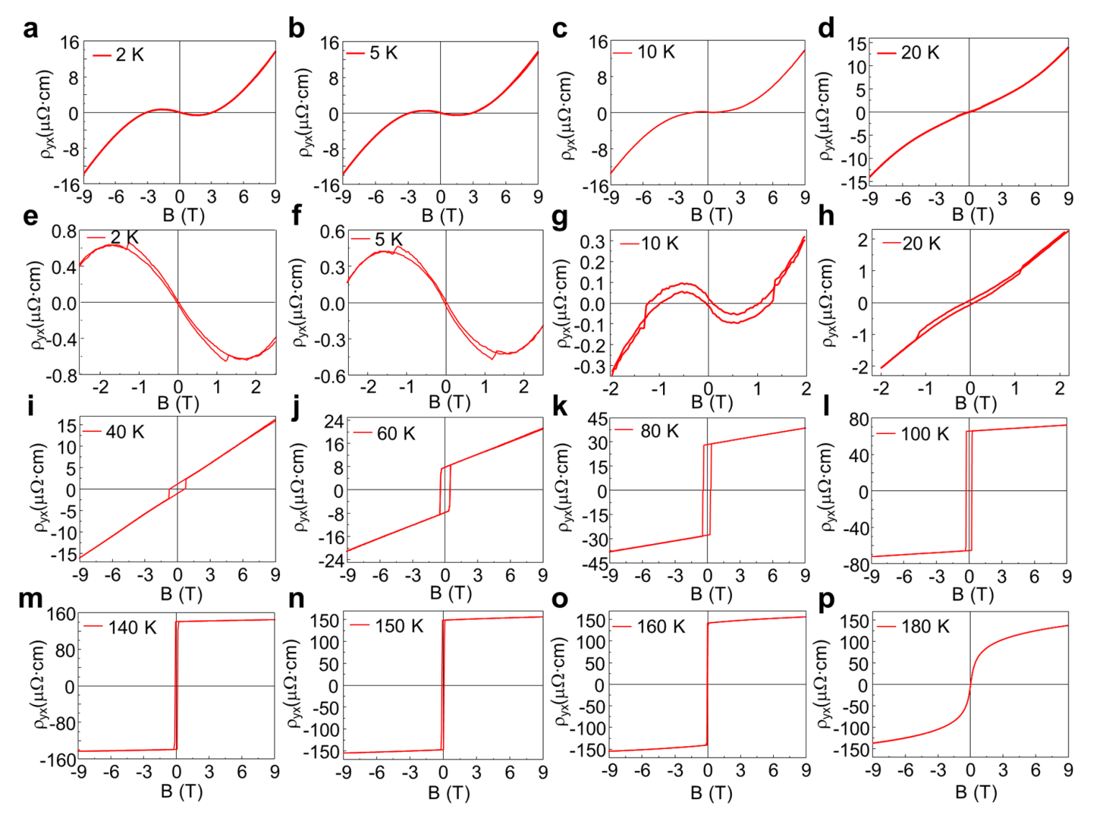

Fig. S8. Magnetic field dependence of Hall resistivity. a-d, i-p, The field-dependent ρ_{yx} measured at different temperatures from 2 K to 180 K in an out-of-plane configuration with B⊥I, showing a maximum of Hall resistivity around 150 K. The coercivity field increases obviously with the decrease of temperature below 180 K. Due to the switching of magnetization and berry curvature, a sharp switch with a rectangular shape occurs in the Hall resistivity loop from 40 K to180 K. The curve of resistivity versus temperature shows a remarkable nonlinear change from 2 K to 20 K, which is attributed to the dual carrier conduction mechanism. e-h, The enlarged parts of (a-d) diagram, showing a significant hysteresis loop at low magnetic fields from 2 K to 20 K.

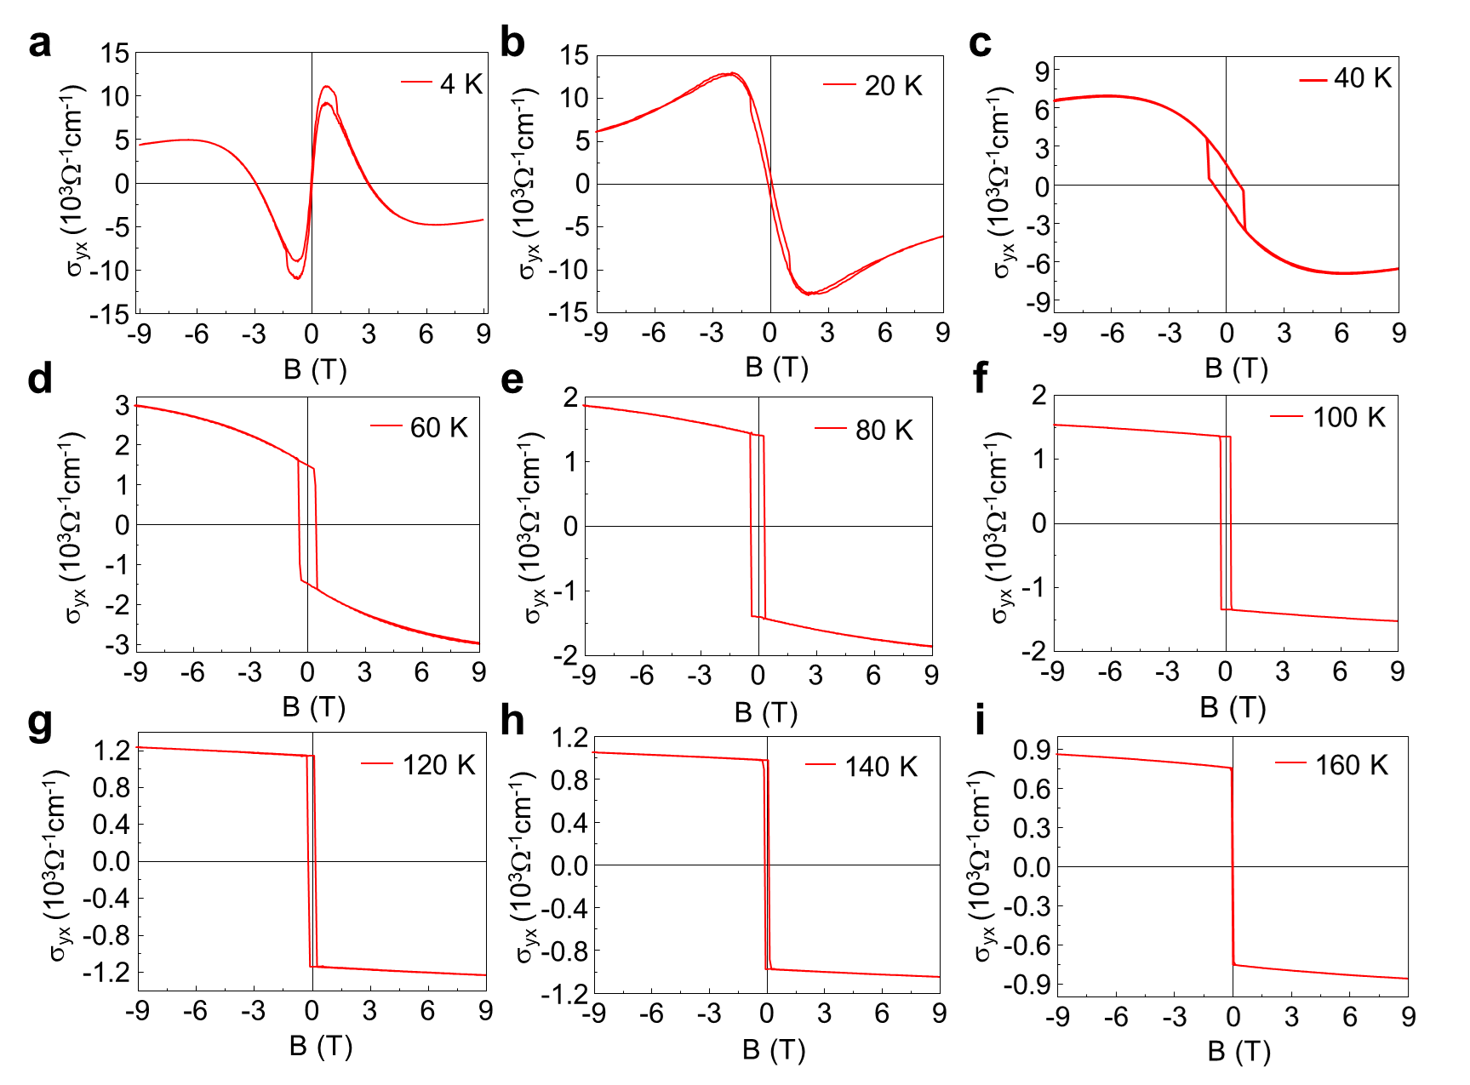

Fig. S9. Magnetic field dependence of Hall conductivity. a-i, The field-dependent σ_{yx} are measured at different temperatures from 2 K to 160 K in an out-of-plane configuration with B⏊I. Magnetic field dependence of the Hall conductivity (σ_{yx}) at various temperatures, showing the coexistence of AHE with the hysteretic behavior and NHE with the nonlinear profile.

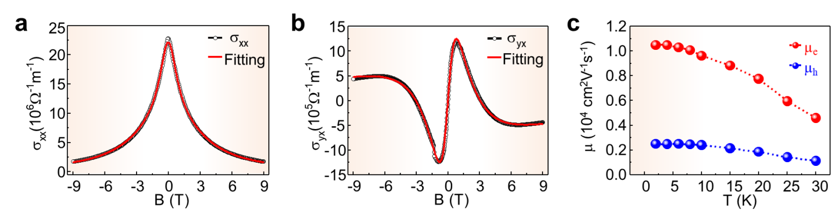
Fig. S10. Two-carrier model fitting. The curves (red) for the longitudinal conductivity (a) and Hall conductivity (b) fitted by the two-carrier model, ${\text{σ}}_{\text{xx}}\left(\text{B}\right)\text{=}\frac{{\text{n}}_{\text{h}}\text{e}{\text{μ}}_{\text{h}}}{\text{1+}{\text{μ}}_{\text{h}}^{\text{2}}{\text{B}}^{\text{2}}}\text{+}\frac{{\text{n}}_{\text{e}}\text{e}{\text{μ}}_{\text{e}}}{\text{1+}{\text{μ}}_{\text{e}}^{\text{2}}{\text{B}}^{\text{2}}}$, ${\text{σ}}_{\text{yx}}\left(\text{B}\right)\text{=}\frac{{\text{n}}_{\text{h}}\text{e}{\text{μ}}_{\text{h}}^{\text{2}}\text{B}}{\text{1+}{\text{μ}}_{\text{h}}^{\text{2}}{\text{B}}^{\text{2}}}\text{+}\frac{{\text{n}}_{\text{e}}\text{e}{\text{μ}}_{\text{e}}^{\text{2}}\text{B}}{\text{1+}{\text{μ}}_{\text{e}}^{\text{2}}{\text{B}}^{\text{2}}}$, showing a good consistence with the experimental data (black) measured at 2 K. The carrier densities and carrier mobility can be deduced. c, Temperature dependence of carrier mobility (μ_{e} and μ_{h}), indicating the maximum mobility of 10490 and 2484 cm⁻²V⁻¹s⁻¹ for electron and hole at 2 K, respectively.

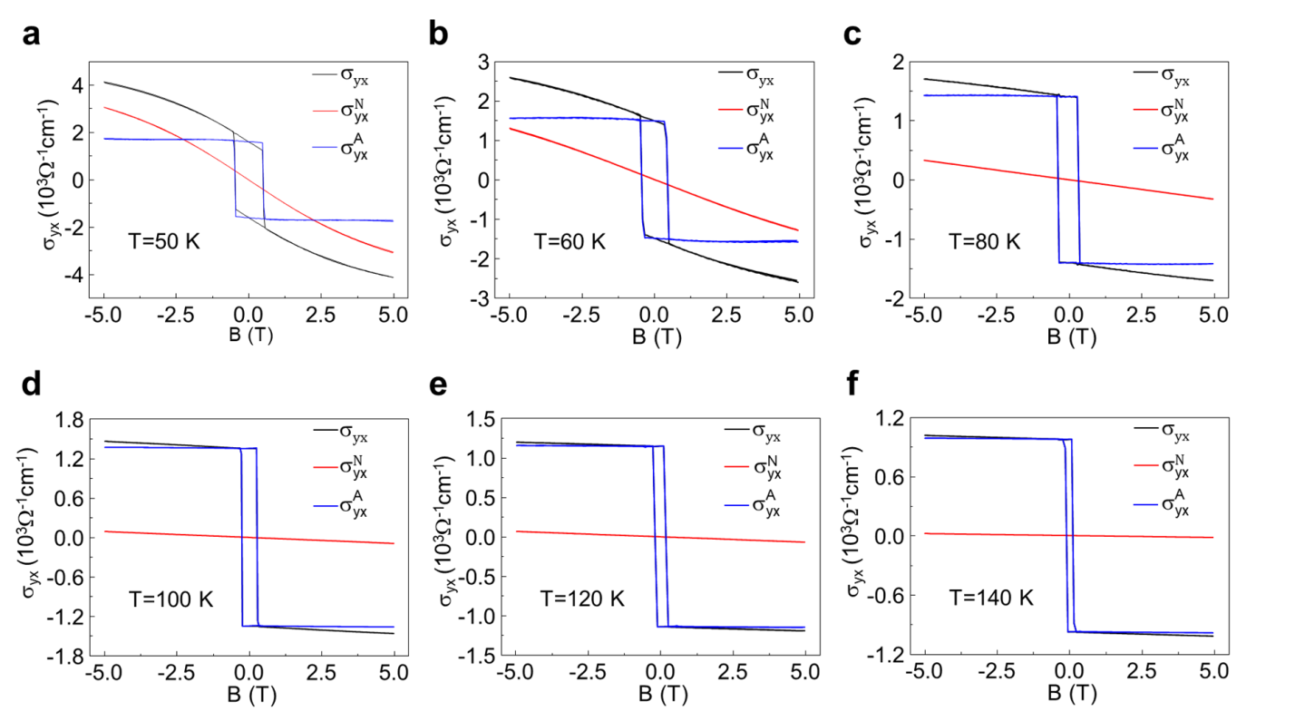

Fig. S11. Determination of the anomalous and normal Hall conductivity at different temperatures. The overall Hall conductivity ${\text{σ}}_{\text{yx}}$ (black curve) is determined by the function ${\text{σ}}_{\text{yx}}\text{=}\frac{\text{-}{\text{ρ}}_{\text{yx}}}{{\text{ρ}}_{\text{yx}}^{\text{2}}\text{+}{\text{ρ}}_{\text{xx}}^{\text{2}}}$. The AHC ${\text{σ}}_{\text{yx}}^{\text{A}}$ (blue curve) is obtained by subtracting the normal Hall conductivity ${\text{σ}}_{\text{yx}}^{N}$ (red curve).

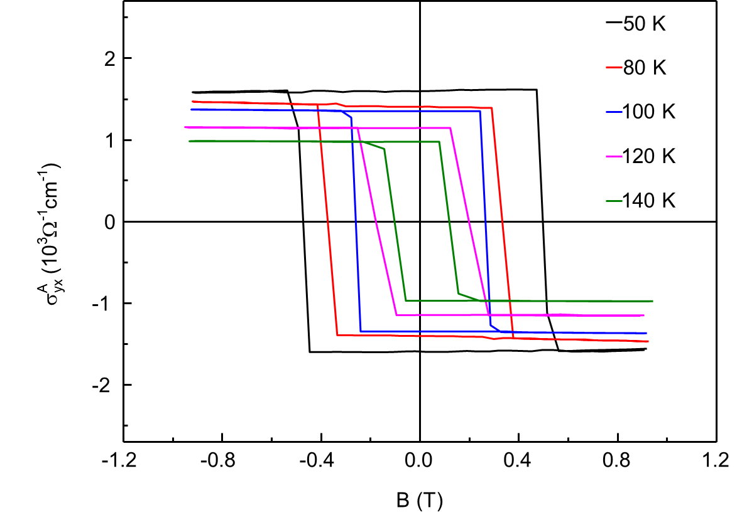

Fig. S12. Temperature dependence of AHC in Co₃Sn₂S₂ crystals. ${\text{σ}}_{\text{yx}}^{\text{A}}$ were measured at 50 K, 80 K, 100 K, 120 K, and 140 K with B⊥I, respectively, showing the hysteretic behavior and the sharp switching below 100 K. The AHC decreases with increasing temperature.

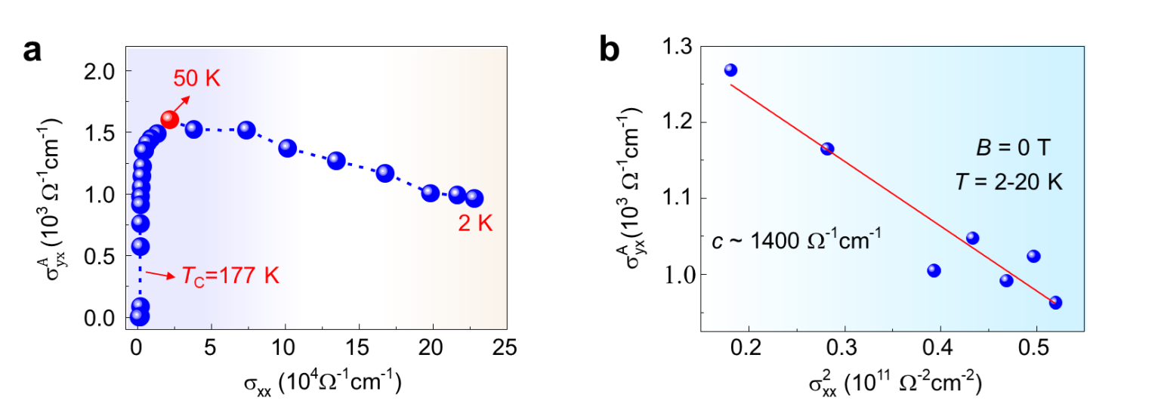

Fig. S13. Intrinsic AHE in Co₃Sn₂S₂ single crystals. a, σ_{xx} dependence of ${\text{σ}}_{\text{yx}}^{\text{A}}$, showing a dramatic decrease below 50 K. b, ${\text{σ}}_{\text{yx}}^{\text{A}}$ plotted against ${\text{σ}}_{\text{xx}}^{\text{2}}$ at the zero magnetic field from 2 K to 20 K. In this temperature range, $ρ_{yx}$<< $ρ_{xx}$ , the scaling relation of ${\text{σ}}_{\text{yx}}^{\text{A}}=-(a{\text{σ}}_{\text{xx0}}^{-1}+b{\text{σ}}_{\text{xx0}}^{-2}){\text{σ}}_{\text{xx}}^{2}-c$, is applied to reveal the AHE mechanism, in which the first, second, and third term represents the skew-scattering, the side-jump effect, and the intrinsic contribution. The extracted intrinsic AHC of the hexagonal Co₃Sn₂S₂ crystal is around 1400 Ω⁻¹cm⁻¹, which is close to the theoretical value calculated based on Berry curvature.

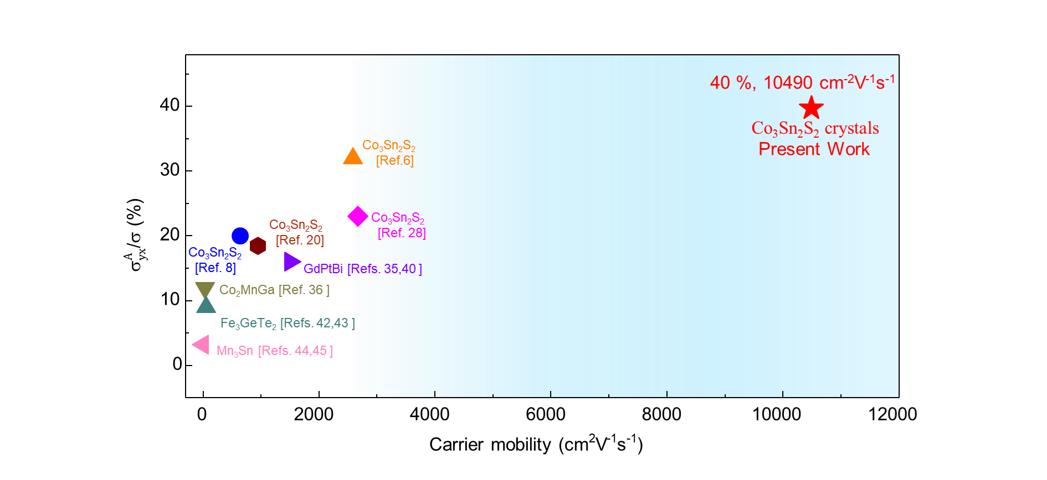

Fig. S14. Comparison of AHA and carrier mobility in Co₃Sn₂S₂ crystals. Our results of AHA and carrier mobility are marked by red star in the right part. Previous reports about AHC and carrier mobility in the left part. The carrier mobility of the samples we prepared is about 4 times that of the previously reported maximum mobility of Co₃Sn₂S₂. And our results for the AHA is clearly higher than the previously reported values.

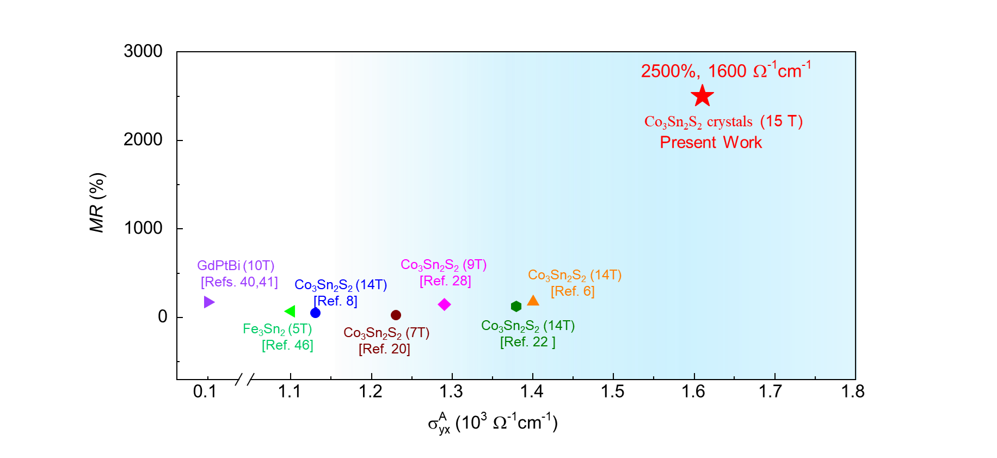
Fig. S15. Comparison of MR and AHC in Co₃Sn₂S₂ crystals. Comparison of our AHC results and MR at 2 K with the previously reported results for GdPtBi, Fe₃Sn₂, Co₃Sn₂S₂ crystals prepared by the self-flux method, and Co₃Sn₂S₂ nanosheets with a thickness of 250 nm and 180 nm by the CVT method.

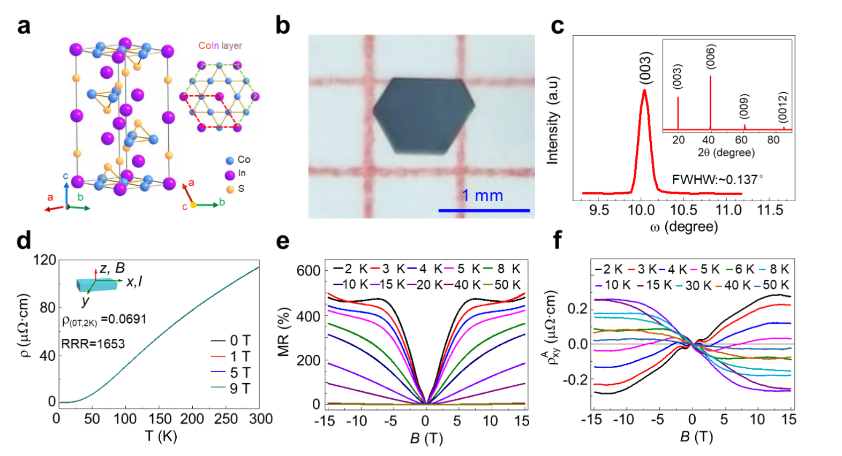

Fig. S16. Crystalline structure and electrical transport properties of Co₃In₂S₂ crystals. a, Crystalline structure of Co₃In₂S₂ crystals. The Co atoms form a kagome lattice. Blue, pink and yellow balls represent Co, In and S atoms, respectively. b, An optical photograph of the hexagonal Co₃In₂S₂ crystal prepared by the CS-CVT method. c, The x-ray rocking curve of (003) reflection for samples. The inset shows x-ray diffraction pattern of Co₃In₂S₂ crystals. d, Temperature dependence of the resistivity under different magnetic fields, showing a large residual resistivity ratio (RRR=ρ_{300K}/ρ_{2K}) of 1653. e, MR as a function of the magnetic field up to 15 T at different temperatures from 2 K to 50 K for B⊥ I. f, Magnetic field dependence of the anomalous Hall resistivity at different temperatures from 2 K to 50 K. The carrier mobility of our sample is determined to be 16380 cm⁻²V⁻¹s⁻¹ for hole at 2 K. The RRR and MR of our sample is about 4 times the highest value reported (420 and ~120%, Chem. Mater. 33, 9741 (2021)). And they didn’t observe the anomalous Hall effect in the field-dependent resistivity curves. This is believed to be mainly due to the low quality of the crystals.

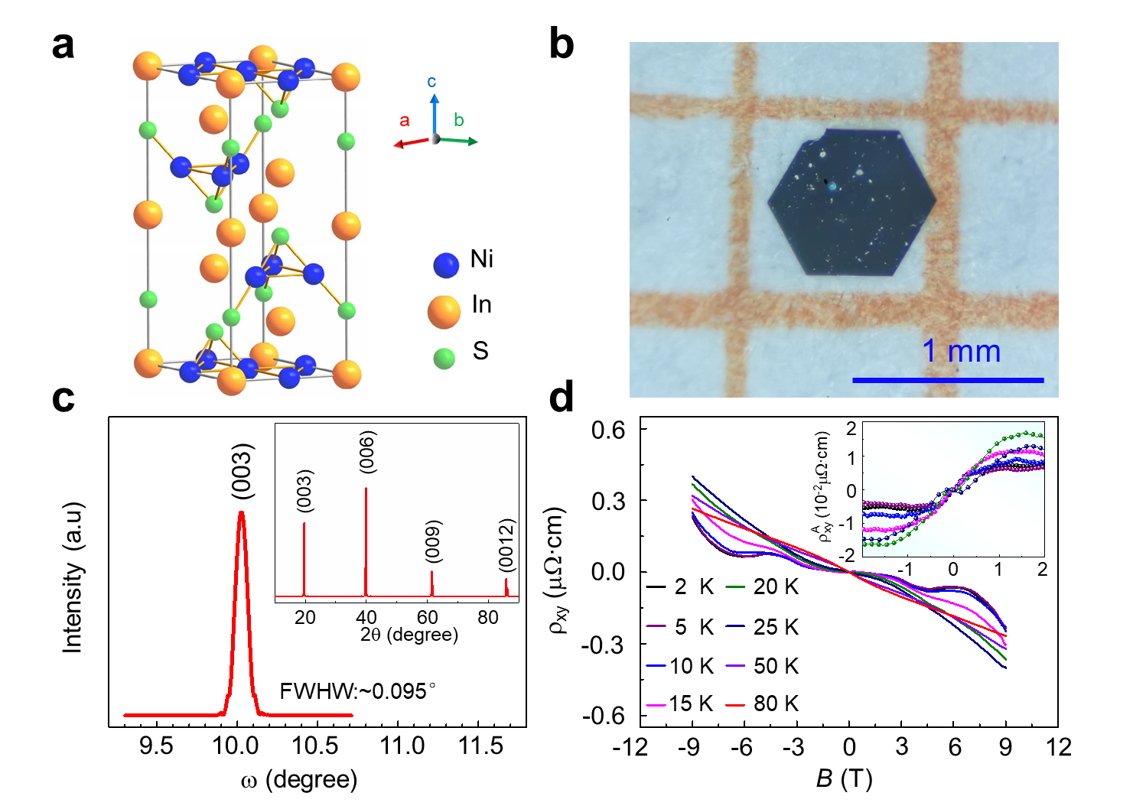
Fig. S17. Crystal structure and electrical transport properties of Ni₃In₂S₂ crystals. a, The crystalline structure of Ni₃In₂S₂ crystals. Blue, yellow and green balls represent Ni, In and S atoms, respectively. b, An optical photograph of the hexagonal Ni₃In₂S₂ crystal. c, The x-ray rocking curve of (003) reflection for samples. The inset shows x-ray diffraction pattern of Ni₃In₂S₂ crystals. d, Magnetic field dependence of the Hall resistivity at different temperatures from 2 K to 80 K. The inset shows the extracted ${}_{\text{xy} }^{\text{A}}$ acquired by subtracting the locally linear ordinary Hall background at different temperatures. The S-shaped Hall resistivity feature persists remains visible at higher temperature where the two-band ordinary Hall resistivity appears to be linear. The carrier mobility of our sample is determined to be 28690 cm⁻²V⁻¹s⁻¹ for electron at 2 K according to two-band mode, about 4 times the highest value reported (8683 cm⁻²V⁻¹s⁻¹ at 2 K, Sci China. Mater. (2023), DOI: 10.1007/s40843-022-2348-9).

