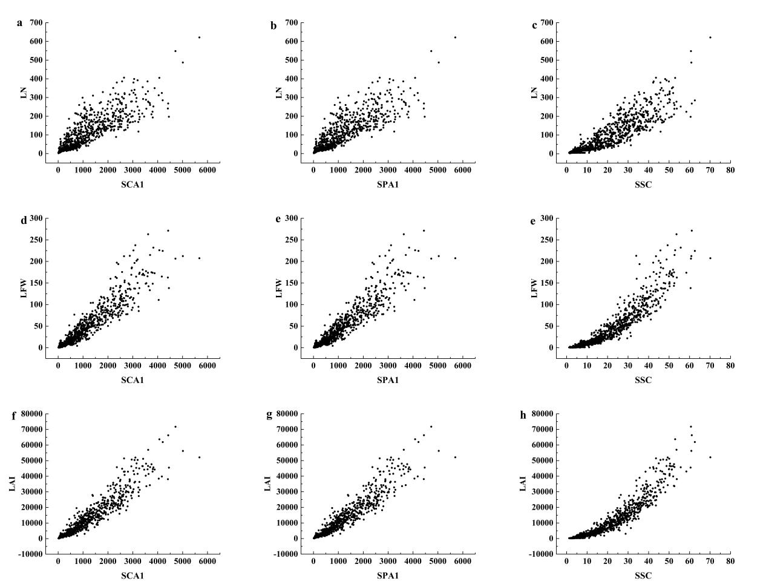
S1. Relationship between highly correlated image parameters and soybean leaf parameters

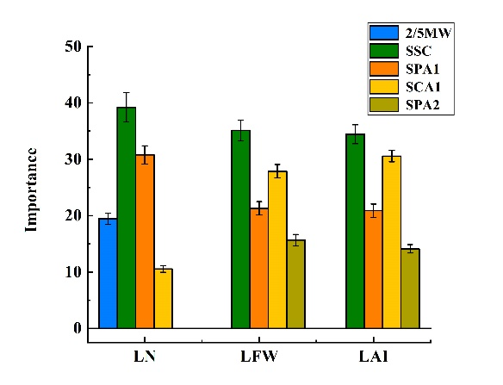
S2. The importance of each input parameter in the RF model

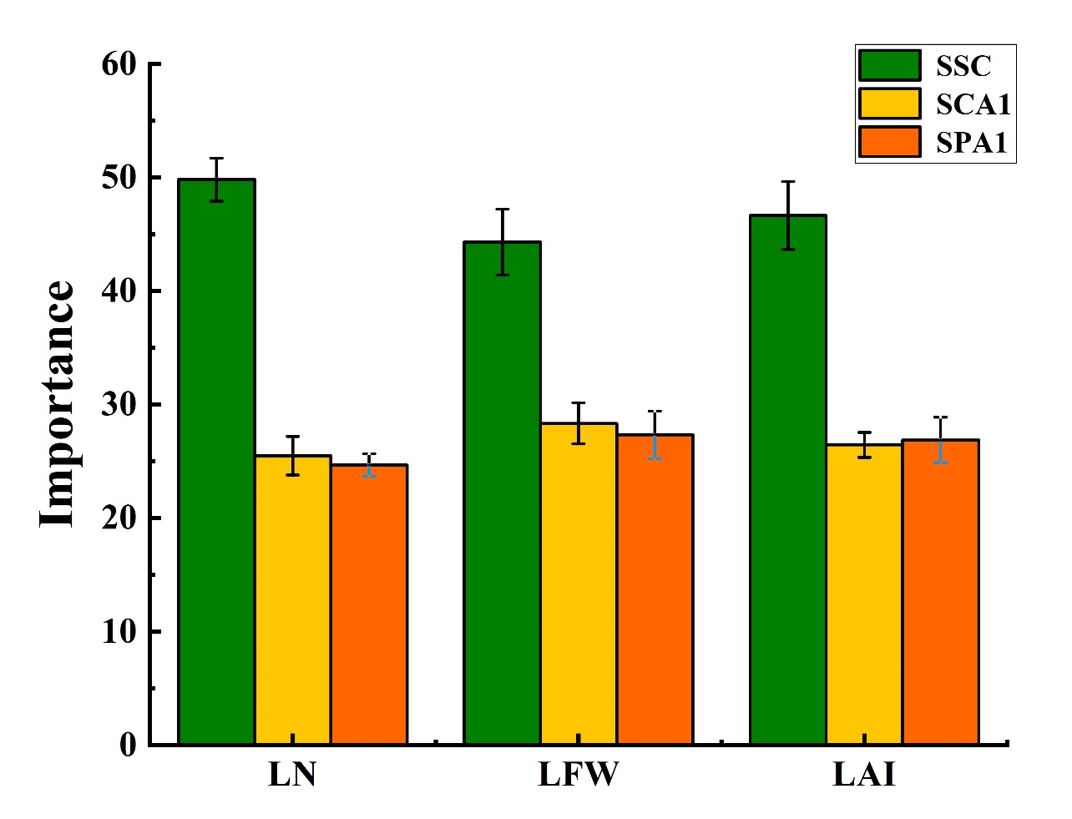
S3. The importance of each parameter in the M7 combination in the Cat Boost model

Coefficients:
Estimate Std. Error t value Pr(>|t|)
(Intercept) 21.20 10.67 1.988 0.047115 *
poly(SCC, 3, raw = TRUE)1 -299.77 113.04 -2.652 0.008130 **
poly(SCC, 3, raw = TRUE)2 1355.27 355.26 3.815 0.000145 ***
poly(SCC, 3, raw = TRUE)3 -977.28 340.61 -2.869 0.004203 **
---
Signif. codes: 0 ‘***’ 0.001 ‘**’ 0.01 ‘*’ 0.05 ‘.’ 0.1 ‘ ’ 1

Residual standard error: 35.67 on 985 degrees of freedom
Multiple R-squared: 0.4654, Adjusted R-squared: 0.4637
F-statistic: 285.8 on 3 and 985 DF, p-value: < 2.2e-16

